**1) Requires proper planning.**  
**2) Data Modelling.**  
- Understand business requirement.  
- Conceptual Model.  
- Logical Model.  
- Physical Model for particular dbms.  
**3) Conceptual models.**  
- Represents the entities and their relationships.  
**4) Logical models.**  
- More detail then conceptual one.  
- Almost know what tables we need.  
- Specify type.  
- Relationship.  
  
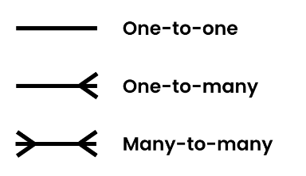  
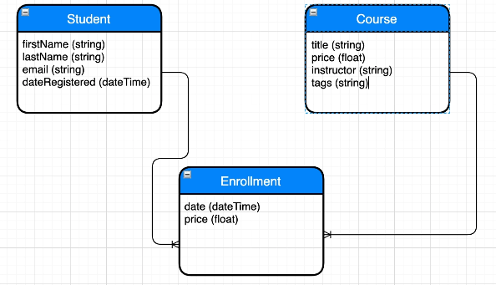  
  
 **5) Physical Models.**File -> New Model, add diagram.  
  
Creating table.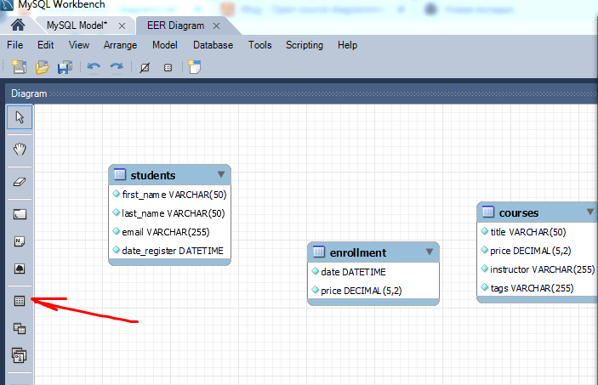  
  
**6) Primary Keys.**  
Unique id for each запись в таблице.  
Id column.  
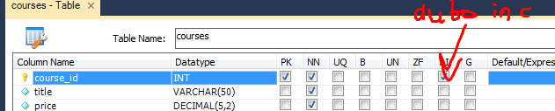  
**7) Foreign keys.**  
A key that is primary key in another table.  
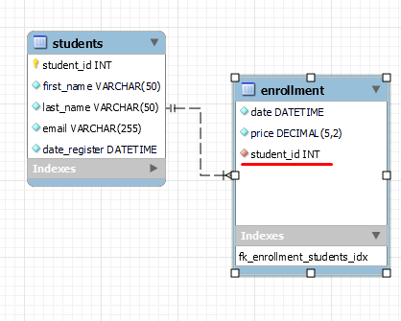  
  
**8) Foreign key constraints.**  
**9) Normalization.**Process of reviewing db of design and fix for some rules.  
  
**10) 1NF.** **11) Link Tables.**No many to many relationship in relation db.  
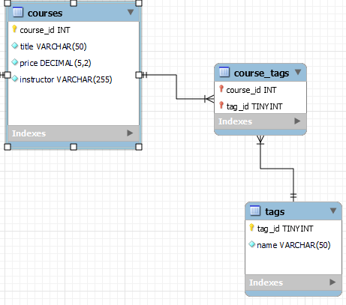  
  
Now our db in 1NF.  
Only 1 value in 1 cell.  
 **12) 2NF.**  
Must be in 1NF.  
AND!  
  
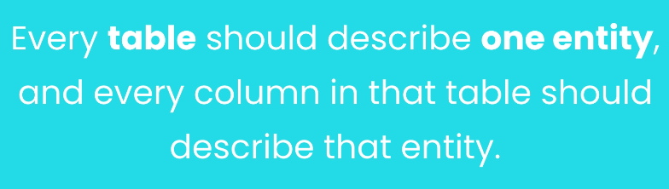  
For example: if our course would have enrollement_date, than we must have delete it. But we have a problem here! Instructor is gonna duplicated himself if he will be in another course. Solution: add table for instructor.  
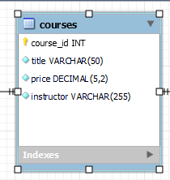  
  
**13) 3NF.**  
Already 2NF.  
AND.  
  
  
**14) My Pragmatic Advice.**  
No dublicates, unless it is foreign keys.  
  
**15) Don’t model the universe.**  
**16) Forward engineering a model.**  
How to Model to DB.  
Database -> forward engineering.  
  
**17) Synchronizing a Model with a DB.**  
 **18) Reverse Engineering a DataBase.**  
**19) Flight booking system.**