**25) Creating and dropping databases.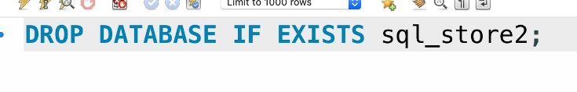 26) Creating Tables.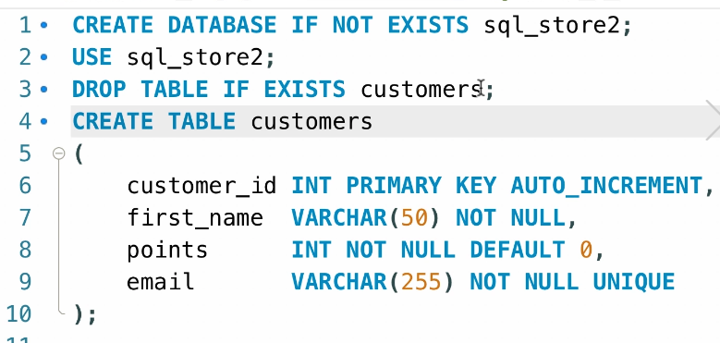 OR** **27) Altering Tables.**Maybe we have forgotten about adding some columns to our table or column.  
  
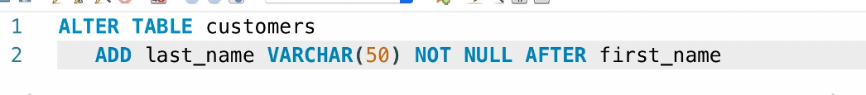  
If you have spaces in your column’s name so you must use backticks.  
  
You can also add more than 1 columns in one query.  
  
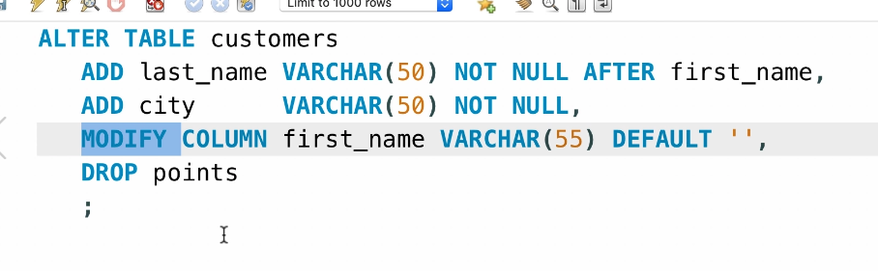  
**28) Creating Relationships.**  
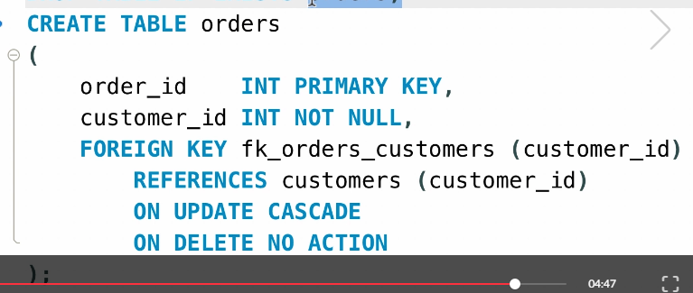  
**29) Altering Primary and Foreign key Constraints.**  
  
