**2) Inserting a row.**INSERT INTO  
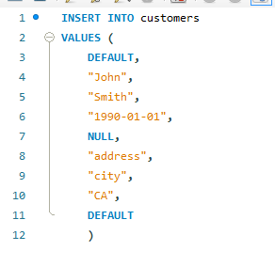  
**3) Inserting multiple rows**.  
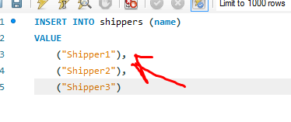  
  
**4) Inserting hierarchical rows.**  
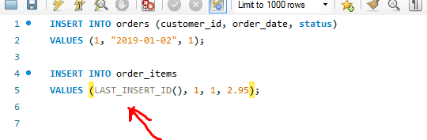 **5) Creating a copy of a table.**But you need to choose PK and AI by yourself.  
  
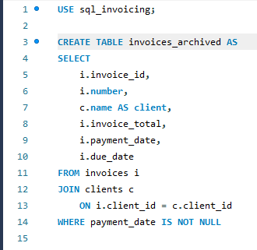  
  
**6) Updating a single row.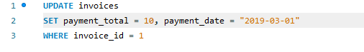 7) Updating Multiple Rows.**

**8) Using subqueries in updates.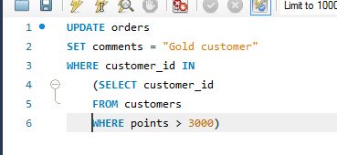 9) Deleting Rows.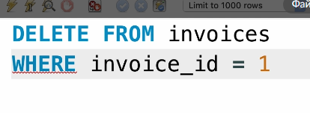 10) Restoring the DB.**  
Через file -> script и выбор начального скрипта.