**1) Aggregate Functions.**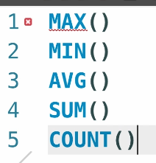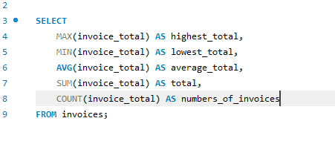You can also use it with dates and strings.  
  
It operates with only null values.  
Count returns not null values.  
  
  
**2) The GROUP BY clause.**  
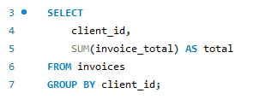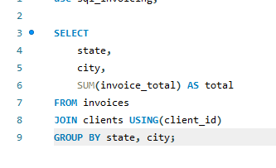 **3) The HAVING Clause.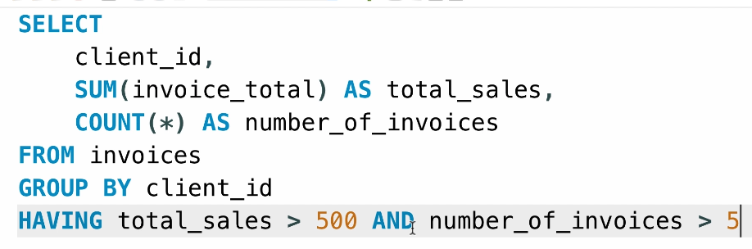 Having –** filter data, after we grouped it.  
 **4) The ROLLUP operator.**  
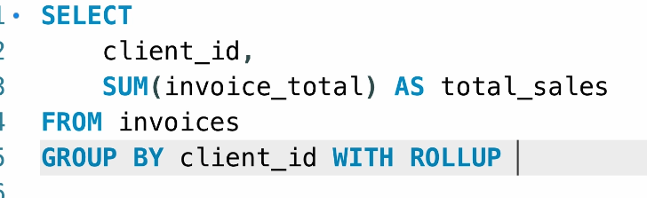 **We get 1 more row with all total sales together.**