**How to Set Up The application**

**1- Getting an API Token**

1- Go to <https://developers.google.com/tenor/guides/quickstart>

2- Click Sign up for log int to Google Cloud Console and log in using a gmail account

3- Click Get a Tenor API Key

4- Give the app a name and accept the google terms

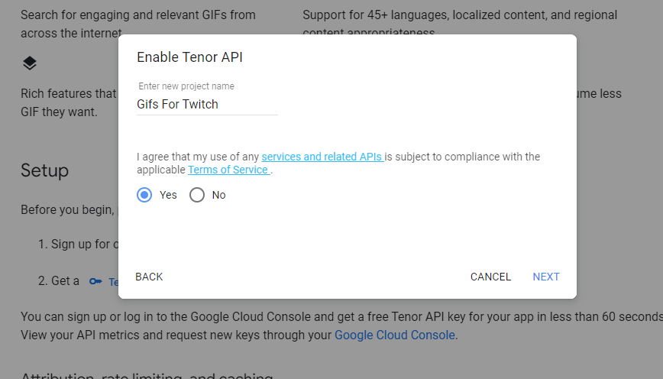

5- Click Show Key

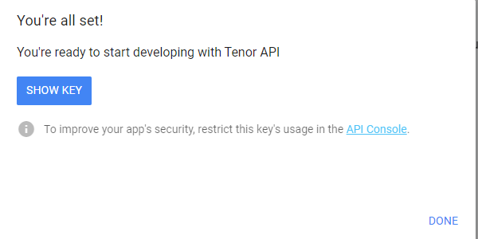

Paste the key into the Configuration.exe text box and click save

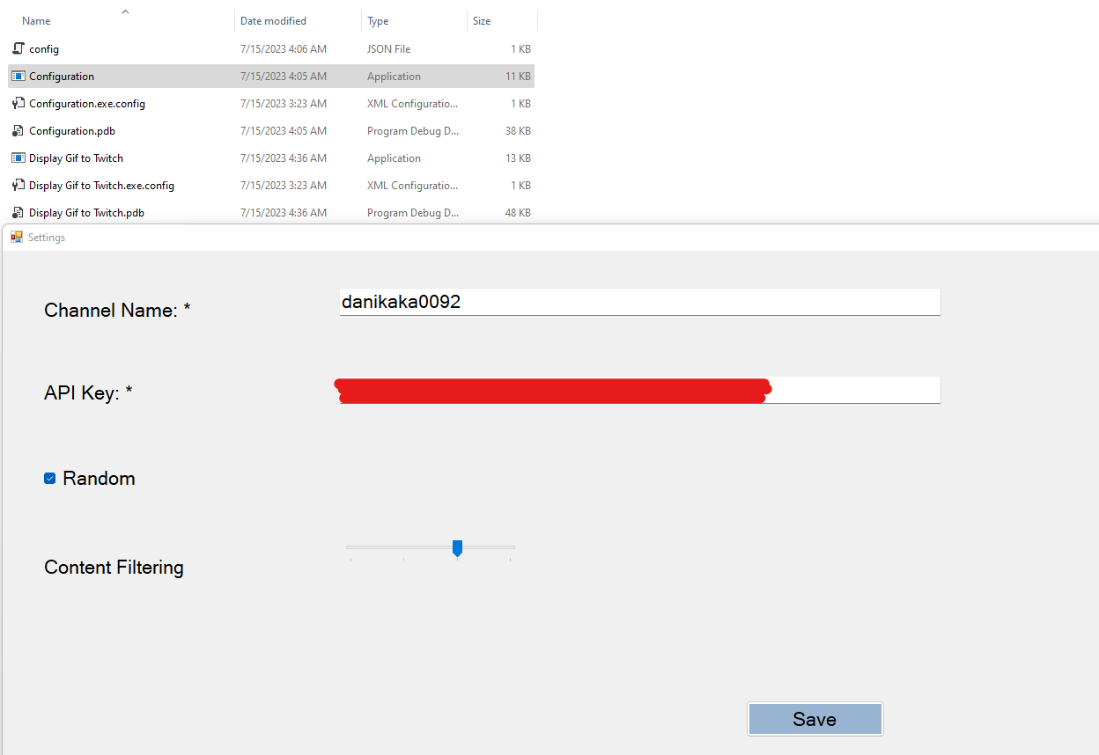

**2- Configure the App**

1. Run the Configuration.exe form.
2. Fill out your channel name
3. Fill out API Key obtained from Step
4. Check the “Random” Box if you want gif search results to be random, uncheck it if you want to always get the most relevant result.
5. **Recommended**: Slide the content filtering to the right if you want the results to be more family friendly, sliding this to the late could result in showing some gifs that are generally considered sus.

**Run The Application**

1. Run the file “Gifs on Twitch”

**OBS Set up**

1. **Go to your scene in OBS and add new Window Capture Source**

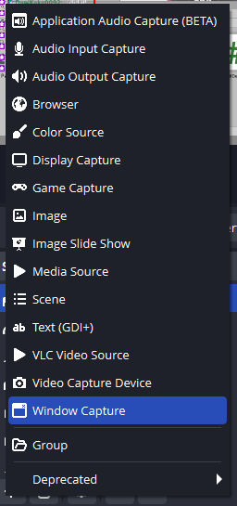

1. Select the Gifs On Twitch Window

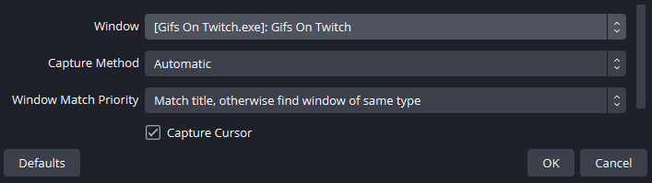

1. Right Click the source and click “Filters”
2. Click the + button and add a Chroma Key filter

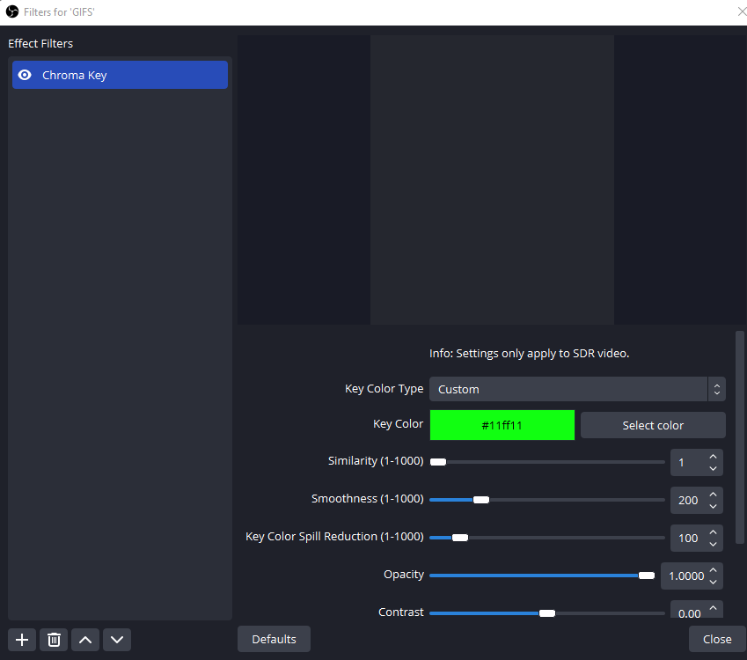

1. Select Custom color and set it to #11ff11
2. Set similarity to 1 and smoothness to 200.

**Test the application**

1. Type any words or phrases in your chat and confirm that the gif is displayed on the screen.

**Enjoy**!

If you and your friends are enjoying the extension , come say hi when you see me live on twitch:

<https://www.twitch.tv/danikaka0092/>