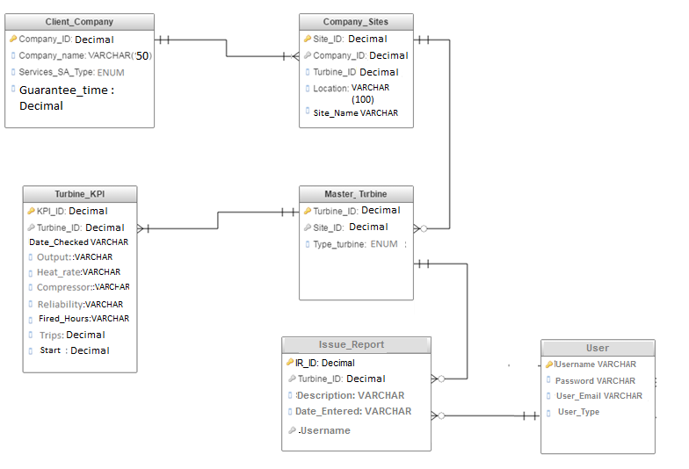

|  |
| --- |
| DROP TABLE IF EXISTS Client_Company;  CREATE TABLE Client_Company (  Company_ID NUMERIC(5) NOT NULL PRIMARY KEY,  Company_name VARCHAR(50) NOT NULL,  Services_SA_Type ENUM ('Cooperative Agreement', 'Contract', 'Grant'),  Guarantee_time NUMERIC(5) NOT NULL  ); |
| INSERT INTO Client_Company (Company_ID, Company_name, Services_SA_Type, Guarantee_time) VALUES ("1","Alfa","Contract","2");  INSERT INTO Client_Company (Company_ID, Company_name, Services_SA_Type, Guarantee_time) VALUES ("2","Beta","Cooperative Agreement","3");  INSERT INTO Client_Company (Company_ID, Company_name, Services_SA_Type, Guarantee_time) VALUES ("234","Graham","Contract","4"); |
| DROP TABLE IF EXISTS Company_Site;  CREATE TABLE Company_Site (  Site_ID NUMERIC(5) NOT NULL PRIMARY KEY,  Company_ID NUMERIC(5) NOT NULL,  Turbine_ID NUMERIC(5) NOT NULL,  Location VARCHAR(100),  Site_name VARCHAR(30),  Foreign key (Company_ID) references Client_Company (Company_ID)  ); |
| INSERT INTO Company_Site (Site_ID, Company_ID, Turbine_ID, Location) VALUES ("1","1"," 1","London");  INSERT INTO Company_Site (Site_ID, Company_ID, Turbine_ID, Location) VALUES ("2","1"," 2","Sofia");  INSERT INTO Company_Site (Site_ID, Company_ID, Turbine_ID, Location) VALUES ("3","2"," 3","Tokyo");  INSERT INTO Company_Site (Site_ID, Company_ID, Turbine_ID, Location) VALUES ("4","2"," 4","Orlando"); |
| DROP TABLE IF EXISTS Master_Turbine;  CREATE TABLE Master_Turbine (  Turbine_ID NUMERIC(5) NOT NULL PRIMARY KEY,  Site_ID NUMERIC(5) NOT NULL,  Type_Turbine ENUM ('Gas', 'Steam'),  Foreign key (Site_ID) references Company_Site (Site_ID)  ); |
| INSERT INTO Master_Turbine (Turbine_ID, Site_ID, Type_Turbine) VALUES ("1","1","Steam");  INSERT INTO Master_Turbine (Turbine_ID, Site_ID, Type_Turbine) VALUES ("2","1","Gas");  INSERT INTO Master_Turbine (Turbine_ID, Site_ID, Type_Turbine) VALUES ("3","2","Steam");  INSERT INTO Master_Turbine (Turbine_ID, Site_ID, Type_Turbine) VALUES ("4","2","Gas"); |
| DROP TABLE IF EXISTS Turbine_KPI;  CREATE TABLE Turbine_KPI (  KPI_ID NUMERIC(20) NOT NULL PRIMARY KEY,  Turbine_ID NUMERIC(5) NOT NULL,  Date_Checked VARCHAR(30),  Output VARCHAR(30),  Heat_Rate VARCHAR(30),  Compressor VARCHAR(30),  Availability VARCHAR(30),  Realibility VARCHAR(30),  Fired_Hours VARCHAR(30),  Trips NUMERIC(1),  Start NUMERIC(1),  Foreign key (Turbine_ID) references Master_Turbine (Turbine_ID)  ); |
| DROP TABLE IF EXISTS Issue_Report;  CREATE TABLE Issue_Report (  IR_ID NUMERIC(10) NOT NULL PRIMARY KEY,  Turbine_ID NUMERIC(5) NOT NULL,  IR_Description VARCHAR(300),  Date_Entered VARCHAR(30),  Username VARCHAR(30) NOT NULL,  CONSTRAINT FOREIGN KEY (Turbine_ID) references Master_Turbine (Turbine_ID),  CONSTRAINT FOREIGN KEY (Username) references User (Username)  ); |
| INSERT INTO Issue_Report (IR_ID, Turbine_ID, IR_Description, Date_Entered, Username) VALUES ("1", "1", "There was an issue experienced in turbine 1", "02.08.2016", "AdminStef"); |
| DROP TABLE IF EXISTS User;  CREATE TABLE User (  Username VARCHAR(30) NOT NULL PRIMARY KEY,  Password VARCHAR(64) NOT NULL,  User_Email VARCHAR(60),  User_Type ENUM ('SM', 'Admin', ' RMandD')  ); |
| INSERT INTO User (Username, Password, User_Email, User_Type) VALUES ("AdminStef", "blueteamturbine", "Stefan.baterbee@ge.com", "Admin"); |
| LOAD DATA LOCAL INFILE '/var/www/html/mysql/Book1.data'  INTO TABLE Turbine_KPI  FIELDS TERMINATED BY ','  ENCLOSED BY '"'  LINES TERMINATED BY '\n'  IGNORE 1 ROWS; |