Android is an operatinng system used by mobile phones, tvs, and smart wear.
Android was developed by google.inc
andrpid apps are software applications that run on android.

Android studio

kotlin/java
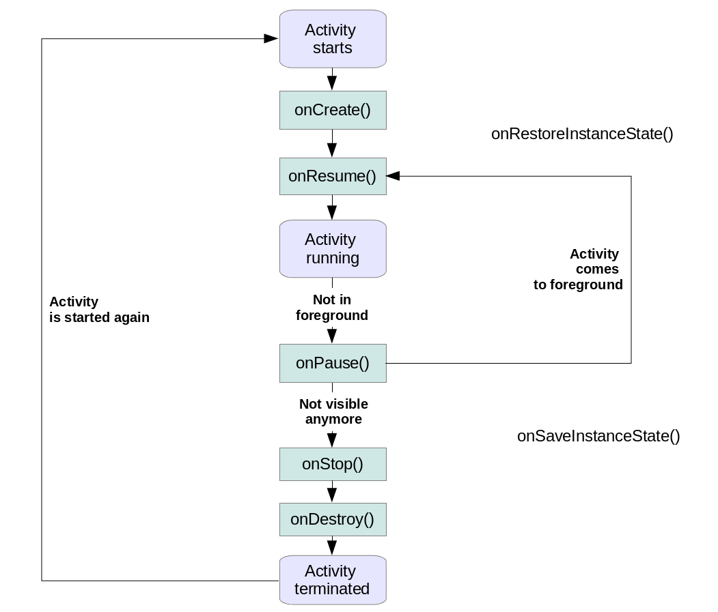

source- https://www.vogella.com/tutorials/AndroidLifeCycle/article.html
android activity cycle starts with the start of the activity.
Then it goes through phases where it is in foreground and in those in which it is in background.
An activity may go back and forth the two .
Ultimately it is killed by the os.

Ui elements in android apps are
-textview
-plaintext
-button
-imageview
-scrollbar
-checkbox

refferences were taken from-
https://developer.android.com
https://www.youtube.com/watch?v=oh4YOj9VkVE
https://stackoverflow.com



