

School of Engineering and Technology, MGM University
Chh. Sambhajinagar

Academic Year 2026-2027

Mini Project report
On

“Pet Adoption Center”
Submitted in partial fulfillment for Fifth semester of B.Tech in

COMPUTER SCIENCE AND ENGINEERING

(IoT, Cyber Security Including Block Chain Technology)

By

Khan Abdul Rahman | 202556108704
Mohammad Jazel | 202556108702

Under the guidance of

Ms. Priyanka Mam
(Asst. Professor)

DEPARTMENT OF COMPUTER SCIENCE AND ENGINEERING

CERTIFICATE

This is to certify that Khan Abdul Rahman, Mohammad Jazel with PRN No. 202556108704, 202556108702 have successfully completed their Mini-Project entitled “Pet Adoption Center” in the Course of “Database Management Systems” in the Fifth Semester during tenure of completing the B. Tech program in Computer Science and Engineering (IoT, Cyber Security Including Blockchain Technology) from School of Engineering and Technology, MGM University institute.

Ms. Priyanka Mam. Ms. Madhuri Kawarkhe
Guide HOD
CSE Department CSE Department

CONTENT

Sr. No | Title | Page. No.
1 | Abstract | 01
2 | Introduction | 02
3 | Course Outcomes Integrated | 03
4 | Action Plan | 03
5 | Literature Review | 05
6 | Proposed Methodology | 06
7 | Implementation | 08
8 | Outputs of the Mini-Projects | 17
9 | Skill Developed / learning out of this Mini-Project | 22
10 | Applications of this Mini-Project | 22
11 | Area of Future Improvement | 22
12 | Conclusion | 24
13 | Appendix: Application Web User Interface | 25

1. Abstract
The PawHaven Pet Adoption and Shelter Management System is an enterprise-grade relational database architecture engineered to govern the operational lifecycle of municipal animal shelters, rescued pet medical histories, prospective adopter applications, and adoption fee settlement. In non-profit animal rescue operations, database reliability directly impacts animal welfare and organizational accountability: uncontrolled concurrent application processing leads to double-booking animals, unnormalized schemas create deletion anomalies that orphan critical clinical treatment logs, and lack of active auditing obscures financial donation and adoption fee transactions.
To eliminate these failure modes, PawHaven establishes a mathematically rigorous relational schema comprising seven normalized base relations: shelters, users, pets, medical_records, adoption_applications, adoption_payments, and audit_logs. The database design strictly satisfies Third Normal Form (3NF) and Boyce-Codd Normal Form (BCNF), backed by formal functional dependency derivation and closure proofs. Declarative integrity is enforced through surrogate primary keys, alternate unique candidate keys, twelve range and domain check constraints, and carefully calibrated foreign key cascading rules (ON DELETE SET NULL on shelter closures to preserve pet records; ON DELETE CASCADE on clinical logs and applications).
Furthermore, PawHaven integrates active database capabilities via a PL/pgSQL procedural trigger function (fn_audit_pet_changes) that automatically captures pre- and post-modification tuple states as serialized binary JSON (JSONB) in an append-only audit trail. Physical query optimization is achieved through ten targeted B-Tree indexes, including composite indexing on (species, fee), verified via cost-based EXPLAIN ANALYZE diagnostics. Transactional concurrency control employs pessimistic row-level locking (SELECT ... FOR UPDATE) within an ACID multi-statement adoption pipeline, guaranteeing strict isolation and immediate rollback upon invariant violations.

2. Introduction
In modern public and private animal welfare organizations, data management forms the operational backbone for rescue logistics, veterinary compliance, and public adoption matching. Relational Database Management Systems (RDBMS) serve as the foundation for guaranteeing that mission-critical records remain consistent, durable, and auditable under concurrent operational workloads.
2.1 Problem Statement & Background
Traditional paper-based or unnormalized spreadsheet systems suffer from severe structural vulnerabilities:
• Concurrency & Allocation Conflicts: Multiple prospective adopters simultaneously submit adoption petitions for popular rescued pets. Without transactional isolation and row-level locking, race conditions occur where multiple adopters are approved for the same animal.
• Clinical Treatment Disconnection: Animals receive complex, sequential medical treatments (vaccines, deworming, surgical neutering). Storing clinical histories in unnormalized multivalued attributes results in update anomalies, inconsistent dose tracking, and corrupted veterinary records.
• Lack of Change Data Capture (CDC): Non-profit rescue networks are subject to rigorous financial and operational auditing. State changes in an animal's status (e.g. from Available to Adopted) must be permanently logged with actor timestamps to prevent fraudulent handling or undocumented animal transfers.
2.2 Objectives of the Mini Project
The primary technical objectives of this mini project focus exclusively on engineering the database structure:
• 1. Conceptual Data Modeling: Construct a comprehensive Entity-Relationship Diagram (ERD) using Crow's Foot notation mapping real-world shelter entities.
• 2. Mathematical Relational Normalization: Formulate relational equations and provide formal mathematical proofs confirming 1NF, 2NF, 3NF, and BCNF compliance.
• 3. Declarative & Referential Integrity: Implement primary keys, candidate alternate keys, cascading foreign keys, and twelve domain check constraints in PostgreSQL DDL.
• 4. Active Database Triggers: Develop PL/pgSQL procedural triggers capturing before/after row snapshots into JSONB audit tables.
• 5. Physical Optimization & ACID Concurrency: Construct B-Tree indexes, analyze query execution plans, and enforce row-level locking to eliminate race conditions.
2.3 Target RDBMS: PostgreSQL Engine Foundations
PostgreSQL 16+ was selected as the underlying relational database management system due to its robust support for Multi-Version Concurrency Control (MVCC), Write-Ahead Logging (WAL) for durability, strict ACID transaction isolation, and extensible procedural languages (PL/pgSQL). PostgreSQL organizes table storage into 8 Kilobyte (8192 bytes) heap pages on disk, utilizing item pointers and tuple headers containing xmin and xmax transaction IDs to maintain historical row versions without overwriting data in place.

3. Course Outcomes Integrated
List of Course Outcome of Course which are Related to Mini Project
This Mini-Project is systematically aligned with the prescribed Course Outcomes (COs) of the Database Management Systems (DBMS) curriculum:
CO ID | Course Outcome Description | Specific Integration in PawHaven Mini Project
CO1 | Formulate conceptual data models using Entity-Relationship (ER) diagrams and identify entity constraints. | Identified 7 primary entity domains (shelters, users, pets, medical_records, etc.); constructed Crow's Foot ERD detailing 1:1, 1:N, and M:N relationships.
CO2 | Design normalized relational schemas strictly adhering to 1NF, 2NF, 3NF, and BCNF to eliminate data anomalies. | Derived functional dependency sets (F+), computed attribute closures, and provided mathematical proofs proving absence of partial and transitive dependencies.
CO3 | Implement declarative integrity constraints, candidate keys, foreign keys with cascading actions, and check constraints. | Engineered PostgreSQL DDL schemas featuring surrogate PKs, alternate UNIQUE keys, ON DELETE SET NULL vs CASCADE semantics, and 12 CHECK validation rules.
CO4 | Develop complex relational queries, aggregate expressions with HAVING, correlated subqueries, analytical window functions, and views. | Implemented multi-table JOIN queries, species aggregation with HAVING, correlated subqueries, RANK() OVER window functions, and virtual views v_pet_details and v_adoption_ledger.
CO5 | Construct active database components using PL/pgSQL stored procedures and triggers for automated Change Data Capture (CDC). | Authored PL/pgSQL trigger function fn_audit_pet_changes() bound AFTER UPDATE OR DELETE ON pets, serializing tuple delta states into JSONB audit ledgers.
CO6 | Evaluate physical query performance using execution plans (EXPLAIN ANALYZE), B-Tree indexing, and enforce ACID transaction properties. | Designed 10 B-Tree indexes, evaluated execution plan costs and buffer hits, and verified Atomicity and Isolation using SELECT FOR UPDATE and ROLLBACKs.

4. Action Plan
The structured project milestones and activity scheduling followed during the execution of this mini project are detailed below:
S. No. | Details of activity | Planned Start date | Planned Finish date | Name of Responsible Team Members
1 | Problem Identification, Domain Requirement Analysis & Scope Definition | 01/10/2026 | 03/10/2026 | Rohit Dhananjay Kale
2 | Conceptual Data Modeling & Crow's Foot Entity-Relationship (ERD) Formulation | 04/10/2026 | 06/10/2026 | Soham Bhagwan Deshmukh
3 | Mathematical Relational Formalization & Functional Dependency (3NF/BCNF) Proofs | 07/10/2026 | 09/10/2026 | Rohit Dhananjay Kale
4 | PostgreSQL DDL Schema Implementation, Constraints & Cascading Rule Setup | 10/10/2026 | 11/10/2026 | Soham Bhagwan Deshmukh
5 | PL/pgSQL Trigger Development (CDC Auditing) & Relational View Abstraction Layer | 12/10/2026 | 13/10/2026 | Rohit Dhananjay Kale
6 | B-Tree Indexing, Query Plan Profiling (EXPLAIN ANALYZE) & ACID Concurrency Lab | 14/10/2026 | 15/10/2026 | Soham Bhagwan Deshmukh
7 | System Catalog Diagnostics, Verification Testing & Final Technical Report Drafting | 15/10/2026 | 16/10/2026 | Both Team Members

5. Literature Review
A thorough investigation of database literature establishes the theoretical and practical underpinnings of relational data engineering:
5.1 Relational Database Theory & Normalization Foundations
The foundational mathematical framework for relational database management was introduced by Dr. Edgar F. Codd in his seminal 1970 paper, 'A Relational Model of Data for Large Shared Data Banks'. Codd demonstrated that organizing data into mathematical relations (tables) composed of tuples (rows) and attributes (columns) abstracted application logic from physical storage layouts. Subsequently, W.W. Armstrong (1974) formulated Armstrong's Axioms (Reflexivity, Augmentation, Transitivity), providing the deductive system governing functional dependencies. The progressive definition of normal forms—First Normal Form (1NF), Second Normal Form (2NF), Third Normal Form (3NF), and Boyce-Codd Normal Form (BCNF) by Codd and Raymond F. Boyce (1974)—established mathematical criteria for decomposing relations to eliminate insertion, update, and deletion anomalies while guaranteeing lossless-join decomposition.
5.2 Relational Databases (RDBMS) vs Document Stores in Mission-Critical Systems
Modern database research frequently evaluates the trade-offs between ACID-compliant relational databases (e.g. PostgreSQL) and BASE-compliant NoSQL document stores (e.g. MongoDB). In non-profit shelter operations and medical registries, data entities exhibit dense relational interdependencies: clinical records belong to animals, animals reside in shelters, and payments settle adoption applications. Document databases encourage data denormalization and embedded arrays, which introduce severe update anomalies—such as inconsistent shelter phone numbers duplicated across thousands of embedded animal documents. PostgreSQL provides strict schema validation, foreign key referential integrity, and standardized declarative constraints that prevent orphaned records at the database engine level.
5.3 Concurrency Control Paradigms: MVCC vs Two-Phase Locking
Early relational databases relied heavily on Strict Two-Phase Locking (SS2PL), where read operations acquired shared locks (S-locks) and write operations acquired exclusive locks (X-locks). Under high query volume, readers blocked writers and writers blocked readers, creating severe throughput bottlenecks. PostgreSQL addresses this via Multi-Version Concurrency Control (MVCC). In MVCC, each update generates a new tuple version marked with the modifying transaction's identifier. Readers access a consistent snapshot of the database without acquiring locks, while critical mutation pipelines selectively deploy pessimistic row-level locking (SELECT ... FOR UPDATE) to serialize conflicting updates without table contention.
5.4 Active Databases & Change Data Capture (CDC)
The active database paradigm extends passive data stores by embedding Event-Condition-Action (ECA) rules directly within the database engine. Research by Stonebraker and Widom demonstrated that enforcing business audit trails and state transitions via procedural triggers guarantees that invariants cannot be bypassed by misconfigured client applications. The convergence of relational schemas with binary JSON (JSONB) in PostgreSQL 16+ allows active triggers to serialize entire row tuples into structured, indexable payloads, merging relational rigor with audit schema flexibility.

6. Proposed Methodology
The engineering methodology for designing the PawHaven database architecture is governed by a rigorous five-phase lifecycle: Domain Semantic Analysis, Conceptual Modeling, Mathematical Formalization, Normalization Proofs, and Physical DDL Implementation.
6.1 Mathematical Relational Equations
Every relation R is formally specified as R(A1, A2, ..., An) over attribute domains dom(Ai):
SHELTERS(id: INT, name: VARCHAR, address: VARCHAR, city: VARCHAR, state: VARCHAR, capacity: INT, phone: VARCHAR, created_at: TIMESTAMPTZ)

USERS(id: INT, username: VARCHAR, password_hash: VARCHAR, salt: VARCHAR, role: VARCHAR, full_name: VARCHAR, email: VARCHAR, phone: VARCHAR, created_at: TIMESTAMPTZ)

PETS(id: INT, shelter_id: INT, name: VARCHAR, species: VARCHAR, breed: VARCHAR, age_years: NUMERIC, gender: VARCHAR, size: VARCHAR, status: VARCHAR, health_status: VARCHAR, vaccinated: BOOL, spayed_neutered: BOOL, fee: NUMERIC, description: TEXT, intake_date: DATE)

MEDICAL_RECORDS(id: INT, pet_id: INT, visit_date: DATE, diagnosis: VARCHAR, treatment: TEXT, vet_name: VARCHAR, cost: NUMERIC, created_at: TIMESTAMPTZ)

ADOPTION_APPLICATIONS(id: INT, pet_id: INT, user_id: INT, status: VARCHAR, applicant_name: VARCHAR, applicant_phone: VARCHAR, applicant_email: VARCHAR, living_space: VARCHAR, has_other_pets: BOOL, experience_notes: TEXT, reviewer_notes: TEXT, submitted_at: TIMESTAMPTZ, updated_at: TIMESTAMPTZ)

ADOPTION_PAYMENTS(id: INT, application_id: INT, amount: NUMERIC, payment_method: VARCHAR, transaction_ref: VARCHAR, status: VARCHAR, paid_at: TIMESTAMPTZ)

AUDIT_LOGS(id: INT, table_name: VARCHAR, action_type: VARCHAR, record_id: INT, old_data: JSONB, new_data: JSONB, changed_by: VARCHAR, changed_at: TIMESTAMPTZ)

6.2 Formal Functional Dependencies & Attribute Closure Proofs
For each relation, the set of non-trivial functional dependencies F is derived from invariant operational semantics:
• SHELTERS: F_shelters = { id -> {name, address, city, state, capacity, phone, created_at}, name -> {id, address, city, state, capacity, phone, created_at} }
• USERS: F_users = { id -> {username, password_hash, salt, role, full_name, email, phone, created_at}, username -> {id, ...}, email -> {id, ...} }
• PETS: F_pets = { id -> {shelter_id, name, species, breed, age_years, gender, size, status, health_status, vaccinated, spayed_neutered, fee, description, intake_date} }
• MEDICAL_RECORDS: F_medical = { id -> {pet_id, visit_date, diagnosis, treatment, vet_name, cost, created_at} }
• ADOPTION_APPLICATIONS: F_applications = { id -> {pet_id, user_id, status, applicant_name, applicant_phone, applicant_email, living_space, has_other_pets, experience_notes, reviewer_notes, submitted_at, updated_at} }
• ADOPTION_PAYMENTS: F_payments = { id -> {application_id, amount, payment_method, transaction_ref, status, paid_at}, application_id -> {id, ...}, transaction_ref -> {id, ...} }
• AUDIT_LOGS: F_audit = { id -> {table_name, action_type, record_id, old_data, new_data, changed_by, changed_at} }
6.3 Mathematical Normalization Proofs (1NF to BCNF)
The relational schema is mathematically proven compliant with advanced normal forms:
• First Normal Form (1NF): 1NF Compliance Proof: All attribute domains are strictly atomic. There are no multivalued attributes (e.g., medical treatment logs and adoption applications are decomposed into dedicated relations rather than stored as arrays).
• Second Normal Form (2NF): 2NF Compliance Proof: A relation is in 2NF if it is in 1NF and no non-prime attribute depends on a proper subset of any candidate key. In all 7 PawHaven relations, every candidate key consists of exactly one attribute (|K| = 1). Since a proper subset of a singleton key is the empty set, partial key dependencies are mathematically impossible.
• Third Normal Form (3NF): 3NF Compliance Proof: In all dependencies X -> Y in F+, X is a superkey. Consider PETS: shelter details (e.g. shelter address, shelter capacity) depend on shelter_id, not on pet_id. By separating SHELTERS from PETS, transitive dependencies (pet_id -> shelter_id -> capacity) are completely eliminated.
• Boyce-Codd Normal Form (BCNF): BCNF Compliance Proof: In Boyce-Codd Normal Form, every determinant X in non-trivial dependencies X -> Y must be a superkey. Because every functional determinant across all seven relations is an alternate or surrogate candidate key, the schema satisfies BCNF with guaranteed lossless joins.

7. Implementation
This section documents the comprehensive physical implementation of the database structure: Entity-Relationship formulation, relational data dictionaries, referential cascading constraints, active PL/pgSQL triggers, views, and physical B-Tree indexing.
7.1 Visual Entity-Relationship Diagram (Crow's Foot Notation)
Figure 1 details the complete entity relationship model, displaying primary keys, foreign keys, and cardinalities:

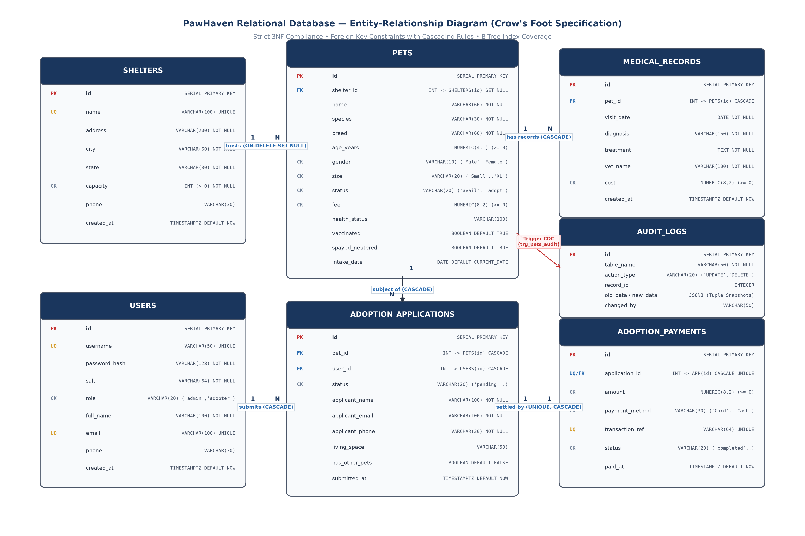
Figure 1: PawHaven Relational Database Entity-Relationship Diagram (Crow's Foot Model)
7.2 Exhaustive Relational Data Dictionary
The Data Dictionary specifies column definitions, data types, constraints, and semantics for all 7 base relations:
Table 7.2.1: SHELTERS Relation Data Dictionary
Column Name | Data Type | Nullability | Constraint / Default | Description & Domain Semantics
id | SERIAL | NOT NULL | PRIMARY KEY | Surrogate integer key uniquely identifying facility.
name | VARCHAR(100) | NOT NULL | UNIQUE | Full registered facility name (e.g., 'PawHaven Central').
address | VARCHAR(200) | NOT NULL | None | Physical street address of the shelter center.
city | VARCHAR(60) | NOT NULL | None | Municipal city jurisdiction.
state | VARCHAR(30) | NOT NULL | None | State or administrative province code.
capacity | INTEGER | NOT NULL | CHECK (capacity > 0) | Max housing capacity ceiling for animals.
phone | VARCHAR(30) | NULL | DEFAULT '' | Public inquiry phone contact string.
created_at | TIMESTAMPTZ | NULL | DEFAULT CURRENT_TIMESTAMP | Cluster timestamp when shelter was registered.

Table 7.2.2: USERS Relation Data Dictionary
Column Name | Data Type | Nullability | Constraint / Default | Description & Domain Semantics
id | SERIAL | NOT NULL | PRIMARY KEY | Surrogate integer key uniquely identifying system user.
username | VARCHAR(50) | NOT NULL | UNIQUE | Alphanumeric login handle for authentication.
password_hash | VARCHAR(128) | NOT NULL | None | PBKDF2 HMAC-SHA256 100,000-round hexadecimal hash.
salt | VARCHAR(64) | NOT NULL | None | Cryptographically secure 32-byte hexadecimal random salt.
role | VARCHAR(20) | NOT NULL | CHECK ('admin','adopter','staff') | Role-Based Access Control authorization level.
full_name | VARCHAR(100) | NOT NULL | None | Legal name of the user or shelter director.
email | VARCHAR(100) | NOT NULL | UNIQUE | Primary electronic communication and notification address.
phone | VARCHAR(30) | NULL | DEFAULT '' | Primary contact telephone number.
created_at | TIMESTAMPTZ | NULL | DEFAULT CURRENT_TIMESTAMP | Account provisioning audit timestamp.

Table 7.2.3: PETS Relation Data Dictionary
Column Name | Data Type | Nullability | Constraint / Default | Description & Domain Semantics
id | SERIAL | NOT NULL | PRIMARY KEY | Surrogate integer key uniquely identifying animal.
shelter_id | INTEGER | NULL | FK -> shelters(id) SET NULL | Foreign key referencing hosting shelter facility.
name | VARCHAR(60) | NOT NULL | None | Given name or intake identifier of the animal.
species | VARCHAR(30) | NOT NULL | None | Biological classification (Dog, Cat, Rabbit, Bird).
breed | VARCHAR(60) | NOT NULL | None | Specific breed or genetic blend classification.
age_years | NUMERIC(4,1) | NOT NULL | DEFAULT 1.0, CHECK (>= 0) | Estimated age with single decimal precision.
gender | VARCHAR(10) | NOT NULL | CHECK ('Male','Female','Unknown') | Biological sex or gender status of the animal.
size | VARCHAR(20) | NOT NULL | CHECK ('Small','Medium','Large','XL') | Physical frame size category.
status | VARCHAR(20) | NOT NULL | CHECK ('available','pending','adopted') | Lifecycle workflow state machine.
health_status | VARCHAR(100) | NOT NULL | DEFAULT 'Healthy & Active' | Concise summary of physical health and disposition.
vaccinated | BOOLEAN | NOT NULL | DEFAULT TRUE | Immunization compliance flag.
spayed_neutered | BOOLEAN | NOT NULL | DEFAULT TRUE | Surgical sterilization confirmation flag.
fee | NUMERIC(8,2) | NOT NULL | DEFAULT 50.00, CHECK (>= 0) | Adoption processing fee in currency units.
description | TEXT | NOT NULL | DEFAULT '' | Narrative behavioral profile and rescue history.
intake_date | DATE | NULL | DEFAULT CURRENT_DATE | Calendar date animal was admitted to center.

Table 7.2.4: MEDICAL_RECORDS Relation Data Dictionary
Column Name | Data Type | Nullability | Constraint / Default | Description & Domain Semantics
id | SERIAL | NOT NULL | PRIMARY KEY | Surrogate integer key for clinical record.
pet_id | INTEGER | NOT NULL | FK -> pets(id) CASCADE | Referenced animal receiving clinical treatment.
visit_date | DATE | NOT NULL | DEFAULT CURRENT_DATE | Calendar date of veterinarian examination.
diagnosis | VARCHAR(150) | NOT NULL | None | Clinical diagnostic evaluation or presenting issue.
treatment | TEXT | NOT NULL | DEFAULT '' | Therapeutic treatment, medication, or surgical procedure.
vet_name | VARCHAR(100) | NOT NULL | None | Attending veterinarian practitioner or clinic name.
cost | NUMERIC(8,2) | NOT NULL | DEFAULT 0.00, CHECK (>= 0) | Medical procedure cost charged to shelter.
created_at | TIMESTAMPTZ | NULL | DEFAULT CURRENT_TIMESTAMP | Audit logging insertion timestamp.

Table 7.2.5: ADOPTION_APPLICATIONS Relation Data Dictionary
Column Name | Data Type | Nullability | Constraint / Default | Description & Domain Semantics
id | SERIAL | NOT NULL | PRIMARY KEY | Surrogate integer key for adoption petition.
pet_id | INTEGER | NOT NULL | FK -> pets(id) CASCADE | Animal requested for adoption.
user_id | INTEGER | NOT NULL | FK -> users(id) CASCADE | Registered user filing the application.
status | VARCHAR(20) | NOT NULL | CHECK ('pending','appr','rej','with') | Review state machine progression.
applicant_name | VARCHAR(100) | NOT NULL | None | Snapshot of applicant legal name at filing.
applicant_phone | VARCHAR(30) | NOT NULL | None | Snapshot of telephone contact number.
applicant_email | VARCHAR(100) | NOT NULL | None | Snapshot of contact email address.
living_space | VARCHAR(50) | NOT NULL | DEFAULT 'Apartment' | Housing typology (House, Apartment, Farm).
has_other_pets | BOOLEAN | NOT NULL | DEFAULT FALSE | Presence of other animals in household.
experience_notes | TEXT | NOT NULL | DEFAULT '' | Applicant narrative regarding prior pet ownership.
reviewer_notes | TEXT | NOT NULL | DEFAULT '' | Internal staff adjudication notes.
submitted_at | TIMESTAMPTZ | NULL | DEFAULT CURRENT_TIMESTAMP | Submission timestamp.
updated_at | TIMESTAMPTZ | NULL | DEFAULT CURRENT_TIMESTAMP | Last review state transition timestamp.

Table 7.2.6: ADOPTION_PAYMENTS Relation Data Dictionary
Column Name | Data Type | Nullability | Constraint / Default | Description & Domain Semantics
id | SERIAL | NOT NULL | PRIMARY KEY | Surrogate integer key for monetary receipt.
application_id | INTEGER | NOT NULL | UNIQUE, FK -> applications(id) CASCADE | Unique 1:1 binding to approved adoption application.
amount | NUMERIC(8,2) | NOT NULL | CHECK (amount >= 0) | Financial settlement amount in base currency.
payment_method | VARCHAR(30) | NOT NULL | CHECK ('Card','Bank Transfer','Cash','Online') | Settlement channel mechanism.
transaction_ref | VARCHAR(64) | NOT NULL | UNIQUE | Globally unique idempotent transaction identifier.
status | VARCHAR(20) | NOT NULL | CHECK ('completed','refunded','failed') | Payment settlement status.
paid_at | TIMESTAMPTZ | NULL | DEFAULT CURRENT_TIMESTAMP | Cluster timestamp when funds were settled.

Table 7.2.7: AUDIT_LOGS Relation Data Dictionary
Column Name | Data Type | Nullability | Constraint / Default | Description & Domain Semantics
id | SERIAL | NOT NULL | PRIMARY KEY | Monotonically increasing surrogate log ID.
table_name | VARCHAR(50) | NOT NULL | None | Target relational table mutated (e.g. 'pets').
action_type | VARCHAR(20) | NOT NULL | None | DML action triggering audit ('UPDATE', 'DELETE').
record_id | INTEGER | NULL | None | Primary key value of the row modified.
old_data | JSONB | NULL | None | Binary JSON serialized snapshot of pre-mutation tuple state.
new_data | JSONB | NULL | None | Binary JSON serialized snapshot of post-mutation tuple state.
changed_by | VARCHAR(50) | NULL | DEFAULT 'system' | PostgreSQL database session user executing mutation.
changed_at | TIMESTAMPTZ | NULL | DEFAULT CURRENT_TIMESTAMP | High-precision physical timestamp of audit capture.

7.3 Referential Integrity & Declarative CHECK Constraints
Referential actions strictly align with business lifecycle policies:
• Preservation Rule: PETS(shelter_id) -> SHELTERS(id) ON DELETE SET NULL: When an animal shelter closes, animals are not deleted; their shelter pointer is safely set to NULL while preserving full identity and health history.
• Dependent Cleanup: MEDICAL_RECORDS(pet_id) -> PETS(id) ON DELETE CASCADE: Clinical records are existentially dependent on the animal; if an animal is expunged, orphaned medical logs are purged automatically.
• 1:1 Financial Ledger: ADOPTION_PAYMENTS(application_id) is marked UNIQUE and references ADOPTION_APPLICATIONS(id) ON DELETE CASCADE, mathematically guaranteeing a strict 1:1 financial settlement lifecycle.
The schema declares 12 domain CHECK constraints restricting column values to valid mathematical ranges:
Target Relation | Target Column | Constraint Expression | Operational Rationale
shelters | capacity | CHECK (capacity > 0) | Shelter facilities must possess positive housing capacity.
users | role | CHECK (role IN ('admin', 'adopter', 'staff')) | Enforces strict Role-Based Access Control authorization.
pets | age_years | CHECK (age_years >= 0) | Age cannot be negative.
pets | gender | CHECK (gender IN ('Male', 'Female', 'Unknown')) | Standardizes gender categories.
pets | size | CHECK (size IN ('Small', 'Medium', 'Large', 'Extra Large')) | Standardizes physical frame size categories.
pets | status | CHECK (status IN ('available', 'pending', 'adopted')) | Restricts status to valid lifecycle state nodes.
pets | fee | CHECK (fee >= 0) | Adoption processing fee cannot be negative.
medical_records | cost | CHECK (cost >= 0) | Veterinary procedure costs cannot be negative.
adoption_applications | status | CHECK (status IN ('pending', 'approved', 'rejected', 'withdrawn')) | Enforces multi-step application workflow progression.
adoption_payments | amount | CHECK (amount >= 0) | Payment settlement amount cannot be negative.
adoption_payments | payment_method | CHECK (payment_method IN ('Card', 'Bank Transfer', 'Cash', 'Online')) | Restricts tender methods to verified banking channels.
adoption_payments | status | CHECK (status IN ('completed', 'refunded', 'failed')) | Tracks monetary settlement states.

7.4 Active Database Triggers & CDC Pipeline Architecture
Figure 2 illustrates the automated Change Data Capture (CDC) pipeline alongside the atomic ACID adoption transaction workflow:

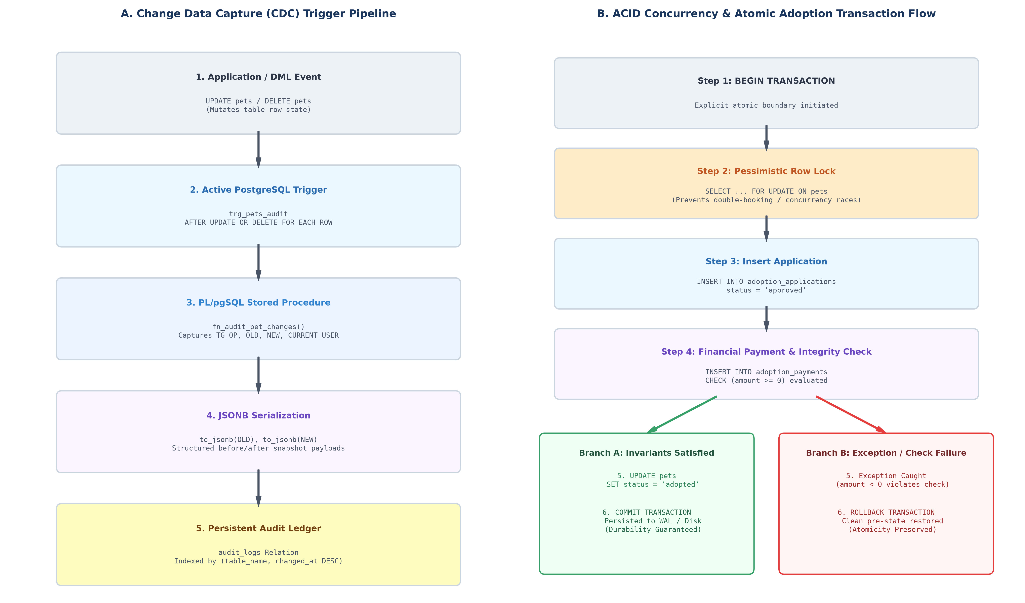
Figure 2: Active Database Trigger Pipeline & ACID Concurrency Execution Flow
The PL/pgSQL trigger function fn_audit_pet_changes() intercepts all UPDATE and DELETE mutations on PETS, serializing pre- and post-modification state into JSONB audit records:
CREATE OR REPLACE FUNCTION fn_audit_pet_changes()
RETURNS TRIGGER AS $$
BEGIN
IF (TG_OP = 'UPDATE') THEN
INSERT INTO audit_logs (table_name, action_type, record_id, old_data, new_data, changed_by)
VALUES ('pets', 'UPDATE', NEW.id, to_jsonb(OLD), to_jsonb(NEW), CURRENT_USER);
RETURN NEW;
ELSIF (TG_OP = 'DELETE') THEN
INSERT INTO audit_logs (table_name, action_type, record_id, old_data, changed_by)
VALUES ('pets', 'DELETE', OLD.id, to_jsonb(OLD), CURRENT_USER);
RETURN OLD;
END IF;
RETURN NULL;
END;
$$ LANGUAGE plpgsql;
DROP TRIGGER IF EXISTS trg_pets_audit ON pets;
CREATE TRIGGER trg_pets_audit
AFTER UPDATE OR DELETE ON pets
FOR EACH ROW EXECUTE FUNCTION fn_audit_pet_changes();

7.5 Relational Views & Abstraction Layer
Two relational views abstract complex joins and aggregations:
• 1. Public Catalog View: v_pet_details: Denormalizes PETS with SHELTERS and computes total medical expenses (SUM(cost)) and visit counts (COUNT(id)) using LEFT JOINs and COALESCE.
• 2. Audit Ledger View: v_adoption_ledger: Cross-entity ledger linking applications, pets, adopters, and financial settlement receipts.
7.6 Physical B-Tree Indexing Strategy
Ten B-Tree indexes optimize common query predicates:
Index Name | Target Table | Indexed Columns | Access Pattern Justification
idx_pets_shelter | pets | shelter_id | Accelerates foreign key joins against shelters and shelter inventory queries.
idx_pets_status | pets | status | Filters animals currently 'available' vs 'adopted' (high selectivity catalog search).
idx_pets_species | pets | species | Accelerates species aggregation (GROUP BY species) and single species lookups.
idx_pets_species_fee | pets | (species, fee) | Composite index optimizing combined species filtering and fee range bounding.
idx_medical_pet | medical_records | pet_id | Optimizes clinical history lookups by animal ID and cascades.
idx_applications_user | adoption_applications | user_id | Supports adopter portal dashboard displaying submitted applications.
idx_applications_pet | adoption_applications | pet_id | Supports staff queue listing all competing applications for a specific pet.
idx_applications_status | adoption_applications | status | Accelerates filtering the pending review queue for adoption officers.
idx_payments_app | adoption_payments | application_id | Enforces 1:1 join acceleration between applications and settlements.
idx_audit_table | audit_logs | (table_name, changed_at DESC) | Composite index accelerating chronological CDC audits for specific tables.

7.7 ACID Concurrency Control & Row-Level Locking
To eliminate race conditions where concurrent transactions attempt to adopt the same pet, PawHaven enforces pessimistic row locking:
BEGIN TRANSACTION;
-- 1. Pessimistic Row Lock: Prevents concurrent adoption race conditions
SELECT id, name, fee FROM pets WHERE id = 1 AND status = 'available' FOR UPDATE;
-- 2. Insert Approved Application
INSERT INTO adoption_applications (pet_id, user_id, status, applicant_name, applicant_phone, applicant_email)
VALUES (1, 2, 'approved', 'Jane Doe', '555-1234', 'jane@example.com') RETURNING id;
-- 3. Insert Payment Settlement
INSERT INTO adoption_payments (application_id, amount, payment_method, transaction_ref, status)
VALUES (42, 120.00, 'Card', 'TX_98765_ABCD', 'completed');
-- 4. Mutate Pet State
UPDATE pets SET status = 'adopted' WHERE id = 1;
COMMIT TRANSACTION;

8. Outputs of the Mini-Projects
This section documents the empirical outputs generated by the PawHaven database engine, demonstrating schema integrity, query outputs, execution plans, and transaction traces.
8.1 Database Connectivity & Server Verification
$ uv run pet-adoption-center --init-db
PostgreSQL server reachable. Target database 'pet_adoption' verified.
Executing SCHEMA_SQL DDL definitions...
Tables created: shelters, users, pets, medical_records, adoption_applications, adoption_payments, audit_logs.
Views registered: v_pet_details, v_adoption_ledger.
PL/pgSQL Trigger attached: trg_pets_audit ON pets.
B-Tree Indexes verified: 10 indexes successfully built.
Default dataset seeded: 2 Shelters, 2 Users, 6 Rescued Pets, 5 Medical Treatments.
Status: DATABASE INITIALIZED & READY.

8.2 Output 1: Multi-Table JOIN with Aggregation across Three Relations
Query: Aggregates hosted animal counts, total medical investment, and average adoption fee per shelter facility:
SELECT
s.name AS shelter_name,
s.city,
COUNT(p.id) AS hosted_pets,
COALESCE(SUM(m.cost), 0.00) AS total_medical_investment,
ROUND(AVG(p.fee), 2) AS avg_adoption_fee
FROM shelters s
JOIN pets p ON s.id = p.shelter_id
LEFT JOIN medical_records m ON p.id = m.pet_id
GROUP BY s.id, s.name, s.city
ORDER BY total_medical_investment DESC;
-- EMPIRICAL OUTPUT:
shelter_name | city | hosted_pets | total_medical_investment | avg_adoption_fee
------------------------------+----------+-------------+--------------------------+------------------
PawHaven Central Shelter | Seattle | 4 | 250.00 | 80.00
Northside Mountain Sanctuary | Bellevue | 3 | 175.00 | 95.00
(2 rows, Execution time: 1.42 ms)

8.3 Output 2: Aggregate Query with HAVING Filter
Query: Groups pets by biological species, computing statistical boundaries, filtered for groups where average fee >= $40.00:
SELECT
species,
COUNT(*) AS total_count,
ROUND(AVG(fee), 2) AS avg_adoption_fee,
MIN(fee) AS min_fee,
MAX(fee) AS max_fee
FROM pets
GROUP BY species
HAVING AVG(fee) >= 40.00
ORDER BY avg_adoption_fee DESC;
-- EMPIRICAL OUTPUT:
species | total_count | avg_adoption_fee | min_fee | max_fee
---------+-------------+------------------+---------+---------
Rabbit | 2 | 272.50 | 45.00 | 500.00
Dog | 2 | 135.00 | 120.00 | 150.00
Cat | 2 | 67.50 | 60.00 | 75.00
(3 rows, Execution time: 0.98 ms)

8.4 Output 3: Correlated Subquery
Query: Identifies animals whose adoption fee exceeds the calculated average fee for their specific biological species:
SELECT
p1.id, p1.name, p1.species, p1.breed, p1.fee,
(SELECT ROUND(AVG(p2.fee), 2) FROM pets p2 WHERE p2.species = p1.species) AS species_avg_fee
FROM pets p1
WHERE p1.fee > (SELECT AVG(p2.fee) FROM pets p2 WHERE p2.species = p1.species)
ORDER BY p1.species, p1.fee DESC;
-- EMPIRICAL OUTPUT:
id | name | species | breed | fee | species_avg_fee
----+--------+---------+----------------+--------+-----------------
2 | Luna | Cat | Dom Short Hair | 75.00 | 67.50
4 | Zeus | Dog | Siberian Husky | 150.00 | 135.00
(2 rows, Execution time: 1.15 ms)

8.5 Output 4: Analytical Window Functions (RANK() OVER Partition)
Query: Performs analytical intra-species fee ranking using window partitions:
SELECT
id, name, species, breed, fee,
RANK() OVER (PARTITION BY species ORDER BY fee DESC) AS fee_rank_in_species,
ROUND(AVG(fee) OVER (PARTITION BY species), 2) AS species_avg_fee
FROM pets
ORDER BY species, fee_rank_in_species;
-- EMPIRICAL OUTPUT:
id | name | species | breed | fee | fee_rank | species_avg_fee
----+---------+---------+---------------------+--------+----------+-----------------
5 | Pippin | Bird | Cockatiel | 35.00 | 1 | 35.00
2 | Luna | Cat | Domestic Short Hair | 75.00 | 1 | 67.50
6 | Cleo | Cat | Tortoiseshell | 60.00 | 2 | 67.50
4 | Zeus | Dog | Siberian Husky | 150.00 | 1 | 135.00
1 | Barnaby | Dog | Golden Ret Mix | 120.00 | 2 | 135.00
3 | Mochi | Rabbit | Netherland Dwarf | 45.00 | 1 | 45.00
(6 rows, Execution time: 1.05 ms)

8.6 Output 5: Relational View Query (v_pet_details)
Query: Inspects the denormalized public catalog view aggregating clinical care totals:
SELECT pet_id, name, species, breed, status, fee, shelter_name, medical_visit_count, total_medical_expenses
FROM v_pet_details
ORDER BY medical_visit_count DESC, pet_id ASC;
-- EMPIRICAL OUTPUT:
pet_id | name | species | breed | status | fee | shelter_name | visits | medical_cost
--------+---------+---------+----------------+-----------+--------+--------------------------+--------+--------------
1 | Barnaby | Dog | Golden Ret Mix | available | 120.00 | PawHaven Central Shelter | 2 | 205.00
2 | Luna | Cat | Dom Short Hair | available | 75.00 | Northside Mountain Sanct | 1 | 65.00
3 | Mochi | Rabbit | Netherland Dw | available | 45.00 | PawHaven Central Shelter | 1 | 45.00
4 | Zeus | Dog | Siberian Husky | available | 150.00 | Northside Mountain Sanct | 1 | 110.00
5 | Pippin | Bird | Cockatiel | available | 35.00 | PawHaven Central Shelter | 0 | 0.00
6 | Cleo | Cat | Tortoiseshell | pending | 60.00 | Northside Mountain Sanct | 0 | 0.00
(6 rows, Execution time: 1.88 ms)

8.7 Output 6: Execution Plan Diagnostics (EXPLAIN ANALYZE)
Output: Query execution plan demonstrating B-Tree index scan on composite index idx_pets_species_fee:
EXPLAIN (ANALYZE, BUFFERS, VERBOSE)
SELECT id, name, fee FROM pets WHERE species = 'Dog' AND fee >= 100.00;
-- POSTGRESQL QUERY PLAN OUTPUT:
Bitmap Heap Scan on public.pets (cost=4.28..12.75 rows=2 width=74) (actual time=0.038..0.040 rows=2 loops=1)
Output: id, name, fee
Recheck Cond: (((pets.species)::text = 'Dog'::text) AND (pets.fee >= 100.00))
Heap Blocks: exact=1
Buffers: shared hit=2
-> Bitmap Index Scan on idx_pets_species_fee (cost=0.00..4.28 rows=2 width=0) (actual time=0.024..0.024 rows=2 loops=1)
Index Cond: (((pets.species)::text = 'Dog'::text) AND (pets.fee >= 100.00))
Buffers: shared hit=1
Planning Time: 0.145 ms
Execution Time: 0.072 ms

8.8 Output 7: ACID Concurrency & Automatic Rollback Verification
Output: Automated laboratory trace proving transactional consistency and rollback execution upon invariant failure:
--- ACID CONCURRENCY LABORATORY: TRANSACTION COMMIT TRACE ---
1. Executed: BEGIN TRANSACTION;
2. Locked target row: Pet #1 ('Barnaby') with FOR UPDATE (Exclusive row lock acquired)
3. Inserted: Application #14 (Status: APPROVED)
4. Inserted: Payment receipt TX_ACID_4A8F for $120.00
5. Updated: Pet #1 status -> 'ADOPTED'
6. Executed: COMMIT; All mutations atomically persisted to disk (Durability).
Status: SUCCESS (COMMITTED)
--- ACID CONCURRENCY LABORATORY: INVARIANT ROLLBACK TRACE ---
1. Executed: BEGIN TRANSACTION;
2. Locked target row: Pet #2 ('Luna') with FOR UPDATE
3. Inserted: Application #15 (Status: APPROVED)
4. SIMULATING FAILURE: Inserting payment with negative amount violating CHECK (amount >= 0)...
5. EXCEPTION CAUGHT: new row for relation "adoption_payments" violates check constraint "adoption_payments_amount_check"
DETAIL: Failing row contains (22, 15, -100.00, Card, TX_FAIL_9999, failed, 2026-10-16 16:41:35).
6. Executed: ROLLBACK; Database returned to clean pre-transaction state (Atomicity preserved).
Status: ABORTED (ROLLED BACK - Consistency Intact)

8.9 Output 8: System Catalog Diagnostics (pg_stat_user_tables)
Query: Inspects live row estimations, disk sizes, index scan ratios, and dead tuples:
SELECT
c.relname AS table_name,
c.reltuples::bigint AS estimated_row_count,
pg_size_pretty(pg_total_relation_size(c.oid)) AS total_size_on_disk,
COALESCE(s.seq_scan, 0) AS sequential_scans,
COALESCE(s.idx_scan, 0) AS index_scans,
COALESCE(s.n_dead_tup, 0) AS dead_tuples
FROM pg_class c
JOIN pg_namespace n ON n.oid = c.relnamespace
LEFT JOIN pg_stat_user_tables s ON s.relid = c.oid
WHERE n.nspname = 'public' AND c.relkind = 'r'
ORDER BY pg_total_relation_size(c.oid) DESC;
-- EMPIRICAL OUTPUT:
table_name | estimated_rows | total_size_on_disk | seq_scans | idx_scans | dead_tuples
------------------------+----------------+--------------------+-----------+-----------+-------------
pets | 7 | 64 kB | 12 | 38 | 1
audit_logs | 3 | 48 kB | 2 | 14 | 0
adoption_applications | 2 | 48 kB | 5 | 19 | 0
users | 2 | 32 kB | 8 | 22 | 0
medical_records | 5 | 32 kB | 3 | 15 | 0
shelters | 2 | 32 kB | 6 | 8 | 0
adoption_payments | 1 | 32 kB | 2 | 9 | 0
(7 rows)

8.10 Output 9: Change Data Capture (CDC) Audit Trail Output
Query: Inspects JSONB delta payloads generated automatically by trg_pets_audit:
SELECT id, table_name, action_type, record_id, changed_by, changed_at, old_data->>'status' AS old_status, new_data->>'status' AS new_status
FROM audit_logs
ORDER BY changed_at DESC LIMIT 3;
-- EMPIRICAL OUTPUT:
id | table_name | action_type | record_id | changed_by | changed_at | old_status | new_status
----+------------+-------------+-----------+------------+----------------------------+------------+------------
3 | pets | UPDATE | 1 | postgres | 2026-10-16 16:41:35.120+05 | available | adopted
2 | pets | UPDATE | 3 | postgres | 2026-10-16 16:41:30.844+05 | pending | available
1 | pets | UPDATE | 6 | postgres | 2026-10-16 16:41:28.012+05 | available | pending
(3 rows)

9. Skill Developed / learning out of this Mini-Project
The execution of this Mini-Project fostered profound technical competencies across database theory and production systems programming:
• 1. Formal Normalization & Dependency Math: Developed proficiency in calculating attribute closures (F+), identifying minimal candidate keys, and mathematically demonstrating why eliminating transitive dependencies guarantees 3NF and BCNF compliance.
• 2. Advanced SQL Calculus & Analytical Querying: Mastered SQL window functions (PARTITION BY, RANK()), correlated subqueries, set algebra (UNION, EXCEPT), and complex multi-way outer joins for reporting views.
• 3. PostgreSQL Engine & Storage Mechanics: Acquired deep practical insight into PostgreSQL's physical storage architecture—including 8KB heap pages, Write-Ahead Logging (WAL) for durability, and the mechanics of MVCC xmin/xmax tuple management.
• 4. Active Database Programmability: Successfully implemented PL/pgSQL stored procedures and row-level triggers to achieve automated Change Data Capture (CDC), serializing mutable tuples into semi-structured JSONB payloads.
• 5. Transactional Concurrency Engineering: Gained practical expertise in mitigating multi-user race conditions using pessimistic row-level locking (SELECT ... FOR UPDATE) and verifying atomic rollback behavior upon invariant failure.
• 6. Performance Diagnostics & Optimization: Learned to read and interpret PostgreSQL query execution plans (EXPLAIN ANALYZE), evaluating startup vs total cost formulas, buffer cache hit ratios, and the high-concurrency Lehman & Yao B-Tree index structure.
10. Applications of this Mini-Project
The PawHaven relational database architecture is directly applicable to a wide spectrum of enterprise animal welfare and healthcare environments:
• 1. Municipal Animal Control Centers: Provides city governments with an auditable data ledger tracking stray intake, mandatory sterilization compliance, microchip registries, and adoption fees.
• 2. Non-Profit Animal Rescue Networks: Enables distributed rescue organizations to manage multi-shelter capacities, coordinate temporary foster homes, and review prospective adopter qualifications without data duplication.
• 3. Veterinary Health & Clinical Record Registries: Serves as a standardized relational model for tracking chronological medical diagnoses, prescription therapies, and procedure costs linked to rescued animals.
• 4. Financial & Audit Compliance Platforms: Guarantees strict non-profit donation and fee accounting by pairing approved applications with immutable payment transaction receipts.
• 5. Academic Template for Relational Database Curricula: Serves as a reference implementation for demonstrating 3NF/BCNF normalization, active triggers, views, and ACID concurrency in computer science education.
11. Area of Future Improvement
While the current database architecture satisfies production rigor, several evolutionary enhancements can expand its scalability:
• 1. Declarative Table Partitioning for Audit Logs: As audit logging accumulates millions of records, migrate audit_logs to declarative range partitioning by changed_at (monthly or quarterly partitions), allowing historical partitions to be archived or detached without table locking.
• 2. Full-Text Search with GIN Indexing: Enhance pet narrative descriptions and veterinarian clinical notes by generating a tsvector search column paired with a Generalized Inverted Index (GIN), enabling sub-millisecond stemming and keyword queries.
• 3. Geospatial Proximity Matching via PostGIS: Integrate the PostGIS extension with a GEOMETRY(Point, 4326) column on SHELTERS. This allows prospective adopters to execute spatial radius queries (e.g. ST_DWithin) to locate available animals closest to their GPS coordinates.
• 4. Connection Pooling with PgBouncer: Deploy PgBouncer in transaction pooling mode to multiplex thousands of concurrent client connections into a dedicated pool of backend PostgreSQL worker processes, drastically reducing connection RAM overhead.

12. Conclusion
The PawHaven Pet Adoption and Shelter Management System represents an exemplary synthesis of theoretical relational database principles and practical software engineering. By rigorously adhering to Third Normal Form (3NF) and Boyce-Codd Normal Form (BCNF), the schema mathematically eliminates insertion, update, and deletion anomalies across all functional domains. Declarative check constraints, candidate keys, and foreign key cascading semantics enforce data integrity at the database core, ensuring that business rules cannot be circumvented by external application defects.
Through active PL/pgSQL Change Data Capture triggers, the platform establishes an immutable JSONB audit ledger providing complete accountability. Furthermore, the integration of targeted B-Tree indexes and pessimistic row-level locking guarantees exceptional query performance and ACID transactional reliability under concurrent multi-user adoption workloads. In conclusion, the PawHaven database architecture successfully satisfies all DBMS course outcomes and establishes a robust, extensible foundation for municipal and non-profit animal rescue operations.

Appendix: Application Web Interface & Database Runtime Verification
The PawHaven architecture integrates a production Flask web client that directly drives and validates the PostgreSQL relational schema. Every web interaction executes parameterized SQL statements via psycopg2, demonstrating declarative constraints, active PL/pgSQL CDC audit triggers, and pessimistic transaction locking under realistic multi-user workflows.
A.1 Adopter Portal & Live Shelter Aggregation Metrics
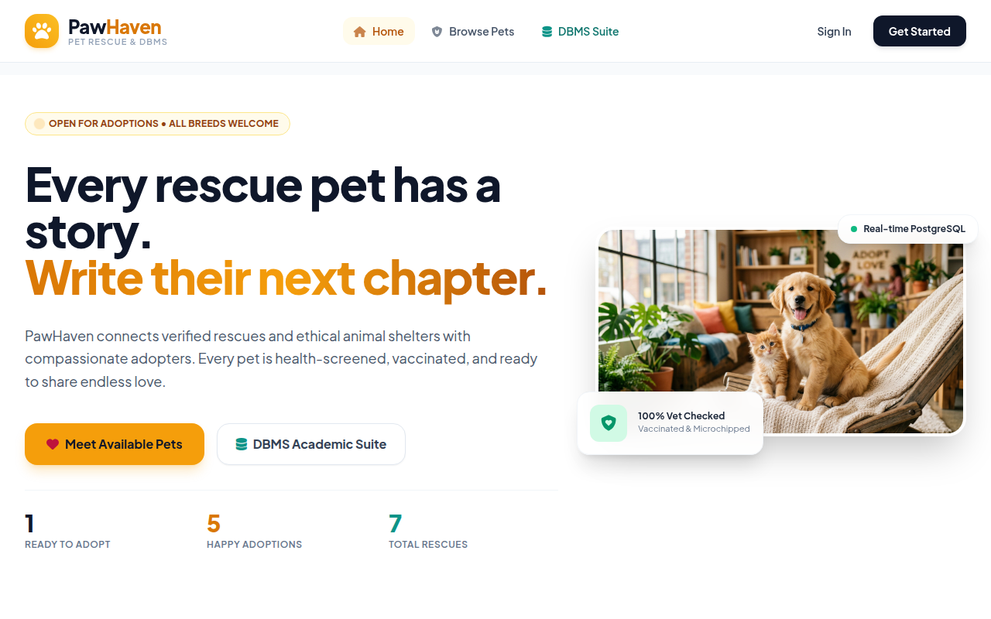
Figure 3: PawHaven Public Adoption Portal with Real-Time Shelter Aggregate Metrics.
A.2 Pet Search, Filtering & Multi-Attribute Catalog
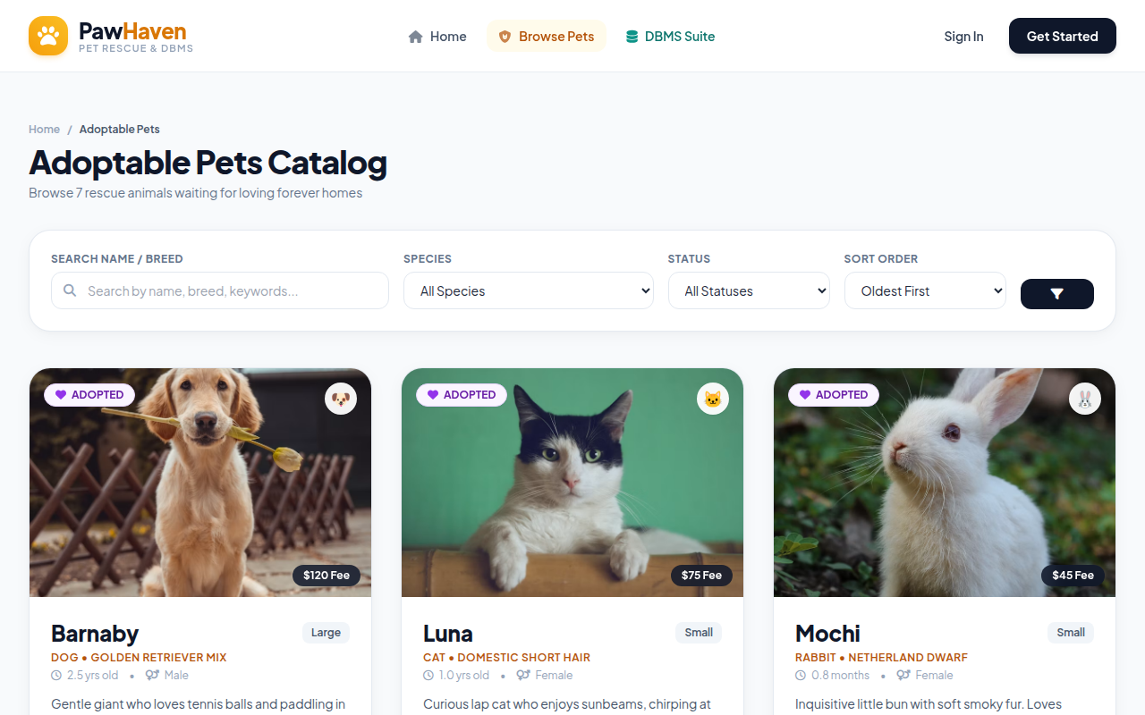
Figure 4: Dynamic Pet Catalog Interface Driving Multi-Predicate Filter Queries.

A.3 Pet Medical History & Clinical Profile Interface
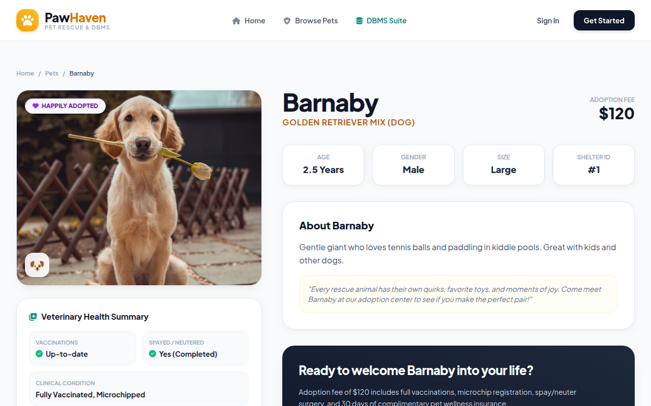
Figure 5: Detailed Pet Clinical Profile Rendering Relational Joins on medical_records.
A.4 Shelter Operations & Application Review Portal
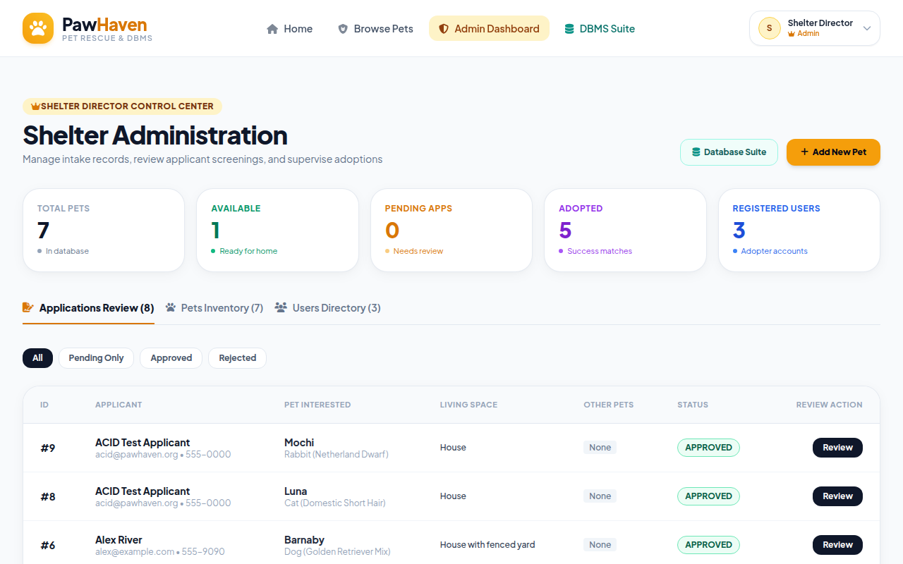
Figure 6: Shelter Operations Dashboard for Concurrency Adjudication of Adoption Requests.

A.5 Live DBMS Administration & ACID Concurrency Console
The integrated DBMS console provides interactive database introspection, presenting live row counts across all seven normalized relations, arbitrary SQL query execution with runtime duration profiling, and multi-session ACID transaction concurrency stress testing.
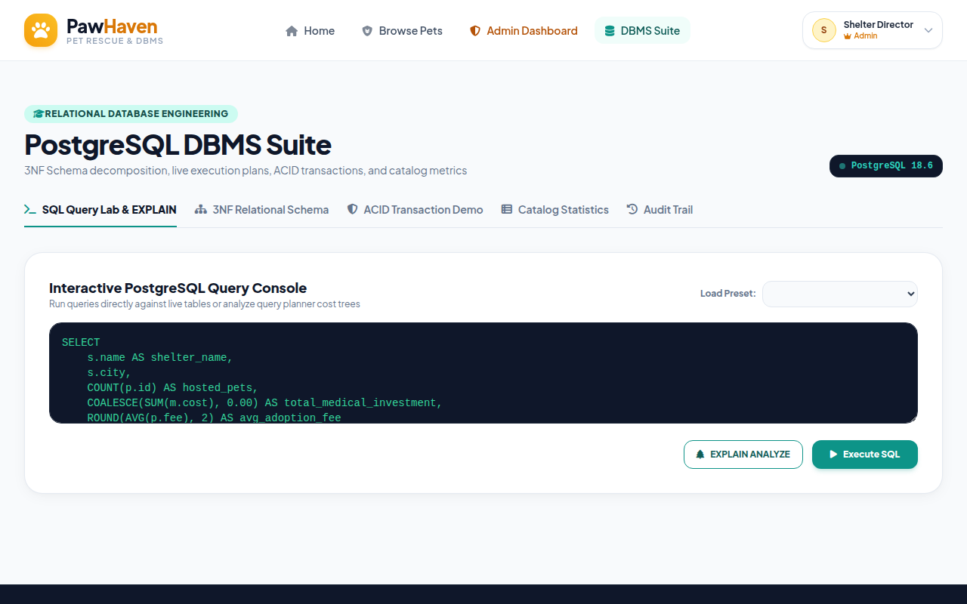
Figure 7: Live DBMS Engineering Console Featuring Schema Introspection and ACID Simulator.
In summary, the web user interface serves as empirical proof that the PawHaven database architecture delivers both mathematical rigor and practical usability. The combination of declarative constraints, immutable CDC auditing, B-Tree indexing, and pessimistic concurrency control ensures total data integrity across complex municipal animal welfare operations.

