- Writing Component
The software is an AI-powered reporter built to help you explore World Bank data without having to wrestle with raw numbers. You choose one or more countries, an indicator (like GDP per capita or population), and a year range, and the app takes it from there. It fetches the data from the World Bank API, presents it in a clean table alongside a time-series chart, and lets you download everything as a CSV. Once a query runs, you can hit Generate AI Report and get a short, readable summary back: a few bullet-point insights, a recommendation or two, all written in plain language rather than a wall of figures.
How the components work together
There are three main parts, and they hand off to each other in a natural sequence. The API layer (query.py) is responsible for building the request URL, calling the World Bank API, and shaping the JSON response into a tidy table with country, year, value, and so on. It also does simple caching, so if you run the same query twice, the second time is noticeably faster. The Shiny app (app.py) is what you actually see and interact with: it uses that table to power the sidebar controls, the data grid, the line chart, and the CSV download. Then, when you click Generate AI Report, the AI layer (ai_report.py) picks up the same table, computes per-country summary stats (mean, min, max), and builds a compact prompt for the model. That prompt goes to whichever backend is available, whether local Ollama, Ollama Cloud, or OpenAI, and the model's reply comes back rendered in the app with proper Markdown formatting, so bold text and bullet points look like normal text rather than raw symbols.
The whole flow is: user choices, then the API, then the table, with both the chart and AI report drawing from the same source.
Design choices and challenges
One of the more deliberate decisions was to run a single data pipeline that serves both the Shiny app and the AI report, rather than maintaining two separate scripts that could drift out of sync. The Shiny app queries the data and holds it in memory; the AI layer reads from that same in-memory table and only sends a compact summary, specifically the per-country stats, to the model. This keeps prompts small and avoids the awkwardness of dumping an entire dataset into a model call.
Supporting multiple AI backends, including local Ollama, Ollama Cloud, and OpenAI, with a simple fallback order was another conscious choice, mostly for flexibility. The app works offline with Ollama and scales up to cloud inference when API keys are available.
The trickiest part was prompt design. Early versions of the report prompt produced output that was either too long, too inconsistent, or oddly structured. Tightening the instructions by explicitly asking for a short summary, 3 to 5 bullet insights, 1 to 2 recommendations, and a word limit made a real difference in how readable and predictable the reports turned out. Getting the Markdown rendering right was a smaller but satisfying fix: without it, users were seeing raw bold syntax and * bullet characters instead of formatted text.
- Git Repository Links
https://github.com/danish-safdariyan/ai-reporter-app.git
- Screenshots/Outputs

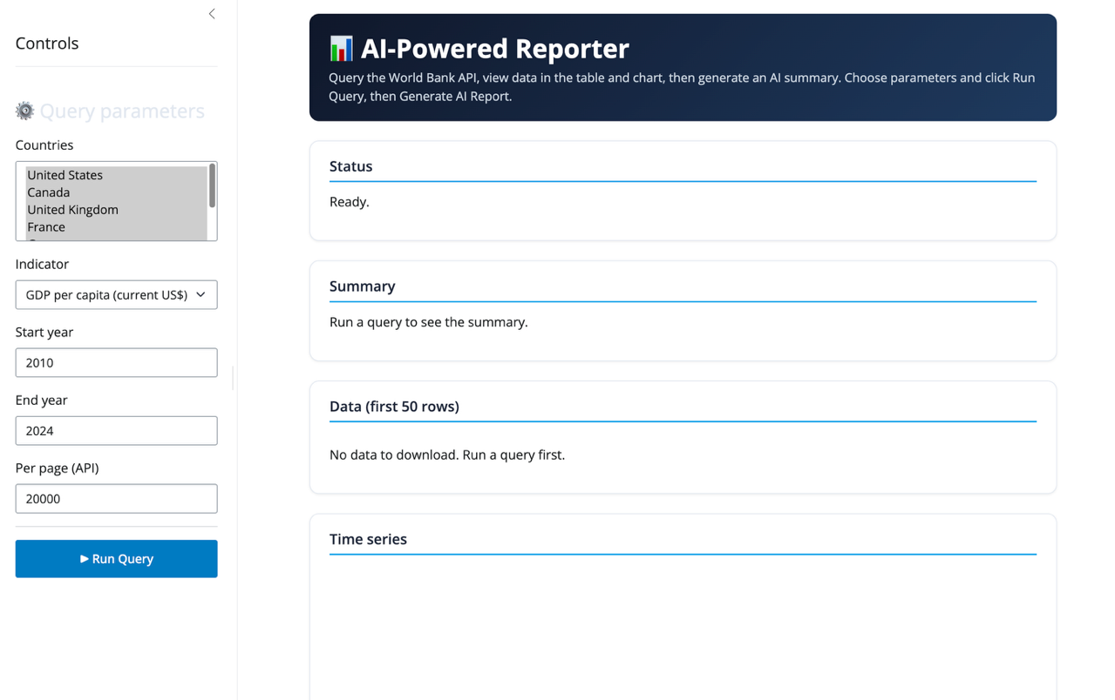
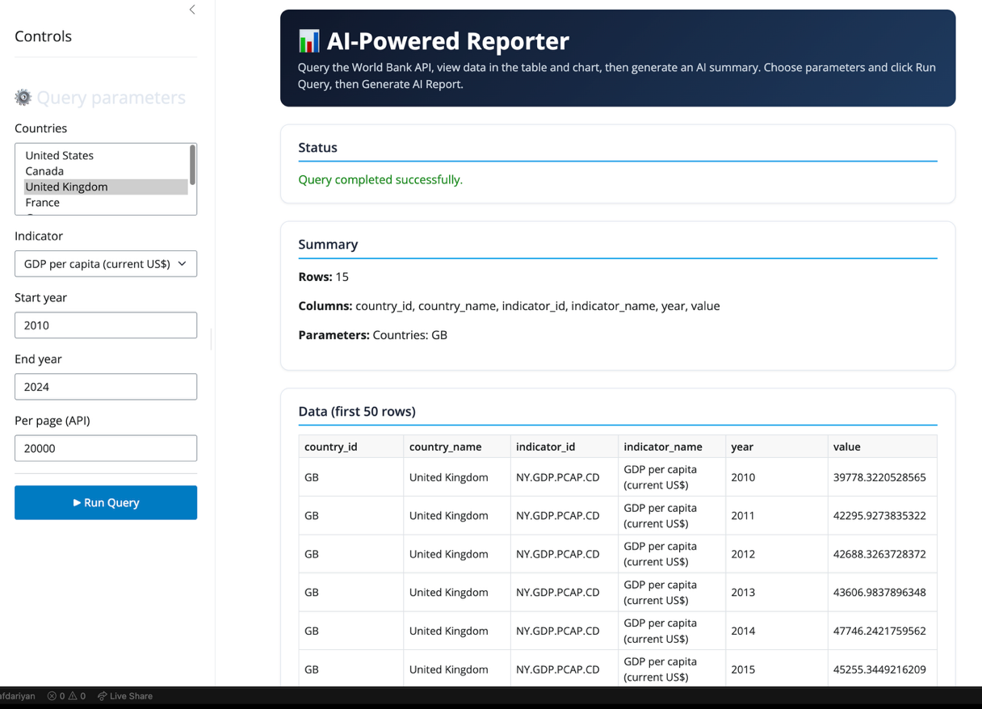
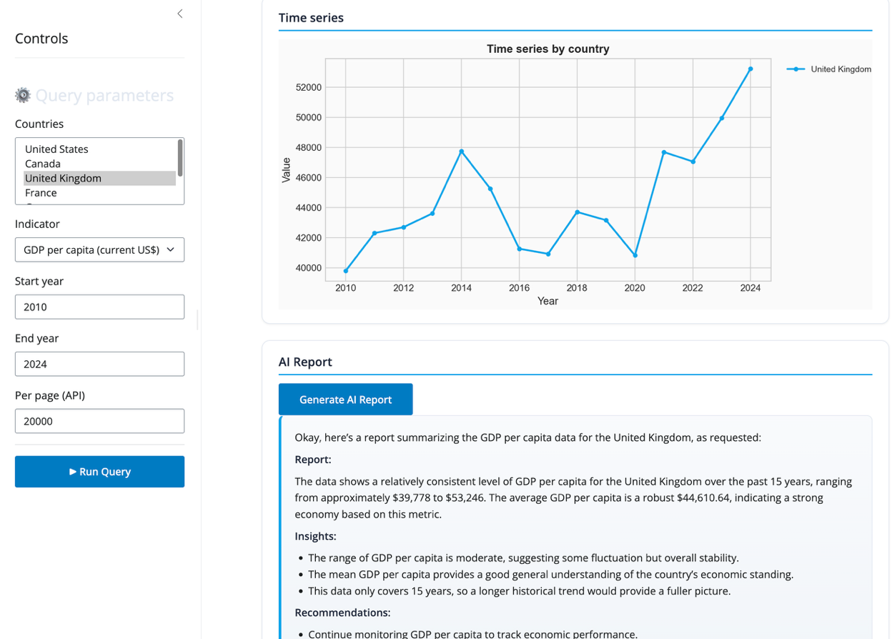

- Documentation

Column name | Data type | Description
country_id | string | World Bank country code (e.g. USA, GBR)
country_name | string | Full country name (e.g. United States, United Kingdom).
indicator_id | string | World Bank indicator code (e.g. NY .GDP.PCAP.CD).
indicator_name | string | Full indicator name (e.g. GDP per capita (current US$)).
year | numeric | Year of the observation.
value | numeric | Value of the indicator for that country and year; can be null if missing.

Technical details
- API: World Bank Indicators API (v2). Base URL: https://api.worldbank.org/v2. Endpoint: GET /country/{country_codes}/indicator/{indicator_code} with query parameters date (year range), format=json, and per_page.
- API key: Optional. The World Bank API often works without a key. If you want to set one, use the env var WORLD_BANK_API_KEY in a .env file.
- AI report: The app tries, in order: (1) local Ollama, (2) Ollama Cloud (if OLLAMA_API_KEY is set), (3) OpenAI (if OPENAI_API_KEY is set). Set these in .env only if you use cloud AI.
- Packages: shiny, pandas, requests, matplotlib, python-dotenv, markdown-it-py (see requirements.txt).
- File structure:
app.py — Shiny UI and server (query form, table, chart, download, AI report).
query.py — World Bank API client (URL building, fetch, normalize to table, cache).
ai_report.py — Builds a short summary from the data table and calls Ollama/OpenAI.
requirements.txt — Python dependencies.

Usage instructions
- Install dependencies
From the project folder (the one that contains app.py and requirements.txt):
cd ai_reporter_app
pip install -r requirements.txt
- Run the app
- shiny run app.py
- Then open the URL shown in the terminal (e.g. http://127.0.0.1:8000). Choose countries, indicator, and year range, click Run Query, then use Generate AI Report if you want a summary (requires Ollama running locally or the optional API keys above).

