|  |  |
| --- | --- |
| NAME | SYED MUHAMMAD DANISH |

PRACTICE QUESTIONS:

## QUESTION 1: Using Prompt(Full Name by Alert)

## CODE:

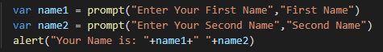

## OUTPUT:

# 1.

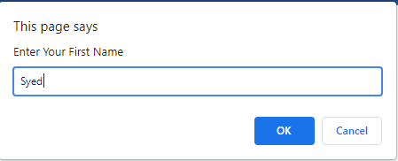

# 2.

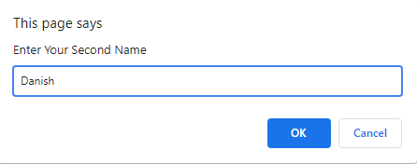

# 3.

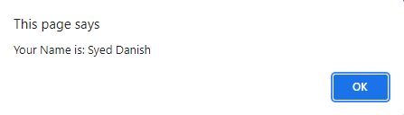

## QUESTION 2: Using Prompt (Print Your Name 10 times by Do-While)

## CODE:

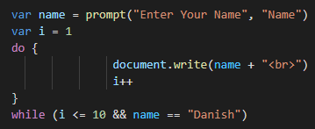

## OUTPUT:

## 1.

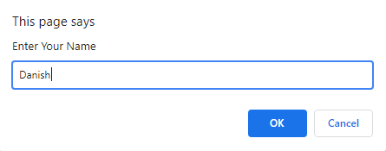

# 2.

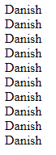

## QUESTION 3: UsingPrompt(Username by If-Esle)

## CODE:

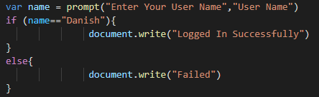

## OUTPUT:

# 1.IF (name==”Danish”)

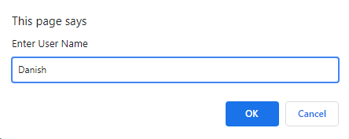 Screenshot 2022-01-13 124943.png

# 2.ELSE

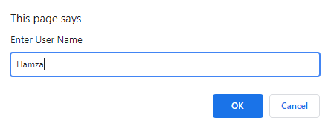 Screenshot 2022-01-13 125105.png

## QUESTION 4: Using Prompt(Correct Name by Do-While)

## CODE:

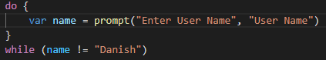

## OUTPUT:

# 1.(Username is correct after ok it ends)



# 2.(Username is incorrect, after ok it will refreshing until we write the right one)



## QUESTION 5: Using Prompt(Correct Name & Password by If-Else)

## CODE:

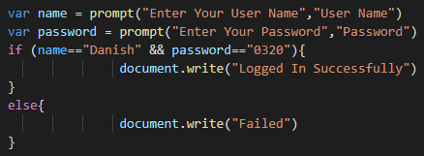

## OUTPUT:

# 1.IF (name==”Danish” && password==”0320”)

 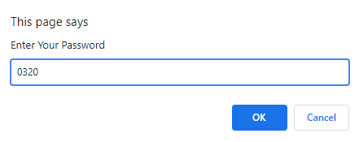

Screenshot 2022-01-13 124943.png

# 2.Else

 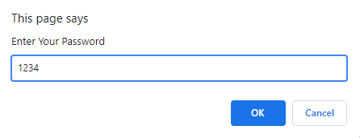

Screenshot 2022-01-13 125105.png

## QUESTION 6: Using Prompt(Print Table by While)

## CODE:

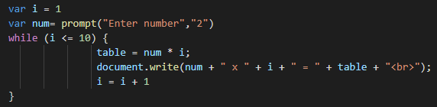

## OUTPUT:

# 1. Enter the number of the table do you want & Click on “OK”

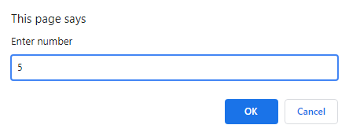

# 2. Table of 5

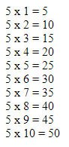

## QUESTION 7: Using Prompt(Print Table by While)

## CODE:

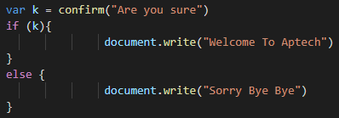

## OUTPUT:

# 1.If (k) (If OK then)

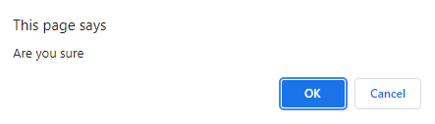

# Screenshot 2022-01-13 201944.png

# 2.Else (If Cancel then)

Screenshot 2022-01-13 202015.png

## QUESTION 8: Using Prompt(Print Table by While)

## CODE:

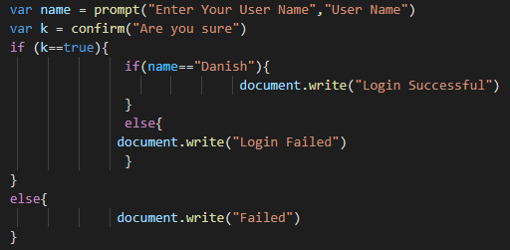

## OUTPUT:

# 1.If(k)**(If name==”Danish”, & confirm is ok then Login Successful)**



Screenshot 2022-01-13 203043.png

## Else(If user enter’s wrong name after confirmation Login Failed)

Screenshot 2022-01-13 203121.png

# 2.Else(If cancel from confirmation then Failed)

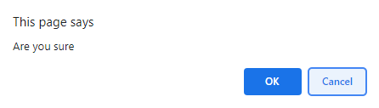Screenshot 2022-01-13 125105.png

## QUESTION 9: (Write a do-while loop that asks the user to enter two numbers. The numbers should be added and the sum displayed. The loop should ask the user whether he or she wishes to perform the operation again. If so, the loop should repeat; otherwise, it should terminate.)

## CODE: