ASSIGNMENT[19-01-22]:

# QUESTION 1: Predict the output of the following code, also identify they error IF ANY.

## CODE:

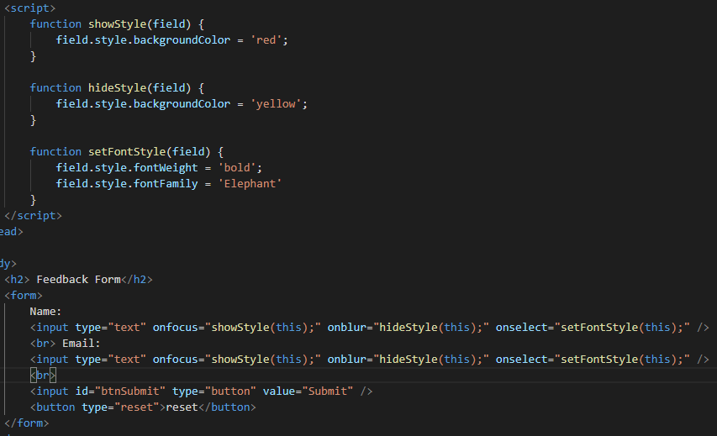

OUTPUT:

1. 2. 3.

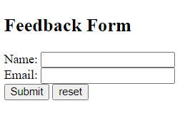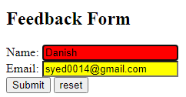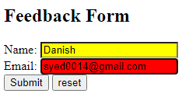

ERROR:

## QUESTION 2:

**Make a Sign Up Form with 5 input fields,**

* Username
* Password
* Repeat Password
* Email
* Phone number

Using JAVA SCRIPT apply following validations,

* if any field is empty an alert should appear saying “please fill all the fields”
* if password and repeat password are not same an alert should appear saying “both passwords should be same”

If all validations are properly implemented an alert should appear saying “Thank you for signing in” afterthe alert all data should be cleared from the input fields.

## CODE:

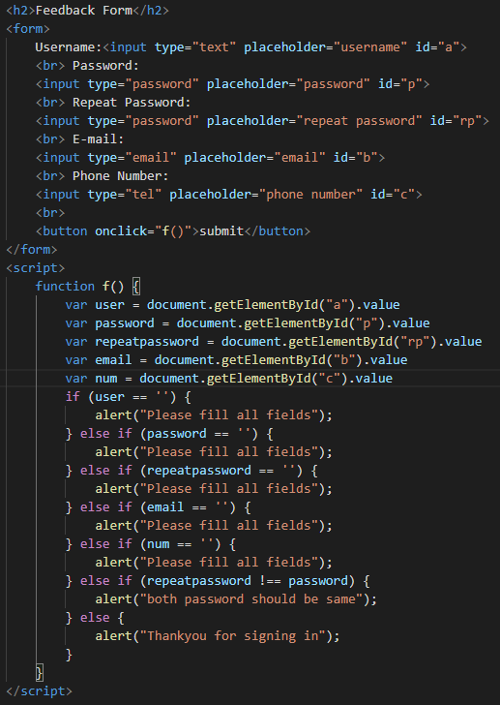

## OUTPUT:

### 1.This is Feedback Form

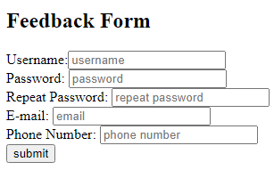

### 2.If any field remain’s empty it show’s ;

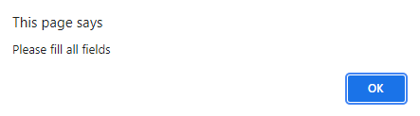

### 3.If repeat password doesn’t match to password on click of submit it show’s;

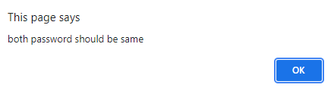

### 4.If all field are correctly & fully filled it show’s after ok all field willl be cleared;

