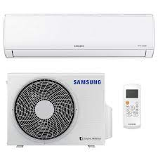

Samsung AS185EWH Split AC (1.5 Ton 5 Star Rating Maroon)

**Brand** Samsung

**Special Feature** Antibacterial_coating

**Colour** white

**Item** 22.5 x 106.5 x 29.8Centimeters

**Item Weight** 53200 Grams

**About this items**

* Split AC; 1.5 ton capacity
* Energy Rating: 5 Star
* 1 year warranty on product; 5 years warranty on compressor
* Features: Dehumidification, anti-bacterial filter and auto restart
* Compressor Type: UTR

**Product description**

The Samsung Split Air Conditioner 1.5 Ton AS185EWH perfectly suits your needs of a mid-sized room during the scorching summers. Flashing a full HD filter with high potency, the AC wards off bacteria and dust from making their way into the room. The cover can be easily removed and washed at home from time to time. The UTR plus compressor purges hot air and provides comfort even during severe weather conditions. The air-Conditioner is devised to operate on maximum power when switched to Turbo mode.