1. Write a Python program to print "Hello Python"?

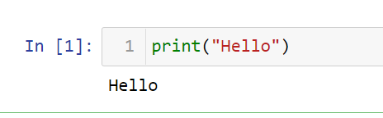

1. Write a Python program to do arithmetical operations addition and division.?

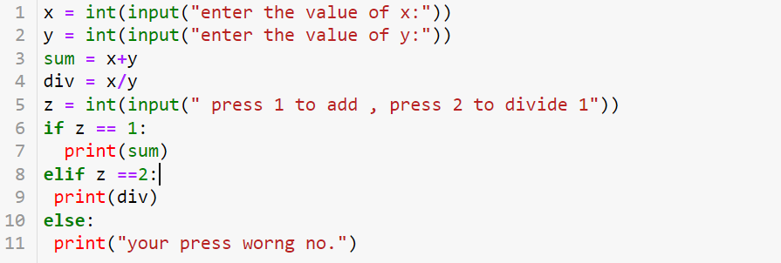

1. Write a Python program to find the area of a triangle?

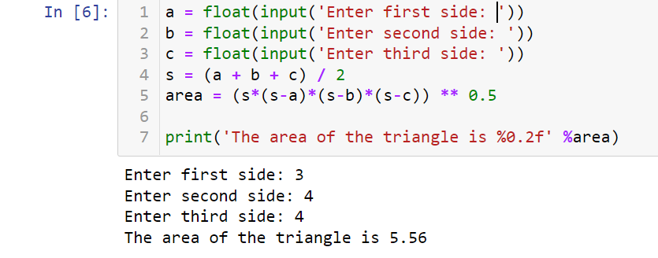

1. Write a Python program to swap two variables?

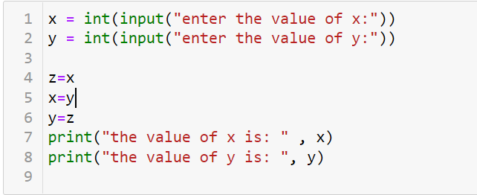

1. Write a Python program to generate a random number?

