1. Write a Python Program to Find the Factorial of a Number?

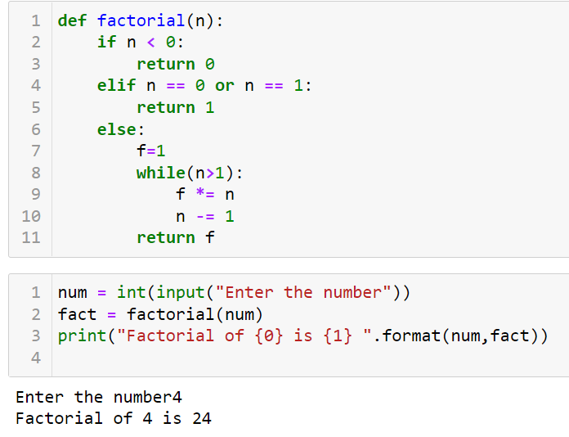

1. Write a Python Program to Display the multiplication Table?

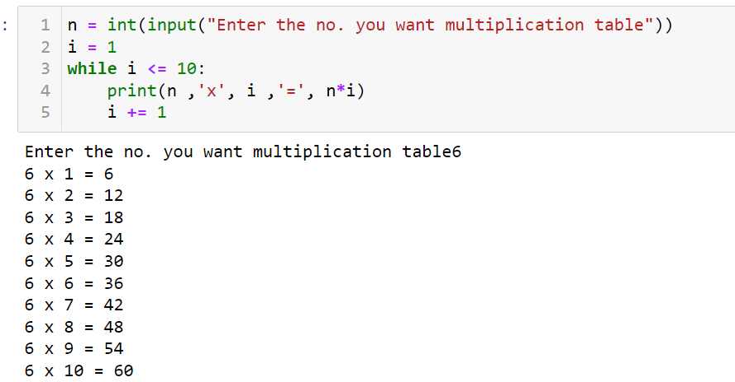

1. Write a Python Program to Print the Fibonacci sequence?

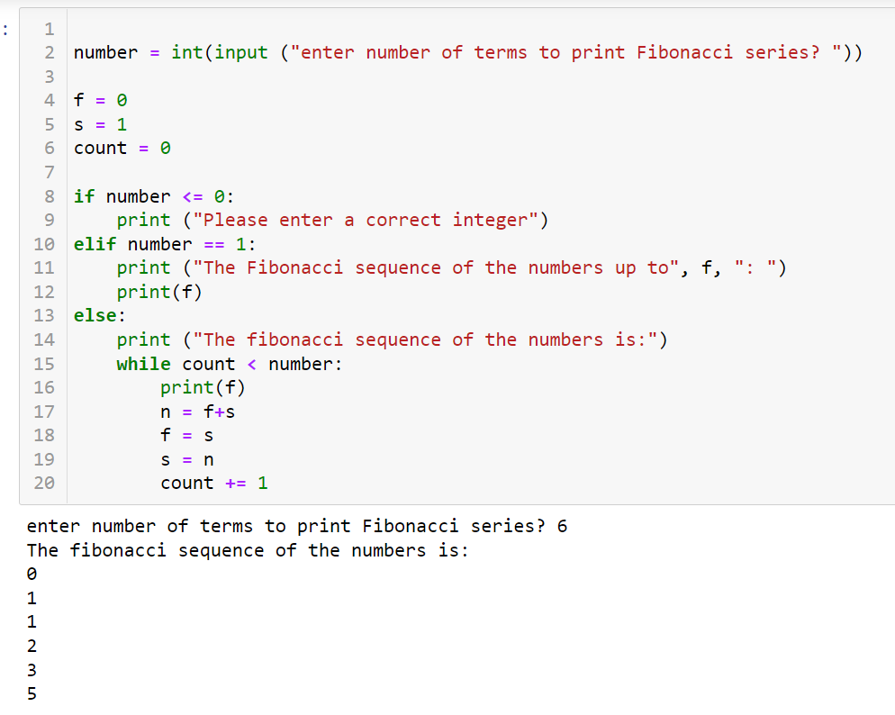

1. Write a Python Program to Check Armstrong Number?

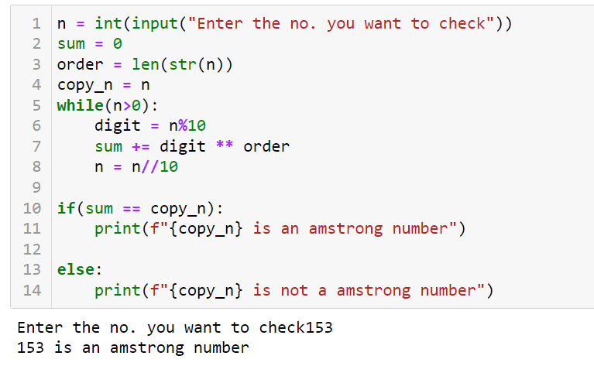

1. Write a Python Program to Find Armstrong Number in an Interval?

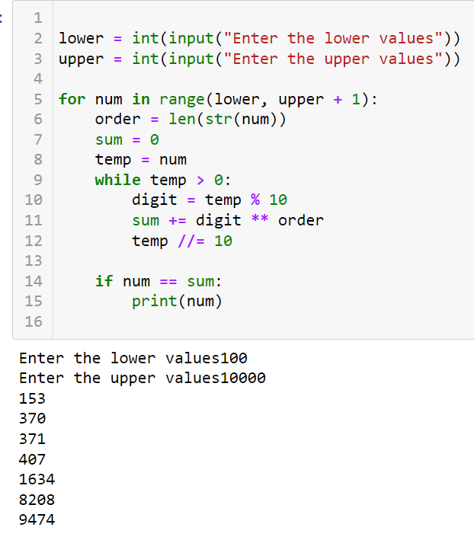

1. Write a Python Program to Find the Sum of Natural Numbers?

