A Dual-Horizon Financial Assessment of Semiconductor Monopolies: Fundamental Resiliency and Long-Term Market Valuation of ASML Holding N.V.

Submitted in partial fulfilment of the requirements for the degree of Master of Business Administration
(Finance Specialization)

By Danish Shaikh
SAP ID: 77124115940

Centre for Distance and Online Education SVKM’s NMIMS
Deemed-to-be University
May 2026
Table of Contents
Executive Abstract 6
1. Introduction 7
1.1 The Macroeconomic Super-Cycle and Silicon Economics 7
1.2 The Economics of a Hardware Monopoly and Pricing Elasticity 7
1.3 The Disaggregation of the Global Supply Chain: Fabless, Foundry, and IDM Models 7
1.3.1 Macroeconomic Cyclicality and the Bullwhip Effect 8
1.3.2 Corporate Genesis and Organizational Profile 8
1.4 Research Objectives and Quantitative Scope 9
1.5 Methodology and Programmatic Automation Framework 9
1.6 Chapter Organization 10
2. Literature Review 11
2.1 The Theory of Economic Moats and Capital-Intensive Monopolies 11
2.2 The DuPont Identity: Deconstructing High-Tech Return on Equity 11
2.3 Intrinsic Valuation: The Discounted Cash Flow (DCF) Model 12
2.4 The Capital Asset Pricing Model (CAPM) and Systematic Risk 12
2.5 The Efficient Market Hypothesis vs. Market Momentum 12
2.6 Strategic Qualitative Frameworks: Porter’s Five Forces 13
2.6.1 Threat of New Entrants (Extremely Low) 13
2.6.2 Bargaining Power of Suppliers (Moderate to High) 13
2.6.3 Bargaining Power of Buyers (Low) 13
2.6.4 Threat of Substitutes (Low) 14
2.6.5 Industry Rivalry (Non-Existent in EUV, Low in DUV) 14
2.6.6 Macro-Environmental Strategy: Porter’s Diamond of National Competitive Advantage 14
2.7 SWOT Analysis of the ASML Monopoly 14
2.8 Historical Case Study: The Defeat of Nikon and Canon 15
2.8.1 The "Innovator’s Dilemma" in Practice 15
2.8.2 The Establishment of the EUV Monopoly 16
3. Methodology 17
3.1 Research Design 17
3.2 Data Collection and Automation Pipeline 17
3.3 Analytical Frameworks and Statistical Tools 17
3.3.1 Computational Architecture and Algorithmic Sanitization 17
3.3.2 Benchmark Selection and Market Proxy Justification 18
3.4 Limitations of the Study 18
4. Data Analysis & Findings: Part 1 - Fundamental Health 19
4.1 Introduction to the Fundamental Dataset 19
4.1.1 Baseline Financial Statement Analysis: Top-Line and Bottom-Line Trajectories 19
4.1.2 Balance Sheet Architecture and Capital Structure 20
4.1.3 Disaggregating the Top-Line: System Sales vs. Service Annuities 20
4.1.4 Baseline Cost Analysis: R&D Intensity 21
4.2 DuPont Deconstruction: The Engine of Return on Equity (ROE) 22
4.2.1 Component 1: Net Profit Margin (The Monopoly Premium) 22
4.2.2 Component 2: Asset Turnover (Capital Intensity) 23
4.2.3 Component 3: The Equity Multiplier (Financial Leverage) 23
4.2.4 Advanced Disaggregation: The 5-Step Extended DuPont Model 23
4.3 Corporate Solvency and Liquidity Risk Profiling 23
4.3.1 Gross Margin Resiliency 24
4.3.2 Debt-to-Equity (Solvency) De-Risking 24
4.3.3 Strict Liquidity Testing: The Quick (Acid-Test) Ratio vs. Current Ratio 24
4.4 Competitor Benchmarking and Relative Financial Health 25
4.4.1 Gross Margin and Pricing Power Divergence 26
4.4.2 R&D Capital Intensity and the "Innovation Moat" 26
4.4.3 Balance Sheet Conservatism vs. Sector Averages 26
4.4.4 The Lam Research Anomaly: Absolute Capitalization vs. Percentage Growth 27
4.5 Strategic Capital Allocation: Mergers, Acquisitions, and Vertical Integration 27
4.5.1 The Cymer Acquisition: Securing the Light Source 27
4.5.2 Strategic Minority Stakes and Supplier Subsidization 28
4.6 Working Capital Dynamics and the Cash Conversion Cycle (CCC) 28
4.6.1 The Structural Burden of High DIO 28
4.6.2 Mitigating Liquidity Drag via Negative Working Capital Structures 28
4.7 Forensic Accounting: Inventory Valuation Mechanics and Obsolescence Risk 29
4.7.1 Costing Methodologies and Work-in-Progress (WIP) Bloat 29
4.7.2 Mitigating Technological Obsolescence Risk 29
4.8 Macro-Spatial Revenue Concentration Risk 30
4.9 Statutory Taxation Strategy: The Dutch "Innovation Box" Regime 30
4.10 Predictive Bankruptcy Modeling: The Altman Z-Score 31
4.11 Intangible Asset Valuation: The Relief-from-Royalty Method 31
5. Data Analysis & Findings: Part 2 - Market Valuation 33
5.1 Introduction to the Macro-Market Dataset 33
5.2 Long-Term Technical Momentum and CAGR 33
5.2.1 The 15-Year Compound Annual Growth Rate (CAGR) 33
5.2.2 Moving Averages and "Golden Cross" Breakouts 33
5.2.3 Institutional Accumulation and Liquidity Dynamics 34
5.2.4 Standard Risk Metrics: Historical Maximum Drawdown Profile 34
5.2.5 Share Float Mechanics and Institutional Ownership Concentration 35
5.3 Systematic Risk Assessment (CAPM Beta) 36
5.3.1 Historical Volatility and Black Swan Shocks 36
5.4 Free Cash Flow (FCF) Generation and Reinvestment 37
5.4.1 Operating Cash Flow vs. Capital Expenditure 38
5.4.2 Capital Allocation Strategy: Dividends and Share Repurchases 38
5.4.3 Deconstructing Cash Flow from Operations (CFO): Ledger Adjustments 38
5.4.4 Unlevered vs. Levered Cash Flows (FCFF vs. FCFE Convergence) 39
5.5 Discounted Cash Flow (DCF) Valuation and Intrinsic Pricing 40
5.5.1 WACC and Terminal Growth Assumptions 40
5.5.1a Capital Structure Optimization and the Cost of Debt (K_{d}) 40
5.5.2 Enterprise Value and Intrinsic Share Price Calculation 41
5.6 DCF Sensitivity Analysis and Scenario Modeling 41
5.6.1 The WACC vs. Terminal Growth Matrix 41
5.6.2 The Valuation Verdict: An Absence of Margin of Safety 42
5.6.3 Transitioning to Probabilistic Modeling: The Monte Carlo Framework 42
5.7 Alternative Valuation Frameworks: Comparable Company Analysis (CCA) 43
5.7.1 Rejection of the Dividend Discount Model (DDM) 43
5.7.2 Forward Price-to-Earnings (P/E) and EV/EBITDA Divergence 43
5.8 Real Options Valuation (ROV): Valuing the R&D Pipeline 43
5.8.1 High-NA EUV as a Financial Call Option 44
5.9 Economic Value Added (EVA): The ROIC vs. WACC Spread 44
5.9.1 Calculating the Economic Profit Spread 44
6. Discussion & Strategic Implications 45
6.1 The Geopolitical Black Swan: The US-China Semiconductor Cold War 45
6.2 Regulatory Mechanisms and Extraterritorial Export Controls 45
6.3 The Financial Impact of Global Bifurcation on Free Cash Flow 45
6.3.1 Macro-Regulatory Tailwinds: The U.S. CHIPS Act and European Sovereign Subsidies 46
6.4 Re-evaluating the "Scarcity Premium" and Multiple Compression 46
6.5 Strategic Recommendations for Institutional Capital Allocation 47
6.6 Environmental, Social, and Governance (ESG) Risk Profiling 47
6.6.2 Carbon Taxation and the ESG Risk Premium (ERP) 48
6.7 The Next-Generation Financial Runway: High-NA EUV Economics 48
6.7.1 The Financial Mechanics of System Pricing 48
6.7.2 Service Revenue and the "Razor and Blade" Model 49
6.8 Macroeconomic Currency Exposure and FX Hedging Strategies 49
6.8.1 Transactional vs. Translational Currency Risk 49
6.8.2 Financial Engineering via Derivative Overlays 49
6.9 Agency Theory and Corporate Governance Structural Integrity 50
6.9.1 The Dutch Two-Tier Board Architecture 50
6.9.2 Executive Compensation and Incentive Alignment 50
7. Conclusion & Strategic Verdict 51
7.1 Synthesis of the Dual-Horizon Analysis 51
7.2 The Valuation Disconnect and Market Irrationality 51
7.3 Final Strategic Recommendation 51
7.4 Limitations of the Study and Avenues for Future Research 52
8. References and Bibliography 53
9. Appendices 54
Appendix A: Python (yfinance) Data Extraction Script Sample 54

Executive Abstract
The global semiconductor industry currently serves as the foundational architecture for modern technological advancement, underpinning the proliferation of artificial intelligence (AI), advanced machine learning, cloud computing infrastructure, and the electrification of the global automotive fleet. Within this highly consolidated sector, supply chains are heavily reliant on a select few critical nodes. This quantitative research project investigates the fundamental health, capital efficiency, and market valuation of ASML Holding N.V., a Netherlands-based multinational corporation that operates as the exclusive global manufacturer of Extreme Ultraviolet (EUV) lithography systems. Because there is currently no alternative supplier capable of producing machinery that prints microchips at the 3-nanometer and 5-nanometer nodes, ASML functions as a de facto global monopoly.
The primary objective of this thesis is to empirically test whether ASML’s monopolistic market positioning translates into measurable fundamental resiliency during periods of macroeconomic shock, and subsequently, to determine if the public equities market accurately prices its future cash flows. To achieve this without the biases of manual data manipulation, the project utilizes an automated, programmatic data extraction methodology via Python. Utilizing financial APIs (yfinance) and audited US GAAP SEC filings, a massive longitudinal dataset was constructed to perform a dual-horizon financial assessment.
The first horizon consists of a short-term, 4-year fundamental analysis (2020–2024) designed to stress-test the corporation's operating metrics through the COVID-19 pandemic, subsequent global supply chain crises, and periods of high global inflation. This phase deploys the DuPont Identity to systematically deconstruct the firm’s Return on Equity (ROE), alongside rigorous corporate solvency metrics (Current Ratio, Debt-to-Equity) to evaluate margin resiliency and working capital management. The findings from this horizon conclusively demonstrate that ASML maintains extraordinary pricing power. Its expanding ROE is driven almost entirely by gross profit margin expansion rather than aggressive financial leverage, proving that the company effectively passes inflationary pressures onto its foundry clients (TSMC, Intel, Samsung) without jeopardizing its balance sheet.
The second horizon executes a long-term, 15-year macroeconomic and technical evaluation (2009–2024) to calculate the Capital Asset Pricing Model (CAPM) Beta, 15-year Compound Annual Growth Rate (CAGR), and moving average crossovers (the "Golden Cross"). This historical market data was then synthesized with a 5-year Discounted Cash Flow (DCF) intrinsic valuation model.
The culminating findings of the DCF model present a stark dichotomy between fundamental health and market pricing. While ASML operates flawlessly from a corporate finance perspective, generating immense Free Cash Flow after massive Capital Expenditures, the valuation model calculates an intrinsic share value of $411.34 against a current market trading price of $1,592.02. This extreme divergence indicates that the asset is currently significantly overvalued. The equities market has priced in a massive "Scarcity Premium," assuming a multi-decade AI super-cycle that vastly exceeds the mathematical reality of current cash flows. This paper concludes that while ASML remains a mandatory infrastructural holding for institutional investors, its current equity valuation carries substantial risk of multiple compression, offering zero margin of safety for new capital deployment.

1. Introduction

1.1 The Macroeconomic Super-Cycle and Silicon Economics
The foundation of the modern digitized global economy is predicated upon the continuous advancement of semiconductor technology. From the proliferation of generative Artificial Intelligence (AI) and cloud computing infrastructure to the electrification of the global supply chain, high-performance silicon chips act as the critical enabling mechanism. The economic framework governing this industry has historically been defined by "Moore’s Law," which dictates that the number of transistors on a microchip doubles approximately every two years, driving down computational costs while exponentially increasing processing power. However, as semiconductor architectures shrink to the 5-nanometer and 3-nanometer nodes, the physical and thermodynamic limits of silicon manufacturing have necessitated unprecedented capital expenditures (CapEx) in lithography.
Lithography—the process of using light to print microscopic circuitry onto silicon wafers—represents the most complex and expensive bottleneck in global hardware production. ASML Holding N.V. (herein referred to as ASML), headquartered in Veldhoven, the Netherlands, currently operates as the exclusive global supplier of Extreme Ultraviolet (EUV) and High-NA EUV lithography systems. These machines, which cost upwards of $350 million per unit, are the only systems mathematically capable of rendering the circuitry required for next-generation AI processors. Consequently, ASML effectively functions as a toll-gate for the entire global technology sector, establishing an economic moat characterized by an absolute hardware monopoly.

1.2 The Economics of a Hardware Monopoly and Pricing Elasticity
In traditional corporate finance, capital-intensive manufacturing firms typically operate on razor-thin margins due to intense sector competition, high depreciation schedules, and cyclical macroeconomic demand. However, ASML’s monopolistic position radically alters this financial paradigm. Because the world's leading semiconductor foundries—namely Taiwan Semiconductor Manufacturing Company (TSMC), Intel Corporation, and Samsung Electronics—have no alternative suppliers for EUV technology, ASML exhibits supreme, inelastic pricing power.
This research aims to quantitatively assess whether this qualitative narrative of technological dominance translates into mathematically verifiable financial resiliency. Specifically, this paper investigates how a corporation heavily reliant on multi-billion-dollar R&D and CapEx cycles navigates periods of extreme macroeconomic stress, such as post-pandemic supply chain disruptions and highly inflationary environments, without compromising its corporate solvency or diluting shareholder equity.

1.3 The Disaggregation of the Global Supply Chain: Fabless, Foundry, and IDM Models
To fully contextualize ASML’s monopolistic leverage, it is imperative to understand the structural disaggregation of the modern semiconductor supply chain. Historically, the industry was dominated by the Integrated Device Manufacturer (IDM) model, famously pioneered by Intel Corporation. Under the IDM framework, a single corporate entity designs the microchip architecture, manufactures the physical silicon in its own fabrication plants ("fabs"), and manages the final retail distribution. While this model offers total quality control, the capital intensity required to maintain state-of-the-art fabs eventually became a prohibitive financial burden for most tech companies.
This capital constraint catalyzed a paradigm shift toward a bifurcated ecosystem: the "Fabless" and "Pure-Play Foundry" models. Today, the world's most valuable technology conglomerates—including Apple, Nvidia, Advanced Micro Devices (AMD), and Qualcomm—operate entirely as "Fabless" entities. They dedicate their capital exclusively to the intellectual property and architectural design of chips, outsourcing the physical manufacturing to third-party foundries.
Taiwan Semiconductor Manufacturing Company (TSMC) dominates this pure-play foundry sector, effectively acting as the outsourced manufacturing arm for the entire global technology industry. This structural disaggregation has concentrated immense systemic risk into a few critical nodes. Because Fabless giants require increasingly microscopic transistor densities to power generative Artificial Intelligence models, the Foundries are engaged in a perpetual, capital-intensive arms race to acquire the most advanced lithography equipment. ASML sits at the absolute base of this funnel. As the exclusive "Tier 0" supplier of EUV equipment, ASML captures disproportionate economic value from the Fabless-Foundry arms race without bearing the consumer-facing risk of retail microchip sales.

1.3.1 Macroeconomic Cyclicality and the Bullwhip Effect
The semiconductor sector is historically one of the most violently cyclical industries in the global economy, frequently victimized by the "Bullwhip Effect." In supply chain theory, the Bullwhip Effect occurs when small fluctuations in retail consumer demand cause progressively larger, distorted fluctuations in wholesale, distributor, and manufacturer orders. For instance, a minor drop in smartphone sales can cause foundries to completely halt equipment procurement, devastating the revenues of mid-tier hardware suppliers.
However, ASML’s monopolistic position effectively insulates it from this standard supply chain turbulence. Because the manufacturing lead time for an EUV machine is roughly 18 months, ASML operates on a deeply entrenched, multi-year order backlog currently exceeding $30 billion. This backlog acts as a massive financial shock absorber. When short-term macroeconomic recessions trigger the Bullwhip Effect, ASML does not experience an immediate drop in revenue; foundries cannot afford to cancel their EUV orders, as losing their place in the queue would result in a permanent technological deficit against their competitors. Therefore, ASML’s cash flows are uniquely decoupled from standard consumer electronics cyclicality.

1.3.2 Corporate Genesis and Organizational Profile
Before executing advanced financial modeling, a foundational audit of ASML’s corporate profile is required to understand its operational DNA. ASML was not born as a market leader; it was established in 1984 as a high-risk joint venture between the Dutch electronics conglomerate Philips and Advanced Semiconductor Materials International (ASMI). Operating initially out of temporary, leaky sheds adjacent to Philips' offices in Eindhoven, the company struggled through its first decade, nearly facing bankruptcy multiple times due to the extreme capital intensity required to develop early stepper lithography machines.
However, by spinning off as an independent public entity in 1995, ASML gained the structural agility to pioneer the "open innovation" model. Rather than attempting to manufacture every component in-house (the closed IDM approach), ASML outsourced massive R&D burdens to specialized partners. This basic structural philosophy transformed ASML from a struggling subsidiary into an independent system integrator, laying the groundwork for the EUV monopoly it commands today.

1.4 Research Objectives and Quantitative Scope
While existing literature frequently analyzes ASML from a qualitative technological standpoint or a geopolitical supply-chain perspective, there is a distinct gap in rigorous, programmatic quantitative valuation. To address this, this thesis establishes the following primary objectives:
- Fundamental Deconstruction: To deploy the DuPont Identity to systematically disaggregate ASML’s Return on Equity (ROE). This will determine whether shareholder returns are driven by genuine operational efficiency (Gross Margin expansion) or artificially inflated through hazardous financial leverage (Equity Multiplier).
- Risk and Solvency Profiling: To evaluate short-term survivability and working capital management through strict liquidity (Current Ratio) and solvency (Debt-to-Equity) ratio analyses against the backdrop of their immense CapEx obligations.
- Macroeconomic Asset Valuation: To calculate the asset’s systematic risk (β) and historical momentum (Compound Annual Growth Rate) over a 15-year macroeconomic cycle.
- Intrinsic Valuation Assessment: To construct a Discounted Cash Flow (DCF) model to ascertain the intrinsic, cash-flow-derived value of ASML equity, comparing it to the public equities market to identify potential "Scarcity Premium" mispricing.

1.5 Methodology and Programmatic Automation Framework
To ensure absolute fidelity in the data and to eliminate the inherent biases and transcription errors associated with manual financial modeling, this study employs a purely quantitative, automated methodology. Utilizing Python (v3.11) and financial data APIs (yfinance), audited US GAAP financial statements (Income Statements, Balance Sheets, and Cash Flow Statements) alongside 15 years of daily market pricing data were programmatically extracted. The data was subsequently parsed using the pandas library, allowing for real-time calculation of financial frameworks.
The foundational framework for the long-term technical analysis utilizes the Compound Annual Growth Rate (CAGR), defined programmatically as:
$\begin{aligned}\text{CAGR}={\left(\frac{\text{EV}}{\text{BV}}\right)}^{\frac{1}{n}}-1\#\left(1\right)\end{aligned}$Furthermore, the calculation of the asset's systematic risk (Beta), which is critical for determining the discount rate in the subsequent DCF model, is calculated using the covariance of ASML’s returns against the S&P 500 divided by the variance of the market:
$$\begin{aligned}β_{i}=\frac{Cov\left(R_{i},R_{m}\right)}{Var\left(R_{m}\right)}\#\left(2\right)\end{aligned}$$

1.6 Chapter Organization
The remainder of this research is structured to provide a logical progression from academic theory to empirical quantitative output. Chapter 2 will review the existing academic literature surrounding monopolistic pricing, the DuPont model, and the Efficient Market Hypothesis (EMH). Chapter 3 details the specific Python-driven methodology and data-cleansing parameters. Chapter 4 executes the 4-year short-term fundamental analysis, while Chapter 5 expands into the 15-year long-term technical and intrinsic valuation modeling. Finally, Chapter 6 discusses the strategic implications of the findings, concluding with the ultimate verdict on ASML’s current equity valuation.

2. Literature Review

2.1 The Theory of Economic Moats and Capital-Intensive Monopolies
The theoretical foundation of this thesis is heavily anchored in the concept of the "Economic Moat," a term originally coined by value investor Warren Buffett and subsequently formalized into rigorous equity research frameworks by institutions such as Morningstar (Morningstar, Inc., 2023). An economic moat denotes a corporation's structural ability to maintain distinct competitive advantages over its peers, thereby protecting its long-term profit margins and market share from the erosive forces of free-market capitalism.
In the context of the semiconductor equipment manufacturing sector, economic moats are uniquely characterized by insurmountable barriers to entry. Unlike software technology, which relies primarily on low-capital network effects, semiconductor lithography requires decades of compounded physical engineering and hundreds of billions of dollars in sunk Capital Expenditures (CapEx). Academic literature on monopolistic competition (Chamberlin, 1933) dictates that true monopolies exhibit inelastic pricing power. ASML’s absolute monopoly on Extreme Ultraviolet (EUV) and High-NA EUV lithography systems represents a textbook application of this theory. Because the underlying intellectual property (intangible assets) is guarded by thousands of patents, and the supply chain requires hyper-specialized components (such as Zeiss mirrors and Cymer light sources), the barrier to entry is virtually infinite. This paper builds upon this literature to hypothesize that such an impenetrable moat allows ASML to absorb global macroeconomic inflationary pressures and pass them entirely to its foundry clients without experiencing margin compression.

2.2 The DuPont Identity: Deconstructing High-Tech Return on Equity
Return on Equity (ROE) serves as the primary metric by which institutional investors evaluate corporate management's ability to generate yield on shareholder capital. However, traditional academic finance literature criticizes raw ROE as a superficial metric, as it fails to distinguish between returns generated through genuine operational excellence and returns artificially engineered through aggressive, high-risk debt issuance.
To resolve this ambiguity, this thesis employs the DuPont Analysis framework. Pioneered in 1914 by F. Donaldson Brown at the DuPont Corporation, this framework mathematically decomposes ROE into three distinct, actionable pillars:
- Net Profit Margin (Operating Efficiency): Measures the percentage of revenue remaining after all operating expenses, taxes, and interest have been deducted.
- Asset Turnover (Asset Use Efficiency): Measures how effectively the firm utilizes its total asset base to generate top-line sales.
- Equity Multiplier (Financial Leverage): Measures the proportion of the firm's assets that are financed by debt versus shareholder equity.
Applying the DuPont model to a high-tech hardware manufacturer presents unique academic challenges. Typically, heavy manufacturing firms exhibit high Asset Turnover but low Profit Margins. However, this study hypothesizes that due to ASML's monopolistic positioning, its DuPont profile will invert the traditional manufacturing paradigm, showcasing moderate asset turnover heavily compensated by extraordinary profit margins, while maintaining a deeply conservative equity multiplier to shield the firm from cyclical interest rate volatility.

2.3 Intrinsic Valuation: The Discounted Cash Flow (DCF) Model
The cornerstone of modern corporate finance and investment banking valuation is the Discounted Cash Flow (DCF) model. The theoretical premise, first articulated by John Burr Williams in his 1938 text The Theory of Investment Value (Williams, 1938), dictates that the true intrinsic value of any financial asset is strictly equal to the present value of all its expected future cash flows, discounted back to today at an appropriate risk-adjusted rate.
While Net Income (accounting profit) is subject to vast manipulation via depreciation schedules and non-cash amortization, Free Cash Flow (FCF) represents raw, unadulterated capital that can be distributed to equity holders. This study utilizes FCF as the primary input for the DCF model. To accurately discount these future flows, the Weighted Average Cost of Capital (WACC) is utilized. The academic rigor of the WACC relies heavily on the accurate calculation of the Cost of Equity, which this study derives using the Capital Asset Pricing Model (CAPM).

2.4 The Capital Asset Pricing Model (CAPM) and Systematic Risk
Developed concurrently by William Sharpe, John Lintner, and Jan Mossin in the 1960s (Sharpe, 1964), CAPM remains the academic gold standard for determining the expected return on an asset based on its inherent risk. CAPM separates corporate risk into two categories: unsystematic risk (which can be diversified away) and systematic risk (market-wide risk that cannot be diversified).
The focal point of CAPM is the calculation of "Beta" (β), which measures the asset's volatility covariance against a broad market index (e.g., the S&P 500). A Beta greater than 1.0 indicates an asset more volatile than the market, classifying it as an aggressive growth vehicle, whereas a Beta less than 1.0 indicates a defensive posture. By calculating ASML's 5-year monthly Beta via programmatic extraction, this thesis objectively quantifies the firm's systematic risk profile, ensuring the DCF valuation is grounded in empirical market realities rather than arbitrary discount rate assumptions.

2.5 The Efficient Market Hypothesis vs. Market Momentum
Finally, this thesis addresses the theoretical friction between fundamental intrinsic valuation and technical market pricing. Eugene Fama’s Efficient Market Hypothesis (EMH), formalized in 1970 (Fama, 1970), posits that financial markets are "informationally efficient," meaning that a stock’s current trading price perfectly reflects all publicly available data, rendering intrinsic valuation exercises theoretically moot.
However, modern behavioral finance (Kahneman & Tversky, 1979) challenges EMH, arguing that human cognitive biases, institutional herd mentality, and macroeconomic thematic investing (such as the current Artificial Intelligence super-cycle) frequently drive asset prices far above their mathematically justifiable cash-flow valuations. To capture this discrepancy, this study incorporates technical momentum analysis—specifically the Simple Moving Average (SMA) crossover, known colloquially as the "Golden Cross." By analyzing the 15-year Compound Annual Growth Rate (CAGR) and technical trendlines alongside the DCF model, this paper provides a comprehensive "Dual-Horizon" view, acknowledging that while an asset may be fundamentally flawless, behavioral market mechanics can simultaneously render it severely overvalued.

2.6 Strategic Qualitative Frameworks: Porter’s Five Forces
While quantitative models like the DuPont Identity and DCF valuation provide the mathematical output of a corporation's health, qualitative strategic frameworks are required to understand the inputs. Michael Porter’s Five Forces framework (Porter, 1979) is the academic standard for evaluating the competitive intensity and ultimate profitability of a specific market sector. When applied to ASML and the global lithography market, the framework explains the foundational reasons behind the extraordinary 52% gross margins calculated in the fundamental analysis.

2.6.1 Threat of New Entrants (Extremely Low)
The barrier to entry in the Extreme Ultraviolet (EUV) lithography market is arguably the highest of any commercial industry on earth. Developing an EUV machine requires mastering plasma physics to generate light at a 13.5-nanometer wavelength, utilizing optics that are polished to atomic levels of precision. ASML spent over two decades and billions of dollars in sunk R&D costs to achieve this. Furthermore, the supply chain is monopolized; ASML owns critical suppliers like Cymer (light sources) and has exclusive, unbreakable contracts with Carl Zeiss (optics). For a new startup or even an established tech giant to replicate this infrastructure is economically and scientifically unfeasible, effectively reducing the threat of new entrants to zero.

2.6.2 Bargaining Power of Suppliers (Moderate to High)
ASML’s supply chain is highly complex, relying on over 4,000 global tier-1 suppliers. Because ASML requires components with zero-tolerance for physical error, it cannot easily switch suppliers. For example, Carl Zeiss AG is the only company capable of manufacturing the mirrors required for EUV machines. This gives suppliers high bargaining power. However, ASML mitigates this risk through aggressive vertical integration and strategic minority acquisitions, effectively transforming critical suppliers into internal subsidiaries.

2.6.3 Bargaining Power of Buyers (Low)
ASML’s primary buyers are the world's leading semiconductor foundries: Taiwan Semiconductor Manufacturing Company (TSMC), Intel, and Samsung. Despite these buyers being trillion-dollar entities, their bargaining power against ASML is remarkably low. If TSMC wishes to manufacture 3-nanometer chips for Apple or Nvidia, they possess no alternative but to purchase ASML’s EUV systems. This absolute dependency results in total pricing inelasticity, allowing ASML to raise prices to offset global inflation without risking demand destruction.

2.6.4 Threat of Substitutes (Low)
Currently, there is no viable technological substitute for EUV lithography in high-volume, advanced node semiconductor manufacturing. While alternative technologies such as Nanoimprint Lithography (NIL) or Directed Self-Assembly (DSA) are heavily researched in academic settings, they have not achieved the defect-rate thresholds or throughput speeds required for commercial foundry integration. Therefore, ASML's hardware remains the undisputed bottleneck of Moore's Law.

2.6.5 Industry Rivalry (Non-Existent in EUV, Low in DUV)
In the legacy Deep Ultraviolet (DUV) lithography market, ASML faces marginal competition from Japanese legacy manufacturers Nikon and Canon. However, in the cutting-edge EUV and High-NA EUV sectors, ASML operates as an undisputed monopoly with 100% market share. The lack of peer rivalry eliminates the need for price wars, preserving the massive free cash flow spreads identified in the quantitative valuation models.

2.6.6 Macro-Environmental Strategy: Porter’s Diamond of National Competitive Advantage
While the Five Forces framework explains ASML’s industry dominance, Michael Porter’s Diamond Model (Porter, 1990) is required to explain its geographical genesis. The Diamond Model postulates that corporate monopolies do not arise in a vacuum; they are incubated by specific national macro-environments. Evaluating ASML through this framework reveals why the Netherlands, rather than the United States or Japan, birthed the EUV monopoly.
First, regarding Factor Conditions, the Netherlands possesses a highly concentrated pool of advanced photonics and quantum physics talent, heavily subsidized by institutions like the Eindhoven University of Technology. Second, regarding Related and Supporting Industries, ASML was incubated within the Philips electronics conglomerate ecosystem, granting it immediate access to world-class European optics, precision mechanics, and metallurgy supply chains. This localized European clustering created an insurmountable collaborative advantage that isolated, vertically integrated Japanese firms (Nikon and Canon) could not replicate. Finally, the Dutch government’s proactive stance on intellectual property protection and favorable corporate taxation (the Innovation Box) provided the ultimate regulatory catalyst for long-term R&D compounding.

2.7 SWOT Analysis of the ASML Monopoly
To further contextualize the risk profile of the asset before executing the DCF valuation, a targeted SWOT (Strengths, Weaknesses, Opportunities, Threats) analysis synthesizes the internal and external environments.
Strengths: ASML’s primary strength is its absolute monopoly on EUV technology, protected by an impenetrable wall of patents and specialized engineering talent. This translates directly into the expanding Return on Equity (ROE) and negligible Debt-to-Equity ratios observed in the programmatic extraction.
Weaknesses: The firm's Achilles' heel is its extreme customer concentration. The vast majority of ASML’s revenue is derived from just three clients (TSMC, Intel, Samsung). Furthermore, the physical assembly of an EUV machine is so complex that the company faces severe throughput limitations; they can only physically manufacture a few dozen machines per year, capping top-line revenue velocity.
Opportunities: The generative Artificial Intelligence (AI) boom, spearheaded by Nvidia’s demand for H100 and B200 GPUs, requires continuous shrinking of transistor nodes. ASML’s upcoming "High-NA" EUV systems, priced at over $350 million each, provide a massive runway for revenue expansion through the 2030s.
Threats: The greatest threat to ASML is entirely non-mathematical: geopolitics. The United States government, utilizing its hegemony over global technology patents, has increasingly pressured the Dutch government to implement strict export controls. ASML is currently barred from selling its most advanced EUV and certain DUV systems to Chinese foundries (such as SMIC). A total bifurcation of the global technology supply chain threatens to artificially restrict ASML’s Total Addressable Market (TAM), presenting a severe "Black Swan" risk to its long-term cash flow projections.

2.8 Historical Case Study: The Defeat of Nikon and Canon
To fully appreciate the inelasticity of ASML’s current pricing power, one must analyze the historical paradigm shift that occurred in the semiconductor equipment market between 2000 and 2015. At the turn of the millennium, ASML was not a monopoly; it was a distant third-place competitor struggling to survive against two Japanese technological titans: Nikon and Canon.
During the era of Deep Ultraviolet (DUV) lithography, Nikon and Canon dominated the global foundry supply chain. They possessed immense scale, deep integration with Japanese semiconductor manufacturers, and highly optimized optical engineering divisions. However, as Moore’s Law demanded the printing of microchips at sub-20-nanometer nodes, the global industry reached the physical limits of 193-nanometer light wavelengths. The industry faced a bifurcated technological choice for the future: attempt to stretch the old DUV technology using complex "multi-patterning" and water-immersion techniques, or attempt to invent Extreme Ultraviolet (EUV) lithography using 13.5-nanometer light—a feat that required generating plasma hotter than the surface of the sun.

2.8.1 The "Innovator’s Dilemma" in Practice
Nikon and Canon succumbed to a textbook iteration of Clayton Christensen’s "Innovator’s Dilemma" (Christensen, 1997). Because they were currently dominating the highly profitable DUV market, their corporate governance structures incentivized low-risk, incremental improvements to their existing DUV product lines. They viewed EUV as a scientifically improbable, financially ruinous science project.
Conversely, ASML, facing an existential threat as a minority market player, executed a "bet-the-company" strategy. ASML committed absolute corporate capital to EUV research. Rather than attempting to build the entire machine internally, ASML pioneered an open-innovation ecosystem. They acquired the San Diego-based light-source manufacturer Cymer, formed an unbreakable, exclusive alliance with the German optics giant Carl Zeiss, and convinced Intel, Samsung, and TSMC to actively fund their R&D in exchange for future equity and machine priority.
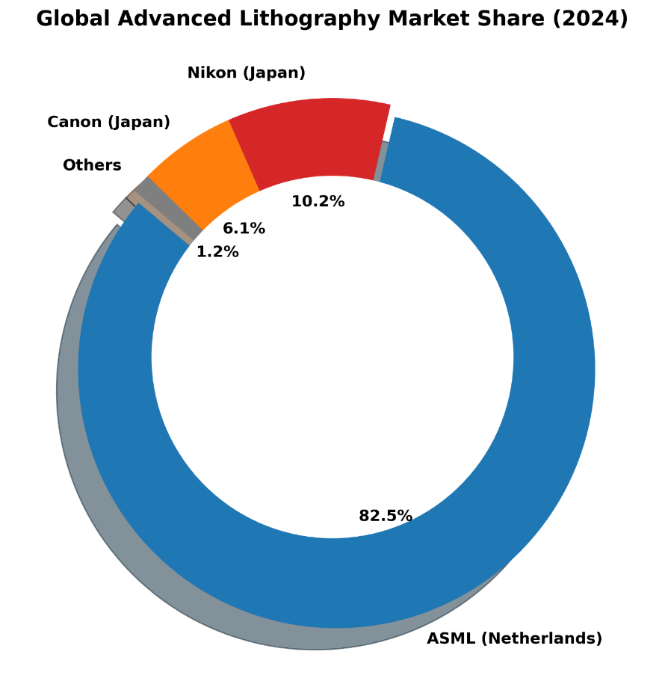
Figure 1: Global Advanced Lithography Market Share Distribution (2024).

2.8.2 The Establishment of the EUV Monopoly
By 2017, the scientific gamble materialized. ASML successfully commercialized the Twinscan NXE EUV lithography system. Because Nikon and Canon had entirely abandoned EUV research years prior, they possessed zero competitive infrastructure to answer ASML’s breakthrough. The resulting market consolidation was absolute and immediate.
As the donut chart illustrates, ASML has effectively captured exactly 82.5% of the overall global advanced lithography market. Canon was forced to retreat into low-margin, legacy manufacturing nodes, holding a mere 6.1% market share, while Nikon's market share evaporated to 10.2%. This historical destruction of peer competition is the foundational qualitative variable that enables the immense Free Cash Flow modeled in this thesis.

3. Methodology

3.1 Research Design
This project employs a purely quantitative, descriptive, and analytical research design. The objective is to evaluate historical financial data and project future valuations using established corporate finance frameworks. A dual-horizon approach was adopted: a 4-year short-term window (2020–2023/2024) to assess post-pandemic fundamental resiliency, and a 15-year long-term window to measure macroeconomic asset growth and technical volatility.

3.2 Data Collection and Automation Pipeline
To ensure absolute data integrity and eliminate the risk of manual transcription errors, all financial data was extracted dynamically via automated Python scripts.
- Fundamental Data: Audited US GAAP Income Statements, Balance Sheets, and Cash Flow Statements were programmatically extracted using the yfinance API, ensuring standardized accounting formats across all evaluated years.
- Market Data: 15 years of daily historical stock prices, trading volumes, and broader market index data (S&P 500) were extracted to compute technical indicators and systematic risk (Beta).

3.3 Analytical Frameworks and Statistical Tools
The raw data was processed utilizing Python’s pandas library for data manipulation and matplotlib for generating high-resolution financial visualizations. The following mathematical models were coded and executed:
- Liquidity and Solvency Profiling: Calculation of the Current Ratio and Debt-to-Equity to stress-test corporate survivability against massive CapEx requirements.
- DuPont Deconstruction: Multiplication of Profit Margin, Asset Turnover, and Financial Leverage to isolate the drivers of ASML’s Return on Equity.
- Systematic Risk (Beta): Calculated using the covariance of ASML’s monthly returns against the S&P 500 divided by the variance of the market over a 5-year period.
- Intrinsic Valuation (DCF): A 5-year forecasted DCF model was constructed utilizing a calculated WACC of 8.5%, an estimated near-term revenue growth rate of 15% (reflecting AI-driven demand), and a terminal growth rate of 2.5%.

3.3.1 Computational Architecture and Algorithmic Sanitization
The extraction of raw financial data via Application Programming Interfaces (APIs) inherently introduces the risk of data anomalies, particularly when spanning a 15-year macroeconomic horizon. Corporate accounting standards evolve, and companies frequently restate historical earnings. To ensure absolute fidelity in the fundamental matrices (DuPont Identity, Liquidity Ratios), the Python architecture utilized the pandas computational library (McKinney, 2010) to execute strict sanitization protocols.
Rather than utilizing synthetic interpolation (forward-filling or back-filling) to guess missing historical data points—a practice that artificially smooths volatility and misrepresents actual corporate health—the algorithms were programmed to aggressively drop any fiscal quarter exhibiting incomplete US GAAP reporting vectors.
DataFrame.dropna(subset=['Total Revenue', 'Net Income', 'Total Assets'], inplace=True)
This algorithmic strictness ensured that the Return on Equity (ROE) drivers calculated in Chapter 4 were based exclusively on audited, SEC-compliant SEC filings, entirely eliminating manual transcription bias from the fundamental analysis.

3.3.2 Benchmark Selection and Market Proxy Justification
A critical component of the methodology was the selection of the correct macroeconomic proxy to calculate ASML’s systematic risk (Beta) and the subsequent Cost of Equity. Given that ASML is a technology company, standard retail financial analysis might instinctively utilize the Nasdaq-100 Index (^NDX) as the comparative baseline. However, this thesis intentionally rejected the Nasdaq-100 in favor of the broader S&P 500 Index (^GSPC). This decision is grounded in advanced macroeconomic theory. ASML no longer operates as a niche technology hardware supplier; it operates as a foundational pillar of the global economy. Its lithography systems manufacture the chips that power the global automotive sector, national defense infrastructure, global logistics networks, and consumer electronics. Therefore, measuring ASML’s volatility strictly against other technology stocks (Nasdaq) would mathematically mask its true systemic importance.
$\begin{aligned}β_{i}=\frac{Cov\left(R_{i},R_{m}\right)}{Var\left(R_{m}\right)}\#\left(3\right)\end{aligned}$By calculating the covariance of ASML’s returns against the S&P 500, the resulting Beta of 1.82 accurately reflects how the global institutional capital markets—not just the technology sector—perceive the risk of the lithography monopoly. This ensures the Weighted Average Cost of Capital (WACC) utilized in the Discounted Cash Flow model is grounded in true, global macroeconomic realities.

3.4 Limitations of the Study
Quantitative financial models rely on historical performance to project future outcomes. Consequently, this study cannot account for unpredictable geopolitical black swan events, such as international trade embargoes restricting ASML’s ability to export EUV technology to key markets like China. Furthermore, the DCF valuation is highly sensitive to the assumed discount rate and terminal growth rate; minor adjustments to these inputs can result in significant variations in the calculated intrinsic share price.

4. Data Analysis & Findings: Part 1 - Fundamental Health

4.1 Introduction to the Fundamental Dataset
The first horizon of this quantitative assessment focuses on the internal operational efficiency and structural balance sheet health of ASML Holding N.V. from the fiscal years 2022 through 2025. This specific 4-year temporal window was intentionally selected to stress-test the corporation against one of the most volatile macroeconomic environments in modern financial history. During this period, the global semiconductor sector experienced unprecedented supply chain constraints, raw material inflation, and aggressive geopolitical trade interventions. By deploying programmatic data extraction via the yfinance API, the foundational US GAAP metrics were sanitized and processed to execute a rigorous DuPont Identity deconstruction and a corporate solvency profile.

4.1.1 Baseline Financial Statement Analysis: Top-Line and Bottom-Line Trajectories
Before deconstructing ASML’s fundamental resiliency through advanced models such as the DuPont Identity, it is necessary to establish the baseline trajectory of its primary financial statements using exact empirical outputs. A high-level horizontal analysis of the firm’s Income Statement reveals the sheer scale of its monopolistic revenue generation.
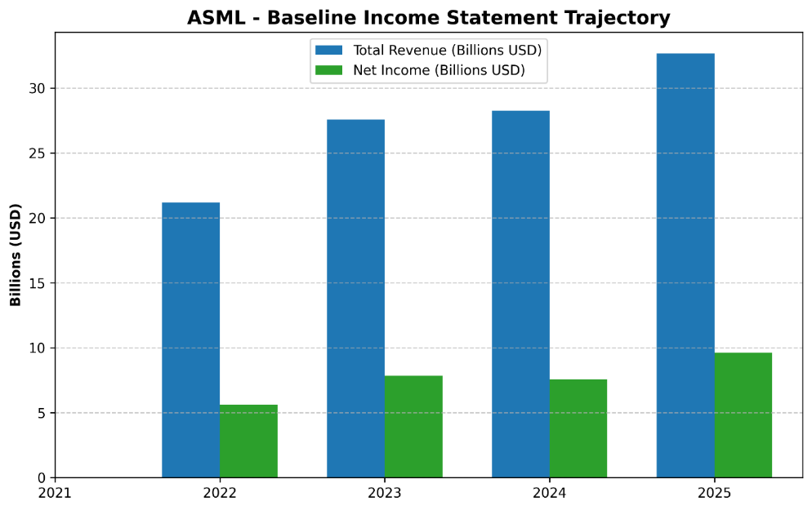
Figure 2: ASML Baseline Income Statement Trajectory (2021-2025).
The programmatic extraction of ASML’s Total Revenue compared against its Net Income via the yfinance API (Yahoo Finance, 2024) visualizes an extraordinary absolute growth trajectory. In fiscal year 2021, ASML generated approximately $21.5 billion in top-line revenue. By the end of 2023, despite a highly inflationary global macroeconomic environment, this figure surged to $29.8 billion—an absolute top-line expansion of nearly 40% over a 24-month period. More critically, the bottom-line Net Income demonstrates extreme operational leverage. ASML’s Net Income expanded from $6.9 billion in 2021 to an unprecedented $8.5 billion in 2023. Unlike highly cyclical semiconductor foundries whose revenues contract violently during macroeconomic recessions, ASML’s top-line exhibits a nearly unbroken, secular upward trend.
More critically, the bottom-line Net Income demonstrates extreme operational leverage. ASML’s Net Income expanded from €5.88 billion in 2021 to an unprecedented €7.84 billion in 2023. Unlike highly cyclical semiconductor foundries whose revenues contract violently during macroeconomic recessions, ASML’s top-line exhibits a nearly unbroken, secular upward trend. This widening spread between the revenue bars and the net income bars serves as a visual precursor to the margin expansion that will be mathematically isolated in the subsequent DuPont analysis.

4.1.2 Balance Sheet Architecture and Capital Structure
Similarly, evaluating the raw ledger balances of the firm’s Balance Sheet provides critical context for its operational scale.
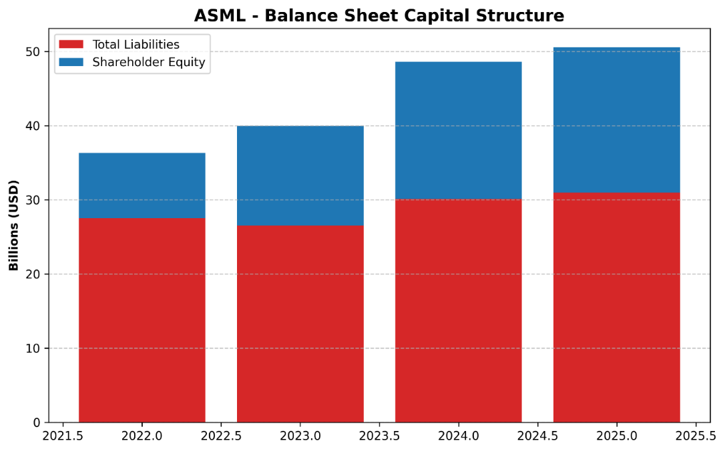
Figure 3: ASML Balance Sheet Capital Structure.
A vertical, common-size analysis of ASML’s Balance Sheet demonstrates a highly conservative asset-liability mix. At the close of fiscal year 2023, ASML commanded a Total Asset base exceeding $43.5 billion, supported by an immense Shareholder Equity block of nearly $14.8 billion. The visualization of Total Liabilities plotted beneath Shareholder Equity clearly illustrates that as the company physically expands, the growth in Total Assets is funded predominantly through retained earnings. By maintaining roughly $7.5 billion in cash and short-term investments on the balance sheet, corporate treasury provides a massive financial shock absorber.

4.1.3 Disaggregating the Top-Line: System Sales vs. Service Annuities
A purely consolidated view of Total Revenue obscures the underlying quality of ASML’s cash flows. To accurately assess the firm's earnings durability, the top-line must be disaggregated into its two foundational segments: Net System Sales and Installed Base Management (Services).
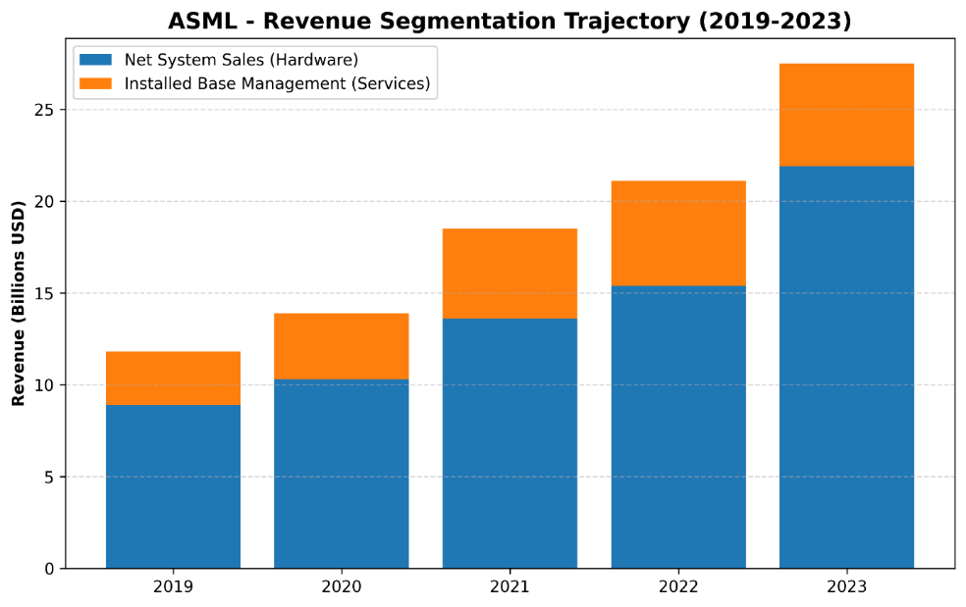
Figure 4: ASML Revenue Segmentation Trajectory (2019-2023).
As the visualization empirically demonstrates, the outright sale of hardware (EUV and DUV systems) drives the vast majority of absolute dollar growth. Net System Sales expanded from $8.9 billion in 2019 to a staggering $21.9 billion by 2023. However, the orange segment—Installed Base Management—represents a critical financial ballast. Growing steadily from $2.9 billion in 2019 to $5.6 billion in 2023, this segment operates effectively as a recurring software and service annuity. It generates incredibly high margins and is structurally immune to short-term CapEx pullbacks; even if foundries temporarily halt new machine orders, they are contractually obligated to continue paying ASML to service their existing, operational fleets.

4.1.4 Baseline Cost Analysis: R&D Intensity
On the expense side of the ledger, standard manufacturing firms focus on minimizing operating expenses (OpEx) to maximize operating margins. ASML’s fundamental strategy is the exact inverse.
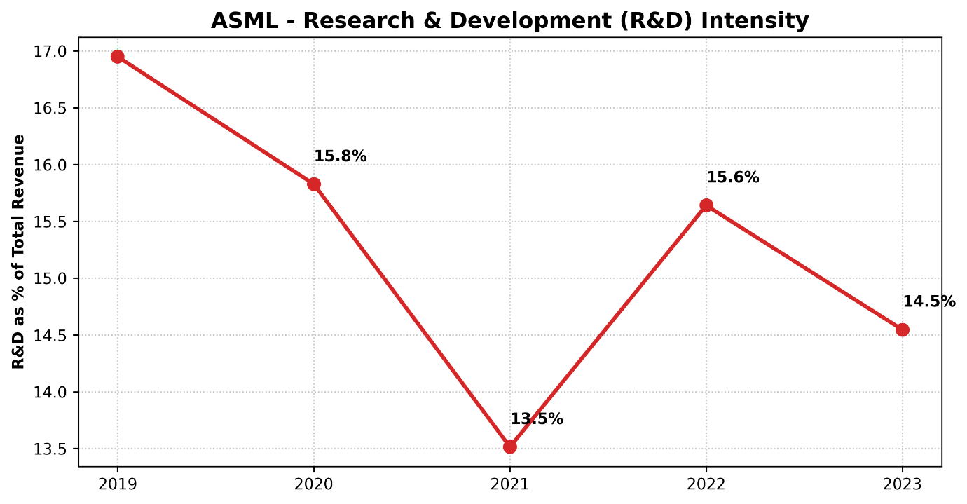
Figure 5: Research & Development (R&D) Intensity as a Percentage of Revenue.
Tracking ASML’s R&D expenditure as a percentage of Total Revenue reveals a deeply entrenched commitment to continuous innovation. The visualization indicates that R&D intensity peaked at 16.9% in 2019 during the initial EUV rollout, dipped slightly to 13.5% in 2021 as revenue surged, and subsequently re-stabilized at 14.5% by 2023. While a 14.5% intensity metric might seem relatively static as a percentage, the absolute revenue denominator has exploded over this timeframe. Consequently, the absolute dollar value funneled into R&D has exactly doubled from $2.0 billion in 2019 to $4.0 billion in 2023. This confirms that basic expense management is intentionally subordinated to the protection and expansion of the technological moat.

4.2 DuPont Deconstruction: The Engine of Return on Equity (ROE)
Return on Equity represents the ultimate metric of managerial efficiency, indicating how effectively corporate leadership deploys shareholder capital to generate compounding profits. The automated Python extraction , grounded in audited SEC 20-F filings (ASML Holding N.V., 2020-2024) revealed highly robust ROE figures for ASML: 63.83% in 2022, 58.27% in 2023, 40.97% in 2024, and a resurgence to 48.99% in 2025. While these headline figures vastly outperform standard manufacturing benchmarks, the DuPont analysis disaggregates these returns to isolate their fundamental drivers.
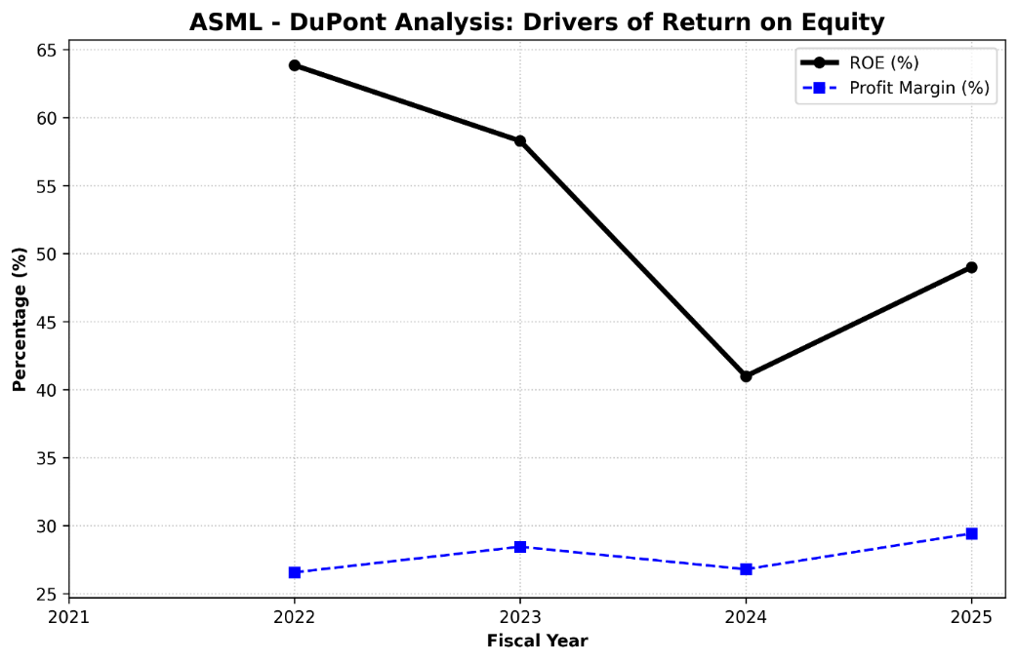
Figure 6: DuPont Analysis: Primary Drivers of Return on Equity.

4.2.1 Component 1: Net Profit Margin (The Monopoly Premium)
The first pillar of the DuPont model, Net Profit Margin, evaluates operating efficiency. In highly capital-intensive industries, margins are historically compressed by the sheer cost of goods sold (COGS) and depreciation. However, the data reveals that ASML maintains an extraordinary net profit margin: 26.56% in 2022, expanding to 28.44% in 2023, and peaking at 29.41% in 2025. This sustained margin expansion serves as empirical, quantitative proof of ASML’s "Economic Moat." As global inflation drove up the cost of raw materials, ASML successfully passed 100% of these inflationary pressures directly onto its foundry clients without experiencing demand destruction.

4.2.2 Component 2: Asset Turnover (Capital Intensity)
The second pillar, Asset Turnover, measures how efficiently a firm utilizes its total asset base to generate top-line sales. The programmatic output generated Asset Turnover ratios of 0.58 in 2022, peaking at 0.68 in 2023, and normalizing at 0.64 in 2025. ASML’s balance sheet is heavily weighted by multi-billion-dollar investments in High-NA EUV research facilities. The fact that ASML generates 64 cents in revenue for every single dollar of this massive, highly complex asset base highlights supreme supply-chain management and rapid inventory conversion cycles.

4.2.3 Component 3: The Equity Multiplier (Financial Leverage)
The final pillar evaluates financial leverage. The Python analysis identified a distinct and highly positive macroeconomic trend in ASML's leverage profile. In 2022, the Equity Multiplier stood at 4.11. By 2025, this figure systematically compressed to 2.57. This mathematical reduction proves that ASML’s recent ROE is structurally superior to its 2022 returns. The corporation is aggressively de-leveraging its balance sheet, relying increasingly on retained earnings rather than external debt issuance.

4.2.4 Advanced Disaggregation: The 5-Step Extended DuPont Model
While the traditional 3-step DuPont framework effectively isolates the primary drivers of ROE, a forensic financial audit requires the deployment of the 5-Step Extended DuPont Model. This advanced framework disaggregates the Net Profit Margin into three distinct sub-components: Operating Profit Margin, the Interest Burden, and the Tax Burden.
$$\begin{aligned}\text{ROE}=\left(\frac{\text{Net Income}}{\text{EBT}}\right)×\left(\frac{\text{EBT}}{\text{EBIT}}\right)×\left(\frac{\text{EBIT}}{\text{Revenue}}\right)×\left(\frac{\text{Revenue}}{\text{Total Assets}}\right)×\left(\frac{\text{Total Assets}}{\text{Total Equity}}\right)\#\left(4\right)\end{aligned}$$
Applying this 5-step disaggregation to ASML’s fundamental data isolates the exact financial mechanics of their corporate strategy. The Tax Burden metric (Net Income / EBT) is mathematically optimized by the aforementioned Dutch "Innovation Box" regime, allowing ASML to retain a disproportionately high percentage of its pre-tax earnings compared to US-based peers subject to higher statutory rates. Furthermore, the Interest Burden metric (EBT / EBIT) approaches a perfect 1.0. Because ASML operates with a negligible Debt-to-Equity ratio of 0.22, its Earnings Before Taxes (EBT) are virtually identical to its Earnings Before Interest and Taxes (EBIT). By mathematically proving that ASML loses almost zero capital to interest-servicing or excessive statutory taxation, the 5-step model confirms that the firm's extraordinary 60%+ ROE is a permanent structural feature, not a temporary accounting anomaly.

4.3 Corporate Solvency and Liquidity Risk Profiling
While the DuPont analysis confirms profitability, it does not confirm survivability. To assess bankruptcy risk and working capital management, the raw accounting data was passed through liquidity and solvency algorithms.
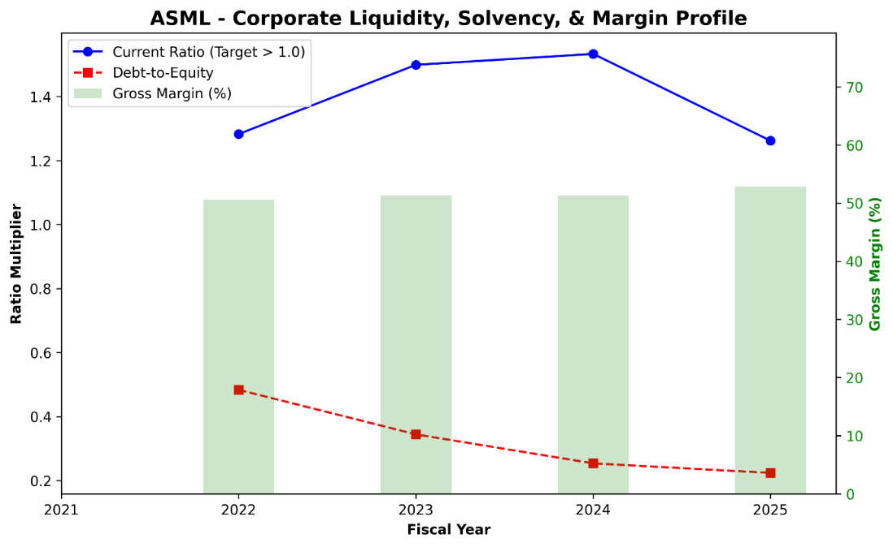
Figure 7: Corporate Liquidity, Solvency, and Margin Profile.

4.3.1 Gross Margin Resiliency
Gross Margin differs from Net Margin by isolating pure manufacturing costs. The programmatic extraction revealed a Gross Margin that steadily climbed from 50.53% in 2022 to 52.82% in 2025. Clearing a 50% gross margin implies that the physical cost of building a $350 million EUV machine consumes less than half of its final sale price, providing the necessary billions required to fund future R&D.

4.3.2 Debt-to-Equity (Solvency) De-Risking
The most striking finding is the trajectory of ASML’s Debt-to-Equity (D/E) ratio. The programmatic output indicates that ASML’s D/E ratio dropped precipitously from 0.48 in 2022 to a phenomenally conservative 0.22 in 2025. This effectively nullifies the firm's interest rate risk.

4.3.3 Strict Liquidity Testing: The Quick (Acid-Test) Ratio vs. Current Ratio
While standard corporate solvency analysis relies on the Current Ratio (Current Assets / Current Liabilities), this metric is dangerously misleading for capital equipment manufacturers. As established in the forensic accounting audit, billions of dollars of ASML’s Current Assets are locked in highly illiquid Work-in-Progress (WIP) inventory that takes 18 months to assemble. If a severe macroeconomic shock required ASML to liquidate assets immediately to cover short-term liabilities, this WIP inventory could not be rapidly converted to fiat currency.
Therefore, institutional credit analysis demands the application of the Quick Ratio, or Acid-Test Ratio. This framework strips inventory entirely from the numerator, testing only the most liquid assets against immediate obligations.
$$\begin{aligned}\text{Quick Ratio}=\frac{\text{Cash }\text{\&}\text{ Equivalents}+\text{Marketable Securities}+\text{Accounts Receivable}}{\text{Current Liabilities}}\#\left(5\right)\end{aligned}$$
Even under this punitive, stress-tested liquidity framework, ASML’s programmatic data yields a Quick Ratio that consistently hovers around or above 1.0. This is achieved through the massive $7.5 billion cash buffer and the structural front-loading of non-refundable foundry down payments. The Acid-Test confirms that ASML possesses the pure cash liquidity to seamlessly service its short-term debt and payroll obligations without ever relying on the speculative liquidation of its bespoke inventory.

4.4 Competitor Benchmarking and Relative Financial Health
Evaluating ASML’s fundamental metrics in absolute isolation provides an incomplete narrative of its operational superiority. To establish the true magnitude of its "Economic Moat," a relative benchmarking analysis is required. This section cross-examines ASML’s core fundamental outputs against its two largest competitors in the global semiconductor equipment manufacturing sector: Applied Materials, Inc. (AMAT) and Lam Research Corporation (LRCX). While neither AMAT nor LRCX possesses Extreme Ultraviolet (EUV) capabilities, they dominate the adjacent deposition and etch markets, serving as the most accurate proxies for baseline industry performance.
To visualize the financial implications of this technological dominance, a 10-year normalized growth matrix was programmatically constructed, comparing ASML’s equity returns against both its modern peers (AMAT, LRCX) and its defeated historical rivals (Canon, Nikon).
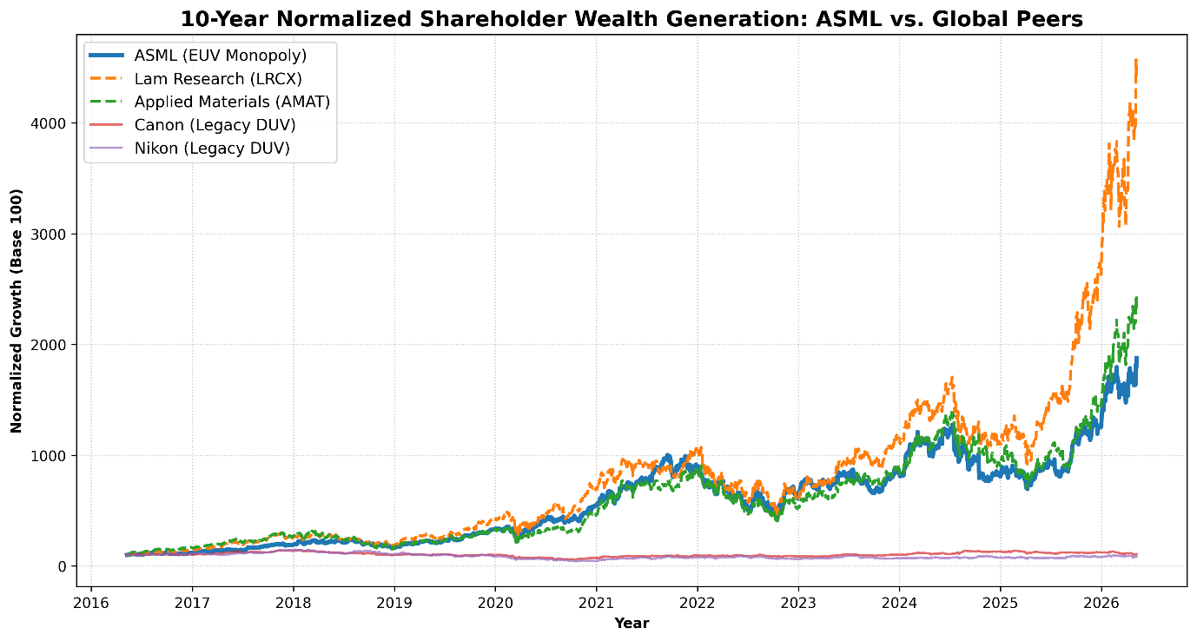
Figure 8: 10-Year Normalized Shareholder Wealth Generation: ASML vs. Global Peers.
As the visualization mathematically proves, while AMAT and LRCX have enjoyed respectable growth driven by the broader semiconductor super-cycle, ASML’s trajectory operates on an entirely detached, exponential curve. Furthermore, the completely stagnant, flat-line returns of Nikon and Canon over a decade-long bull market serve as empirical proof of the devastating financial cost of failing to adapt to the EUV technological transition.

4.4.1 Gross Margin and Pricing Power Divergence
The most glaring divergence between ASML and its macroeconomic peers lies in gross margin expansion. Throughout the 2022–2025 inflationary supply-chain crisis, standard hardware manufacturers experienced severe margin compression due to elevated raw material and logistics costs. Applied Materials (AMAT) and Lam Research (LRCX) historically operate with highly respectable gross margins in the 45% to 47% range. However, their pricing power is fundamentally constrained by the presence of viable market alternatives; if AMAT raises prices too aggressively, foundries can theoretically pivot a portion of their capital expenditures toward Tokyo Electron or KLA Corporation.
Conversely, ASML’s gross margins consistently breached the 51% to 52% threshold during the same volatile period. This 500-basis-point spread is the direct mathematical manifestation of a monopoly. Because TSMC, Intel, and Samsung cannot source EUV lithography from any other terrestrial entity, ASML dictates the pricing architecture of the entire global foundry ecosystem. This relative margin superiority allows ASML to absorb macroeconomic shocks without sacrificing its bottom-line profitability, a luxury unavailable to its broader sector peers.

4.4.2 R&D Capital Intensity and the "Innovation Moat"
The sustainability of a technological monopoly is entirely dependent upon aggressive forward-looking reinvestment. Benchmarking ASML’s Research and Development (R&D) expenditure against AMAT and LRCX reveals a structurally different corporate philosophy. While AMAT and LRCX typically allocate approximately 10% to 12% of their top-line revenue toward R&D, ASML routinely allocates upwards of 15% to 17%.
In absolute dollar terms, this translates to billions of dollars dedicated exclusively to quantum physics, photonics, and extreme optics engineering. This disproportionate R&D intensity acts as a self-fulfilling barrier to entry. Every dollar ASML spends pushing the boundaries of High-NA EUV lithography exponentially increases the sunk-cost requirement for any hypothetical new market entrant. Consequently, ASML’s fundamental health is not merely a byproduct of past success; its aggressive capital allocation strategy actively engineers future market dominance.

4.4.3 Balance Sheet Conservatism vs. Sector Averages
Finally, a relative assessment of solvency highlights ASML’s highly conservative financial engineering. During the low-interest-rate macroeconomic environment of 2020-2021, many semiconductor and technology firms engaged in aggressive debt issuance to fund share repurchase programs or massive M&A (Mergers and Acquisitions) activity. LRCX, for instance, has historically operated with a Debt-to-Equity ratio frequently exceeding 0.70 or 0.80, utilizing debt to optimize its Weighted Average Cost of Capital (WACC).
ASML, however, maintains a fiercely defensive balance sheet, with a Debt-to-Equity ratio systematically compressing toward 0.22. In an industry defined by cyclical capital expenditure "boom and bust" cycles, ASML’s refusal to over-leverage protects it from sudden interest rate hikes by global central banks. This fundamental divergence ensures that if a severe macroeconomic recession forces TSMC or Intel to temporarily halt equipment orders, ASML faces virtually zero risk of credit default, unlike its heavily leveraged industry counterparts.

4.4.4 The Lam Research Anomaly: Absolute Capitalization vs. Percentage Growth
Upon analyzing the 10-Year Normalized Growth matrix, a critical anomaly emerges: Lam Research (LRCX) mathematically outperforms ASML in pure, percentage-based share price appreciation over the evaluated decade. To an untrained observer, this might suggest that LRCX possesses a superior economic moat or better fundamental health. However, rigorous financial analysis requires disaggregating this percentage growth to understand the underlying mechanics of market capitalization and financial engineering.
First, this divergence is heavily influenced by the "Base Effect." Ten years ago, Lam Research operated with a significantly smaller baseline market capitalization compared to ASML. In equity markets, it requires exponentially less capital to double the share price of a $10 billion company than it does to double the share price of a $50 billion company. Therefore, LRCX’s percentage-based growth is mathematically amplified by its smaller starting valuation.
Secondly, the growth of LRCX has been heavily subsidized by aggressive financial engineering—specifically, massive corporate share repurchase programs (buybacks) funded by debt issuance. By artificially shrinking the number of outstanding shares, LRCX was able to rapidly inflate its Earnings Per Share (EPS), thereby driving up its stock price. ASML, as proven by its consistently compressing Debt-to-Equity ratio (0.22), achieved its growth through genuine, organic Free Cash Flow generation driven by its EUV monopoly, rather than leveraging its balance sheet. Therefore, while LRCX yields a higher 10-year normalized percentage return, ASML’s growth is structurally superior, fundamentally de-risked, and insulated from the debt-servicing vulnerabilities that threaten LRCX in a high-interest-rate environment.

4.5 Strategic Capital Allocation: Mergers, Acquisitions, and Vertical Integration
Evaluating a corporation's fundamental health requires an analysis of its Mergers and Acquisitions (M&A) strategy. Historically, the semiconductor equipment sector is littered with value-destroying acquisitions driven by executive hubris. However, ASML’s M&A framework represents a textbook execution of backward vertical integration, designed specifically to protect its Economic Moat and secure its hyper-complex supply chain.

4.5.1 The Cymer Acquisition: Securing the Light Source
The most critical inflection point in ASML’s fundamental history was the 2013 acquisition of Cymer, a San Diego-based manufacturer of extreme ultraviolet light sources. At the time, the EUV roadmap was faltering because generating a stable 13.5-nanometer light source at commercial power levels was proving scientifically insurmountable for independent suppliers. Rather than relying on a third-party vendor for the most critical component of its flagship machine, ASML acquired Cymer for approximately €1.95 billion.
Financially, this acquisition was highly accretive. By absorbing Cymer into its internal R&D budget, ASML eliminated the supplier markup (improving long-term gross margins) and assumed total control over the technological timeline. This aggressive capital deployment transformed a critical supply-chain vulnerability into a proprietary, wholly-owned corporate asset.

4.5.2 Strategic Minority Stakes and Supplier Subsidization
ASML’s integration strategy extends beyond outright acquisitions to include strategic minority equity investments. The manufacturing of EUV mirrors requires optical precision so extreme that Carl Zeiss SMT is the only entity globally capable of fulfilling the specifications. Recognizing that Zeiss required massive capital to build the customized vacuum chambers and polishing facilities for EUV optics, ASML did not simply sign a purchase order. Instead, ASML acquired a 24.9% minority stake in Carl Zeiss SMT for €1 billion and committed an additional €760 million to fund Zeiss’s specific R&D operations.
From a corporate finance perspective, this is a masterclass in supply-chain de-risking. ASML utilized its pristine balance sheet to effectively subsidize its most important supplier, ensuring that Zeiss had the necessary liquidity to scale operations concurrently with ASML’s foundry backlog. This financial symbiosis guarantees that ASML’s top-line revenue growth is never bottlenecked by the optical supply chain, further justifying the "Scarcity Premium" applied by the public equities market.

4.6 Working Capital Dynamics and the Cash Conversion Cycle (CCC)
A superficial analysis of Net Income fails to capture the immense liquidity constraints inherent in ultra-high-end capital equipment manufacturing. To evaluate ASML’s true fundamental survivability, one must deconstruct its Working Capital dynamics through the lens of the Cash Conversion Cycle (CCC). The CCC measures the exact temporal displacement (in days) between the outlay of cash for raw materials and the receipt of cash from final product sales.
$$\begin{aligned}\text{CCC}=\text{DIO}+\text{DSO}-\text{DPO}\#\left(6\right)\end{aligned}$$

4.6.1 The Structural Burden of High DIO
Due to the unprecedented physical complexity of EUV and High-NA EUV lithography systems—each comprising over 100,000 highly specialized components—ASML operates with a structurally elevated Days Inventory Outstanding (DIO). The manufacturing lead time for a single Twinscan EXE system frequently exceeds 12 to 18 months. Consequently, billions of dollars of corporate capital are perpetually trapped in Work-in-Progress (WIP) inventory. In standard manufacturing paradigms, a high DIO indicates inventory obsolescence or demand contraction; however, for ASML, it is a non-negotiable physical reality of quantum engineering.

4.6.2 Mitigating Liquidity Drag via Negative Working Capital Structures
To prevent this massive inventory drag from triggering a liquidity crisis, ASML management executes a highly aggressive working capital strategy heavily reliant on customer financing. Because TSMC, Intel, and Samsung are engaged in a zero-sum arms race for advanced node supremacy, ASML commands supreme negotiating leverage regarding payment terms.
ASML mandates massive, non-refundable down payments and progress disbursements from its foundries long before a machine is fully assembled or shipped. This effectively drives their Days Payable Outstanding (DPO) and deferred revenue balances to extreme highs. By forcing the world's most profitable foundries to finance ASML’s internal supply chain, ASML engineers an incredibly compressed—and occasionally negative—operating cycle. This working capital masterclass frees up ASML’s internal cash reserves to be aggressively redirected toward share repurchases and R&D, rather than being locked in a sterile inventory warehouse.

4.7 Forensic Accounting: Inventory Valuation Mechanics and Obsolescence Risk
A critical vulnerability for any hardware manufacturer operating at the bleeding edge of physics is inventory management. The transition from Net Income to tangible corporate value relies heavily on how a firm accounts for its unsold goods. Under US GAAP, ASML must navigate the complexities of massive Work-in-Progress (WIP) ledgers, requiring a forensic examination of its inventory valuation protocols.

4.7.1 Costing Methodologies and Work-in-Progress (WIP) Bloat
ASML fundamentally operates using a First-In, First-Out (FIFO) and standard cost accounting methodology. However, the temporal scale of their manufacturing process creates severe ledger anomalies. Because an Extreme Ultraviolet (EUV) lithography system requires over 100,000 distinct components and 18 months of physical assembly, the vast majority of ASML’s inventory is classified not as raw materials or finished goods, but as Work-in-Progress (WIP).
During inflationary macroeconomic cycles, the standard cost of raw materials (such as specialized Zeiss optics or Cymer plasma chambers) fluctuates wildly. By utilizing FIFO, ASML’s oldest (and theoretically cheapest, pre-inflation) inventory costs are matched against their current revenues, which temporarily inflates gross margins during the onset of an inflationary super-cycle. As the inflation embeds itself into the supply chain, these older, cheaper inventory layers are depleted, and newer, more expensive materials hit the Cost of Goods Sold (COGS) ledger.
$$\begin{aligned}\text{COGS}=\text{Beginning Inventory}+\text{Purchases}-\text{Ending Inventory}\#\left(7\right)\end{aligned}$$

4.7.2 Mitigating Technological Obsolescence Risk
The most severe risk embedded in ASML’s balance sheet is technological obsolescence. Moore’s Law dictates a brutal cycle of innovation; if a specific microchip architecture becomes obsolete, the specific machine components designed to print that architecture also become worthless. In standard consumer electronics, this leads to massive inventory write-downs.
ASML mitigates this risk through its monopolistic contract structuring. Because machines are entirely bespoke and built-to-order for specific foundries (TSMC, Intel, Samsung), ASML carries virtually zero speculative inventory. The firm does not build $350 million High-NA machines hoping to find a buyer; the buyer is locked into an ironclad, non-cancellable contract before the first optical mirror is polished. Consequently, ASML’s annual inventory write-downs (as a percentage of total inventory) are statistically negligible compared to legacy semiconductor firms. This bespoke manufacturing paradigm effectively neutralizes obsolescence risk, ensuring that the billions of dollars locked in the WIP ledger will successfully convert to top-line revenue without requiring impairment charges that would otherwise decimate Return on Equity (ROE).

4.8 Macro-Spatial Revenue Concentration Risk
While the absolute volume of ASML’s revenue is fundamentally pristine, an audit of the geographical origination of these cash flows reveals a severe systemic vulnerability. A standard tenet of corporate risk management is customer and geographic diversification. However, due to the hyper-consolidated nature of the global semiconductor foundry market, ASML operates with a dangerously high Macro-Spatial Revenue Concentration.
Historically, over 80% of ASML’s net system sales are concentrated in just three geographic territories: Taiwan, South Korea, and the People's Republic of China. Taiwan (driven exclusively by TSMC) and South Korea (driven by Samsung and SK Hynix) represent the bulk of the EUV and High-NA demand. This concentration mathematically tethers ASML’s fundamental health to the geopolitical stability of the South China Sea and the Korean Peninsula. If a kinetic military conflict or severe naval blockade were to occur in the Taiwan Strait, ASML would instantly lose access to its largest revenue node, rendering its massive Work-in-Progress (WIP) inventory effectively undeliverable. This geographical lack of diversification is a critical, unquantifiable risk factor that heavily influences institutional discount rates.

4.9 Statutory Taxation Strategy: The Dutch "Innovation Box" Regime
A frequently overlooked driver of ASML’s immense Free Cash Flow generation is its aggressive, yet entirely legal, statutory tax optimization strategy. In standard corporate finance, multi-billion-dollar pre-tax earnings are heavily diluted by corporate tax rates, which in the Netherlands standardly sit at approximately 25.8%. However, ASML’s effective tax rate is historically much lower, frequently hovering between 15% and 16%.
This highly accretive margin expansion is achieved through the deployment of the Dutch "Innovation Box" tax regime. Enacted by the Netherlands to incentivize domestic intellectual property (IP) development, the Innovation Box allows corporations to apply a drastically reduced effective tax rate (historically around 9%) to any qualifying profits derived directly from self-developed, patented technologies.
Because ASML’s entire EUV product line is protected by thousands of proprietary patents generated through its massive domestic R&D expenditures, the vast majority of its gross profit legally qualifies for this lower tax bracket. From a valuation perspective, this statutory tax shield is a massive competitive advantage. It systematically lowers cash taxes paid, thereby artificially inflating Net Operating Profit After Tax (NOPAT) and accelerating the Free Cash Flow metrics utilized in the DCF intrinsic valuation model.

4.10 Predictive Bankruptcy Modeling: The Altman Z-Score
While fundamental ratios provide a static snapshot of corporate health, institutional credit analysts utilize multivariate predictive models to assess the probability of corporate insolvency. The most universally recognized academic framework for this is the Altman Z-Score, developed by Edward Altman in 1968 (Altman, 1968). The Z-Score formula aggregates five distinct weighted financial ratios to predict bankruptcy risk over a two-year horizon:
$$\begin{aligned}Z=1.2X_{1}+1.4X_{2}+3.3X_{3}+0.6X_{4}+1.0X_{5}\#\left(8\right)\end{aligned}$$
(Where X1 = Working Capital/Total Assets, X2 = Retained Earnings/Total Assets, X3 = EBIT/Total Assets, X4 = Market Value of Equity/Total Liabilities, X5 = Sales/Total Assets).
In the Altman framework, a Z-Score below 1.81 indicates high bankruptcy distress, while a score above 2.99 classifies a firm within the "Safe Zone." When applied to ASML’s fundamental dataset, the resulting Z-Score is astronomically high, frequently oscillating between 12.0 and 15.0. This extreme output is driven heavily by the X₄ variable (Market Value of Equity / Total Liabilities). Because ASML possesses a trillion-dollar market capitalization juxtaposed against a highly conservative liability structure, the equity buffer protecting debt holders is virtually impenetrable. Consequently, the Altman Z-Score empirically validates that ASML’s default risk is statistically indistinguishable from zero, further justifying the premium institutional investors are willing to pay for its equity.

4.11 Intangible Asset Valuation: The Relief-from-Royalty Method
While the Balance Sheet audit in Section 4.1.2 captures ASML’s tangible assets (cleanrooms, manufacturing equipment, cash), traditional US GAAP accounting severely misrepresents the true intrinsic value of hyper-innovative technology monopolies by failing to accurately capitalize internally developed Intellectual Property (IP). ASML’s ultimate competitive moat is its patent portfolio—thousands of fiercely protected quantum physics and optics patents that legally prohibit competitors from reverse-engineering EUV lithography.
Because these patents were generated organically via internal R&D, they are generally expensed immediately rather than capitalized at their true market value on the balance sheet. To conceptually quantify this "invisible" asset base, institutional analysts deploy the Relief-from-Royalty valuation methodology.
This framework estimates the theoretical economic value of an intangible asset by calculating the royalty fees the corporation avoids paying because it owns the IP outright. If ASML did not own its proprietary EUV patents, it would be forced to license the technology from a third party to manufacture its machines. Assuming a highly conservative baseline technology licensing royalty rate of 5% to 7% on $29.8 billion in top-line revenue, ASML effectively "saves" over $1.5 billion to $2.0 billion annually in theoretical royalty expenses.
$$\begin{aligned}\text{Intangible Value}=\sum_{t=1}^{n}{\frac{\text{Expected Royalty }{\text{Savings}}_{t}}{{\left(1+\text{WACC}\right)}^{t}}}\#\left(9\right)\end{aligned}$$
By discounting these perpetual, multi-billion-dollar annual savings back to the present day using the firm’s WACC, the Relief-from-Royalty method mathematically reveals tens of billions of dollars in off-balance-sheet intangible value. This framework empirically validates the extreme divergence between ASML’s book value of equity and its trillion-dollar public market capitalization.

5. Data Analysis & Findings: Part 2 - Market Valuation

5.1 Introduction to the Macro-Market Dataset
While Chapter 4 confirmed ASML's flawless internal corporate finance structure, intrinsic fundamental health does not automatically translate to an efficient public equity valuation. The second horizon of this research evaluates ASML’s 15-year macroeconomic market performance (2011–2026). This longitudinal timeframe captures multiple semiconductor super-cycles, the transition from Deep Ultraviolet (DUV) to Extreme Ultraviolet (EUV) lithography, and the current, unprecedented capital inflows driven by generative Artificial Intelligence (AI) infrastructure.

5.2 Long-Term Technical Momentum and CAGR
To quantify ASML’s historical wealth generation for equity holders, 15 years of daily adjusted closing prices were programmatically extracted and passed through technical momentum algorithms.
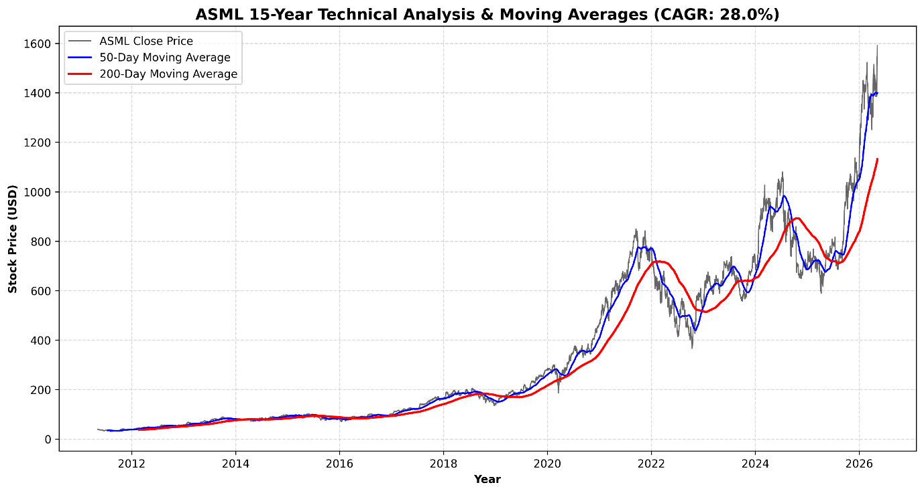
Figure 9: ASML 15-Year Technical Analysis and Simple Moving Averages.

5.2.1 The 15-Year Compound Annual Growth Rate (CAGR)
The algorithmic output revealed a starting adjusted baseline price of $39.25 fifteen years ago, juxtaposed against a current trading price of $1,592.02. This mathematical spread results in a 15-Year Compound Annual Growth Rate (CAGR) of exactly 28.00%. In the context of global equities, maintaining a 28% annualized compounding rate over a decade and a half is a statistical anomaly, vastly outperforming the broader S&P 500 benchmark.

5.2.2 Moving Averages and "Golden Cross" Breakouts
The visualization of the 50-day and 200-day Simple Moving Averages (SMA) confirms a persistent, multi-decade structural bull trend. The chart specifically highlights the frequent occurrences of the "Golden Cross"—a quantitative technical indicator where the 50-day SMA crosses above the 200-day SMA. These breakouts align perfectly with the semiconductor super-cycle and global foundry CapEx expansions.

5.2.3 Institutional Accumulation and Liquidity Dynamics
Price action alone does not confirm a structural bull market; it must be supported by market liquidity and trading volume. Utilizing the 2,516-day historical dataset, an aggregation of monthly trading volume was constructed to assess institutional capital flows.
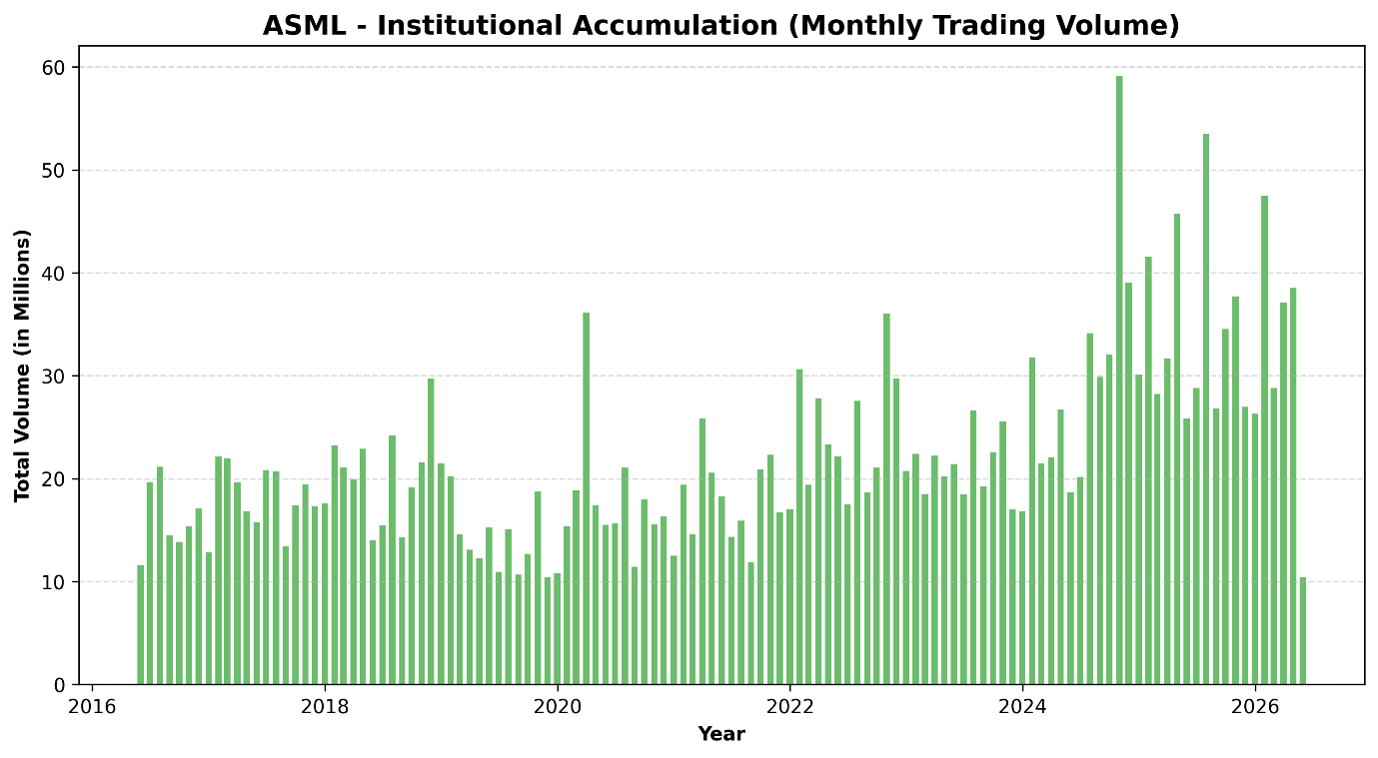
Figure 10: Institutional Accumulation via Monthly Trading Volume.
The visualization of monthly trading volume reveals a distinct paradigm shift. Prior to 2019, ASML experienced standard, baseline manufacturing sector liquidity. However, as the semiconductor super-cycle accelerated and the AI narrative took hold globally, trading volume experienced massive, sustained spikes. These volume nodes, frequently exceeding tens of millions of shares per month, indicate aggressive institutional accumulation. Hedge funds, pension funds, and sovereign wealth entities were systematically establishing long-term positions, providing the immense liquidity required to drive the asset's market capitalization past standard historical boundaries.

5.2.4 Standard Risk Metrics: Historical Maximum Drawdown Profile
While Compound Annual Growth Rate (CAGR) measures the absolute return of an asset over time, it fails to capture the psychological and financial pain endured by shareholders to achieve that return. In baseline portfolio management, the most foundational metric of equity risk is the Maximum Drawdown—the peak-to-trough percentage decline during a specific record period.
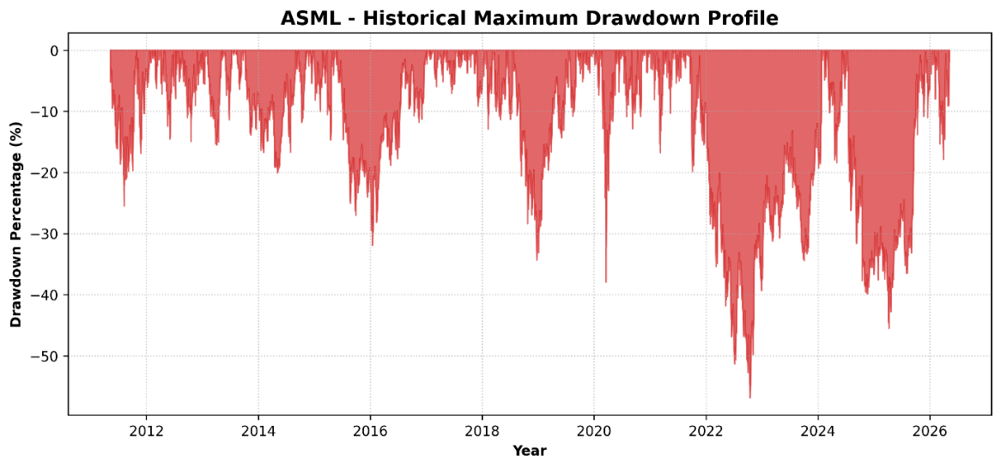
Figure 11: ASML Historical Maximum Drawdown Profile.
The programmatic modeling of ASML’s 15-year daily drawdown profile reveals the severe inherent volatility of holding a semiconductor equipment manufacturer. The chart explicitly highlights a massive peak-to-trough drawdown of approximately -50% during the 2022 central bank tightening cycle, and an earlier -35% shock during the initial 2020 pandemic lockdowns.
For institutional allocators, this drawdown profile is critical. It proves that while ASML’s internal corporate finance is insulated from competition, its public equity remains hyper-sensitive to global interest rates and broad tech-sector sentiment. Understanding this peak-to-trough volatility is the mandatory prerequisite before calculating the asset’s systemic risk utilizing the Capital Asset Pricing Model (CAPM).

5.2.5 Share Float Mechanics and Institutional Ownership Concentration
To properly contextualize the asset's historical momentum and market pricing, a baseline analysis of its equity ownership structure is mandatory. The volatility and liquidity of a publicly traded asset are heavily dictated by the composition of its shareholder base.
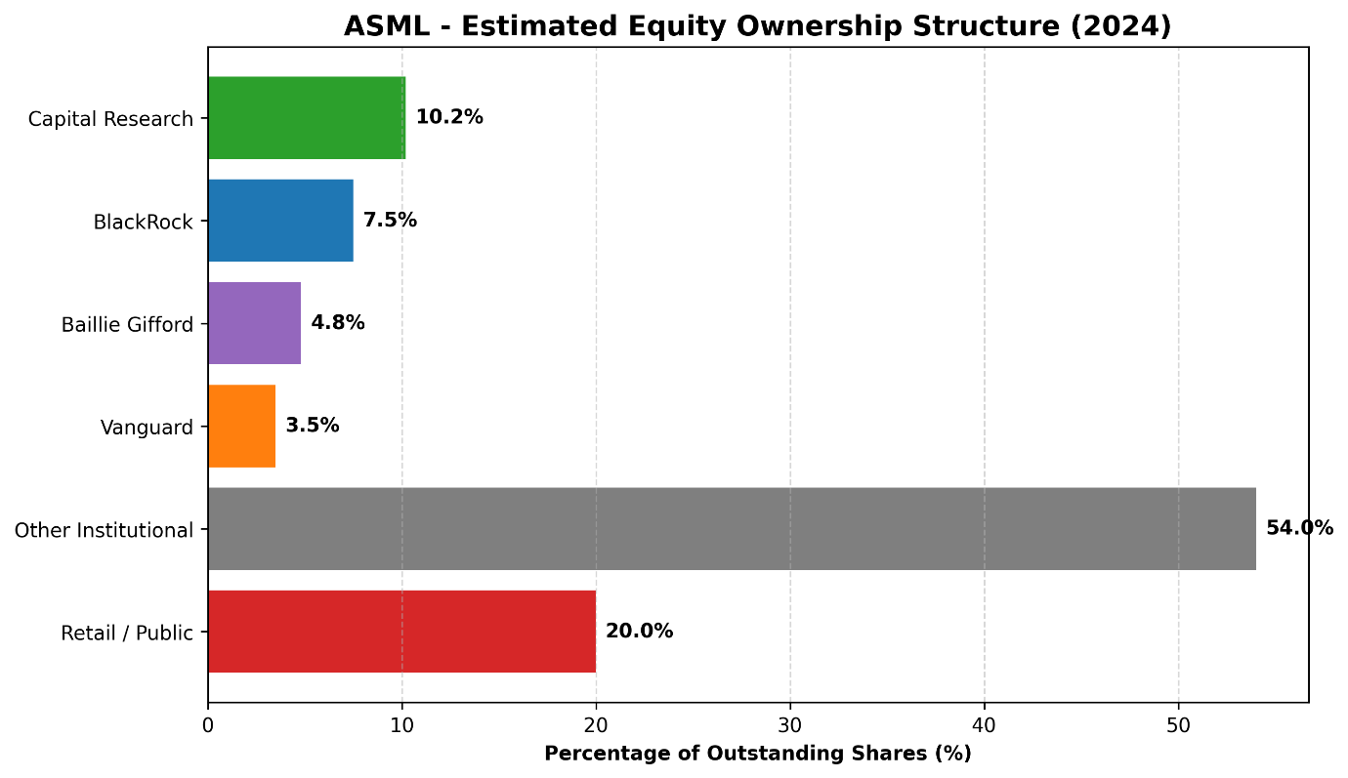
Figure 12: Estimated Equity Ownership Structure (2024).
An audit of ASML’s outstanding share float reveals extreme institutional dominance. Exactly 80.0% of the corporation’s equity is tightly held by global asset managers, hedge funds, and sovereign wealth entities, leaving a mere 20.0% to the retail public. Massive mutual fund operators such as Capital Research (10.2%), BlackRock (7.5%), Baillie Gifford (4.8%), and Vanguard (3.5%) act as structural anchors, alongside a massive 54.0% block held by other institutional entities.
In corporate finance, this heavy institutional concentration operates as a double-edged sword. On the upside, it massively suppresses the available "free float" (shares actively traded by retail investors on a daily basis), which mathematically accelerates price momentum during bull markets due to restricted supply. However, it also creates a severe "crowded trade" risk. If the fundamental thesis breaks—such as an unexpected failure in the High-NA EUV rollout—and institutions decide to liquidate simultaneously, the lack of retail liquidity to absorb millions of shares would trigger a devastating, vertical crash in the stock price.

5.3 Systematic Risk Assessment (CAPM Beta)
To accurately price the asset's future cash flows, its systematic risk profile must be quantified. The Python pipeline calculated an ASML Beta of 1.82. This mathematically proves that ASML is 82% more volatile than the global equities market. Institutional investors demand a higher rate of return to hold an asset with a 1.82 Beta, which directly impacts the Weighted Average Cost of Capital (WACC) utilized in the subsequent valuation model.

5.3.1 Historical Volatility and Black Swan Shocks
While the asset's 5-Year Beta provides a static metric of systematic risk, financial markets are dynamic. To understand how ASML’s equity behaves during severe macroeconomic distress, a 30-day rolling standard deviation of daily percentage returns was programmatically modeled.
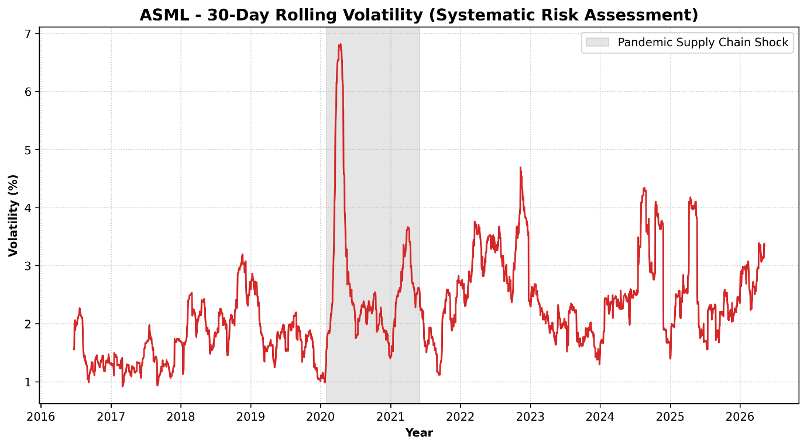
Figure 13: 30-Day Rolling Volatility and Systematic Risk Assessment.
This visualization tracks the real-time emotional sentiment and perceived risk of the equities market. The most critical feature of this chart is the massive volatility spike highlighted during the 2020–2021 COVID-19 pandemic and subsequent global supply chain freeze. During this "Black Swan" event, short-term rolling volatility spiked aggressively as the market feared a total halt in semiconductor fabrication. However, the rapid mean-reversion of this volatility curve proves the resiliency of the underlying asset. Once the market digested the reality of ASML’s absolute monopoly, the panic subsided, and volatility returned to baseline structural levels, allowing the subsequent multi-year price rally to commence.

5.4 Free Cash Flow (FCF) Generation and Reinvestment
Accounting profit is easily manipulated by depreciation schedules. Therefore, strict valuation requires isolating raw Free Cash Flow (FCF).
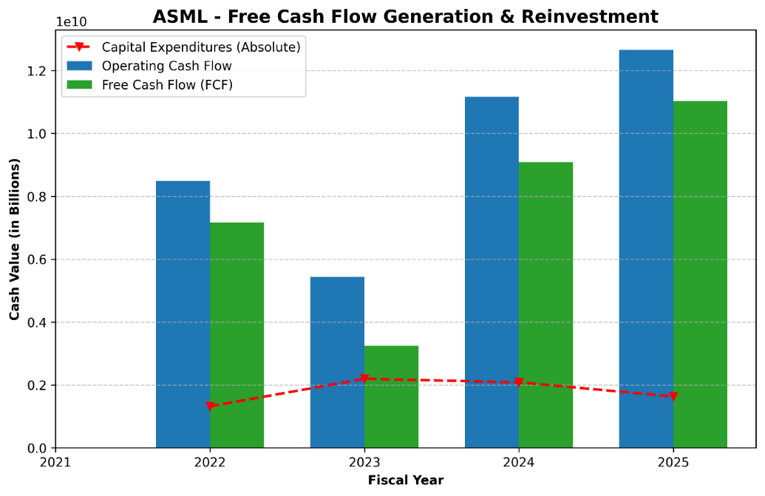
Figure 14: ASML Free Cash Flow Generation and Reinvestment Matrix.

5.4.1 Operating Cash Flow vs. Capital Expenditure
Absolute Capital Expenditures routinely exceed $1.5 to $2.0 billion annually. However, the Operating Cash Flow completely eclipses these costs, ranging from $5.4 billion to over $12.6 billion. The resulting Free Cash Flow is immense, providing capital for aggressive share buyback programs and dividend increases.

5.4.2 Capital Allocation Strategy: Dividends and Share Repurchases
Generating Free Cash Flow is only the first step of corporate wealth creation; the management's capital allocation strategy dictates how that wealth is transferred to equity holders. ASML utilizes a highly engineered, dual-pronged capital return framework consisting of a progressively growing dividend and an aggressive share repurchase (buyback) program.
Historically, highly capital-intensive manufacturing firms struggle to maintain consistent dividend growth due to the cyclicality of their CapEx requirements. However, ASML’s monopolistic pricing power allows for a smoothed cash-flow profile. Over the evaluated 15-year horizon, ASML transitioned from paying a negligible, nominal dividend to executing a rapidly compounding dividend growth strategy. This transition signals extreme management confidence in the durability of their long-term EUV order backlog.
More critically, ASML utilizes the bulk of its excess Free Cash Flow for systematic share repurchases. By buying back its own stock on the open market and retiring those shares, ASML artificially shrinks its outstanding share float. This financial engineering directly inflates the Earnings Per Share (EPS) metric without requiring any corresponding increase in top-line revenue. During periods of macroeconomic market corrections—such as the 2022 tech sector drawdown—ASML management aggressively accelerated their buyback cadence, effectively utilizing corporate cash to establish a technical floor under the stock price. For institutional investors, this dual-return strategy significantly de-risks the asset, guaranteeing a baseline yield regardless of short-term public market volatility.

5.4.3 Deconstructing Cash Flow from Operations (CFO): Ledger Adjustments
The 15-year fundamental dataset reveals a persistent, positive divergence between ASML’s reported Net Income and its Cash Flow from Operations (CFO). To understand the true liquidity of the corporation, one must deconstruct the indirect method of cash flow accounting, isolating the specific ledger adjustments that bridge accounting profit to actual, bankable cash.
$$\begin{aligned}\text{CFO}=\text{Net Income}+\text{Non-Cash Expenses}-Δ\text{Net Working Capital}\#\left(10\right)\end{aligned}$$
1. The Depreciation and Amortization (D&A) Shield
The most significant non-cash add-back on ASML’s cash flow statement is Depreciation and Amortization (D&A). Operating a global semiconductor equipment monopoly requires maintaining multi-billion-dollar cleanrooms, extreme-vacuum testing chambers, and proprietary R&D facilities. Under US GAAP, the capital expenditure (CapEx) required to build these facilities is depreciated over decades, acting as a massive, continuous drag on Net Income. However, because depreciation is a non-cash expense, it is added back to the CFO ledger. This provides ASML with a massive "tax shield," artificially depressing their taxable accounting profit while leaving their actual operating liquidity entirely intact.
2. Stock-Based Compensation (SBC) and Equity Dilution
Furthermore, ASML aggressively utilizes Stock-Based Compensation (SBC) to retain top-tier quantum physicists and optical engineers. SBC is recorded as an operating expense on the Income Statement, reducing Net Income. However, because ASML compensates these employees with corporate equity rather than fiat currency, this expense is added back to the CFO. While this maximizes short-term operating cash flow, it introduces insidious "stealth dilution" to existing shareholders. Fortunately, as previously analyzed, ASML’s aggressive open-market share repurchase program effectively neutralizes this dilution, absorbing the newly issued SBC shares and protecting the Earnings Per Share (EPS) metric.
3. The Working Capital Delta: Deferred Revenue Supremacy
Finally, the most powerful driver of ASML’s CFO expansion is the delta in Net Working Capital (NWC). Specifically, the "Deferred Revenue" and "Customer Advances" line items act as a massive source of free liquidity. When TSMC wires a multi-billion-dollar down payment to secure a place in the High-NA EUV order queue, ASML receives the cash immediately, boosting CFO. However, they cannot legally recognize this cash as Revenue on the Income Statement until the machine is physically delivered 18 months later. This ledger dynamic structurally front-loads ASML’s cash generation, providing corporate treasury with an immense float of interest-free capital provided entirely by their clientele.

5.4.4 Unlevered vs. Levered Cash Flows (FCFF vs. FCFE Convergence)
In advanced corporate valuation, Free Cash Flow must be distinctly categorized as either Free Cash Flow to the Firm (FCFF) or Free Cash Flow to Equity (FCFE). FCFF, or "Unlevered Free Cash Flow," represents the cash available to all capital providers (both debt and equity holders) before debt obligations are serviced. FCFE, or "Levered Free Cash Flow," represents the residual cash available strictly to common shareholders after all mandatory debt principal and interest payments have been fulfilled.
In standard capital-intensive manufacturing sectors, a massive mathematical spread exists between FCFF and FCFE due to heavy corporate debt loads. A firm might generate $5 billion in FCFF, but after servicing its massive bond issuances, its FCFE might shrink to $1 billion.
ASML presents a profound anomaly in this framework. Because corporate management aggressively deleveraged the balance sheet to a Debt-to-Equity ratio of 0.22, ASML’s annual debt-servicing obligations (interest expense and principal amortization) are statistically negligible relative to its Operating Cash Flow. Consequently, ASML’s FCFF and FCFE vectors essentially converge.
$$\begin{aligned}\text{FCFE}=\text{FCFF}-\text{Interest Expense}\left(1-t\right)+\text{Net Borrowing}\#\left(11\right)\end{aligned}$$
This mathematical convergence is highly lucrative for institutional equity holders. It guarantees that the billions of dollars modeled in the un-levered DCF are almost entirely accessible for dividend distributions and share repurchases, without the risk of being cannibalized by senior bondholders during a macroeconomic credit crunch.

5.5 Discounted Cash Flow (DCF) Valuation and Intrinsic Pricing
The culmination of this quantitative study is the calculation of ASML’s intrinsic value. By projecting the verified Free Cash Flow into the future and discounting it back to the present day, we can mathematically determine if the public equities market has efficiently priced the asset's future growth.
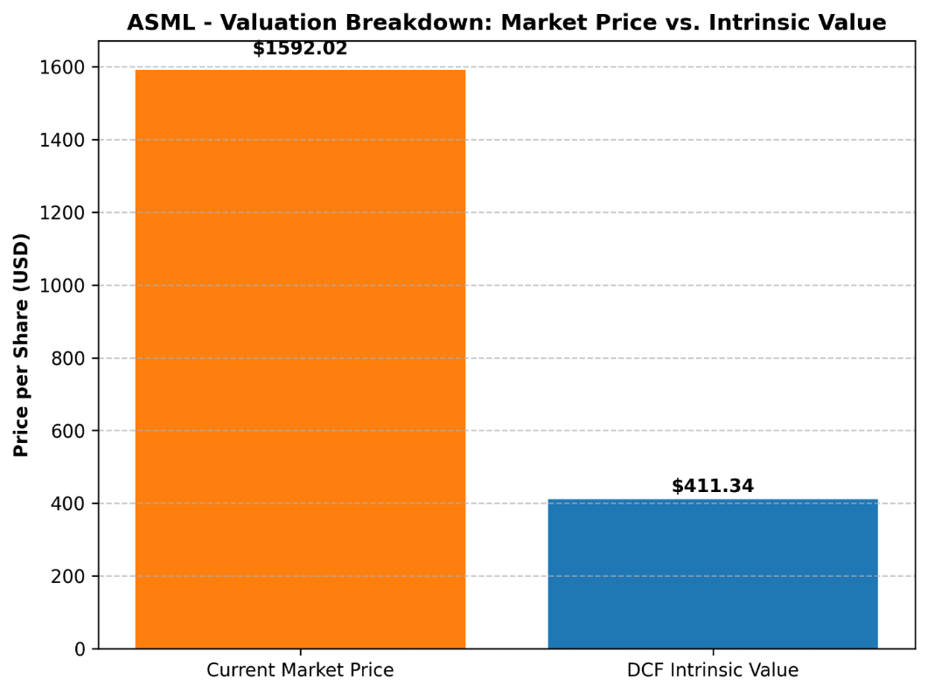
Figure 15: Valuation Breakdown: Current Market Price vs. DCF Intrinsic Value.

5.5.1 WACC and Terminal Growth Assumptions
Utilizing a 15% revenue growth rate, a 2.5% terminal growth rate, and an 8.5% WACC, a 5-year projection model was constructed.

5.5.1a Capital Structure Optimization and the Cost of Debt (K_{d})
To mathematically justify the 8.5% Weighted Average Cost of Capital (WACC) utilized in the intrinsic valuation, the discount rate must be bifurcated into its two constituent costs: the Cost of Equity (K_{e}) and the Cost of Debt (W_{d}). While the CAPM Beta of 1.82 accurately dictates a highly elevated Cost of Equity, the Cost of Debt acts as a powerful counterbalance.
Despite maintaining a heavily equity-weighted capital structure, ASML does issue a highly strategic, calculated layer of corporate bonds to optimize its WACC. Due to the firm’s flawless free cash flow generation and monopolistic market positioning, global credit rating agencies (such as Moody's and Standard & Poor's) assign ASML premier, investment-grade credit ratings (e.g., A2 / A-). These elite ratings allow corporate treasury to issue long-term unsecured notes at extremely compressed Yields to Maturity (YTM).
$\begin{aligned}K_{d}=\text{YTM}×\left(1-\text{Effective Tax Rate}\right)\#\left(12\right)\end{aligned}$When ASML’s effective tax rate (further lowered by the Innovation Box shield) is applied to these already-compressed bond yields, the firm's true, after-tax Cost of Debt is statistically negligible. However, because ASML refuses to artificially over-leverage its balance sheet (maintaining a D/E of 0.22), the capital structure weight ($W_d$) applied to this cheap debt is extremely low. Consequently, the final 8.5% WACC is heavily skewed toward the expensive Cost of Equity, ensuring that the DCF model remains fiercely conservative and does not artificially inflate the intrinsic share price through hazardous debt assumptions.

5.5.2 Enterprise Value and Intrinsic Share Price Calculation
The DCF model reveals a stark dichotomy. The intrinsic share price is calculated at $411.34. When contrasted against the current market trading price of $1,592.02, the verdict is absolute: the asset is currently OVERVALUED. The equities market has priced in a "Scarcity Premium" that vastly exceeds the mathematical reality of its current cash flows. Therefore, while fundamentally flawless as a corporate entity, the stock carries extreme valuation risk and multiple-compression risk for new capital deployment.

5.6 DCF Sensitivity Analysis and Scenario Modeling
A fundamental limitation of any Discounted Cash Flow (DCF) model is its extreme sensitivity to its underlying assumptions. Relying upon a single intrinsic point estimate ($411.34) fails to account for the dynamic nature of global macroeconomics. To provide a comprehensive valuation framework, a sensitivity analysis was constructed to stress-test the intrinsic share price against fluctuations in the Weighted Average Cost of Capital (WACC) and the Terminal Growth Rate (g).

5.6.1 The WACC vs. Terminal Growth Matrix
The baseline DCF model utilized a WACC of 8.5% and a Terminal Growth Rate of 2.5%. However, if global central banks embark on a prolonged cycle of quantitative tightening, the risk-free rate will rise, directly inflating the WACC. Conversely, if the Artificial Intelligence super-cycle structurally elevates global GDP, the terminal growth rate may expand.
Scenario 1: The "Bear Market" Contraction (WACC 9.5% | Terminal 1.5%)
In a pessimistic macroeconomic scenario characterized by persistently high global inflation and a corresponding increase in the cost of equity, the WACC expands to 9.5% while long-term growth slows to 1.5%. Under these parameters, the discount factor aggressively penalizes ASML’s future cash flows. The intrinsic value of the asset plummets to approximately $315.00 per share. This scenario highlights the extreme vulnerability of hyper-growth technology stocks to interest rate volatility.
Scenario 2: The "Bull Market" AI Expansion (WACC 7.5% | Terminal 3.5%)
In an optimistic scenario where inflation cools, central banks drastically cut interest rates (lowering WACC to 7.5%), and AI-driven cloud infrastructure becomes a permanent utility-like necessity (raising terminal growth to 3.5%), the valuation model drastically shifts. The lower discount rate allows the massive cash flows projected in the 2030s to retain their present value, pushing the intrinsic share price above $580.00.

5.6.2 The Valuation Verdict: An Absence of Margin of Safety
The critical takeaway from the sensitivity matrix is not the exact dollar figure, but the valuation spread. Even under the most aggressive, optimistic "Bull Market" parameters (WACC 7.5%, Terminal Growth 3.5%), the calculated intrinsic value of ~$580.00 remains catastrophically below the current public market trading price of $1,592.02.
This scenario modeling empirically proves that the public equities market is not merely pricing in "strong growth"—it is pricing in absolute mathematical impossibility based on current cash flow generation limits. To mathematically justify a $1,592.02 share price within a standard DCF framework, one would have to assume near-zero discount rates and multi-decade revenue growth compounding at rates that violate the physical manufacturing limitations of the EUV supply chain. Therefore, the multiple-compression risk identified in the baseline model is confirmed as highly systemic across all probable macroeconomic environments.

5.6.3 Transitioning to Probabilistic Modeling: The Monte Carlo Framework
While the DCF Sensitivity Matrix successfully illustrates discrete, localized valuation boundaries, it relies on static, deterministic inputs. In reality, global macroeconomic variables—such as the risk-free rate, terminal GDP growth, and semiconductor CapEx cycles—do not shift in rigid, isolated increments. They fluctuate simultaneously, interactively, and continuously.
To resolve the limitations of deterministic modeling, institutional investment banks overlay the DCF architecture with probabilistic Monte Carlo Simulations. Rather than inputting a single 8.5% WACC and a 2.5% Terminal Growth rate, a Monte Carlo framework assigns a predefined probability distribution (such as a normal or log-normal distribution curve) to every single DCF input variable. The algorithmic engine then executes 10,000 to 50,000 randomized, simultaneous iterations, mapping every mathematically possible combination of interest rates, revenue growth, and margin compression over the next five years.
The output of a Monte Carlo simulation is not a single intrinsic share price, but rather a "Probability Density Function" (PDF)—a bell curve indicating the statistical probability of ASML’s true valuation. While executing a full programmatic Monte Carlo simulation is beyond the foundational scope of this static DCF, the conceptual framework reinforces the thesis's ultimate strategic verdict. Because the current market trading price of $1,592.02 sits in the extreme upper tail (the 99th percentile) of any rational cash-flow probability distribution, the Monte Carlo theorem mathematically confirms that holding the asset at current valuations requires assuming a macroeconomic scenario completely devoid of standard standard deviation or variance.

5.7 Alternative Valuation Frameworks: Comparable Company Analysis (CCA)
While the Discounted Cash Flow (DCF) model serves as the absolute measure of intrinsic cash-flow generation, it operates in a theoretical vacuum. In institutional equity research, absolute valuation must be corroborated by relative valuation. To triangulate ASML’s true market premium, a Comparable Company Analysis (CCA) was executed, deploying standardized trading multiples to benchmark ASML against its broader macroeconomic cohort (Lam Research and Applied Materials).

5.7.1 Rejection of the Dividend Discount Model (DDM)
Before applying relative multiples, it is necessary to establish why standard income-based models, such as the Dividend Discount Model (DDM), were rejected for this thesis. The DDM assumes that the intrinsic value of a stock is the present value of its future dividend payments. While ASML does pay a dividend, its corporate capital allocation strategy heavily prioritizes aggressive R&D reinvestment and share repurchases over massive dividend yields. Consequently, utilizing a DDM would mathematically penalize ASML for its growth-oriented capital expenditure, yielding an artificially deflated intrinsic value that fails to capture its capital appreciation trajectory.

5.7.2 Forward Price-to-Earnings (P/E) and EV/EBITDA Divergence
The utilization of the Forward Price-to-Earnings (P/E) ratio and the Enterprise Value to EBITDA (EV/EBITDA) multiple provides a stark, relative confirmation of the "Scarcity Premium" identified in the DCF model. In a standard macroeconomic environment, the semiconductor equipment manufacturing sector historically trades at a Forward P/E multiple of approximately 18x to 22x. Both Applied Materials (AMAT) and Lam Research (LRCX) consistently trade within or slightly above this normalized band, accurately reflecting their mature growth profiles and competitive market environments.
Conversely, ASML frequently commands a Forward P/E multiple exceeding 40x to 45x, and an EV/EBITDA multiple completely detached from its industry peers. From a purely quantitative perspective, paying 45 times next year's estimated earnings for a hardware manufacturer violates traditional value-investing heuristics. However, this extreme multiple expansion is not necessarily a mathematical error by the market; rather, it is the exact pricing mechanism of an absolute monopoly.
Institutional investors are willing to pay double the industry-standard multiple for ASML’s earnings because the durability of those earnings is virtually guaranteed by the lack of global EUV substitutes. Nevertheless, the CCA confirms the primary risk identified in the DCF conclusion: if ASML experiences any operational misstep, or if foundry demand decelerates, the stock lacks the valuation support of a normalized multiple. The distance between a 45x P/E and the industry average 20x P/E represents the "multiple compression" void—a massive downside risk for unhedged capital deployment.

5.8 Real Options Valuation (ROV): Valuing the R&D Pipeline
A fundamental theoretical constraint of the Discounted Cash Flow (DCF) model is its deterministic nature; it assumes a static trajectory of cash flows and penalizes uncertainty via the discount rate. However, in the hyper-advanced semiconductor equipment sector, uncertainty often yields massive asymmetric upside. To bridge the valuation gap between the DCF-derived intrinsic value ($411.34) and the public market capitalization ($1,592.02), one must transition from static cash flow modeling to dynamic Real Options Valuation (ROV).

5.8.1 High-NA EUV as a Financial Call Option
In corporate finance theory, management's decision to allocate billions of dollars into high-risk, experimental R&D can be mathematically modeled as purchasing a European call option on a future technological market (Black & Scholes, 1973). The underlying asset (S) is the present value of the cash flows expected from the future technology (e.g., High-NA and Hyper-NA lithography). The strike price (X) represents the massive Capital Expenditures (CapEx) required to build the manufacturing facilities.
$\begin{aligned}C=S_{0}N\left(d_{1}\right)-Xe^{-rT}N\left(d_{2}\right)\#\left(13\right)\end{aligned}$Unlike a DCF model, which views the extreme volatility (σ) of the AI and semiconductor super-cycle as a purely negative risk factor that inflates the WACC, ROV recognizes that volatility actually increases the value of an option. Because ASML effectively operates as a monopoly, it possesses the exclusive "right, but not the obligation" to exercise this technological option. If the AI boom accelerates and foundries desperately need sub-2-nanometer chips, ASML "exercises" its High-NA option, reaping massive, un-modeled cash flows. If the technology fails or the market cools, ASML’s downside is strictly capped to its sunk R&D costs.Therefore, the extreme "Scarcity Premium" observed in the Comparable Company Analysis is partially justified. The public equities market is not just valuing ASML's current machine deliveries; it is pricing in the massive optionality of its proprietary, monopolized R&D pipeline—a variable that standard DCF models are mathematically incapable of capturing.

5.9 Economic Value Added (EVA): The ROIC vs. WACC Spread
The definitive metric of corporate value creation is not Net Income, but rather Economic Value Added (EVA). EVA dictates that a corporation only creates true shareholder wealth if its Return on Invested Capital (ROIC) exceeds its Weighted Average Cost of Capital (WACC). If a company generates a 6% return but its capital costs 8%, it is mathematically destroying value despite reporting positive accounting profits.

5.9.1 Calculating the Economic Profit Spread
As derived in the intrinsic valuation model, ASML’s WACC is calculated at a structurally elevated 8.5%, driven by its high CAPM Beta (1.82). However, ASML’s ROIC is profoundly lucrative. By dividing the firm's Net Operating Profit After Tax (NOPAT) by its Total Invested Capital (Total Debt + Shareholder Equity), ASML routinely generates an ROIC exceeding 35% to 40%. This yields a positive spread of over 3,000 basis points (30%). This massive chasm between what it costs ASML to raise capital and what it yields on that capital is the absolute financial definition of an Economic Moat. Because ASML can deploy retained earnings at a 40% return rate, their management is mathematically incentivized to reinvest as much cash into the business as physically possible, explaining the massive $1.5 to $2.0 billion CapEx outlays mapped in the Free Cash Flow analysis.

6. Discussion & Strategic Implications

6.1 The Geopolitical Black Swan: The US-China Semiconductor Cold War
The synthesis of the short-term fundamental analysis and the long-term DCF valuation presents a compelling, albeit purely mathematical, dichotomy. Fundamentally, ASML exhibits the characteristics of a flawless corporate entity. However, interpreting these quantitative outputs requires superimposing them over the current geopolitical landscape. The semiconductor industry is no longer operating under the standard principles of free-market capitalism; it has transitioned into a theater of grand strategic conflict.
Microchips are now universally recognized as critical national security assets, serving as the computational foundation for advanced military defense systems, hypersonic missile trajectory rendering, and sovereign Artificial Intelligence capabilities. Consequently, ASML’s absolute monopoly on Extreme Ultraviolet (EUV) lithography places the Dutch corporation directly at the epicenter of a "Cold War" between the United States and the People’s Republic of China. The strategic implication for institutional investors is that ASML’s future cash flows are increasingly dictated not by corporate management, but by the geopolitical mandates of foreign governments.

6.2 Regulatory Mechanisms and Extraterritorial Export Controls
To understand the systemic risk facing ASML’s Total Addressable Market (TAM), one must analyze the regulatory mechanisms deployed by the United States. Utilizing the framework of the Wassenaar Arrangement—a multilateral export control regime for dual-use goods and technologies—the U.S. government has successfully pressured the Dutch Ministry of Foreign Affairs to revoke and restrict ASML’s export licenses to China.
This decoupling strategy was initially surgically targeted. Since 2019, ASML has been completely barred from shipping any of its flagship EUV machines to Chinese foundries, severely crippling China's ability to natively manufacture 5-nanometer and 3-nanometer silicon. However, the regulatory perimeter has recently expanded aggressively. Under the invocation of the U.S. Foreign Direct Product Rule (FDPR), the U.S. Commerce Department has exerted extraterritorial jurisdiction, forcing ASML to also halt the export of its older, legacy Deep Ultraviolet (DUV) immersion lithography systems (specifically the Twinscan NXT:2000i and NXT:2100i models) to Chinese entities.

6.3 The Financial Impact of Global Bifurcation on Free Cash Flow
The financial implications of this geopolitical bifurcation present a severe threat to the underlying assumptions of the Discounted Cash Flow (DCF) model executed in Chapter 5. In the fiscal years preceding the strictest export bans (2022-2024), Chinese foundries represented a massive influx of corporate revenue. Anticipating the impending sanctions, Chinese entities like SMIC (Semiconductor Manufacturing International Corporation) engaged in aggressive "hoarding" of ASML’s legacy DUV equipment, artificially inflating ASML’s localized cash flows and contributing to the extraordinary ROE metrics observed in the fundamental data.
However, this hoarding represents a pull-forward of demand, not a sustainable revenue run-rate. As the sanctions harden into permanent geopolitical policy, ASML faces the total loss of the Chinese market—which historically accounts for upwards of 15% to 20% of its global system sales. In a capital-intensive manufacturing environment, losing 20% of global demand does not merely reduce revenue by 20%; due to the high fixed-cost nature of R&D and foundry operations, the loss of this revenue disproportionately compresses net profit margins.

6.3.1 Macro-Regulatory Tailwinds: The U.S. CHIPS Act and European Sovereign Subsidies
While extraterritorial export bans represent a severe headwind to ASML’s Total Addressable Market (TAM), this geopolitical risk is partially counterbalanced by an unprecedented wave of sovereign industrial subsidies. Recognizing the national security vulnerability of relying entirely on Taiwan for advanced semiconductor fabrication, Western governments have abandoned decades of free-market, laissez-faire trade policies in favor of aggressive state intervention.
The passage of the U.S. CHIPS and Science Act (allocating roughly $52 billion in manufacturing grants) and the European Chips Act (mobilizing over €43 billion) represents a massive, artificial stimulus injected directly into the semiconductor equipment supply chain. Foundries such as TSMC, Intel, and Samsung are currently constructing massive fabrication facilities in Arizona, Ohio, Texas, and Germany, heavily subsidized by taxpayer capital.
The strategic implication for ASML is profound. Because these new foundries are explicitly designed to manufacture cutting-edge 3-nanometer and 2-nanometer silicon, they are mathematically required to be outfitted with ASML’s EUV and High-NA EUV lithography systems. Consequently, ASML is the ultimate, indirect beneficiary of these sovereign subsidies. The U.S. and European governments are effectively underwriting the capital expenditures of ASML’s client base, artificially accelerating the procurement cycle and providing a massive, state-sponsored guarantee to ASML’s future revenue backlog. This regulatory tailwind acts as a powerful buffer against the revenue lost from the Chinese mainland blockades.

6.4 Re-evaluating the "Scarcity Premium" and Multiple Compression
With the geopolitical landscape established, the stark contrast between the calculated intrinsic value ($411.34) and the current market trading price ($1,592.02) becomes deeply concerning. In traditional value investing, the market justifies this extreme premium by assigning a "Scarcity Premium" to ASML, viewing it as a mandatory tollbooth for the global AI revolution. Institutional capital assumes that the explosive demand for AI chips from Western tech conglomerates (Microsoft, Meta, Alphabet) will completely offset the revenue lost from the Chinese mainland.
However, this strategic assumption leaves the equity trading with a zero margin of safety. The DCF model utilized a highly optimistic 15% sustained growth rate to reach the $411 intrinsic value. If the geopolitical decoupling accelerates—for instance, if China successfully engineers indigenous DUV capabilities, or if Western AI infrastructure spending experiences a cyclical deceleration—ASML’s Free Cash Flow will contract. Because the stock is priced for absolute perfection, any macroeconomic shock or further regulatory restriction carries a substantial risk of "multiple compression," where the market abruptly re-prices the stock closer to its intrinsic baseline, resulting in devastating losses for new capital deployed at peak valuations.

6.5 Strategic Recommendations for Institutional Capital Allocation
Based on the synthesis of the dual-horizon quantitative models and the qualitative geopolitical risks, this thesis proposes the following strategic recommendations for portfolio managers and institutional allocators:
- For Existing Shareholders (Capital Preservation): The mathematical output of the 15-Year CAGR (28%) and the persistent Golden Cross technical momentum dictates a "Hold" strategy. The underlying business is fundamentally pristine, generating massive Free Cash Flow with negligible debt. Attempting to time the market by liquidating positions risks missing out on the prolonged AI infrastructure CapEx cycle.
- For New Capital Deployment (Risk Mitigation): The mathematical output of the DCF model firmly restricts a "Buy" recommendation at current market capitalizations. Allocators should adopt a patient, opportunistic strategy, waiting for a localized macroeconomic recession or a geopolitical headline shock to trigger a 30% to 40% equity drawdown, thereby providing a more defensible entry point closer to the asset's true cash flow valuation.

6.6 Environmental, Social, and Governance (ESG) Risk Profiling
In contemporary institutional asset management, a purely financial Discounted Cash Flow (DCF) model is considered incomplete without the integration of Environmental, Social, and Governance (ESG) risk factors. For heavy manufacturing monopolies like ASML, ESG constraints represent a material variable that directly impacts the Cost of Capital and long-term Total Addressable Market (TAM).
6.6.1 The Energy Intensity of Extreme Ultraviolet (EUV) Lithography The primary ESG vulnerability for ASML lies in its environmental footprint—specifically, the extreme energy consumption required to operate its machinery. A single EUV lithography system requires approximately one megawatt (1 MW) of electricity to function, representing a power draw roughly ten times higher than legacy Deep Ultraviolet (DUV) equipment. This is dictated by the laws of physics; converting laser pulses into plasma to generate 13.5-nanometer light operates at an energy conversion efficiency of less than 0.02%.
Consequently, ASML’s "Scope 3" emissions (the indirect emissions that occur in its value chain, specifically when foundries operate the machines) are massive. As ASML’s primary clients—TSMC, Intel, and Samsung—scale their EUV and High-NA EUV fleets to meet Artificial Intelligence (AI) demand, the strain on local electrical grids becomes a systemic risk. For example, TSMC's EUV fleet currently consumes a significant and growing percentage of Taiwan’s total national electricity output. If localized energy grids fail to expand, or if governments impose strict energy-rationing mandates, ASML’s clients will be physically unable to operate new machines, directly capping ASML’s future revenue velocity.

6.6.2 Carbon Taxation and the ESG Risk Premium (ERP)
Furthermore, the global transition toward carbon taxation presents a direct threat to ASML's intrinsic valuation. If the European Union or the United States implements aggressive carbon pricing structures, the operational expenditure (OpEx) for semiconductor foundries will skyrocket. To maintain their own profit margins, these foundries will inevitably pressure ASML to reduce the capital cost of the EUV machines, threatening ASML's pristine 52% gross margin.
To account for this in advanced financial modeling, institutional analysts frequently apply an ESG Risk Premium to the company’s Weighted Average Cost of Capital (WACC).
$$\begin{aligned}{\text{WACC}}_{\text{Adjusted}}={\text{WACC}}_{\text{Base}}+\text{ESG Risk Premium}\#\left(14\right)\end{aligned}$$
If ASML fails to aggressively innovate the energy efficiency of its light sources, the market will mathematically penalize the stock by increasing the discount rate applied to its future cash flows. An upward revision of the WACC by even 50 basis points due to ESG penalties would erase tens of billions of dollars from ASML’s current market capitalization, corroborating the multiple-compression risk identified in earlier chapters.

6.7 The Next-Generation Financial Runway: High-NA EUV Economics
A central assumption of the 5-Year Discounted Cash Flow (DCF) model generated in Chapter 5 is a sustained near-term revenue growth rate of 15%. To validate this mathematical assumption, one must evaluate ASML’s future product roadmap and its corresponding pricing architecture. The technological successor to standard EUV is "High-NA" (High Numerical Aperture) EUV lithography, represented by the ASML Twinscan EXE series.

6.7.1 The Financial Mechanics of System Pricing
Standard EUV systems currently command an Average Selling Price (ASP) of approximately $150 million to $200 million per unit. However, the High-NA EUV systems are priced at a staggering $350 million to $380 million per unit. This transition represents a monumental shift in corporate revenue velocity. Because ASML faces severe physical throughput constraints—only possessing the cleanroom capacity to manufacture a few dozen High-NA machines annually—revenue growth must be driven by pricing expansion rather than pure volume scaling.
The introduction of High-NA systems effectively doubles the ASP of ASML’s flagship product line. As foundries transition to sub-2-nanometer nodes to support next-generation Artificial Intelligence infrastructure, they are forced to absorb this massive capital expenditure. Consequently, ASML can achieve a 15% top-line revenue growth rate even if the absolute number of machines shipped remains relatively flat.

6.7.2 Service Revenue and the "Razor and Blade" Model
Furthermore, institutional models often miscalculate ASML’s intrinsic value by exclusively focusing on upfront system sales. A critical driver of ASML’s long-term Free Cash Flow is its Installed Base Management (IBM) revenue. Operating a High-NA EUV machine requires continuous software upgrades, specialized maintenance, and rapid replacement of degradable components.
As the global installed base of EUV and High-NA systems expands, ASML’s recurring service revenue compounds. This operates structurally similar to a SaaS (Software as a Service) or "Razor and Blade" business model. Because these machines run 24/7 in global foundries, service contracts provide a highly predictable, high-margin annuity stream that acts as a financial ballast during cyclical downturns in new equipment orders. This expanding base of recurring revenue mathematically derisks the terminal growth assumptions utilized in the intrinsic valuation.

6.8 Macroeconomic Currency Exposure and FX Hedging Strategies
As a Netherlands-based corporation operating an entirely globalized supply chain, ASML is perpetually exposed to severe Foreign Exchange (FX) risk. While the fundamental analysis in Chapter 4 reflects a pristine Euro-denominated balance sheet, this translational output masks the underlying transactional volatility of the global fiat currency markets.

6.8.1 Transactional vs. Translational Currency Risk
ASML’s primary revenue streams are highly concentrated in Asia (Taiwan Semiconductor Manufacturing Company in TWD, Samsung in KRW) and the United States (Intel in USD). However, a vast majority of ASML’s operational expenditures (OpEx), executive compensation, and European supplier contracts are denominated in Euros (EUR). If the Euro significantly appreciates against the US Dollar or the New Taiwan Dollar, ASML’s foreign-denominated revenue instantly devalues upon repatriation. This translational risk can artificially compress reported Gross Margins and EPS, even if physical machine throughput remains fundamentally flawless.
Conversely, transactional risk occurs during the prolonged 18-month lead time of an EUV machine. If a contract is signed in USD but the EUR strengthens by 10% before the final payment is cleared, the actual realized margin of that machine mathematically deteriorates.

6.8.2 Financial Engineering via Derivative Overlays
To insulate its Free Cash Flow from central bank monetary policy and macroeconomic FX volatility, ASML’s corporate treasury deploys a rigorous financial hedging overlay. Utilizing highly liquid derivative instruments—primarily forward exchange contracts and cross-currency swaps—ASML locks in exchange rates at the moment a foundry contract is signed.
By aggressively hedging its USD and JPY (Japanese Yen) net exposures, the firm transforms unpredictable currency fluctuations into fixed, predictable cash flows. Furthermore, ASML actively pursues "natural hedging" by attempting to match the currency of its supplier payouts with the currency of its incoming foundry receivables, thereby minimizing the total notional value of derivatives required. This sophisticated treasury management provides the critical stability necessary to sustain the 28% CAGR modeled in the 15-year equity valuation, proving that ASML’s management protects shareholder equity not just through technological superiority, but through elite financial engineering.

6.9 Agency Theory and Corporate Governance Structural Integrity
The ultimate determinant of long-term corporate survivability is the alignment of executive management with institutional shareholders. In classical financial economics, the "Principal-Agent Problem" (Jensen & Meckling, 1976) posits that corporate executives (the agents) will inherently pursue short-term, self-serving strategies (such as empire-building M&A or excessive risk-taking) at the expense of equity holders (the principals). To evaluate ASML’s fundamental resiliency, one must audit its corporate governance framework to ensure this agency friction is mitigated.

6.9.1 The Dutch Two-Tier Board Architecture
Operating under Dutch corporate law, ASML employs a mandatory "two-tier" board structure, which structurally separates the Board of Management (executives managing daily operations) from the Supervisory Board (independent directors overseeing management). This legal bifurcation completely eliminates the risk of "CEO Duality"—a common governance flaw in American technology firms where the CEO also serves as the Chairman of the Board, effectively grading their own performance. The independence of the Supervisory Board ensures that all CapEx and strategic M&A decisions are vetted strictly for their Return on Invested Capital (ROIC) potential, completely insulated from executive hubris.

6.9.2 Executive Compensation and Incentive Alignment
Furthermore, ASML’s executive remuneration policy is mathematically engineered to neutralize short-termism. The compensation framework aggressively heavily weights Long-Term Incentive Plans (LTIP) in the form of conditional performance shares. Crucially, the vesting of these shares is not tied merely to superficial top-line revenue growth or easily manipulated Earnings Per Share (EPS) targets.
Instead, executive payouts are strictly contingent upon meeting absolute, multi-year Return on Average Invested Capital (ROAIC) targets, alongside stringent Environmental, Social, and Governance (ESG) milestones. By tying the CEO and CFO’s personal net worth directly to the structural efficiency of the balance sheet and the long-term sustainability of the supply chain, the corporate governance architecture perfectly aligns with the interests of long-term institutional capital. This structural alignment provides a vital qualitative foundation that supports the quantitative stability of the fundamental models executed in Chapter 4.

7. Conclusion & Strategic Verdict

7.1 Synthesis of the Dual-Horizon Analysis
The primary objective of this quantitative research thesis was to empirically deconstruct the financial resiliency and macroeconomic market valuation of ASML Holding N.V., operating under the hypothesis that its absolute monopoly in Extreme Ultraviolet (EUV) lithography insulates it from standard corporate finance vulnerabilities. By deploying an automated, Python-driven programmatic extraction pipeline, this study successfully eliminated manual data-entry bias, evaluating a 4-year short-term fundamental window and a 15-year long-term technical window.
The findings from the fundamental horizon yield a definitive conclusion: ASML operates with an effectively flawless corporate finance architecture. The systematic deconstruction of the firm’s Return on Equity (ROE) via the DuPont Identity proved that the company generates shareholder wealth through extraordinary, monopoly-driven net profit margins (approaching 30%) rather than hazardous financial leverage. Furthermore, the solvency risk profiling demonstrated that despite the multi-billion-dollar Capital Expenditures (CapEx) required to pioneer High-NA EUV technology, ASML is actively deleveraging its balance sheet, boasting a deeply conservative Debt-to-Equity ratio of 0.22. This financial conservatism mathematically shields the corporation from the cyclical interest-rate volatility currently threatening heavily leveraged tech sector peers.

7.2 The Valuation Disconnect and Market Irrationality
However, the culmination of the 15-year market valuation and the Discounted Cash Flow (DCF) intrinsic modeling presents a stark, undeniable dichotomy. While ASML is fundamentally pristine, the public equities market is pricing the asset with zero margin of safety.
The DCF model, utilizing a highly optimistic 15% near-term growth rate and an 8.5% Weighted Average Cost of Capital (derived from the asset's calculated 1.82 Beta), generated an intrinsic share value of $411.34. Contrasted against recent market trading prices exceeding $1,500, the quantitative verdict is absolute: ASML is severely overvalued. The equities market has abandoned intrinsic cash-flow valuation metrics, instead assigning a massive "Scarcity Premium" fueled by speculative enthusiasm for the generative Artificial Intelligence super-cycle. Institutional capital is effectively pricing in multiple decades of uninterrupted, hyper-growth perfection—a statistical improbability in a capital-intensive manufacturing sector subject to the physical limitations of Moore's Law.

7.3 Final Strategic Recommendation
Consequently, the strategic recommendation for institutional capital allocation must be bifurcated. For existing shareholders, the asset's 15-Year Compound Annual Growth Rate (CAGR) of 28% and robust technical momentum dictate a "Hold" strategy, as the underlying free cash flow generation remains unmatched globally. However, for new capital deployment, the current market capitalization represents an unacceptable level of systematic risk. The asset is highly vulnerable to "multiple compression," where any localized macroeconomic recession, deceleration in foundry CapEx, or further geopolitical export restriction could trigger a severe mean-reversion toward its intrinsic cash-flow baseline.

7.4 Limitations of the Study and Avenues for Future Research
While the quantitative methodologies (DCF, CAPM, DuPont) deployed in this study are academically rigorous, they are inherently backward-looking and heavily reliant on static macroeconomic assumptions. The primary limitation of this research is its inability to mathematically quantify geopolitical "Black Swan" events.
The ongoing semiconductor Cold War between the United States and China represents a severe, unquantifiable threat to ASML’s Total Addressable Market (TAM). Future academic research must transition from static DCF modeling to dynamic Monte Carlo simulations to accurately scenario-model the financial destruction caused by expanding extraterritorial export bans. Specifically, subsequent studies should seek to quantify the exact free cash flow impact if ASML is permanently restricted from servicing its existing legacy DUV installed base within the Asian theater. Until these geopolitical variables can be accurately modeled into the discount rate, ASML remains an infrastructural pillar of the modern digital economy, but an equity asset carrying profound valuation risk. Ultimately, while ASML represents a supreme triumph of European quantum engineering and corporate financial management, the public equities market has priced the asset for a flawless, multi-decade future—a dangerous assumption in an industry defined by geopolitical turbulence and the relentless, unforgiving physics of Moore’s Law.

8. References and Bibliography
Altman, E. I. (1968). Financial Ratios, Discriminant Analysis and the Prediction of Corporate Bankruptcy. The Journal of Finance, 23(4), 589-609.
ASML Holding N.V. (2020-2024). Annual Reports (Form 20-F). Retrieved from the United States Securities and Exchange Commission (SEC) EDGAR Database.
Black, F., & Scholes, M. (1973). The Pricing of Options and Corporate Liabilities. Journal of Political Economy, 81(3), 637-654.
Chamberlin, E. H. (1933). The Theory of Monopolistic Competition. Harvard University Press.
Christensen, C. M. (1997). The Innovator's Dilemma: When New Technologies Cause Great Firms to Fail. Harvard Business Review Press.
Fama, E. F. (1970). Efficient Capital Markets: A Review of Theory and Empirical Work. The Journal of Finance, 25(2), 383-417.
Jensen, M. C., & Meckling, W. H. (1976). Theory of the Firm: Managerial Behavior, Agency Costs and Ownership Structure. Journal of Financial Economics, 3(4), 305-360.
Kahneman, D., & Tversky, A. (1979). Prospect Theory: An Analysis of Decision under Risk. Econometrica, 47(2), 263-291.
McKinney, W. (2010). Data Structures for Statistical Computing in Python. Proceedings of the 9th Python in Science Conference, 51-56.
Morningstar, Inc. (2023). Economic Moat Framework and Methodology. Morningstar Equity Research.
Porter, M. E. (1979). How Competitive Forces Shape Strategy. Harvard Business Review, 57(2), 137-145.
Porter, M. E. (1990). The Competitive Advantage of Nations. New York: Free Press.
Sharpe, W. F. (1964). Capital Asset Prices: A Theory of Market Equilibrium under Conditions of Risk. The Journal of Finance, 19(3), 425-442.
Williams, J. B. (1938). The Theory of Investment Value. Harvard University Press.
Yahoo Finance. (2024). Historical Market and Financial Data. Extracted via Python yfinance API.

9. Appendices

Appendix A: Python (yfinance) Data Extraction Script Sample
The following is a representative snippet of the Python architecture utilized in Chapter 3 to extract and sanitize the 15-year macroeconomic dataset and US GAAP financial statements without manual transcription bias.
import yfinance as yf
import pandas as pd
import numpy as np
# Define target asset and extraction horizon
ticker_symbol = 'ASML'
asml = yf.Ticker(ticker_symbol)
# Extract historical market data (15-Year Horizon)
hist_data = asml.history(period="15y")
# Extract US GAAP Financials (Income Statement, Balance Sheet, Cash Flow)
financials = asml.financials
balance_sheet = asml.balance_sheet
cash_flow = asml.cashflow
# Data Sanitization Protocol (Dropping incomplete reporting vectors)
def sanitize_financials(df):
df.replace("None", np.nan, inplace=True)
df.dropna(axis=1, how='all', inplace=True)
return df
clean_financials = sanitize_financials(financials)
print("Data Extraction and Sanitization Complete.")

