BufferedReader br = new BufferedReader(new InputStreamReader(System.in));
String line = br.readLine();
System.out.println(line);

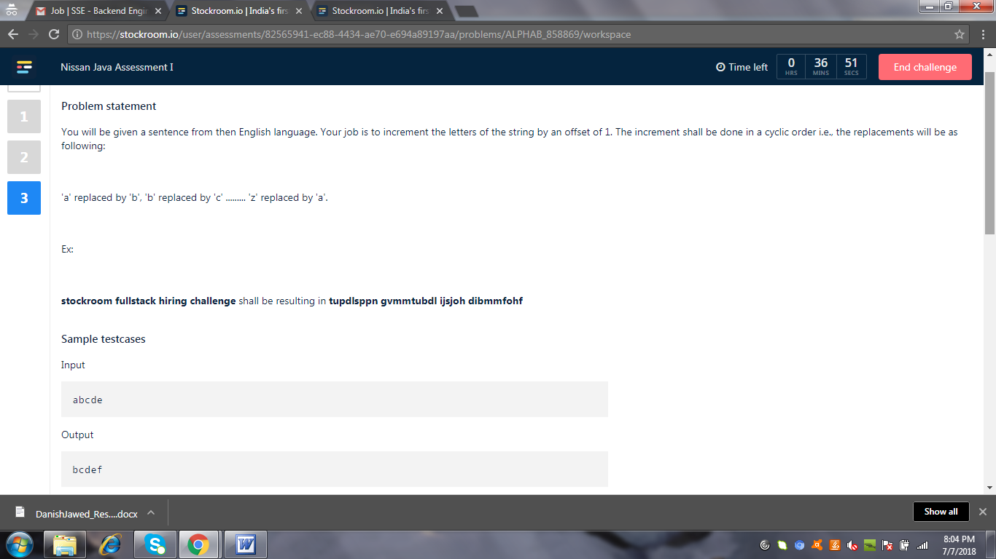

2.
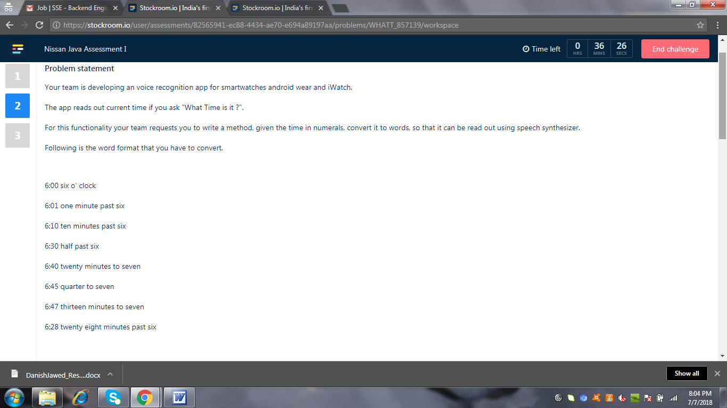
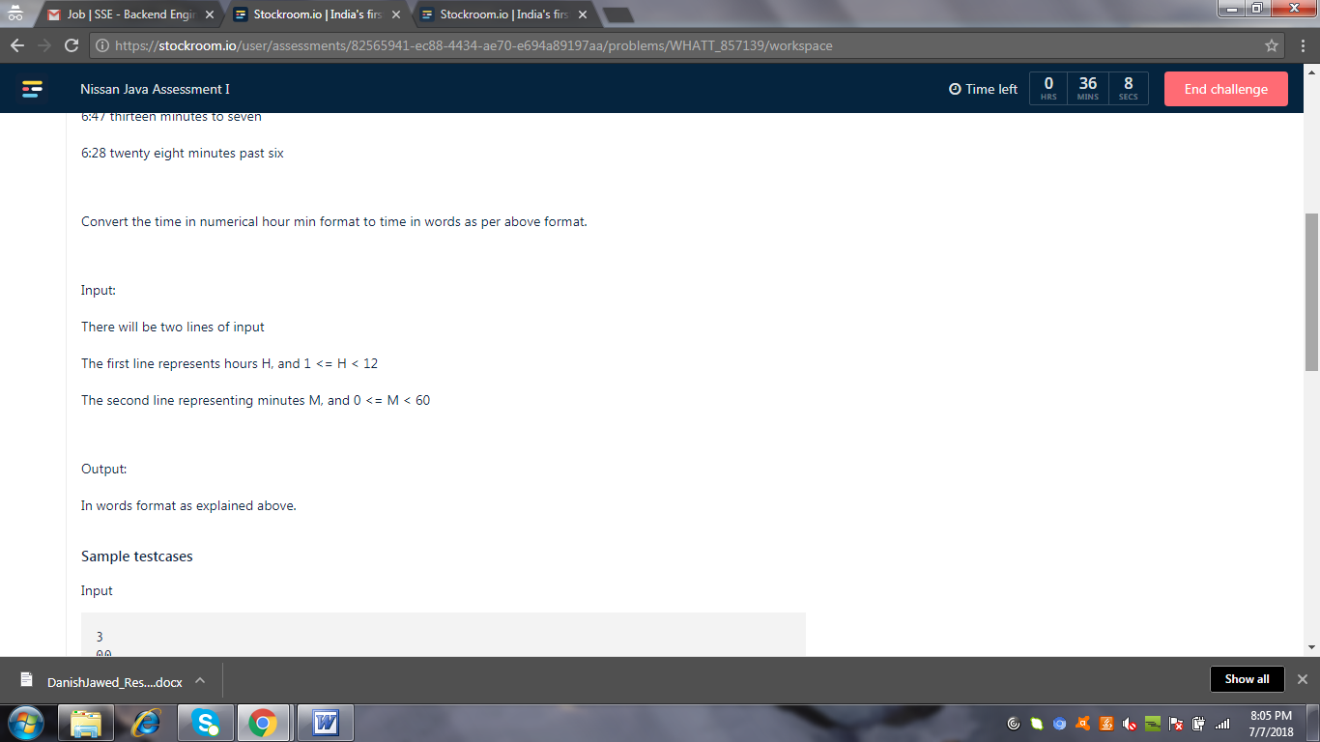

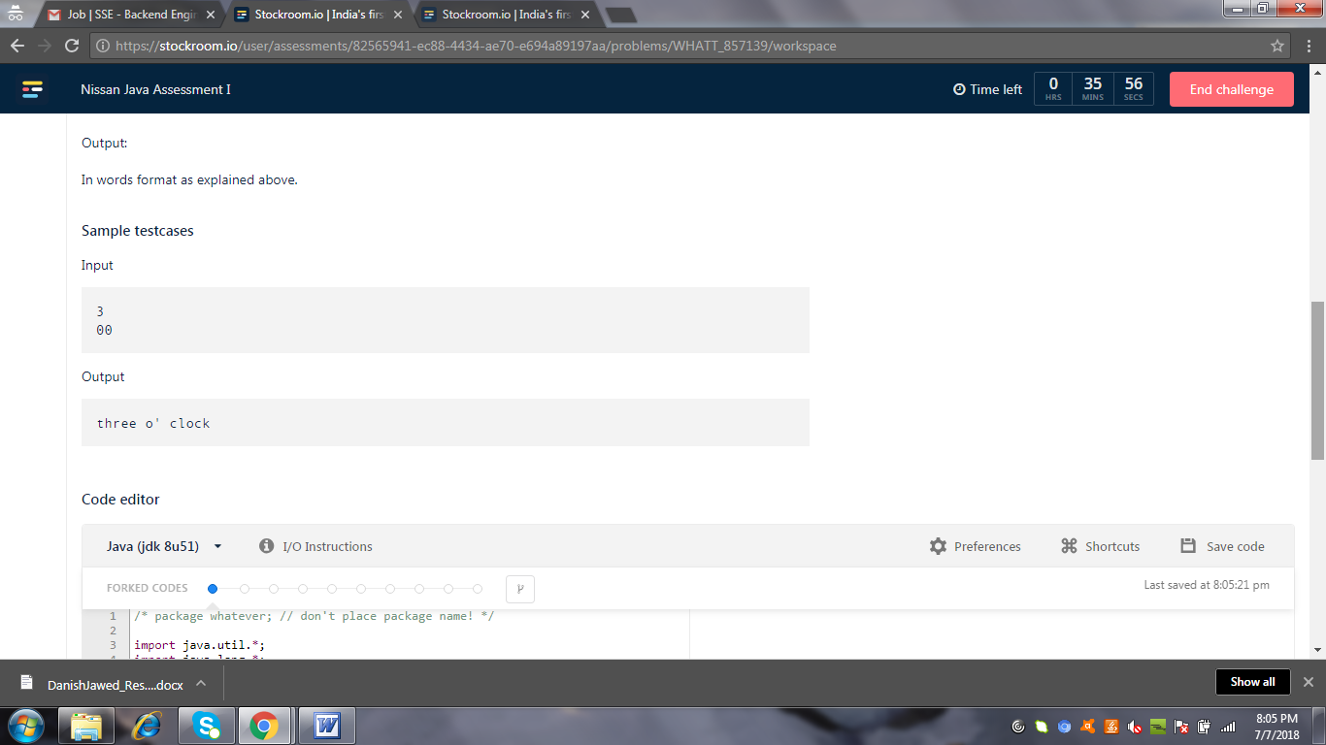

BufferedReader br = new BufferedReader(new InputStreamReader(System.in));
String line;
int count=0;
int N1=0;
int N2=0;
while( (line = br.readLine() ) != null) {
if(count==0)
N1 = Integer.parseInt(line);
else
N2 = Integer.parseInt(line);
count++;
}
System.out.println(N1);
System.out.println(N2);
System.out.println(count);

3.
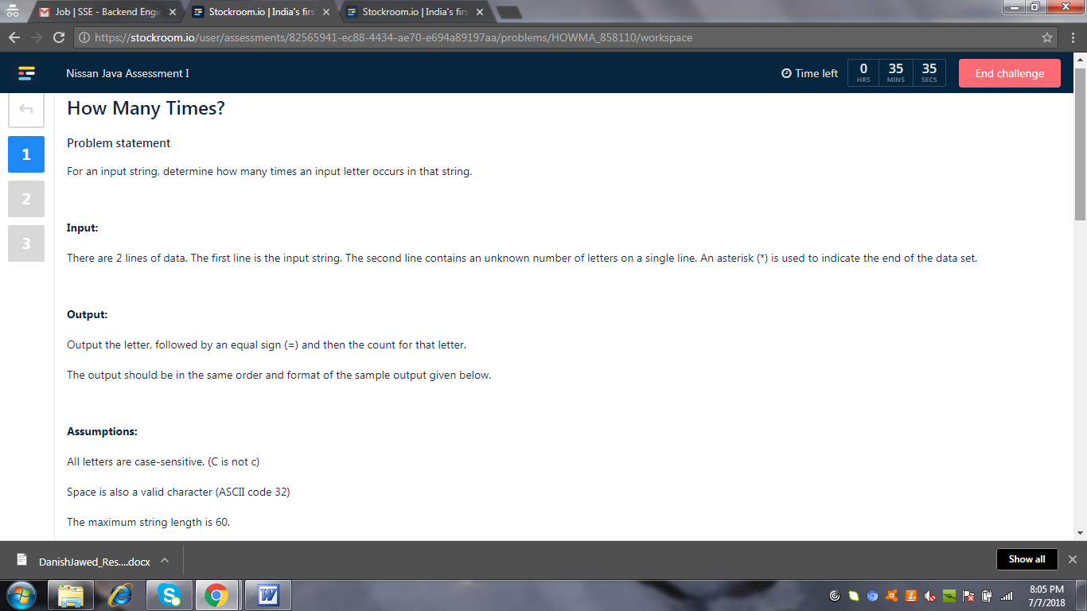

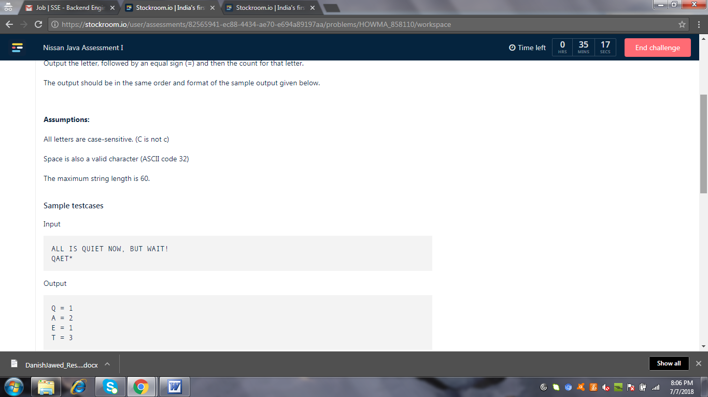

String s1="";
String s2="";
int count=0;
BufferedReader br = new BufferedReader(new InputStreamReader(System.in));
String line;
while( (line = br.readLine() ) != null) {
if(count==0)
s1 = line;
else
s2 = line;
count++;
}
System.out.println(s1);
System.out.println(s2);

for(int i = 0; i < s2.length(); i++){

}

