# Bot for Bank

This project will be built using artificial intelligence that analyze the customer query and understand the user query and will response the relevance message. Customer can ask any bank related question like loan, account, interest rate etc. Customer can ask question in any format but strongly in **English Language.**  This project will help to bakers to response the customer in busy schedule.

# Workflow

1. Customer will send the query
2. System will receive the query and remove all the stop words
3. Steaming will be done in the system after removing the stop words
4. After steaming it will perform the spellcheck.
5. Match the words with the tags in the database
6. Response the message which matches the tag.

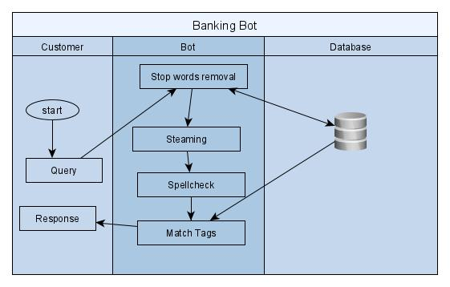

*Fig: Activity Diagram for Banking Bot*