**1.1 Computer Network**

Network is the collection of computer, software and hardware that are all connected to each other to help their work together. A network connects computers by means of cabling system (or wireless media), specialized software and devices that manage data traffic. A network enables users to share files and resources such as printer as well as send message electrically to each other.

Computer network falls under two types

1. Client server network
2. P2P (peer-to-peer) network

* **Client Server Network**

Each client is assigned as account name and password that is verified by an authentication service. The authentication service guards access to the network. With the centralization of user accounts, security and access control, server based networks simplify the administration of large network.

The concentration of network resources such as files, printers and applications on servers also makes it easier to backup and maintain the data. Resource can be located on specialized dedicated servers for easier access.

Advantages

* Easier to administer when the network is large.
* All data can be backed up on one central location.

Disadvantages

* Requires expensive, more powerful hardware for the server machines.
* Has a single point of failure user data is unavailable when the server is down.
* Requires expensive specialized network administrative and operational software.
* Requires a professional administrator.
* **Peer-to-Peer Network**

Network computers act as equal partners, or peers. Each computer can take on the client function or the server function.

Suppose computer A may request for a file from computer B, which then sends file to computer A. In this case, computer A acts like the client and computer B as server.

At a later time, their role may be reserved; individual users control their own resources.

The users may decide to share certain files with other users. The users may also require passwords before they allow others to access their resources. Since individual users make these decisions, there is no central point of control or administration in the network.

When a computer acts as a server, the user of that machine may experience reduced performance as the machine server the requests made by other system.

Advantages

* Less expensive to implement.
* Doesn’t require additional specialized network administration software.
* Doesn’t require a dedicated network administrator.

Disadvantages

* Less secure.
* Doesn’t scale well to large networks, and administration becomes unmanageable.
* Each must be trained to perform administrative tasks.
* All machines sharing resources negatively impact the performance.

**Advantages and Disadvantages of Computer Network**

* **Advantages**

1. **File Sharing**

The major advantage of a computer network is that it allows file sharing and remote file access. A person sitting at one work station that is connected to a network can easily see files present on another workstation provided he/she is authorized to do so.

If the files are stored on server and all of its clients share that storage capacity, then it becomes easier to make a file available to multiple users.

1. **Resource Sharing**

For example, if there are twelve examples in an organization, each having their own computers, they will require twelve modems and twelve printers if they go to use resources at the same time. A computer network on the other hand provides cheaper alternative by the provision of resources sharing. All computers can be interconnected using a network and just one modem and printer can efficiently provides the services to all twelve users.

1. **Inexpensive Set-Up**

Shared resources mean reduction in hardware costs. Shared files means reduction in memory requirements, which indirectly means reduction in file storage expenses.

1. **Flexible Handling**

A user can log on to the computer anywhere on the network and access his/her files. This offers flexibility to the user as to where he/she should be during the course of his/her routine.

1. **Increased Storage Capacity**

A standalone computer might fall short of storage memory, but when many computers are on a network the memory of different computers can be used in such a case.

* **Disadvantages**

1. **Security**

If a computer is on a network, a hacker can get unauthorized access by using different tools. In case of big organizations, various security software need to be used to prevent theft of any confidential and classified data.

1. **Virus Attack**

If even one computer on a network gets affected by a virus, there is a possible threat for the other systems getting affected too. Viruses can spread on a network easily, because of inter-connectivity of workstations.

1. **Lack Of Robustness**

If the main file server of computer network breaks down, the entire system becomes useless.

1. **Need Of Expert Handler**

The technical skills and know-how required to operate and administer a computer network is considerably high.

1. **Lack Of Independence**

Since most computers have a centralized server and dependent clients, the clients/users lack any freedom whatsoever.

**Network Edge**

* **End System**
* End system are also referred to as host because they host (ie, run) application program such as a web browser program, a web server program, an email reader program.
* Host are further divided into two categories:
* Clients
* Servers
* Informally, clients tend to be desktop and mobile pc’s and so on, whereas servers tend to be more powerful machine that stores and distribute web pages, stream video so on.
* **Clients and Servers**
* A client is a program running on one end system that requests and receive a service from a server running on other end system.
* Not all internet applications are client-server model; they are also peer-to-peer model like Bit Torrent and eMute.

**Network Core**

* It means the approach to moving data through a network of links and switches.
* There are two types:
* Circuit Switching
* Packet Switching
* In **circuit switched network**, the resources needed along a path (buffer, link transmission rate) to provide for communication between the end systems are reserved for the duration of the communication session between the end systems.
* It reserves a constant transmission rate in the network’s links for the duration of the communication. Since bandwidth has been reserved for this sender-to-receiver. Connection, the sender can transfer the data to the receiver at the guaranteed constant rate.
* In **packed switched network**, the resources are not reserved for a sessions message use the resources on demand, and as a consequence may have to wait (i.e. queue) for access to a communication link.
* The packet is sent into the network without reserving and bandwidth if one of the links is busy because other packets need to be transmitted over the link at the same time, our packet will have to wait in a buffer at the sending side of the transmission link, and suffer a delay.

There are two approaches in packet switched network

1. **Datagram Network**

* Any network that forwards the packets according to the destination address is called a datagram network.
* The routers in the internet forwards packets according to the destination address. Hence, internet is datagram network.

1. **Virtual Circuit Network**

* Any network that forwards the packets according to virtual circuit identifier (fixed route) is called a virtual circuit network.
* Preplanned route established before packets sent.
* Examples are X25, Frame relay, ATM technologies.

**Network Access**

1. Dial-Up

* Accessing the internet over ordinary analog telephone lines using a dial-up modem.
* The term “dial-up” is used because the user software actually dials an ISP’s phone number and makes a traditional phone connection with the ISP.
* Two major drawbacks:
* Extremely slow, maximum 50 kbps.
* Cannot use phone line while accessing internet.

1. DSL (Digital Subscriber Line)

* DSL internet is accessed from the same company that provides it wired local phone access.

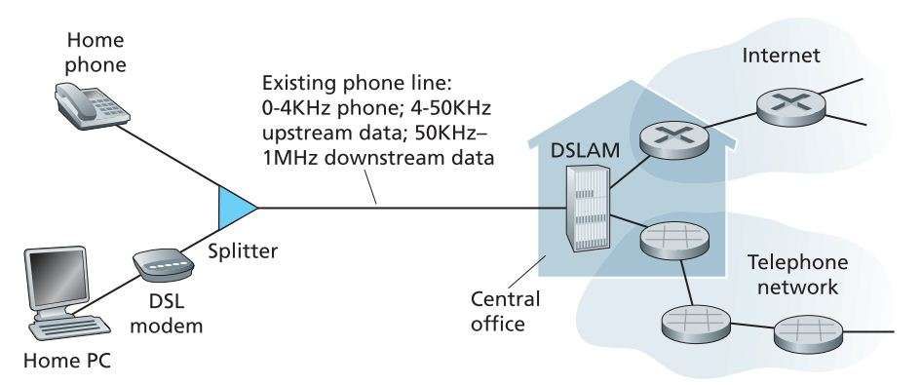

* Advantages:

1. High data rate (download 1-2 mbps, upload 128 kbps-1mbps)
2. Users can simultaneously talk on the phone and access internet.
3. Cable

* Cable internet access make the use of cable TV company’s existing infrastructure
* Both the fiber and co-axial cable are employed, it is also called hybrid fiber coax (HFC)
* Requires cable modem, which connects to the home PC through Ethernet port.

1. Wireless Network

* Wireless LAN (Wi-Fi)

IEEE 802.11

* Wide Area Wireless Access e.g.:- 3G, GPRS.
* WiMAX
* Intel WiMAX 2009
* k/a IEEE 802.16 is a long distance derivation of the 802.11 WiFi protocol speed 5-10 Mbps.

**Physical Media**

1. **Guided Media**

The waves are guided along a solid medium.

1. Twisted Pair Cable
2. Coaxial Cable
3. Optical Fiber
4. **Twisted Pair Cable**

It consists of two insulated strands (each about 1mm thick) of copper wire twisted around each other to form a pair. One or more twisted pairs are used in it. The purpose of twisting is to eliminate electrical interference from the wires and cancels any noises from the adjacent pair. The more twist per linear foot, the greater the effect.

There are two types:

1. **SIP (Shielded Twisted Pair)**
   * Has a foil or a wire braid wrapped around the individual wires of the pair.
   * Minimizes EMI radiation.
2. **UTP (Unshielded Twisted Pair)**

No shielding and is more victim of EMI but is the most frequently used because it is inexpensive and easier to install.

1. **Coaxial Cable**

It is made of two conductors that share the same axis, the centre is a copper wire that is insulated by a plastic coating and then wrapped with an outer conductor (usually a wire braid).

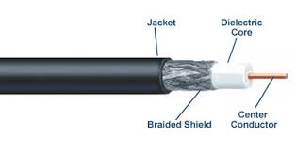

There are two types:

1. **Thick Net**

* 0.38 inch in diameter
* Also called 10b5 cable, which means speed 10 and signal can be strong up to 500m.

1. **Thin Net**

* 0.25 inch in diameter.
* Similar to the material commonly used in cable TV.
* Also called 10b2 cable, means 10 mbps and can carry up to 200 m before being weak.

1. **Optical Fiber**

* A thin, flexible medium that conducts pulses of light, with each pulse representing a bit.
* Can support high bit rates, up to Gbps, immune to EMI, has very low signal attenuation up to 100 km
* Standard is optical carrier (OC), ranges from 51.8 Mbps to39.8 Gbps.
* OC-1, OC-3, OC-12, OC-24, OC-48, OC-96, OC-192, OC-768 are available.
* OC-n, where the link speed equals n*51.8 Mbps.

There are two types:

1. **Single Mode (Mono Mode)**

For longer distance and LASER is used as light source.

1. **Multi Mode**

For shorter distance and LED is used as light source.

1. **Unguided Media**

The waves propagate in the atmosphere and in outer space, such as in a wireless LAN or a digital satellite channel.

1. Terrestrial Radio Channel
2. Satellite Radio Channel
3. **Terrestrial Radio Channel**

* Carry signals in the electromagnetic spectrum.
* No need of physical wire to be installed, can penetrate walls, provide connectivity to mobile user, and potentially carry a signal for long distances.
* May face
* Path loss
* Shadow fading(which decrease the signal strength as signal travels over a distance and around/through obstructing objects)
* Multiple fading (due to signal reflection off of interfering objects)
* E.g. wireless LAN, cellular access technology.

1. **Satellite Radio Channels**

* Links two or more Earth-based microwave transmitter/receiver known as ground stations.
* Satellite receives transmissions on one frequency band, regenerates the signal using a repeater, and transmits the signal on another frequency.
* Two types:

1. **Geostationary Satellite**

* Permanently remain above the same spot on Earth at 36,000 km above surface.
* Propagate delay of 280 ms.

1. **Low Earth Orbiting (LEO) satellite**

* Placed much closer to Earth and do not remain permanently above one spot on Earth.
* Rotate around Earth and may communicate with each other as well as with ground stations.
* For continuous coverage, many satellites need to be placed.