Danish
DevOps and AWS
Deep-Dive Hands-On Handbook
v1.2
A complete concept and hands-on guide for a working DBA transitioning into DevOps and AWS — covering Linux, Networking, Git, Docker, AWS, Terraform, Ansible, Kubernetes, CI/CD, and Monitoring. Every concept explained in plain English with real-world analogies and diagrams.

How to Use This Handbook
Do not treat this as a theory-only document. For every section, first read the Concepts heading, then complete the Hands-On Lab on your laptop or in AWS. Keep one GitHub repository named devops-labs and save every command, YAML file, Terraform file, and note inside it.

Learning Rule | Meaning
One topic at a time | Do not jump to Kubernetes before Linux, Git, Docker, and AWS basics are comfortable.
Type commands manually | Copy/paste is fast but typing makes you remember syntax and error patterns.
Write notes in README files | Every lab should create a small README explaining what you learned.
Keep cost under control | Use local labs first, AWS Free Tier for cloud labs, and stop/delete resources after practice.

Chapter- Laptop Setup — Install These First
Tool | Purpose | Official Download
VS Code | Main editor for Terraform, Ansible, Dockerfile, Kubernetes YAML, scripts, and notes. | https://code.visualstudio.com/download
Git | Version control for all DevOps files and lab history. | https://git-scm.com/install/
Docker Desktop | Runs containers locally for Docker, app, and database labs. | https://www.docker.com/products/docker-desktop/
VirtualBox | Runs Linux virtual machines locally. | https://www.virtualbox.org/wiki/Downloads
Ubuntu Server ISO | Linux OS used for server practice. | https://ubuntu.com/download/server
AWS Free Tier account | Cloud practice with EC2, S3, IAM, RDS, CloudWatch. | https://aws.amazon.com/free/

What DevOps Means Before Tools
DevOps is not one tool. It is a way to deliver software and infrastructure safely, repeatedly, and quickly. The tools only support the bigger goal: reduce manual work, reduce mistakes, improve visibility, and recover quickly when production breaks.
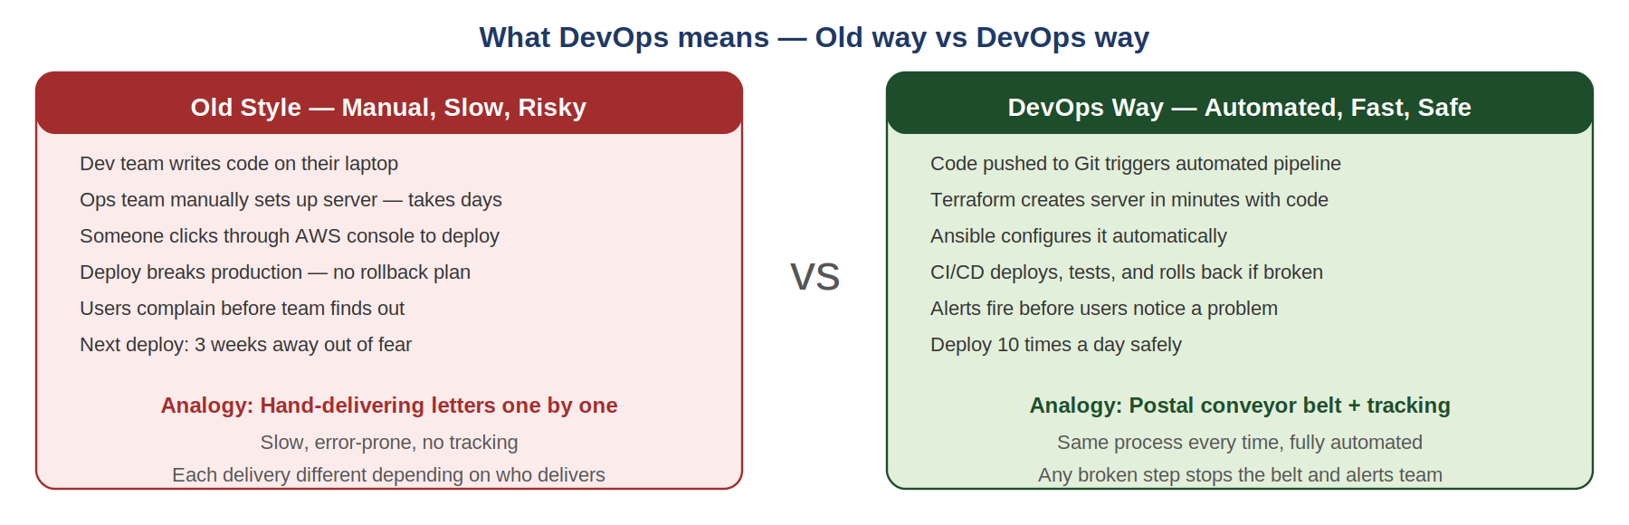
The Core Shift
In the old world, developers write code and throw it over the wall to operations who manually set up servers and deploy. This is slow, error-prone, and each deployment is slightly different. DevOps removes the wall — the same automated process runs every time, from dev laptop to production, with no manual steps in between.
Real-World Analogy
Old DevOps is like hand-delivering letters one by one — slow, each delivery slightly different, no tracking. Modern DevOps is like a postal sorting conveyor belt — same automated process every time, full tracking, and if something goes wrong the belt stops and alerts the team immediately.

Old Style | DevOps Style
Manual server setup | Server setup automated using Ansible or machine images.
Clicking in console | Infrastructure created using Terraform code. Reproducible every time.
Manual deployments | Deployments run through CI/CD pipelines. Automated and tested.
Find issues after customers complain | Monitoring and alerts detect issues early — before users notice.
No rollback plan | Git history, versioned artifacts, and rollback steps exist and are tested.

Chapter 1 — Linux Fundamentals
Linux is the operating system behind most production servers, cloud instances, databases, containers, and Kubernetes nodes. For a DBA moving into DevOps, Linux is the first practical foundation.

1.1 Linux Concepts

What is Linux?
Linux is an operating system like Windows, but it is commonly used on servers because it is stable, scriptable, secure, and efficient. Most AWS EC2 servers run Linux variants such as Ubuntu, Amazon Linux, or Red Hat.
Why Linux and not Windows for servers?
Linux is open source, runs on almost any hardware, consumes far fewer resources than Windows Server, and — most importantly for DevOps — everything can be scripted. No GUI clicking required. A task you do by clicking through 10 menus in Windows takes one command in Linux. For automation, scripting, and containers, Linux is the natural home.

The Linux Filesystem
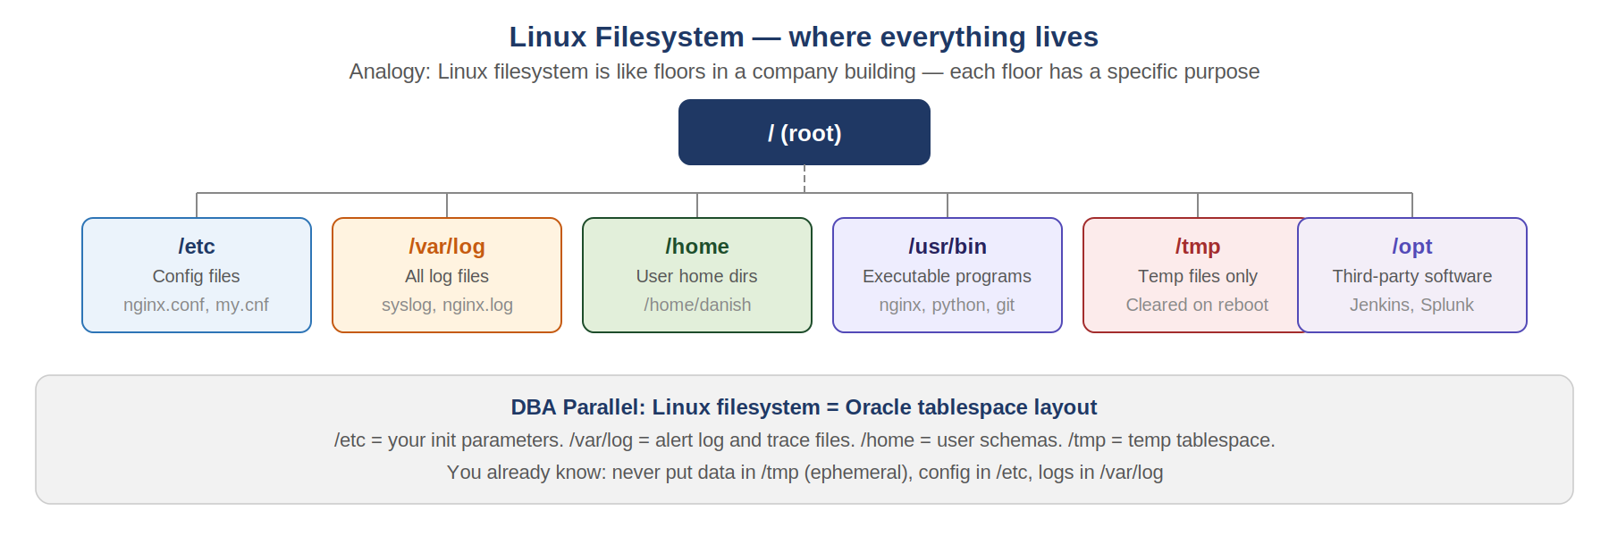
The Linux filesystem is a tree of folders starting from / (root). Each folder has a specific purpose. Understanding this prevents running commands in the wrong place and helps you find files instantly during incidents.
Real-World Analogy
The Linux filesystem is like floors in a company building. /etc is the admin office where all configuration files live. /var/log is the CCTV recording room where all logs are stored. /home is the employee floor. /tmp is the recycling bin that gets emptied on restart. /usr/bin is the tool shed where programs live.

Linux Permissions
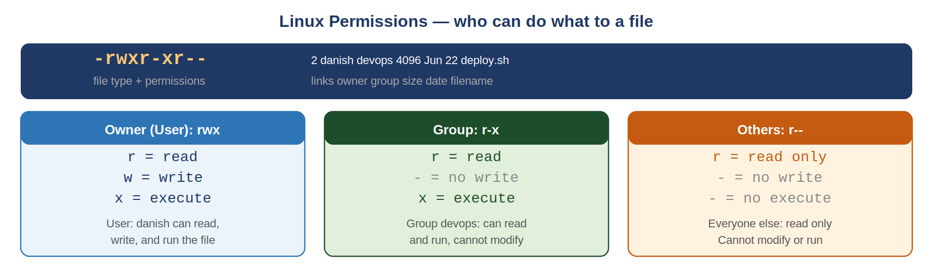
Linux controls who can read, write, or execute every file and directory. Three groups have separate permissions: the owner user, the owner group, and everyone else (others). Wrong permissions are one of the most common causes of deployment failures.
Reading Permission String: -rwxr-xr--
The first character is file type (- for file, d for directory). Next three are owner permissions (rwx = read, write, execute). Next three are group permissions. Last three are others. Mnemonic: think of it as three sets of three doors for three groups of people.
DBA to DevOps Mindset Bridge
As a DBA you grant table-level privileges: GRANT SELECT ON db.table TO user. Linux permissions are the same concept at the filesystem level. chmod 644 = owner reads/writes, group and others read only. chmod 600 = owner only, like a private key file.

Services and Logs
systemd manages services on modern Linux. Services are background processes — nginx, mysql, docker, jenkins. You start, stop, restart, enable (start on boot), and check status of services using systemctl.
Command | What It Does | DBA Parallel
systemctl status nginx | Shows if nginx is running, recent log lines. | SELECT * FROM v$session to check DB health.
systemctl restart nginx | Restarts service after config change. | ALTER SYSTEM SET parameter (restart required).
systemctl enable nginx | Makes service start automatically on boot. | Setting DB autostart in /etc/oratab.
journalctl -u nginx -n 50 | Shows last 50 log lines for nginx. | tail -100 alert_log.ora

Term | Beginner Meaning | Production Example
Shell | Command interpreter where you type Linux commands. | Bash terminal used to troubleshoot EC2.
Process | A running program. | mysqld, nginx, docker, java app.
Service | A managed background process. | systemctl restart nginx.
Package manager | Tool to install software. | apt install nginx on Ubuntu.
Log | Text record of events and errors. | /var/log/syslog or journalctl.

1.2 Linux Labs

Lab 1-A — Create Ubuntu VM in VirtualBox
Purpose: Create a safe Linux practice server without touching production or paying AWS cost.
- Install VirtualBox on your laptop.
- Download Ubuntu Server ISO.
- Open VirtualBox, click New, name VM Ubuntu-DevOps-Lab.
- Assign 2 CPUs, 4 GB RAM, 40 GB disk.
- Attach Ubuntu ISO as optical disk. Start VM and follow installer.
- Create username devopsuser.
Expected Result: You can login to a Linux terminal prompt.
Common Mistake: Do not allocate all laptop RAM to VM. Leave at least 4 GB for your host OS.

Lab 1-B — Run Linux Discovery Commands
Command | What It Means | Expected Result
whoami | Shows current logged-in user. | Confirm you are not accidentally root.
pwd | Prints current directory. | Prevents running commands in wrong folder.
ls -lah | Lists files with permissions and size. | You can see hidden files and ownership.
free -m | Shows memory usage in MB. | Useful when server is slow due to low RAM.
df -h | Shows disk usage by filesystem. | Critical for disk-full incidents.
uptime | Shows how long server has been running. | Quick health check.
sudo apt update && sudo apt install htop -y | Install htop process viewer. | htop command becomes available.
Expected Result: You can explain each command output. Write a linux-notes.txt file with your findings.
DBA to DevOps Mindset Bridge
Linux incident response is your DBA incident response: CPU spike (top/htop), disk full (df -h), memory pressure (free -m), log analysis (journalctl), service health (systemctl status). Every one of these maps directly to your existing DBA emergency playbook.

Chapter 2 — Networking Basics for DevOps
Networking connects users, applications, APIs, load balancers, databases, and cloud services. Many production incidents are actually network incidents: DNS failure, blocked port, wrong route, TLS expiry, or firewall rule.

2.1 Networking Concepts

IP Address, DNS, and Ports
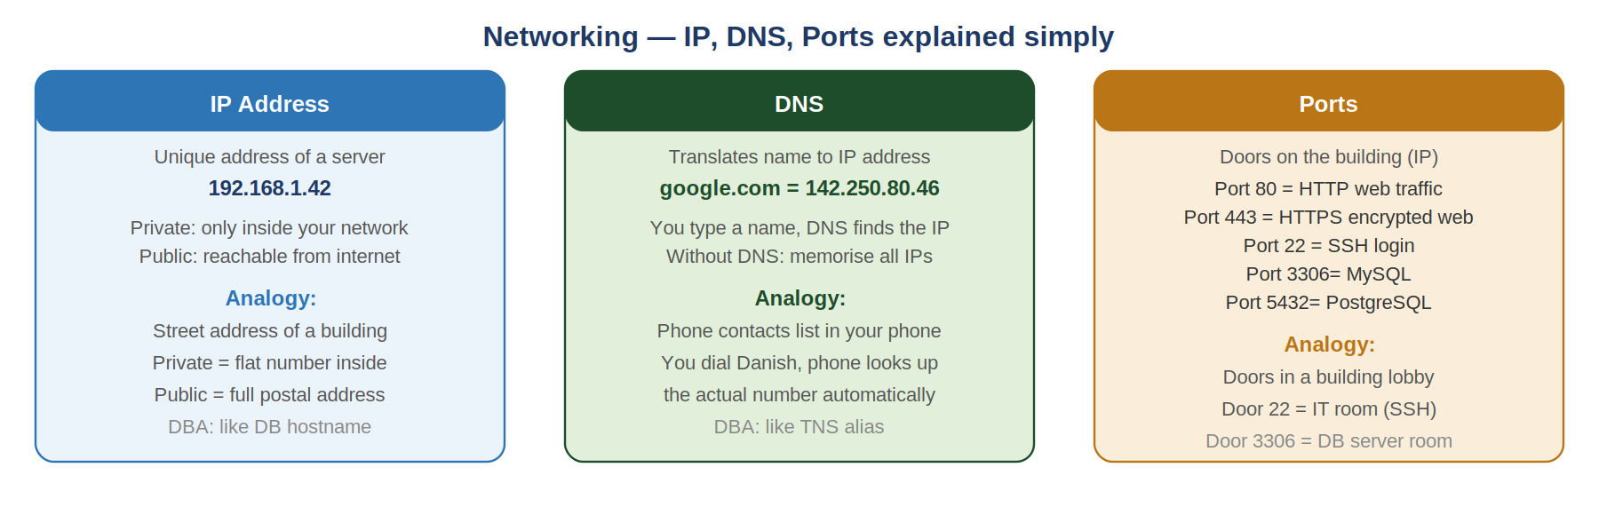
Why networking matters for a DBA
Every database connection is a network call. When an app cannot reach the DB, it is almost always one of three things: wrong hostname (DNS), wrong port (firewall blocking 3306), or wrong IP range (security group). Understanding these three concepts resolves 80% of connectivity issues.

VPC and Subnets in AWS
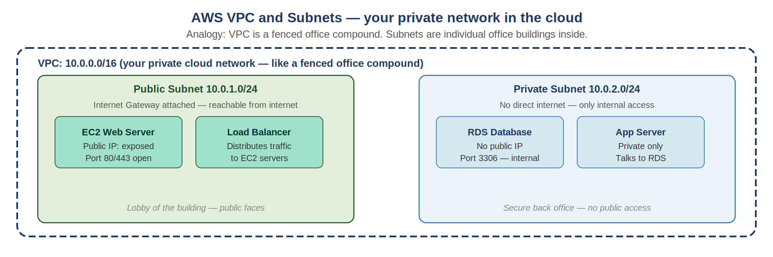
A VPC is your private network inside AWS. Subnets divide the VPC into smaller sections. Public subnets can receive internet traffic. Private subnets have no direct internet access — your databases should always be in private subnets.
Real-World Analogy
VPC is a fenced office compound. Public subnet is the lobby and reception area — accessible by visitors. Private subnet is the back office and server room — only staff with access pass can enter. Your database is in the back office, never the lobby.
DBA to DevOps Mindset Bridge
Security groups in AWS are your database firewall rules. ALLOW port 3306 from app security group = GRANT CONNECT to app_user. If DB cannot be reached, check security group inbound rules first, then NACL, then route table — in that order.

Term | Beginner Meaning | Production Example
IP address | Unique network address of a server. | EC2 public IP: 54.23.45.67 (reach from internet).
Port | Door number on a server for a specific service. | Port 3306 MySQL, 5432 Postgres, 22 SSH, 80 HTTP.
DNS | Translates domain name to IP address. | mydb.company.com resolves to 10.0.2.45.
Security Group | AWS virtual firewall for EC2 and RDS instances. | Allow port 3306 from app-server-sg only.
Load balancer | Distributes traffic across multiple servers. | ALB spreads web requests across 3 EC2 servers.
VPC | Your private network in AWS. | 10.0.0.0/16 — all your AWS resources live here.

2.2 Networking Labs
Command | What It Means | Expected Result
ipconfig (Windows) / ip addr (Linux) | Shows your network interfaces and IP addresses. | Your private IP address visible.
ping 8.8.8.8 | Tests network connectivity to Google DNS. | Replies confirm internet path works.
nslookup google.com | Tests DNS resolution for a domain name. | Returns IP addresses for google.com.
curl -I http://localhost | Tests HTTP connectivity to local server. | HTTP 200 OK if nginx is running.
ss -lntp | Shows all listening TCP ports and processes. | See which ports are open on your VM.
nc -vz <ip> 3306 | Tests TCP connectivity to a specific port. | Succeeded = port is reachable and open.
Common Mistake: Never expose RDS port 3306 to 0.0.0.0/0 in security groups. Always restrict to the specific app server security group or your office IP range.
DBA to DevOps Mindset Bridge
Your DBA experience troubleshooting ORA-12541 (no listener) or MySQL 2003 (cannot connect) is exactly the same workflow: is the port open? Is the hostname resolving? Is there a firewall? Networking in DevOps adds the same discipline to every service, not just the database.

Chapter 3 — Git, GitHub, and VS Code
Git is version control, GitHub is the online repository platform, and VS Code is the editor where you write and manage all DevOps files. Together they form your daily workspace.

3.1 Concepts

What is Git?
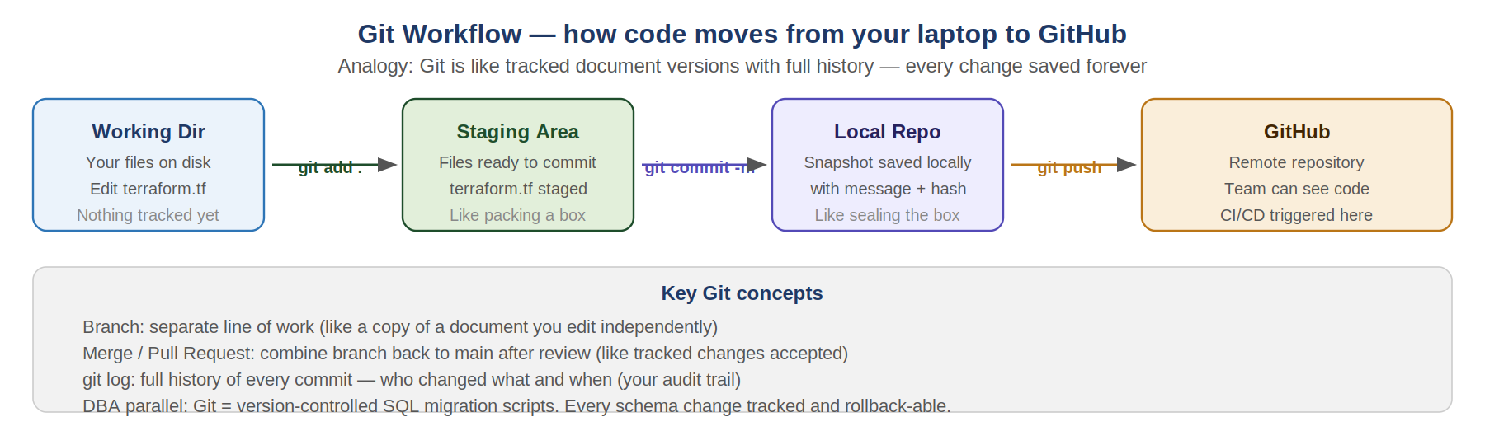
Git — version control for infrastructure
Git tracks every change to every file with who made it, when, and why. You can see the full history, compare versions, revert to any previous state, and work on separate branches without affecting the main codebase. In DevOps, ALL infrastructure is code — Terraform files, Ansible playbooks, Dockerfiles, Kubernetes YAML — and all of it lives in Git.
Real-World Analogy
Git is like tracked changes in a Word document, but for all your code files at once, with a full timestamped history of every change, the ability to compare any two versions, and the ability to undo anything instantly. GitHub is the shared folder where everyone saves their tracked-changes documents.

What is a Branch?
A branch is a parallel copy of your code where you can make changes without affecting the main (production) codebase. When changes are ready and reviewed, you merge the branch back into main. This is how teams work on features or fixes without breaking each other's work.
DBA to DevOps Mindset Bridge
Git for DevOps is what RMAN catalog is for backups — the authoritative record of every version. Your schema migration scripts should live in Git. Every change to Terraform, Ansible, or Kubernetes YAML should be committed and peer-reviewed via a Pull Request before applying to production. Same discipline as change management, but automated and enforced.

Term | Beginner Meaning | Production Example
Repository | Folder tracked by Git. | devops-labs repo with all your IaC files.
Commit | Snapshot of changes with message and author. | 'Add EC2 instance for web tier' committed to history.
Branch | Separate line of work from main. | feature/add-rds-alarm branch.
Pull Request | Request to review and merge branch into main. | Peer review before infrastructure change goes live.
git clone | Download an existing repository to your laptop. | Clone the devops-labs repo after creating it on GitHub.

3.2 Git, GitHub, VS Code Labs
Command | What It Means | Expected Result
git --version | Checks Git is installed. | Shows git version number.
git config --global user.name 'Danish' | Sets your name for commits. | Your name appears in git log.
git init | Initializes a new Git repository in current folder. | Hidden .git folder created.
git status | Shows changed files and current branch. | Lists what needs to be committed.
git add . | Stages all changed files for commit. | Files ready for snapshot.
git commit -m 'first lab' | Creates a commit snapshot with message. | Commit hash created in local history.
git push | Uploads local commits to GitHub. | Changes visible on GitHub.com.
Common Mistake: Never commit secrets, passwords, or AWS access keys to Git. Add .env and .pem files to .gitignore before your first commit or they are in the history forever.
DBA to DevOps Mindset Bridge
Your schema migration SQL scripts belong in Git. Every ALTER TABLE, every stored procedure change, every index creation should be a commit with a message. Then if something goes wrong in production, you have a clear rollback path via git revert.

Chapter 4 — Docker Containers
Docker packages applications and their dependencies into containers that run consistently on your laptop, a test server, and production — without the 'works on my machine' problem.

4.1 Docker Concepts

What Problem Docker Solves
Without Docker, deploying an app means: install the right Python version, install the right libraries, set environment variables, configure the OS, and pray it matches prod. With Docker, everything is packaged into one image. That image runs identically everywhere.
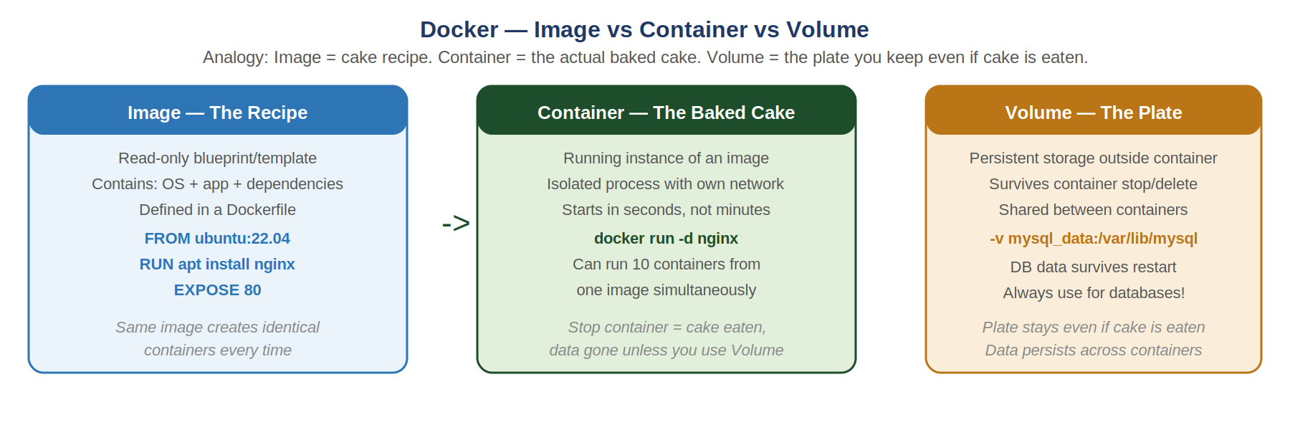
Image vs Container — the key distinction
An image is the blueprint — read-only, built once, shared. A container is a running instance of that image — isolated, ephemeral, disposable. One image can spawn 100 identical containers. When you stop and delete a container, the image is untouched and you can create a fresh container instantly. This is why you MUST use Volumes for database data — the container is disposable, the data must survive.
Real-World Analogy
Image is a cake recipe. Container is the baked cake. Volume is the plate. You can bake 10 cakes from one recipe (one image, 10 containers). If you eat the cake (stop the container) the plate remains (volume with your data persists). Without the plate, all your data disappears when the container stops.

Docker Compose
Docker Compose defines multi-container applications in one YAML file. Instead of running long docker run commands manually, docker compose up starts your entire application stack — app server, database, cache — with one command.
version: '3' services: mysql: image: mysql:8 environment: MYSQL_ROOT_PASSWORD: secret volumes: - mysql_data:/var/lib/mysql ports: - '3307:3306' volumes: mysql_data:

Term | Beginner Meaning | Production Example
Image | Read-only blueprint built from Dockerfile. | mysql:8, nginx:1.24, python:3.11.
Container | Running instance of an image. | Your MySQL container named mysqltest.
Dockerfile | Instructions to build a custom image. | FROM ubuntu + RUN apt install nginx.
Volume | Persistent storage that survives container lifecycle. | mysql_data volume keeps DB data on restart.
Docker Compose | YAML to define multi-container stack. | App + MySQL + Redis launched together.
-p 3307:3306 | Port mapping host:container. | Access container's 3306 as localhost:3307.

4.2 Docker Labs

Lab 4-A — Run MySQL in Docker
docker run -d --name mysqltest -e MYSQL_ROOT_PASSWORD=root -v mysql_data:/var/lib/mysql -p 3307:3306 mysql:8
docker ps
docker exec -it mysqltest mysql -uroot -proot
Expected Result: MySQL container running. You connect and see mysql> prompt. Run SHOW DATABASES;
Common Mistake: Always use -v for database containers. Without a volume, all data is lost when the container stops. This is the most common Docker mistake for DBAs.

Lab 4-B — Build a Custom Dockerfile
# Dockerfile FROM ubuntu:22.04 RUN apt-get update && apt-get install -y nginx EXPOSE 80 CMD ["nginx", "-g", "daemon off;"]
docker build -t my-nginx .
docker run -d -p 8080:80 my-nginx
curl http://localhost:8080
Expected Result: curl returns nginx welcome page HTML.
DBA to DevOps Mindset Bridge
Docker for DBAs: use containers for safe test environments — try a MySQL version upgrade, test a schema change, simulate replication, run a migration dry-run. The container is disposable, your experiment is safe. Production databases in containers require careful storage, backup, failover, and performance planning — often RDS is better for production.

Chapter 5 — AWS Fundamentals
AWS provides cloud servers, storage, networking, managed databases, monitoring, and security. It lets you practice real cloud operations with low cost when you manage resources carefully.

5.1 AWS Concepts
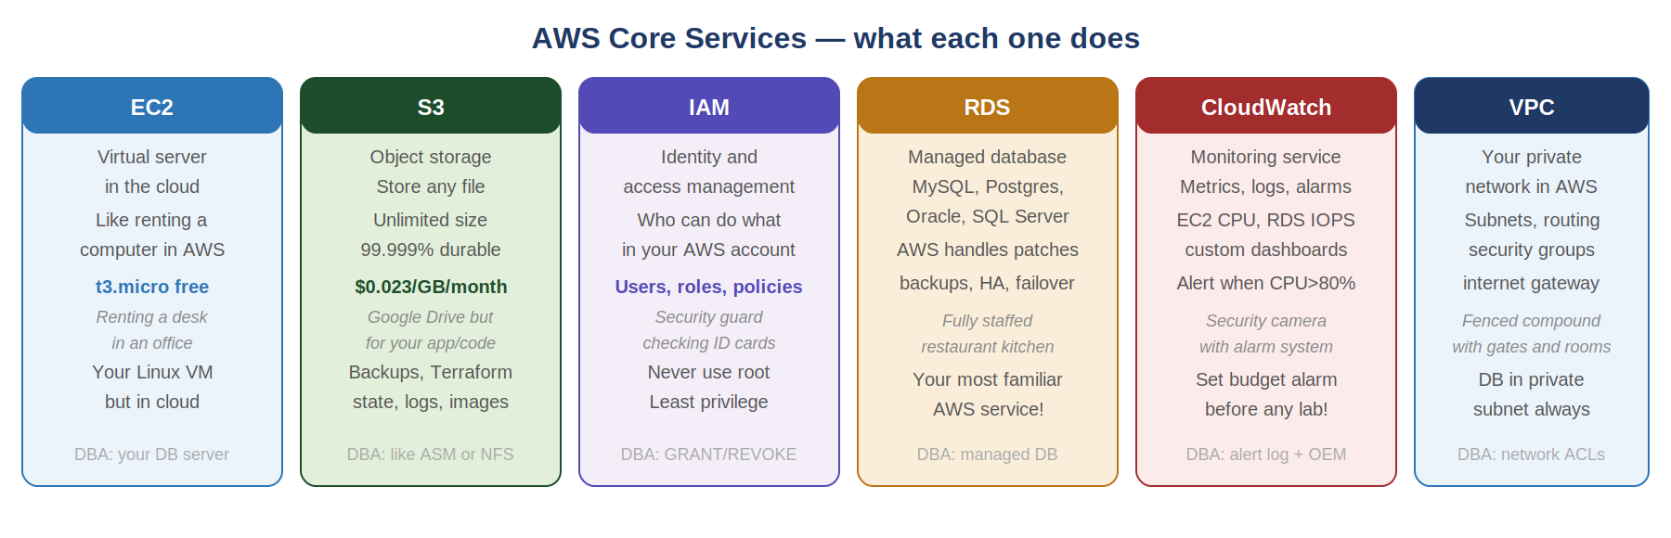
Why AWS for DevOps?
AWS gives you infrastructure on demand — spin up a server in 60 seconds, shut it down when done. You only pay for what you use. For a DBA learning DevOps, AWS Free Tier provides real production-grade services: EC2 (Linux server), RDS (managed MySQL), S3 (file storage), IAM (access control), and CloudWatch (monitoring) — all free within limits.

EC2 — Virtual Server in the Cloud
What EC2 really is
EC2 is like renting a computer in a data centre. You choose the OS (Amazon Linux, Ubuntu, Windows), CPU, memory, and storage. You SSH into it and work exactly like you would with a physical Linux server. The difference: it starts in 60 seconds, costs $0.013/hour for a t3.micro, and you can terminate it when done. No hardware procurement, no data centre, no long-term commitment.

RDS — Your Most Familiar AWS Service
RDS is a managed database — AWS does your DBA jobs
RDS runs MySQL, PostgreSQL, Oracle, or SQL Server but AWS manages patches, backups, replication, failover, and storage autoscaling. You still design schemas, write queries, tune indexes, and manage users — but OS-level work, binary patching, and hardware is handled. Multi-AZ RDS gives automatic failover with zero data loss — like having your standby database managed for you.

IAM — Security and Access Control
IAM — the same as GRANT/REVOKE but for the whole AWS account
IAM controls who can do what in your AWS account. Users log in with credentials. Roles are identities assumed by services (EC2 role can read S3). Policies are JSON documents that define what actions are allowed. NEVER use the root account — create an IAM admin user. Apply least privilege: only grant the permissions actually needed, nothing more.
DBA to DevOps Mindset Bridge
IAM is your GRANT statement at the cloud level. An EC2 instance role that can read S3 = GRANT SELECT ON bucket TO ec2_user. An RDS user with only SELECT = read replica user in your DBA world. Same principle: minimum necessary access, nothing more.

Term | Beginner Meaning | DBA Parallel
Region | Geographic AWS area (us-east-1, eu-west-1). | Datacenter location for compliance and latency.
Availability Zone | Isolated datacenter within a region. | Separate fault domain — use for HA like standby.
Security Group | Instance-level firewall (stateful). | DB firewall: allow port 3306 from app server only.
Key Pair | SSH private key to login to EC2. | PEM file = your SSH credential for cloud servers.
Free Tier | Limited free/credit usage for learning. | t3.micro EC2, 20GB RDS, 5GB S3 free per month.

5.2 AWS Labs

Lab 5-A — Launch EC2 and SSH
- Open AWS Console -> EC2 -> Launch Instance.
- AMI: Ubuntu 22.04. Instance type: t3.micro (Free Tier).
- Create key pair: devops-key.pem. Download and save it.
- Security group: allow SSH port 22 from your IP only.
- Launch instance. Wait for status: running.
chmod 400 devops-key.pem
ssh -i devops-key.pem ubuntu@<EC2-PUBLIC-IP>
Expected Result: You are logged into your cloud Linux server.
Common Mistake: Stop the EC2 instance after the lab! Running EC2 charges by the hour. Terminate (not just stop) when done with the chapter.

Lab 5-B — Create Budget Alert
- AWS Console -> Billing -> Budgets -> Create Budget.
- Set $10 monthly limit. Email alert at 80%.
- This is mandatory before any AWS lab.
Expected Result: Budget alert email confirmed. You will never get surprise bills.
DBA to DevOps Mindset Bridge
AWS EC2 is your Linux server — same commands, same files, same troubleshooting. AWS RDS is your database but managed. The cloud is not magic — it is Linux servers and networking, the same things you know, accessible via APIs instead of procurement forms.

Chapter 6 — Terraform Infrastructure as Code
Terraform lets you create cloud infrastructure using code instead of clicking manually in the AWS Console. Your server setup becomes a file in Git — reproducible, reviewable, and rollback-able.

6.1 Terraform Concepts
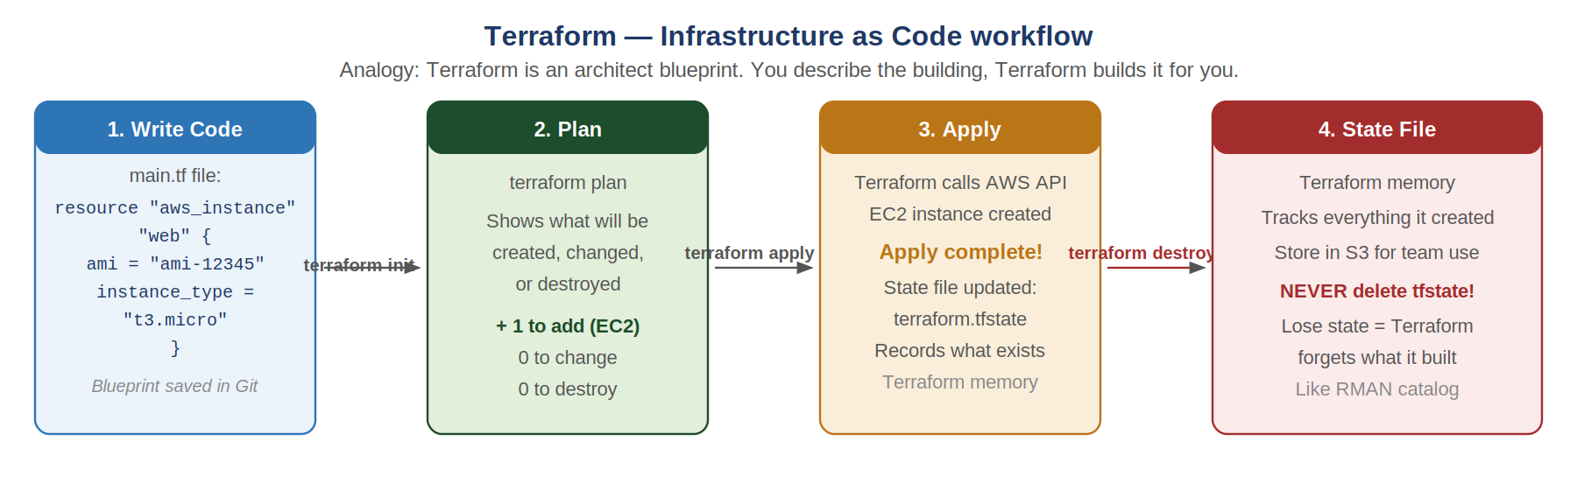
Why Terraform exists
Without Terraform, setting up a server requires clicking through 15 console screens, and if you need the exact same setup next month you have to remember or document every click. With Terraform, you write the desired state once in code. terraform plan shows you exactly what will change before it happens. terraform apply makes it happen. terraform destroy deletes it cleanly. Everything in Git, fully reviewable.
Real-World Analogy
Terraform is an architect's blueprint. You describe the building — 3 floors, 10 rooms each, these materials. The construction company (AWS) builds it. If you want 5 floors instead, change the blueprint and rebuild. No phoning the builder to manually add floors — you update the plan and it applies automatically.

The State File — Terraform's Memory
Terraform keeps a state file (terraform.tfstate) that records everything it has created. When you run terraform plan again, Terraform compares your code to the state file and shows only what needs to change. If you delete the state file, Terraform forgets what it built and can no longer manage those resources. Store the state file in S3 with state locking via DynamoDB for team use.

Term | Beginner Meaning | Production Example
Provider | Plugin that knows how to talk to a cloud API. | aws provider for AWS, azurerm for Azure.
Resource | One piece of infrastructure defined in code. | aws_instance, aws_db_instance, aws_vpc.
Variable | Reusable input so you avoid hardcoding values. | instance_type = var.instance_type.
Output | Value printed after terraform apply. | EC2 public IP, RDS endpoint.
State | Terraform's memory of what it has built. | terraform.tfstate — store in S3, never delete.

6.2 Terraform Labs

Lab 6-A — Install Terraform
# Ubuntu / WSL curl -fsSL https://apt.releases.hashicorp.com/gpg | sudo apt-key add - sudo apt-add-repository 'deb [arch=amd64] https://apt.releases.hashicorp.com focal main' sudo apt update && sudo apt install terraform -y terraform --version

Lab 6-B — Create EC2 with Terraform
# main.tf terraform { required_providers { aws = { source = "hashicorp/aws", version = "~> 5.0" } } } provider "aws" { region = "us-east-1" } resource "aws_instance" "web" { ami = "ami-0c02fb55956c7d316" instance_type = "t3.micro" tags = { Name = "DevOps-Lab", Owner = "Danish" } }
terraform init
terraform plan
terraform apply
terraform destroy # ALWAYS run after lab to avoid charges
Expected Result: EC2 instance created and visible in AWS Console. terraform destroy removes it cleanly.
Common Mistake: Always run terraform destroy after lab sessions. Running EC2 instances cost money even if you are not using them.
DBA to DevOps Mindset Bridge
Terraform plan is your dry run before the actual change — like EXPLAIN PLAN in Oracle or EXPLAIN in MySQL. You see what will happen before it happens. terraform apply with approval is your production change window. terraform destroy is your rollback. Treat Terraform changes with the same caution as a production schema migration.

Chapter 7 — Ansible Configuration Automation
Ansible automates server setup and configuration over SSH. It installs software, copies files, starts services, and applies settings — across one server or one thousand — with the same YAML playbook.

7.1 Ansible Concepts
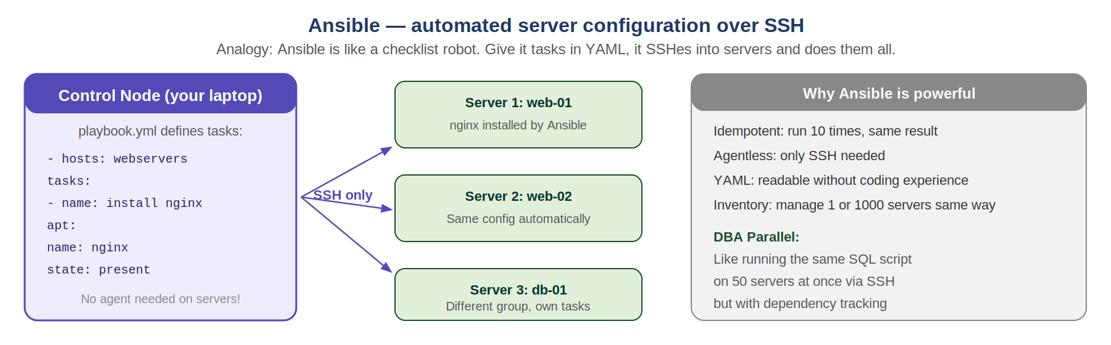
Why Ansible exists
Without Ansible, configuring 10 servers means SSHing into each one and running the same commands manually — slow, error-prone, and inconsistent. With Ansible, you write the steps once in a YAML playbook. Ansible SSHes into all servers in parallel, runs the steps, and reports success or failure. No agent needed on the managed servers — only SSH access.
Idempotency — the most important Ansible concept
An idempotent operation produces the same result no matter how many times it runs. Ansible modules are idempotent: 'install nginx' checks if nginx is already installed and skips if it is. 'copy this file' checks if the file is already there and unchanged. This means you can run the same playbook on a server 10 times and nothing breaks — it only changes what needs changing.
Real-World Analogy
Ansible is a checklist robot. Give it a YAML checklist of tasks. It SSHes into each server on the inventory list and ticks off every item. If an item is already done, it skips it. If it fails, it reports exactly which item failed and on which server. You do not need to touch the servers yourself.

Term | Beginner Meaning | Production Example
Control node | Your laptop or CI/CD server where Ansible runs. | Runs ansible-playbook command.
Managed node | Target server that Ansible configures over SSH. | EC2 instances, VMs, on-prem servers.
Inventory | List of servers and groups to manage. | [webservers] host1 host2 [dbservers] db01.
Playbook | YAML file listing tasks to run on hosts. | install_nginx.yml, configure_mysql.yml.
Module | Pre-built action: apt, copy, service, template. | apt module installs packages idempotently.
Role | Reusable structured collection of tasks. | mysql_backup role used across all DB servers.

7.2 Ansible Labs

Lab 7-A — Install Ansible and Test Connectivity
sudo apt install ansible -y ansible --version
# inventory.ini [local] localhost ansible_connection=local
ansible -i inventory.ini all -m ping
Expected Result: Returns pong for each host. Connection working.

Lab 7-B — Write and Run a Playbook
# install_nginx.yml - hosts: local become: yes tasks: - name: Install nginx apt: name: nginx state: present update_cache: yes - name: Start nginx service service: name: nginx state: started enabled: yes
ansible-playbook -i inventory.ini install_nginx.yml
Expected Result: nginx installed and running. Run it again — nginx already present, task skips (idempotent).
Common Mistake: Never run ansible-playbook against production hosts without testing on staging first. Ansible runs fast across many servers — a mistake propagates quickly.
DBA to DevOps Mindset Bridge
Ansible for DBAs: distribute my.cnf templates, deploy backup scripts, install monitoring agents, run SQL health checks across all DB servers simultaneously. Ansible replace your manual SSH loop — instead of SSHing into 20 servers one by one to update a config, write one playbook and run once.

Chapter 8 — Kubernetes Basics
Kubernetes (K8s) manages containers at scale. It schedules containers across multiple servers, restarts failed ones, exposes services, scales up under load, and rolls back bad deployments — automatically.

8.1 Kubernetes Concepts
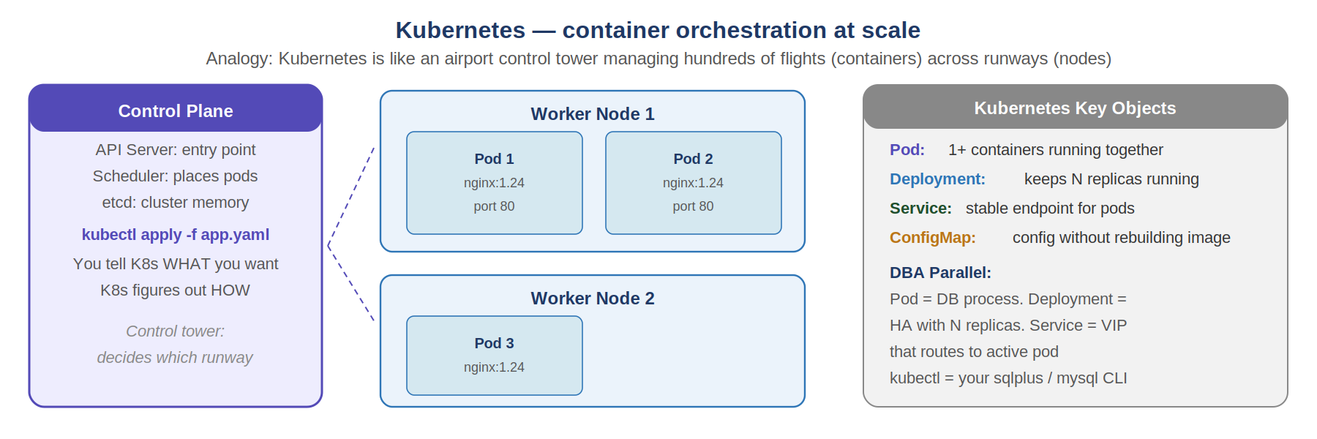
Why Kubernetes exists
Docker runs containers, but it does not manage them at scale. If a container crashes, Docker does not restart it. If traffic spikes, Docker does not add more containers. If a host server fails, Docker does not move containers to another server. Kubernetes does all of this automatically. You declare WHAT you want (3 replicas of my nginx container) and Kubernetes figures out HOW to make it happen and keeps it that way.
Real-World Analogy
Kubernetes is an airport control tower managing hundreds of flights (containers) across multiple runways (nodes). You tell the tower: I need 3 planes landing per hour. The tower assigns runways, manages queues, reroutes if a runway is busy, and calls in more planes if demand increases. You never manually assign individual planes to runways.

Pod — the smallest unit
A Pod is one or more containers that run together on the same node, sharing network and storage. Usually one container per Pod. Pods are ephemeral — if a Pod dies, Kubernetes creates a new one. This is why you use Services as stable endpoints rather than Pod IPs directly.
Deployment — keeps Pods running
A Deployment declares: I want N replicas of this container always running. If a Pod crashes, Deployment creates a replacement. If you want to update the app version, Deployment does a rolling update — replaces Pods one by one so there is zero downtime. If the new version is broken, kubectl rollout undo brings back the previous version instantly.

Term | Beginner Meaning | DBA Parallel
Pod | 1+ containers running together, sharing network. | One DB process on one server.
Deployment | Keeps N replicas of a Pod always running. | HA group with N standby replicas.
Service | Stable IP/DNS endpoint that routes to Pods. | Virtual IP (VIP) pointing to active DB node.
Namespace | Logical grouping of Kubernetes resources. | Database schema or separate cluster environment.
kubectl | CLI tool for Kubernetes — your K8s shell. | Your psql, mysql, or sqlplus CLI.
ConfigMap | Non-sensitive config injected into Pods. | init parameters file or config table.

8.2 Kubernetes Labs

Lab 8-A — Start Minikube Local Cluster
# Install minikube: https://minikube.sigs.k8s.io/docs/start/
minikube start
kubectl get nodes
Expected Result: One node in Ready state. Your local Kubernetes cluster is running.

Lab 8-B — Deploy Nginx and Scale
kubectl create deployment nginx --image=nginx:1.24
kubectl expose deployment nginx --type=NodePort --port=80
kubectl get pods
kubectl scale deployment nginx --replicas=3
kubectl get pods # now 3 pods
kubectl rollout undo deployment nginx # rollback
kubectl delete deployment nginx && kubectl delete service nginx
Expected Result: 3 nginx Pods running. Rolling update and rollback both work. Clean up after lab.
DBA to DevOps Mindset Bridge
Kubernetes for DBAs: stateless apps run perfectly in K8s. Stateful databases in K8s are complex — StatefulSet, PersistentVolume, proper backup, and failover all need careful design. For most production databases, AWS RDS or equivalent managed services are safer. Use K8s for your app tier, RDS for your data tier.

Chapter 9 — CI/CD Pipelines
CI/CD automates the path from code commit to production deployment. Every code push triggers a chain of automated steps: build, test, deploy to staging, and deploy to production — with gates to stop bad code from reaching users.

9.1 CI/CD Concepts
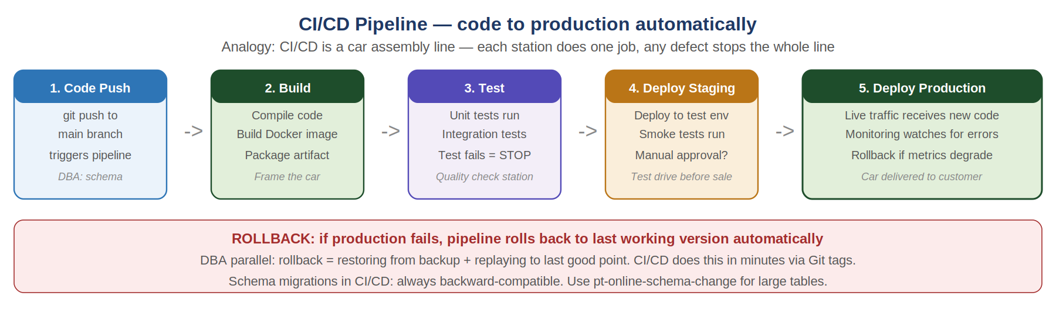
Continuous Integration (CI)
CI means every code push is automatically built and tested. If tests fail, the team is notified immediately. The goal: find bugs within minutes of introduction, not days later during manual testing. CI requires a test suite — without tests, CI is just automated building with no quality gate.
Continuous Delivery/Deployment (CD)
CD means the software is always in a deployable state and can be released to production at any time, or automatically. Continuous Delivery requires a manual approval step before production. Continuous Deployment goes fully automatic — every passing build deploys to production. Most teams start with Continuous Delivery and add approval gates.
Real-World Analogy
CI/CD is a car assembly line. Each station (build, test, staging, production) does exactly one job. If a quality check fails at any station, the line stops — the car (code change) does not proceed. No defective car reaches the customer. The line runs the same every time, with no manual variation.

Term | Beginner Meaning | Production Example
CI | Automatically build and test every commit. | Push to GitHub triggers GitHub Actions workflow.
CD | Automatically deploy tested code to environments. | Passing tests deploy to staging, then production.
Pipeline | Series of automated stages from code to production. | build -> test -> staging deploy -> prod deploy.
Artifact | Built output ready to deploy. | Docker image tagged with commit hash.
Rollback | Revert to previous working version. | kubectl rollout undo or re-deploy previous image tag.
Gate | Manual or automated approval before proceeding. | Manager approves before production deploy.

9.2 CI/CD Labs

Lab 9-A — GitHub Actions First Workflow
# .github/workflows/ci.yml name: CI Pipeline on: push: branches: [main] jobs: build: runs-on: ubuntu-latest steps: - uses: actions/checkout@v3 - name: Run tests run: echo 'Tests passing' && exit 0 - name: Build Docker image run: echo 'docker build -t my-app .'
git add . && git commit -m 'add CI workflow' && git push
Expected Result: GitHub Actions tab shows workflow running and passing. Green checkmark on commit.
Common Mistake: Schema migrations in CI/CD need special care. App code rollback is instant (redeploy old image). Database schema rollback on a large table with millions of rows is painful. Design migrations to be backward-compatible and use pt-online-schema-change for large tables.
DBA to DevOps Mindset Bridge
CI/CD is your change management process automated. Your DBA change approval workflow (request, review, schedule, test, deploy, monitor, rollback) is exactly the CI/CD pipeline — but manual. CI/CD automates every step except the judgement calls, adds tests at every stage, and makes the whole process faster and safer.

Chapter 10 — Monitoring and Logging
Monitoring tells you what is happening right now. Logging tells you what happened and why. Production without monitoring is flying blind — you only hear about problems after users complain.

10.1 Monitoring Concepts
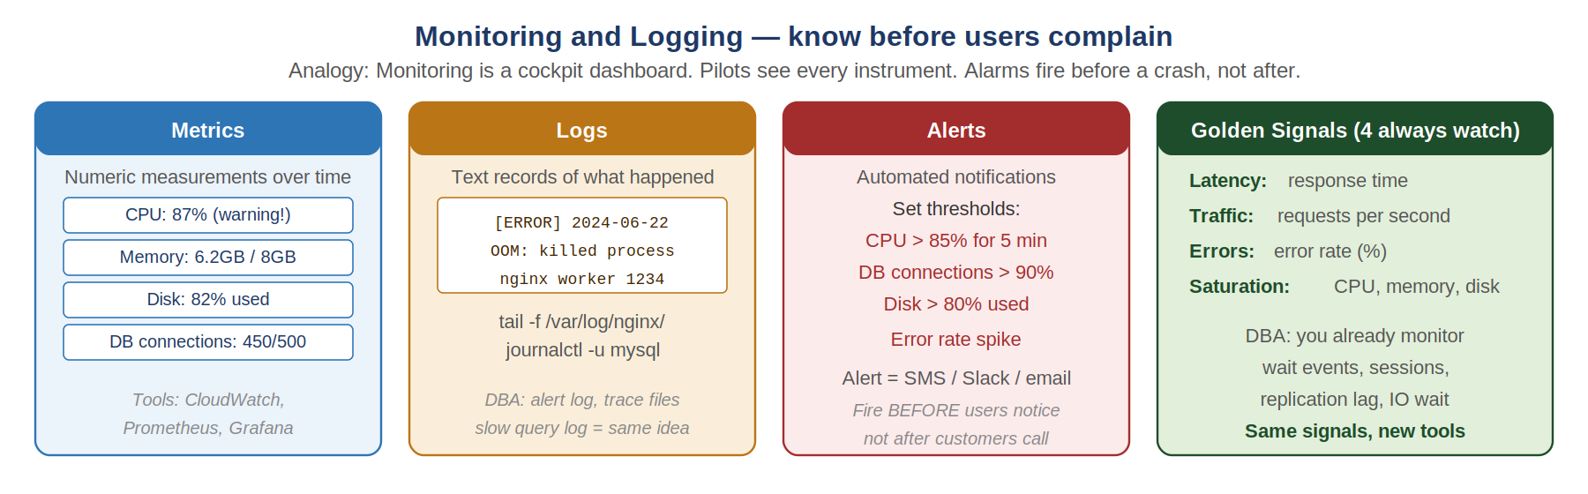
The monitoring mindset shift
As a DBA you already monitor: slow query log, wait events, connections, replication lag, buffer pool hit rate, disk IO, and backup status. DevOps extends this same discipline to every layer of the stack: CPU, memory, disk, network, application error rates, response times, and deployment events. The goal is always the same — know before users do.
Real-World Analogy
Monitoring is a cockpit dashboard. Pilots see every instrument — altitude, speed, fuel, engine temperature — at all times. Alarms fire before critical thresholds are crossed. The pilot takes action before the plane has a problem. You never wait for the plane to crash to know something was wrong.

Golden Signals — The 4 Things Always Watch
Signal | What It Measures | Alert Threshold Example
Latency | How long requests take to respond. | p99 response time > 2 seconds for 5 minutes.
Traffic | How many requests per second. | Sudden 10x spike may indicate attack or viral event.
Errors | Percentage of requests returning errors. | Error rate > 1% for 3 minutes triggers alert.
Saturation | How full is the system: CPU, memory, disk, connections. | CPU > 85% for 5 min, Disk > 80%, DB connections > 90%.

CloudWatch — AWS Native Monitoring
CloudWatch collects metrics from all AWS services automatically. EC2 CPU, RDS connections, S3 request rates, Lambda invocations — all stream into CloudWatch. You create Alarms that trigger SNS notifications (email, SMS, Slack) when thresholds are crossed. CloudWatch Logs aggregates log files from all your servers into one searchable place.

10.2 Monitoring Labs

Lab 10-A — Basic Server Health Checks
Command | What It Measures | DBA Parallel
top / htop | CPU usage and process list. | Active sessions and CPU wait in v$session.
free -m | Memory usage in MB. | SGA/PGA memory monitoring in DBA_HIST.
df -h | Disk usage by mount point. | Tablespace usage monitoring.
tail -f /var/log/syslog | Live system log stream. | tail -f alert_log.ora
systemctl status nginx | Service health and recent logs. | SHOW REPLICA STATUS in MySQL.
ss -lntp | Open ports and listening processes. | netstat -an for DB listener check.

Lab 10-B — Create CloudWatch Alarm
- Open AWS Console -> CloudWatch -> Alarms -> Create alarm.
- Metric: EC2 -> Per-Instance Metrics -> CPUUtilization.
- Threshold: Greater than 80 for 2 consecutive 5-minute periods.
- Action: Create SNS topic and subscribe your email.
- Name alarm: DevOps-Lab-High-CPU.
Expected Result: Alarm created in OK state. Email subscription confirmed. Alarm fires when CPU exceeds 80%.

10.3 DBA/DevOps Production Automation
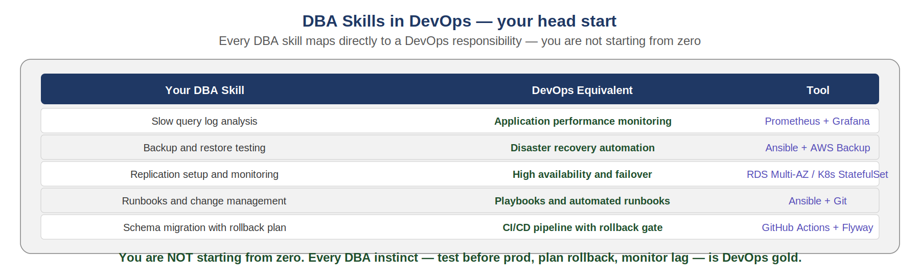
This section connects your DBA background directly with DevOps skills. Every DBA skill you have today maps to a DevOps responsibility. You are not starting from zero — you are extending your existing expertise into automation.
Schema Changes in CI/CD
Online schema changes on large tables (ALTER TABLE on 500M rows) require special tooling in DevOps pipelines. Tools like pt-online-schema-change (Percona) or gh-ost work by creating a shadow table, copying data incrementally, and cutting over without locking. These tools integrate into CI/CD pipelines as migration steps with rollback capability.
Runbooks as Code
A runbook is a documented procedure for handling a specific incident or operation. In DevOps, runbooks become Ansible playbooks — automated, repeatable, testable. Your manual DBA runbook for failover becomes an Ansible play that checks replication state, promotes standby, updates DNS, and sends a notification — all in sequence, all logged.
DBA to DevOps Mindset Bridge
Your entire DBA career is your DevOps head start. You already think about: what happens if this fails? what is the rollback? who is on call? how do I know it is working? how long does restore take? These are the questions DevOps engineers ask about every system. You just now apply them to servers, pipelines, and containers — not only databases.

30-Day Practical Study Plan
Days | Focus | Deliverable
1-3 | Laptop setup, VS Code, GitHub repo created. | devops-labs repo with folders and README.
4-8 | Linux fundamentals: filesystem, permissions, services, processes. | Ubuntu VM running, command notes committed to Git.
9-11 | Networking: IP, DNS, ports, VPC, security groups. | Port scan and DNS resolution exercises completed.
12-15 | Docker: containers, images, volumes, Docker Compose. | MySQL container with volume and docker-compose file.
16-19 | AWS basics: EC2, S3, IAM, VPC, budget alarm. | EC2 launched and SSH working. Budget alarm set.
20-22 | Terraform: write, plan, apply, destroy EC2 and S3. | EC2 created and destroyed using Terraform code.
23-25 | Ansible: inventory, playbook, install nginx, idempotency. | Playbook installs nginx on local and runs twice cleanly.
26-28 | Kubernetes: minikube, pods, deployments, services, scaling. | Nginx deployment with 3 replicas and rollback tested.
29-30 | CI/CD: GitHub Actions workflow with build, test, deploy steps. | Workflow triggers on push and passes all steps.
31-33 | Monitoring: CloudWatch alarms, Prometheus, Grafana dashboard. | Health checklist, CloudWatch alarm on EC2 CPU confirmed.
34-35 | DBA/DevOps automation: runbook, schema change process, backup automation. | Ansible playbook for DB health check and backup verification.

Low-Cost AWS Safety Checklist
- Create a $10 billing alert in AWS Budgets BEFORE launching any resource.
- Use only t3.micro or t2.micro EC2 instances for labs (Free Tier eligible).
- Stop or terminate EC2 instances after every lab session.
- Delete unused EBS volumes, snapshots, NAT Gateways, and load balancers.
- RDS Free Tier: db.t3.micro, 20 GB storage. Delete instance when lab is complete.
- S3: Empty and delete buckets created in labs after chapter completion.
- Keep all S3 buckets private. Never make a bucket public for lab purposes.
- Never paste AWS access keys in GitHub. Add credentials to .gitignore.
- Tag every resource: Owner=Danish, Purpose=DevOps-Learning.
- Review AWS Cost Explorer weekly during the 30-day study plan.

Official Links

Tools
VS Code: https://code.visualstudio.com/download
Git: https://git-scm.com/install/
Docker Desktop: https://www.docker.com/products/docker-desktop/
VirtualBox: https://www.virtualbox.org/wiki/Downloads
Ubuntu Server ISO: https://ubuntu.com/download/server
Terraform: https://developer.hashicorp.com/terraform/install
Ansible: https://docs.ansible.com/projects/ansible/latest/installation_guide/index.html
Minikube: https://minikube.sigs.k8s.io/docs/start/
kubectl: https://kubernetes.io/docs/tasks/tools/

AWS
AWS Free Tier: https://aws.amazon.com/free/
AWS CLI install: https://docs.aws.amazon.com/cli/latest/userguide/getting-started-install.html
EC2 User Guide: https://docs.aws.amazon.com/AWSEC2/latest/UserGuide/
RDS User Guide: https://docs.aws.amazon.com/AmazonRDS/latest/UserGuide/
CloudWatch: https://docs.aws.amazon.com/AmazonCloudWatch/latest/monitoring/

