Danish
DevOps and AWS
Chapter 2 — Networking Deep Dive
All vital networking concepts for a DBA moving into DevOps and AWS — explained in plain English with real-world analogies, diagrams, DBA parallels, and hands-on labs.
What You Will Learn
OSI Model | Why it matters — which layers DBAs deal with every day
IP Addressing | Private vs public, CIDR notation, subnets explained simply
TCP vs UDP | Why all databases use TCP and what happens when connections drop
DNS | How name resolution works, TTL, RDS failover and DNS
Ports and Firewalls | Common ports, Security Groups, NACLs, inbound vs outbound
VPC Architecture | Subnets, route tables, Internet Gateway, NAT Gateway, Bastion
Load Balancers | ALB vs NLB, health checks, zero-downtime deploys
TLS/SSL | Encrypting DB connections in transit — compliance requirement
NAT vs IGW | Private subnet DB reachability — the most common DBA confusion
Troubleshooting | Systematic step-by-step connectivity debugging flow

Why Networking Matters for DBAs
Database connectivity problems are almost always networking problems. When an application cannot reach the database, developers blame the DBA, the DBA blames the network, and everyone opens tickets. Understanding networking lets you diagnose problems in minutes instead of hours — and it makes you a far more effective cloud engineer.

The DBA Networking Reality
As a DBA you have already dealt with: connection refused (wrong port or firewall), TNS-12541 (listener not reachable), replication lag (network latency), timeout during backup (bandwidth saturation), and failed failover (DNS not updated). Every one of these is a networking concept. You just never had to dig into them the way DevOps engineers do. This chapter changes that.

Networking Problem | DBA Symptom | Root Cause
Port blocked | MySQL ERROR 2003: Can't connect | Security group not allowing port 3306 from app server
DNS failure | Application sees 'host not found' | Route 53 record not updated after RDS failover
Wrong subnet | EC2 cannot reach RDS | App server in public subnet, RDS in different VPC
No TLS | Compliance audit failure | DB connections not encrypted in transit
NAT missing | RDS cannot download patches | Private subnet has no NAT Gateway route
SG too open | Security audit flag | DB security group allows 0.0.0.0/0 on port 3306

2.1 The OSI Model — Why Layers Matter
The OSI model is a 7-layer framework for understanding how data travels from an application on one machine to an application on another machine. You do not need to memorise all 7 layers. You need to understand layers 3 to 7 because that is where all database connectivity and cloud networking happens.
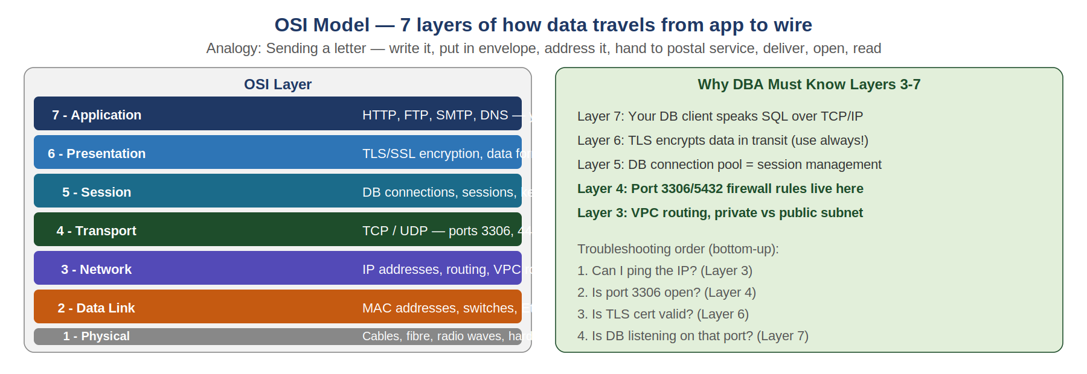
What the OSI model really means for you
Think of sending a database query from your app to MySQL. At Layer 7 (Application), your code says SELECT * FROM orders. At Layer 6 (Presentation), TLS encrypts it. At Layer 5 (Session), the database session maintains the connection. At Layer 4 (Transport), TCP breaks it into packets and sends on port 3306. At Layer 3 (Network), IP routing sends it to the right server IP across VPC subnets. Layers 1 and 2 are the physical cable and switch — AWS manages these invisibly.
Real-World Analogy
Sending a letter internationally: You write it (Layer 7 Application). Put it in a sealed envelope (Layer 6 Presentation/TLS). Address it to a specific department (Layer 5 Session). The postal service assigns a tracking number (Layer 4 Transport). Sort by country, city, postcode (Layer 3 Network routing). Load onto a van (Layer 2 Data Link). Drive on the road (Layer 1 Physical).

DBA to DevOps Mindset Bridge
When you get a connection refused error — the problem is Layer 4 (port blocked by firewall). When you get hostname not found — Layer 7 DNS failure. When connection succeeds but is slow — Layer 3 routing inefficiency or cross-region traffic. Knowing which layer to look at cuts your troubleshooting time in half.
Layer | Protocol / Example | Where to Look When Broken
7 - Application | HTTP, MySQL protocol, PostgreSQL wire protocol | DB logs, application logs, connection string errors
6 - Presentation | TLS 1.2/1.3 encryption, JSON/XML format | TLS certificate expired, SSL handshake failure
5 - Session | DB connection pool, keepalive, idle timeout | Too many connections, connection pool exhausted
4 - Transport | TCP port 3306, UDP port 53 | Security Groups, NACLs, firewall rules, netstat/ss
3 - Network | IP address, VPC routing, subnet | Route tables, VPC peering, wrong subnet, CIDR
2 - Data Link | MAC address, VPN, Ethernet | Managed by AWS — rarely a DBA concern in cloud

2.2 IP Addressing, CIDR, and Subnets
Every device on a network has an IP address — a unique number that identifies it. Understanding IP ranges, private vs public addresses, and CIDR notation is fundamental to designing secure AWS architectures that keep databases safely isolated.
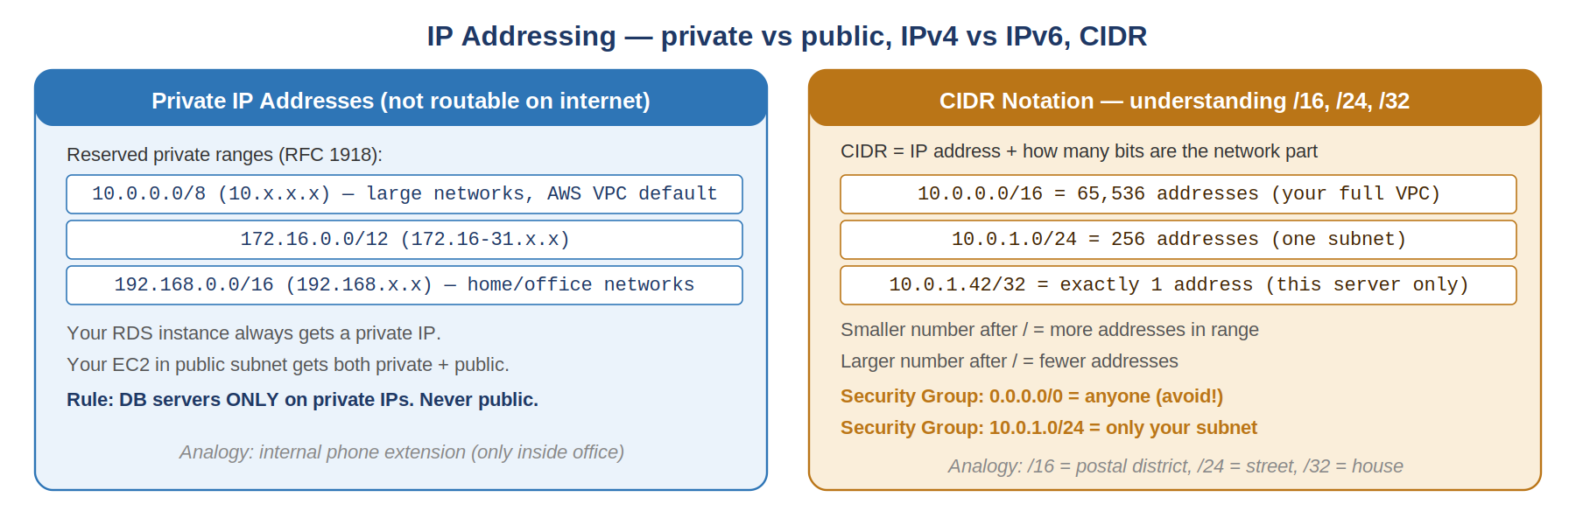
Private vs Public IP — the core security decision
Private IPs (10.x.x.x, 172.16-31.x.x, 192.168.x.x) are not routable on the public internet. A server with only a private IP cannot be reached from outside your network — which is exactly what you want for databases. Public IPs are routable from anywhere on the internet. Your web server needs a public IP. Your database should never have one.
CIDR Notation — reading /16, /24, /32
CIDR (Classless Inter-Domain Routing) tells you how large an IP range is. The number after the slash is how many bits are fixed for the network — the remaining bits define individual addresses. /16 fixes 16 bits, leaving 16 bits for hosts = 65,536 addresses. /24 fixes 24 bits, leaving 8 bits = 256 addresses. /32 fixes all 32 bits = exactly one specific IP address.
Real-World Analogy
/16 is like a postal district (e.g. London). /24 is a specific street in that district. /32 is a specific house number on that street. A security group rule with 10.0.0.0/16 allows traffic from the entire VPC. A rule with 10.0.1.42/32 allows only from that one specific server.

CIDR | Range | Number of Addresses | Typical Use
10.0.0.0/8 | 10.0.0.0 to 10.255.255.255 | 16 million | Enterprise networks, large AWS VPCs
10.0.0.0/16 | 10.0.0.0 to 10.0.255.255 | 65,536 | Standard AWS VPC size for a project
10.0.1.0/24 | 10.0.1.0 to 10.0.1.255 | 256 | One subnet (public or private)
10.0.1.42/32 | 10.0.1.42 only | 1 (exact IP) | Single server allow in Security Group
0.0.0.0/0 | All IPv4 addresses | All (internet) | Public internet — use with extreme caution

DBA to DevOps Mindset Bridge
When designing an AWS VPC for a database project: use 10.0.0.0/16 for the VPC, 10.0.1.0/24 for the public subnet (web/bastion), and 10.0.2.0/24 for the private subnet (RDS). This gives you 256 addresses per subnet — more than enough, with room to add subnets later in the /16 range.
Critical Rule: Never put a database in a subnet that has a route to the Internet Gateway. Always private subnet. If you need to access the DB for admin work, use a bastion host or VPN — not a public IP on the DB.

2.3 TCP vs UDP — Why Databases Always Use TCP
Two main transport protocols carry data across networks: TCP (reliable, ordered, connection-based) and UDP (fast, connectionless, best-effort). Every database engine uses TCP because data integrity is non-negotiable — a lost or reordered query packet would corrupt the response.
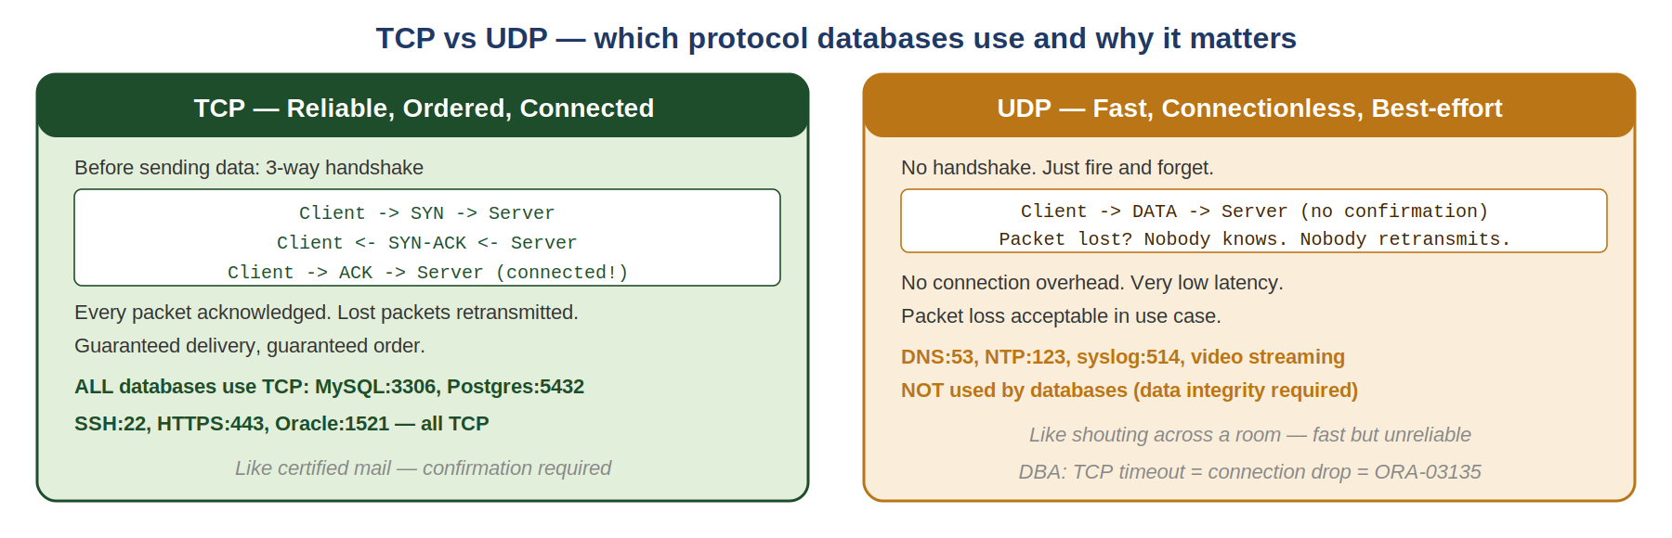
TCP 3-Way Handshake — the foundation of every DB connection
Before any data flows, TCP establishes a connection through a 3-way handshake: the client sends SYN (I want to connect), the server responds SYN-ACK (I accept, here is my sequence number), the client sends ACK (confirmed). Only after this handshake does data flow. Every MySQL connection, every RDS query, every replication stream starts with this exact sequence. Understanding this explains why connection setup has latency, and why firewalls that drop SYN packets prevent connections completely.
TCP Keepalive — preventing silent disconnections
TCP keepalive sends small probe packets on idle connections to confirm both sides are still alive. Without keepalive, a firewall or NAT gateway may silently drop an idle connection after a timeout (often 5-15 minutes). The application thinks the connection is still valid, but the next query fails. This is a very common DBA production issue with connection pools — set tcp_keepalive_time in MySQL and keepalives in your connection pool.
Real-World Analogy
TCP is like certified mail. You send a letter, the post office confirms delivery, and if it gets lost it resends. UDP is like dropping leaflets from an aircraft — fast delivery to many, but no confirmation, no retransmit, some never arrive. Databases need certified mail because a single corrupted SQL packet could produce wrong results.

Protocol | Connection | Reliability | Used By | DBA Impact
TCP | Connection required (3-way handshake) | Guaranteed delivery and order | MySQL:3306, PostgreSQL:5432, Oracle:1521, SSH:22, HTTPS:443 | Every DB connection is TCP. Firewall blocks SYN = no connection.
UDP | No connection, fire-and-forget | Best effort, can lose packets | DNS:53, NTP:123, syslog:514, DHCP | DNS for DB hostnames uses UDP. NTP for transaction timestamps uses UDP.

DBA to DevOps Mindset Bridge
When you see MySQL ERROR 2013: Lost connection to MySQL server during query — that is TCP keepalive timeout. A firewall or NAT gateway dropped the idle TCP connection. Fix: set wait_timeout in MySQL, set connection pool keepalive, or adjust net_read_timeout. You have seen this exact problem — now you know the networking layer causing it.
TCP Error | Root Cause | Fix
ERROR 2003: Can't connect | Port 3306 not reachable — TCP handshake fails | Open Security Group inbound rule for port 3306 from app server SG
ERROR 2013: Lost connection | TCP connection dropped by firewall/NAT during idle | Enable TCP keepalive, reduce wait_timeout, use connection pool keepalive
Connection timeout after 10s | NAT Gateway or firewall rejecting SYN | Check route table — does private subnet route to NAT Gateway?
High connection count | Connection pool not reusing TCP connections | Configure max_pool_size, test connection health check, enable keepalive

2.4 DNS — Name Resolution for DBAs
DNS (Domain Name System) translates human-readable hostnames into IP addresses. Every RDS endpoint, every EC2 hostname, every S3 URL goes through DNS. For DBAs, DNS is critical during failovers — when the primary database fails over, the DNS endpoint updates to point to the new primary.
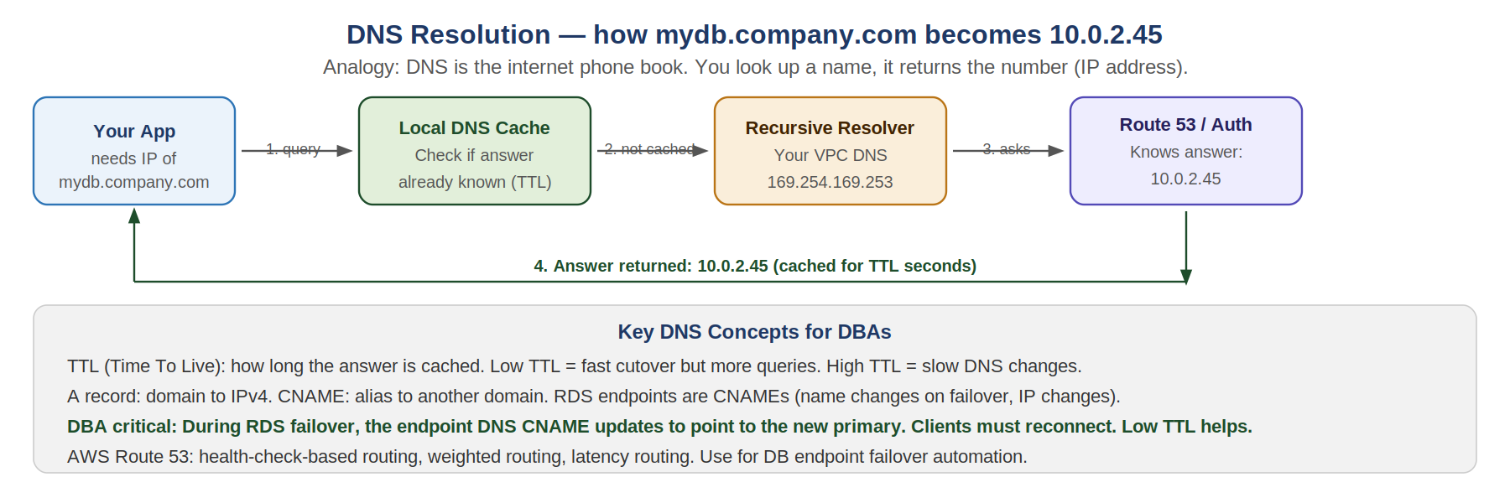
How DNS Resolution Works
When your application connects to mydb.us-east-1.rds.amazonaws.com, your operating system first checks its local cache. If not found, it asks the configured DNS resolver (in VPC: 169.254.169.253, the AWS resolver). The resolver asks Route 53 or the authoritative server. The answer comes back: the endpoint resolves to 10.0.2.45. This answer is cached for TTL seconds. Next query within TTL: served from cache instantly.
TTL — Time To Live — the most important DNS number for DBAs
TTL is how long a DNS answer is cached before clients re-query. High TTL (86400 = 1 day): fast, low DNS traffic, but DNS changes take a full day to propagate. Low TTL (30-60 seconds): slower (more DNS queries), but changes take effect in 30-60 seconds. For RDS Multi-AZ: AWS sets RDS endpoint TTL at 5 seconds. When failover happens, the endpoint CNAME updates within seconds. Applications must reconnect (close and reopen connection) to get the new IP. Connection pools that cache resolved IPs without respecting TTL will keep trying the old (dead) primary.
Real-World Analogy
DNS is like a phone contacts list with an expiry date. You saved Danish's number as 0300-1234567 and it expires in 60 seconds. After 60 seconds you re-check the directory to see if his number changed. If you never re-check (ignore TTL), you keep calling the old number even after he changed it. During RDS failover: the directory changes immediately, but apps that cached the old IP never re-check and keep connecting to the dead primary.

DNS Record Type | What It Does | DBA Relevance
A Record | Maps hostname directly to IPv4 address | EC2 instance public DNS -> public IP
CNAME | Alias — maps one hostname to another hostname | RDS endpoint is a CNAME (changes on failover without IP change)
PTR Record | Reverse lookup — IP to hostname | Used in DB connection logging, useful for audit trails
SOA Record | Start of Authority — defines DNS zone authority | Understanding who controls your company's DNS zone
TTL | How long the cached answer is valid | Critical: low TTL on RDS endpoints for fast failover

Route 53 for High Availability — health-check routing
AWS Route 53 can route DB connection traffic based on health checks. Configure a Route 53 health check on your primary RDS endpoint (port 3306). Route 53 sends DNS queries to the primary. If health check fails, Route 53 automatically answers with the standby endpoint instead. Applications reconnect to the standby via DNS, with no manual intervention. This works for both RDS Multi-AZ and cross-region active-passive setups.

DBA to DevOps Mindset Bridge
RDS Multi-AZ failover process: Primary DB fails -> AWS detects -> RDS promotes standby -> RDS updates the CNAME endpoint (5 second TTL) -> Applications that reconnect get the new primary IP -> Failover complete in 60-120 seconds. Applications that do not handle reconnection (or have high-TTL cached IPs) will stay broken until they restart. Your connection pool must retry with reconnect=true.

DNS Labs

Lab — DNS Resolution Testing
# Basic DNS lookup nslookup google.com
# Detailed DNS with record types dig google.com A
# Check RDS endpoint resolution nslookup mydb.us-east-1.rds.amazonaws.com
# Check TTL on RDS endpoint dig mydb.us-east-1.rds.amazonaws.com | grep -i ttl
# Trace full DNS resolution path dig +trace mydb.us-east-1.rds.amazonaws.com
# Reverse lookup (IP to hostname) nslookup 10.0.2.45
# Test if local cache vs fresh query # First query: goes to DNS server # Second query (within TTL): from cache — should be faster
Expected Result: nslookup returns IP address. dig shows TTL value. For RDS endpoints: note the CNAME chain before the final A record IP.
Common Mistake: If ping by IP works but nslookup fails for the same host: DNS is broken, not the server. Check VPC DNS settings (enableDnsSupport and enableDnsHostnames must both be true).

2.5 Ports, Firewalls, and AWS Security Groups
A port is a numbered door on a server that routes traffic to a specific service. A firewall decides which ports are open or blocked. AWS Security Groups are stateful virtual firewalls attached to EC2 and RDS instances. Understanding ports and Security Groups is essential for any DBA working in AWS.
What is a Port?
Every server has 65,535 possible ports (numbered 0-65535). Each service listens on a specific port number. When your app connects to a database, it sends traffic to port 3306 (MySQL) or 5432 (PostgreSQL). The operating system delivers that traffic to the MySQL or PostgreSQL process because it is registered to listen on that port. If nothing is listening on that port, you get 'Connection refused'. If a firewall blocks the port, you get a timeout.
Port | Service | Protocol | DBA Relevance
22 | SSH — Secure Shell | TCP | Connect to EC2 servers. Bastion host SSH access. NEVER open to 0.0.0.0/0.
80 | HTTP — unencrypted web | TCP | Web apps before SSL. Redirect to 443 in production.
443 | HTTPS — encrypted web | TCP | All web traffic. ALB listener. API calls over TLS.
1521 | Oracle Database listener | TCP | Your Oracle DBA daily port. Same Security Group rules apply.
3306 | MySQL / MariaDB | TCP | RDS MySQL. Open only to app server SG, never to internet.
5432 | PostgreSQL / Aurora PG | TCP | RDS PostgreSQL. Same rule: private only.
5439 | Amazon Redshift | TCP | Data warehouse port. Private subnet, analytics cluster access.
6379 | Redis (ElastiCache) | TCP | Cache layer. Always private subnet. Never public.
27017 | MongoDB | TCP | Document DB. Private subnet if using DocumentDB on AWS.

AWS Security Groups — stateful virtual firewall
Security Groups control inbound and outbound traffic for EC2 and RDS instances. They are stateful: if you allow inbound traffic on port 3306, the response traffic is automatically allowed back out without needing an explicit outbound rule. You attach Security Groups to instances, not to subnets. Multiple Security Groups can be attached to one instance. Crucially: Security Groups can reference other Security Groups — allow inbound port 3306 from app-server-sg means only EC2 instances with that Security Group can connect.
Real-World Analogy
A Security Group is like a doorman at a building who checks ID. The doorman (SG) on the database door only lets in people who show the app-server badge (app-server-sg). It does not matter where they came from — only the badge matters. If you show a different badge (or no badge), you are turned away, regardless of IP address.

Security Group Rule Type | Example | What It Controls
Inbound rule by CIDR | Allow TCP 3306 from 10.0.1.0/24 | Any IP in that subnet range can connect
Inbound rule by SG | Allow TCP 3306 from app-server-sg | Only EC2 with that SG can connect (recommended for DB)
Outbound rule | Allow all outbound traffic | Default: allows all. Can restrict to specific destinations.
No matching rule | Any traffic not explicitly allowed | Implicitly DENIED. Security Groups default-deny.

NACL vs Security Group — two layers of defence
NACLs (Network Access Control Lists) operate at the subnet level and are stateless — you must explicitly allow both inbound AND outbound traffic. They are processed in rule number order and stop at the first match. Security Groups operate at the instance level and are stateful. Use NACLs as a subnet-level guardrail (block entire IP ranges), use Security Groups for fine-grained per-instance control. For most DBA work, Security Groups are what you configure daily.

Critical Rule: Never create a Security Group rule allowing port 3306 from 0.0.0.0/0. This exposes your database to every IP on the internet. A database exposed publicly will be attacked within minutes. Always restrict to the specific app server Security Group or a specific VPN/office CIDR.

Security Group Labs

Lab — Create and Test Security Groups for RDS
- Open AWS Console -> EC2 -> Security Groups -> Create security group.
- Name: app-server-sg. Add inbound: TCP 22 from your office IP/32.
- Create second security group: rds-sg.
- Inbound rule: TCP 3306 from source = app-server-sg (select Security Group, not CIDR).
- Launch EC2 with app-server-sg and RDS with rds-sg.
- SSH to EC2. Try: nc -vz <RDS-endpoint> 3306 — should succeed.
- From your laptop: nc -vz <RDS-endpoint> 3306 — should fail (not in app-server-sg).
# From EC2 (in app-server-sg): nc -vz mydb.us-east-1.rds.amazonaws.com 3306 # Expected: Connection to mydb... 3306 port [tcp/mysql] succeeded!
# From your laptop (not in app-server-sg): nc -vz mydb.us-east-1.rds.amazonaws.com 3306 # Expected: nc: connect to ... port 3306 (tcp) timed out
Expected Result: EC2 in app-server-sg can reach RDS on port 3306. Your laptop cannot. Security Group isolation working correctly.
DBA to DevOps Mindset Bridge
Security Groups are your database firewall rules, but more flexible — they reference other Security Groups, not just IP ranges. This is better than IP-based rules because app server IPs can change (autoscaling), but the Security Group stays the same. Configure RDS Security Group to allow from app-server-sg and you never have to update the rule when servers scale.

2.6 AWS VPC Architecture — the Complete Picture
A VPC (Virtual Private Cloud) is your isolated private network in AWS. Every resource you create in AWS lives inside a VPC. Understanding VPC design determines how securely and efficiently your databases communicate with applications.
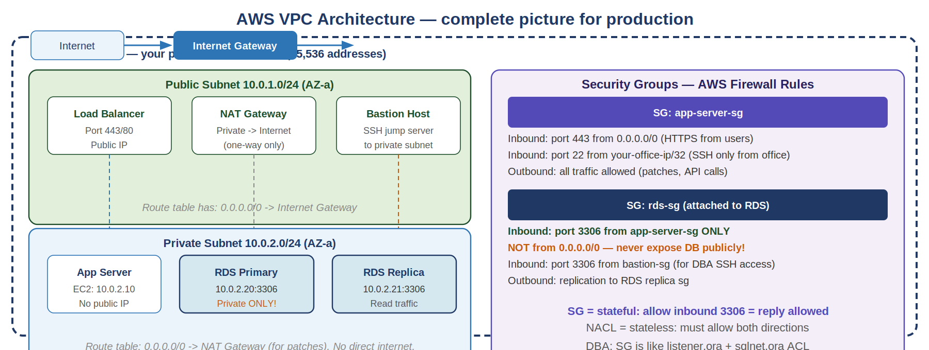
VPC Design for a Production Database Setup
A well-designed VPC has at least two Availability Zones (AZs) for redundancy, public subnets for internet-facing resources (load balancer, NAT gateway, bastion host), and private subnets for all databases and application servers. Resources in private subnets have no public IP and cannot receive inbound internet traffic — they can only be reached from within the VPC or via VPN.
Route Tables — traffic directors
Every subnet is associated with a route table that tells traffic where to go. Public subnets have a route: 0.0.0.0/0 -> Internet Gateway (traffic to anywhere goes via IGW). Private subnets have a route: 0.0.0.0/0 -> NAT Gateway (traffic to internet goes via NAT, cannot receive from internet). The absence of an IGW route is what makes a subnet private — it physically cannot accept inbound internet traffic.
Real-World Analogy
A VPC is a fenced office compound. The Internet Gateway is the main entrance/exit gate. The public subnet is the reception area and lobby — accessible to visitors. The private subnet is the secure back office where the servers and database room are — you need a keycard and the right clearance to enter. The NAT Gateway is a one-way door in the fence — staff inside can call out for deliveries (outbound to internet), but the courier cannot walk in uninvited (no inbound from internet).

VPC Component | What It Does | Required For
VPC | Your private network boundary. Contains all subnets. | Everything. First thing you create.
Internet Gateway (IGW) | Allows inbound+outbound internet traffic to public subnets. | Public-facing load balancers, bastion hosts.
Public Subnet | Subnet with route to IGW. Resources can have public IPs. | Load balancer, NAT Gateway, bastion host.
Private Subnet | Subnet WITHOUT route to IGW. No inbound from internet. | RDS databases, application servers, ElastiCache.
NAT Gateway | Allows private subnet resources to initiate outbound internet connections. | Private EC2/RDS downloading patches, calling external APIs.
Route Table | Rules that direct traffic: where does 0.0.0.0/0 go? | Controls whether subnet is public (-> IGW) or private (-> NAT).
Security Group | Instance-level stateful firewall. Attached to EC2 and RDS. | Fine-grained port-level access control.
NACL | Subnet-level stateless firewall. Extra guardrail. | Block entire IP ranges at subnet boundary.
VPC Peering | Connect two VPCs so they can communicate privately. | Multi-account setups, shared services VPC.
Bastion Host | EC2 in public subnet. SSH to it, then SSH to private servers. | Admin access to private subnet EC2 and RDS.

Lab — Design Your VPC on Paper First
Purpose: Before clicking in the console, design the network on paper. This is the most important habit for avoiding misconfigurations.
# Your VPC Design for a DB project: # VPC CIDR: 10.0.0.0/16 # # Public Subnet A (AZ us-east-1a): 10.0.1.0/24 # - Application Load Balancer # - NAT Gateway # - Bastion Host (EC2 for SSH access) # # Private Subnet A (AZ us-east-1a): 10.0.2.0/24 # - App servers (EC2) # - RDS Primary (MySQL 8.0) # # Private Subnet B (AZ us-east-1b): 10.0.2.0/24 # - RDS Standby (Multi-AZ replica) # # Route Tables: # Public: 0.0.0.0/0 -> Internet Gateway # Private: 0.0.0.0/0 -> NAT Gateway # # Security Groups: # alb-sg: inbound 443 from 0.0.0.0/0 # app-sg: inbound 8080 from alb-sg # bastion-sg: inbound 22 from your-office-ip/32 # rds-sg: inbound 3306 from app-sg AND bastion-sg
Expected Result: You have a complete network design written down before touching the AWS Console. This prevents 90% of VPC configuration mistakes.
DBA to DevOps Mindset Bridge
Designing a VPC is like designing a database schema — get it right before you build it, because changing it later is painful. The VPC CIDR cannot be changed after creation. Subnet CIDRs cannot change. Route table associations can change but require careful planning. Think first, click second.

2.7 NAT Gateway vs Internet Gateway — the DB Server Rule
This is the most commonly misunderstood networking concept for DBAs moving to AWS. NAT Gateway and Internet Gateway serve completely different purposes — and understanding which one your database subnet uses determines your security posture.
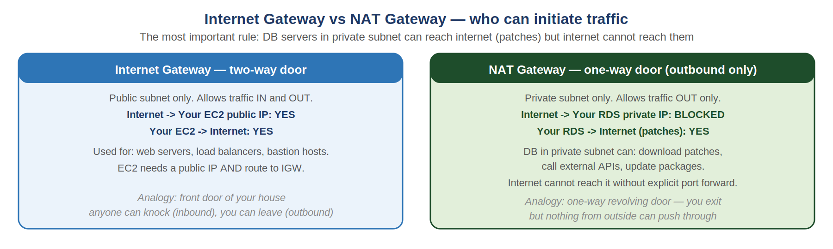
Internet Gateway — bidirectional internet access
The Internet Gateway allows traffic to flow in both directions between your subnet and the public internet. A resource in a subnet with an IGW route AND a public IP address can: receive connections from the internet (e.g. a web server receiving HTTPS traffic), and initiate connections to the internet (e.g. downloading packages). If your database is in a public subnet with an IGW route, anyone on the internet can attempt to connect to port 3306. This is a critical security risk.
NAT Gateway — outbound only for private subnets
The NAT Gateway sits in a public subnet and allows private subnet resources to initiate outbound internet connections ONLY. The key word is initiate — your RDS instance can call out to download patches or send logs to CloudWatch. But the internet cannot initiate connections to your RDS instance because it has no public IP and no IGW route. The NAT Gateway translates the private IP to its own public IP for outbound requests, and routes responses back.
Question | Internet Gateway | NAT Gateway
Can internet initiate connection to my resource? | YES (if resource has public IP) | NO (private subnet, no public IP)
Can my resource connect to the internet? | YES | YES (outbound only)
Where is it placed? | Internet Gateway — attached to VPC | NAT Gateway — placed in PUBLIC subnet
What subnet should my DB be in? | Never public with IGW route | Private subnet with NAT Gateway route
Cost | Free (part of VPC) | ~$0.045/hour + $0.045/GB data

Critical Rule: Your RDS database should NEVER be in a subnet with a route to the Internet Gateway. If it must reach the internet (patches, CloudWatch), put it in a private subnet and route through NAT Gateway. If even NAT is not needed, remove the 0.0.0.0/0 route entirely from the private subnet route table.
DBA to DevOps Mindset Bridge
The NAT Gateway is like the mailroom of a secure building. Staff inside (your private RDS) can send mail out (outbound internet calls). But the mailroom does not let delivery people walk directly into the server room. All deliveries are received by the mailroom and only passed in if explicitly requested. The internet never gets a direct path to your database.

Lab — Verify Your RDS Has No Public Route
# Check which route table your RDS subnet uses: aws ec2 describe-route-tables --filters 'Name=association.subnet-id,Values=subnet-XXXXX'
# Look for routes. SAFE result (private subnet): # Destination: 10.0.0.0/16 Target: local # Destination: 0.0.0.0/0 Target: nat-XXXXXXX <- NAT Gateway # UNSAFE result (public subnet with IGW): # Destination: 0.0.0.0/0 Target: igw-XXXXXXX <- Internet Gateway DANGER!
# Check if RDS has a public IP: aws rds describe-db-instances --query 'DBInstances[*].{ID:DBInstanceIdentifier,Public:PubliclyAccessible}'
Expected Result: RDS subnet route table shows NAT Gateway (not IGW) for 0.0.0.0/0. RDS PubliclyAccessible shows false. Both must be true for a secure setup.

2.8 Load Balancers — HA and Zero-Downtime Deployments
A load balancer distributes incoming network traffic across multiple servers so no single server is overwhelmed, and so deployments and server failures do not cause downtime. For DBAs, load balancers also provide proxy-based connection pooling and database failover through services like RDS Proxy.
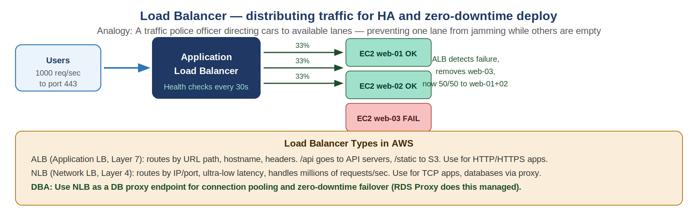
Why load balancers matter for databases
Even if your application servers use a load balancer, every one of them opens individual connections to the database. With autoscaling, you might have 50 app servers each opening 20 connections to RDS = 1,000 connections. MySQL's max_connections might be 500. Solution: RDS Proxy acts as a connection pool load balancer between the application and RDS — pooling and sharing connections across all app servers, dramatically reducing DB connection count.
Health Checks — detecting failures automatically
Load balancers continuously check if backend servers are healthy by sending probe requests (e.g. HTTP GET /health or TCP connect to port 3306). If a server fails to respond within the threshold, the load balancer marks it unhealthy and stops sending traffic to it. Healthy servers absorb the extra load. When the failed server recovers, traffic gradually returns. This happens automatically without any manual intervention.
Load Balancer Type | Layer | Best Used For | DBA Relevance
ALB (Application LB) | 7 (HTTP/HTTPS) | Web apps, APIs, microservices. Route by URL path or header. | App tier in front of API servers that call the DB.
NLB (Network LB) | 4 (TCP/UDP) | High throughput, low latency. Millions of requests/sec. | TCP load balancing. Can front-end a DB proxy.
RDS Proxy | 7 (DB protocol) | Connection pooling for RDS MySQL/PostgreSQL. | Direct DBA tool — reduces connections, faster failover.
Gateway LB | 3 (Network) | Third-party firewalls, intrusion detection. | Security appliances in front of VPC traffic.

RDS Proxy — the load balancer for your database
RDS Proxy sits between your application and RDS. It maintains a pool of connections to RDS and multiplexes application requests across them. Benefits: Applications connect to RDS Proxy (never directly to RDS). RDS Proxy maintains persistent connections to RDS. On RDS failover, RDS Proxy detects the new primary within seconds and routes new requests there — much faster than waiting for DNS TTL. Connection pool reduces RDS max_connections usage dramatically.
DBA to DevOps Mindset Bridge
You have managed Oracle Connection Manager or MySQL ProxySQL. RDS Proxy is the managed AWS equivalent. Configure RDS Proxy once, point all applications to the Proxy endpoint instead of the RDS endpoint, and get automatic connection pooling, failover handling, and IAM authentication support for free.

2.9 TLS and SSL — Encrypting Database Connections
TLS (Transport Layer Security, the modern version of SSL) encrypts data in transit between your application and database. Without TLS, anyone on the network path — including cloud infrastructure — can read database queries and results in plain text.
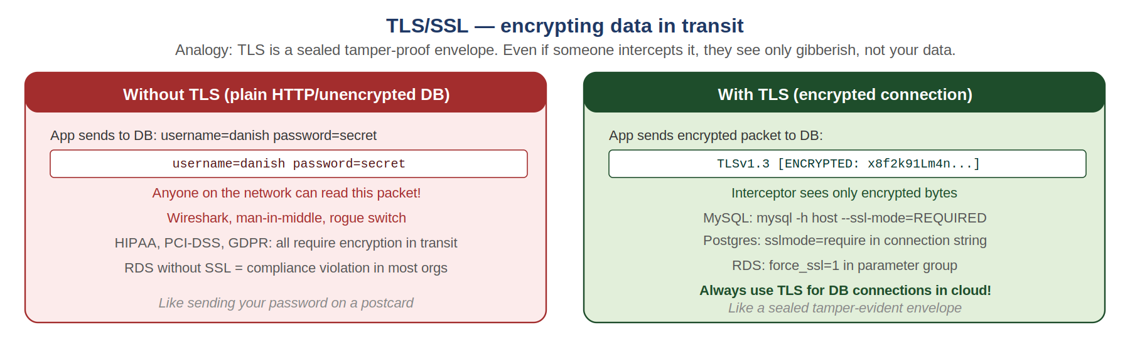
Why TLS for databases is mandatory
Database connections carry the most sensitive data in your organisation: customer records, financial transactions, personal information, passwords. Without TLS, this data travels as plain text inside AWS. While AWS internal traffic is unlikely to be intercepted, compliance frameworks (PCI-DSS, HIPAA, SOC2, GDPR) explicitly require encryption in transit. RDS supports TLS for MySQL, PostgreSQL, Oracle, and SQL Server. Enabling it takes one parameter change.
How TLS Works — simplified for DBAs
TLS uses asymmetric encryption (public/private key pair) for the initial handshake to securely exchange a symmetric session key. After that, all data is encrypted with the faster symmetric key. For RDS: AWS provides the CA certificate (Amazon Root CA). Your application must trust this certificate. Connection string adds ssl-mode=require or sslmode=require. Every query is now encrypted end-to-end.

Database | How to Enable TLS | Connection String Example
AWS RDS MySQL | Set require_secure_transport=ON in parameter group | mysql -h endpoint --ssl-mode=REQUIRED --ssl-ca=rds-ca.pem
AWS RDS PostgreSQL | Set ssl=on in parameter group (default on RDS) | psql 'host=endpoint sslmode=require sslrootcert=rds-ca.pem'
AWS RDS Oracle | SSL option group configuration | jdbc:oracle:thin:@...?ssl=true
Amazon Redshift | Default TLS on. sslmode parameter. | jdbc:redshift://cluster.region.redshift.amazonaws.com:5439/db?ssl=true
ElastiCache (Redis) | TLS in transit enabled at cluster creation | rediss://cluster.cache.amazonaws.com:6380 (note: rediss not redis)

Lab — Enable and Verify TLS on MySQL RDS
# Download Amazon RDS CA bundle: curl -o rds-ca.pem https://truststore.pki.rds.amazonaws.com/global/global-bundle.pem
# Connect WITH TLS required: mysql -h mydb.us-east-1.rds.amazonaws.com -u admin -p \ --ssl-mode=REQUIRED --ssl-ca=rds-ca.pem
# Verify TLS is active inside MySQL: mysql> SHOW STATUS LIKE 'Ssl_cipher'; # Should return: Ssl_cipher | AES256-GCM-SHA384 (or similar)
# In RDS Parameter Group: set force_ssl=1 # This FORCES all connections to use TLS # Connections without TLS are REJECTED
# Verify no unencrypted connections: mysql> SELECT user, host, ssl_type FROM mysql.user;
Expected Result: Ssl_cipher shows an active cipher name (not empty). Connections without --ssl-mode=REQUIRED or from clients that do not support TLS are rejected when force_ssl=1.
Common Mistake: Do not set force_ssl=1 before updating all applications to connect with TLS. You will lock yourself out of the database if legacy applications do not support TLS.
DBA to DevOps Mindset Bridge
You already use SSH (TLS-like encryption) to connect to servers. TLS for databases is the exact same concept — your SQL queries get the same protection as your SSH commands. Once force_ssl=1 is set in your parameter group, the database refuses any unencrypted connection, just like SSH with PasswordAuthentication=no refuses password logins.

2.10 Network Troubleshooting — Systematic Debugging
The most valuable networking skill is systematic troubleshooting from the bottom up. Always start at Layer 3 (can I reach the IP?) and work up to Layer 7 (can the application connect?). Jumping straight to application logs wastes time — 80% of 'database connection issues' are actually network or firewall issues.
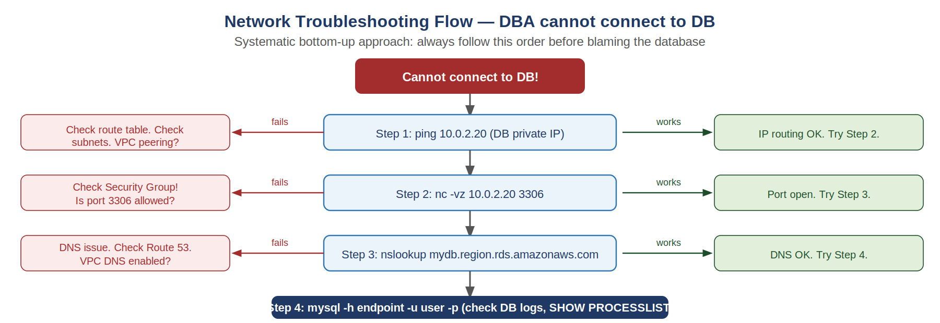
The Bottom-Up Rule — always follow this order
Layer 3 first: Can I ping the IP? If not, routing or VPC peering issue. Layer 4 next: Can I nc or telnet to the specific port? If not, Security Group or NACL blocking the port. Layer 7 DNS: Does the hostname resolve to the correct IP? If not, DNS or Route 53 issue. Layer 7 App: Can the application actually authenticate and query? If not, DB-level issue (wrong credentials, max_connections, DB not started).

Complete Troubleshooting Command Reference

Layer 3 — IP Routing
Command | What It Tests | What Failure Means
ping 10.0.2.20 | Basic IP reachability | No route, wrong subnet, NACL blocking ICMP
traceroute 10.0.2.20 | Full hop-by-hop path to destination | See exactly where packets stop — useful for VPC peering
ip route show | Local routing table | See what routes exist on this server
aws ec2 describe-route-tables | AWS VPC route table | Check if subnet routes to IGW or NAT correctly

Layer 4 — Port Connectivity
Command | What It Tests | What Failure Means
nc -vz 10.0.2.20 3306 | TCP connection to MySQL port | Security Group, NACL, or nothing listening on 3306
nc -vz host 443 | TCP connection to HTTPS port | Certificate or load balancer port issue
ss -lntp | Local listening ports | Check if MySQL is actually listening on 3306
ss -tnp | grep 3306 | Active MySQL connections | See current connections and their states
telnet 10.0.2.20 3306 | Old-style TCP port test | Works on Windows where nc is unavailable

DNS — Layer 7 Name Resolution
Command | What It Tests | What Failure Means
nslookup host | DNS resolution for hostname | DNS server unreachable or record missing
dig host A | Detailed DNS lookup with TTL | Check TTL, see full resolution chain
dig +trace host | Full recursive DNS resolution | See each server in the DNS chain
dig @169.254.169.253 host | Query AWS internal resolver directly | VPC DNS service health check
host hostname | Simple DNS lookup | Quick check for dev use

Application — Layer 7 Database Connectivity
# MySQL connection test: mysql -h 10.0.2.20 -u admin -p --connect-timeout=10
# Test with specific port: mysql -h endpoint -P 3306 -u admin -p
# Verbose SSL debug: mysql -h endpoint -u admin -p --ssl-mode=REQUIRED -v
# Check max connections status: mysql> SHOW GLOBAL STATUS LIKE 'Threads_connected'; mysql> SHOW GLOBAL VARIABLES LIKE 'max_connections';
# Check who is connected: mysql> SHOW PROCESSLIST;

Quick Reference — Most Common Errors and Fixes
Error Message | Root Cause | Fix
ERROR 2003: Can't connect | TCP port unreachable | Check Security Group inbound rule for port 3306 from your source SG/IP
ERROR 2013: Lost connection | TCP connection dropped mid-query | Enable keepalive, check wait_timeout, check NAT gateway timeout settings
ERROR 1040: Too many connections | max_connections exceeded | Use RDS Proxy, increase max_connections, check for connection leaks
host not found | DNS resolution failure | Check Route 53 record, VPC DNS settings (enableDnsSupport=true)
Connection refused | Port open but nothing listening | Check if MySQL service is running: systemctl status mysql
SSL connection error | TLS certificate mismatch | Download correct Amazon RDS CA bundle, update connection string
timeout (no error) | Firewall silently dropping packets | Security Group or NACL blocking traffic, no response sent back

DBA to DevOps Mindset Bridge
Your DBA incident response is perfect networking troubleshooting: you check the alert log, check active sessions, check wait events, check replication status — all in a specific order. Apply the same discipline to networking: check Layer 3 (ping), Layer 4 (nc port), DNS (nslookup), then application (mysql client). Do not skip layers. The answer is almost always at Layer 4 (Security Group).

2.11 Comprehensive Networking Labs
These labs bring together all networking concepts. Complete them in order — each one builds on the previous. All labs use your Ubuntu VM for free, with optional AWS steps clearly marked.

Lab 2-A — Build a Complete Local Network Map
Purpose: Understand your own network before working with cloud networks.
# 1. Find your IP, gateway, and DNS ip addr show # Your IP addresses ip route show # Your default gateway cat /etc/resolv.conf # Your DNS servers
# 2. Test connectivity layers in order: ping -c 4 8.8.8.8 # Layer 3: Can you reach internet IP? nslookup google.com # DNS: Can you resolve names? curl -I https://google.com # Layer 7: Full HTTP/S test
# 2. Scan what is listening on your VM: ss -lntp # All listening ports and processes sudo netstat -tulnp # Alternative command
# 4. Test port connectivity to a public service: nc -vz google.com 443 # HTTPS port - should succeed nc -vz google.com 3306 # MySQL port - should fail (not open publicly)
Expected Result: You can identify your IP, gateway, DNS server. ping succeeds. Port 443 to google.com succeeds. Port 3306 to google.com fails (expected — Google does not run MySQL publicly).

Lab 2-B — DNS Deep Dive
Purpose: Understand how DNS resolution works and practice diagnosing DNS issues.
# Install dig if not present: sudo apt install dnsutils -y
# 1. Basic lookup: nslookup amazon.com dig amazon.com A
# 2. Check TTL: dig amazon.com | grep -i ttl
# 2. Full resolution trace (watch each DNS server in chain): dig +trace google.com
# 4. Query specific DNS server directly: dig @8.8.8.8 amazon.com # Query Google's DNS dig @169.254.169.253 google.com # Query AWS resolver (from EC2 only)
# 5. Simulate DNS failure by breaking resolution: sudo sh -c 'echo "nameserver 1.2.2.4" > /etc/resolv.conf' nslookup google.com # Should fail # Fix it: sudo sh -c 'echo "nameserver 8.8.8.8" > /etc/resolv.conf' nslookup google.com # Should work again
Expected Result: dig shows TTL value for amazon.com. +trace shows the full DNS chain. Breaking /etc/resolv.conf causes DNS failure even though IP connectivity (ping) still works — demonstrating the Layer 3 vs DNS distinction.
Common Mistake: Restore /etc/resolv.conf to its original content after the DNS break test or your VM will lose name resolution.

Lab 2-C — TLS Certificate Inspection
Purpose: Understand TLS certificates, expiry dates, and what information they contain.
# 1. Connect and inspect TLS certificate: openssl s_client -connect google.com:443 -brief
# 2. Check certificate expiry date: openssl s_client -connect amazon.com:443 2>/dev/null | openssl x509 -noout -dates
# 2. See full certificate details: openssl s_client -connect amazon.com:443 2>/dev/null | openssl x509 -noout -text | head -40
# 4. Download RDS CA bundle and inspect: curl -o rds-ca.pem https://truststore.pki.rds.amazonaws.com/global/global-bundle.pem openssl x509 -in rds-ca.pem -noout -dates -subject
Expected Result: You see certificate issuer, subject, and expiry dates. You understand what 'certificate expired' means — the notAfter date has passed. You have the RDS CA bundle ready for connecting to RDS with TLS.

Lab 2-D — AWS VPC Setup with Correct Security Groups (AWS Free Tier)
Purpose: Create a properly designed VPC with public and private subnets and correct Security Group isolation.
- AWS Console -> VPC -> Create VPC -> VPC and more.
- Name: devops-lab-vpc. IPv4 CIDR: 10.0.0.0/16.
- Number of AZs: 2. Public subnets: 2. Private subnets: 2.
- NAT Gateways: 1 (in 1 AZ). VPC endpoints: none.
- Create VPC. Review the created subnets and route tables.
# Verify route tables via CLI: aws ec2 describe-route-tables --filters 'Name=vpc-id,Values=vpc-XXXXX' \ --query 'RouteTables[*].{ID:RouteTableId,Routes:Routes}'
- Create Security Groups: app-server-sg (inbound 22 from your IP), rds-sg (inbound 3306 from app-server-sg).
- Launch EC2 in public subnet with app-server-sg. Connect via SSH.
- From EC2: nc -vz <private-subnet-IP> 3306 — simulate reaching RDS.
Expected Result: VPC created with proper subnets. Public subnet route table has Internet Gateway. Private subnet route table has NAT Gateway. EC2 in public subnet can be SSH'd. Security Group allows port 3306 only from app-server-sg.
Common Mistake: Delete the NAT Gateway and release the Elastic IP after this lab. NAT Gateways cost ~$0.045/hour even when idle. Keep the VPC but remove NAT to avoid charges.

Lab 2-E — Full Connectivity Troubleshooting Exercise
Purpose: Practice the systematic troubleshooting flow on a deliberately broken connection.
# Setup: Install nginx on your Ubuntu VM sudo apt install nginx -y sudo systemctl start nginx # Check it is listening: ss -lntp | grep nginx # Should show 0.0.0.0:80
# Now simulate a firewall block using iptables: sudo iptables -A INPUT -p tcp --dport 80 -j DROP # Try to connect (from same VM, simulating external attempt): curl -m 5 http://localhost # Should timeout nc -vz localhost 80 # Should timeout
# Troubleshoot systematically: # Step 1 - Is the service listening? ss -lntp | grep :80 # Yes it is (nginx running) # Step 2 - Is the port blocked? sudo iptables -L INPUT -v -n # See the DROP rule # Step 3 - Fix it: sudo iptables -D INPUT -p tcp --dport 80 -j DROP curl http://localhost # Now works
# Clean up: sudo iptables -F # Flush all iptables rules
Expected Result: You deliberately break port 80 with iptables, diagnose it using the systematic method (service running? port blocked?), and fix it. This simulates the exact AWS Security Group troubleshooting flow.
DBA to DevOps Mindset Bridge
This iptables exercise is exactly what you do with AWS Security Groups — the mechanism is different but the diagnostic logic is identical. Service is running (systemctl status), port is open (ss -lntp), but traffic is blocked (iptables DROP = Security Group deny). Fix is remove the block (iptables -D = delete Security Group rule).

Quick Reference — Networking Commands for DBAs
Category | Command | What It Does
IP | ip addr show | Show all IP addresses on this server
IP | ip route show | Show routing table — where does traffic go
IP | ip route get 10.0.2.20 | Show specific route to a destination
Ping | ping -c 4 10.0.2.20 | Test Layer 3 connectivity (4 packets)
Ping | ping -c 4 -W 2 host | Ping with 2s timeout per packet
Trace | traceroute 10.0.2.20 | Show every hop between you and destination
Port | nc -vz host 3306 | Test if TCP port 3306 is reachable
Port | nc -vz -w 3 host 3306 | Port test with 3s timeout
Port | ss -lntp | Show all listening ports and processes
Port | ss -tnp | Show all active TCP connections
Port | ss -tnp | grep 3306 | Show only MySQL connections
DNS | nslookup hostname | Resolve hostname to IP
DNS | dig hostname A | Resolve with TTL and full details
DNS | dig +trace hostname | Full recursive DNS resolution trace
DNS | dig @8.8.8.8 hostname | Query specific DNS server
TLS | openssl s_client -connect host:443 | Connect and inspect TLS certificate
TLS | openssl x509 -in cert.pem -noout -dates | Check certificate expiry
HTTP | curl -I https://host | HTTP headers only (test endpoint)
HTTP | curl -v https://host | Verbose: see TLS handshake details
HTTP | curl -m 5 http://host | HTTP with 5s timeout
AWS | aws ec2 describe-security-groups | List Security Groups and rules
AWS | aws ec2 describe-route-tables | List route tables in VPC
AWS | aws rds describe-db-instances | Show RDS instances and endpoints
DB | mysql -h host -P 3306 -u user -p | Connect to MySQL on specific port
DB | mysql> SHOW PROCESSLIST | Active MySQL connections
DB | mysql> SHOW STATUS LIKE 'Ssl_cipher' | Verify TLS is active on connection

DBA to DevOps Networking — Complete Parallel Map
Every networking concept you have just learned has a direct parallel in your DBA world. You are not learning something entirely new — you are extending existing expertise into a new layer of the stack.

Networking Concept | AWS Implementation | DBA Parallel
IP address | EC2 private IP, RDS endpoint | DB hostname in tnsnames.ora / my.cnf
Port | SG inbound rule: TCP 3306 | Listener port, sqlnet.ora port config
Firewall rule | AWS Security Group | DB firewall, sqlnet access control
Private network | VPC private subnet | Isolated DB network (separate VLAN)
Name resolution | Route 53 CNAME for RDS | TNS alias, /etc/hosts for DB hostname
DNS TTL | 5 seconds on RDS CNAME endpoint | Time it takes failover to propagate
Failover DNS update | RDS Multi-AZ endpoint CNAME updates | Primary changes, SCAN IP updates
Load balancer | RDS Proxy for connection pooling | Oracle Connection Manager, ProxySQL
TLS encryption | RDS ssl=require, force_ssl=1 | Oracle SQLNet encryption, MySQL --ssl
NAT Gateway | Private RDS reaches internet outbound | DB server behind corporate proxy
Bastion host | Jump server to SSH to private EC2 | SQL*Plus via jump server
Security Group reference | Allow RDS SG inbound from app-SG | GRANT CONNECT to specific schema
VPC peering | Connect two private networks | DB link between two Oracle databases
Health check | ALB health check on /health | DB listener health check, PING command
Connection timeout | TCP keepalive, wait_timeout | sqlnet.expire_time, idle session timeout

You are already a networking engineer. You just did not know it yet.

