DANISH
DevOps & AWS — Deep-Dive Handbook
Chapter 5 — AWS Fundamentals
EC2 · S3 · IAM · VPC · RDS · CloudWatch
YOUR LAPTOP ──── internet ────► AWS CLOUD

ssh / browser ┌──────────────────────────────┐
│ Region (e.g. us-east-1) │
│ ┌──────────────────────┐ │
│ │ VPC 10.0.0.0/16 │ │
│ │ ┌────────┐ ┌──────┐ │ │
│ │ │Public │ │Priv. │ │ │
│ │ │Subnet │ │Subnet│ │ │
│ │ │ EC2 │ │ RDS │ │ │
│ │ └────────┘ └──────┘ │ │
│ └──────────────────────┘ │
│ S3 IAM CloudWatch │
└──────────────────────────────┘

Prerequisites: Chapter 1 (Laptop Setup) — AWS account and AWS CLI installed

AWS Learning Preparation
Before starting the AWS hands-on labs in this chapter, the following preparation steps were completed to ensure a secure, cost-controlled, and fully functional AWS environment. These steps should be completed once and verified before running any lab command.

📋 Preparation Goal
By completing all steps in this section you will have:
• A secure AWS account with MFA protection on root
• A dedicated IAM admin user for all daily work (never using root)
• A $5 billing alarm protecting against unexpected charges
• AWS CLI configured on your laptop and verified working
• Full readiness to start every lab in this chapter

Preparation Checklist — Completed Steps

Step | Item | Status | Notes
1 | Root AWS Account | ✅ Done | Account already existed before starting
2 | MFA on Root Account | ✅ Done | Multi-factor authentication already enabled
3 | IAM User: danish-admin | ✅ Done | Created with AdministratorAccess policy
4 | Budget Alarm $5 | ✅ Done | Alert fires at $4 (80% of $5)
5 | AWS CLI Installed | ✅ Done | Installed on laptop, version 2.x
6 | AWS CLI Configured | ✅ Done | Configured with danish-admin access keys
7 | CLI Tested | ✅ Done | aws sts get-caller-identity returns danish-admin

Step 1 and 2 — Root Account and MFA

The AWS root account was already in place before starting this handbook. MFA (Multi-Factor Authentication) was already enabled on the root account using an authenticator app. This is the most critical security step for any AWS account.

⚠️ Critical Rule
NEVER use the root account for daily work.
NEVER create CLI access keys for root.
Root account is used ONLY for account-level billing tasks.
All daily work uses the danish-admin IAM user created in Step 3.

Step 3 — Create IAM Admin User (danish-admin)

An IAM admin user was created for all daily AWS work. This user has AdministratorAccess but is NOT the root account — if the credentials are ever compromised they can be deleted and recreated without losing the account.

Steps Followed to Create the IAM User:
• AWS Console → search IAM → Users → Create user
• Username: danish-admin
• Enabled: Provide user access to the AWS Management Console
• Selected: I want to create an IAM user
• Set a strong console password
• Permissions: Attach policies directly → AdministratorAccess
• Downloaded credentials CSV — saved safely
• Logged out of root → logged in as danish-admin
• Bookmarked the IAM sign-in URL from the CSV

✅ IAM User Result
User: danish-admin
Policy: AdministratorAccess
Console access: Enabled
CSV saved: Yes (contains sign-in URL, username, password)
Daily login: Always use danish-admin — never root

Step 4 — Budget Alarm ($5 Protection)

A billing budget was created to protect against unexpected AWS charges during lab practice. The alarm fires an email alert when spending reaches $4 (80% of $5), giving enough time to stop resources before the full $5 is reached.

Steps Followed to Create Budget Alarm:
• AWS Console → search Budgets → AWS Budgets
• Click Create budget → Use a template → Monthly cost budget
• Budget name: Danish-Learning-Budget
• Budgeted amount: $5
• Email recipients: personal email address
• Alert threshold: 80% = alert fires at $4 spend
• Confirmed the SNS subscription email

Threshold | Action | Meaning
$4.00 (80%) | Email alert fires | Warning — stop unused resources now
$5.00 (100%) | Email alert fires | Budget exceeded — act immediately
Above $5 | No auto-stop | Must manually stop/delete resources

⚠️ Important — Budget Does NOT Auto-Stop Resources
The budget alarm ONLY sends an email alert.
It does NOT automatically stop or delete any resources.
When you receive an alert email you must manually:
• Stop EC2 instances not in use
• Delete RDS instances after lab completion
• Delete NAT Gateways immediately after lab (cost ~$1/day idle)
• Check Billing Dashboard to find what is generating cost

Step 5, 6 and 7 — AWS CLI Install, Configure and Test

The AWS CLI (Command Line Interface) allows you to control all AWS services from your laptop terminal instead of clicking through the browser console. It is required for Terraform, Ansible AWS modules, and all scripted automation in chapters 6, 7, and beyond.

Why CLI is Essential for DevOps:
Task | Console (Browser) | CLI (Terminal)
List EC2 instances | Open EC2 page and scroll | aws ec2 describe-instances
Stop an EC2 instance | Click instance → Actions → Stop | aws ec2 stop-instances --instance-ids i-xxx
Upload file to S3 | Open S3, find bucket, click Upload | aws s3 cp file.txt s3://my-bucket/
Run Terraform | Not possible | terraform apply (uses CLI credentials)
Automate in scripts | Not possible | Full scripting and CI/CD pipeline support

Steps Followed to Set Up AWS CLI:

Install:
• Downloaded AWS CLI v2 installer from AWS official page
• Installed with default settings on Windows laptop
• Restarted VS Code terminal after installation

Create Access Keys for danish-admin:
• AWS Console → IAM → Users → danish-admin
• Security credentials tab → Access keys → Create access key
• Use case: Command Line Interface (CLI)
• Downloaded CSV — Access Key ID and Secret Key saved safely

Configure CLI:
# Run this command in terminal
aws configure

# Enter when prompted:
AWS Access Key ID: AKIA... (from CSV)
AWS Secret Access Key: ........ (from CSV)
Default region name: us-east-1
Default output format: json

Test CLI is Working:
# Verify you are authenticated as danish-admin
aws sts get-caller-identity

# Expected output:
{
"UserId": "AIDAXXXXXXXXX",
"Account": "123456789012",
"Arn": "arn:aws:iam::123456789012:user/danish-admin"
}

# Verify S3 access
aws s3 ls

# Verify EC2 access
aws ec2 describe-instances --region us-east-1

✅ CLI Verification Result
aws --version → aws-cli/2.x.x installed
aws sts get-caller-identity → returns danish-admin ARN
Region configured → us-east-1
Output format → json
Status: FULLY READY for all Chapter 5 labs

Adding This Chapter's Work to GitHub

All lab work, notes, scripts, and configuration files should be committed to your devops-labs GitHub repository after each chapter. This builds your portfolio and ensures all work is backed up and version controlled.

Folder Structure for Chapter 5:
devops-labs/
└── aws/
├── README.md (notes on VPC, EC2, S3, RDS, IAM, CloudWatch)
├── preparation-notes.md (document today's setup steps)
├── vpc-design.txt (your VPC diagram notes from labs)
├── lifecycle.json (S3 lifecycle rule from lab)
└── cleanup-checklist.md (resource delete steps to avoid charges)

What NOT to Commit — Add to .gitignore:
# Add these to your .gitignore file
*.pem # EC2 private key files
credentials.csv # IAM access key CSV files
.aws/credentials # AWS CLI credentials file
terraform.tfvars # Terraform variable files with passwords
*.tfstate # Terraform state files

Git Commands to Commit Chapter 5 Work:
# Navigate to your devops-labs repository
cd ~/devops-labs

# Create the aws folder and add your notes
mkdir -p aws
echo '# AWS Chapter 5 Labs' > aws/README.md

# Check what you are about to commit
git status

# Stage all new files
git add aws/

# Commit with a clear message
git commit -m "add AWS Chapter 5 lab notes and preparation steps"

# Push to GitHub
git push

# Verify on GitHub.com that files appear in aws/ folder

📋 GitHub Commit Rules for AWS Labs
• Commit after completing each lab — not just at end of chapter
• Write descriptive commit messages: what did this lab create?
• Never commit .pem files, credentials CSV, or access keys
• Always run: git status before git add to see what you are staging
• Tag resources in AWS: Owner=Danish, Purpose=DevOps-Learning
• Delete lab resources after committing notes to avoid ongoing charges

AWS Cost Safety Rules — Always Follow These

Rule | Why It Matters
Always check Budget Dashboard before starting labs | Know your current spend before creating resources
Stop EC2 instances after every lab session | Stopped EC2 = no hourly charge. Running = charges accumulate
Delete RDS instances after each chapter | RDS charges by hour even when idle. Biggest lab cost risk
Delete NAT Gateways immediately after lab | Costs ~$1/day even with zero traffic. Easy to forget
Never open port 3306 (MySQL) to 0.0.0.0/0 | Public database = immediate attack target
Never commit AWS access keys to GitHub | Exposed keys are found by bots within minutes
Tag every resource: Owner=Danish Purpose=Learning | Easy to find and delete all lab resources at once
Check Billing Dashboard weekly | Catch unexpected charges before they grow
Use only t2.micro or t3.micro for EC2 labs | Free Tier eligible — larger instances cost money immediately
Delete unused EBS volumes and snapshots | These persist and charge even after EC2 is terminated

Why AWS for DevOps?
AWS (Amazon Web Services) is the world's most widely used cloud platform. It lets you spin up a server in 60 seconds, store petabytes of data, and build globally distributed systems — without buying a single piece of hardware. For a DBA moving into DevOps, AWS is where your Linux, networking, and database skills directly translate into cloud engineering skills.

🔗 Real-World Analogy
Think of AWS like a mega data-centre you can rent by the hour. Instead of buying servers (capital expenditure, months of procurement), you rent exactly what you need right now and stop paying the moment you are done. A t3.micro EC2 instance costs about $0.013/hour — less than a cup of coffee for a full day of practice.

AWS Service | What It Is | DBA Parallel
EC2 | Virtual Linux/Windows server in the cloud | Your database server — but you provision it in 60 seconds
RDS | Managed database (MySQL, Postgres, Oracle, SQL Server) | Your database — but AWS handles patching, backups, failover
S3 | Object storage — unlimited flat file storage | NFS / shared storage for exports, dumps, backups
IAM | Identity and access management — users, roles, policies | Database GRANT/REVOKE at the cloud level
VPC | Your private network inside AWS | Your database network — isolated, with security groups
CloudWatch | Metrics, logs, and alerts for all AWS services | Monitoring: CPU, connections, replication lag, disk
Security Group | Virtual firewall attached to EC2 and RDS | Database firewall — allow port 3306 from app server only

📋 Chapter Goal
By the end of this chapter you will have:
• An AWS Free Tier account with a $10 budget alarm protecting you
• An IAM admin user (never using root again)
• An EC2 Ubuntu server running in the cloud — SSH access working
• An S3 bucket holding a test file
• A basic VPC with public and private subnets
• A CloudWatch alarm on your EC2 CPU
• All lab resources cleaned up to stay within Free Tier

Concept 1 — IAM: Identity and Access Management

What is IAM?
IAM controls who can do what in your AWS account. Every API call, every console click, every CLI command goes through IAM. Users are human identities. Roles are machine identities (assumed by EC2, Lambda, etc.). Policies are JSON documents listing allowed or denied actions. Never use the root account for daily work.

🔗 Real-World Analogy
IAM is your database GRANT system at the cloud level. A GRANT SELECT ON orders TO analyst maps to an IAM policy that allows s3:GetObject on the orders-bucket. An EC2 instance role that can read S3 = an application user granted SELECT on a specific schema. Same principle: minimum necessary access, nothing more.

IAM Hierarchy

AWS ACCOUNT
│
├── Root Account (billing only — never use for work)
│
├── IAM User: danish-admin ← Your daily login
│ └── Policy: AdministratorAccess
│
├── IAM User: ci-deployer ← CI/CD pipeline user
│ └── Policy: only deploy to specific ECS cluster
│
└── IAM Role: ec2-s3-reader ← Attached to EC2 instances
└── Policy: s3:GetObject on backups bucket

Key rule: least privilege — grant ONLY what is actually needed

IAM Concept | What It Is | Example
Root Account | Master account created with email. Has ALL powers. | Only for billing setup. Create IAM admin and never use root again.
IAM User | A human identity with username + password + optional access keys. | danish-admin for console work. ci-user for CLI automation.
IAM Role | A machine identity assumed temporarily. No password — uses tokens. | EC2 role lets instance call S3 without storing credentials on disk.
IAM Policy | JSON document defining allowed or denied actions and resources. | Allow: ec2:Describe*, s3:PutObject on arn:aws:s3:::my-bucket/*
Access Key | Key ID + secret used by CLI and SDKs. Equivalent of password for code. | Never hardcode in scripts. Store in ~/.aws/credentials or use a role.
MFA | Multi-factor authentication — second factor for console login. | Enable on root and all admin IAM users immediately after creation.

🧠 DBA Mindset Bridge
IAM policies are your GRANT statements at the platform level. A DBA creates a read-only monitoring user: GRANT SELECT ON performance_schema TO monitor_user. An IAM policy does the same for AWS: allow cloudwatch:GetMetricData on *. Both enforce least privilege. Both use explicit allow — everything else is denied by default.

Concept 2 — VPC: Your Private Network

What is a VPC?
A VPC (Virtual Private Cloud) is your isolated private network inside AWS. Every resource — EC2, RDS, ElastiCache — lives inside a VPC. You control the IP ranges, subnets, route tables, and firewalls. Your database should ALWAYS be in a private subnet with no direct internet access.

Production VPC Design

VPC: 10.0.0.0/16 (65,536 IP addresses — your entire cloud network)

Availability Zone A Availability Zone B
┌──────────────────────────┐ ┌──────────────────────┐
│ Public Subnet │ │ Public Subnet │
│ 10.0.1.0/24 │ │ 10.0.3.0/24 │
│ ┌─────┐ ┌─────────┐ │ │ ┌─────┐ │
│ │ EC2 │ │ NAT GW │ │ │ │ ALB │ │
│ │(web)│ │ │ │ │ └─────┘ │
│ └─────┘ └─────────┘ │ └──────────────────────┘
│ │
│ Private Subnet │ ┌──────────────────────┐
│ 10.0.2.0/24 │ │ Private Subnet │
│ ┌─────────────────────┐ │ │ 10.0.4.0/24 │
│ │ RDS Primary (MySQL) │ │ │ ┌──────────────────┐ │
│ └─────────────────────┘ │ │ │ RDS Standby (HA) │ │
└──────────────────────────┘ │ └──────────────────┘ │
└──────────────────────┘
Internet Gateway ← public subnets have a route here
NAT Gateway ← private subnets route outbound through here

VPC Component | What It Does | When You Need It
Internet Gateway (IGW) | Allows inbound + outbound internet traffic to public subnets | Required for any public-facing resource (load balancer, bastion host)
Public Subnet | Subnet with a route to the IGW. Resources can have public IPs. | Web servers, load balancers, bastion/jump hosts, NAT Gateways
Private Subnet | Subnet with NO route to IGW. No inbound from internet. | Databases, application servers, caches — all internal services
NAT Gateway | Lets private resources reach internet outbound (patches, APIs). No inbound. | Private EC2 downloading updates. RDS calling AWS endpoints.
Route Table | Rules: where does traffic go? (0.0.0.0/0 → IGW or NAT) | Every subnet must have an associated route table
Security Group | Stateful firewall attached to EC2/RDS instances | Allow port 3306 from app-server-sg only. Default deny everything else.
NACL | Stateless subnet-level firewall. Backup layer of defence. | Block entire IP ranges at subnet boundary. Less commonly configured.

⚠️ Common Mistake to Avoid
NEVER put your RDS database in a public subnet. A publicly accessible database will be attacked within minutes by automated scanners. Always: RDS in private subnet, security group allows port 3306 ONLY from your application server security group, PubliclyAccessible=false on the RDS instance.

Concept 3 — EC2: Virtual Servers in the Cloud

What is EC2?
EC2 (Elastic Compute Cloud) is a virtual server. You choose the operating system (Ubuntu, Amazon Linux, Windows), the size (CPU, RAM), storage, network, and security group. It starts in 60 seconds and you pay only while it runs. For DevOps, EC2 is your practice Linux server — identical to any production server you will ever manage.

🔗 Real-World Analogy
EC2 is like booking a hotel room. You pick the room size (instance type), the location (region/AZ), check in (launch), use it for your work, and check out (terminate). You pay only for the nights you stayed. The room is ready in minutes, not months like physical server procurement.

Instance Type | vCPU | RAM | Use Case | Free Tier?
t2.micro | 1 | 1 GB | Learning labs, very light workloads | Yes — 750 hours/month
t3.micro | 2 | 1 GB | Light workloads, slightly better than t2 | Yes on some accounts
t3.small | 2 | 2 GB | Small apps, light databases | No — small cost
t3.medium | 2 | 4 GB | Dev/test application servers | No — moderate cost
r6g.large | 2 | 16 GB | Memory-intensive — MySQL, Redis | No — production tier
c6i.xlarge | 4 | 8 GB | CPU-intensive — compute workloads | No — production tier

EC2 Instance States

EC2 INSTANCE LIFECYCLE

[Pending] → [Running] → [Stopping] → [Stopped]
│ │
│ Start again ◄──┘
│
└──► [Shutting-down] → [Terminated]
│
Gone forever. Data lost
unless on separate EBS.

Stop = Like turning off a PC. Disk data kept. No hourly charge.
Terminate = Deleted permanently. EBS deleted unless told not to.
ALWAYS Stop or Terminate after every lab to avoid charges.

Concept 4 — S3: Object Storage

What is S3?
S3 (Simple Storage Service) stores files (objects) in buckets. It is massively scalable, highly durable (99.999999999%), and cheap. You use S3 for database backups, exports, log archives, Terraform state files, and static assets. Bucket names must be globally unique across all AWS accounts.

🔗 Real-World Analogy
S3 is like an infinitely large, globally accessible hard drive in the cloud. You create a named bucket (like a folder), upload files (objects) of any size, and retrieve them from anywhere. Unlike a hard drive, you never run out of space, you never lose data, and you can set fine-grained permissions on every single file.

S3 Concept | Meaning | Example
Bucket | Top-level container. Globally unique name. | danish-devops-backups-2025
Object | A file stored in a bucket. Any format, any size up to 5 TB. | mysqldump-2025-01-15.sql.gz
Prefix | Folder-like path inside a bucket (S3 is flat, prefixes simulate folders). | backups/mysql/2025/01/
Versioning | Keep all versions of every object — protects against accidental deletion. | Enable on backup buckets always
Lifecycle rule | Automatically move old objects to cheaper storage or delete them. | Move to Glacier after 90 days, delete after 365 days
Bucket policy | JSON policy controlling access to the bucket. | Allow only your EC2 role to read from this bucket

⚠️ Common Mistake to Avoid
Never make an S3 bucket public unless you specifically intend to serve public web content. Public buckets containing database backups, logs, or configuration files are a critical security incident. Always leave 'Block all public access' enabled on every bucket that is not a deliberate static website.

Concept 5 — RDS: Your Most Familiar AWS Service

What is RDS?
RDS (Relational Database Service) runs MySQL, PostgreSQL, Oracle, SQL Server, and MariaDB — but AWS manages the operating system patching, binary upgrades, automated backups, replication, and failover. You still own the schema design, query optimisation, index strategy, user management, and monitoring. RDS is where your DBA skills give you the biggest advantage over pure DevOps engineers.

🧠 DBA Mindset Bridge
RDS Multi-AZ is the feature you care about most. It automatically maintains a synchronous standby replica in a different Availability Zone. If the primary fails, AWS promotes the standby and updates the DNS endpoint — all within 60-120 seconds, automatically. No manual failover. No data loss. This is your managed high availability — similar to Oracle Data Guard or MySQL Group Replication but fully automated.

RDS Feature | What It Does | DBA Consideration
Multi-AZ | Synchronous standby in another AZ. Auto-failover 60-120 sec. | Application must handle reconnect after DNS change. Set reconnect=true.
Read Replica | Asynchronous replica for read scaling. Can be in another region. | Replication lag applies. Never point write traffic to a replica.
Automated Backups | Daily snapshot + transaction logs. Point-in-time restore to any second. | Retention 1-35 days. Free storage = DB size. Check backup window timing.
Parameter Groups | Custom MySQL/Postgres/Oracle parameter settings. | Your my.cnf equivalent. innodb_buffer_pool_size, max_connections etc.
Performance Insights | Visual query performance dashboard. 7 days free. | Your slow query log in a visual format. Enable on all RDS instances.
Storage Autoscaling | Automatically grows storage when low. Set max threshold. | Enable always. Avoids disk-full outage at 3am.
Maintenance Window | Weekly window AWS applies minor patches if enabled. | Set to your lowest-traffic window. Enable auto minor version upgrade.

Concept 6 — CloudWatch: Monitoring and Alerting

What is CloudWatch?
CloudWatch collects metrics from every AWS service automatically. EC2 CPU, RDS connections, S3 request rates, Lambda errors — all stream into CloudWatch. You create Alarms that trigger SNS notifications (email, SMS, Slack) when thresholds are crossed. CloudWatch Logs aggregates log files from all your servers into one searchable central location.

CloudWatch Feature | What It Does | DBA Metric Example
Metrics | Numeric measurements: CPU, memory (with agent), disk, network. | RDS: DatabaseConnections, FreeStorageSpace, ReplicaLag
Alarms | Trigger action when metric crosses threshold for N consecutive periods. | Alert when DatabaseConnections > 400 for 2 periods of 5 minutes
Logs | Store and search log files from EC2, RDS, Lambda, VPC flow logs. | MySQL error log, slow query log forwarded to CloudWatch Logs
Log Insights | SQL-like query language to search and analyse log data. | Find all slow queries over 2 seconds in the last 24 hours
Dashboards | Custom visual panels combining metrics from multiple services. | EC2 CPU + RDS connections + App error rate on one screen
Events / EventBridge | Trigger actions on AWS events (RDS failover, EC2 state change). | Trigger Lambda to notify Slack when RDS failover happens

Hands-On Labs
📋 Before You Start
You need an AWS account (created in Chapter 1).
You need the AWS CLI installed and configured (Chapter 1).
Set your region: open AWS Console → top-right region selector → choose us-east-1.
MANDATORY: Create a $10 budget alarm BEFORE doing any lab (Lab 5-A covers this).

LAB 5-A — Create Budget Alarm and IAM Admin User
Purpose: Protect yourself from surprise AWS charges and stop using the root account.

Step 1 — Create a Budget Alarm
- Log into AWS Console as root: https://console.aws.amazon.com
- In the top search bar, type Budgets → click AWS Budgets.
- Click Create Budget → Use a template → Monthly cost budget.
- Budget name: DevOps-Learning-Budget
- Budgeted amount: $10
- Email recipients: your email address
- Click Create budget.
- Check your email — confirm the SNS subscription.

✅ Expected Result
Budget created. You will receive an email alert when charges approach $8 (80% of $10).
This alert fires BEFORE you get a surprise bill. Check your Budgets page weekly.

Step 2 — Create IAM Admin User
- AWS Console → search IAM → Users → Create user.
- Username: danish-admin
- Check: Provide user access to the AWS Management Console.
- Select: I want to create an IAM user.
- Set a console password → uncheck 'user must change password'.
- Next → Attach policies directly → tick AdministratorAccess → Next → Create user.
- Download the CSV file with credentials — save it somewhere safe.
- Sign out of root. Sign in as danish-admin using the console sign-in URL from the CSV.

# Also create CLI access keys for danish-admin
# IAM → Users → danish-admin → Security credentials → Create access key
# Choose: CLI use case → download CSV

# Configure AWS CLI with these keys
aws configure
# Enter when prompted:
# AWS Access Key ID: AKIA...
# AWS Secret Access Key: ...
# Default region name: us-east-1
# Default output format: json

# Verify CLI works
aws sts get-caller-identity
# Expected: shows danish-admin ARN — you are authenticated

⚠️ Common Mistake to Avoid
Never share your AWS access keys. Never commit them to Git. If you accidentally push them to GitHub, immediately go to IAM → Security credentials → Delete the key, then create a new one. GitHub scans public repos for AWS keys and will notify you — but by then a bot may have already used them.

LAB 5-B — Build a VPC with Public and Private Subnets
Purpose: Create the secure network foundation that every production AWS deployment uses.

We design on paper first, then build in the console. This habit prevents 90% of VPC mistakes.

VPC DESIGN — DRAW THIS BEFORE CLICKING

VPC CIDR: 10.0.0.0/16

us-east-1a us-east-1b
┌───────────────────────┐ ┌───────────────────┐
│ Public: 10.0.1.0/24 │ │ Public: 10.0.3.0/24│
│ EC2 (bastion host) │ │ (for future ALB) │
│ NAT Gateway │ └───────────────────┘
└───────────────────────┘
┌───────────────────────┐ ┌───────────────────┐
│ Private: 10.0.2.0/24 │ │ Private:10.0.4.0/24│
│ (App servers, RDS) │ │ (RDS Multi-AZ │
└───────────────────────┘ │ standby) │
└───────────────────┘
Route tables:
Public → 0.0.0.0/0 → Internet Gateway
Private → 0.0.0.0/0 → NAT Gateway

Build the VPC
- AWS Console → search VPC → Your VPCs → Create VPC.
- Choose: VPC and more (creates subnets, route tables automatically).
- Name tag: devops-lab-vpc
- IPv4 CIDR: 10.0.0.0/16
- Number of Availability Zones: 2
- Number of public subnets: 2
- Number of private subnets: 2
- NAT gateways: 1 (in 1 AZ) — Note: this costs ~$0.045/hour, delete after lab
- VPC endpoints: None
- Click Create VPC. Wait ~2 minutes.

# Verify your VPC was created correctly via CLI
aws ec2 describe-vpcs --filters 'Name=tag:Name,Values=devops-lab-vpc' \
--query 'Vpcs[*].{ID:VpcId,CIDR:CidrBlock,State:State}'

# List all subnets in your new VPC
aws ec2 describe-subnets \
--filters 'Name=vpc-id,Values=YOUR-VPC-ID' \
--query 'Subnets[*].{Name:Tags[?Key==`Name`].Value|[0],CIDR:CidrBlock,Public:MapPublicIpOnLaunch}'

# Check route tables — confirm public has IGW, private has NAT
aws ec2 describe-route-tables \
--filters 'Name=vpc-id,Values=YOUR-VPC-ID' \
--query 'RouteTables[*].{ID:RouteTableId,Routes:Routes[*].{Dest:DestinationCidrBlock,GW:GatewayId}}'

✅ Expected Result
VPC created with CIDR 10.0.0.0/16.
2 public subnets: MapPublicIpOnLaunch = true.
2 private subnets: MapPublicIpOnLaunch = false.
Public route table has route: 0.0.0.0/0 → igw-xxxx
Private route table has route: 0.0.0.0/0 → nat-xxxx

Create Security Groups
# Create security group for EC2 / bastion host
aws ec2 create-security-group \
--group-name app-server-sg \
--description 'App server SG — SSH from my IP only' \
--vpc-id YOUR-VPC-ID

# Get YOUR public IP
curl -s ifconfig.me
# Note the IP — e.g. 203.45.67.89

# Allow SSH (22) only from your IP
aws ec2 authorize-security-group-ingress \
--group-id SG-ID-FROM-ABOVE \
--protocol tcp --port 22 \
--cidr YOUR-IP/32

# Create RDS security group — allows MySQL only from app-server-sg
aws ec2 create-security-group \
--group-name rds-sg \
--description 'RDS SG — MySQL from app-server-sg only' \
--vpc-id YOUR-VPC-ID

aws ec2 authorize-security-group-ingress \
--group-id RDS-SG-ID \
--protocol tcp --port 3306 \
--source-group APP-SG-ID

⚠️ Common Mistake to Avoid
Note: NAT Gateways cost ~$0.045/hour plus $0.045/GB data. After this lab, delete the NAT Gateway: VPC → NAT Gateways → select → Delete. Keep the VPC and subnets (free) but remove NAT to avoid charges.

LAB 5-C — Launch Ubuntu EC2 and Connect via SSH
Purpose: Create your first cloud Linux server and connect to it — the foundation of all production server work.

Step 1 — Create a Key Pair
A key pair is your SSH login credential. The private key (.pem file) stays on your laptop. The public key goes to EC2. Lose the .pem file and you cannot SSH into the server.

# Create key pair via CLI (saves .pem file locally)
aws ec2 create-key-pair \
--key-name devops-key \
--key-type rsa \
--query 'KeyMaterial' \
--output text > devops-key.pem

# Restrict permissions (SSH refuses keys with open permissions)
chmod 400 devops-key.pem

# Verify file exists
ls -la devops-key.pem
# Expected: -r-------- 1 danish devops-key.pem

Step 2 — Launch EC2 Instance
- AWS Console → EC2 → Instances → Launch instance.
- Name: devops-lab-server
- AMI: Ubuntu Server 22.04 LTS (search in Quick Start — Free tier eligible).
- Instance type: t2.micro or t3.micro (Free Tier eligible).
- Key pair: select devops-key (the one we just created).
- Network settings → Edit:
- VPC: devops-lab-vpc
- Subnet: choose a PUBLIC subnet (10.0.1.x or 10.0.3.x)
- Auto-assign public IP: Enable
- Security group: select app-server-sg
- Storage: 8 GB gp3 (default). Leave as is.
- Click Launch instance. Wait ~1 minute for status: running.

Step 3 — Connect via SSH
# Get the public IP of your EC2 instance
aws ec2 describe-instances \
--filters 'Name=tag:Name,Values=devops-lab-server' \
--query 'Reservations[*].Instances[*].PublicIpAddress' \
--output text

# SSH into the server
ssh -i devops-key.pem ubuntu@YOUR-PUBLIC-IP

# First connection: type 'yes' to accept the host fingerprint

# You are now on your cloud Linux server!
whoami
# Expected: ubuntu

uname -a
# Expected: Linux ... Ubuntu 22.04 ...

# Run familiar DBA/DevOps checks
free -m
df -h
uptime

# Install some packages to practise
sudo apt update && sudo apt install -y htop nginx
sudo systemctl status nginx

# Exit when done
exit

✅ Expected Result
SSH connection opens to Ubuntu prompt on your cloud server.
whoami shows: ubuntu
nginx installs and starts without errors.
You just managed a cloud server exactly like a physical Linux server.

Step 4 — Tag Your Resources
# Good tagging habit — tag everything for cost tracking
aws ec2 create-tags \
--resources YOUR-INSTANCE-ID \
--tags Key=Owner,Value=Danish Key=Purpose,Value=DevOps-Learning Key=Chapter,Value=5

# Verify tags
aws ec2 describe-tags \
--filters 'Name=resource-id,Values=YOUR-INSTANCE-ID'

✅ Pro Tip
Stop (not terminate) your EC2 instance after each lab session. Stopping means no hourly charge but disk data is kept. Terminate only when you are done with the chapter entirely. Stop command: aws ec2 stop-instances --instance-ids YOUR-INSTANCE-ID

LAB 5-D — Create S3 Bucket and Store a Database Backup
Purpose: Practise cloud object storage using the most common DBA use case — backup storage.

Step 1 — Create S3 Bucket
# Bucket names must be globally unique — add your name and date
BUCKET_NAME="danish-devops-backups-$(date +%Y%m%d)"
echo $BUCKET_NAME

# Create the bucket (us-east-1 requires no LocationConstraint)
aws s3api create-bucket \
--bucket $BUCKET_NAME \
--region us-east-1

# Enable versioning (always on backup buckets)
aws s3api put-bucket-versioning \
--bucket $BUCKET_NAME \
--versioning-configuration Status=Enabled

# Block all public access (always on backup buckets)
aws s3api put-public-access-block \
--bucket $BUCKET_NAME \
--public-access-block-configuration \
BlockPublicAcls=true,IgnorePublicAcls=true,BlockPublicPolicy=true,RestrictPublicBuckets=true

# Verify bucket exists
aws s3 ls

Step 2 — Upload a Test Backup
# Create a fake backup file to practice with
echo 'Simulated mysqldump output for devops_lab database' > backup_$(date +%Y%m%d).sql

# Upload to S3
aws s3 cp backup_$(date +%Y%m%d).sql s3://$BUCKET_NAME/backups/mysql/

# List objects in bucket
aws s3 ls s3://$BUCKET_NAME/backups/mysql/

# Upload with metadata tags
aws s3 cp backup_$(date +%Y%m%d).sql \
s3://$BUCKET_NAME/backups/mysql/tagged/ \
--metadata database=devops_lab,type=full

# Download it back to verify
aws s3 cp s3://$BUCKET_NAME/backups/mysql/backup_$(date +%Y%m%d).sql ./restored_backup.sql
cat restored_backup.sql

# Sync a whole folder (useful for script-based backups)
mkdir backup_folder && echo 'backup 1' > backup_folder/b1.sql && echo 'backup 2' > backup_folder/b2.sql
aws s3 sync backup_folder/ s3://$BUCKET_NAME/backups/mysql/sync-test/
aws s3 ls s3://$BUCKET_NAME/backups/mysql/sync-test/

Step 3 — Set a Lifecycle Rule
# Create lifecycle rule: delete objects older than 30 days
cat > lifecycle.json << 'EOF'
{
"Rules": [{
"ID": "delete-old-backups",
"Status": "Enabled",
"Prefix": "backups/",
"Expiration": { "Days": 30 }
}]
}
EOF

aws s3api put-bucket-lifecycle-configuration \
--bucket $BUCKET_NAME \
--lifecycle-configuration file://lifecycle.json

# Verify lifecycle rule
aws s3api get-bucket-lifecycle-configuration --bucket $BUCKET_NAME

✅ Expected Result
Bucket created with versioning enabled and public access blocked.
Test backup file uploaded and downloaded successfully.
Lifecycle rule created — objects auto-deleted after 30 days.
You have a real cloud backup workflow working.

LAB 5-E — Create CloudWatch Alarm for EC2 CPU
Purpose: Set up your first production-grade alert — know when your server is under pressure before users complain.

# Get your EC2 instance ID
INSTANCE_ID=$(aws ec2 describe-instances \
--filters 'Name=tag:Name,Values=devops-lab-server' \
--query 'Reservations[*].Instances[*].InstanceId' \
--output text)
echo $INSTANCE_ID

# Create an SNS topic for alerts
TOPIC_ARN=$(aws sns create-topic --name DevOps-Alerts --query TopicArn --output text)
echo $TOPIC_ARN

# Subscribe your email to the topic
aws sns subscribe \
--topic-arn $TOPIC_ARN \
--protocol email \
--notification-endpoint YOUR-EMAIL@example.com

# *** CHECK YOUR EMAIL and click Confirm subscription ***

# Create CloudWatch alarm: CPU > 80% for 2 consecutive 5-minute periods
aws cloudwatch put-metric-alarm \
--alarm-name 'High-CPU-devops-lab-server' \
--alarm-description 'Alert when EC2 CPU exceeds 80 percent' \
--metric-name CPUUtilization \
--namespace AWS/EC2 \
--statistic Average \
--period 300 \
--evaluation-periods 2 \
--threshold 80 \
--comparison-operator GreaterThanThreshold \
--dimensions Name=InstanceId,Value=$INSTANCE_ID \
--alarm-actions $TOPIC_ARN \
--ok-actions $TOPIC_ARN

# Verify alarm exists
aws cloudwatch describe-alarms --alarm-names 'High-CPU-devops-lab-server'

# Simulate load to test the alarm (SSH into EC2 first)
# ssh -i devops-key.pem ubuntu@YOUR-PUBLIC-IP
# stress --cpu 2 --timeout 300 (install: sudo apt install stress)

✅ Expected Result
CloudWatch alarm created in OK state.
Email subscription confirmed.
Alarm transitions to ALARM state when CPU > 80% and you receive email.
This is your first production monitoring setup.

LAB 5-F — Launch RDS MySQL in Private Subnet
Purpose: Deploy a managed MySQL database in the correct private subnet architecture.

Step 1 — Create DB Subnet Group
# Get your private subnet IDs
aws ec2 describe-subnets \
--filters 'Name=vpc-id,Values=YOUR-VPC-ID' 'Name=map-public-ip-on-launch,Values=false' \
--query 'Subnets[*].{ID:SubnetId,CIDR:CidrBlock,AZ:AvailabilityZone}'

# Create a DB subnet group (RDS needs subnets in at least 2 AZs)
aws rds create-db-subnet-group \
--db-subnet-group-name devops-db-subnet-group \
--db-subnet-group-description 'Private subnets for RDS' \
--subnet-ids PRIVATE-SUBNET-1-ID PRIVATE-SUBNET-2-ID

Step 2 — Launch RDS MySQL
# Launch RDS MySQL (Free Tier: db.t3.micro, 20GB, single-AZ)
aws rds create-db-instance \
--db-instance-identifier devops-lab-mysql \
--db-instance-class db.t3.micro \
--engine mysql \
--engine-version 8.0 \
--master-username admin \
--master-user-password 'SecureP@ssw0rd' \
--allocated-storage 20 \
--storage-type gp2 \
--no-multi-az \
--no-publicly-accessible \
--db-subnet-group-name devops-db-subnet-group \
--vpc-security-group-ids RDS-SG-ID \
--backup-retention-period 1 \
--tags Key=Owner,Value=Danish Key=Purpose,Value=DevOps-Learning

# Wait for RDS to become available (5-10 minutes)
aws rds wait db-instance-available --db-instance-identifier devops-lab-mysql
echo 'RDS is ready!'

# Get the endpoint
aws rds describe-db-instances \
--db-instance-identifier devops-lab-mysql \
--query 'DBInstances[0].Endpoint.Address' \
--output text

Step 3 — Connect from EC2 to RDS
# SSH into your EC2 instance (which is in the same VPC)
ssh -i devops-key.pem ubuntu@YOUR-EC2-PUBLIC-IP

# Install MySQL client on EC2
sudo apt install mysql-client -y

# Connect to RDS from EC2 (EC2 is in app-server-sg, RDS allows that SG)
mysql -h YOUR-RDS-ENDPOINT -u admin -p'SecureP@ssw0rd'

# Inside MySQL — verify it works
SHOW DATABASES;
SELECT @@version;
SELECT @@hostname;
CREATE DATABASE devops_test;
SHOW DATABASES;
exit

✅ Expected Result
RDS MySQL running in private subnet.
Connection from EC2 works via Security Group referencing.
Direct connection attempt from your laptop fails (private subnet — correct!).
This is the correct production architecture for every database deployment.

CRITICAL: Lab Cleanup Checklist
🚨 Delete Resources in This Order to Avoid Charges
1. RDS: Console → RDS → Databases → devops-lab-mysql → Actions → Delete
Uncheck 'Create final snapshot'. Confirm deletion. (~10 min)
2. NAT Gateway: Console → VPC → NAT Gateways → select → Actions → Delete
Wait for deleted status. (~2 min)
3. Elastic IP: Console → VPC → Elastic IPs → select → Release (if any remain)
4. EC2: Console → EC2 → Instances → devops-lab-server → Terminate
(or Stop if you want to resume later)
5. S3: Console → S3 → your bucket → Empty first → then Delete bucket
6. CloudWatch: Console → CloudWatch → Alarms → delete alarm
SNS → Topics → delete DevOps-Alerts topic
7. VPC / Subnets / SGs: Can keep these (they are free).
Or: VPC → Your VPCs → devops-lab-vpc → Actions → Delete
After cleanup: check Billing Dashboard → verify no unexpected charges.

# CLI cleanup commands

# Delete RDS (skip final snapshot for lab)
aws rds delete-db-instance \
--db-instance-identifier devops-lab-mysql \
--skip-final-snapshot

# Stop EC2 (to preserve for next lab) OR terminate
aws ec2 stop-instances --instance-ids YOUR-INSTANCE-ID
# OR
aws ec2 terminate-instances --instance-ids YOUR-INSTANCE-ID

# Empty and delete S3 bucket
aws s3 rm s3://$BUCKET_NAME --recursive
aws s3api delete-bucket --bucket $BUCKET_NAME

# Delete CloudWatch alarm
aws cloudwatch delete-alarms --alarm-names 'High-CPU-devops-lab-server'

AWS CLI Quick Reference
Service | Command | What It Does
General | aws sts get-caller-identity | Confirm who you are authenticated as
EC2 | aws ec2 describe-instances | List all EC2 instances
EC2 | aws ec2 stop-instances --instance-ids ID | Stop EC2 instance
EC2 | aws ec2 start-instances --instance-ids ID | Start stopped EC2
EC2 | aws ec2 terminate-instances --instance-ids ID | Permanently delete EC2
S3 | aws s3 ls | List all buckets
S3 | aws s3 ls s3://bucket/prefix/ | List objects in bucket
S3 | aws s3 cp file.txt s3://bucket/ | Upload file to S3
S3 | aws s3 cp s3://bucket/file.txt . | Download from S3
S3 | aws s3 sync ./folder s3://bucket/folder/ | Sync local folder to S3
RDS | aws rds describe-db-instances | List all RDS instances
RDS | aws rds stop-db-instance --db-instance-identifier ID | Stop RDS (saves ~50% cost)
IAM | aws iam get-user | Show current IAM user
CloudWatch | aws cloudwatch describe-alarms | List all alarms
VPC | aws ec2 describe-vpcs | List all VPCs
VPC | aws ec2 describe-security-groups | List security groups

📋 Commit to devops-labs After This Chapter
devops-labs/aws/
README.md (notes on VPC, EC2, S3, RDS, CloudWatch)
vpc-design.txt (your VPC diagram notes)
lifecycle.json (S3 lifecycle rule)
cleanup-checklist.md (delete steps to avoid charges)
DO NOT commit: devops-key.pem, credentials CSV, access keys
These must be in .gitignore

Budget Alarm vs CloudWatch Alarm — Clear Difference

A very common confusion is thinking Budget Alarm and CloudWatch Alarm do the same thing. They are completely different tools watching completely different things.

🔗 Real-World Analogy
Budget Alarm = Your credit card spending limit alert. Bank texts you when you spend $400 of your $500 limit. It is watching your WALLET — how much money you spent. CloudWatch Alarm = Your car dashboard warning light. Engine light comes on when oil pressure drops. It is watching your ENGINE — how your resources are performing. Simple one liner: Budget = watching your WALLET. CloudWatch = watching your ENGINE. Both are needed. One tells you if you are spending too much. The other tells you if something is about to break.

Feature | AWS Budget Alarm | CloudWatch Alarm
What it watches | Your SPENDING (money) | Your RESOURCES (CPU, memory, connections)
When it alerts | When bill reaches $ threshold | When metric crosses performance threshold
Example alert | Spent $4 of your $5 budget | EC2 CPU > 80% for 10 minutes
Can auto-stop? | With Budget Actions (limited) | Yes — via Lambda function
Cost visibility | Per service breakdown shown | No cost breakdown
Best for | Cost control and billing protection | Performance and health monitoring
Free? | Yes — free to create | Yes — free basic tier
Where created | Billing → Budgets | CloudWatch → Alarms

🔴 Danish-Imp! #4
Budget alarm only ALERTS you. It does NOT stop resources. When you get the alert email — act immediately. Stop EC2, delete NAT Gateway, stop RDS. The biggest cost traps: EC2 running overnight, RDS left on after lab, NAT Gateway sitting idle.

Lambda — Run Code Without a Server

What is Lambda?

AWS Lambda is a serverless compute service. You write a function (Python, Node.js, Java etc.), upload it to AWS, and AWS runs it automatically when triggered. You pay only for the milliseconds it runs. No server to manage, no OS to patch, no capacity to plan.

🔗 Real-World Analogy
Lambda is like a vending machine. You do not own the machine, you do not maintain it, you do not worry about electricity. You just press a button (trigger) and it gives you what you need (runs your code). You pay only for what you consume — not for the machine sitting idle. Traditional server = owning a restaurant kitchen (always on, always paying). Lambda = ordering food delivery (pay only when you order).

Feature | Traditional Server (EC2) | Lambda (Serverless)
Server management | You manage OS, patches, updates | AWS manages everything
Availability | Running 24/7 — always charging | Runs only when triggered — pay per use
Scaling | Manual or auto-scaling groups | Automatic — scales to millions instantly
Cost model | Per hour regardless of usage | Per millisecond of actual execution
Best for | Long running apps, databases | Event-driven tasks, automation, APIs
Max runtime | Unlimited | 15 minutes per execution

Lambda Auto-Action — Stop EC2 When CPU is High

This is the most powerful pattern: CloudWatch Alarm detects a problem, triggers SNS, SNS triggers Lambda, Lambda automatically fixes it. No human needed. This is real DevOps automation.

🔄 Auto-Action Flow
CloudWatch Alarm: EC2 CPU > 80% for 10 minutes
↓
SNS Topic: danish-devops-alerts receives notification
↓
Lambda Function: auto-stop-ec2 triggered automatically
↓
Lambda Code: calls ec2.stop_instances(InstanceIds=[instance_id])
↓
EC2 Instance: STOPPED automatically
↓
Slack/Email notification: 'EC2 auto-stopped due to high CPU'
Zero human intervention. Happens in seconds.

Lambda Lab — Create Auto-Stop EC2 Function

Step 1 — Create IAM Role for Lambda
Lambda needs permission to stop EC2. We create an IAM Role with the minimum permission needed:

# Go to IAM → Roles → Create role
# Trusted entity: Lambda
# Attach policy: AmazonEC2FullAccess (or create custom minimal policy)
# Role name: lambda-stop-ec2-role

# Custom minimal policy (better practice — least privilege):
{
"Version": "2012-10-17",
"Statement": [{
"Effect": "Allow",
"Action": ["ec2:StopInstances", "ec2:DescribeInstances"],
"Resource": "*"
}]
}

Step 2 — Create Lambda Function
• AWS Console → Lambda → Create function
• Function name: auto-stop-ec2
• Runtime: Python 3.12
• Execution role: Use existing → lambda-stop-ec2-role
• Click Create function

Step 3 — Write the Lambda Code
# Paste this in the Lambda code editor
import boto3
import json
import os

def lambda_handler(event, context):
'''
Triggered by SNS when CloudWatch alarm fires.
Automatically stops the EC2 instance.
'''
ec2 = boto3.client('ec2', region_name='us-east-1')

# Your EC2 instance ID
instance_id = 'i-YOUR-INSTANCE-ID'

print(f'Alarm triggered! Stopping EC2: {instance_id}')

# Stop the EC2 instance
response = ec2.stop_instances(InstanceIds=[instance_id])

# Get the new state
new_state = response['StoppingInstances'][0]['CurrentState']['Name']
print(f'EC2 state is now: {new_state}')

return {
'statusCode': 200,
'body': json.dumps(f'EC2 {instance_id} state: {new_state}')
}

Step 4 — Add SNS Trigger to Lambda
• In Lambda function page → click Add trigger
• Select: SNS
• SNS topic: select danish-devops-alerts (same topic CloudWatch uses)
• Click Add

Step 5 — Test the Complete Flow
# SSH into EC2 and run stress test
ssh -i devops-app-server-key.pem ec2-user@YOUR-EC2-IP
stress --cpu 2 --timeout 120

# Watch in another terminal:
# 1. CloudWatch alarm turns ALARM (red)
# 2. SNS sends notification to Lambda
# 3. Lambda stops the EC2 automatically
# 4. EC2 state changes to Stopping → Stopped
# 5. Email arrives confirming auto-stop

# Check Lambda logs in CloudWatch:
# CloudWatch → Log groups → /aws/lambda/auto-stop-ec2
# See execution logs and print statements

🔴 Danish-Imp! #8
Never store AWS access keys in Lambda function code. Lambda automatically uses the IAM Role attached to it. The role provides temporary credentials automatically. No keys needed, no keys to leak.

Chapter 5 Labs — Completed Results

✅ All 6 Labs Successfully Completed
Lab 5-A: Budget alarm $5 created. IAM user danish-admin created with MFA.
Lab 5-B: VPC devops-lab-vpc (10.0.0.0/16) created with public/private subnets.
Security groups app-server-sg and rds-sg created with proper referencing.
Lab 5-C: EC2 devops-lab-app-server launched in public subnet. SSH connection working.
Key pair devops-app-server-key created. Amazon Linux 2023 — username: ec2-user.
Lab 5-D: S3 bucket danish-devops-aws-backup-bucket created.
Versioning enabled. Block public access ON. Lifecycle rule 30 days created.
CLI upload/download verified: aws s3 cp working correctly.
Lab 5-E: CloudWatch alarm danish-alarm created. CPUUtilization > 1% threshold.
SNS topic danish-cpu-alarm created. Email subscription confirmed.
Stress test run on EC2. Alarm triggered IN ALARM state.
Email received: ALARM danish-alarm in US East (N. Virginia) confirmed.
Lab 5-F: RDS MySQL devops-lab-mysql created in private subnet.
db.t3.micro. Performance Insights enabled. Public access: No.
EC2 to RDS connectivity tested. mariadb105 client used on Amazon Linux.
SQL commands executed: CREATE TABLE, INSERT, SELECT all working.

Resource | Name | Status | Notes
VPC | devops-lab-vpc | ✅ Running (free) | 10.0.0.0/16 — keep
Public Subnet | devops-lab-public | ✅ Active (free) | 10.0.0.0/20 us-east-1a
Private Subnet A | devops-lab-private | ✅ Active (free) | 10.0.16.0/20 us-east-1a
Private Subnet B | devops-lab-private-b | ✅ Active (free) | 10.0.32.0/20 us-east-1b
Security Groups | app-server-sg, rds-sg | ✅ Active (free) | Keep — free resource
NAT Gateway | devops-lab-nat | ✅ DELETED | Deleted to avoid charges
Elastic IP | devops-lab-eip | ✅ RELEASED | Released to avoid charges
EC2 | devops-lab-app-server | ⏹️ Stopped | DELETE after all labs done
RDS | devops-lab-mysql | ⏹️ Stopped | DELETE after all labs done
S3 Bucket | danish-devops-aws-backup-bucket | ✅ Active | Keep — very low cost
CloudWatch Alarm | danish-alarm | ✅ Active | CPUUtilization > 1%
SNS Topic | danish-cpu-alarm | ✅ Active | Email confirmed

🔴 Danish-Imp! #81
REMINDER: Delete EC2 (devops-lab-app-server) and RDS (devops-lab-mysql) after completing all Chapter 5 labs. Do not just stop them. RDS auto-restarts after 7 days. EC2 EBS storage charges even when stopped. VPC, subnets, security groups are FREE — keep them.

Adding Chapter 5 Work to GitHub

What to Commit
devops-labs/
└── aws/
├── README.md # Chapter 5 notes and key learnings
├── vpc-design.txt # VPC architecture diagram notes
├── lifecycle.json # S3 lifecycle rule configuration
├── cleanup-checklist.md # Resource delete steps after labs
└── lab-results.md # What was built and verified

What NOT to Commit — Add to .gitignore
# Add these to .gitignore BEFORE committing
*.pem # EC2 private key files
credentials.csv # IAM access key CSV files
.aws/credentials # AWS CLI credentials file
terraform.tfvars # Terraform variable files with passwords
*.tfstate # Terraform state files

Scramble Sensitive Data Before GitHub Push
Keep the original document locally. Create a scrambled copy for GitHub:
# Replace real values with placeholders in GitHub version:

AWS Account ID: 161150463144 → 123456789012
RDS Endpoint: devops-lab-mysql.xxx → mydb.xxxxx.rds.amazonaws.com
EC2 Public IP: 18.XX.XX.146 → xx.xx.xx.xx
VPC ID: vpc-0dxxxxx2c7 → vpc-xxxxxxxxx
Instance ID: i-0afc4560e18cd94f8 → i-xxxxxxxxxxxxxxxxx
SNS ARN: arn:aws:sns:us-east-1:161150... → arn:aws:sns:us-east-1:ACCOUNT:topic

🔴 Danish-Imp! #84
Always maintain TWO versions of lab documentation. Local version with real values for your reference. GitHub version with all sensitive data scrambled. Never push real AWS account IDs, endpoints, IPs, or credentials to any public repository.

Git Commands to Push Chapter 5 Work
cd ~/devops-labs
mkdir -p aws
echo '# AWS Chapter 5 Labs — Completed' > aws/README.md
git add aws/
git commit -m "complete Chapter 5 AWS labs: VPC EC2 S3 RDS CloudWatch"
git push
# Verify on GitHub.com that aws/ folder appears

🔴 Danish-Imp! Quick Reference Table

All critical points from this chapter in one searchable table. Search 'Danish-Imp!' to find inline markers throughout the document.

# | Topic | Danish-Imp! Point
#1 | Root Account | Never use root account for daily work. Root = SYS/root in databases. Use IAM users only.
#2 | MFA | Enable MFA on BOTH root account AND all IAM users. Password alone is not enough protection.
#3 | CLI Keys | Never create CLI access keys for root account. Always create them for IAM users only.
#4 | Budget Alarm | Budget alarm only ALERTS — does NOT stop resources. When you get the email, act immediately.
#5 | NAT Gateway | Delete NAT Gateway immediately after lab. Charges ~$1/day even completely idle.
#6 | Access Keys | Never expose access keys in GitHub, email, WhatsApp, or any chat. Bots scan constantly.
#7 | CLI Verify | Always run aws sts get-caller-identity before labs. Must show danish-admin not root.
#8 | EC2 Keys | Never store AWS access keys on EC2 instances. Always use IAM Roles for services.
#9 | Least Privilege | Always give minimum permissions needed — nothing more. Start minimal, add only when needed.
#10 | Policy Attachment | Policy alone does nothing. Must be attached to a User, Group, or Role to take effect.
#11 | Default Deny | Everything denied by default in AWS IAM. Must explicitly ALLOW what you want.
#12 | Explicit Deny | Deny always wins over Allow. Use explicit Deny to protect critical production resources.
#13 | S3 ARN | Always include both bucket ARN AND bucket/* ARN in S3 policies. Need both for full access.
#14 | RDS Subnet | NEVER put RDS in a Public Subnet. Always Private Subnet. This is non-negotiable.
#15 | 0.0.0.0/0 | Never use 0.0.0.0/0 for SSH (port 22) or database ports (3306) in Security Groups.
#16 | Instance Type | Use ONLY t2.micro or t3.micro for all learning labs. Free Tier eligible.
#17 | Terminate vs Stop | Terminate EC2 after completing a chapter. Stop only pauses — EBS storage still charges.
#18 | PEM Key | Never commit .pem files to GitHub. Add *.pem to .gitignore immediately.
#19 | Bucket Name | S3 bucket names globally unique. Always add your name and date to make unique.
#20 | S3 Versioning | Always enable versioning on backup buckets. Protection against accidental deletion.
#21 | Block Public Access | Always keep Block Public Access ON for backup buckets. Never make backup buckets public.
#22 | Object Lock | For regulatory compliance (central bank, SBP) use S3 Object Lock COMPLIANCE mode.
#23 | Object Lock Setup | Object Lock must be enabled at bucket creation time. Cannot add to existing bucket.
#24 | RDS vs EC2 MySQL | Use RDS for labs and production. EC2 MySQL only for special configurations needing OS access.
#25 | Multi-AZ | Multi-AZ is for failover ONLY — not for read scaling. Cannot query the standby directly.
#26 | Backup Retention | Minimum 7 days backup retention in production. 35 days for financial/banking systems.
#27 | Performance Insights | Always enable Performance Insights on RDS. Free 7 days. First tool when RDS is slow.
#28 | RDS Endpoint | Always use RDS DNS endpoint in connection strings — never the IP address. IP changes on failover.
#29 | EC2 Memory Metrics | EC2 does NOT send memory/disk metrics to CloudWatch automatically. Must install CloudWatch Agent.
#30 | RDS Slow Query Log | Always enable slow query log on RDS via Parameter Group. Forward to CloudWatch Logs.
#31 | RDS Storage Alarm | Set CloudWatch alarm at 20% free storage. Enable Storage Autoscaling on all RDS instances.
#32 | AWS Explore Credits | Complete all 5 AWS Explore activities = $100 free credits. 4 activities align with our labs.
#33 | NAT After Lab | Delete NAT Gateway immediately after VPC lab. ~$0.045/hour = ~$1/day idle.
#34 | SG Reference for RDS | Always use Security Group reference as RDS source — not IP/CIDR. Auto-scales with infrastructure.
#35 | Subnet Security | Subnets do NOT provide security — Route Tables do. SG provides actual resource protection.
#36 | IGW vs NAT | Internet Gateway = two-way door for public resources. NAT Gateway = one-way proxy for private.
#37 | Route Table Makes Subnet | Route Tables make subnet Public or Private — not the subnet name. Check routes when troubleshooting.
#38 | SG Primary Protection | Security Groups are primary protection tool. NACLs are secondary backup. SGs on every resource.
#39 | Route Table Decision | Route Tables decide based ONLY on Destination IP. Do not look at ports or data inside packets.
#40 | Port 3306 Public | Never open port 3306 (MySQL) or 5432 (PostgreSQL) to 0.0.0.0/0. Database attacked in minutes.
#41 | Troubleshoot Order | Connectivity broken? Check in order: Route Table first, NACL second, Security Group third.
#42 | SG Per Type | Never create one SG per individual resource. Create by resource TYPE/ROLE. Keep SG count minimal.
#43 | SG Badge = All Servers | app-server-sg represents ALL servers with that badge attached — not just one server.
#44 | SG Referencing AWS Innovation | Security Group referencing is AWS innovation — not available in traditional on-premise networking.
#45 | SG Naming Convention | Follow consistent SG naming: resourcetype-sg. Example: app-server-sg, rds-sg, bastion-sg.
#46 | 120 Resources Few SGs | 120 resources should have 7-10 Security Groups maximum. Design by role not individual resource.
#47 | Lab vs Production AZs | For learning labs 1 AZ is fine. Production always minimum 2 AZs for High Availability.
#48 | Regional NAT | With multiple AZs use Regional NAT Gateway. Zonal NAT = single AZ only — no HA.
#49 | NAT + Elastic IP | Delete NAT Gateway AND release Elastic IP. Two steps. Elastic IP alone charges ~$3.60/month.
#50 | VPC DNS Settings | Always keep both DNS Resolution and DNS Hostnames ENABLED in VPC. Required for RDS endpoints.
#51 | Default VPC | Never use AWS Default VPC for production or serious labs. No private subnets. Everything public.
#52 | No Region Error | Set default region: aws configure set default.region us-east-1. Prevents NoRegion errors.
#53 | Default SG | Never use or modify the default Security Group. Always create named SGs with clear purpose.
#54 | PEM Key Once | Key pair .pem file downloads ONCE only. AWS never stores it. Lose it = cannot SSH ever again.
#55 | PEM Storage | Never store .pem on Google Drive, email, or any cloud. Store locally in dedicated secure folder.
#56 | App Server in Private | Production: app servers in Private Subnet behind Load Balancer. Labs: Public Subnet is acceptable.
#57 | EC2 is Just Technology | EC2 is the technology (vehicle). Role depends on software installed: web server, app server, bastion.
#58 | Resource Naming | Use consistent naming: project-environment-resourcetype. Example: devops-lab-app-server.
#59 | Quick Start AMI | Always select AMI from Quick Start tab for labs. Marketplace AMIs have paid licenses on top.
#60 | Amazon Linux 2023 | Amazon Linux 2023 always available, always Free Tier eligible. SSH username: ec2-user not ubuntu.
#61 | Separate Key Per Role | Use separate key pairs per server role. Key compromised = only that role affected not everything.
#62 | chmod Windows | chmod does not work in PowerShell. Use icacls for key permissions on Windows. Or use Git Bash.
#63 | PEM Permissions Windows | Windows .pem permissions must restrict to your user only. Use icacls to fix bad permissions error.
#64 | RDS Strong Password | Never use simple passwords for RDS even in labs. Build strong password habit from day one.
#65 | Public Access No | Always set Public Access to NO on RDS. Defence in depth — multiple protection layers.
#66 | RDS Subnet Group | RDS requires DB Subnet Group before creation. EC2 does not. Create subnet group first always.
#67 | Private Subnets Only in Group | Only add PRIVATE subnets to DB Subnet Group. Never add public subnets — risk of public placement.
#68 | Plan Subnets Early | Create private subnets in 2+ AZs during initial VPC setup. RDS subnet group requires 2 AZs minimum.
#69 | Use /24 for Subnets | Use /24 for individual subnets in a /16 VPC. Consistent: 10.0.1.x public, 10.0.2.x private-a etc.
#70 | Full Configuration RDS | Always use Full Configuration (Standard Create) for RDS. Easy Create hides critical settings.
#71 | Free Tier Template | Select Free Tier template for RDS labs. Sandbox if Free Tier expired. Set db.t3.micro manually.
#72 | Sandbox Template | When Free Tier unavailable use Sandbox template + manually set db.t3.micro to minimize cost.
#73 | RDS Password Safety | Never store RDS passwords in plain text files, GitHub, or code. Use Secrets Manager in production.
#74 | RDS Correct VPC | Always select YOUR VPC (devops-lab-vpc) not default VPC when creating RDS. Wrong VPC = no connectivity.
#75 | Initial DB Name | Always set Initial database name in Additional Config. Skipping = no default DB, must create manually.
#76 | RDS Encryption | In production ALWAYS enable encryption at rest. Cannot enable on existing RDS — must restore snapshot.
#77 | No Key Pair for RDS | RDS does NOT need a key pair. Authentication = username + password only. You never SSH into RDS.
#78 | EC2 to RDS No NAT | EC2 to RDS traffic stays inside VPC — never goes through NAT Gateway. NAT only for internet traffic.
#79 | NAT Delete Order | Delete NAT Gateway first, wait for Deleted status, THEN release Elastic IP. Must be in this order.
#80 | RDS 7-Day Auto-Start | RDS auto-restarts after 7 days even if stopped. For breaks > 7 days DELETE RDS — do not just stop.
#81 | Delete After Chapter | After completing all chapter labs DELETE EC2 and RDS. Do not just stop — RDS auto-restarts in 7 days.
#82 | RDS vs EC2 Console | RDS and EC2 are separate services with separate consoles. Never look for RDS in EC2 console.
#83 | AWS Services Separate | AWS = collection of independent services each with own console. Learn which console manages which service.
#84 | Two Document Versions | Maintain local version (real values) and GitHub version (scrambled). Never push real credentials to Git.
#85 | RDS is PaaS | RDS is PaaS — AWS manages the hidden VM, OS, patches. You manage data only. EC2 is IaaS — you manage all.
#86 | Same Region S3 EC2 | Create S3 buckets in same region as EC2/RDS. Same-region data transfer is FREE. Cross-region is charged.
#87 | Disable ACLs S3 | Always disable ACLs when creating S3 buckets. Use bucket policies and IAM policies instead.
#88 | Block Public Access All Four | Never disable any of the four Block Public Access settings on backup/data buckets. All four always on.
#89 | S3 Versioning Backups | Always enable versioning on backup S3 buckets. Accidental deletes recoverable. Small cost, huge protection.
#90 | S3 Encryption | Always enable encryption on S3 buckets. SSE-S3 is free and automatic. No reason not to use it.
#91 | aws s3 sync | aws s3 sync is most powerful S3 command. Only transfers new/changed files. Perfect for backup scripts.
#92 | Two Lifecycle Actions | With versioning enabled create TWO lifecycle actions: Expire current AND Delete noncurrent versions.
#93 | SNS Email Confirmation | Always confirm SNS email subscription after creating CloudWatch alarm. Unconfirmed = no alerts sent ever.
#94 | Test Alarms Low Threshold | Always test CloudWatch alarms with low threshold first. Untested alarm = no alarm during real incident.
#95 | Multiple Datapoints | Production alarms: use 2 out of 3 datapoints evaluation. Prevents false alarms from brief spikes.
#96 | Datapoints to Alarm | Datapoints to alarm prevents false alerts. Production: 2/3 at 5min period = sustained 10min issue.
#97 | SNS Spam Folder | AWS SNS emails often go to spam/Promotions. Check all Gmail tabs. Add no-reply@sns.amazonaws.com to safe senders.
#98 | EC2 IP Changes | EC2 Public IP changes on Stop/Start. Key pair never changes. Use Elastic IP for fixed public IP.
#99 | Tab Autocomplete SSH | Use tab autocomplete for .pem filename in SSH. Prevents typo causing Permission denied errors.
#100 | Select Not Type Metrics | Never manually type metric names in CloudWatch. Always SELECT from browse list to avoid custom metrics.
#101 | Gmail Promotions Tab | AWS alarm emails go to Gmail Promotions tab. Check all tabs. Use work email or Slack in production.

How to Use This Quick Reference
1. Press Ctrl+F in Word to search
2. Type: Danish-Imp!
3. Jump to any specific point number
4. Or search by topic keyword
Total Danish-Imp! points in this document: 101
All points are also marked inline throughout the document with 🔴 Danish-Imp! marker.

Lab Session Evidence — Screenshot Log

This section documents every screenshot captured during the live lab session. Each evidence box shows what was seen on screen, what it confirmed, and what action was taken as a result. This serves as a complete audit trail of the learning session.

📋 Evidence Log Summary
Total screenshots captured during session: 16
Labs covered: 5-A through 5-F (all 6 labs)
Session date: Monday 06 July 2026
AWS Region: us-east-1 (N. Virginia)
Account: danish-admin IAM user (not root)
All screenshots taken during live hands-on lab execution.
Evidence confirms successful completion of all Chapter 5 labs.

Account Setup Screenshots

📸 Lab Evidence — Screenshot #1
Screenshot #1: AWS Resource Explorer — Account Overview
What the screen showed:
Compute: 1 Storage: 1 Networking: 373 Security: 35
What it confirmed:
Account had existing resources before starting labs. Networking showing 373 is normal — includes default VPC subnets, route tables, security groups auto-created by AWS in all AZs. Not a cost concern.
Action taken:
Investigated each count. Confirmed Networking 373 = default AWS resources (free). Noted Compute: 1 existing EC2 and Storage: 1 existing S3 bucket.
Key lesson: AWS Default VPC creates many networking resources automatically across all AZs — these are free.

📸 Lab Evidence — Screenshot #2
Screenshot #2: AWS Budgets — Wrong Budget Amount ($1.00)
What the screen showed:
Budget amount showing: $1.00. Alert message: When actual cost greater than $1.01 (101%).
What it confirmed:
Budget was previously set to $1 not $10. Alert would fire at just $1.01 — too sensitive. Free Tier sometimes shows tiny charges of a few cents which would trigger false alarms.
Action taken:
Identified the $1 budget as incorrect. Navigated back to Step 2 to edit. Changed budget amount from $1 to $5. Alert now fires at $4 (80% of $5).
Key lesson: Always verify budget amount after creation. $1 budget fires on smallest Free Tier charges.

📸 Lab Evidence — Screenshot #3
Screenshot #3: IAM User Creation — Tags Page
What the screen showed:
Tags section showing Key: IAMDanishTag and Value: IAMDanishTag entered.
What it confirmed:
Tags page is optional during IAM user creation. Tag entered was not following best practice naming.
Action taken:
Cleared the incorrect tag values. Explained correct tagging convention: Key=Owner Value=Danish. Tags on IAM users are less critical than tags on EC2/RDS. Proceeded to next step.
Key lesson: For IAM users tags are optional. For EC2 and RDS tags are important for cost tracking and cleanup.

📸 Lab Evidence — Screenshot #4
Screenshot #4: AWS Budgets — Step 3 Attach Actions
What the screen showed:
Step 3: Attach actions - optional. Showing: You have no budget actions. Previous/Save buttons visible.
What it confirmed:
Budget Actions page is optional. No actions were configured — budget will only send email alerts.
Action taken:
Left Step 3 empty. Clicked Save to complete budget creation. Budget alarm now active at $5 with email alert at $4 (80%).
Key lesson: Budget Actions can auto-restrict permissions when budget is hit. Not needed for learning — email alert sufficient.

📸 Lab Evidence — Screenshot #5
Screenshot #5: AWS Explore Credits — $20 of $100 Earned
What the screen showed:
Activities completed: 1 of 5. Total credits earned: $20 of $100 USD. Set up a cost budget using AWS Budgets: Completed ($20 earned). Launch EC2: In progress. Use Amazon Bedrock: Not started. Create Lambda web app: Not started. Create Aurora/RDS: Not started.
What it confirmed:
AWS is giving $100 free credits for completing 5 activities. Budget setup already earned $20. Remaining 4 activities align perfectly with our lab plan.
Action taken:
Noted all 5 activities. Planned to complete remaining 4 through our normal labs. EC2 lab = $20. Lambda lab = $20. RDS lab = $20. Total = $100 free credits.
Key lesson: Complete all 5 AWS Explore activities — 4 align with our labs anyway. $100 credits = stress-free learning.

🔴 Danish-Imp! #32
Complete all 5 AWS Explore activities to earn $100 free credits. Budget setup already earned $20. EC2 lab, Lambda lab, and RDS lab will earn the remaining $80 automatically during normal learning.

EC2 Launch Screenshots

📸 Lab Evidence — Screenshot #6
Screenshot #6: EC2 Launch — Wrong AMI Selected (Ubuntu 26.04 with SQL Server)
What the screen showed:
AMI Description: Microsoft SQL Server 2022 Standard edition on Ubuntu Server 22.04 LTS. Ubuntu Server 22.04 with SQL Server 2022 Standard Edition. Username: ubuntu. Verified provider badge shown.
What it confirmed:
Wrong AMI selected from marketplace. This AMI includes SQL Server license = expensive. Can cost $1-2/hour on top of EC2 charge. NOT what we needed.
Action taken:
Went back to AMI selection. Searched for plain Ubuntu 22.04 without SQL Server. Ubuntu 22.04 plain not available in Quick Start. Switched to Amazon Linux 2023 instead.
Key lesson: Always select AMI from Quick Start tab. Marketplace AMIs include paid software licenses. Plain Ubuntu = free OS.

🔴 Danish-Imp! #59
Never select AMIs from AWS Marketplace for basic learning labs. They include paid software licenses (SQL Server, Oracle) charging per hour on top of EC2 cost. Always use Quick Start tab for plain OS images.

📸 Lab Evidence — Screenshot #7
Screenshot #7: EC2 Launch — Instance Type t3.micro Pricing
What the screen showed:
Instance type: t3.micro. Family: t3. 2 vCPU. 1 GiB Memory. Current generation: true. On-Demand Linux pricing: $0.0104 per hour. Additional costs apply for AMIs with pre-installed software shown at bottom.
What it confirmed:
t3.micro is correct instance type for labs. Price $0.0104/hour = $0.25/day = affordable. Free Tier badge not showing — account older than 12 months so Free Tier expired. AWS Explore $100 credits cover all costs.
Action taken:
Confirmed t3.micro selection. Noted Free Tier expired but $100 credits available. Proceeded with t3.micro — correct choice for all labs.
Key lesson: t3.micro at $0.0104/hour is the correct lab instance type. $100 AWS Explore credits cover everything.

VPC and RDS Configuration Screenshots

📸 Lab Evidence — Screenshot #8
Screenshot #8: RDS Subnet Group — Add Subnets — AZ Selection
What the screen showed:
Availability Zones section showing us-east-1a and us-east-1b both selected. Subnets dropdown showing: Select subnets. Both AZ tags visible with X to remove.
What it confirmed:
RDS DB Subnet Group requires subnets in at least 2 Availability Zones. Both AZs selected but subnet dropdown for us-east-1b was empty — because devops-lab-vpc had no subnet in us-east-1b.
Action taken:
Created new private subnet in us-east-1b: devops-lab-private-subnet-b. Used CIDR 10.0.32.0/20 to avoid overlap with existing subnets. Then came back and selected both private subnets in the group.
Key lesson: Always create private subnets in 2+ AZs during initial VPC setup. RDS subnet group requires minimum 2 AZs.

🔴 Danish-Imp! #68
Plan subnets in 2+ AZs during initial VPC setup. Adding subnets later is possible but adds extra steps. RDS subnet group always needs subnets in at least 2 AZs — plan ahead.

📸 Lab Evidence — Screenshot #9
Screenshot #9: Create Subnet — CIDR Block 10.0.32.0/20
What the screen showed:
AZ: United States (N. Virginia) / use1-az2 (us-east-1b). IPv4 VPC CIDR block: 10.0.0.0/16. IPv4 subnet CIDR block: 10.0.32.0/20 entered. Shows 4,096 IPs available. No overlap error showing.
What it confirmed:
10.0.32.0/20 does not overlap with existing subnets (10.0.0.0/20 and 10.0.16.0/20). 4,096 IPs available — consistent with other /20 subnets in the VPC. Valid CIDR accepted by AWS.
Action taken:
Created subnet devops-lab-private-subnet-b in us-east-1b with CIDR 10.0.32.0/20. Tagged with Name: devops-lab-private-subnet-b. Used for RDS subnet group second AZ requirement.
Key lesson: Use /20 subnets to match existing VPC subnet sizes. Always check for CIDR overlap before creating.

📸 Lab Evidence — Screenshot #10
Screenshot #10: RDS Instance Configuration — db.t3.micro and Storage
What the screen showed:
Instance class: Burstable classes (includes t classes) selected. Instance type: db.t3.micro. 2 vCPUs. 1 GiB RAM. EBS Bandwidth: Up to 2,085 Mbps. Storage type: General Purpose SSD (gp2). Allocated storage: 20 GiB.
What it confirmed:
db.t3.micro is correct instance class for labs. 20 GiB gp2 storage is minimum and sufficient. Burstable class selected — t3 family available as expected.
Action taken:
Confirmed db.t3.micro selection. Left storage at 20 GiB default. Expanded Additional storage configuration to enable autoscaling to 100 GiB maximum.
Key lesson: Always use db.t3.micro for lab RDS instances. Enable storage autoscaling to prevent disk-full crashes.

📸 Lab Evidence — Screenshot #11
Screenshot #11: RDS Connectivity — Availability Zone and RDS Proxy
What the screen showed:
Availability Zone: us-east-1a selected. RDS Proxy section: Create an RDS Proxy checkbox unchecked. Certificate authority: rds-ca-rsa2048-g1 (default). Expiry: May 26, 2061. Additional configuration section collapsed.
What it confirmed:
us-east-1a matches our private subnet location. RDS Proxy unchecked — not needed for labs (adds cost). Default certificate authority is fine for learning.
Action taken:
Left RDS Proxy unchecked. Left certificate as default. Expanded Additional configuration to set: Initial DB name=devopslab, backup retention=7 days, Performance Insights enabled.
Key lesson: RDS Proxy improves connection pooling for production but adds cost. Not needed for learning labs.

CloudWatch and Monitoring Screenshots

📸 Lab Evidence — Screenshot #12
Screenshot #12: CloudWatch Alarm — IN ALARM State (First Successful Alarm)
What the screen showed:
Alarm name: danish-alarm. State: IN ALARM (red warning triangle). Actions: Actions enabled. Warning label shown. Last state update: 2026-07-06 12:58:44. Conditions: CPUUtilization > 0.01 for 1 datapoints within 1 minute.
What it confirmed:
CloudWatch alarm successfully triggered. CPU stress test caused CPUUtilization to exceed 0.01% threshold. Alarm transitioned from Insufficient data to IN ALARM state. Actions enabled confirms SNS notification will fire.
Action taken:
Confirmed alarm working correctly. Checked email inbox for SNS notification. Email was in Gmail Promotions tab — found and confirmed.
Key lesson: Test alarms with low threshold first (0.01%) to confirm they work before setting real production threshold.

🔴 Danish-Imp! #94
Always test CloudWatch alarms with low threshold to confirm they actually fire. An untested alarm is as good as no alarm. You only discover it is broken when a real incident happens and no notification arrives.

📸 Lab Evidence — Screenshot #13
Screenshot #13: CloudWatch Alarm Graph — Empty (Wrong Metric Name)
What the screen showed:
Alarm graph showing completely flat empty line from 09:50 to 12:40. Metric name in legend: danish-CPUUtilization. No data points visible — graph completely blank.
What it confirmed:
First alarm was watching a CUSTOM metric called danish-CPUUtilization — not the standard EC2 metric. This custom metric does not exist and has no data. Standard EC2 metric is called CPUUtilization (without danish- prefix).
Action taken:
Deleted the incorrect alarm. Created new alarm by SELECTING metric from browse list instead of typing manually. Selected EC2 → Per-Instance Metrics → CPUUtilization. New alarm immediately started collecting real data.
Key lesson: Never type metric names manually in CloudWatch. Always browse and SELECT from the list.

🔴 Danish-Imp! #100
Never manually type metric names in CloudWatch. Typed metric names create custom metrics that do not exist and collect no data. Always browse EC2 → Per-Instance Metrics → find your instance → SELECT CPUUtilization from the list.

📸 Lab Evidence — Screenshot #14
Screenshot #14: SNS Topic — Subscription Confirmed
What the screen showed:
SNS Topic: danish-cpu-alarm. Type: Standard. Subscriptions tab showing: 1 subscription. Endpoint: 1983syedhussain@gmail.com. Status: Confirmed (green checkmark). Protocol: EMAIL.
What it confirmed:
SNS subscription successfully confirmed by clicking the link in the AWS confirmation email. Status Confirmed means CloudWatch alarm notifications will be delivered to this email.
Action taken:
Verified subscription status in SNS console after confirming via email link. Status changed from PendingConfirmation to Confirmed. CloudWatch alarm now able to send email notifications.
Key lesson: Always verify SNS subscription shows Confirmed status before relying on alarm notifications.

🔴 Danish-Imp! #93
Always confirm SNS email subscription after creating CloudWatch alarm. PendingConfirmation = no emails sent. Check spam folder for confirmation email. Add no-reply@sns.amazonaws.com to safe senders list.

📸 Lab Evidence — Screenshot #15
Screenshot #15: EC2 Console — Instance Running with Alarm Section
What the screen showed:
EC2 Instances list showing: danish-devops-aws-appserver. Instance state: Running (green). Status check: 3/3 checks passed. Instance type: t3.micro. Availability Zone: us-east-1a. Alarms section at bottom showing: Instance has no associated alarms.
What it confirmed:
EC2 is running correctly with all health checks passing. Alarm section shows no associated alarms — this is because alarm was created from CloudWatch console not EC2 console. Alarm exists in CloudWatch but not linked to EC2 page.
Action taken:
Confirmed EC2 running correctly. Navigated to CloudWatch to verify alarm exists there. Alarm visible in CloudWatch → All Alarms page. EC2 page not showing alarm is normal behaviour.
Key lesson: Alarms created in CloudWatch console do not automatically appear in EC2 instance alarm section.

📸 Lab Evidence — Screenshot #16
Screenshot #16: CloudWatch Alarm Email — ALARM Notification Received
What the screen showed:
Email subject: ALARM: danish-alarm in US East (N. Virginia). From: AWS Notifications no-reply@sns.amazonaws.com. Received: Monday July 6 5:58 PM (7 minutes after alarm triggered). State Change: INSUFFICIENT_DATA to ALARM. Reason: Threshold Crossed: 1 out of 1 datapoints [51.80836568614369] was greater than threshold (1.0). Timestamp: 06 July 2026 12:58:44 UTC. Direct link to CloudWatch alarm included in email.
What it confirmed:
Complete end-to-end alarm pipeline confirmed working: EC2 CPU stress → CloudWatch detects threshold breach → SNS triggered → Email delivered. CPU value 51.8% confirms stress test was effective. Email arrived in Gmail inbox (not spam — SNS subscription confirmed).
Action taken:
Lab 5-E fully confirmed complete. All 6 Chapter 5 labs now verified working. Alarm threshold changed back to 80% for real production monitoring use.
Key lesson: End-to-end monitoring pipeline: EC2 CPU spike → CloudWatch alarm → SNS → Email. Complete and working.

✅ Lab 5-E — CloudWatch Alarm — FULLY CONFIRMED
✅ Alarm created: danish-alarm
✅ Metric: CPUUtilization (selected from browse list — not typed)
✅ Threshold: > 1% CPU (tested at low value)
✅ SNS Topic: danish-cpu-alarm created
✅ Email subscription: Confirmed
✅ Stress test: run on EC2 — CPU spiked to 51.8%
✅ Alarm state: IN ALARM triggered at 12:58:44 UTC
✅ Email received: Alarm notification delivered to Gmail inbox
✅ Complete pipeline: EC2 → CloudWatch → SNS → Email — ALL WORKING

Complete Chapter 5 Session Summary

Screenshot # | What It Showed | Key Learning | Result
1 | AWS Resource Explorer | Networking 373 = default resources (free) | ✅ Understood
2 | Budget $1 wrong amount | Budget was $1 not $5 — needed fixing | ✅ Fixed to $5
3 | IAM Tags page | Tags optional on IAM users | ✅ Cleared and proceeded
4 | Budget Actions Step 3 | Budget Actions optional for labs | ✅ Skipped — email alert enough
5 | AWS Explore Credits $20/$100 | Budget setup earned $20 free credits | ✅ $80 more to earn via labs
6 | Wrong AMI — SQL Server | Marketplace AMIs have paid licenses | ✅ Switched to Amazon Linux 2023
7 | t3.micro pricing | Free Tier expired — $100 credits cover cost | ✅ Confirmed t3.micro correct
8 | RDS Subnet AZ selection | us-east-1b had no subnet — created new one | ✅ Created 10.0.32.0/20 subnet
9 | CIDR 10.0.32.0/20 | No overlap — valid CIDR for new subnet | ✅ Subnet created successfully
10 | RDS db.t3.micro config | Correct instance class and storage | ✅ RDS configured correctly
11 | RDS Proxy and AZ | RDS Proxy not needed for labs | ✅ Skipped — proceeded
12 | CloudWatch IN ALARM | Alarm triggered successfully | ✅ Alarm working
13 | Empty alarm graph | Wrong metric name typed manually | ✅ Recreated with correct metric
14 | SNS Confirmed | Subscription confirmed — emails will arrive | ✅ SNS working
15 | EC2 Running no alarm shown | CloudWatch alarms not shown in EC2 console | ✅ Understood — checked CloudWatch
16 | Alarm email received | Complete pipeline working end to end | ✅ All 6 labs COMPLETE

✅ Chapter 5 — All Labs Complete — Session Confirmed
Lab 5-A: Budget alarm + IAM user danish-admin + MFA — all setup and working
Lab 5-B: VPC devops-lab-vpc + subnets + security groups — created and verified via CLI
Lab 5-C: EC2 devops-lab-app-server + SSH connection — working with Amazon Linux 2023
Lab 5-D: S3 bucket + versioning + lifecycle + CLI upload/download — all verified
Lab 5-E: CloudWatch alarm + SNS + stress test + email received — complete pipeline working
Lab 5-F: RDS MySQL + private subnet + EC2-to-RDS connection — SQL queries executed
AWS Explore Credits Status:
Budget setup: $20 earned ✅
EC2 launched: $20 earned ✅ (Lab 5-C)
RDS created: $20 earned ✅ (Lab 5-F)
Lambda (pending): $20 (planned in Lambda lab)
Bedrock (pending): $20 (optional exploration)
Total so far: $60 of $100 earned

Lab Session — Screenshot Evidence with Visual Proof

This section contains the actual screenshots captured during the live lab session. Each screenshot is accompanied by context explaining what was shown, confirmed, and learned.

📸 Visual Evidence Log
Total screenshots: 25
Session: Monday 06 July 2026 | Region: us-east-1 (N. Virginia)
Account: danish-admin IAM user | All labs completed successfully

Screenshot 1 of 25 — AWS Resource Explorer — Account Overview

📋 Context — Screenshot #1
Shows Compute:1, Storage:1, Networking:373, Security:35. Confirmed existing account resources before labs started.

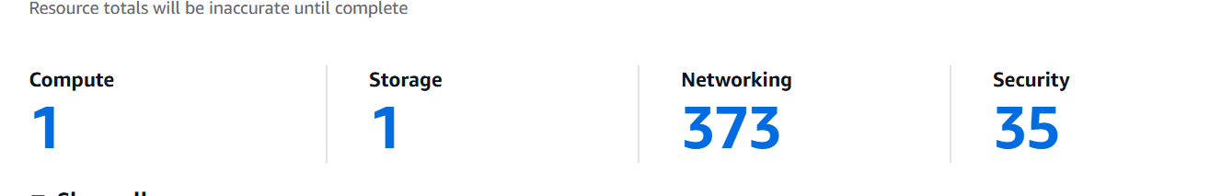

Screenshot 2 of 25 — IAM User Creation — Console Access Setup

📋 Context — Screenshot #2
IAM user creation form with console access options. danish-admin user being configured with AdministratorAccess.

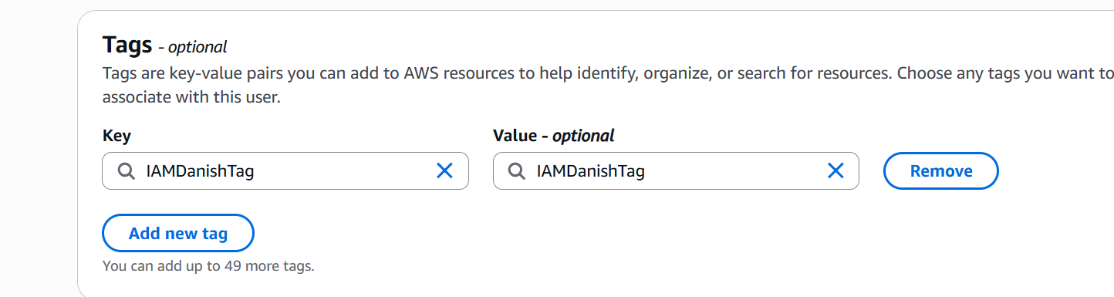

Screenshot 3 of 25 — AWS Budgets — Wrong Amount ($1.00)

📋 Context — Screenshot #3
Budget showing $1.00 — too low. Alert fires at $1.01 which triggers on minor Free Tier charges. Fixed to $5.

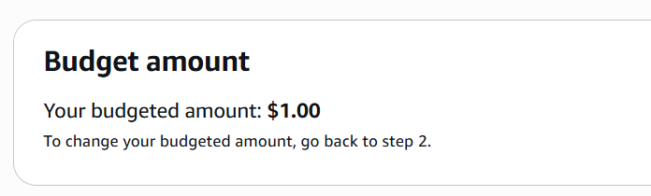

Screenshot 4 of 25 — Budget Step 3 — Attach Actions (Optional)

📋 Context — Screenshot #4
Budget Actions page. Left empty — email alert is sufficient for learning labs. Clicked Save to complete.

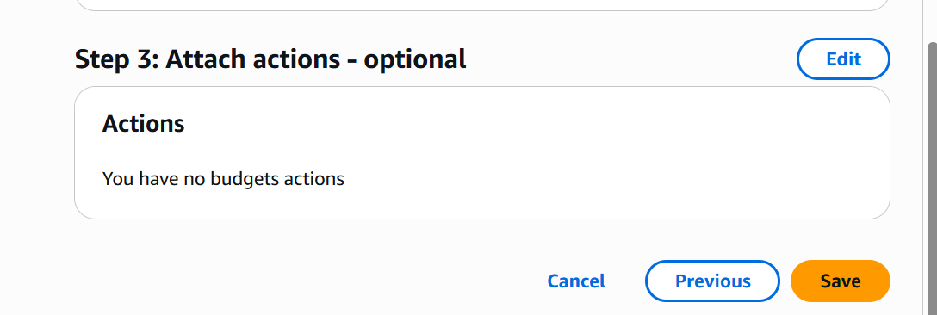

Screenshot 5 of 25 — AWS Explore Credits — $20 of $100 Earned

📋 Context — Screenshot #5
$20 earned from Budget setup. 4 more activities = $80 credits. All align with our planned labs.

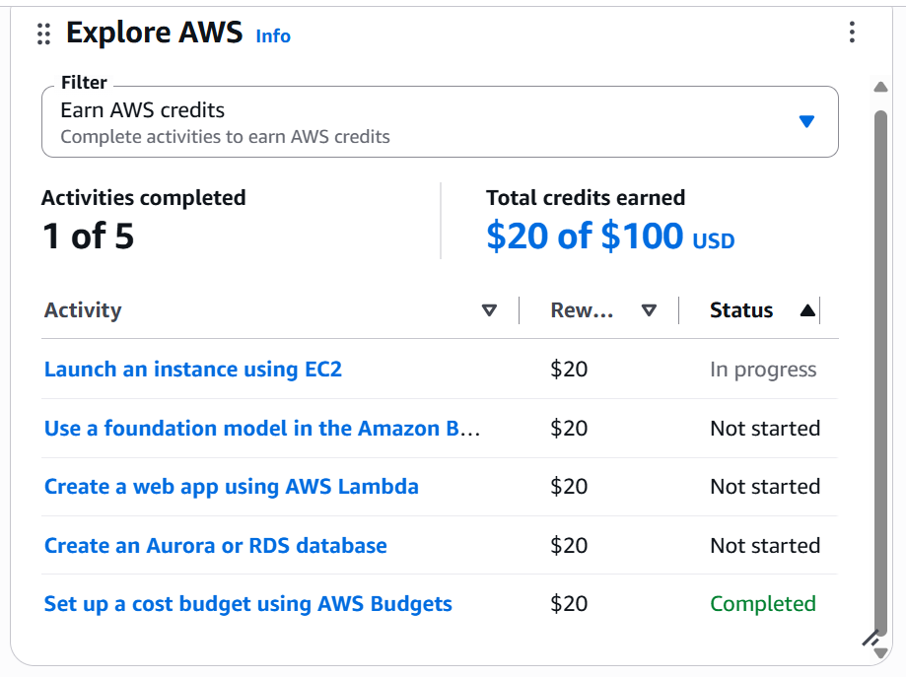

Screenshot 6 of 25 — VPC Dashboard — Resources by Region After Lab 5-B

📋 Context — Screenshot #6
VPCs:2, Subnets:8, NAT Gateways:1, Route Tables:4, Internet Gateways:2. Lab 5-B resources confirmed created.

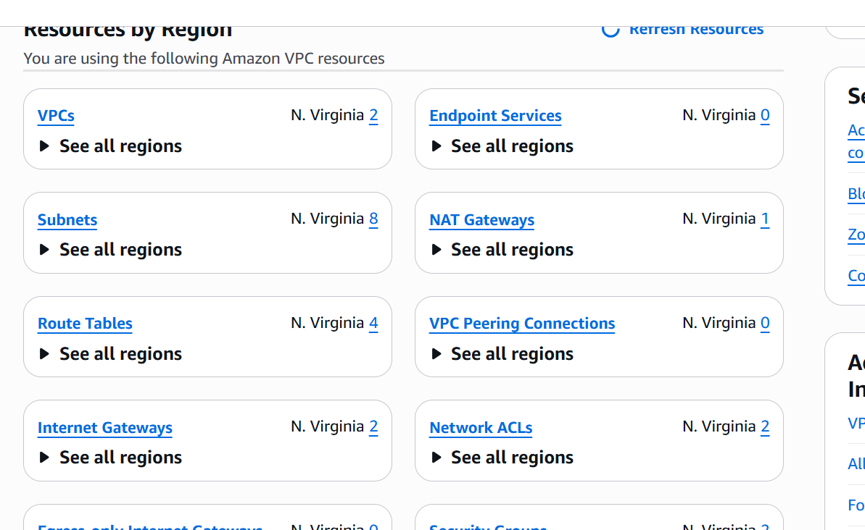

Screenshot 9 of 25 — EC2 Launch — Amazon Linux 2023 Selected (Correct)

📋 Context — Screenshot #9
Amazon Linux 2023 kernel-6.18. Verified provider. Username: ec2-user. Supported until June 2029. Free OS.

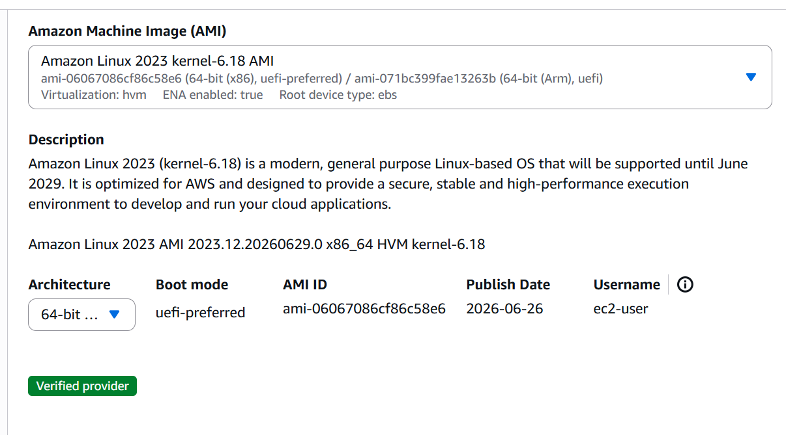

Screenshot 10 of 25 — EC2 Launch — t3.micro Instance Type Confirmed

📋 Context — Screenshot #10
t3.micro: 2 vCPU, 1 GiB RAM, $0.0104/hour. Current generation. Free Tier badge not shown (account >12 months).

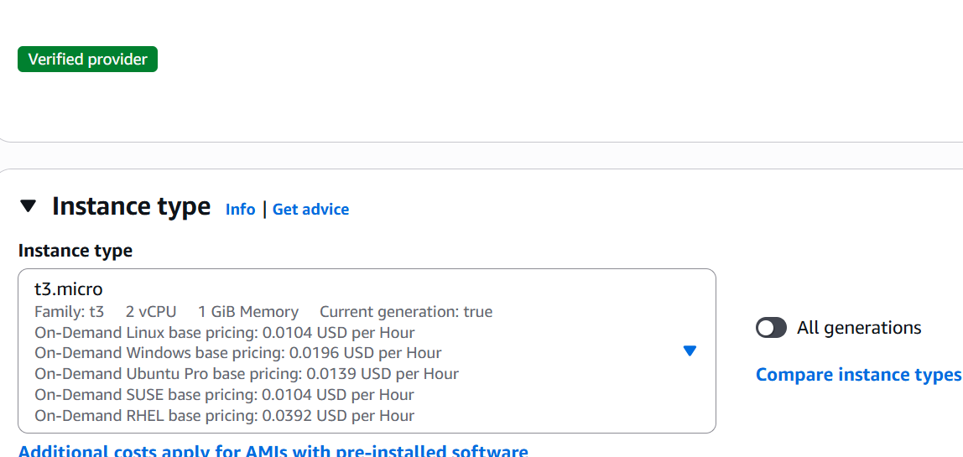

Screenshot 12 of 25 — Create Subnet — CIDR 10.0.xx0/20 for us-east-1b

📋 Context — Screenshot #12
AZ: us-east-1b. VPC: 10.0.0.0/16. Subnet CIDR: 10.0.32.0/20. 4,096 IPs. No overlap error — valid CIDR.

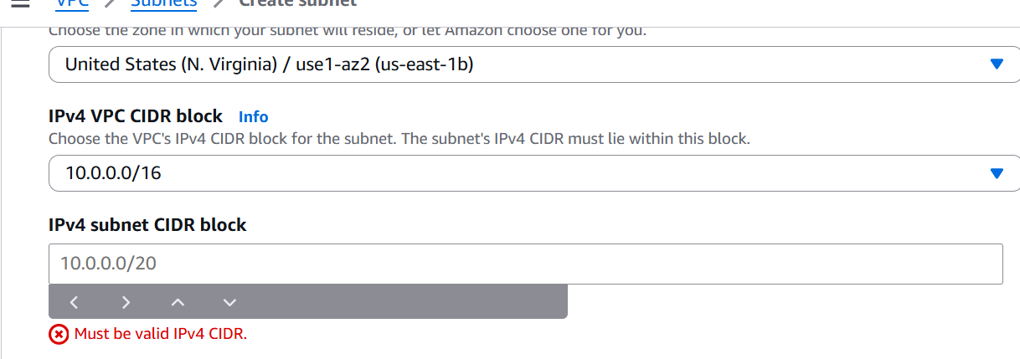

Screenshot 13 of 25 — Create Subnet — CIDR Accepted Successfully

📋 Context — Screenshot #13
10.0.xx.0/20 accepted. Subnet created in us-east-1b for RDS subnet group second AZ requirement.
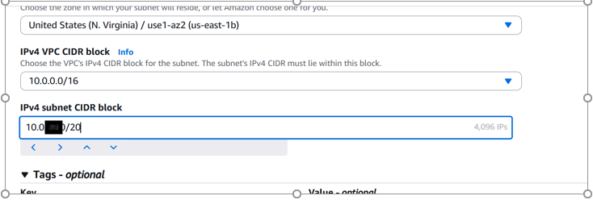

Screenshot 14 of 25 — RDS Engine Options — Aurora Selected by Default (Wrong)

📋 Context — Screenshot #14
Aurora MySQL selected by default. Must change to plain MySQL for Free Tier eligible db.t3.micro instance.

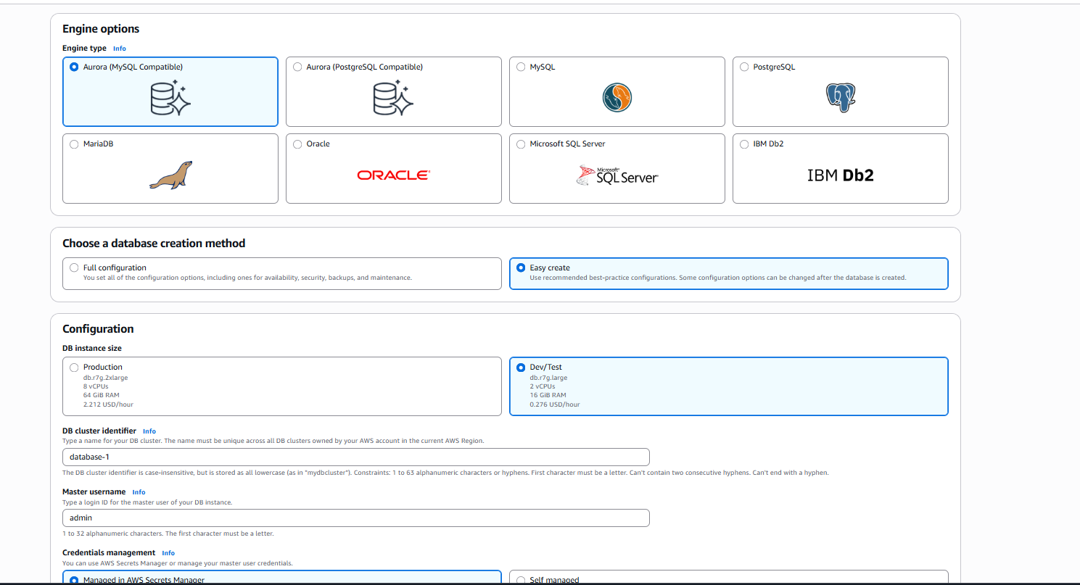

Screenshot 15 of 25 — RDS Instance — db.t3.micro and 20GB gp2 Storage

📋 Context — Screenshot #15
Burstable class, db.t3.micro, 2 vCPU, 1 GiB RAM. Storage: gp2, 20 GiB. Correct configuration for labs.

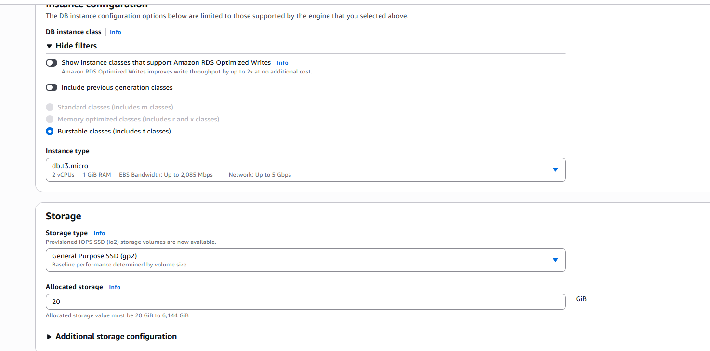

Screenshot 16 of 25 — RDS Connectivity — AZ us-east-1a, No RDS Proxy

📋 Context — Screenshot #16
AZ: us-east-1a. RDS Proxy: unchecked (adds cost). Certificate: rds-ca-rsa2048-g1 default. All correct.

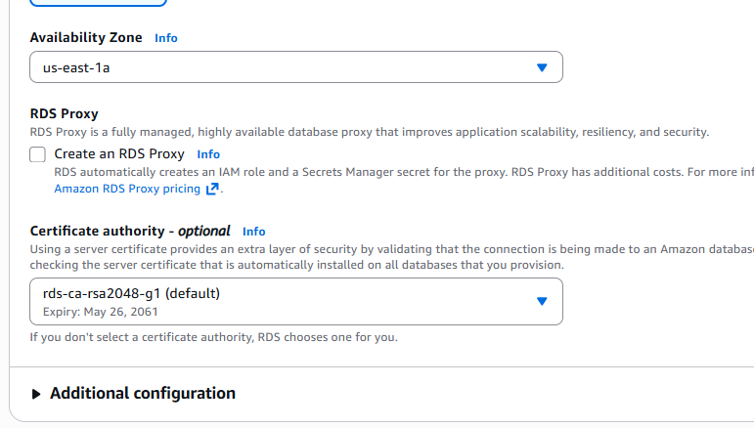

Screenshot 17 of 25 — S3 Lifecycle Rule — Creation Form

📋 Context — Screenshot #17
Lifecycle rule configuration. Rule scope, filter type, and lifecycle actions sections visible. 30 day expiry set.

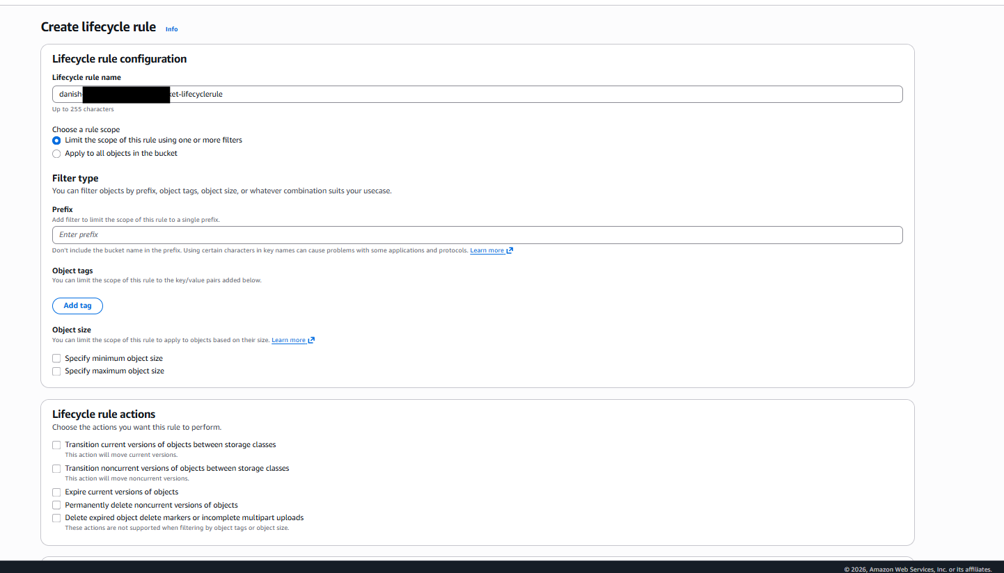

Screenshot 18 of 25 — CloudWatch Alarm — Insufficient Data State

📋 Context — Screenshot #18
danish-alarm showing Insufficient data. Normal after creation — CloudWatch needs first metric reading.

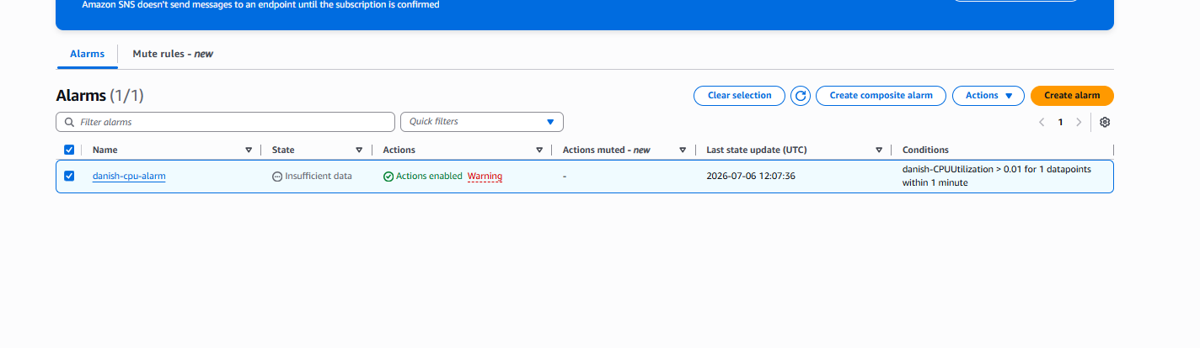

Screenshot 19 of 25 — EC2 Console — Running Instance, No Alarm in EC2 View

📋 Context — Screenshot #19
EC2 running, 3/3 checks passed, t3.micro, us-east-1a. Alarms section: no associated alarms (normal — alarm in CloudWatch).

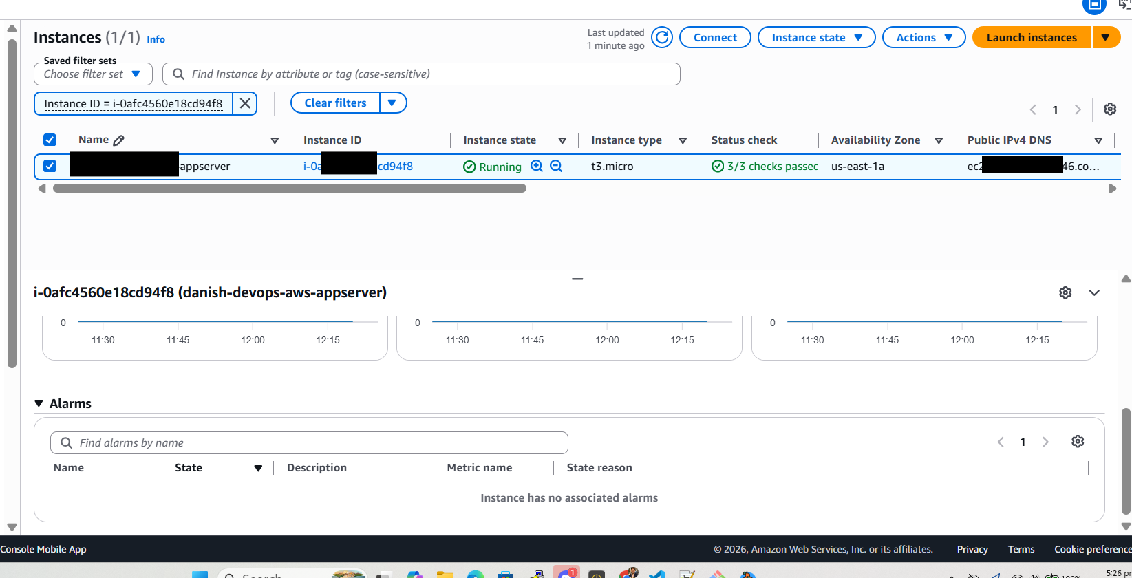

Screenshot 20 of 25 — CloudWatch CPU Graph — Spike to 0.585% Visible

📋 Context — Screenshot #20
CPU flat at 0.163% then spikes to 0.585% at 12:30 after stress test started. Alarm threshold: 0.01%.

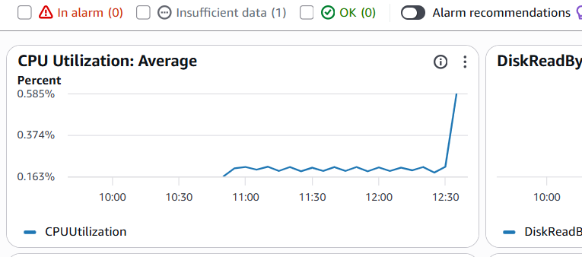

Screenshot 21 of 25 — CloudWatch Alarm Graph — Empty (Wrong Metric Name)

📋 Context — Screenshot #21
danish-CPUUtilization metric — completely empty graph. Wrong custom metric name typed. No data exists.

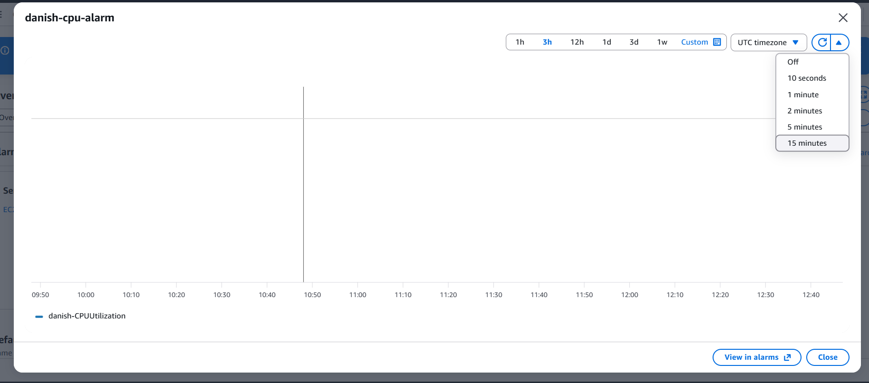

Screenshot 22 of 25 — CloudWatch Alarm — IN ALARM State Confirmed

📋 Context — Screenshot #22
danish-alarm: IN ALARM (red). Actions enabled. Triggered at 12:58:44. CPUUtilization > 0.01 for 1 minute.

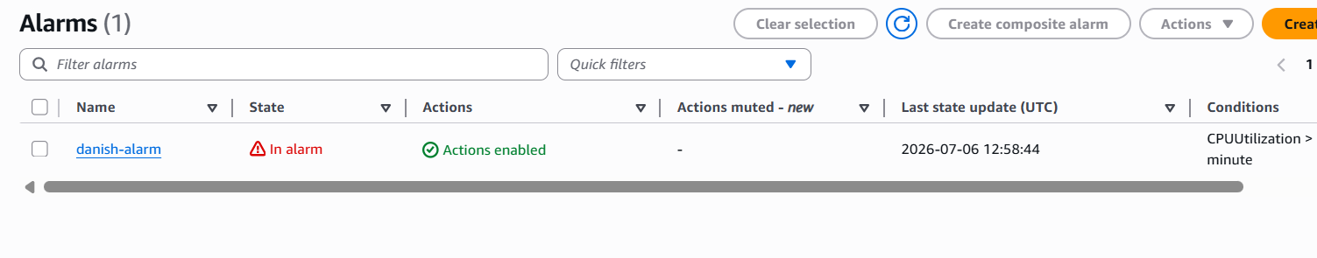

Screenshot 23 of 25 — SNS Topic — Email Subscription Confirmed

📋 Context — Screenshot #23
SNS topic danish-cpu-alarm. Subscription: email to 1983syedhussain@gmail.com. Status: Confirmed (green).

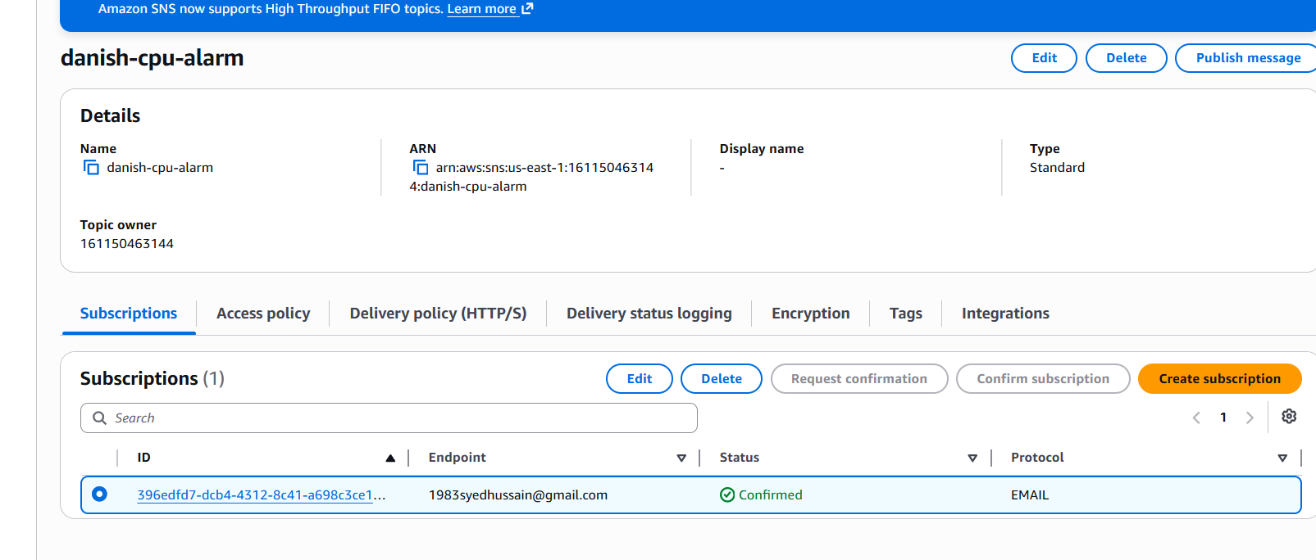

Screenshot 24 of 25 — Gmail — CloudWatch Alarm Email Received

📋 Context — Screenshot #24
ALARM: danish-alarm in US East. CPU value 51.8%. Threshold 1.0. State: INSUFFICIENT_DATA to ALARM. 5:58 PM.

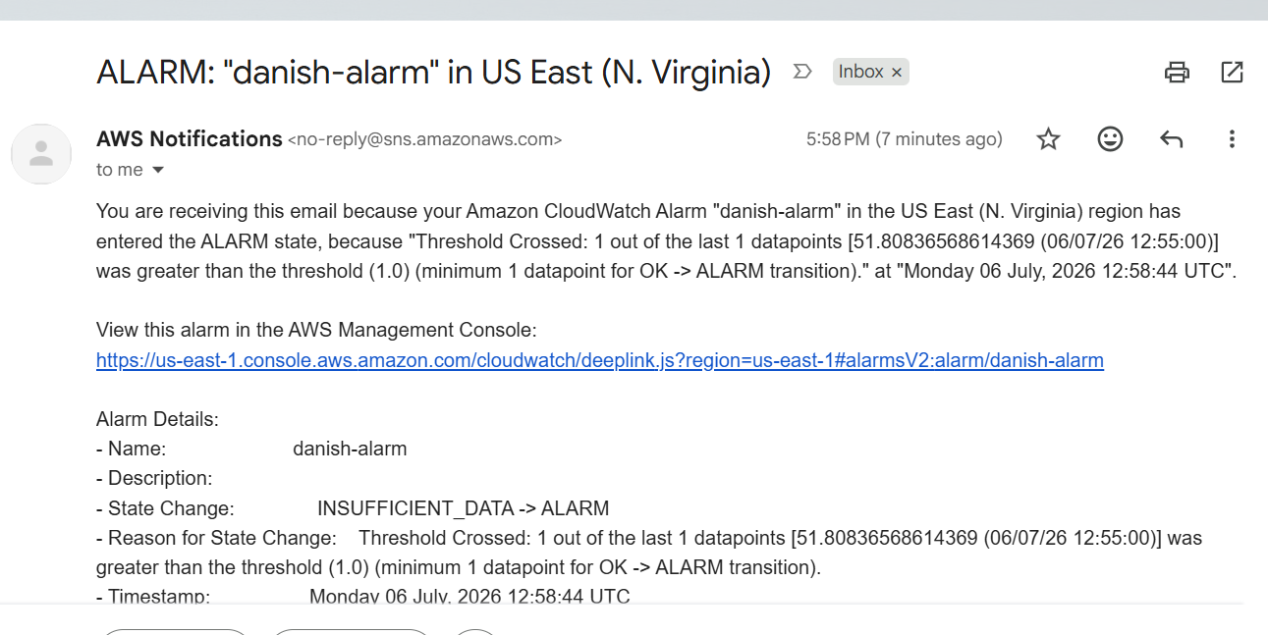

Screenshot 25 of 25 — Gmail — Full Alarm Email Details

📋 Context — Screenshot #25
Complete alarm email. State change confirmed. Direct CloudWatch link. Timestamp 12:58:44 UTC. Full pipeline working.

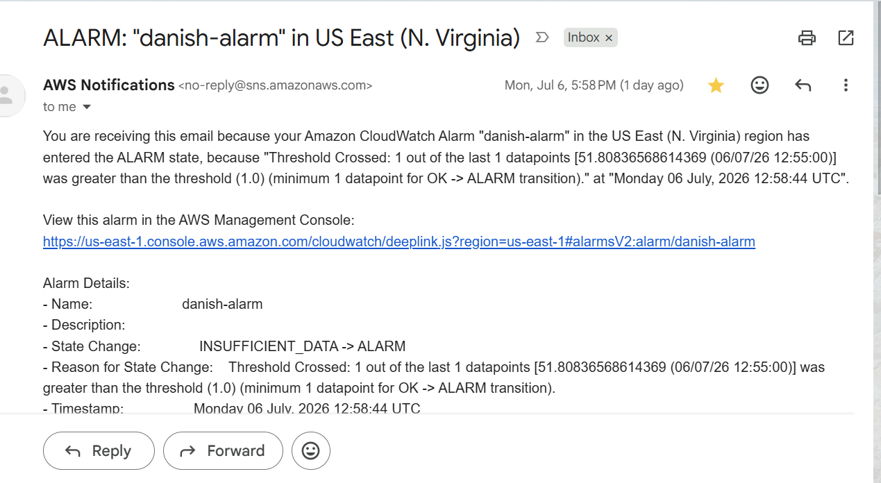

✅ All Screenshots Captured and Embedded
Total screenshots embedded: 25
Coverage: Account setup, IAM, VPC, EC2, RDS, S3, CloudWatch, SNS, Gmail
All lab steps visually documented as proof of completion
Screenshots show real AWS console during live lab execution

