Danish
DevOps and AWS Learning Series for DBAs
Chapter 6 — Terraform (Infrastructure as Code)
DevOps_Terraform_v1.0
A concept-first, hands-on walkthrough of Terraform for a DBA transitioning into DevOps — covering core concepts, five full labs (EC2, VPC, RDS, and CloudWatch monitoring), real troubleshooting near-misses, and a quick-reference summary.

How This Chapter Was Built
This chapter was worked through interactively, topic by topic and lab by lab — each concept confirmed as "clear" before moving forward, and every lab actually executed hands-on with real AWS resources, verified in the AWS Console, and destroyed immediately afterward to avoid ongoing cost.
Every code block in this document was actually typed, run, and validated. Every screenshot is a real result from this session. Every "Real Near-Miss" box documents an actual error or mistake that happened during the work — not a hypothetical — because catching and fixing real mistakes is where the deepest learning happens.
⚠️ Danish-Imp! Sensitive values (AWS account IDs, resource IDs, IP addresses, and personal email addresses) have been redacted throughout this document and in every screenshot. Any password or email shown in example commands has been replaced with a placeholder.

Chapter Roadmap
- Core Concepts: Why Terraform Exists, Provider, Resource, Variables, Outputs, State File, Workflow, Project Structure
- Lab 6-A — Install Terraform and Verify
- Lab 6-B — Create Your First EC2 with Terraform
- Lab 6-C — Build a Complete VPC with Terraform
- Lab 6-D — Provision RDS MySQL with Terraform
- Lab 6-E — Add CloudWatch Alarm to EC2 (End-to-End)
- Real Lessons Learned (near-misses captured during this session)
- Terraform Quick Reference Table
- Danish-Imp! Quick Reference Table

Core Terraform Concepts

1. Why Terraform Exists
Building infrastructure by clicking through the AWS Console leaves no record of what was built or why. Nobody — including future you — can be certain exactly what was clicked. There's no review process, and nothing can be reproduced exactly the same way twice.
Terraform fixes this by making infrastructure code. You write what you want in a .tf file, commit it to Git, someone reviews it in a Pull Request, and only then does it get built. Every decision has a paper trail.
⚠️ Danish-Imp! Infrastructure changes should get the same discipline as code changes — written, reviewed, versioned, and reversible.
Real-world analogy
Terraform is like an architect's blueprint. The blueprint specifies exact room sizes, materials, and wiring. Any builder can follow it and get the same building. Want to add a room? Update the blueprint and rebuild — don't just tell a random worker "add a room, about 4 metres."
Without Terraform vs. With Terraform
Without Terraform | With Terraform
Click through 15 console screens per server | Write ~10 lines of code, run terraform apply
Can't reproduce the exact same environment | Same code = identical environment every time
No record of what was built or why | Every change tracked in Git (author, date, message)
Hard to cleanly delete everything | terraform destroy removes everything it manages
Dev and prod slowly drift apart | Same code, different variables = identical structure
🧠 DBA Mindset Bridge: Think of it exactly like a schema change. You'd never ALTER a 500-million-row production table without writing the SQL first, reviewing it, running EXPLAIN, testing on staging, and having a rollback plan. Terraform brings that same discipline to every security group, VPC, and RDS instance. terraform plan is your EXPLAIN PLAN; terraform apply is your production change window.

2. Provider
A provider is a plugin that lets Terraform talk to a specific platform's API. Terraform itself doesn't know anything about AWS, Azure, or GCP — the provider teaches it. You declare which provider you want, and terraform init downloads that plugin automatically.
terraform {
required_providers {
aws = {
source = "hashicorp/aws"
version = "~> 5.0"
}
}
}

provider "aws" {
region = "us-east-1"
# Credentials come from AWS CLI config (~/.aws/credentials)
# NEVER hardcode access_key and secret_key here
}

⚠️ Danish-Imp! Never hardcode access_key and secret_key inside .tf files. If this file gets pushed to GitHub, your AWS account is compromised within minutes — bots scan public repos for exactly this pattern.
🧠 DBA Mindset Bridge: The provider is like a database driver/connection library (e.g. the MySQL JDBC driver). It's the translation layer between your code's instructions and the actual system you're talking to.

3. Resource
A resource is one actual piece of infrastructure that Terraform manages — an EC2 instance, an S3 bucket, a security group, an RDS database. This is the core building block of every Terraform file.
resource "aws_instance" "web" {
ami = "ami-0c02fb55956c7d316" # Ubuntu 22.04
instance_type = "t3.micro"

tags = {
Name = "devops-web-server"
Owner = "Danish"
}
}

- "aws_instance" — the resource type (defined by the AWS provider); tells Terraform exactly what kind of thing to build. This cannot be renamed.
- "web" — the local name you choose, used only inside your own Terraform code to refer back to this resource — your choice entirely.
- aws_instance.web.id — a resource reference. Terraform automatically figures out dependency order from these references.
🧠 DBA Mindset Bridge: A resource block is like a CREATE TABLE statement — it declares one object that should exist, with its exact properties. The local name is like a table alias inside your script.

4. Variables
Variables make Terraform code reusable instead of hardcoded. Declare a variable once, then use it anywhere in your code — and pass different values for dev, staging, or production without touching the code itself.
Three steps: declare, use, supply
- Declare — create the blank field: variable "environment" { }
- Use — point to where the value goes: var.environment inside a resource
- Supply — fill in the actual value: default, -var flag, or a .tfvars file
# variables.tf — DECLARE
variable "environment" {
type = string
}

# main.tf — USE
resource "aws_instance" "web" {
tags = {
Environment = var.environment
}
}

# command line — SUPPLY
terraform apply -var="environment=dev"

Three ways to supply a value, and their priority
Method | How | Priority
-var flag | terraform apply -var="environment=dev" | Highest — always wins
.tfvars file | terraform.tfvars, loaded automatically | Middle
default | default = "dev" in the variable block | Lowest — used only if nothing else is set
⚠️ Danish-Imp! Never commit a .tfvars file containing secrets to Git — add it to .gitignore.
🧠 DBA Mindset Bridge: This is exactly like a parameterized SQL query or stored procedure with input parameters — write the script once, pass different values at runtime instead of hardcoding a new script for every case.

5. Outputs
Outputs display useful values after terraform apply finishes — like an EC2 instance's public IP, or an RDS endpoint — printed directly in the terminal, without needing to open the AWS Console.
output "ec2_public_ip" {
description = "Public IP of the web server"
value = aws_instance.web.public_ip
}

output "rds_endpoint" {
value = aws_db_instance.mysql.endpoint
sensitive = true # masks the value in terminal output
}

Outputs are just text printed to the terminal by terraform apply, the same way ls or whoami prints text. To see saved outputs again later without re-running apply, use terraform output (or terraform output -raw <name> for a sensitive value).
🧠 DBA Mindset Bridge: Like a RETURNING clause in an INSERT statement — the operation hands the generated value straight back instead of requiring a manual lookup afterward.

6. State File
Every time Terraform creates something, it writes a record into terraform.tfstate — Terraform's memory of exactly what it has built and the real AWS resource ID for each thing. Without it, Terraform has no way to know what already exists versus what needs to be created.
⚠️ Danish-Imp! Never delete terraform.tfstate manually and never edit it by hand. If deleted, the real AWS resources still exist and keep costing money, but Terraform can no longer manage or cleanly destroy them.
⚠️ Danish-Imp! Never commit terraform.tfstate to Git — it can contain sensitive data in plain text and changes on every apply, causing merge conflicts.
🧠 DBA Mindset Bridge: The state file is like a replication metadata table or control file — not the actual data, but the record of what exists and where. Corrupt or lose it, and the infrastructure still exists, but the tool managing it is now blind.

7. The Terraform Workflow
The standard sequence run every time you work with Terraform:
Command | Purpose | Frequency
terraform init | Downloads provider plugins | Once per project (or when providers change)
terraform plan | Previews changes — nothing is built yet | Every time, before applying
terraform apply | Actually builds/changes real infrastructure | Every time you want to make the change real
terraform destroy | Removes everything Terraform is tracking | After every lab session
⚠️ Danish-Imp! Always read the terraform plan output before typing yes on apply — especially watch for unexpected "destroy" lines on resources you didn't intend to touch.
⚠️ Danish-Imp! Always run terraform destroy after every lab session — a resource left running silently racks up hourly charges even when you're not using it.
🧠 DBA Mindset Bridge: plan = EXPLAIN PLAN (preview, no changes made). apply = your actual production change window. destroy = your rollback/cleanup script.

8. Terraform Project Structure
Terraform reads every .tf file in a folder as one combined project, but splitting files by purpose makes code far easier to read, review, and maintain.
File | Purpose
main.tf | Provider block + resource blocks — the "what gets built"
variables.tf | Variable declarations only — the blank fields
outputs.tf | Output declarations — what gets printed after apply
terraform.tfvars | Actual values — kept separate, never committed if sensitive
.gitignore | Tells Git what to exclude
Standard .gitignore for every Terraform project
.terraform/
*.tfstate
*.tfstate.backup
terraform.tfvars

⚠️ Danish-Imp! Add this .gitignore before your first commit in every new Terraform folder — not after.
🧠 DBA Mindset Bridge: Like organizing a migration project — schema, data, and config kept in separate files so any teammate can find and review the right piece quickly.

Lab 6-A — Install Terraform and Verify
Purpose: install Terraform locally and confirm it can authenticate to AWS before any real infrastructure work begins.

Step 1 — Install Terraform (Windows, via winget)
winget install HashiCorp.Terraform
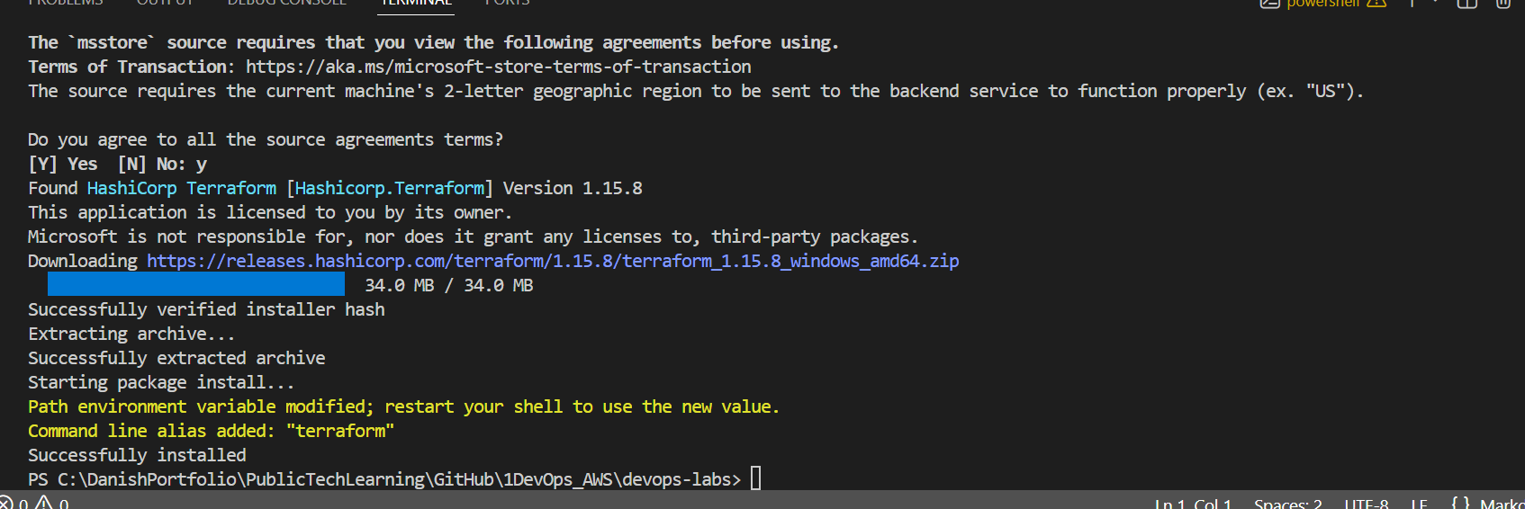
Terraform installed successfully via winget (v1.15.8)
⚠️ Danish-Imp! After install, a message may say the PATH was modified and the shell needs restarting. Close and reopen the terminal (or VS Code entirely) before running terraform version, or it may report "command not found" even though it installed correctly. This is a very common first-time snag on Windows with winget-installed CLI tools.

Step 2 — Verify installation
terraform version
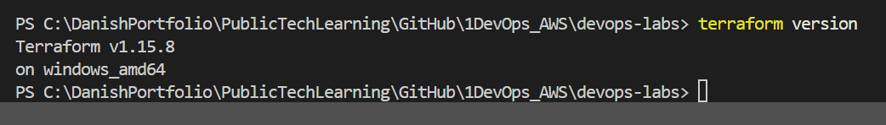
terraform version confirmed after restarting the terminal — v1.15.8 on windows_amd64

Step 3 — Verify AWS CLI authentication
aws sts get-caller-identity
This proves Terraform will be able to authenticate to the AWS account when apply is run later — a separate check from terraform version, since Terraform being installed doesn't guarantee AWS credentials are configured.
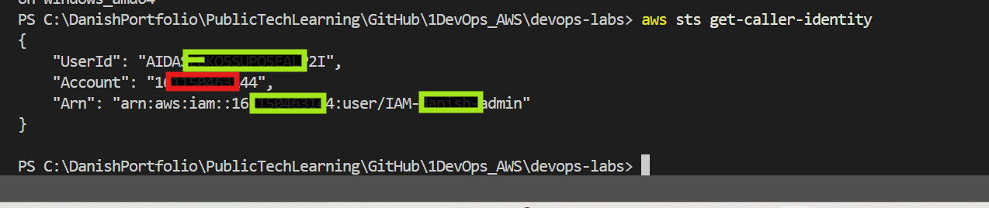
AWS CLI authenticated — confirmed IAM user identity (redacted)
🧠 DBA Mindset Bridge: This mirrors verifying two things before a migration: (1) is the SQL client installed? (2) can it actually authenticate to the database with the right credentials? Both checks are independent — one working doesn't guarantee the other does.
Lab 6-A result: Terraform installed and verified, AWS CLI authenticated successfully under the account's IAM admin user. Ready for hands-on resource creation.

Lab 6-B — Create Your First EC2 with Terraform
Purpose: write real Terraform code from scratch, run the full init → plan → apply → destroy workflow, and watch actual AWS infrastructure appear and disappear from code.
Folder used: devops-labs/6terraform/

Step 1 — Create Project Folder and Files
cd devops-labs/6terraform
touch main.tf variables.tf outputs.tf terraform.tfvars .gitignore README.md

Note: on Windows Git Bash, paths use forward slashes and /c/ instead of C:\ — a common early trap when copying paths from Windows File Explorer or PowerShell error messages.
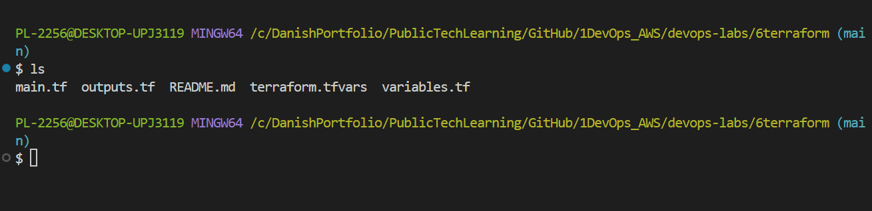
All lab files created inside devops-labs/6terraform/
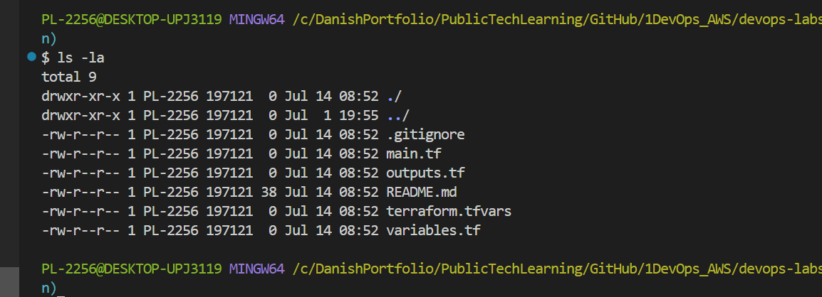
ls -a confirms .gitignore and all files are present

Step 2 — main.tf (provider + EC2 resource)
terraform {
required_providers {
aws = {
source = "hashicorp/aws"
version = "~> 5.0"
}
}
}

provider "aws" {
region = "us-east-1"
}

resource "aws_instance" "web" {
ami = "ami-0c02fb55956c7d316" # Ubuntu 22.04, us-east-1
instance_type = var.instance_type

tags = {
Name = "DevOps-Lab-EC2"
Owner = "Danish"
Chapter = "Terraform"
}
}

Step 3 — variables.tf
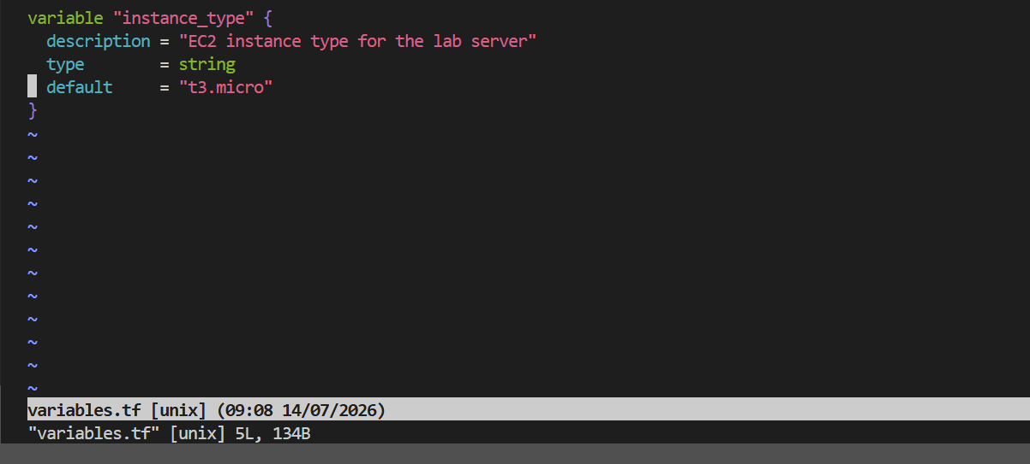
variables.tf — instance_type declared with a Free-Tier-safe default
⚠️ Danish-Imp! Never use anything bigger than t3.micro/t2.micro for lab instances — larger types fall outside Free Tier and start incurring hourly charges immediately.

Step 4 — outputs.tf
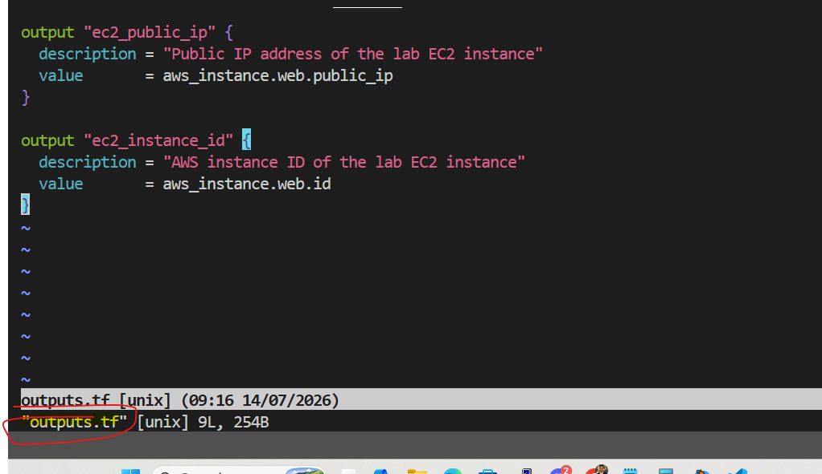
outputs.tf — public IP and instance ID printed after apply

Step 5 — Run the Full Workflow
terraform init
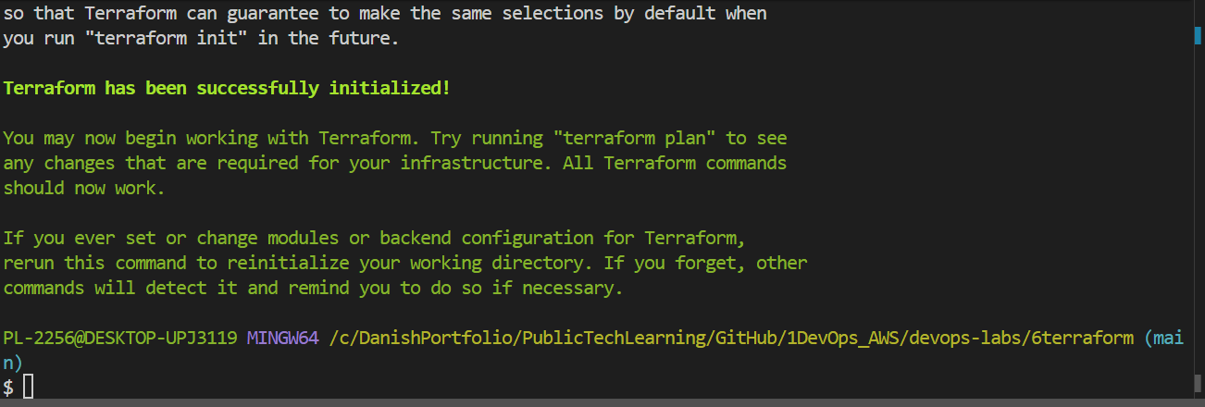
terraform init — AWS provider plugin downloaded successfully
terraform apply
Plan showed: 1 to add, 0 to change, 0 to destroy — exactly the one new EC2 instance expected.
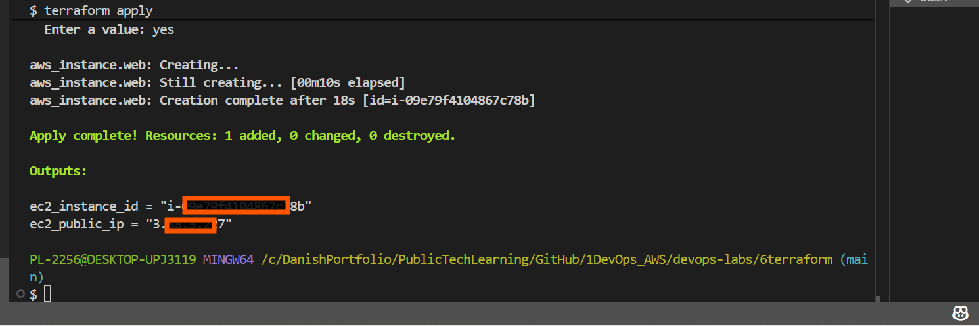
terraform apply complete — real EC2 instance created, outputs printed

Step 6 — Make a Change and See the Plan
A new tag was added to demonstrate an in-place update (~), as opposed to a create (+) or destroy (-):
tags = {
Name = "DevOps-Lab-EC2"
Owner = "Danish"
Chapter = "Terraform"
Purpose = "Terraform-Lab" # new line
}
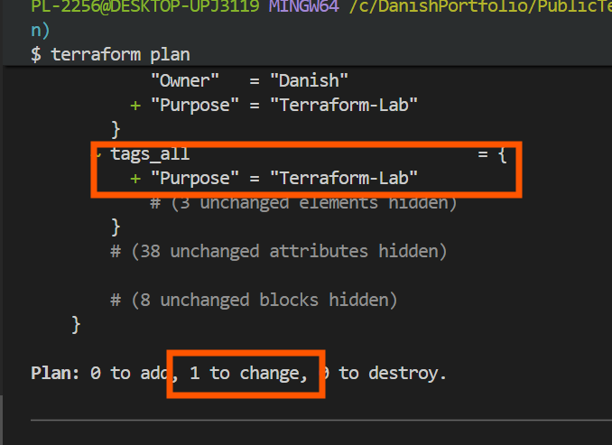
terraform plan showing 0 to add, 1 to change — an in-place tag update
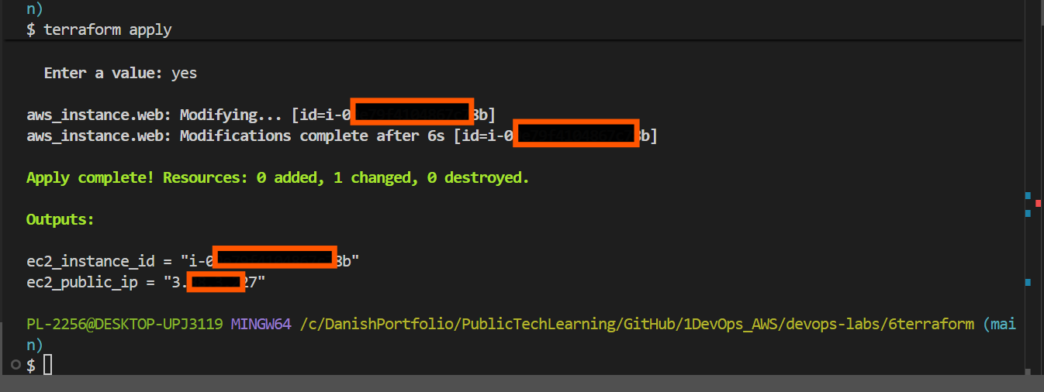
terraform apply — tag updated in-place on the same running instance (6 seconds, no downtime)
⚠️ Danish-Imp! Always pay attention to the symbol Terraform shows for a change: ~ means a safe in-place update; -/+ means a destructive replace (delete and rebuild) — worth pausing on if it ever appears unexpectedly.

Step 7 — Destroy When Done
terraform destroy
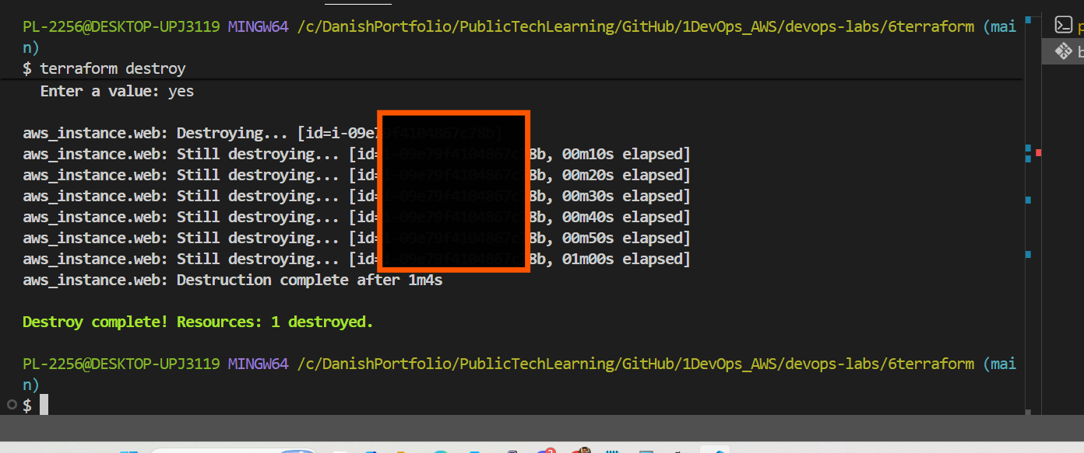
terraform destroy complete — Resources: 1 destroyed
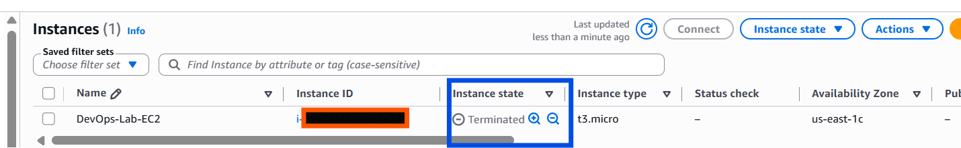
AWS Console confirms the EC2 instance is Terminated
Lab 6-B result: full Terraform lifecycle completed end to end — files written from scratch, real EC2 instance created, verified in the AWS Console, updated in-place, then cleanly destroyed with zero leftover cost.

Lab 6-C — Build a Complete VPC with Terraform
Purpose: build a full mini production-style network from code — a VPC with a public subnet (internet-facing) and a private subnet (no internet access), a route table, and two security groups where the database security group only accepts traffic from the app security group, never from an open IP range.
Folder used: devops-labs/6terraform/6c-vpc-lab/

main.tf — VPC and Internet Gateway
resource "aws_vpc" "main" {
cidr_block = "10.0.0.0/16"
enable_dns_hostnames = true
enable_dns_support = true
tags = { Name = "devops-tf-vpc" }
}

resource "aws_internet_gateway" "igw" {
vpc_id = aws_vpc.main.id
tags = { Name = "devops-tf-igw" }
}

⚠️ Danish-Imp! Creating the Internet Gateway alone does not make anything public. A subnet only becomes public once its route table explicitly points 0.0.0.0/0 to this gateway.

main.tf — Public and Private Subnets
resource "aws_subnet" "public" {
vpc_id = aws_vpc.main.id
cidr_block = "10.0.1.0/24"
availability_zone = "us-east-1a"
map_public_ip_on_launch = true
tags = { Name = "devops-tf-public-1a" }
}

resource "aws_subnet" "private" {
vpc_id = aws_vpc.main.id
cidr_block = "10.0.2.0/24"
availability_zone = "us-east-1a"
tags = { Name = "devops-tf-private-1a" }
}

main.tf — Public Route Table
resource "aws_route_table" "public" {
vpc_id = aws_vpc.main.id
route {
cidr_block = "0.0.0.0/0"
gateway_id = aws_internet_gateway.igw.id
}
tags = { Name = "devops-tf-public-rt" }
}

resource "aws_route_table_association" "public" {
subnet_id = aws_subnet.public.id
route_table_id = aws_route_table.public.id
}
The private subnet deliberately has no route table association — it falls back to the VPC's default route table, which has no internet route. That absence is what makes it private.

main.tf — Security Groups (app-sg and rds-sg)
resource "aws_security_group" "app" {
name = "app-sg"
vpc_id = aws_vpc.main.id

ingress {
from_port = 22
to_port = 22
protocol = "tcp"
cidr_blocks = ["${var.my_ip}/32"]
}
egress {
from_port = 0
to_port = 0
protocol = "-1"
cidr_blocks = ["0.0.0.0/0"]
}
tags = { Name = "app-sg" }
}

resource "aws_security_group" "rds" {
name = "rds-sg"
vpc_id = aws_vpc.main.id

ingress {
from_port = 3306
to_port = 3306
protocol = "tcp"
security_groups = [aws_security_group.app.id] # reference, not CIDR
}
tags = { Name = "rds-sg" }
}

⚠️ Danish-Imp! Never write cidr_blocks = ["0.0.0.0/0"] on a database security group's ingress rule for port 3306. rds-sg here references app-sg directly — only EC2 instances belonging to app-sg can reach port 3306, regardless of IP.
📌 Real Near-Miss — Hardcoded IP briefly in variables.tf: The my_ip variable was briefly given a hardcoded default of a real public IP address before being corrected to have no default at all. variables.tf is not covered by .gitignore (unlike terraform.tfvars), so anything hardcoded there is fully committed and visible if pushed to GitHub. Fixed by removing the default and supplying the IP live at the command line instead: -var="my_ip=$(curl -s ifconfig.me)".

variables.tf — my_ip (corrected, no hardcoded default)
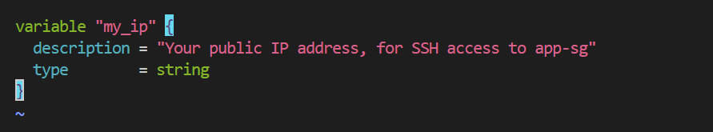
variables.tf corrected — no default, supplied live via -var at runtime

outputs.tf
output "vpc_id" { value = aws_vpc.main.id }
output "public_subnet_id" { value = aws_subnet.public.id }
output "private_subnet_id" { value = aws_subnet.private.id }
output "app_sg_id" { value = aws_security_group.app.id }
output "rds_sg_id" { value = aws_security_group.rds.id }
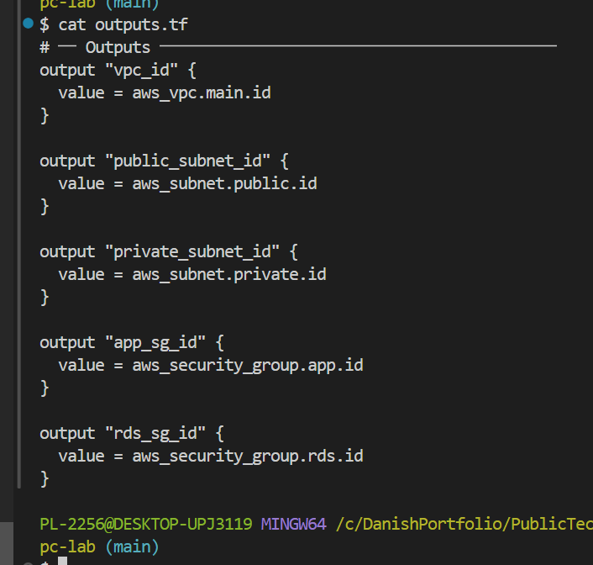
outputs.tf — 5 resource IDs exposed for later reference by other labs

Running the Workflow
terraform init
terraform fmt
terraform validate
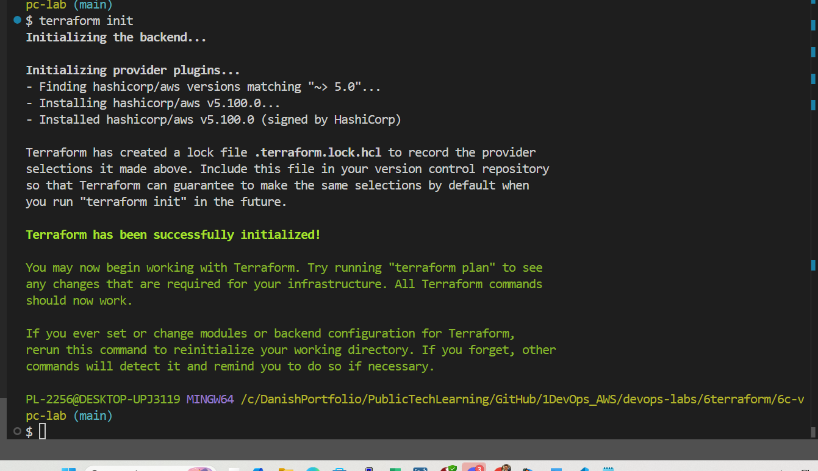
terraform init — AWS provider v5.100.0 installed
📌 Real Near-Miss — terraform validate caught a missing section: The first terraform validate run failed with "Reference to undeclared resource" for both aws_security_group.app and aws_security_group.rds — the security groups section had not actually been saved into main.tf. Running cat main.tf confirmed the file stopped right after the route table section. Adding the missing security group blocks and re-running validate resolved it cleanly. Lesson: always run terraform validate immediately after writing a multi-section file, before moving to plan.
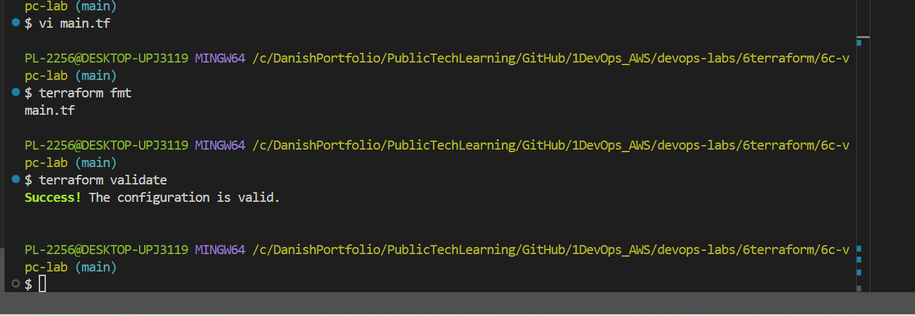
terraform validate — Success, after adding the missing security group blocks
terraform plan -var="my_ip=$(curl -s ifconfig.me)"
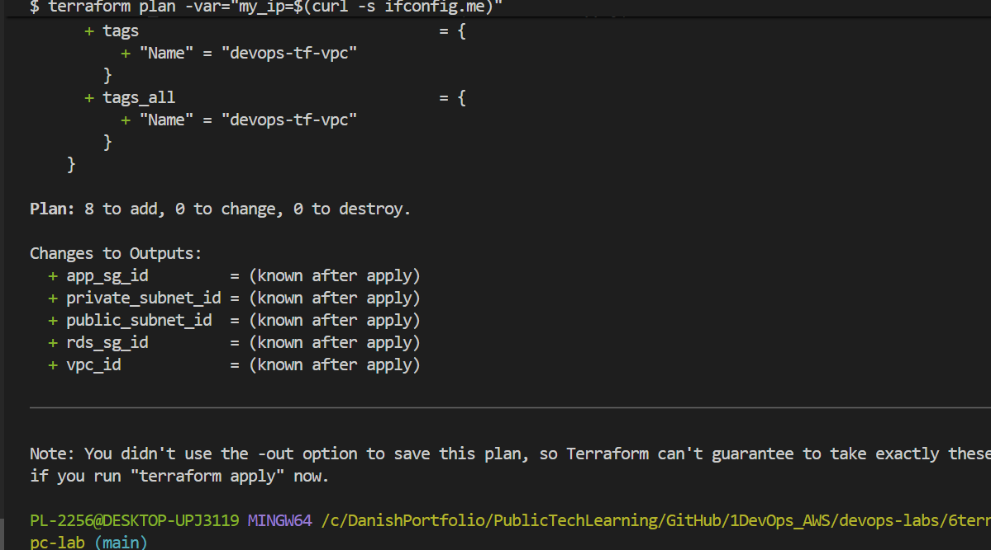
terraform plan — 8 to add (VPC, IGW, 2 subnets, route table, association, 2 security groups)
terraform apply -var="my_ip=$(curl -s ifconfig.me)"
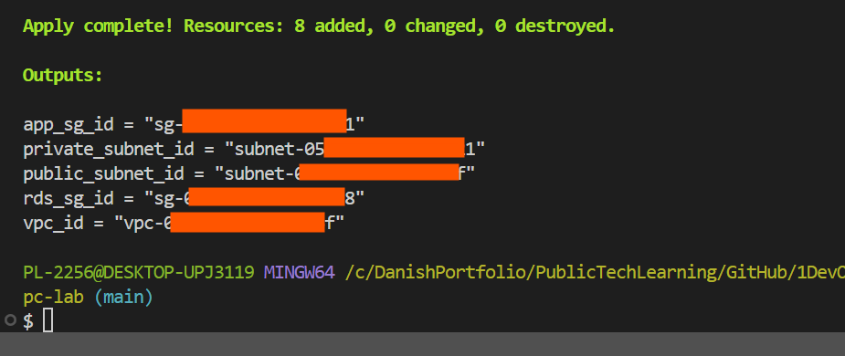
terraform apply complete — 8 resources added, all 5 outputs populated
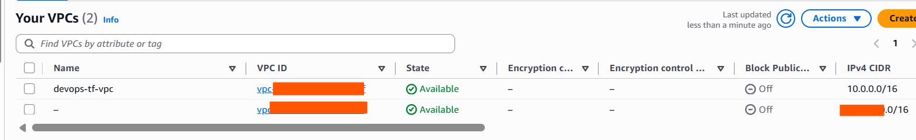
AWS Console confirms devops-tf-vpc, CIDR 10.0.0.0/16, Available

Destroy
terraform destroy -var="my_ip=$(curl -s ifconfig.me)"
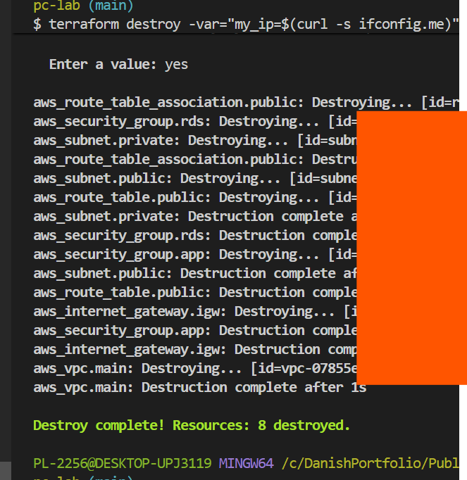
terraform destroy complete — 8 resources destroyed, correct dependency order
🧠 DBA Mindset Bridge: The route table is like a routing rule in a database proxy config — it doesn't create the path itself, it says traffic matching this pattern goes to this destination. No matching rule means an implicit deny, the same as no GRANT existing.
Lab 6-C result: a complete production-style network built from code — VPC, public and private subnets, route table, and two correctly-scoped security groups, with two genuine near-misses caught and fixed along the way.

Lab 6-D — Provision RDS MySQL with Terraform
Purpose: create a real managed MySQL database, correctly placed inside a private subnet, re-using the VPC and security group already built in Lab 6-C — read via Terraform data blocks instead of rebuilt from scratch.
Folder used: devops-labs/6terraform/rds-lab/

Cross-Lab Dependency: VPC → RDS
Lab 6-D does not build its own VPC. It re-uses Lab 6-C's VPC, private subnets, and rds-sg via data blocks. Since Lab 6-C's VPC had already been destroyed at the end of that lab (correctly, following the destroy-after-each-lab rule), it had to be re-applied first as a foundation before Lab 6-D could be built.
⚠️ Danish-Imp! Because of this dependency, the destroy order at the end of this session was: Lab 6-D (RDS) destroyed first, then Lab 6-C (VPC) destroyed last — the reverse of build order, respecting the dependency.

New Concept: data Blocks
Everything used until now was a resource block — meaning "create this." A data block means the opposite: "look up something that already exists, and let me read its details — don't create anything."
data "aws_vpc" "main" {
filter {
name = "tag:Name"
values = ["devops-tf-vpc"]
}
}

data "aws_subnets" "private" {
filter {
name = "tag:Name"
values = ["*private*"]
}
filter {
name = "vpc-id"
values = [data.aws_vpc.main.id]
}
}

data "aws_security_group" "rds" {
name = "rds-sg"
vpc_id = data.aws_vpc.main.id
}

🧠 DBA Mindset Bridge: resource is like CREATE TABLE; data is like a SELECT query against something that already exists — reading, not writing.
⚠️ Danish-Imp! If a data lookup finds zero matches (wrong VPC name, or Lab 6-C wasn't re-applied), terraform plan fails immediately with a clear error — a safety feature, not a bug, since it stops you building an RDS instance in the wrong place.

main.tf — DB Subnet Group and Parameter Group
resource "aws_db_subnet_group" "mysql" {
name = "devops-db-subnet-group"
subnet_ids = data.aws_subnets.private.ids
tags = { Name = "devops-db-subnet-group" }
}

resource "aws_db_parameter_group" "mysql8" {
name = "devops-mysql8-params"
family = "mysql8.0"

parameter {
name = "slow_query_log"
value = "1"
}
parameter {
name = "long_query_time"
value = "2"
}
tags = { Name = "devops-mysql-params" }
}

🧠 DBA Mindset Bridge: The parameter group is directly equivalent to editing my.cnf and restarting MySQL — except here it's version-controlled, reviewable code, attached to the RDS instance declaratively instead of manually edited on a server.

main.tf — The RDS MySQL Instance
resource "aws_db_instance" "mysql" {
identifier = "devops-lab-mysql"
engine = "mysql"
engine_version = "8.0"
instance_class = "db.t3.micro"

allocated_storage = 20
storage_type = "gp2"
storage_encrypted = true

db_name = "devopslab"
username = var.db_username
password = var.db_password

db_subnet_group_name = aws_db_subnet_group.mysql.name
vpc_security_group_ids = [data.aws_security_group.rds.id]
parameter_group_name = aws_db_parameter_group.mysql8.name

multi_az = false # true for production
publicly_accessible = false # NEVER true for production
skip_final_snapshot = true # false for production
backup_retention_period = 1

tags = { Name = "devops-lab-mysql", Owner = "Danish" }
}

output "rds_endpoint" {
value = aws_db_instance.mysql.endpoint
sensitive = true
}

⚠️ Danish-Imp! publicly_accessible = false enforces Chapter 2's core networking rule at the RDS resource level: a database should never be reachable directly from the internet.
⚠️ Danish-Imp! Never set skip_final_snapshot = true on a real production database. In real production this stays false so AWS forces a backup snapshot before allowing deletion — a genuine safeguard against accidental data loss.

variables.tf
variable "db_username" {
description = "RDS master username"
type = string
default = "admin"
}

variable "db_password" {
description = "RDS master password"
type = string
sensitive = true
# Never set a default for passwords
}

Running the Workflow
terraform init
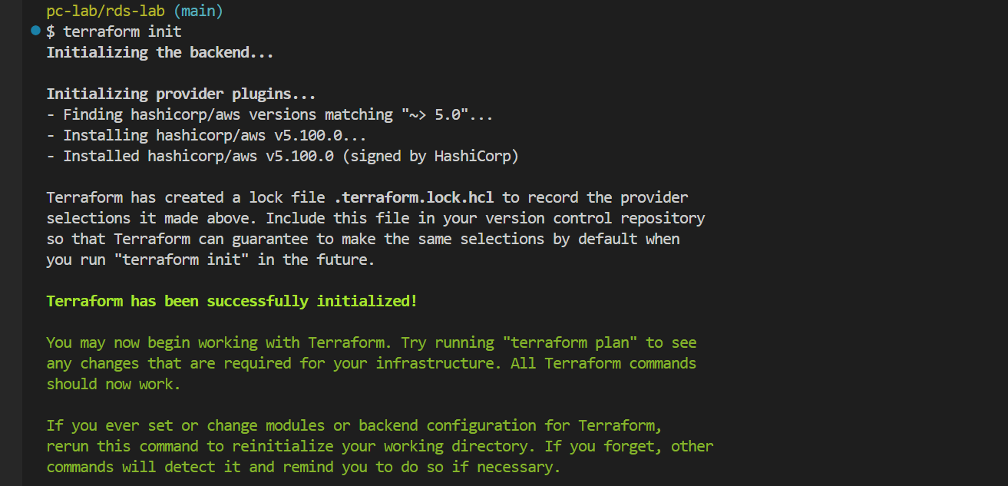
terraform init — provider ready inside rds-lab folder
terraform fmt
terraform validate
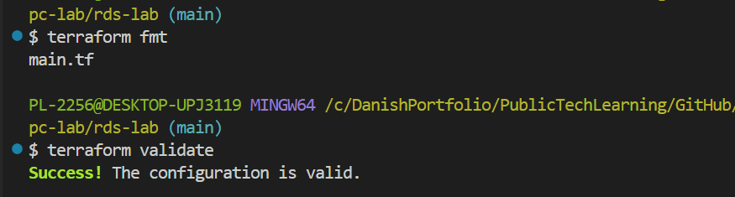
terraform validate — Success
terraform plan -var="db_password=<your-password>"
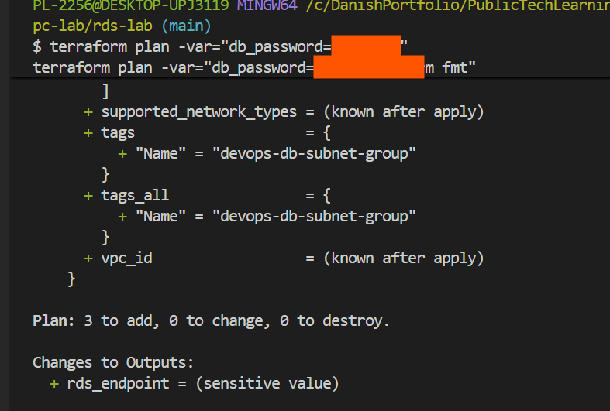
terraform plan — 3 to add (subnet group, parameter group, RDS instance); rds_endpoint shown as (sensitive value)
terraform apply -var="db_password=<your-password>"
📌 Real Near-Miss — RDS requires subnets in at least 2 Availability Zones: The first apply attempt failed with: DBSubnetGroupDoesNotCoverEnoughAZs — Current AZ coverage: us-east-1a. Add subnets to cover at least 2 AZs. Lab 6-C had only created one private subnet, in a single AZ. RDS's DB Subnet Group hard-requires 2+ AZs even for a single-AZ (non-Multi-AZ) database. Fixed by adding a second private subnet (10.0.3.0/24, us-east-1b) to Lab 6-C's main.tf and re-applying that lab before retrying Lab 6-D.
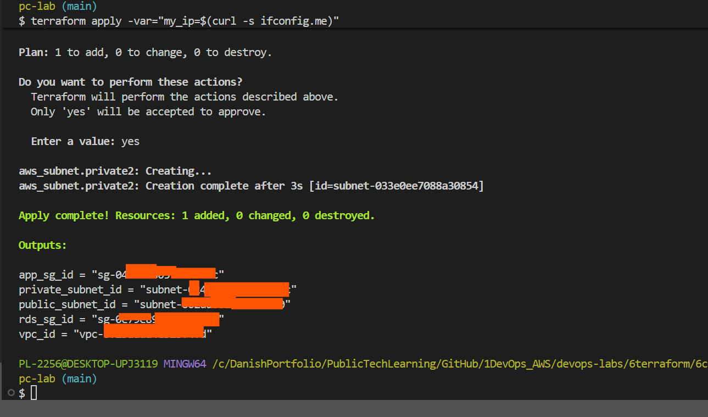
Fix applied in Lab 6-C: second private subnet added in us-east-1b (1 to add, 0 to change)
Retrying the RDS apply after the fix:
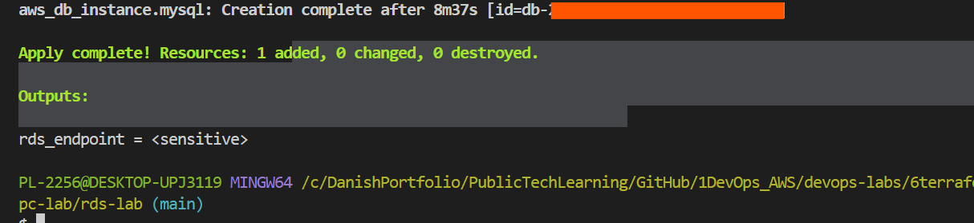
terraform apply complete — RDS MySQL 8.0 created after 8m37s
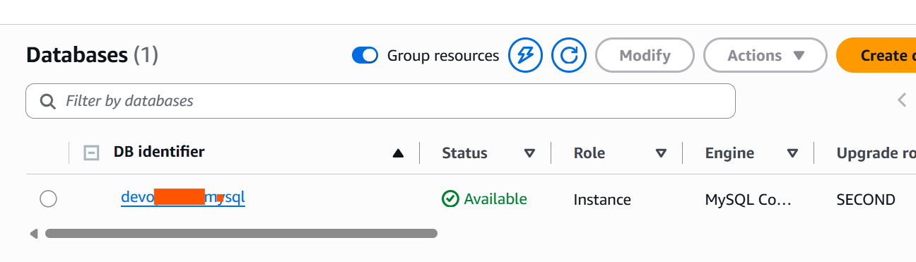
AWS Console confirms the RDS instance is Available, Engine: MySQL Community

Destroy
terraform destroy -var="db_password=<your-password>"
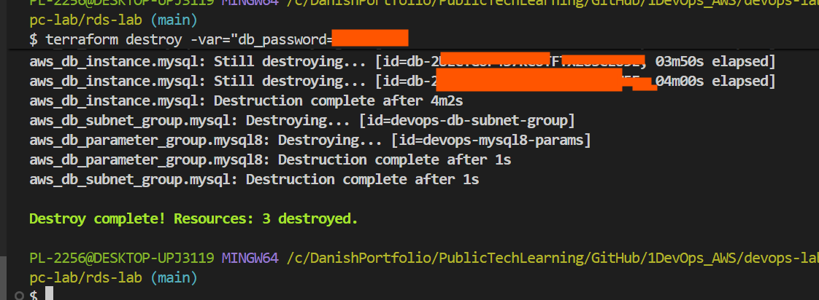
terraform destroy complete — 3 resources destroyed (RDS destroyed first, per dependency order)
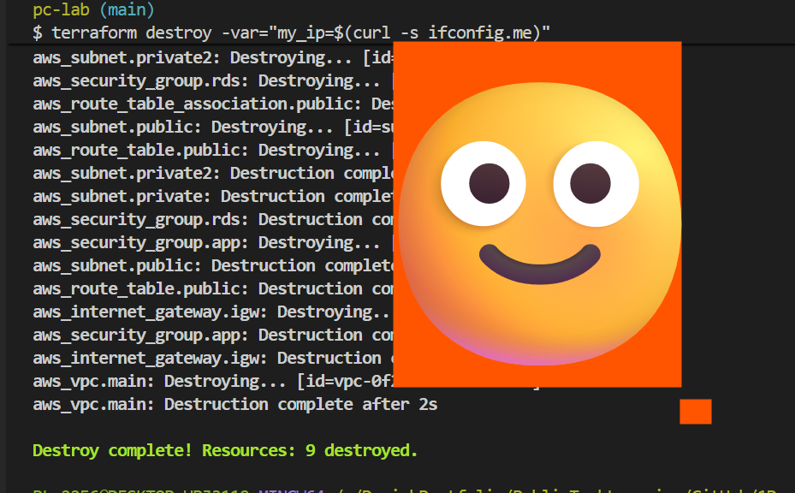
Lab 6-C VPC destroyed last (9 resources — includes the second private subnet added for the fix)
Lab 6-D result: a real, encrypted, privately-placed MySQL 8.0 RDS instance built end to end via Terraform, using data blocks to safely re-use existing infrastructure from a separate project. A real AWS platform requirement (2-AZ subnet coverage) was hit and resolved as it would be in an actual production rollout.

Lab 6-E — Add CloudWatch Alarm to EC2 (End-to-End)
Purpose: build an EC2 instance, an SNS notification topic, an email subscription, and a CloudWatch CPU alarm all in one terraform apply — infrastructure and monitoring deployed together as a single unit, rather than as separate manual steps.
Folder used: devops-labs/6terraform/ (the same folder as Lab 6-B — new resources appended to that main.tf)

What is SNS?
SNS (Simple Notification Service) is AWS's broadcast/announcement system. A topic is the channel itself — it doesn't know who's listening. A subscription is one specific listener attached to that topic (email, SMS, another AWS service). When something publishes to the topic, every subscriber is notified.
This is the same relationship already covered conceptually in the handbook's AWS Fundamentals chapter (CloudWatch alarms triggering SNS notifications) and performed manually via console clicks in the Monitoring chapter's hands-on lab. This lab writes that same operational task as reusable Terraform code.

variables.tf additions
variable "project_name" {
description = "Project name prefix for resource naming"
type = string
default = "devops-lab"
}

variable "alert_email" {
description = "Email address for CloudWatch alarm notifications"
type = string
# no default — supplied live via -var, same discipline as db_password
}

main.tf — SNS Topic and Subscription
resource "aws_sns_topic" "alerts" {
name = "${var.project_name}-alerts"
}

resource "aws_sns_topic_subscription" "email" {
topic_arn = aws_sns_topic.alerts.arn
protocol = "email"
endpoint = var.alert_email
}

⚠️ Danish-Imp! After apply, AWS sends a real confirmation email to this address. The subscription stays in PendingConfirmation state — and alarms will NOT actually notify anyone — until that email's "Confirm subscription" link is clicked. This is an AWS anti-spam safeguard; Terraform cannot auto-confirm it.

main.tf — CloudWatch Alarm (lab-tuned thresholds)
Standard production settings would use an 80% CPU threshold checked over 10 minutes. For fast lab testing and to actually see a real alert email arrive during the session, the threshold was intentionally lowered:
resource "aws_cloudwatch_metric_alarm" "cpu_high" {
alarm_name = "${var.project_name}-high-cpu"
comparison_operator = "GreaterThanThreshold"
evaluation_periods = 1 # lab: 1 (production: 2)
metric_name = "CPUUtilization"
namespace = "AWS/EC2"
period = 60 # lab: 60s (production: 300s)
statistic = "Average"
threshold = 1 # lab: 1% (production: 80%)

alarm_description = "LAB ONLY: CPU above 1 percent for 1 minute — intentionally low for fast testing"
alarm_actions = [aws_sns_topic.alerts.arn]
ok_actions = [aws_sns_topic.alerts.arn]

dimensions = {
InstanceId = aws_instance.web.id
}
tags = { Name = "${var.project_name}-cpu-alarm" }
}

⚠️ Danish-Imp! threshold = 1 and period = 60 is a deliberate LAB-ONLY pattern for fast demonstration. In real production this would be extremely noisy (constant false alarms) — production should use threshold = 80, period = 300, evaluation_periods = 2, matching the AWS Fundamentals chapter's original guidance.
📌 Real Near-Miss — terraform validate caught a second missing section: A validate run failed with "aws_sns_topic .alerts has not been declared" — the SNS topic and subscription blocks had not actually made it into main.tf; only the EC2 resource and the CloudWatch alarm were present. Confirmed via cat main.tf, then the missing blocks were inserted between the EC2 and CloudWatch alarm sections. This is the second time in this chapter that terraform validate caught a genuinely missing section before wasting time on plan/apply — a strong argument for validating immediately after writing any multi-resource file.
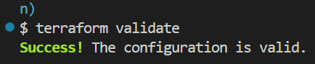
terraform validate — Success, after adding the missing SNS blocks
terraform plan -var="alert_email=<your-email>"
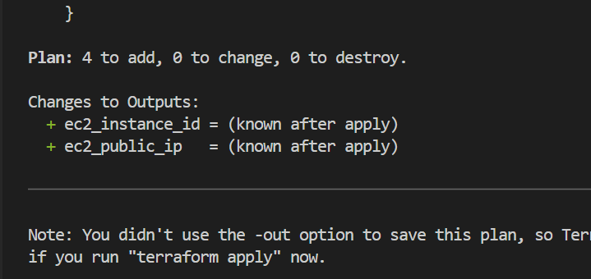
terraform plan — 4 to add (EC2, SNS topic, SNS subscription, CloudWatch alarm)
terraform apply -var="alert_email=<your-email>"
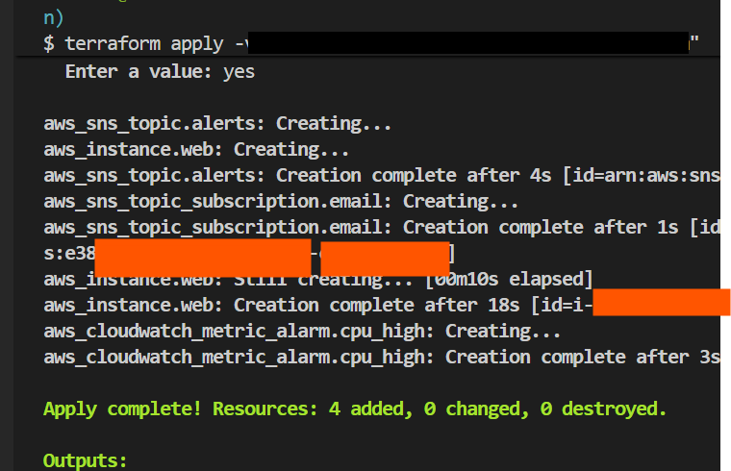
terraform apply complete — 4 resources added (email redacted)
📌 Real Near-Miss — Confirmed the wrong SNS subscription (leftover topic from a prior session): The first confirmation email was clicked, but no alarm email ever arrived. Checking AWS Console → SNS → Subscriptions showed the confirmed subscription was actually attached to a different, unrelated topic (a leftover from an earlier session) — not to this lab's devops-lab-alerts topic. Checking the devops-lab-alerts topic directly confirmed its subscription was still Pending confirmation. Fixed by clicking "Request confirmation" on that specific subscription, verifying the topic ARN in the new email matched devops-lab-alerts, and confirming it correctly. Lesson: when multiple SNS topics/subscriptions exist in one AWS account, always verify the topic ARN in a confirmation email before clicking confirm — two similarly-timed confirmation emails are easy to mix up.
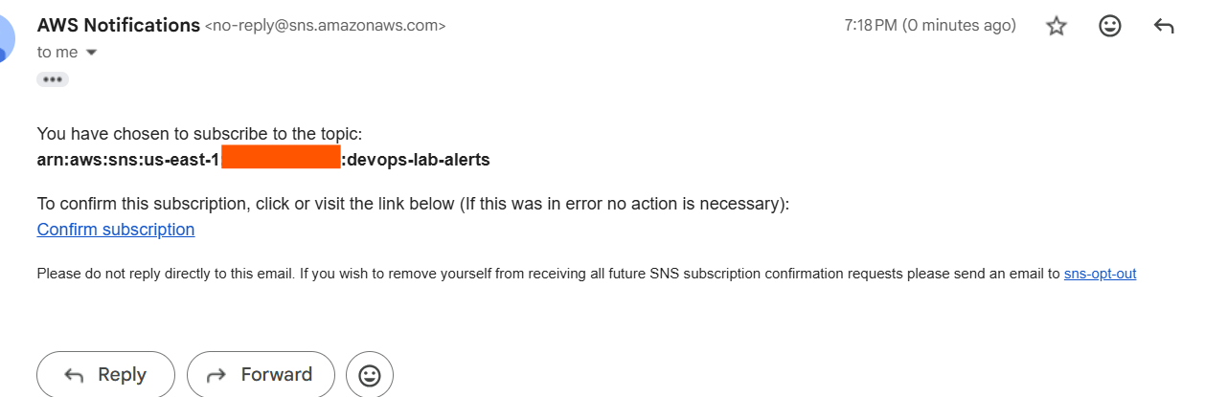
Correct confirmation email — topic ARN ends in :devops-lab-alerts
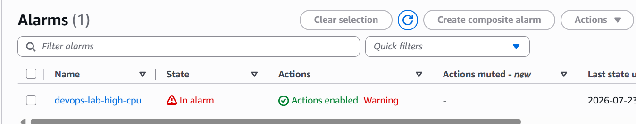
CloudWatch alarm state: In alarm (real CPU exceeded the 1% lab threshold)
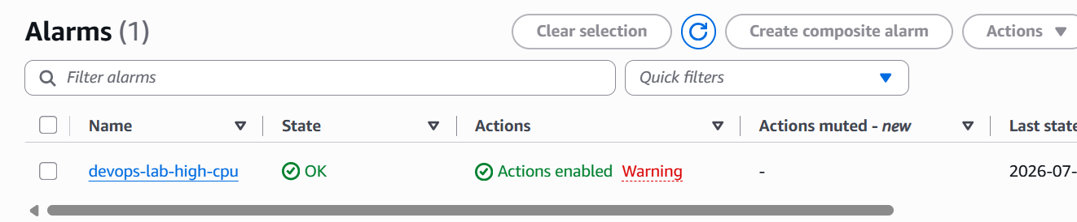
Alarm state later observed as OK — CloudWatch alarms only email on a STATE CHANGE, not while remaining in the same state
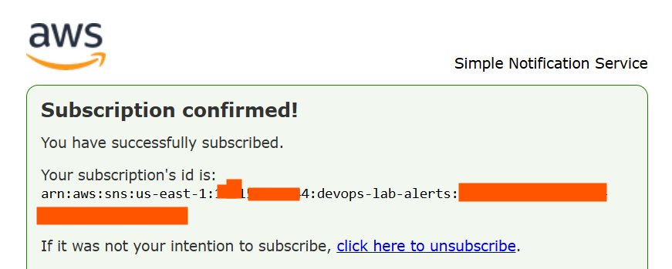
Subscription confirmed — correctly attached to the devops-lab-alerts topic this time

Manually Triggering a Fresh State Change (verification)
Since CloudWatch only emails on a state transition (not while remaining in the same state), the alarm state was forced manually to generate and verify a real notification immediately, rather than waiting for a natural CPU cycle:
aws cloudwatch set-alarm-state \
--alarm-name devops-lab-high-cpu \
--state-value ALARM \
--state-reason "Manual test trigger to verify email notification"
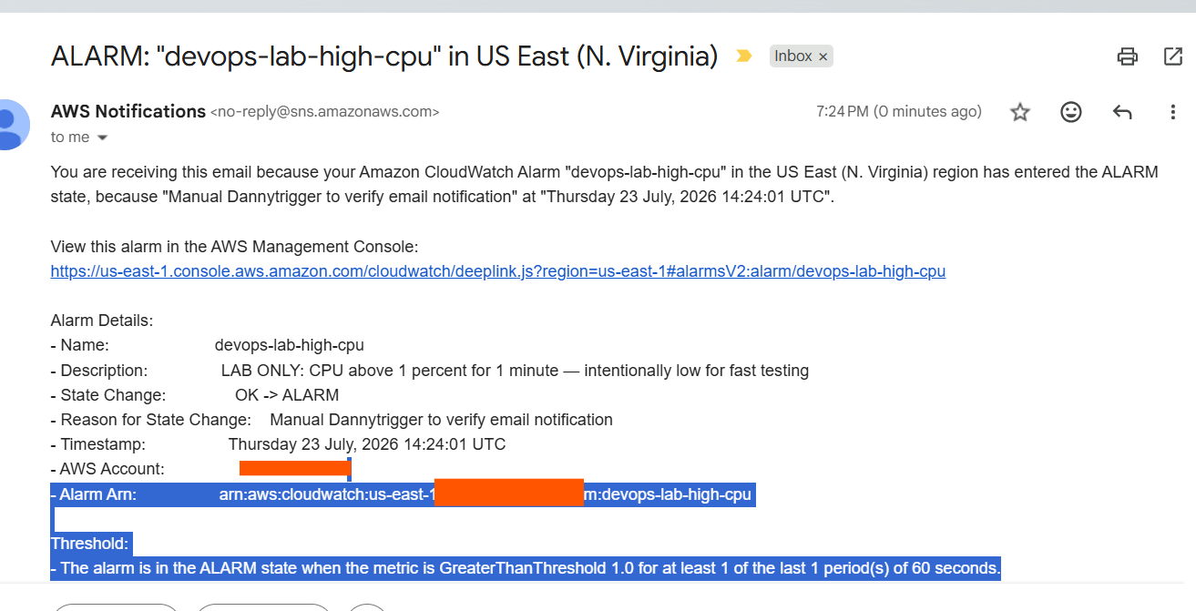
Real alarm email received within seconds — full chain confirmed: EC2 CPU → CloudWatch → Alarm → SNS → Email

Destroy
terraform destroy -var="alert_email=<your-email>"
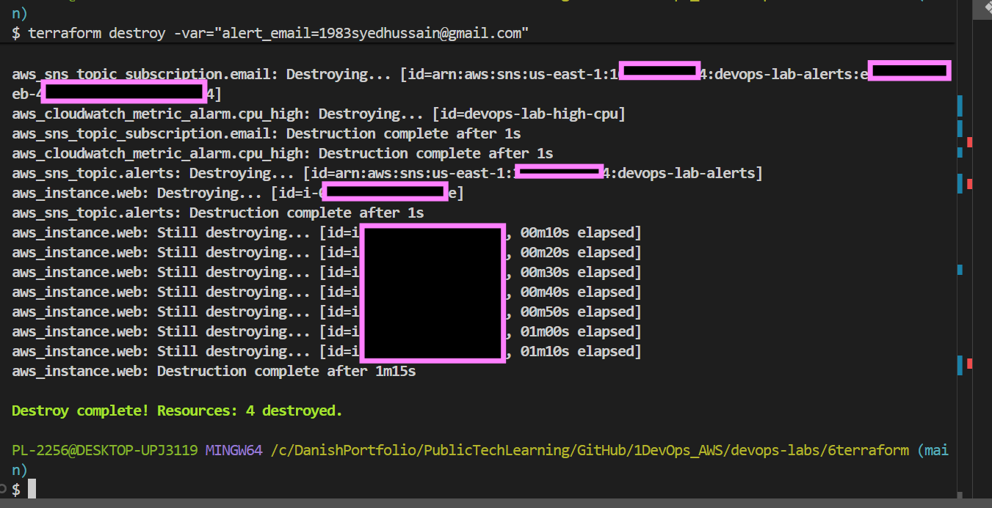
terraform destroy complete — 4 resources destroyed. All Chapter 6 AWS resources fully cleaned up.
🧠 DBA Mindset Bridge: This is exactly like setting an alert threshold on Threads_connected or replication lag — notify me if X stays above threshold Y for Z consecutive checks — the same shape, just applied to EC2 CPU instead of a database metric.
Lab 6-E result: a complete, verified, end-to-end alerting pipeline — EC2 instance, SNS topic, SNS email subscription, and CloudWatch alarm all deployed together in one apply. A real alarm notification email was received and confirmed to match the exact lab-tuned threshold settings, after diagnosing and fixing a genuine subscription mix-up along the way.

Real Lessons Learned — Session Near-Misses
Four genuine mistakes were made and fixed during this chapter's hands-on work. Each one is kept here deliberately, not omitted, because catching real mistakes in real time is where the deepest learning happens.
# | Lab | Near-Miss | Fix
1 | 6-C | my_ip hardcoded as a default value in variables.tf | Removed the default; supplied live via -var="my_ip=$(curl -s ifconfig.me)"
2 | 6-C | terraform validate caught missing security group blocks | Re-added the aws_security_group "app" and "rds" blocks to main.tf
3 | 6-D | DBSubnetGroupDoesNotCoverEnoughAZs — RDS needs 2+ AZs | Added a second private subnet (us-east-1b) to Lab 6-C
4 | 6-E | terraform validate caught missing SNS topic/subscription blocks | Re-added the aws_sns_topic and aws_sns_topic_subscription blocks
5 | 6-E | Confirmed the wrong SNS subscription (leftover topic from a prior session) | Verified topic ARN, requested a fresh confirmation for the correct topic

Terraform Quick Reference

Resource and Block Types Used in This Chapter
Resource / Block Type | What It Creates | Used In
aws_instance | EC2 virtual server | 6-B, 6-E
aws_security_group | Firewall rules for EC2/RDS | 6-C
aws_vpc | Virtual Private Cloud | 6-C
aws_subnet | Subnet inside a VPC | 6-C
aws_internet_gateway | IGW for public internet access | 6-C
aws_route_table + association | Route table and its link to a subnet | 6-C
aws_db_instance | RDS managed database | 6-D
aws_db_subnet_group | Subnet group for RDS placement (needs 2+ AZs) | 6-D
aws_db_parameter_group | Custom MySQL/Postgres engine parameters | 6-D
aws_sns_topic | SNS notification topic | 6-E
aws_sns_topic_subscription | Subscriber attached to an SNS topic | 6-E
aws_cloudwatch_metric_alarm | CloudWatch alert on a metric threshold | 6-E
data.aws_vpc | Look up an existing VPC by tag (read-only) | 6-D
data.aws_subnets | Look up existing subnets by tag/filter (read-only) | 6-D
data.aws_security_group | Look up an existing security group by name (read-only) | 6-D
variable { } | Declare a reusable, parameterized input | All labs
output { } | Print a value after apply completes | All labs

Command Quick Reference
Command | What It Does
terraform init | Downloads provider plugins, prepares the working directory
terraform fmt | Auto-formats code style and indentation
terraform validate | Checks syntax correctness before touching AWS
terraform plan -var="key=value" | Previews changes without applying them
terraform apply -var="key=value" | Builds or updates real infrastructure (asks for yes)
terraform destroy -var="key=value" | Removes all resources this project manages
terraform output | Prints saved output values
terraform output -raw <name> | Prints a single output's raw value (needed for sensitive outputs)

⚠️ Danish-Imp! Quick Reference Table
Every critical warning flagged across this chapter, compiled here for fast lookup.
⚠️ Rule | Why It Matters
Never hardcode access_key/secret_key in .tf files | Public repo exposure compromises the AWS account within minutes
Never commit terraform.tfstate to Git | May contain secrets in plain text; causes merge conflicts
Never set defaults for sensitive variables (my_ip, db_password, alert_email) | Prevents real values from being hardcoded into files headed for GitHub
Always run terraform validate before plan on multi-resource files | Caught real missing-resource errors twice in this chapter
Always read plan output before typing yes on apply | Last chance to catch an unintended destroy-and-recreate change
Never set publicly_accessible = true on RDS | Matches the core networking rule — databases stay in private subnets
Never set skip_final_snapshot = true in real production | Removes the safety net against accidental data loss
RDS DB Subnet Groups need subnets in 2+ AZs, even for single-AZ databases | Real AWS platform requirement — caught live in Lab 6-D
Always destroy dependent resources before what they depend on | RDS (6-D) before VPC (6-C) — avoids dependency errors
Verify the topic ARN in an SNS confirmation email before clicking confirm | Multiple topics can create similarly-timed, easy-to-mix-up confirmation emails
Always run terraform destroy after every lab session | Prevents ongoing AWS charges from forgotten resources
Restart the terminal after installing a CLI tool on Windows | PATH changes don't apply to an already-open terminal session
Use forward slashes and /c/ in Git Bash, not C:\ (PowerShell style) | Git Bash treats backslashes as escape characters, breaking paths silently

Ready for GitHub — Folder Structure and Commit Checklist
This chapter's local working folders, ready to be committed to the devops-labs repository:
devops-labs/6terraform/
├── main.tf, variables.tf, outputs.tf, .gitignore (Lab 6-B — EC2)
├── 6c-vpc-lab/
│ └── main.tf, variables.tf, outputs.tf, .gitignore (Lab 6-C — VPC)
└── rds-lab/
└── main.tf, variables.tf, .gitignore (Lab 6-D — RDS)

Before pushing — verify none of these are staged
- *.tfstate and *.tfstate.backup (may contain real resource data)
- .terraform/ folders (large downloaded provider binaries)
- terraform.tfvars, if it ever holds a real value
⚠️ Danish-Imp! Run git status before every push on a Terraform folder and confirm none of the above appear in the staged file list.

Suggested commit message
git add .
git commit -m "complete terraform chapter: EC2, VPC, RDS, CloudWatch alarm labs"
git push

Both this document (DevOps_Terraform_v1.0) and the devops-labs/6terraform/ folder are ready to move into the GitHub portfolio together.

