Implementation

This project was developed using VSCode editor, PHP 7 and MySQL database

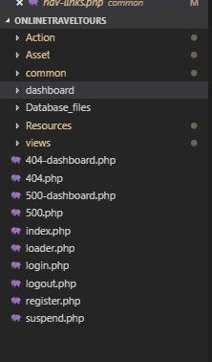**Folder structure**

Action: This file contains all the php scripts required for the functionality of the website.

Asset: The common file contains the front-end part of the website i.e. the JS, CSS, fonts and images used.

Common: The folder common contains the common elements found on the webpages in order to prevent code duplications

It consists of the header, footer both by admin and customer interface

Dashboard: the dashboard folder contains all admin pages as well as all uploaded images onto the site

View: The folder view contains all the webpages of the web applications of the user interface section.

**Coding structure**

Reducing code duplication

External php files were used in order to eliminate code duplication for example:

1. An icon file was created so that any icon created becomes reusable
2. A nav-link file was created to link all pages and links and making them remains in their correct paths as shown below:

Nav links PHP

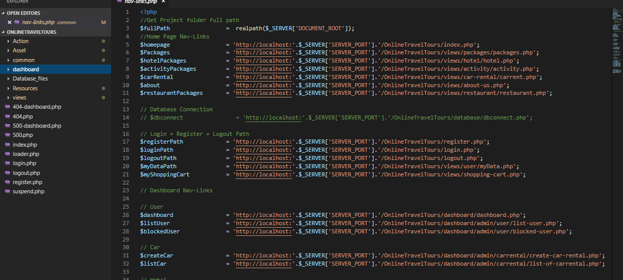

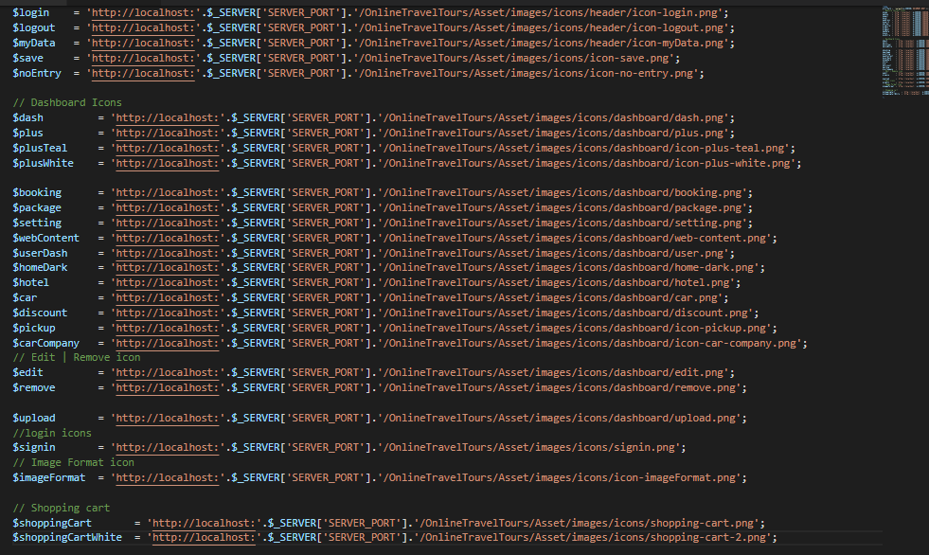Icons PHP

1. Error pages

2 error pages was developed namely page 404 and page 500

404 – will appear If ever page Is not found/ items not found

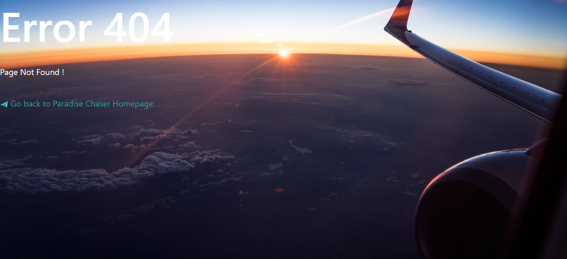

500- will appear if ever there is an issue on the database part or the site has been down i.e. server error

