## CPSC 8430 Deep Learning

##### Danish Bhatkar (C15563212) – [dbhatka@clemson.edu](mailto:dbhatka@clemson.edu)

[**GitHub Repository Link**](https://github.com/danishb7/CPSC8430-Deep-Learning/tree/main/HW1)

# Homework 1

### Question 1.1 – Deep vs Shallow

#### Simulate a function

1. Describe the models you use, including the number of parameters (at least two models) and the function you use.  
     
   **Model 1:-**  
   Number of parameters – 2241  
   Hidden layers – 2  
   Activation layer – ReLU  
     
   **Model 2:-**Number of parameters – 2209  
   Hidden layers – 3  
   Activation layer – ReLU  
     
   Functions used are : sin(x) and x3
2. In one chart, plot the training loss of all models.  
     
   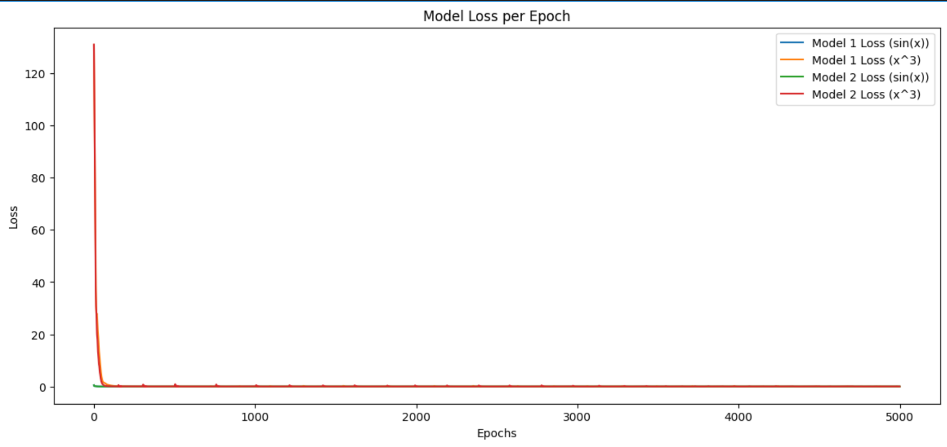

Figure - Training loss of all models

1. In one graph, plot the predicted function curve of all models and the ground-truth  
   function curve.  
   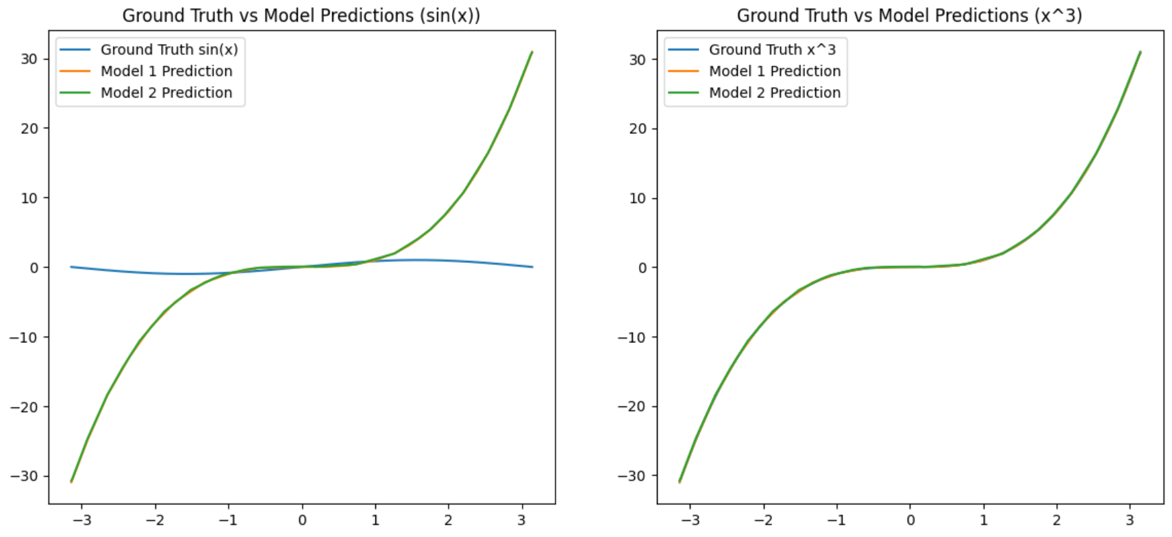

Figure - Ground truth vs Model prediction for both functions

1. Comment on your results.  
   Both the models have different number of layers, but the predictions and the losses obtained are indistinguishable to the naked eye.

** Used more than 1 function (bonus)

#### Train on Actual Tasks

1. Describe the models you use and the task you chose.  
   Both the models are CNNs built using PyTorch and are trained for the dataset **CIFAR-10**.  
   **Model 1:-**Conv. Layers – 2  
   Filter sizes – 12 and 32  
   Feature maps size – 8x8  
   Number of layers – 5  
     
   **Model 2:-**Conv. Layers – 3  
   Filter sizes – 8, 12, 32  
   Feature maps size – 4x4  
   Number of layers – 6
2. In one chart, plot the training loss of all models.
3. In one chart, plot the training accuracy.  
   A comparison of a graph

   Description automatically generated

Figure - Training loss and accuracy of both models

1. Comment on your results.  
   Although, Model 1 has lesser depth as compared to Model 2, it outperforms Model 2 in terms of accuracy and losses recorded as per the above charts. The differences in filters and feature maps lead to this difference in outputs.

### Question 1.2 – Optimization

#### Visualize the Optimization Process

1. Describe your experiment settings. (The cycle you record the model parameters, optimizer, dimension reduction method, etc)  
   The experiment trains a CNN on the CIFAR-10 dataset for 30 epochs using Adam optimizer and CrossEntropyLoss, recording model parameters every 3 epochs. Gradient norms and loss are tracked throughout training, with weights collected and flattened into a matrix.
2. Train the model for 8 times, selecting the parameters of any one layer and whole model and plot them on the figures separately.  
   A graph of a diagram

   Description automatically generated with medium confidence

Figure - Convergence of weights in 2D space

1. Comment on your results.  
   The 2D scatter plot from PCA shows the evolution of the model’s parameters across epochs and runs, revealing distinct trajectories that reflect the variability in training dynamics but convergence toward a similar region in weight space. This suggests consistent learning patterns across different initializations.

#### Observe gradient norm during training

1. Plot one figure which contain gradient norm to iterations and the loss to iterations.  
   A close-up of a graph

   Description automatically generated

Figure - Loss and Gradient norm

1. Comment on your result.  
   The training loss decreases steadily, showing effective learning across all runs, but may suggest room for further optimization if the loss plateaued early.

#### What happens when gradient is almost zero?

1. State how you get the weight which gradient norm is zero and how you define the minimal ratio.  
   To find weights where the gradient norm is zero, we track the L2 norm of the gradients during each training step. If the total gradient norm across all parameters falls below a small threshold, the training loop can terminate early since minimal updates are being made to the model.  
   The minimal ratio is defined as the proportion of weights in the model that are close to zero (decided by considering a threshold value).
2. Train the model for 100 times. Plot the figure of minimal ratio to the loss.  
   A comparison of a graph

   Description automatically generated

Figure - Gradient norm trajectory and Minimal Ratio to Loss

1. Comment on your results.  
   Since the gradient norm increases with training, it suggests that the learning rate might be high or that the models are not converging.  
   Also, as the minimal ratio increases with increase in loss, it suggests that the model is losing its learning capacity as more weights shrink towards zero. It could mean over-regularization or underfitting.

### Question 1.3 – Generalization

#### Can a network fit random labels?

1. Describe your settings of the experiments. (e.g. which task, learning rate, optimizer)/  
   Task – Classification of CIFAR-10 dataset, 10 classes of images  
   Model – CNN with 2 conv. Layers and 2 fully connected layers  
   Optimizer – Adam  
   Learning rate – 0.001  
   Loss function – Cross-entropy loss

#### Number of parameters vs Generalization

1. Describe your settings of the experiments. (e.g. which task, the 10 or more structures you choose).  
   Task – Image classification on CIFAR-10 dataset  
   Dataset – CIFAR-10, consisting of 60,000 32x32 color images in 10 classes.  
   Model structures – 10 models as follows:-
   1. Model 1: 8 filters in both conv layers, 8 hidden units
   2. Model 2: 8 filters (conv1), 16 filters (conv2), 16 hidden units
   3. Model 3: 16 filters in both conv layers, 32 hidden units
   4. Model 4: 16 filters (conv1), 32 filters (conv2), 64 hidden units
   5. Model 5: 32 filters in both conv layers, 64 hidden units
   6. Model 6: 32 filters (conv1), 64 filters (conv2), 128 hidden units
   7. Model 7: 64 filters in both conv layers, 128 hidden units
   8. Model 8: 64 filters (conv1), 96 filters (conv2), 128 hidden units
   9. Model 9: 96 filters (conv1), 128 filters (conv2), 128 hidden units
   10. Model 10: 128 filters in both conv layers, 256 hidden units

Optimizer – Adam  
Loss function – Cross entropy loss

1. Plot the figures of both training and testing, loss and accuracy to the number of parameters.  
   A graph of different colored lines

   Description automatically generated A graph of different colored lines

   Description automatically generated  
   A graph of a graph of different models

   Description automatically generated with medium confidence A graph of different colored lines

   Description automatically generated
2. Comment on your results.  
   The Model #9 outperforms all other trained models in terms of losses and accuracies observed even though it is not the most dense neural network in the list of models.

#### Flatness vs Generalization

1. Describe the settings of the experiments (e.g. which task, what training approaches).  
   Task – Classification of CIFAR-10 dataset using CNN  
   Dataset – CIFAR-10  
   Model – 2 Conv. Layers (ReLU activation + Max pooling) + 2 fully connected layers  
   Training approach – Batch sizes: 64, 128, 256, 512, 1024  
   Optimizer – Adam  
   Learning rate – 0.001  
   Loss function – Cross entropy loss
2. Plot the figures of both training and testing, loss and accuracy, sensitivity to your chosen variable.  
   A screenshot of a graph

   Description automatically generated
3. Comment on your result  
   Loss and accuracy curves across interpolation ratios can show model stability. Smooth curves suggest compatibility between parameters, while sharp changes indicate potential sensitivity.  
   The sensitivity decreases with increasing batch size.