HR Employee Attrition Analysis
Findings & Recommendations Report
Prepared by Danish Muhammed | Dataset: IBM HR Analytics Employee Attrition & Performance (Kaggle)

1. Overview
This report analyzes employee attrition across a 1,470-employee organization to identify which roles, conditions, and factors are most associated with employees leaving the company, and to recommend targeted retention actions. The dataset is a fictional dataset published by IBM data scientists and made publicly available on Kaggle.
Overall attrition rate: 16.1% of employees left the company.

2. Key Findings

2.1 Attrition is concentrated in specific roles
Sales Representatives show by far the highest attrition rate of any role in the company, at 39.8% — more than double the company-wide average. Sales Executives, by contrast, sit much closer to the norm at 17.5%, indicating the retention problem is specific to the entry-level sales role rather than the sales function broadly.
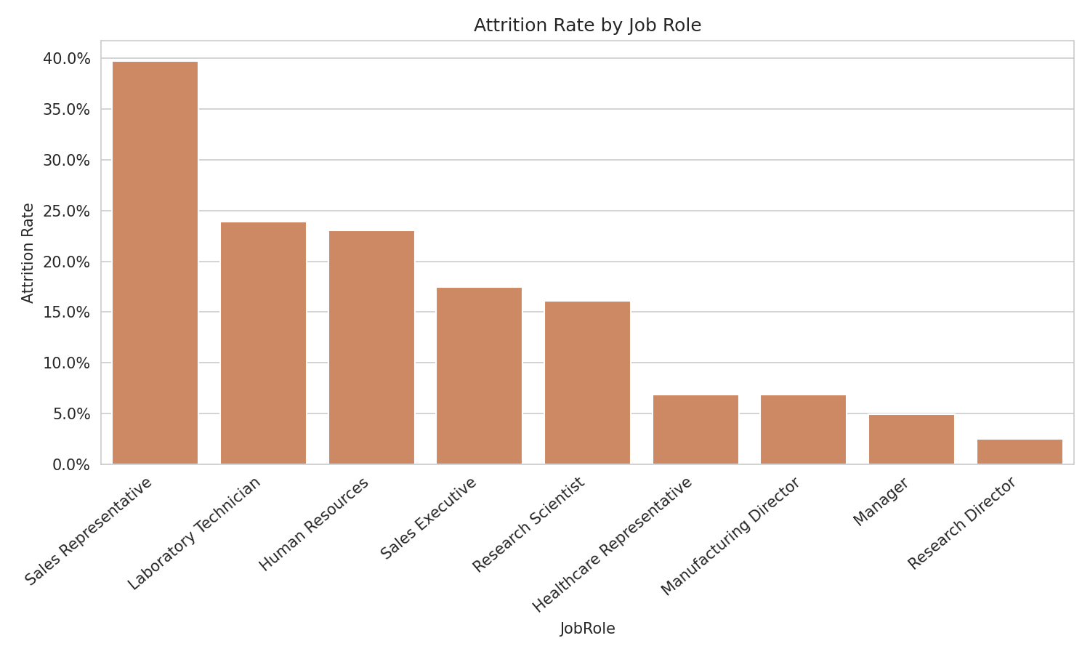

2.2 Overtime is the strongest single driver
Employees who work overtime leave at nearly three times the rate of those who don't — 30.5% versus 10.4%. This was also confirmed as the strongest predictive factor in the statistical model built for this analysis (see Section 4).
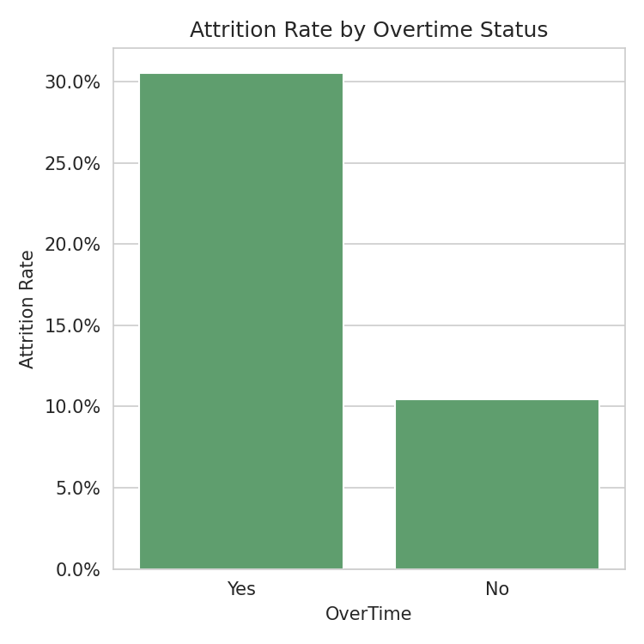

2.3 Compensation gap between stayers and leavers
Employees who left earned an average of $4,787/month, compared to $6,833/month for those who stayed — a gap of roughly 30%. This holds even before controlling for role or seniority, suggesting pay may be a meaningful factor in the decision to leave.
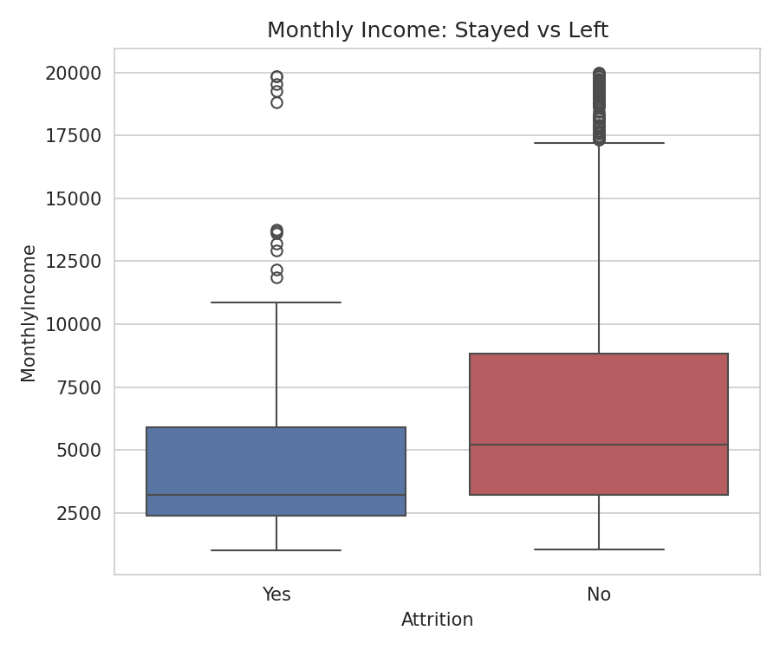

2.4 Attrition risk is highest early in tenure
Employees who left were on average younger (33.6 vs. 37.6 years) and had spent less time at the company (5.1 vs. 7.4 years) than those who stayed. This points to a retention risk window concentrated in the first few years of employment.

2.5 Frequent travel roughly triples attrition risk
Employees who travel frequently for work leave at 24.9%, compared to just 8.0% for employees who don't travel at all — a clear and substantial gap.
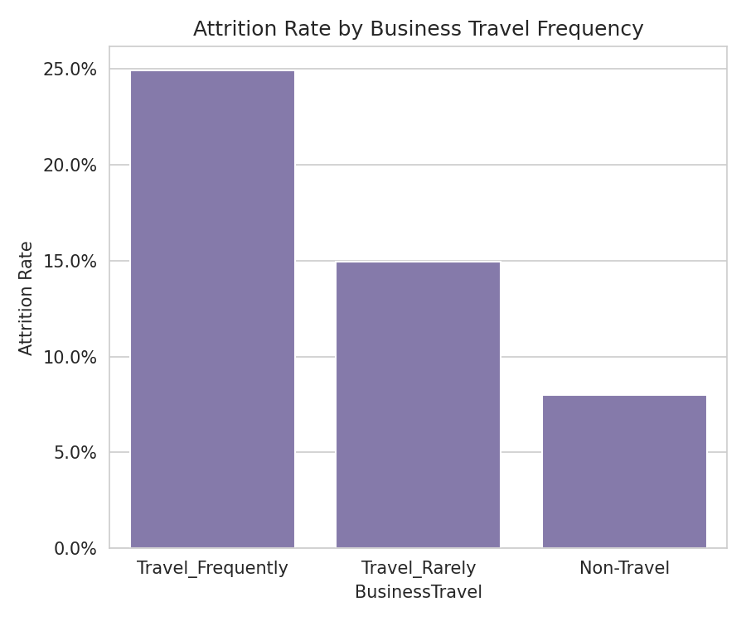

2.6 Department-level view
Sales (20.6%) and Human Resources (19.0%) show higher attrition than Research & Development (13.8%), consistent with the role-level findings above.
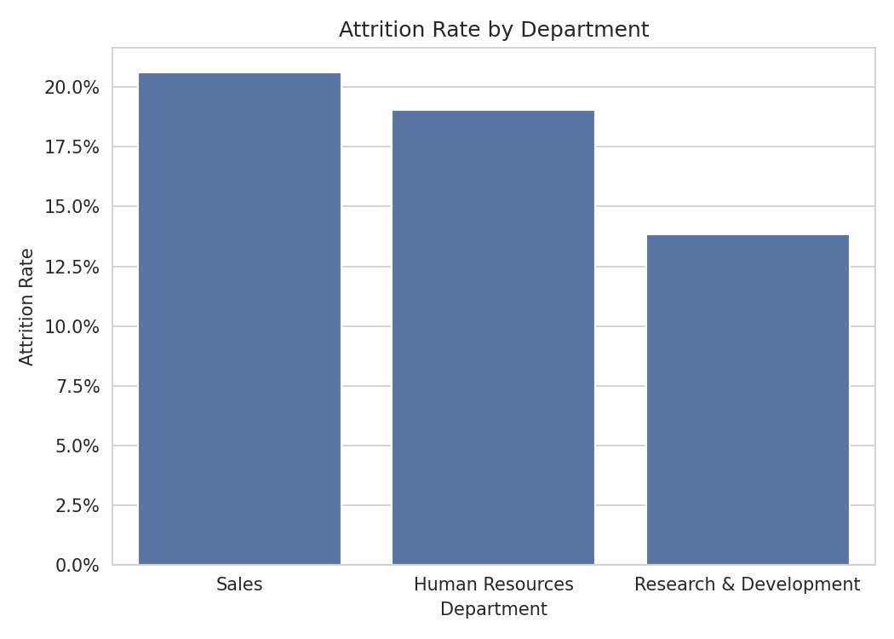

3. Summary Table
Metric | Stayed | Left
Average Monthly Income | $6,833 | $4,787
Average Age | 37.6 yrs | 33.6 yrs
Average Years at Company | 7.4 yrs | 5.1 yrs
Average Job Satisfaction (1-4) | 2.78 | 2.47

4. Predictive Model
A logistic regression model was trained to predict attrition using all available employee attributes. The model reached 87.4% overall accuracy on held-out test data.
A limitation worth noting honestly: because only ~16% of employees in the dataset actually left, the model is better at correctly identifying employees who stay than at catching every employee who will leave (28% recall on departing employees). This is a common and expected limitation with imbalanced datasets like this one, not a flaw unique to this analysis.
Factors that most increased predicted attrition risk: working overtime, marital status, and department.
Factors that most reduced predicted attrition risk: stock option level, environment satisfaction, and job involvement.

5. Recommendations
- Prioritize retention efforts specifically on the Sales Representative role — review workload, overtime exposure, and compensation benchmarking, since this role's attrition rate is a clear outlier.
- Audit overtime policy and workload distribution — overtime is the single strongest attrition driver identified, and may point to burnout or inadequate staffing levels.
- Strengthen early-tenure engagement and onboarding support, since attrition risk is concentrated in employees' first few years.
- Review compensation bands where a meaningful pay gap exists between employees who stay and those who leave in comparable roles.
- Re-examine travel expectations for frequently-traveling roles, given the sharp rise in attrition risk associated with frequent travel.

6. Methodology Note
Analysis was performed in Python using pandas for data cleaning and aggregation, matplotlib/seaborn for visualization, and scikit-learn for the predictive model. Full code and outputs are available in the accompanying Jupyter notebook (hr_attrition_analysis.ipynb) and published to GitHub.

