- Download Oracle Database
- DownLoad sql Developer
- Connect Oracle DB with SQL Developer
- Download IntelliJ IDEA
- Download code from following url
https://github.com/danishmahmood83/sentiment-analysis.git
- Run sql scripts(/src/main/resources/db_script/create_tables.sql) using sql developer
- In Intellija go to (File->Project Structure->Select JDK 17 )
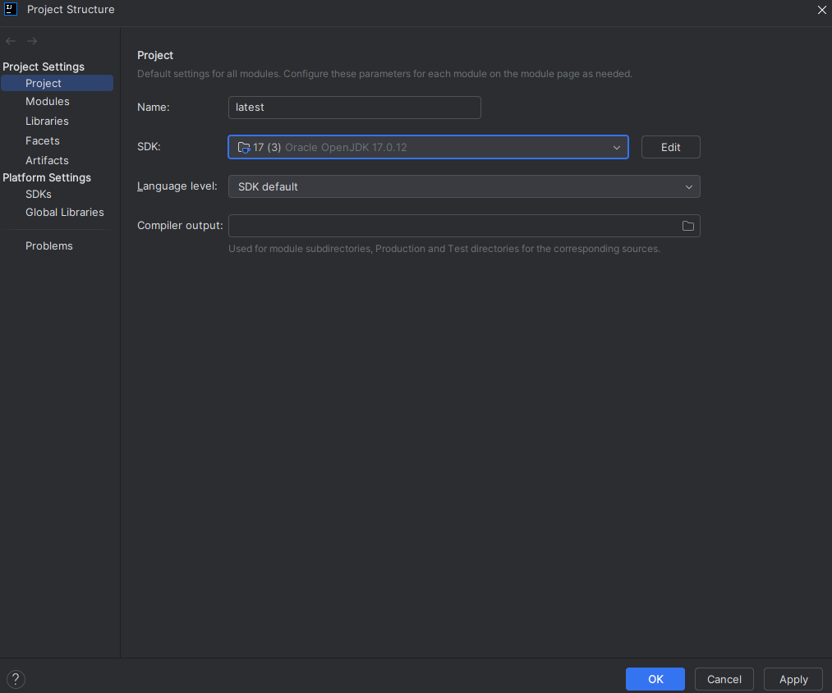
- Run Maven->Clean/Compile/Install
- Run Spring Boot Application.(you will get following highlighted line if app run successfully
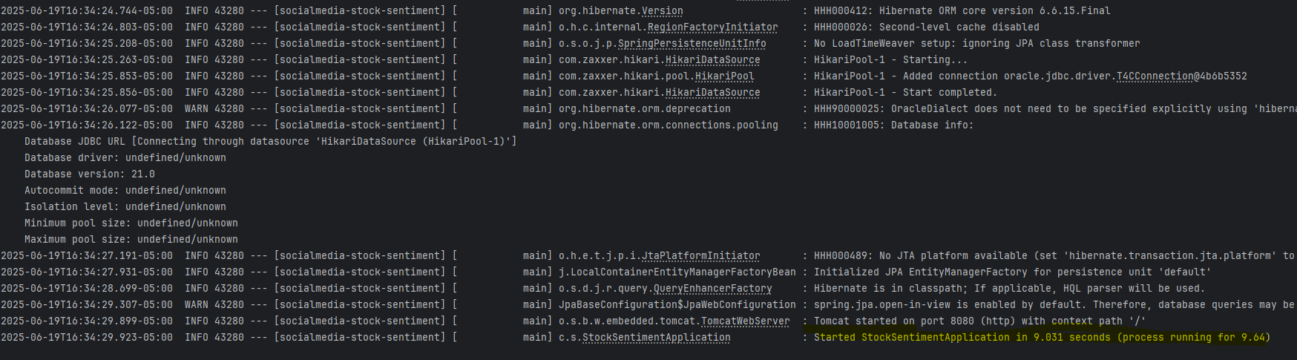
- Go to the Node.js website: https://nodejs.org
- Download the LTS version (recommended for most users) — this includes npm (Node Package Manager).
- Run the installer:
  - Accept the license
- Click next on defaults
- Make sure to check “Automatically install necessary tools” (optional but helpful)
- Verify the installation:Open Command Prompt (cmd) and run:
node -v
npm -v
- You should see versions printed, like:
V18.19.1
9.8.0
- Navigate to your React frontend folder:
cd :/sentiment-analysis/stock-sentiment-ui
- Run npm install
- Run npm install axios react-chartjs-2 chart.js chartjs-plugin-datalabels
- npm start(This will start the React development server.App will open in your browser at:
http://localhost:3000

