BILINGUAL TWEET
LABELING & CLASSIFICATION



Session 2018-2022

Project Advisors
Dr. Muhammad Saeed

Name of Co-Supervisor
Ms. Maryam Feroze

Submitted By

Danish Mahmood Ali | B18101028
Muhammad Ibad | B18101074
Ali bin Ejaz | B18101008
Reeba Nadeem | B18101097

Department of Computer Science
University of Karachi
A research paper submitted to the
Department of Computer Science
in partial fulfillment of the requirements for the
degree
Bachelor of Science
in
Computer Science
by
Danish Mahmood Ali
Muhammad Ibad
Ali bin Ejaz
Reeba Nadeem

University of Karachi

March 6, 2023
Acknowledgements

We truly acknowledge the cooperation and help by Dr. Muhammad Saeed, Assistant Professor Department of Computer Science University of Karachi. Throughout the project he has consistently given us guidance and a sense of direction to effectively make progress. We would also like to thank Ms. Maryam Feroze for her help and support throughout and guiding us with insightful suggestions. We are also indebted to Dr. Ayaz for allowing us to further his work on the project and for helping us during the project. We are extremely thankful to our friends and families whose silent support led us to complete our project.

(Signed)

Danish Mahmood Ali B-18101028
Muhammad Ibad B-18101074
Ali bin Ejaz B-18101008
Reeba Nadeem B-18101097

Date

Mar 6, 2023

Abstract
The increasing use of social media platforms has made them a valuable source for gathering data related to public opinion, sentiment analysis and language trends. In the context of bilingual communities, such as those that communicate in both English and Urdu, social media offers a unique opportunity to study the language usage patterns and semantic structures of these communities. The aim of this project is to develop a semi-supervised machine learning model to classify bilingual tweets written in English and Roman Urdu based on their content. The project will leverage the power of machine learning techniques to automatically categorize tweets into specific categories pertaining to the content in the tweets, such as politics, entertainment, etc. The project will also explore the effectiveness of different machine learning algorithms and techniques, such as deep learning and natural language processing, in achieving accurate and efficient classification. The results of this project have the potential to contribute to our understanding of the language usage patterns of bilingual communities, and may have practical applications in areas that require to keep up with the current trends of social media such as marketing, and social media monitoring.

1 Introduction

1.1: Overview

The project aims to classify bilingual tweets in English and Urdu based on their semantic content using semi-supervised machine learning models. Twitter has become a vital communication platform for people to express their views and opinions in real-time. The study of multilingual content on social media platforms is crucial for various applications such as sentiment analysis, trend analysis, social media monitoring, and opinion mining. The project will focus on identifying and classifying the semantic content of tweets in English and Roman Urdu.

The project will use semi-supervised machine learning algorithms to classify bilingual tweets. The dataset will consist of tweets in English and Roman Urdu, which will be pre-processed, tokenized into a dictionary, and labeled. The classification of the tweets will be based on the semantic content, such as keywords, sentiments and topics discussed in the tweet. The study will consider different machine learning algorithms, such as Support Vector Machines (SVM), Naive Bayes (NB), K-Neighbors Clustering, to classify the tweets.

The project will use a semi-supervised approach to leverage both labeled and unlabeled data. Initially, a small set of tweets will be manually labeled by human annotators to train the machine learning models. The labeled data will then be used to train the machine learning algorithms, which will be used to classify the remaining unlabeled tweets.

1.2: Objective

The main objective of our project is the rework and improvement of an already existing project [1] centered around the classification of bilingual tweets in English and Roman Urdu into multiclass labels. The main goal was to increase the accuracy of the classification of tweets in the second phase, while also improving the labeling of tweets from the model in the first phase.

The tweets are categorized into the following six categories:
- Politics
- Fun Talks
- Technology
- Current Affairs
- Entertainment
- Others

The project aims to further understand more about patterns in English and Roman Urdu tweets as previous research on the topic is not very common or very comprehensive. The project aims to contribute to the field of social media analysis by developing a methodology for classifying tweets in English and Urdu, which can be relevant to organizations that rely on social media data for decision-making purposes.

1.3: Dataset

The dataset was compiled from tweets that were data mined from Twitter using a script which employs the Twitter API. The script fetches tweets that contain hashtags that are given as input to the script. This process is ran for hashtags that are popular at different points of time to get variance in the compiled dataset, and to ensure that the tweets are not solely from certain categories or topics.

The original project consisted of a dataset of approximately five thousand tweets. From the five thousand tweets, three thousand tweets were labeled by a human annotator. These were then in the model in the first phase to label the remaining two thousand tweets.

To improve on the results of the previous project we firstly increased the size of the dataset. From the original five thousand tweets we decided to increase the tweets to approximately nine thousand tweets. From these nine thousand tweets approximately six thousand tweets were human labeled tweets while the remaining three thousand tweets were labeled through the unsupervised model in the first phase of the project.

Increasing the dataset gave the model more data to learn from in both phases of the project which resulted in improved labeling of the tweets as well as improved results in the classification of the tweets in the latter phase.Increasing dataset also reduced the risk of the model overfitting to the training dataset and having low testing accuracy which was
one of the issues in the previous project.

2 Motivation For The Project

2.1: Problem Statement

The problem addressed by this project is the lack of an effective methodology for the classification of bilingual tweets in English and Urdu based on their semantic content. Twitter is a widely used social media platform for people to express their views and opinions in real-time, and the analysis of multilingual content on Twitter is crucial for various applications such as sentiment analysis, social media monitoring, and opinion mining. However, the classification of bilingual tweets in English and Urdu poses a challenge due to the lack of labeled data and the complexity of language translation.

Current approaches to classifying bilingual tweets in English and Urdu rely on traditional machine learning algorithms that require a significant amount of labeled data, which is difficult and time-consuming to obtain. Moreover, these approaches do not effectively capture the nuances of the two languages and the interplay between them. Therefore, there is a need for a new methodology that can effectively classify bilingual tweets in English and Urdu while leveraging unlabeled data.

This project aims to address this problem by developing a semi-supervised machine learning approach to classify bilingual tweets in English and Urdu based on their semantic content. The project will leverage both labeled and unlabeled data and use self-training techniques to improve the accuracy of the classification models. The project will also explore the use of different machine learning algorithms to improve the classification performance. The project's outcome will be a methodology for the semantic classification of bilingual tweets in English and Urdu that can be applied to social media platforms in the future. The project's results will have implications for researchers, marketers, and organizations that rely on social media data for important decision-making purposes or for forecasting purposes

2.2: Related Work

Research has been conducted on the bilingual text consisting of English and Roman Urdu but the research is still in its infancy which is proven by there being no definitive or comprehensive reports on the topic.

A study by the University of Agriculture in Peshawar [2] employs the use of supervised learning models for the purpose of sentiment analysis of tweets and other social media posts in English and Roman Urdu. The study used a relatively small dataset of positive and negative responses that were labeled by an annotator and then used to train the model. The study used Naive Bayes, KNN and Decision Tree algorithms for the purpose of classifying the data according to the appropriate sentiment. The study showed good results of around 95% accuracy albeit the dataset being small.

Another study by the Kinnaird College for Women Lahore [3] uses a lexicon approach to analyze the sentiments of tweets. The study had around a dataset of 5000 labeled tweets but were limited to the topic of politics. The lexicon approach showed good results of being able to correctly predict the sentiment of the tweet with an accuracy of up to 98%.

While these studies provide insights into the classification of multilingual tweets using machine learning algorithms, they do not specifically address the problem of classifying bilingual tweets into multiclass labels. Therefore, there is a need for a new methodology that can effectively classify bilingual tweets in English and Urdu while leveraging unlabeled data. The proposed project aims to address this gap in the literature by developing a semi-supervised machine learning approach to classify bilingual tweets in English and Urdu based on their semantic content.

3 Requirements

3.1: Feature Extraction

To design a model that can effectively and efficiently classify the dataset into appropriate categories some parameters need to be decided for the sake of comparison. For this case involving tweets the most appropriate parameter would be the words used in them. While each tweet may contain an infinite number of word combinations, choosing the appropriate words to constitute a set for comparison remains a difficult task. So, choosing a feature set appropriately is particularly challenging in this regard.

3.2: Requirement of Data

The machine learning models that are to be used in the project rely on the input of human labeled data that the model can be trained on before making any predictions on future data. As a result, producing a sizable volume of labeled training data may present issues, such as the possibility that each human annotator could assign a different label to a tweet depending on their emotions, culture, country, family background, political or religious opinions, etc. As a result, the representation of labels for training data is diverse and non-concrete, which could negatively impact the classifier's performance.

So for the classification of these a large dataset of appropriate needs to be firstly acquired from and then labeled by human experts before it can be used for training the model. Having a large dataset makes this process have a large overhead in terms of time and manpower, having to go through thousands of tweets to find ones that are appropriate and to find human experts capable of objectively labeling these tweets without bias. For this reason the aspect of unsupervised learning was introduced.

4 Methodology

4.1: Pre-processing

Our proposed methodology is based on two phase approach using unsupervised in phase one and supervised learning in phase two

Preprocessing in machine learning refers to the steps taken to prepare data for training a model. Preprocessing is an important step because the quality of the data used to train a machine learning model can have a significant impact on the accuracy and effectiveness of the model. This section includes an explanation for the steps involved in the preprocessing of tweets.

Initially, the data is converted to plain text from JSON, then the tweet tag of the JSON is extracted removing all other JSON tags, links & emoticons. To eliminate any spelling ambiguity and duplicate feature extraction, the text is converted to lowercase. After that all stop words such as ‘is’, ‘am’, ‘are’, ‘they’, etc. are removed as they hold no semantic value and are only used for the structuring of sentences. Following that, all user references such as @TwitterUser and #Hashtags are removed. Keeping hashtags could act as a biased feature that can cause misleading classifications rather than the actual semantic classification of the text itself. The entire text is then run through an encoding checker to ensure that every character has been accurately transformed before all non-alphabetic characters are eventually eliminated. [4]

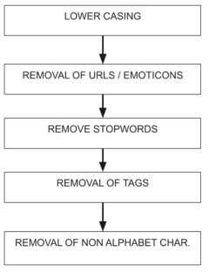
Fig 4.1 The flow of preprocessing

4.2: Dictionary

Feature selection is the process of selecting a subset of relevant features from the original dataset to be used in building a machine learning model. The primary concept behind feature selection is that data may contain some redundant or unnecessary features that may be removed without any loss of important data. By selecting only the most relevant features, we can improve the accuracy and efficiency of the model, reduce the risk of overfitting, and make the model easier to interpret.

For Dictionary generation we used most frequently appearing words in tweets and applied a Bag of Words approach. [5] Using one hot encoding, words in tweets are converted into binary representation such that each word occurring in the feature set is represented as 1 and and the ones that do not as 0.

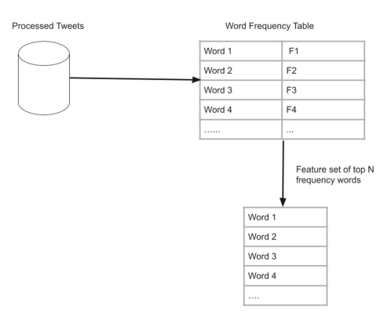
Fig 4.2: Process for Dictionary Generation

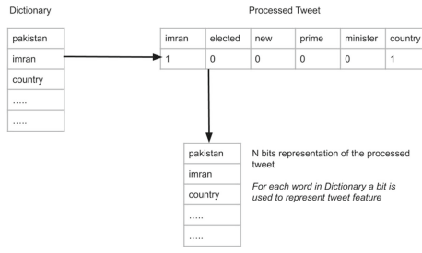
Fig 4.3: Tweet Vectorization using One Hot Encoding

4.3: Models

A project based on the classification of bilingual tweets using unsupervised and supervised machine learning models can leverage a variety of algorithms for classification. So to find an algorithm that could provide the most accurate and efficient was of utmost importance. So the following algorithms were chosen as they provided the best results from the many models used in testing

4.3.1: Multinomial Naive Bayes

Multinomial Naive Bayes is a probabilistic algorithm used for classification tasks . It is a variant of the Naive Bayes algorithm, which assumes that the features are independent of each other given the class.

The input data is represented as a matrix of features, where each row represents a document and each column represents a feature, such as the frequency of a word. The target variable is represented as a vector of labels. The algorithm estimates the prior probabilities of each class based on the frequency of the labels in the training data. It also estimates the conditional probabilities of each feature given the class based on the frequency of the feature in the documents of each class. Model prediction: Given a new document, the algorithm calculates the posterior probabilities of each class given the features of the document using Bayes' theorem (refer to equation 4.1). It then selects the class with the highest posterior probability as the predicted class.

The key assumption of the Multinomial Naive Bayes algorithm is that the features are independent given the class. This assumption allows the algorithm to estimate the conditional probabilities of each feature independently, which simplifies the calculation of the posterior probabilities.

Despite its simplicity and assumptions, Multinomial Naive Bayes has been shown to be effective in many text classification tasks, especially when the number of features is large and the amount of training data is limited.

Bayes Theorem: P(A|B) = P(A) P(B|A) (Equation 4.1)
P(B)

4.3.2: Complement Naive Bayes

Complement Naive Bayes is a variant of the Naive Bayes algorithm used for classification tasks. Unlike the standard Naive Bayes algorithm, which assumes that the features are independent of each other given the class, the Complement Naive Bayes algorithm takes into account the complement of the class. The Complement Naive Bayes algorithm is particularly useful for imbalanced datasets where one class has a much larger number of instances than other classes. In such cases, the standard Naive Bayes algorithm tends to favor the majority class and perform poorly on the minority class. The Complement Naive Bayes algorithm addresses this problem by modeling the complement of the class instead of the class itself.

The data given as input is a matrix of features same as for the Multinomial variation of the Naive Bayes algorithm. The algorithm calculates the posterior probability based on the frequency of labels and conditional probabilities of each feature given the complement of the class based on the frequency of the feature in the documents that do not belong to the class. Finally for the prediction, it calculates probability using the Bayes theorem (refer to equation 4.1) for all the classes. The class with the lowest probability is selected as it represents the highest chance of being in that class.

The Complement Naive Bayes algorithm works by balancing the contribution of each feature to the classification of the classes. Features that are common in the complement of the class are weighted more heavily than features that are common in the class itself. This helps the algorithm to better capture the discriminative features of the minority class.

Despite its effectiveness in handling imbalanced datasets, the Complement Naive Bayes algorithm has higher computational complexity than the standard Naive Bayes algorithm and may require more training data to achieve good performance.

4.3.3: Linear Support Vector Machine (Linear SVM)

Linear Support Vector Machine (SVM) is an algorithm that is widely used for classification tasks. It is a linear model that works by finding the hyperplane that separates the data points into different classes.

A matrix of features is passed as input into the model similar to the previous models and a vector of labels is given as the result. The algorithm finds the hyperplane that maximizes the margin between the closest data points of different classes. The margin is the distance between the hyperplane and the closest data points, and maximizing it helps to reduce the risk of overfitting. The hyperplane is represented by a weight vector w and a bias term b, and is learned by minimizing a loss function that penalizes misclassifications. Given a new data point, the algorithm calculates the distance between the data point and the hyperplane. If the distance is positive, the data point is classified as belonging to one class, and if the distance is negative, it is classified as belonging to the other class.

Linear SVM works well when the data points are linearly separable, that is, when it is possible to draw a straight line (or hyperplane in higher dimensions) that separates the data points into different classes. In cases where the data points are not linearly separable, a variant of SVM called the kernel SVM can be used. The kernel SVM maps the data points into a higher-dimensional space where they can be linearly separated.

Section 4.4: Unsupervised Learning (Phase 1)

Unsupervised learning is a type of machine learning where the model is trained on an unlabeled dataset. Unsupervised learning involves finding patterns and structure within the data without any pre-existing labels or categories.

The models previously used for the first phase were the following:
- K- Neighbors Classifier
- Solid Vector Machine
- Multinomial Naïve Bayes
The mentioned provided varying results with the Multinomial Naïve Bayes proving to be the best out of the 3. However, all 3 models exhibited signs of bad labeling, meaning that the majority of the tweets were labeled into the category of “others”, which after human inspection proved to be the incorrect label more often than not.
Upon further inspection of the dataset, it was found that the dataset was imbalanced meaning that the tweets in certain categories heavily outnumbered the tweets in the remaining categories. Almost half of the tweets in the original human labeled dataset belonged to either the “current affairs” category or “others” category. Different models were used to better tackle the mentioned issues and have better unsupervised labeling for the dataset

4.4.1: Using Multinomial Naive Bayes (Default parameters):
a) Dictionary size: 3000 words
 | Multinomial Naïve Bayes | Percentage
Politics | 218 | 7.14
Fun Talk | 131 | 4.29
Technology | 8 | 0.26
Current Affairs | 1414 | 46.33
Entertainment | 69 | 2.26
Others | 1212 | 39.71
Table 4.1: Results of Multinomial NB with 3000 word dictionary

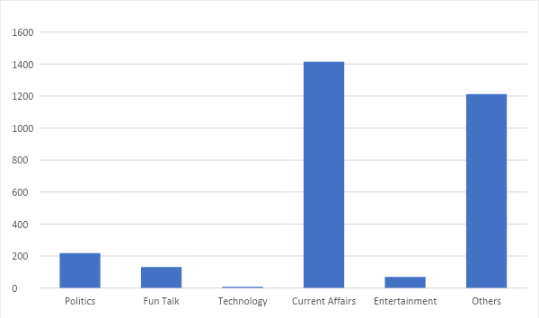
Figure 4.4: Distribution of labels from Multinomial NB (3000 words)

b) Dictionary size: 3500 words
 | Multinomial Naive Bayes | Percentage
Politics | 226 | 7.40
Fun Talk | 120 | 3.93
Technology | 11 | 0.36
Current Affairs | 1415 | 46.36
Entertainment | 61 | 1.99
Others | 1219 | 39.94
Table 4.2: Results of Multinomial NB with 3500 word dictionary

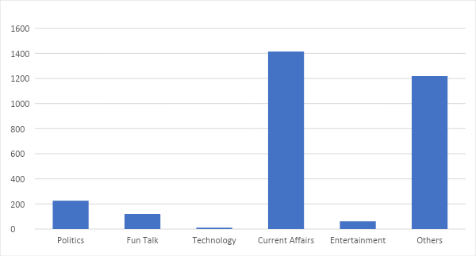
Figure 4.5: Distribution of labels from Multinomial NB (35000 words)

c) Dictionary size: 4000 words
 | Multinomial Naive Bayes | Percentage
Politics | 217 | 7.11
Fun Talk | 113 | 3.70
Technology | 8 | 0.26
Current Affairs | 1436 | 47.05
Entertainment | 56 | 1.83
Others | 1222 | 40.03
Table 4.3: Results of Multinomial NB with 4000 word dictionary

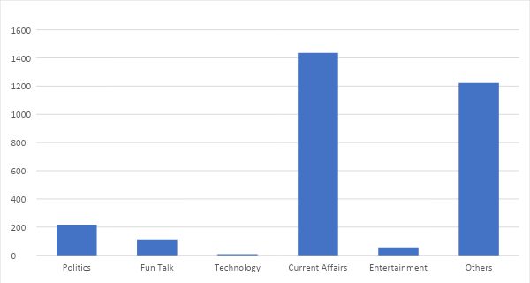
Figure 4.6: Distribution of labels from Multinomial NB (4000 words)

4.4.2: Using Complement Naïve Bayes (Default parameters):
a) Dictionary size: 3000 words

 | Complement Naïve Bayes | Percentage
Politics | 521 | 17.07
Fun Talk | 231 | 7.57
Technology | 77 | 2.52
Current Affairs | 1286 | 42.13
Entertainment | 190 | 6.23
Others | 747 | 24.48
Table 4.4: Results of Complement NB with 3000 word dictionary

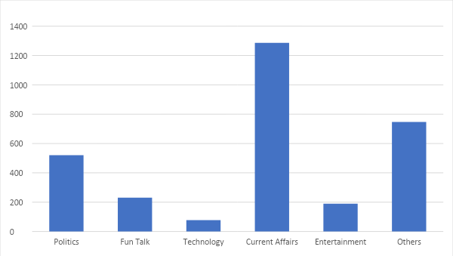
Figure 4.7: Distribution of labels from Complement NB (3000 words)

b) Dictionary size: 3500 words
 | Complement Naïve Bayes | Percentage
Politics | 472 | 15.46
Fun Talk | 212 | 6.95
Technology | 65 | 2.12
Current Affairs | 1322 | 43.32
Entertainment | 187 | 6.13
Others | 794 | 26.02
Table 4.5: Results of Complement NB with 3500 word dictionary

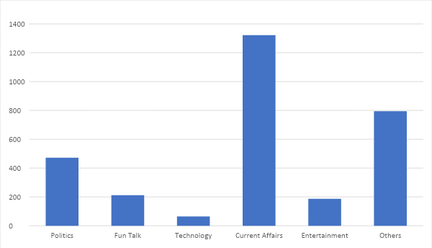
Figure 4.8: Distribution of labels from Complement NB (3500 words)

c) Dictionary size: 4000 words
 | Complement Naïve Bayes | Percentage
Politics | 457 | 14.97
Fun Talk | 198 | 6.48
Technology | 64 | 2.10
Current Affairs | 1343 | 44
Entertainment | 172 | 5.64
Others | 818 | 26.80
Table 4.6: Results of Complement NB with 4000 word dictionary

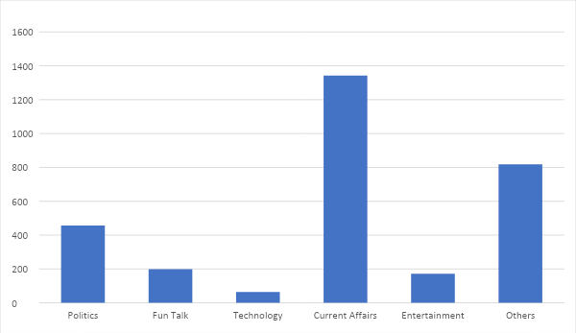
Figure 4.9: Distribution of labels from Complement NB (4000 words)

4.4.3: Using Linear SVM (Default parameters):

a) Dictionary size: 3000 words
 | Linear SVM | Percentage
Politics | 210 | 6.88
Fun Talk | 213 | 6.98
Technology | 22 | 0.72
Current Affairs | 1198 | 39.2
Entertainment | 106 | 3.47
Others | 1303 | 42.69
Table 4.7: Results of Linear SVM with 3000 word dictionary

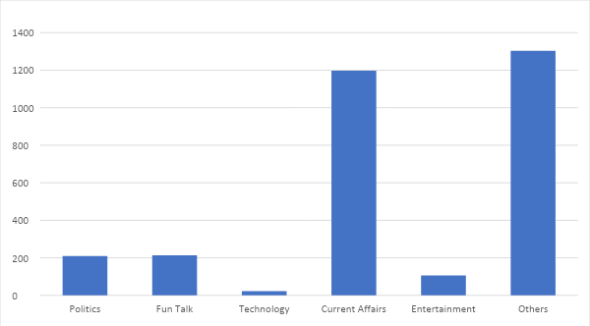
Figure 4.10: Distribution of labels from Linear SVM (3000 words)

b) Dictionary size: 3500 words
 | Linear SVM | Percentage
Politics | 214 | 7.01
Fun Talk | 207 | 6.78
Technology | 21 | 0.69
Current Affairs | 1175 | 38.50
Entertainment | 102 | 3.34
Others | 1333 | 43.68
Table 4.8: Results of Linear SVM with 3500 word dictionary

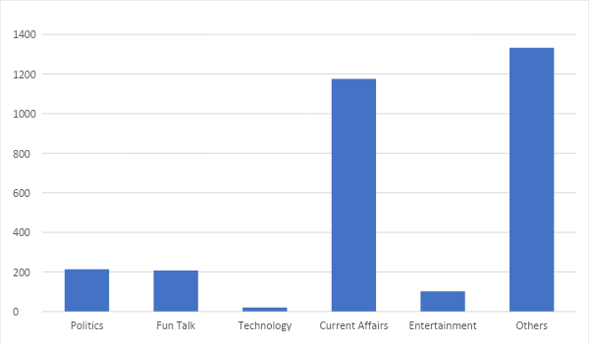
Figure 4.11: Distribution of labels from Linear SVM (3500 words)

c) Dictionary size: 4000 words
 | Linear SVM | Percentage
Politics | 209 | 6.85
Fun Talk | 198 | 6.49
Technology | 22 | 0.72
Current Affairs | 1179 | 38.63
Entertainment | 106 | 3.47
Others | 1338 | 43.84
Table 4.9: Results of Linear SVM with 4000 word dictionary

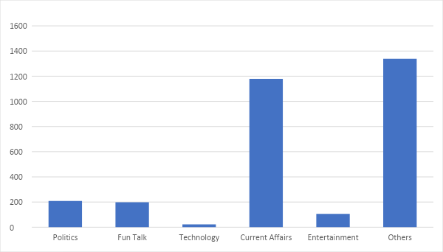
Figure 4.12: Distribution of labels from Linear SVM (4000 words)

4.4.4: Outcome of Phase 1

After using three different models along with varying the dictionary, we obtained the data shown above. It shows the imbalance in effect with the Multinomial Naïve Bayes and Linear SVM models categorizing around 80% to 85% of the 3052 unlabeled tweets into either current affairs category or the others category. Whereas, the Complement Naïve Bayes had a more balanced distribution of labels showcasing that this model is indeed more effective in handling imbalanced datasets, making it the best fit for the unsupervised phase of the project.

4.5: Supervised Learning (Phase 2)

Supervised learning is a type of machine learning algorithm that involves training a model on a labeled dataset, where each example in the dataset has a known output or target variable. The goal of supervised learning is to learn a mapping between input variables (also known as features or predictors) and output variables
The second phase of the project consists of predicting correct labels for the tweets. The dataset now consists of both the human labeled data as well as the data labeled by the model used in the first phase. [6]
The results obtained from the previous project went as high as 87.5% accuracy when using Multinomial Naïve Bayes for both the phases, while using SVM also provided an accuracy crossing 80%. While a high accuracy was obtained there was the downside of having an imbalanced dataset, that had been further imbalanced by the addition of the tweets labeled in the first phase, meaning that the accuracy did not provide the best picture of the outcome.
In this version of the project, measures were already taken to fix the problem of the imbalanced dataset through increasing the size of the dataset and using specific models that worked better against imbalanced datasets. For this phase, we also tuned the hyperparameters until we were able to find the best results. The following models and parameters were used:
- ComplementNB(norm=True)
- MultinomialNB(alpha=0.001)
- svm.LinearSVC(C=12.0, max_iter = 7000, random_state =42)

4.5.1: Results
The results of the second phase while varying the dictionary size are as follows:

Dictionary size: 3000 words
 |  | 1st Phase
 |  | Measures | Linear SVM | Complement NB | Multinomial NB
2nd Phase | Linear SVM | Accuracy | 0.9 | 0.846961326 | 0.860220994
 |  | Recall | 0.824164801 | 0.773515135 | 0.819092148
 |  | Precision | 0.851089269 | 0.801751788 | 0.807108017
 |  | F-Measure | 0.836411901 | 0.785885581 | 0.812205211
 | Complement NB | Accuracy | 0.676243094 | 0.73480663 | 0.728729282
 |  | Recall | 0.621999513 | 0.684397222 | 0.675223924
 |  | Precision | 0.535122016 | 0.600898949 | 0.567817803
 |  | F-Measure | 0.560051727 | 0.629212405 | 0.600674061
 | Multinomial NB | Accuracy | 0.791712707 | 0.791160221 | 0.835359116
 |  | Recall | 0.719302129 | 0.718997809 | 0.785644235
 |  | Precision | 0.725581304 | 0.749508366 | 0.780460614
 |  | F-Measure | 0.721511281 | 0.732630592 | 0.782339426
Table 4.10: Results of Supervised Learning with 3000 word dictionary

Dictionary size: 3500 words
 |  | 1st Phase
 |  | Measures | Linear SVM | Complement NB | Multinomial NB
2nd Phase | Linear SVM | Accuracy | 0.906077348 | 0.850828729 | 0.86961326
 |  | Recall | 0.866759561 | 0.8200231 | 0.808213363
 |  | Precision | 0.876324015 | 0.791889587 | 0.796134642
 |  | F-Measure | 0.871275762 | 0.802444396 | 0.801014018
 | Complement NB | Accuracy | 0.69281768 | 0.762430939 | 0.716022099
 |  | Recall | 0.667654306 | 0.716409979 | 0.661564085
 |  | Precision | 0.553092574 | 0.637883517 | 0.566166756
 |  | F-Measure | 0.582776515 | 0.665161543 | 0.596980491
 | Multinomial NB | Accuracy | 0.788950276 | 0.808287293 | 0.805524862
 |  | Recall | 0.746389317 | 0.749803721 | 0.739849593
 |  | Precision | 0.743581452 | 0.771533559 | 0.772182715
 |  | F-Measure | 0.741750787 | 0.75834983 | 0.754657019
Table 4.11: Results of Supervised Learning with 3500 word dictionary
Dictionary size: 4000 words
 |  | 1st Phase
 |  | Measures | Linear SVM | Complement NB | Multinomial NB
2nd Phase | Linear SVM | Accuracy | 0.924309392 | 0.854696133 | 0.864640884
 |  | Recall | 0.887400745 | 0.801098966 | 0.787522817
 |  | Precision | 0.894272877 | 0.817901106 | 0.81980941
 |  | F-Measure | 0.888761651 | 0.803152685 | 0.802308441
 | Complement NB | Accuracy | 0.716022099 | 0.76519337 | 0.727071823
 |  | Recall | 0.68578346 | 0.695101898 | 0.662679231
 |  | Precision | 0.592456435 | 0.634853952 | 0.578076672
 |  | F-Measure | 0.61946479 | 0.658814861 | 0.607286452
 | Multinomial NB | Accuracy | 0.81160221 | 0.795027624 | 0.832044199
 |  | Recall | 0.775784539 | 0.737246889 | 0.759333381
 |  | Precision | 0.770235554 | 0.750341399 | 0.797864156
 |  | F-Measure | 0.770629936 | 0.74243933 | 0.776211505
Table 4.12: Results of Supervised Learning with 4000 word dictionary

4.5.2: Outcome of Phase 2:
The above data presents the results of the second phase of the project, which utilized three different models and three variations in the dictionary size. The data analysis provides several noteworthy findings. The foremost observation is that Linear SVM is the optimal model to use in both phases of the project as it achieves a consistent 90% accuracy, with a maximum of 92%. Additionally, employing Linear SVM in the second phase alongside the two Naïve Bayes models yields decent results, with accuracy levels averaging around 85% across all cases and other performance metrics demonstrating good results. On the other hand, utilizing Complement Naïve Bayes in the second phase does not generate comparable outcomes as the previous model, with accuracy rates hovering around 70%. The Multinomial Naïve Bayes model shows mixed results, ranging from 78% to 83%.
The results above also indicate that increasing the size of the dictionary has either a positive effect or no effect on the accuracy of the outcome in nearly all cases. Since there were no negative impacts, it is suggested to use a dictionary size of 4000 words as it yielded the best results. While expanding the dictionary size beyond 4000 words had a negligible effect on the outcome, it also heightened the computational burden.
The results from the project have significantly improved for accuracy as can be determined by the figure shown below where the highest accuracy is 87% using NB in both phases. While the other models have sub par accuracies mostly going below even 80%.
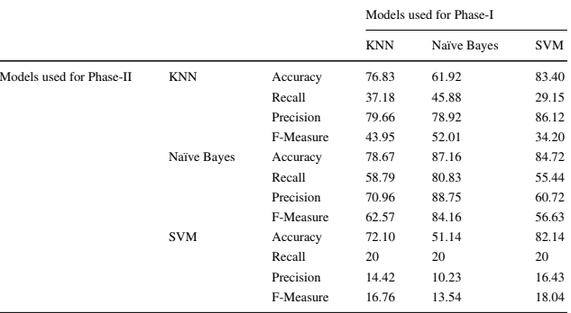
Figure 4.13: Results for previous project

5 Conclusion
After analyzing the results of both phases of the project, we have determined that the best combination of models is Complement Naive Bayes in the first phase and Linear SVM in the second phase. This combination provides an optimal trade-off between correct labeling and high classification accuracy. However, there are still opportunities to improve the project, with a bigger dataset being a possibility as well as increasing the number of categories for classification. Another possible future addition can be assigning multiple labels to a single tweet.

Overall, the project has yielded promising results, with the chosen combination of models achieving an accuracy of 85%. The use of Linear SVM in both phases was particularly effective, with classification accuracy reaching as high as 92% with a slight trade-off in terms of the first phase.

References
- Ayaz H. Khan, Muhammad Zubair, Classification of multi-lingual tweets, into
multi-class model using Naïve Bayes and semi-supervised learning, 2020.

- Muhammad Bilal, Huma Israr, Muhammad Shahid, Amin Khan, Sentiment classification of Roman-Urdu opinions using Naive Bayesian, Decision Tree and KNN classification techniques, University of Agriculture, Peshawar, 2015.

- Farwa Iqbal, Amber Ayoub, Jaweria Manzoor, Rida Hijab Basit, Bilingual Sentiment Analysis of Tweets Using Lexicon, Kinnaird College for Women Lahore, 2018.

- Dharini Ramachandran, Parvathi R, Analysis of Twitter Specific Preprocessing Technique for Tweets, International Conference on Recent Trends in Advanced Computing, 2019.

- Krishna Juluru, Hao-Hsin Shih, Krishna Nand Keshava Murthy, Pierre Elnajjar, Bag-of-Words Technique in Natural Language Processing, 2021.

- Maud Reveilhac, David Morselli, Dictionary-based and machine learning classification approaches: a comparison for tonality and frame detection onTwitter data, 2022.

- https://scikit-learn.org/stable/modules/generated/sklearn.naive_bayes.MultinomialNB
- https://scikit-learn.org/stable/modules/generated/sklearn.naive_bayes.ComplementNB
- https://scikit-learn.org/stable/modules/generated/sklearn.svm.LinearSVC

