Student Name: DANISHMEET SINGH UID: 24BAI70719
Branch: AIT-CSE (AIML) Section/Group: 24AIT_KRG-G2
Semester: 4
Subject Name: Database Management System Subject Code: 24CSH-298

Experiment 6 – Understanding and Implementing Cursors for Row-by-Row Data Processing (Oracle, Accenture, Scaler, D. E. Shaw & Co)
Experiment
Experiment 6: Working with PL/SQL cursors to process multiple rows of a table individually. This experiment demonstrates the use of implicit cursors, explicit cursors, and cursor attributes to implement business logic on row-by-row data in Oracle and PostgreSQL.

Aim
To understand the concept and working of cursors in PL/SQL for row-by-row data processing, and to analyze how implicit cursors, explicit cursors, and cursor attributes are used to implement business logic on multiple rows in a database table.

Objective
- To implement and analyze implicit cursors for single-row operations.
- To implement explicit cursors to fetch and process multiple records.
- To apply cursor attributes (%FOUND, %NOTFOUND, %ROWCOUNT, %ISOPEN) for controlling program flow.
- To process employee records row by row and apply business logic effectively.

Software Requirements
Database Management System:
- Oracle Database Express Edition (Oracle XE)
- PostgreSQL Database
Database Administration Tool / Client Tool:
- Oracle SQL Developer (for Oracle XE)
- pgAdmin (for PostgreSQL)

Problem Statement
In real-world enterprise applications, database queries often return multiple rows that need to be processed individually to apply specific business rules. Using cursors allows row-by-row processing for detailed business logic implementation.

Practical / Experiment Steps
- Design PL/SQL programs that demonstrate:
  - The use of implicit cursors for single-row DML operations
  - The use of explicit cursors to fetch and process multiple records
  - The application of cursor attributes to control program execution
- Create PL/SQL programs to:
  - Fetch employee records from a database table using cursors
  - Process each record individually
  - Display results or apply business logic using cursor attributes

Procedure
- Open Oracle SQL Developer or pgAdmin and connect to the database.
- Create an employee table with sample data (id, name, department, salary).
- Write an anonymous PL/SQL block demonstrating implicit cursor operations.
- Write a PL/SQL block using an explicit cursor to fetch and process multiple records.
- Apply cursor attributes such as %FOUND, %NOTFOUND, %ROWCOUNT, %ISOPEN to control execution flow.
- Execute the blocks and observe the output.
- Capture results and screenshots for documentation.

Input / Output Details
Input
employee table:
- id (Integer)
- name (Varchar)
- department (Varchar)
- salary (Integer)
Cursor logic used:
- Implicit cursor for single-row processing
- Explicit cursor for multi-row processing
- Cursor attributes (%FOUND, %NOTFOUND, %ROWCOUNT, %ISOPEN)
Code:
CREATE TABLE EMPLOYEE (
EMP_ID NUMBER PRIMARY KEY,
EMP_NAME VARCHAR2(50),
SALARY NUMBER
);
INSERT INTO EMPLOYEE VALUES (101, 'Amit', 25000);
INSERT INTO EMPLOYEE VALUES (102, 'Riya', 32000);
INSERT INTO EMPLOYEE VALUES (103, 'Rahul', 45000);
INSERT INTO EMPLOYEE VALUES (104, 'Sneha', 28000);
INSERT INTO EMPLOYEE VALUES (105, 'Arjun', 50000);

COMMIT;

BEGIN
UPDATE EMPLOYEE
SET SALARY = SALARY * 1.10
WHERE SALARY < 30000;

DBMS_OUTPUT.PUT_LINE('Rows Updated: ' || SQL%ROWCOUNT);

IF SQL%FOUND THEN
DBMS_OUTPUT.PUT_LINE('Update Successful');
END IF;
END;
/

DECLARE
CURSOR emp_cursor IS
SELECT EMP_ID, EMP_NAME, SALARY FROM EMPLOYEE
WHERE SALARY > 30000;

v_id EMPLOYEE.EMP_ID%TYPE;
v_name EMPLOYEE.EMP_NAME%TYPE;
v_salary EMPLOYEE.SALARY%TYPE;

BEGIN
OPEN emp_cursor;

LOOP
FETCH emp_cursor INTO v_id, v_name, v_salary;
EXIT WHEN emp_cursor%NOTFOUND;

DBMS_OUTPUT.PUT_LINE(
'ID: ' || v_id ||
' Name: ' || v_name ||
' Salary: ' || v_salary
);
END LOOP;

CLOSE emp_cursor;
END;
/

DECLARE
CURSOR emp_cursor IS SELECT * FROM EMPLOYEE;
emp_record EMPLOYEE%ROWTYPE;

BEGIN
OPEN emp_cursor;

IF emp_cursor%ISOPEN THEN
DBMS_OUTPUT.PUT_LINE('Cursor Opened Successfully');
END IF;

LOOP
FETCH emp_cursor INTO emp_record;
EXIT WHEN emp_cursor%NOTFOUND;

DBMS_OUTPUT.PUT_LINE(
'Employee: ' || emp_record.EMP_NAME ||
' | Salary: ' || emp_record.SALARY
);
END LOOP;

DBMS_OUTPUT.PUT_LINE('Total Rows Processed: ' || emp_cursor%ROWCOUNT);

CLOSE emp_cursor;
END;

Step-wise Output
Step 1 – Create employee Table
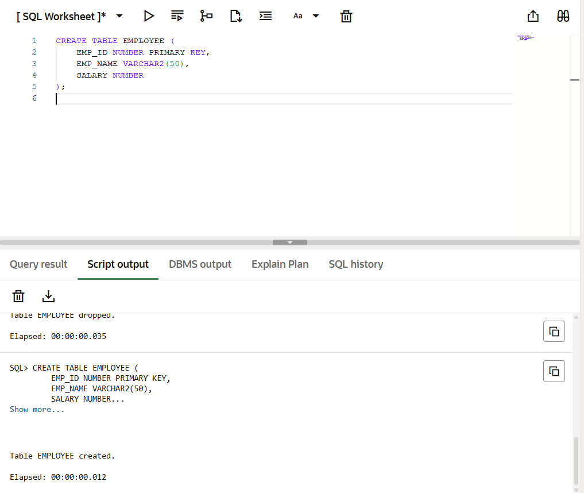
Step 2 – Insert Data into employee Table
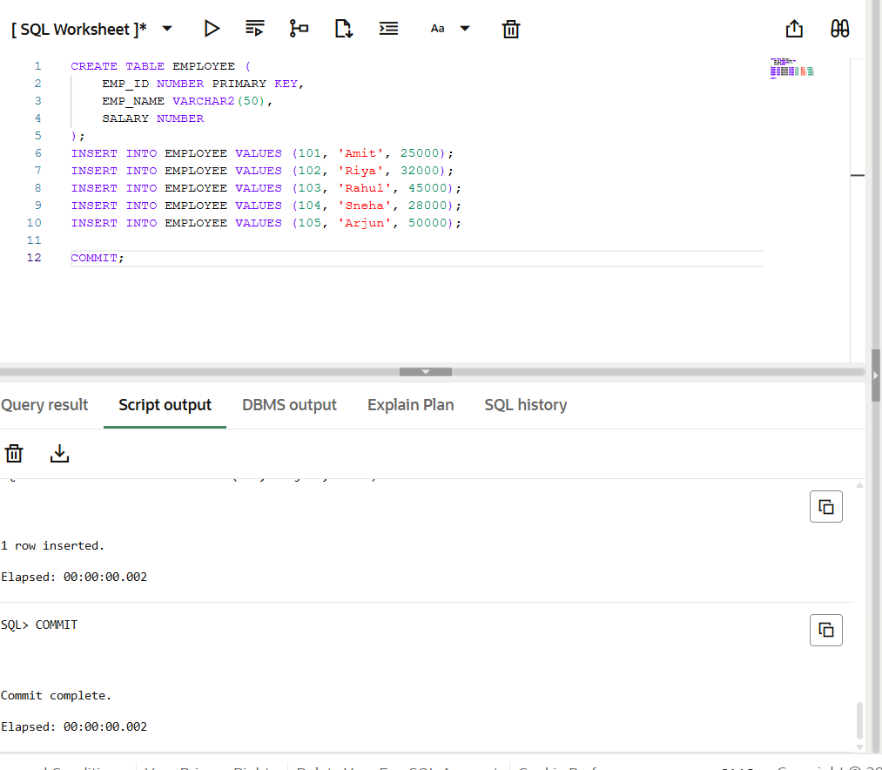
Step 3 – Implicit Cursor Operation
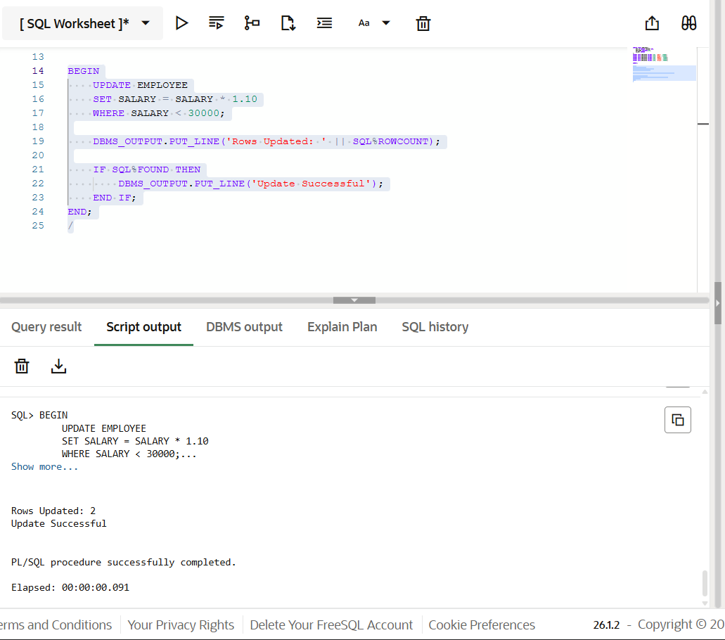
Step 4 – Explicit Cursor Declaration and Fetch
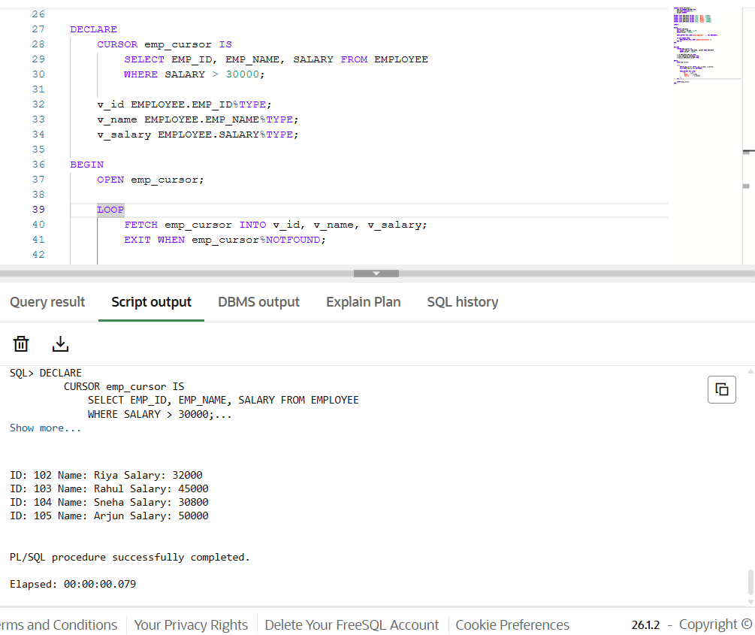
Step 5 – Process Records Using Cursor Attributes
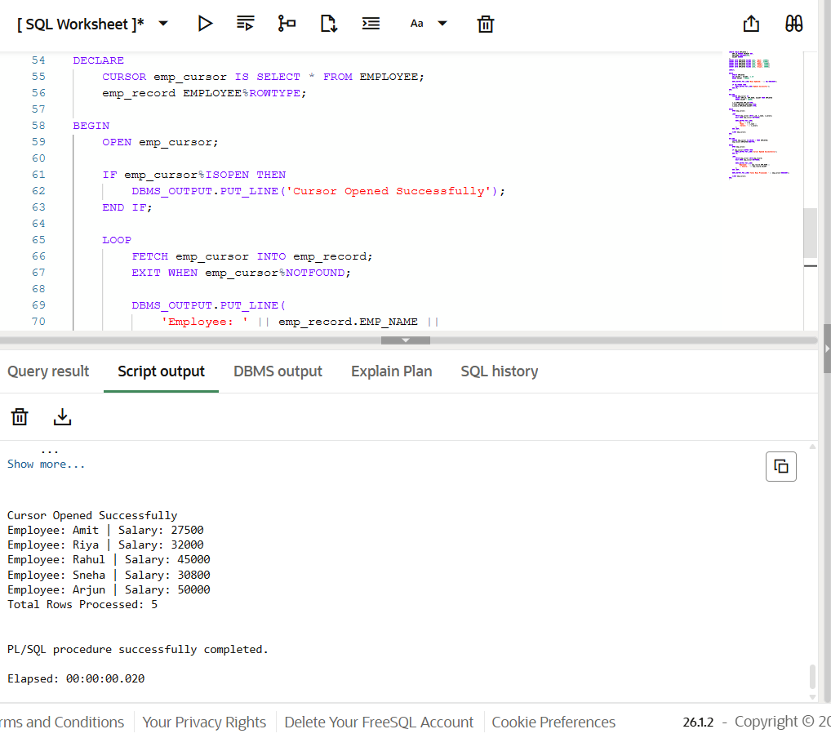

Learning Outcome
After completing this experiment, the learner will be able to:
- Understand the role of cursors in PL/SQL for handling multi-row query results.
- Differentiate between implicit cursors and explicit cursors.
- Use cursor attributes such as %FOUND, %NOTFOUND, %ROWCOUNT, and %ISOPEN.
- Develop PL/SQL programs that process database records row by row.
- Apply cursor-based logic in real-world business scenarios used in organizations like Oracle, Accenture, Scaler, and D. E. Shaw & Co.

