Student Name: DANISHMEET SINGH UID: 24BAI70719
Branch: AIT-CSE (AIML) Section/Group: 24AIT_KRG2
Semester: 4
Subject Name: Database Management System Subject Code: 24CSH-298

Experiment 3
Calculating employee salary and applying a bonus using PL/SQL. This experiment demonstrates variable declaration, arithmetic operations, and displaying output using DBMS_OUTPUT.PUT_LINE.
Aim
The aim of this experiment is to practice writing PL/SQL blocks that perform calculations on employee data, calculate bonuses, and display results in a structured format.
Objective
- To declare variables in PL/SQL.
- To perform arithmetic calculations on employee salary.
- To calculate a bonus amount based on a percentage of salary.
- To display employee details and salary information before and after applying the bonus.
Software Requirements
- Database: Oracle XE or Oracle Live SQL
Practical / Experiment Steps
- Declare variables for employee ID, name, and salary.
- Calculate a 10% bonus on the employee salary.
- Calculate the total salary after adding the bonus.
- Display employee details and salary information before and after bonus.
- Take screenshots of outputs for documentation.

Procedure of the Experiment
- Start the system and log in.
- Open Oracle XE or Live SQL.
- Connect to the database.
- Declare variables for employee details and bonus calculation.
- Write the PL/SQL block to calculate bonus and total salary.
- Execute the PL/SQL block and verify outputs in the console.
- Take screenshots of the outputs (s1 and s2).
Input / Output Details
Input
- Employee details:
    - emp_id INTEGER := 101;
    - emp_name VARCHAR(50) := 'Aryan Dahiya';
    - emp_salary NUMERIC := 45000;
    - bonus_amount NUMERIC;
    - new_salary NUMERIC;
- Bonus calculation: 10% of employee salary
Output
- Step 1: Display employee details and original salary.
- Step 2: Display bonus amount and total salary after applying 10% bonus.
- Screenshots of outputs (s1 and s2) are attached.

Code :
DO $$
DECLARE
emp_id INTEGER := 215;
emp_name VARCHAR(50) := 'Danishmeet Singh';
emp_salary NUMERIC := 62000;
bonus_amount NUMERIC;
new_salary NUMERIC;
BEGIN

bonus_amount := emp_salary * 0.10;
new_salary := emp_salary + bonus_amount;

RAISE NOTICE 'Employee Details';
RAISE NOTICE '----------------';
RAISE NOTICE 'Employee ID : %', emp_id;
RAISE NOTICE 'Employee Name : %', emp_name;

RAISE NOTICE '';
RAISE NOTICE 'Salary Details';
RAISE NOTICE '----------------';
RAISE NOTICE 'Salary Before Bonus : %', emp_salary;
RAISE NOTICE '10%% Bonus Amount : %', bonus_amount;
RAISE NOTICE 'Salary After Bonus : %', new_salary;

END $$;

Step 1 Output
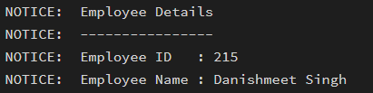
Employee Details
Employee ID : 215
Employee Name : Danishmeet Singh
Salary Before Bonus : 45000

Step 2 Output
Screenshot: Step 2 – Salary After Bonus
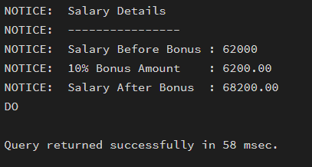

Learning Outcome
After completing this experiment, the student will be able to:
- Declare and use variables in PL/SQL.
- Perform arithmetic operations for salary calculations.
- Calculate bonuses based on a percentage of salary.
- Display structured outputs using DBMS_OUTPUT.PUT_LINE.
- Understand the workflow of PL/SQL blocks for practical data operations.

