Light Sensor with Automatic Control

Information Technology Solutions

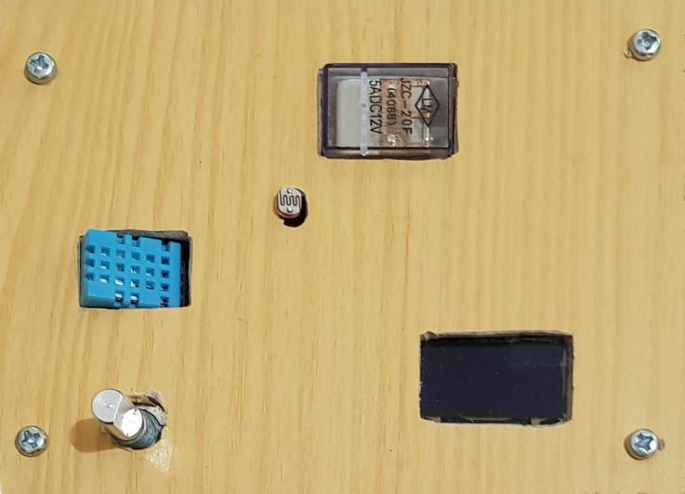

# Description

The following module measures photointensity which can be used to control lights that consume upto 5 Amperes of current with an adjustable threshold value. It can also be used to measure ambient temperature and humidy, however, accuracy may depend on operating conditions.

# Features

1. Light Intensity Measurement
2. Temperature Measurement
3. Humidity Measurement
4. Automatic Light Control
5. Adjustable Threshold
6. 0.96” Monochrome OLED Display
7. Low Quiescent Current
8. 7.2V – 18V Wide Input Range

# Applications

1. Automatic Street Lamps
2. Automatic ambient lighting

|  |  |  |  |
| --- | --- | --- | --- |
| * Test Conditions (unless otherwise stated): No appliance connected and relay turned off | **Min** | **Max** | **Unit** |
| Operating Temperature | 0 | 70 | °C |
| Operating Humidity (Non Condensing) | 0 | 70 | % |
| Input Voltage | 7.2 | 18 | V |
| External Appliance Current | 0 | 5 | A |
| Quiescent Current* | 27.00 | 30.80 | mA |
| Luminous Intensity Measurement Range | 0 | 10,000 | LUX |
| Temperature | 0 | 50 | °C |
| Humidity | 20 | 90 | % |

Measurement Error (Light Intensity)

Linear Response (Light Intensity)

Absolute Maximum Ratings

# Feature Description