
SPG 0562
Android Programming
Mini Project: GMI Prospect Application
App name: GMI Pathway
Prepared by
[Student 1 full name]
[Student 2 full name]
Programme
[Programme name]
Group
[Group]
Examiner
Mohd Fadhli bin Abdul Jalil
Table of Contents
1. Introduction 1
1.1 Background 1
1.2 Problem Statement 1
1.3 Objectives 1
1.4 Scope 1
1.5 Features 2
1.6 Tools and Technologies 2
1.7 Android Topics Applied 3
1.8 Marking Criteria 4
1.9 Accuracy of the Information 4
2. Pseudocode and Flowchart 6
2.1 Whole Application Pseudocode 6
2.2 Enquiry Form and Web Link Pseudocode 7
2.3 Whole Application Flowchart 9
2.4 Eligibility Checker Pseudocode 11
2.5 Eligibility Checker Flowchart 13
3. Screenshots and Explanations 14
3.1 Splash and Home 14
3.2 Courses 14
3.3 Eligibility Checker: SPM 19
3.4 Eligibility Checker: Second Qualification 21
3.5 Eligible Result 22
3.6 Not Eligible Result 24
3.7 Redirect to the Online Application 24
3.8 Contact Us 25
3.9 Enquiry Form 26
3.10 About Us 27
3.11 Extra Features 28
3.12 UI/UX Design 32
4. Source Code 33
4.1 Project Structure 33
4.2 Android Manifest 33
4.3 Activities 34
4.4 Key Classes 64
4.5 Model Classes 98
4.6 XML Layouts 110
4.7 strings.xml 159
4.8 App Icon 166
4.9 Splash Screen 168
4.10 Course Data Sample 169
5. Conclusion 172
5.1 Summary 172
5.2 Testing 172
5.3 Limitations 173
5.4 Future Improvements 173
5.5 Personal Reflection 173
6. References 174

List of Figures
Flowchart of the whole application 10
Detailed flowchart of the Eligibility Checker 13
Splash screen 14
Home screen 14
Home: highlights and grouped shortcuts 14
Diploma tab, departments closed 15
A department opened 15
Pre-University tab 15
Degree tab 16
Course Details, top 18
Collapsible sections 18
Entry requirements 18
Your pathway, with Enquire and Apply Online 19
Eligibility Checker before a qualification is chosen 20
SPM form filled in, top 20
SPM form filled in, lower part 20
Required fields marked 21
O-Level / IGCSE form filled in 22
SPM result: You qualify for 16 programmes 23
O-Level / IGCSE result: You qualify for 14 programmes 23
SPM result: No match yet 24
SPM result: reasons for each programme 24
O-Level / IGCSE result: No match yet 24
GMI's online application opened from Apply Now 25
Contact Us, with social logos 26
Enquiry Form 27
Validation errors 27
Confirmation after the email app 27
About Us, top 28
About Us, history timeline 28
Saved Programmes 29
FAQ 29
Settings 29
Home in Bahasa Melayu 29
Home in dark mode 29
Home in landscape 30
Campus & Facilities 31
A photo full screen 31
Technology Centres 31
Financial Aid 32
GMI News 32
The GMI Pathway app icon 167

List of Tables
Main features of GMI Pathway 2
Tools and technologies 2
Android topics and where the app uses them 3
Where this report shows each marking criterion 4
Sources of the app's information 4
The 18 programmes in the app 16
Test cases proved by DemoScenarioTest 23
Test results 172

1. Introduction

1.1 Background
The German-Malaysian Institute (GMI) is a technical education institute on a 75-acre campus in Kajang, Selangor. It began as a joint venture between the Governments of Malaysia and Germany, and it describes itself as a pioneer of German-style technical and vocational education and training (GMI, n.d.-p, 2026a). Its stated learning approach is 70% practical and 30% theory, supported by 22 Advanced Technology Centres (GMI, 2026a).
This report describes the GMI Prospect Application, our mini project for SPG 0562 Android Programming. We named the finished app GMI Pathway. It helps prospective students explore GMI's programmes, check whether their results meet the entry requirements, and move on to contact GMI or apply online.

1.2 Problem Statement
A student who is thinking about GMI has three questions: what can I study, do I qualify, and how do I apply? The answers are spread across a long PDF Programme Guide, separate web pages and image posters. Entry requirements also differ by programme and by qualification, so working them out by hand is slow and easy to get wrong. An SPM leaver and an O-Level leaver, for example, are judged on different grade scales.

1.3 Objectives
- List all 18 GMI programmes in one place, with their details, grouped the way GMI groups them.
- Check a prospect's results against GMI's published entry rules for six qualifications, and explain every result.
- Give direct routes to GMI: the online application, phone, email, map, website, social media and an Enquiry Form.
- Present the information accurately, with every GMI fact traced to a source.
- Deliver a clear, accessible app that works in English and Bahasa Melayu, on Android 7.0 and newer.

1.4 Scope
The app works on one device and has no accounts or server. Course data, the checker and the campus photos ship inside the app, so they work offline. The internet is needed only for GMI News and for web links.
- Covered: 15 diplomas, 2 pre-university programmes and 1 degree, and the Eligibility Checker for SPM, O-Level / IGCSE, UEC, STPM, Diploma, and Matriculation / Foundation.
- Sent to GMI's admissions team: other routes, such as STAM, SKM Level 3, SVM, GCE A-Level and APEL. These depend on documents and field of study, so the app explains this instead of guessing.
- Also covered: GMI's campus facilities, technology centres, financial aid and latest news, from GMI's website.
- Not included: submitting an application inside the app. The app hands over to GMI's own online application portal.
The checker is a guide. GMI makes the final admission decision, and diplomas also need a medical check. The results screen says so.

1.5 Features
Table 1: Main features of GMI Pathway
Feature | What it does
Course List | 18 programmes under Diploma, Pre-University and Degree tabs, with Diploma departments as dropdowns, and search.
Course Details | Code, duration, intake, mode, credits, fees, subjects, careers and entry requirements, a three-step pathway, and Enquire and Apply buttons.
Eligibility Checker | Compares entered results with each programme's rules. Shows You qualify, Ask GMI, Not eligible yet or Not assessed, with reasons.
Home | Key figures, Apply Now, highlight cards, and shortcuts grouped into Get started, Discover GMI and Help & support.
Online application | Apply Now opens GMI's online application portal in the browser.
Contact Us | Address and map, phone, WhatsApp, email, website and six social media links.
Enquiry Form | Checks five fields, then opens the email app with the message ready to send, and confirms the next step on return.
Campus & Facilities | Photos of eight facility groups, a full-screen viewer with zoom, and the virtual tour spots.
Technology Centres | 12 technology centres and 3 examination centres, each linking to its page on GMI's website.
Financial Aid | The rules for aid and each sponsor GMI lists, with buttons to call or email GMI's sponsorship unit.
GMI News | The latest posts from GMI's website, with a saved copy for offline use.
About Us | History, vision, mission, German-based education, governance and accreditation.
Saved and share | Bookmarks that stay after the app closes, and sharing through any installed app.
FAQ | Common questions, each answered from a recorded source.
Settings | English or Bahasa Melayu, and Light, Dark or System appearance.

1.6 Tools and Technologies
Table 2: Tools and technologies
Item | Details
Language and IDE | Java, Android Studio, Gradle
Android versions | Minimum SDK 24 (Android 7.0), target SDK 36
App ID | com.week14.gmipathway, version 1.0
Interface | AndroidX, Material Components 1.14.0 (Google, n.d.-b), RecyclerView (Android Developers, n.d.-a), ViewPager2
Data | JSON files in assets, read with Gson 2.13.1 (Google, n.d.-a); SharedPreferences for bookmarks and settings
Network | HttpURLConnection reading GMI's public WordPress news feed (GMI, n.d.-r); no extra library
Photos | GMI's own campus photos, from its website (GMI, n.d.-k, n.d.-t), shown with a credit
Splash and language | AndroidX SplashScreen API (Android Developers, n.d.-c); per-app language preferences (Android Developers, n.d.-b)
Font and icons | Figtree, under the SIL Open Font License (The Figtree Project Authors, 2022); Material Symbols, Apache 2.0 (Google, n.d.-c); Simple Icons 11.0.0, CC0, used only to link to GMI's official profiles, with the brands belonging to their owners (Simple Icons contributors, n.d.)
Testing | JUnit 4 unit tests, Android Lint, Android emulators on API 24 and API 37, and a simulated 10-inch tablet

1.7 Android Topics Applied
Table 3: Android topics and where the app uses them
Topic | Where it is used
Activities and explicit Intents | 17 screens. EligibilityActivity passes the results to EligibilityResultActivity in an Intent, and Course Details passes the programme to the Enquiry Form.
Implicit Intents | ExternalLinks opens the browser, phone, email and share sheet. ContactUsActivity opens the map.
Activity lifecycle and saved state | onSaveInstanceState keeps form entries and open sections when the phone rotates. onResume shows the enquiry confirmation after the email app.
XML layouts | 47 layouts plus 3 landscape versions, using ConstraintLayout, LinearLayout, NestedScrollView, and include for shared parts. Tablets get wider margins from values-sw600dp.
Material components | TextInputLayout, MaterialCardView, MaterialButton, TabLayout, AppBarLayout, Snackbar.
RecyclerView and adapters | CourseAdapter and OutcomeAdapter show expandable lists. HighlightAdapter and the photo strips scroll sideways, and NewsAdapter lists the news.
Fragments and ViewPager2 | CourseListFragment is one tab, and CoursePagerAdapter supplies the three tabs. ViewPager2 also pages through photos full screen.
ViewModel and LiveData | NewsViewModel keeps the downloaded news when the phone rotates, so it is not downloaded again.
Networking | NewsRepository and ImageLoader download on background threads, with a saved copy for offline use.
Custom views and touch | ZoomImageView uses ScaleGestureDetector and GestureDetector for pinch and double-tap zoom.
Animation | Screen transitions, a fade-up as course lists appear, and a fade-in for downloaded photos.
Menus and search | Toolbar menus in the Course List and Course Details, and a SearchView in the Course List.
Data storage | BookmarkStore and AppSettings use SharedPreferences.
Reading assets and JSON | CourseRepository reads the catalogue with Gson.
Background work | SplashActivity loads the data on a background thread, so the screen never freezes.
Input validation | EnquiryFormActivity and EligibilityActivity show errors on the fields.
Resources | Strings, plurals, styles, dimensions, fonts, Malay translations in values-ms, and dark colours in values-night.
Unit testing | 68 JUnit tests run the checker against the real data and check the campus data and the news feed reader.

1.8 Marking Criteria
Table 4: Where this report shows each marking criterion
Criterion | Where to find it
Algorithm | Section 2: pseudocode and flowcharts for the whole app and the Eligibility Checker
List of courses | Section 3.2
Eligibility Checker | Sections 2.4, 2.5 and 3.3 to 3.7
Enquiry | Sections 2.2 and 3.9
Class Activities | Section 1.7
XML Layout | Section 4.6
UI/UX | Sections 3.11 and 3.12
Demo | The presentation outline and docs/demo_script.md, supplied with this report

1.9 Accuracy of the Information
The information comes from GMI's published material, checked against the Malaysian Qualifications Register (Malaysian Qualifications Agency, n.d.). These sources were accessed on 30 October 2026, and the campus, financial aid and news sources on 5 November 2026. The app's data records this. Where official sources disagreed, the official GMI website was preferred unless a page was shown to be out of date. The register was treated as the final word on accreditation.
Table 5: Sources of the app's information
App content | Sources
Programmes, codes, fees, subjects, careers | GMI, n.d.-c, n.d.-e, n.d.-f, n.d.-h, n.d.-i, n.d.-q, 2026a; Malaysian Qualifications Agency, n.d.
Diploma entry rules | GMI, 2025e, 2026a; Unit Pengambilan Universiti, n.d.; eCentral, n.d.
Grades of other qualifications | StudyMalaysia, n.d.-a, n.d.-b, n.d.-c; Cambridge International, n.d.
GAPP and GUFP | GMI, n.d.-l, n.d.-o
BELT degree | GMI, n.d.-b, 2025a, 2025b, 2025c, 2025f, 2026b; Universiti Teknikal Malaysia Melaka, n.d.
Intakes, admission and funding | GMI, n.d.-a, n.d.-g, n.d.-j, n.d.-s
About Us | GMI, n.d.-m, n.d.-p, n.d.-u, 2019, 2024a, 2024b, 2025d
Contact details and map position | GMI, n.d.-d; OpenStreetMap contributors, n.d.
Campus, centres, aid and news | GMI, n.d.-j, n.d.-k, n.d.-m, n.d.-n, n.d.-t; GMI, n.d.-r

Three cases are handled openly in the app, instead of being guessed:
- Diploma in Cyber Security Technology: GMI lists the programme but has not published its entry requirements, so the checker says Ask GMI.
- BELT: the degree is registered under Universiti Teknikal Malaysia Melaka (UTeM) and offered with GMI, and SPM alone is not an entry route, so an SPM result shows Not assessed.
- GMI's name: GMI reported approval in 2024 to become GMI University College of Applied Sciences, but its documents still use the old name, so the app uses German-Malaysian Institute and records the approval in the history.

2. Pseudocode and Flowchart
This section explains the app's logic in pseudocode and in flowcharts with standard symbols. The pseudocode uses BEGIN and END, INPUT, OUTPUT, IF, ELSE and ENDIF, and FOR and ENDFOR. WHILE and ENDWHILE mark the loop around the home screen, and FUNCTION marks a named step that returns a value.

2.1 Whole Application Pseudocode
BEGIN GMI Pathway
LOAD the saved language and appearance
OUTPUT splash screen
LOAD the course catalogue for the current language
OUTPUT home screen: key figures, Apply Now, highlights and ten cards

WHILE the app is open
INPUT choice

IF choice = "Courses" THEN
OUTPUT tabs: Diploma, Pre-University, Degree
INPUT search words or a selected programme
IF a programme is selected THEN
OUTPUT programme details and its pathway: before, at and after GMI
IF "Save" is tapped THEN
add or remove the programme in the saved list
ENDIF
IF "Share" is tapped THEN
open the share sheet with the programme's details
ENDIF
IF "Enquire" is tapped THEN
RUN Enquiry Form with this programme already chosen
ENDIF
ENDIF
ELSE IF choice = "Eligibility Checker" THEN
RUN Eligibility Checker // Section 2.4
ELSE IF choice = "Campus" THEN
OUTPUT facility photos and the virtual tour spots
IF a photo is tapped THEN
OUTPUT the photo full screen, with pinch and double-tap zoom
ENDIF
ELSE IF choice = "Tech Centres" THEN
OUTPUT the technology and examination centres
IF "Visit page" is tapped THEN
RUN Open Web Page (the centre's page)
ENDIF
ELSE IF choice = "GMI News" THEN
download the latest posts from GMI's website
IF the download fails AND a saved copy exists THEN
OUTPUT the saved copy and an offline notice
ELSE IF the download fails THEN
OUTPUT "Could not load the news" and a Try Again button
ELSE
save a copy, then OUTPUT the posts
ENDIF
ELSE IF choice = "Financial Aid" THEN
OUTPUT the rules and the sponsors
INPUT call or email the Loan & Sponsorship Unit
ELSE IF choice = "Contact Us" THEN
OUTPUT address, phone numbers, email, website and social links
INPUT contact action
IF contact action = "Send an Enquiry" THEN
RUN Enquiry Form
ELSE
open the phone, map, email or browser app
ENDIF
ELSE IF choice = "About Us" THEN
OUTPUT history, vision, mission and governance
ELSE IF choice = "Saved" THEN
OUTPUT the saved programmes
ELSE IF choice = "FAQ" THEN
OUTPUT the questions
INPUT question
OUTPUT the answer
ELSE IF choice = "Settings" THEN
INPUT language and appearance
save them and apply them to the app
ELSE IF choice = "Apply Now" THEN
RUN Open Web Page (online application address)
ENDIF
ENDWHILE
END

2.2 Enquiry Form and Web Link Pseudocode
Both steps are called from the main program. The Enquiry Form checks all five fields together, so the prospect sees every problem at once.
BEGIN Enquiry Form
INPUT name, email, phone, programme, message
valid = TRUE

IF name is empty THEN
OUTPUT "Please enter your name."
valid = FALSE
ENDIF
IF email is not a valid email address THEN
OUTPUT "Please enter a valid email address."
valid = FALSE
ENDIF
IF phone is not a valid phone number THEN
OUTPUT "Please enter a valid phone number."
valid = FALSE
ENDIF
IF programme is not chosen THEN
OUTPUT "Please choose a programme."
valid = FALSE
ENDIF
IF message is empty THEN
OUTPUT "Please enter your message."
valid = FALSE
ENDIF

IF valid = TRUE THEN
open the email app with GMI's address, the subject and the message filled in
IF no email app is found THEN
OUTPUT "No email app found on this device."
ELSE
IF the prospect comes back from the email app THEN
OUTPUT "Almost done": tap Send there; GMI will reply to the email given
ENDIF
ENDIF
ENDIF
END

BEGIN Open Web Page (address)
IF the device has no internet connection THEN
OUTPUT "No internet connection. Please connect and try again."
ELSE
open the address in the browser
IF no browser is found THEN
OUTPUT "No app found to open this link."
ENDIF
ENDIF
END

2.3 Whole Application Flowchart
Figure 1 shows the whole app. Each decision is one choice on the home screen, and each feature returns to Home when the prospect goes back.
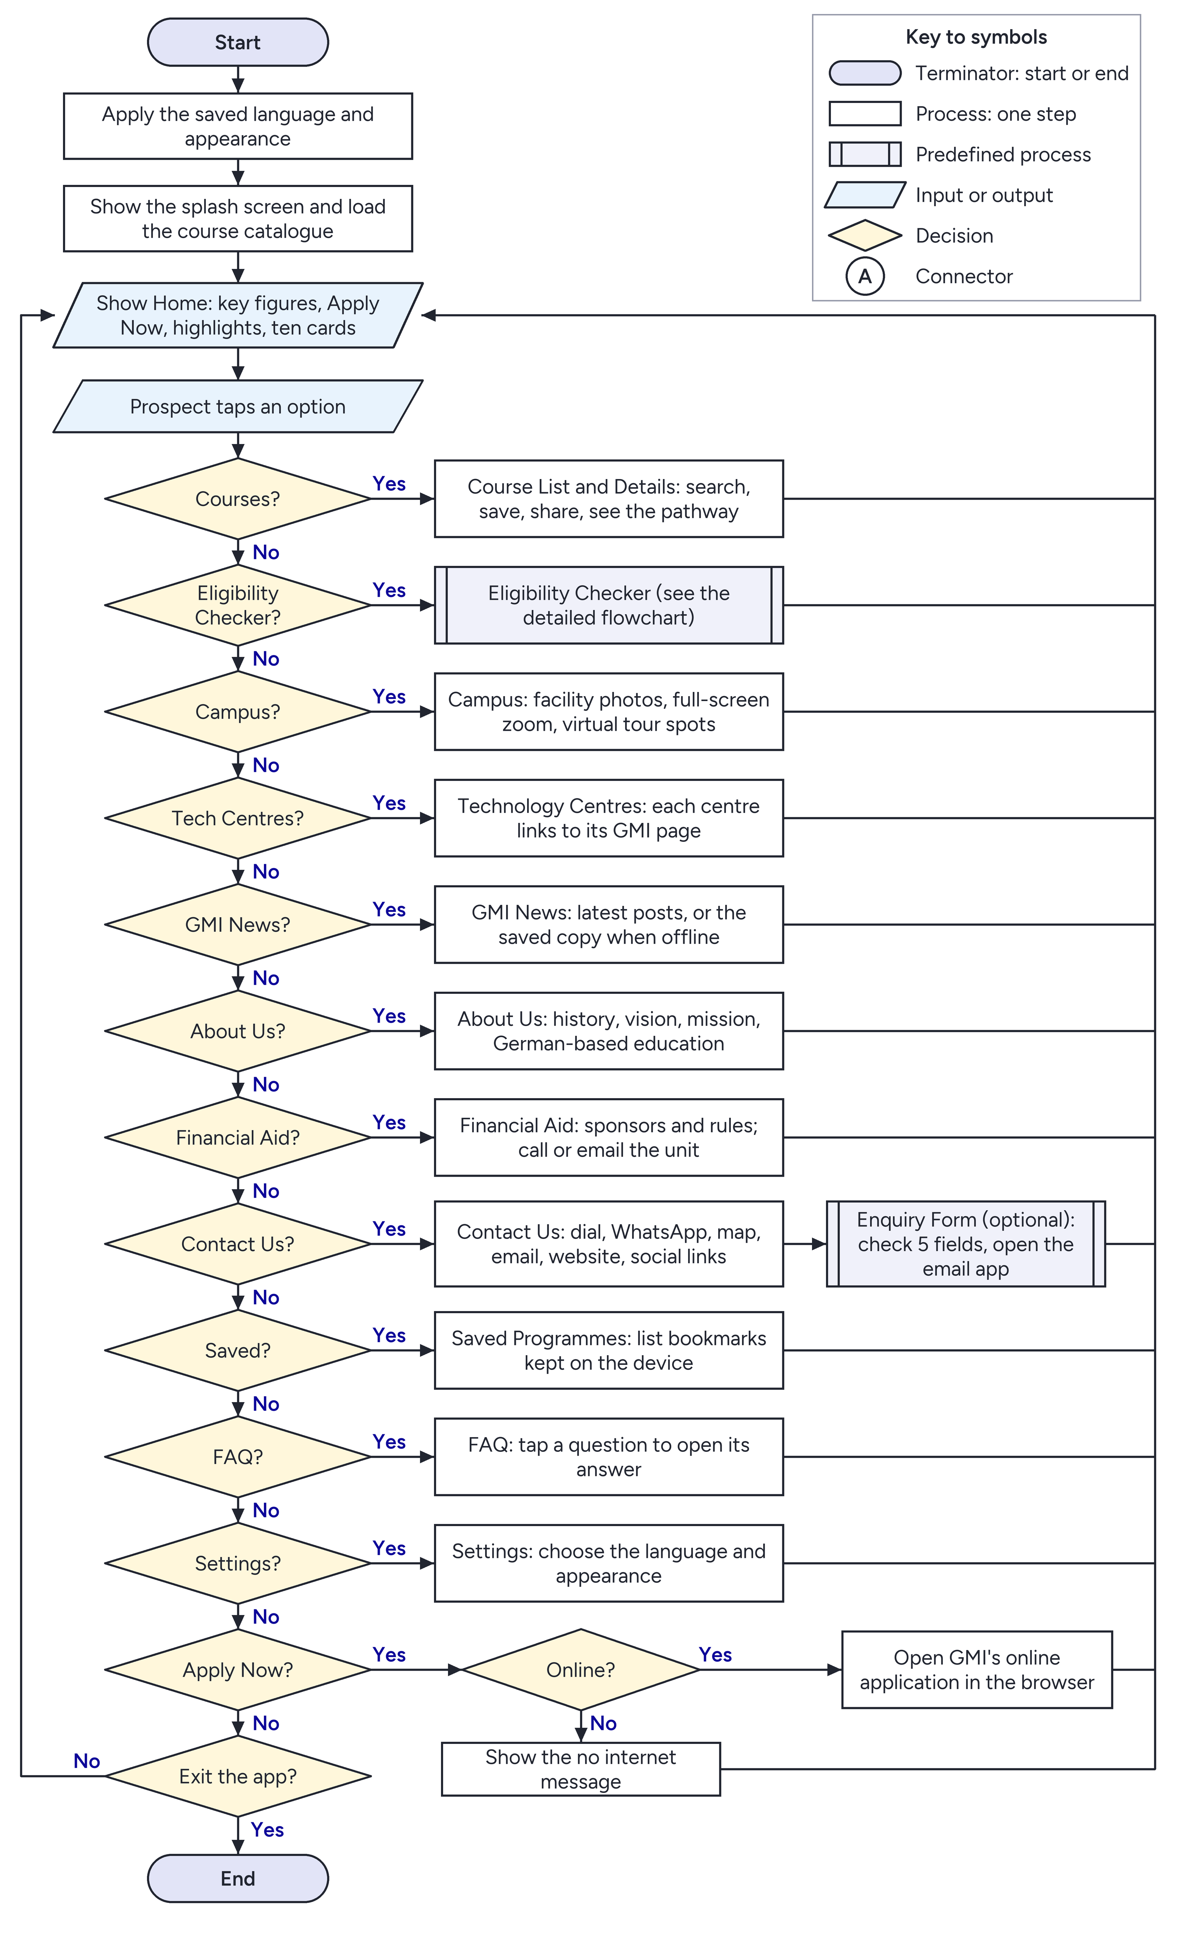
Figure 1: Flowchart of the whole application

2.4 Eligibility Checker Pseudocode
The checker has two parts. The first collects and checks the entries on the form. The second, CheckCourse, runs once for each of the 18 programmes, so one set of results gives one outcome per programme.
BEGIN Eligibility Checker
INPUT qualification

IF qualification = "Other qualification" THEN
OUTPUT the other entry routes and a Contact GMI button
ELSE
build the form from the qualification's required, suggested and supporting subjects
INPUT subjects and grades
INPUT tap on Check Eligibility

complete = TRUE
FOR each row on the form
IF the subject or the grade is missing THEN
OUTPUT "Required" on that field
complete = FALSE
ENDIF
ENDFOR

IF complete = FALSE THEN
OUTPUT "Please complete the highlighted fields."
scroll to the first missing field and wait for new INPUT
ELSE
outcomes = empty list
FOR each course in the catalogue
add CheckCourse(course, results) to outcomes
ENDFOR

count = number of outcomes with status ELIGIBLE
IF count > 0 THEN
OUTPUT "You qualify for " + count + " programmes"
ELSE
OUTPUT "No match yet" and a Contact GMI button
ENDIF
OUTPUT outcomes grouped as You qualify, Ask GMI, Not eligible yet, Not assessed

IF "Apply Now" is tapped THEN
RUN Open Web Page (online application address)
ENDIF
ENDIF
ENDIF
END

FUNCTION CheckCourse(course, results)
group = the entry group of course
IF group is not found THEN
RETURN status ASK GMI, reason "GMI has not published entry requirements"
ENDIF

rules = the rules in group for the chosen qualification
IF rules is empty THEN
RETURN status NOT ASSESSED
ENDIF

closest = none
FOR each rule in rules // meeting any one rule is enough
unmet = Evaluate(rule, results)
IF unmet is empty THEN
RETURN status ELIGIBLE, with the rule's notes
ENDIF
IF closest = none OR unmet is shorter than closest THEN
closest = unmet
ENDIF
ENDFOR

IF every item in closest is contact-only THEN
RETURN status ASK GMI, with closest as the reasons
ELSE
RETURN status NOT ELIGIBLE, with closest as the reasons
ENDIF
ENDFUNCTION

FUNCTION Evaluate(rule, results)
unmet = empty list

IF rule needs the certificate AND a certificate subject is not passed THEN
add "certificate" to unmet // for SPM: Bahasa Melayu and Sejarah
ENDIF

count = number of subjects at or above rule's minimum subject grade
IF count < rule's minimum subjects THEN
add "subject count" to unmet
ENDIF

FOR each requirement in rule
IF no allowed subject reaches requirement's minimum grade THEN
add requirement to unmet // marked contact-only if GMI may waive it
ENDIF
ENDFOR

RETURN unmet
ENDFUNCTION

FUNCTION MeetsGrade(grade, minimum) // grades are listed from best to worst
rank = position of grade in the qualification's grade list
minimumRank = position of minimum in the grade list
IF rank is found AND minimumRank is found AND rank <= minimumRank THEN
RETURN TRUE
ELSE
RETURN FALSE
ENDIF
ENDFUNCTION

How the rules work
- Rules are data. The rules live in assets/courses.json, so a changed requirement needs no change to the Java code.
- Grades are compared by position. Each qualification lists its grades from best to worst, so the same comparison works for SPM, O-Level and every other scale.
- CREDIT and PASS are general levels. Each qualification says which grade they mean. For SPM, a credit is C and a pass is E.
- Any one rule is enough. A programme can have several rules for one qualification. If none is met, the app explains the closest one.
- Some shortfalls are not final. A contact-only item, such as reinforcement Mathematics that GMI may waive, gives Ask GMI instead of Not eligible.

2.5 Eligibility Checker Flowchart
Figure 2 follows the same steps. The left column is the form and the results, and the two columns on the right are the check for one course.
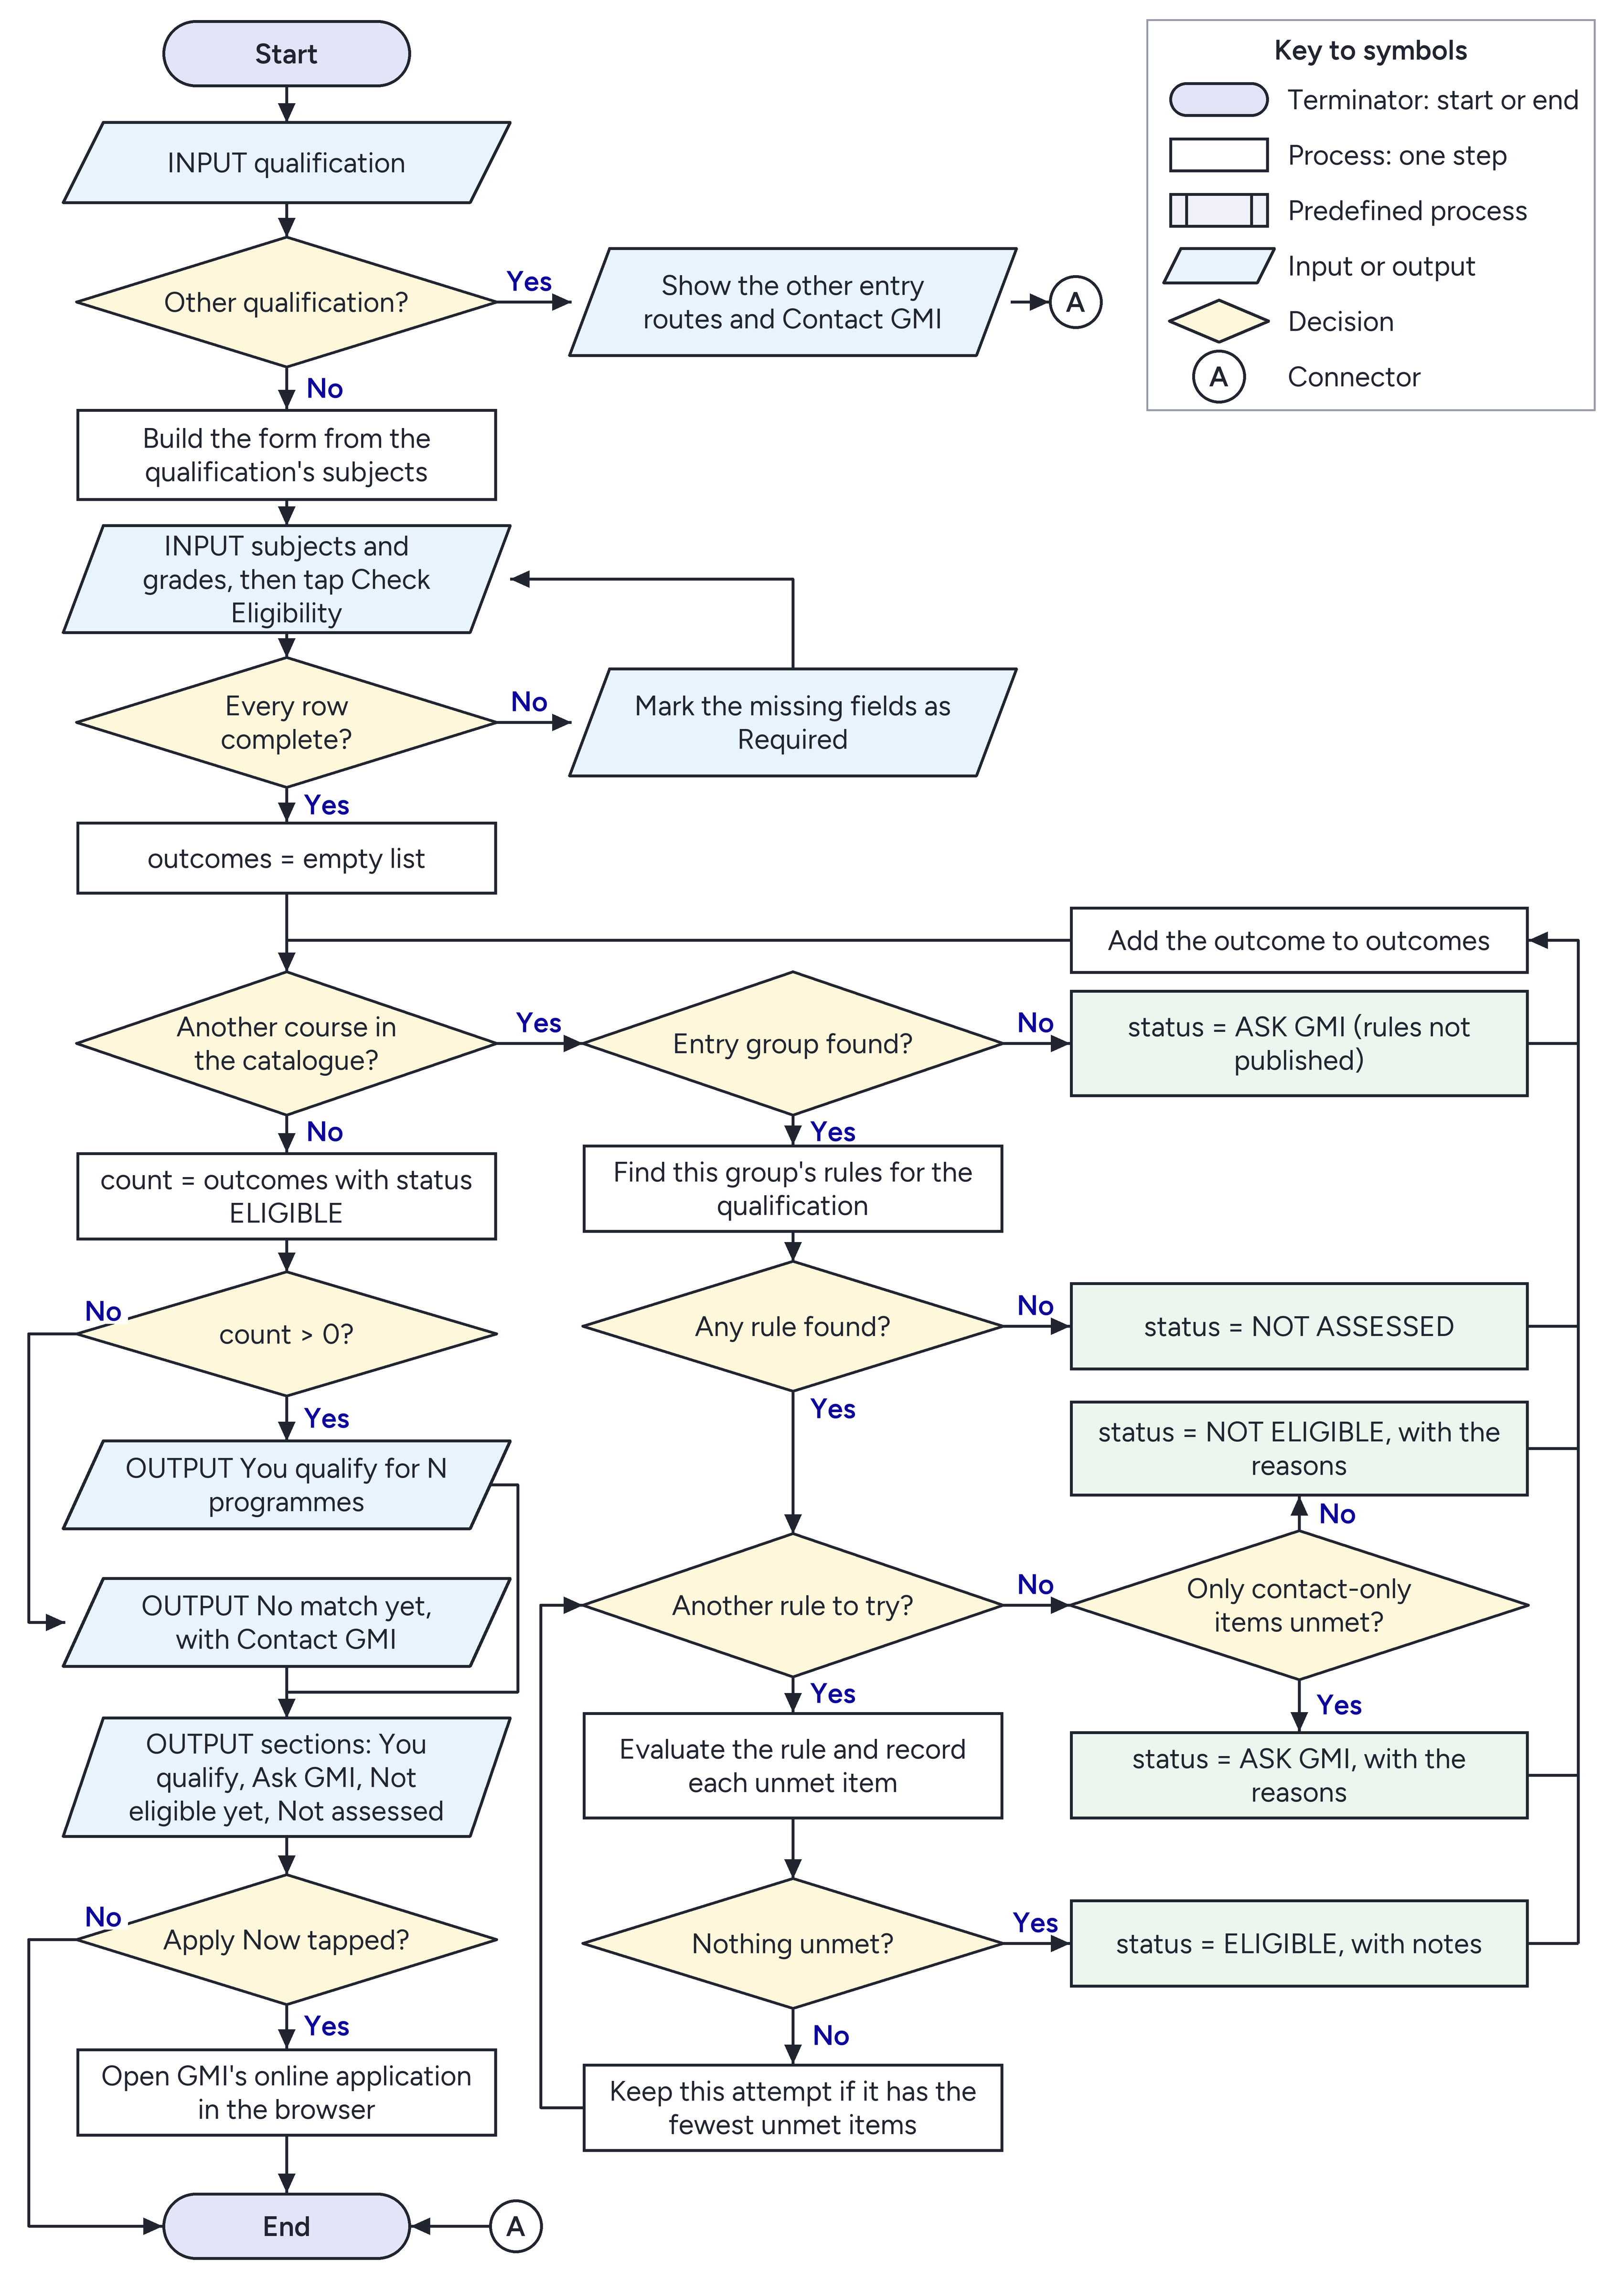
Figure 2: Detailed flowchart of the Eligibility Checker

3. Screenshots and Explanations
All screenshots are real captures from the app running on a Pixel 9a emulator. The Malay screen in Section 3.11 was captured at a smaller display size, so that more of it fits.

3.1 Splash and Home
The splash screen shows our own icon while the course data loads on a background thread. It stays for at least 1.5 seconds, so the branding can be read. Home opens with a campus photo behind the title, the key figures and a red Apply Now button. The shortcuts are grouped so the main tasks come first: Get started holds Courses and the Eligibility Checker in tinted cards, then a row of Highlights scrolls sideways, followed by Discover GMI and Help & support. Each highlight is a published GMI fact and opens the matching page: the January 2027 intake opens the online application, and the UTeM degree and the Cambridge awards open BELT and GAPP. The programme count comes from the data, so it stays correct if the list changes.
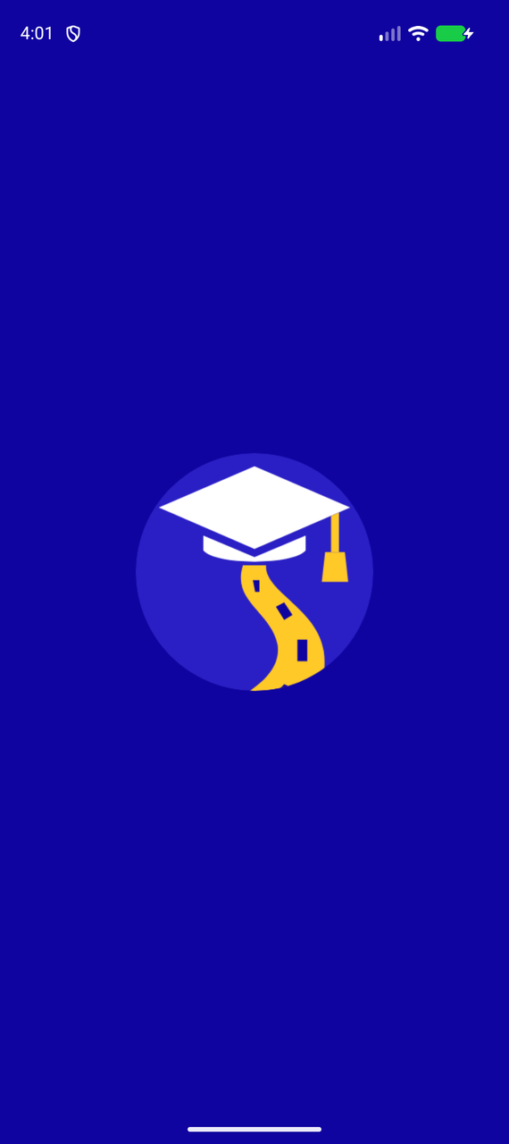  Figure 3: Splash screen | 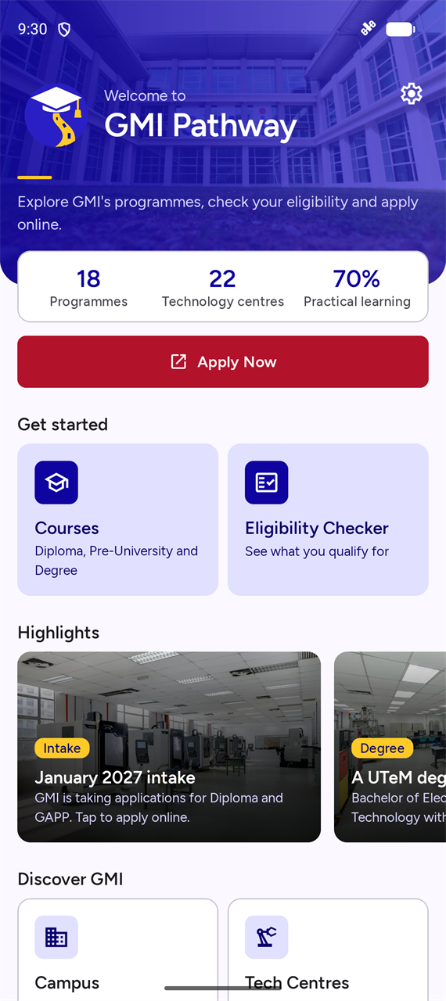  Figure 4: Home screen | 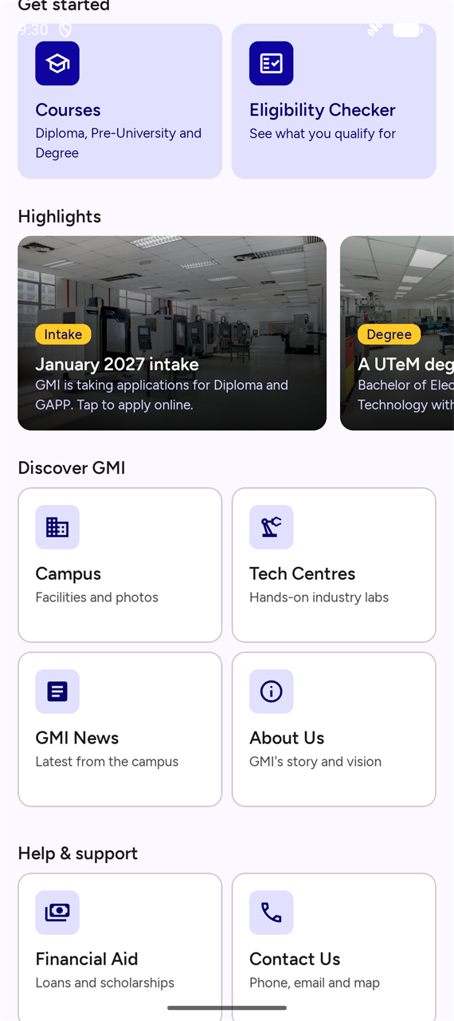  Figure 5: Home: highlights and grouped shortcuts

3.2 Courses
The list holds all 18 programmes, grouped the way GMI groups them. On the Diploma tab the departments are dropdowns that start closed, so the tab opens as a short overview. Every card has the same structure, so programmes are easy to compare. When a department opens, its programmes are indented under it, so the group is clear. The search icon finds programmes by name, department, summary or code, with the words in any order.
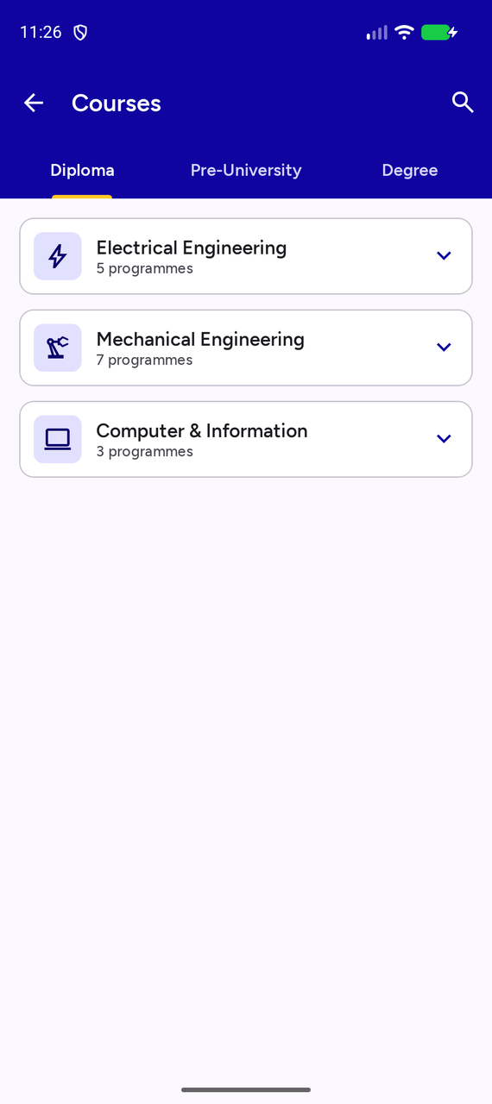  Figure 6: Diploma tab, departments closed | 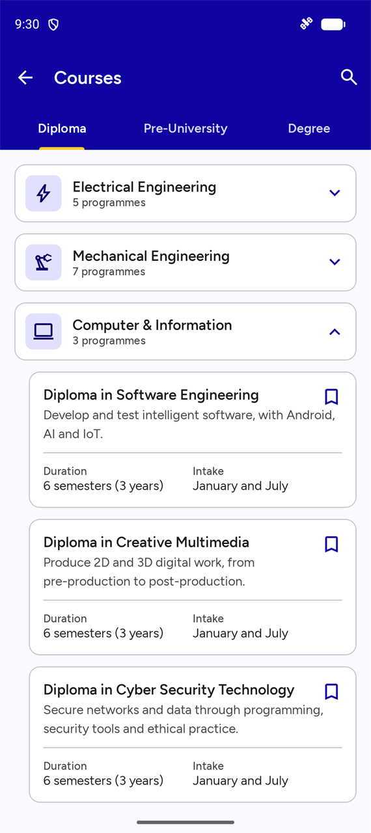  Figure 7: A department opened | 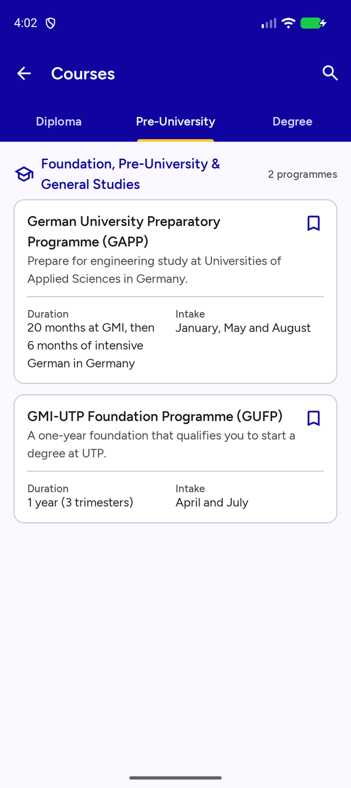  Figure 8: Pre-University tab

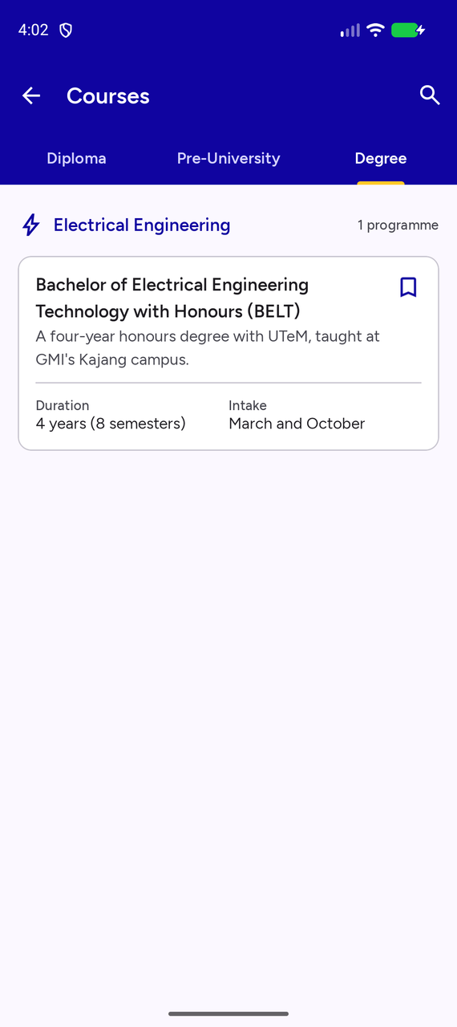
Figure 9: Degree tab

Table 6: The 18 programmes in the app
No. | Programme | Group | MQA code | Duration | Intake
1 | Diploma of Mechatronics Engineering Technology | Electrical Engineering | (R3/0713/4/0041) (07/30) (MQA/FA 14611) | 6 semesters (3 years) | January and July
2 | Diploma of Engineering Technology (Instrumentation and Control) | Electrical Engineering | (R3/0741/4/0012) (07/30) (MQA/FA 14612) | 6 semesters (3 years) | January and July
3 | Diploma of Electronics Engineering Technology (Computer) | Electrical Engineering | (R3/0741/4/0013) (07/30) (MQA/FA 14613) | 6 semesters (3 years) | January and July
4 | Diploma in Engineering Technology (Sustainable Energy and Power Distribution) | Electrical Engineering | (R2/522/4/0017) (10/27) (MQA/FA 17923) | 6 semesters (3 years) | January and July
5 | Diploma in Autotronics Engineering Technology | Electrical Engineering | (R2/0741/4/0009) (12/29) (MQA/FA 17922) | 6 semesters (3 years) | January and July
6 | Diploma of Mechanical Engineering Technology (CNC Precision) | Mechanical Engineering | (R3/0714/4/0025) (12/27) (MQA/FA 14870) | 6 semesters (3 years) | January and July
7 | Diploma of Mechanical Engineering Technology (Manufacturing) | Mechanical Engineering | (R2/0714/4/0011) (02/28) (MQA/FA 14871) | 6 semesters (3 years) | January and July
8 | Diploma in Industrial Quality Engineering Technology | Mechanical Engineering | (R/0741/4/0001) (10/28) (MQA/FA 10032) | 6 semesters (3 years) | January and July
9 | Diploma in Precision Tooling Engineering Technology | Mechanical Engineering | (R3/0714/4/0013) (10/30) (A 5005) | 6 semesters (3 years) | January and July
10 | Diploma in Innovative Product Design Engineering Technology | Mechanical Engineering | (R3/0741/4/0006) (01/31) (A 7165) | 6 semesters (3 years) | January and July
11 | Diploma in Engineering Technology (Industrial Design) | Mechanical Engineering | (R2/0741/4/0010) (02/30) (MQA/FA 4785) | 6 semesters (3 years) | January and July
12 | Diploma in Engineering Technology (Machine Tools Maintenance) | Mechanical Engineering | (R2/0741/4/0008) (12/29) (MQA/FA 4786) | 6 semesters (3 years) | January and July
13 | Diploma in Software Engineering | Computer & Information | (R/0612/4/0007) (03/28) (MQA/FA 9541) | 6 semesters (3 years) | January and July
14 | Diploma in Creative Multimedia | Computer & Information | (R2/0211/4/0171) (07/30) (MQA/FA 6035) | 6 semesters (3 years) | January and July
15 | Diploma in Cyber Security Technology | Computer & Information | (R3/0613/4/0043) (07/31) (MQA/FA15748-01) | 6 semesters (3 years) | January and July
16 | German University Preparatory Programme (GAPP) | Pre-University | (R3/0011/3/0134) (04/27) (A 7643) | 20 months at GMI, then 6 months of intensive German in Germany | January, May and August
17 | GMI-UTP Foundation Programme (GUFP) | Pre-University | (R/0011/3/0218) (10/30) (MQA/FA 13871) | 1 year (3 trimesters) | April and July
18 | Bachelor of Electrical Engineering Technology with Honours (BELT) | Degree | (MQA/FA 9760) | 4 years (8 semesters) | March and October

Tapping a programme opens its details, under a photo of the department's labs. The top of the page shows the programme code, duration, intake, mode of study and fees. Longer sections, such as Subjects and Entry requirements, collapse so the page stays easy to read. Your pathway ends the page with three numbered steps: what the student needs before GMI, how long they study at GMI, and where the programme leads. The toolbar has buttons to save and to share the programme, and two buttons stay at the bottom of the screen: Enquire, which opens the Enquiry Form with this programme already chosen, and Apply Online.
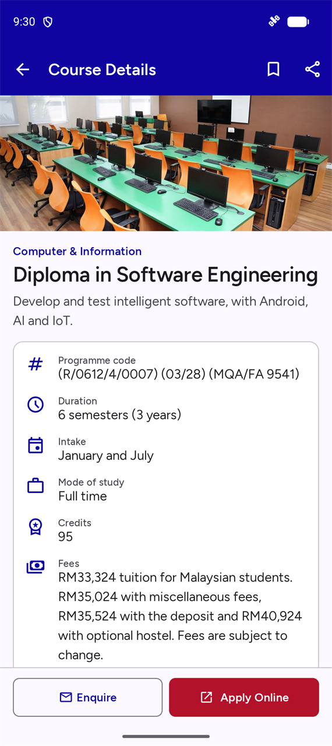  Figure 10: Course Details, top | 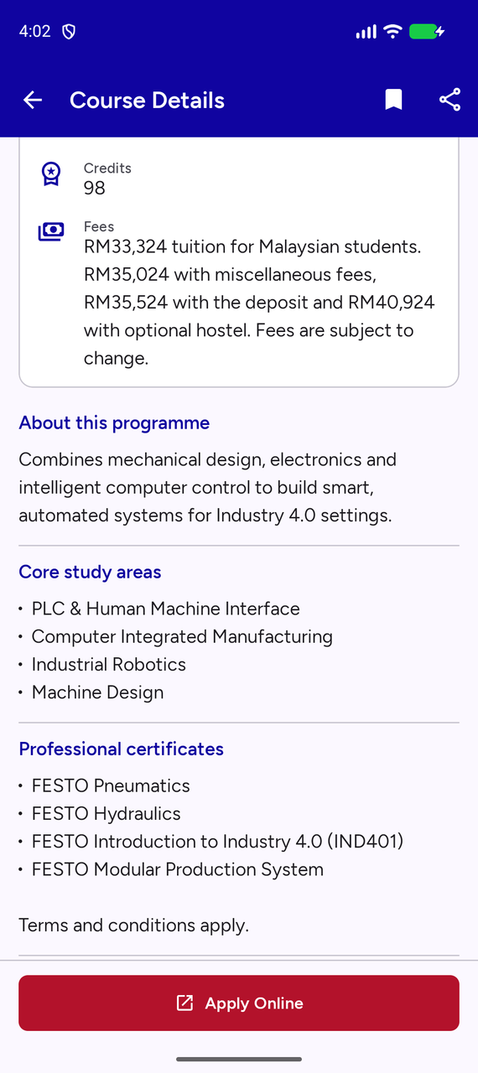  Figure 11: Collapsible sections | 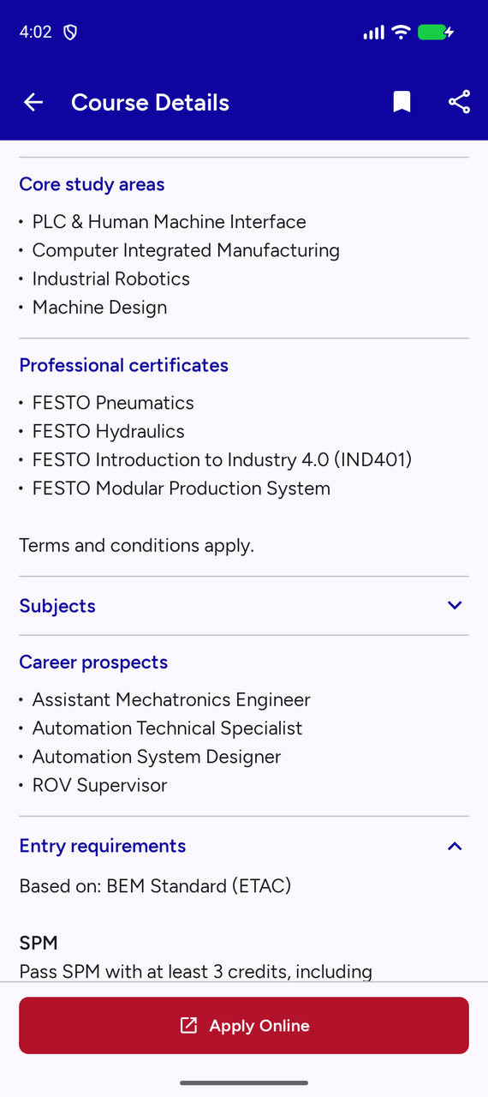  Figure 12: Entry requirements

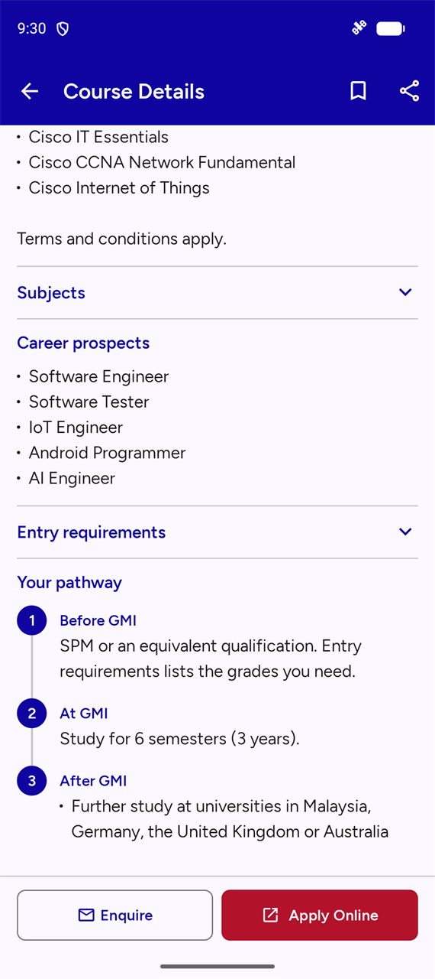
Figure 13: Your pathway, with Enquire and Apply Online

3.3 Eligibility Checker: SPM
The form has two clear steps. Step 1 is the qualification. Step 2 is the subjects and grades. For SPM, the four required subjects are already listed as plain labels, because they cannot be removed. Add subject adds a row, and each row offers only the subjects not yet used, so no subject can be entered twice.
Tapping Check Eligibility with fields missing marks each one as Required, shows a message and scrolls to the first problem.
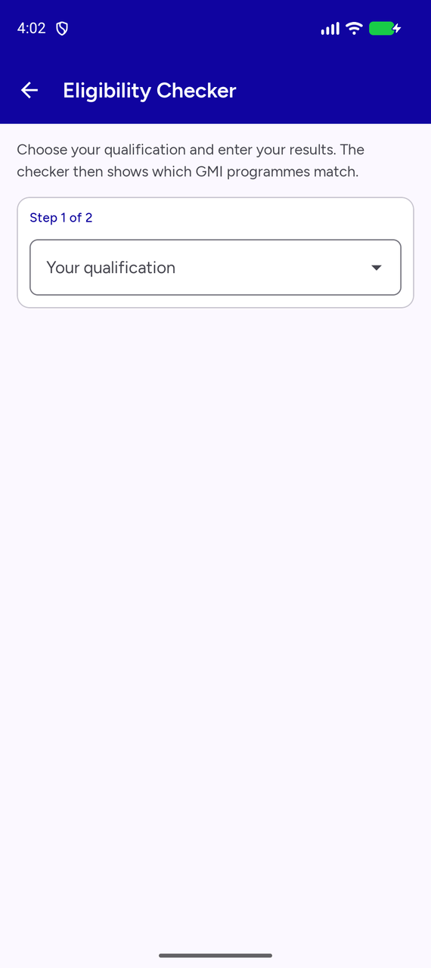  Figure 14: Eligibility Checker before a qualification is chosen | 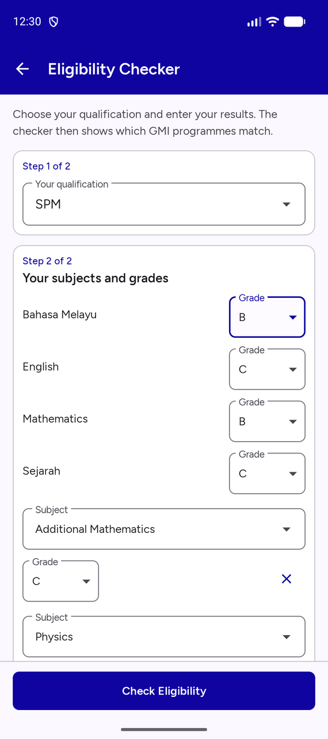  Figure 15: SPM form filled in, top | 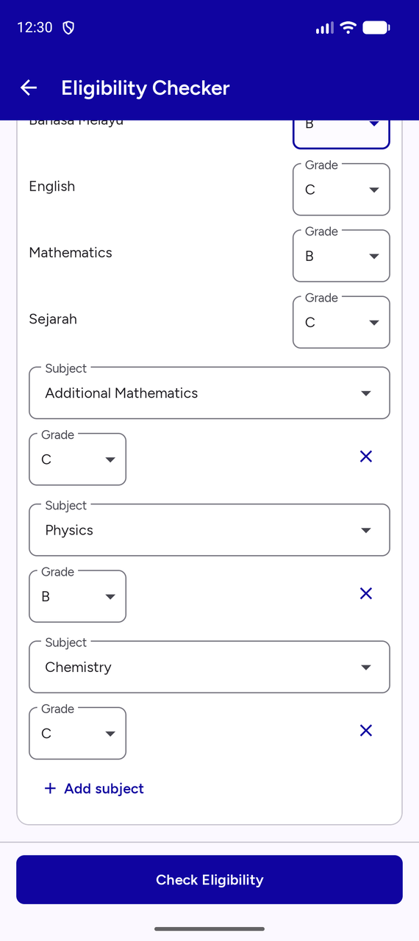  Figure 16: SPM form filled in, lower part

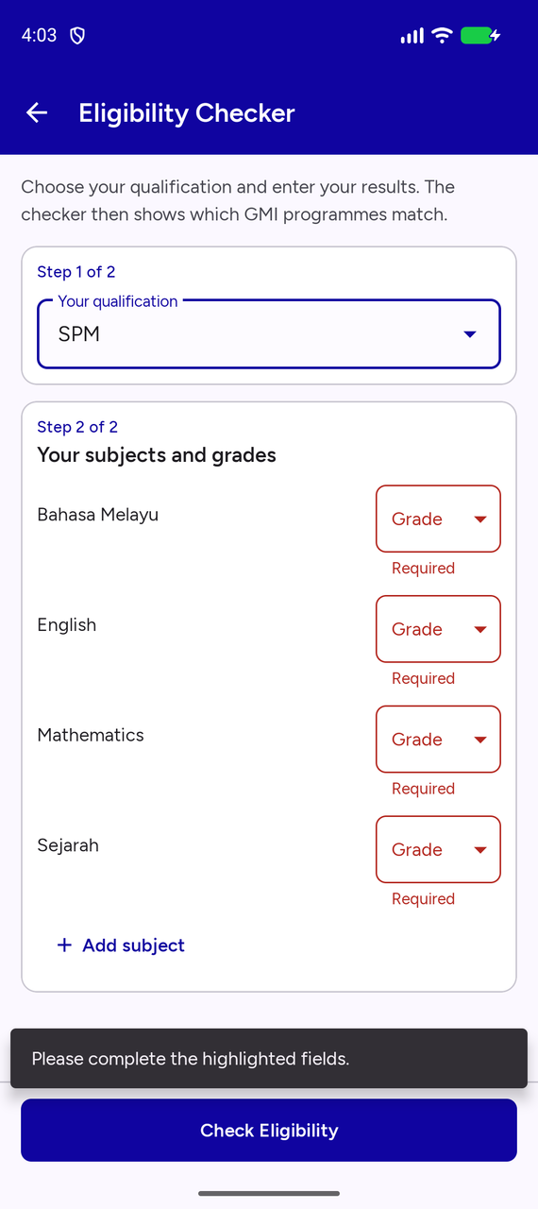
Figure 17: Required fields marked

3.4 Eligibility Checker: Second Qualification
The dropdown offers SPM, O-Level / IGCSE, UEC, STPM, Diploma, Matriculation / Foundation and Other qualification. The form, the grades and the rules all change with the choice. O-Level / IGCSE, shown here, starts with English and Mathematics as suggested rows that can be changed, and uses grades from A* to U. STPM, Diploma and Matriculation / Foundation also ask for supporting SPM results. Choosing Other qualification lists the other entry routes and offers Contact GMI.
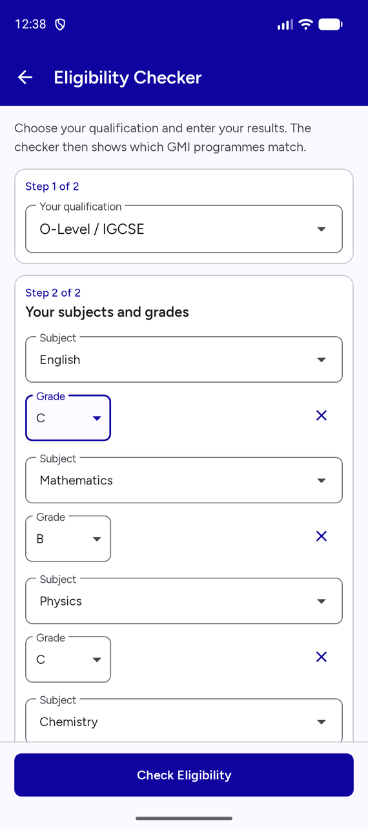
Figure 18: O-Level / IGCSE form filled in

3.5 Eligible Result
The results screen answers the main question first, with a headline. The sections below are You qualify, Ask GMI, Not eligible yet and Not assessed, and each can be opened or closed. Eligible programmes have a blue border and a red Apply Now button. Figures 19 and 20 show test cases 1 and 3 from Table 7.
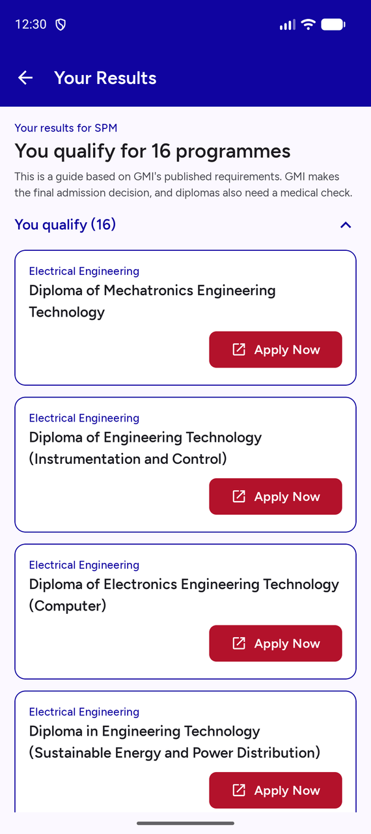  Figure 19: SPM result: You qualify for 16 programmes | 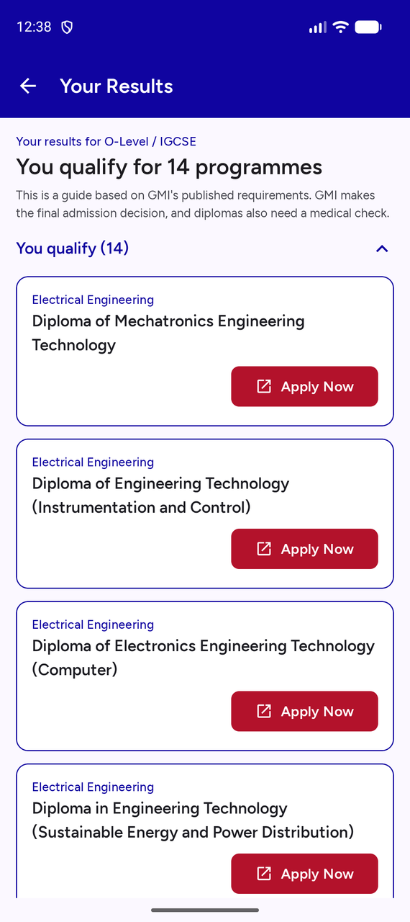  Figure 20: O-Level / IGCSE result: You qualify for 14 programmes

Table 7: Test cases proved by DemoScenarioTest
Test case | Entered results | You qualify | Ask GMI | Not eligible | Not assessed
1. SPM, eligible | Bahasa Melayu B, English C, Mathematics B, Sejarah C, Additional Mathematics C, Physics B, Chemistry C | 16 | 1 | 0 | 1
2. SPM, not eligible | Bahasa Melayu C, English D, Mathematics E, Sejarah E, Physics E, Accounting D | 0 | 1 | 16 | 1
3. O-Level, eligible | English C, Mathematics B, Physics C, Chemistry C | 14 | 1 | 2 | 1
4. O-Level, not eligible | English E, Mathematics D, Physics D | 0 | 1 | 16 | 1
5. Diploma holder | Engineering Technology diploma with CGPA 2.30+, SPM Bahasa Melayu C, SPM Sejarah E | 1 | 1 | 0 | 16

In test case 1, Cyber Security shows Ask GMI, because its rules are unpublished, and BELT shows Not assessed, because SPM alone is not an entry route. In test case 3, the two programmes that are not eligible are GAPP and GUFP, because they need Additional Mathematics. In test case 5, the one programme the student qualifies for is BELT.

3.6 Not Eligible Result
When nothing matches, the headline says No match yet, and a card offers Contact GMI, so the student still has a next step. Each programme that is not met is listed in grey with its reasons, such as "Needs at least C in Mathematics." Grey is deliberate: red is kept for Apply, so the useful actions stand out.
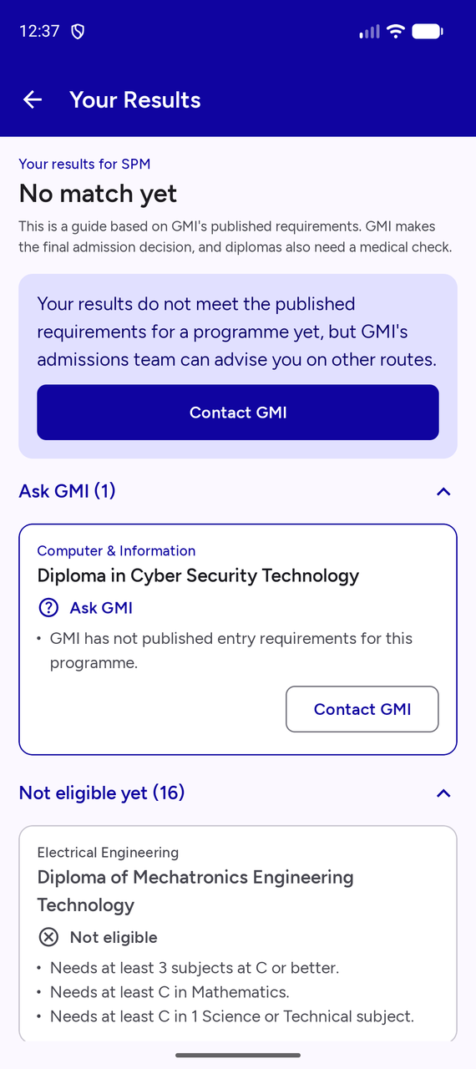  Figure 21: SPM result: No match yet | 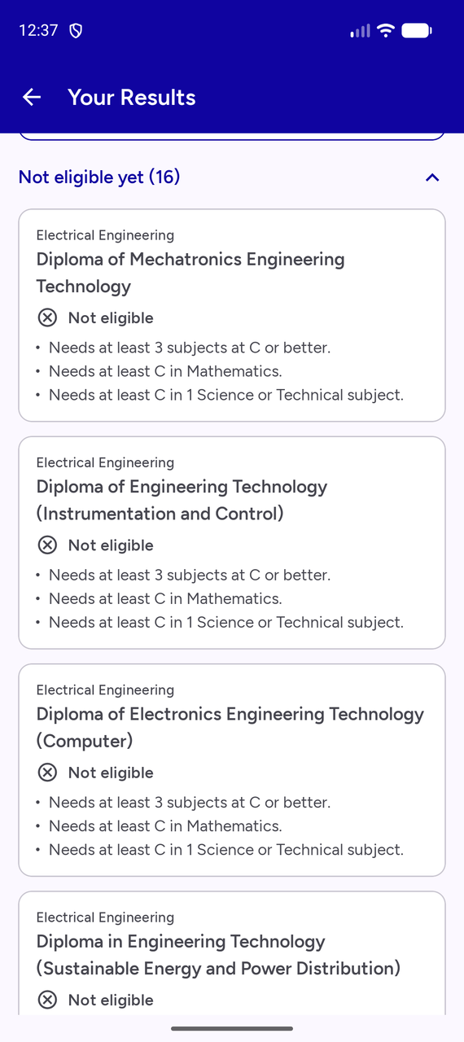  Figure 22: SPM result: reasons for each programme | 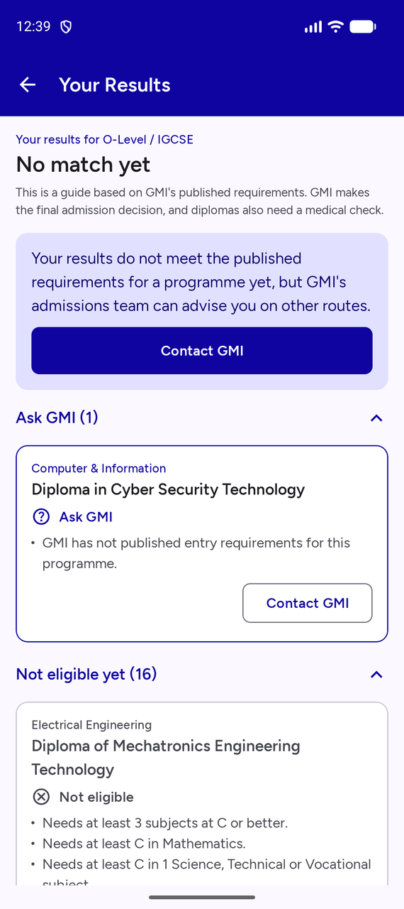  Figure 23: O-Level / IGCSE result: No match yet

3.7 Redirect to the Online Application
Every Apply Now and Apply Online button opens GMI's online application portal, at https://gmi.vialing.com/oa/login (GMI, n.d.-s), in the browser. If the device is offline, the app shows a message instead. The capture below shows the portal's real login page, reached from the eligible result in Figure 19.
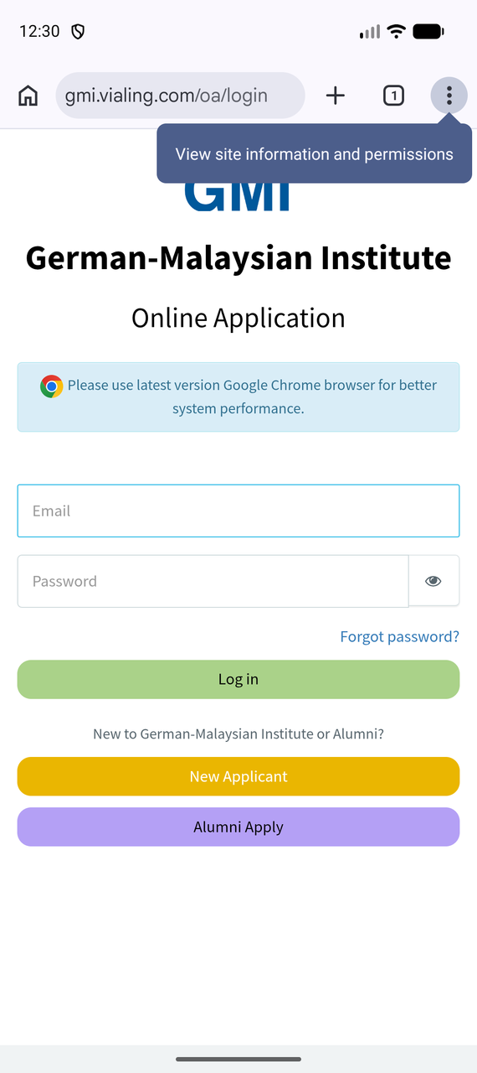
Figure 24: GMI's online application opened from Apply Now

3.8 Contact Us
Contact Us puts every route to GMI in one place. A location card shows the address and Open in Maps. Rows with an arrow can be tapped: phone numbers open the dialer without calling, and WhatsApp, email and the website open their apps. The fax row has no arrow, because it cannot be tapped. Six logo buttons open GMI's official social media pages, and each has a screen reader label. If an app is missing, a message explains this, and the map falls back to the browser.
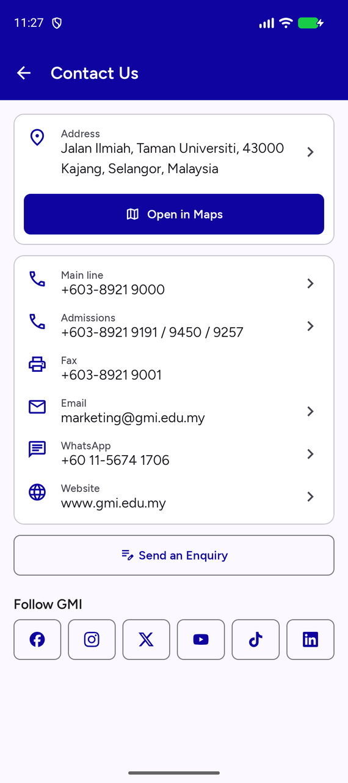
Figure 25: Contact Us, with social logos

3.9 Enquiry Form
The form asks for a name, email address, phone number, programme of interest and message. The programme list includes General enquiry. Helper text guides the student before an error appears, and an error clears as soon as the field is corrected. When all five fields pass, the email app opens with GMI's address, a subject and the message filled in, ready to send. When the student comes back, an Almost done message reminds them to tap Send in the email app and names the address GMI will reply to. The form keeps what was typed, in case they want to change it. Opened from a course page, the form already has that programme chosen.
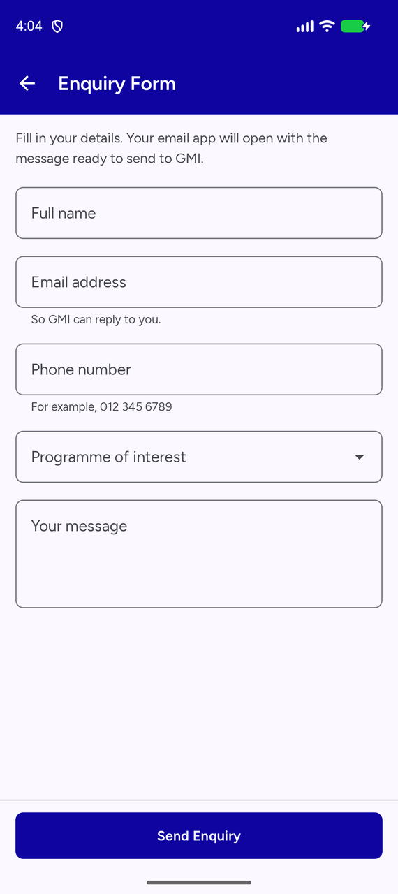  Figure 26: Enquiry Form | 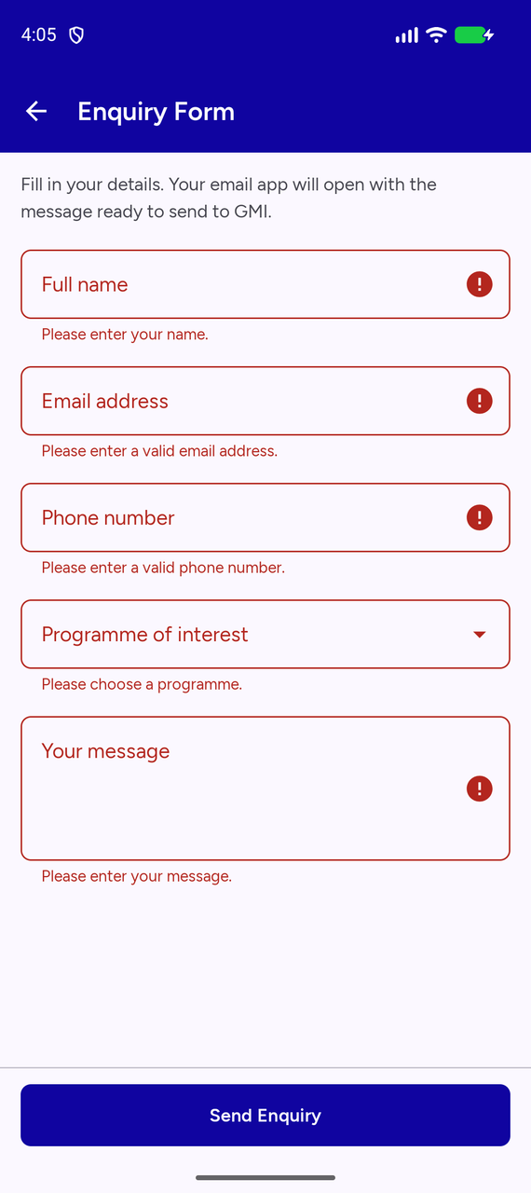  Figure 27: Validation errors | 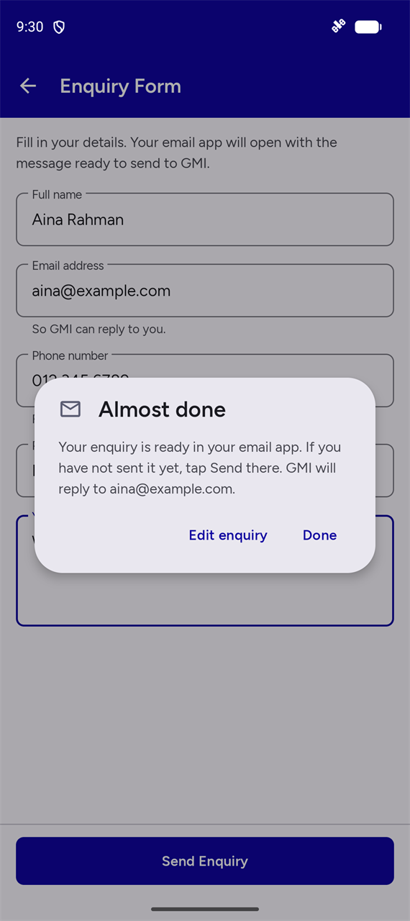  Figure 28: Confirmation after the email app

3.10 About Us
About Us covers who GMI is, its history as a timeline, the vision and mission, its German-based education, governance and accreditation. The vision and mission are highlighted and use the wording from the May 2026 Programme Guide, which is the only dated version.
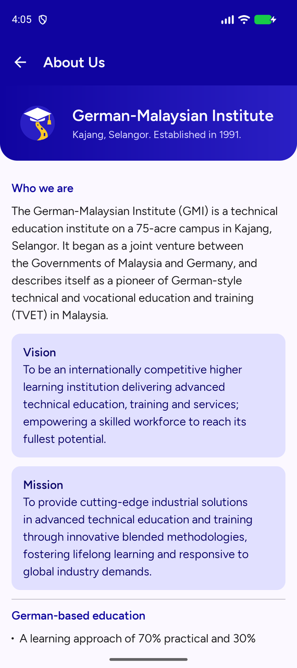  Figure 29: About Us, top | 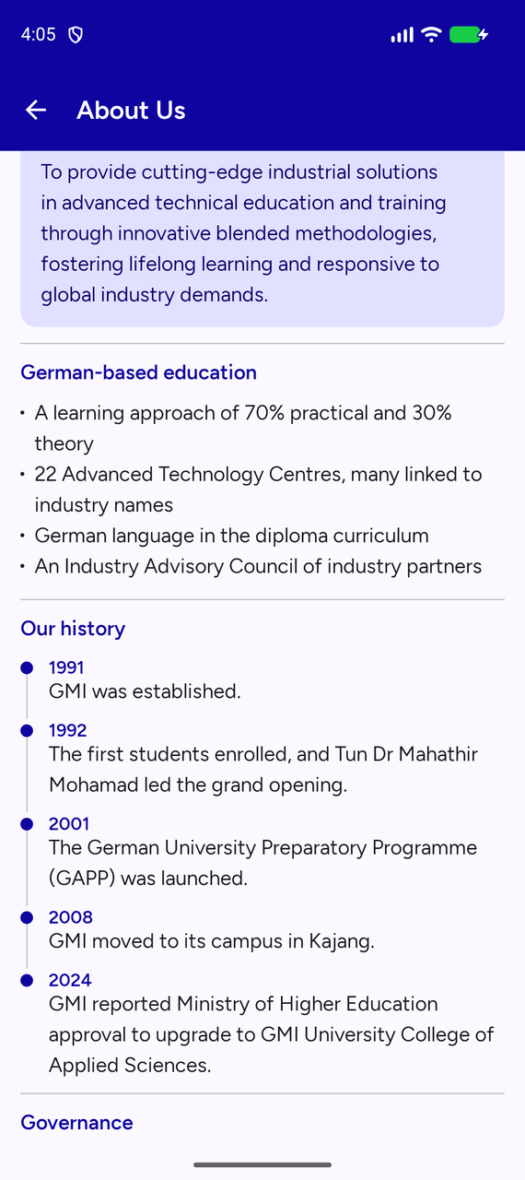  Figure 30: About Us, history timeline

3.11 Extra Features
Saved Programmes keeps bookmarks after the app closes. The FAQ opens each answer on tap, and every answer is traced to a source in our research notes. Settings changes the language and appearance. The whole app switches to Bahasa Melayu, including the course data and the checker, while official programme names stay in English, as GMI publishes them. Dark mode, landscape layouts and tablets are also supported.
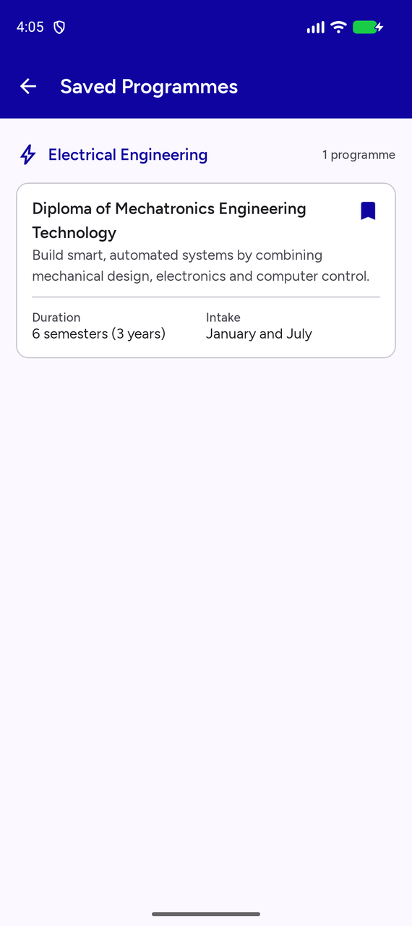  Figure 31: Saved Programmes | 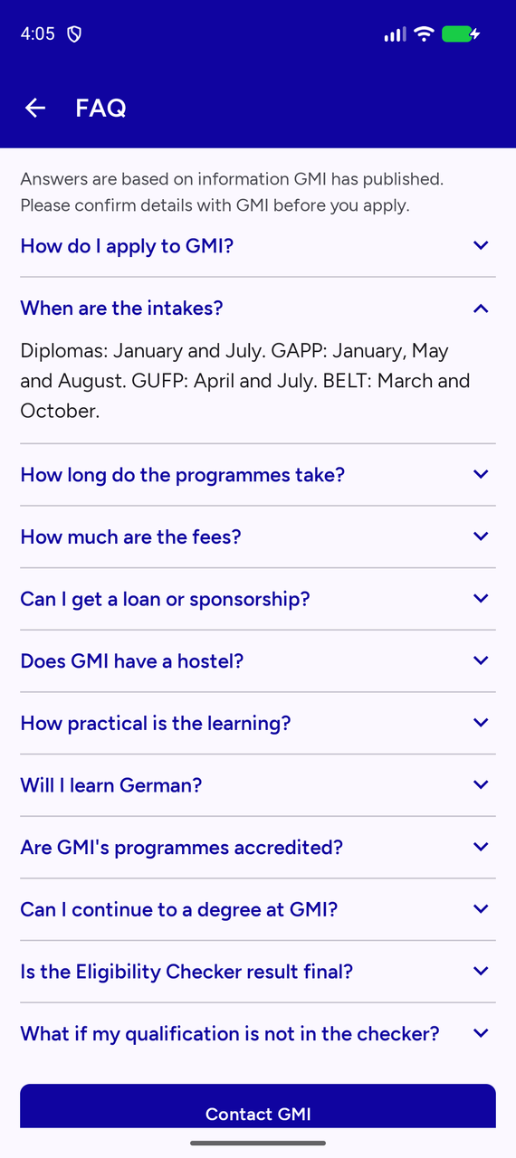  Figure 32: FAQ | 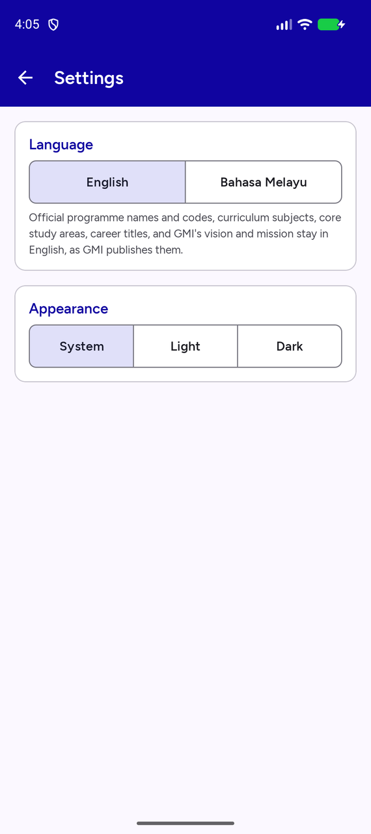  Figure 33: Settings

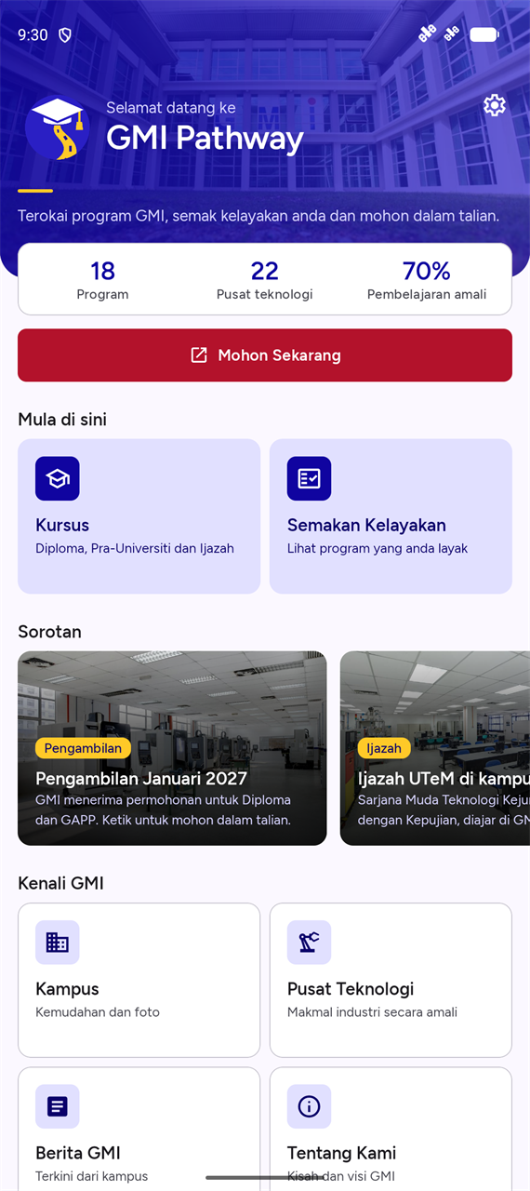  Figure 34: Home in Bahasa Melayu | 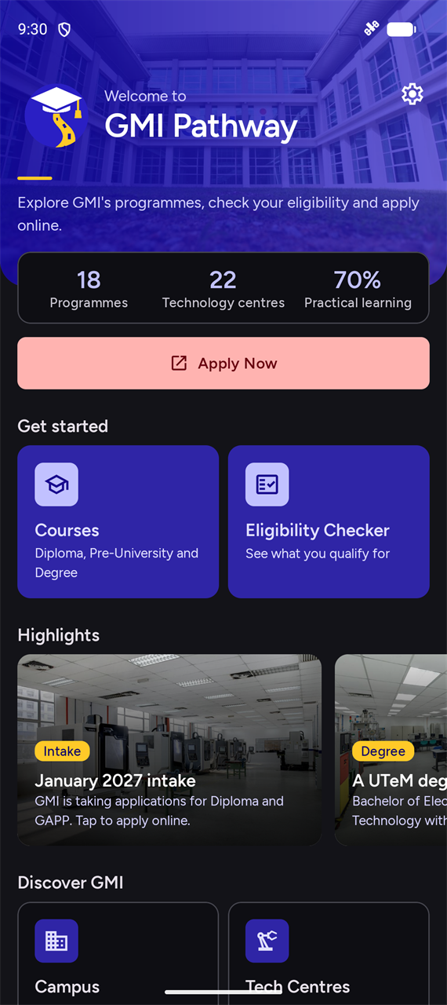  Figure 35: Home in dark mode

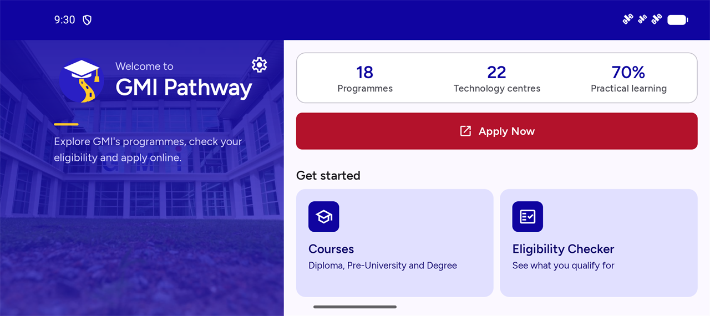
Figure 36: Home in landscape

Campus, Technology Centres, Financial Aid and GMI News
Four screens bring in more of GMI's website (GMI, n.d.-j, n.d.-k, n.d.-t). Campus & Facilities shows GMI's own photos of eight facility groups, from the labs of each department to the library, sports, hostel and surau. Each row of photos scrolls sideways, and tapping one opens it full screen, where it can be zoomed with a pinch or a double tap. The photos ship inside the app, so the screen works offline, and they are credited to GMI on screen. The screen also lists the 15 places in GMI's 360° virtual tour and opens the tour.
Technology Centres describes the 12 centres and 3 examination centres that have their own page on GMI's website, names an industry partner only where GMI's page does, and links to each page. Financial Aid gives the rules first: aid is for Malaysian students, only one sponsor at a time, and only the sponsor can approve it. It then lists each sponsor GMI names, with buttons to call or email GMI's Loan & Sponsorship Unit.
GMI News is the one screen that needs the internet. It reads the latest posts from GMI's public news feed (GMI, n.d.-r), and tapping a post opens the full article on GMI's website. The last download is saved, so when the phone is offline the screen shows the saved news with a notice, or a Try Again message if nothing has been saved yet.
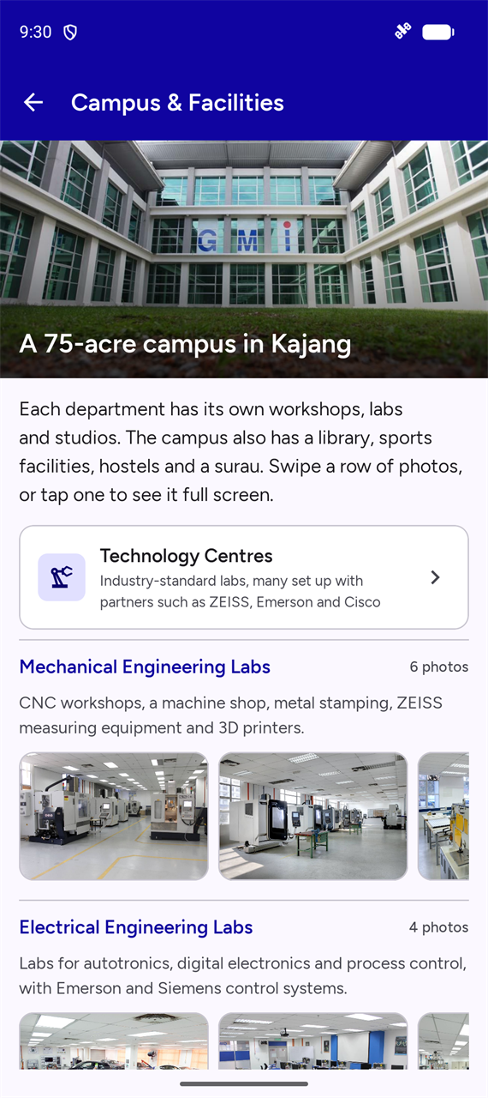  Figure 37: Campus & Facilities | 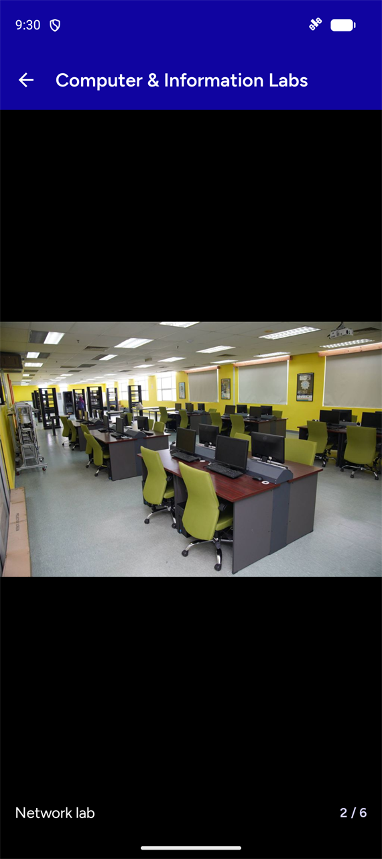  Figure 38: A photo full screen | 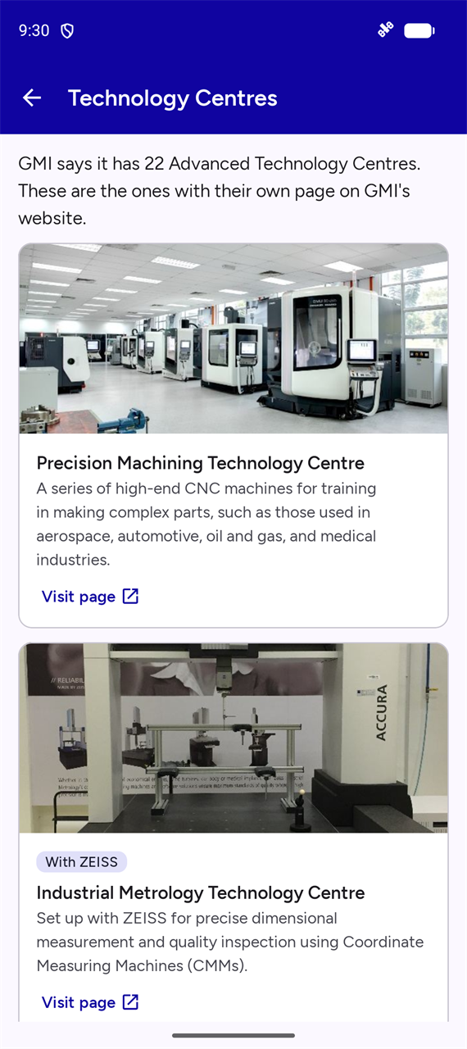  Figure 39: Technology Centres

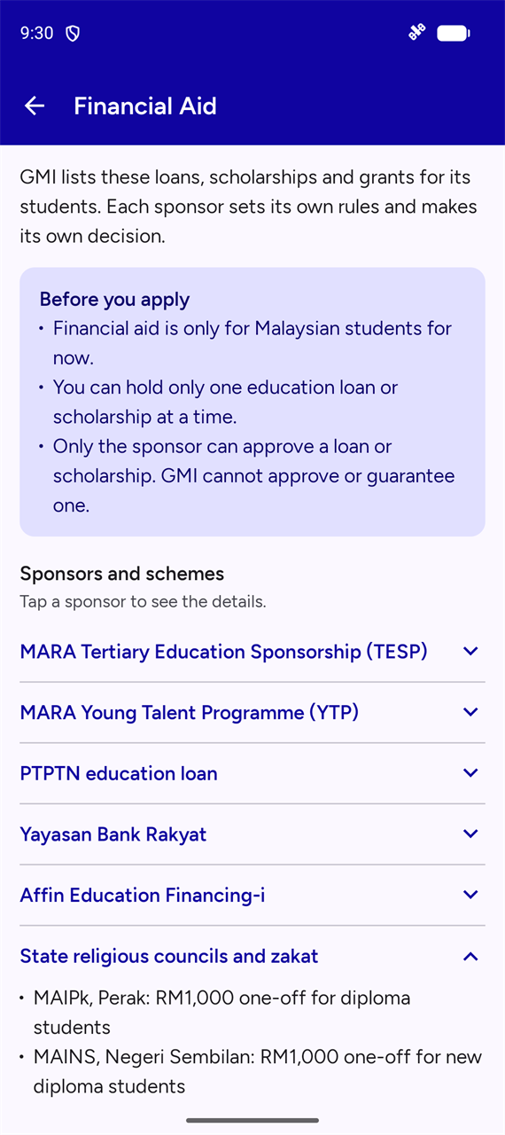  Figure 40: Financial Aid | 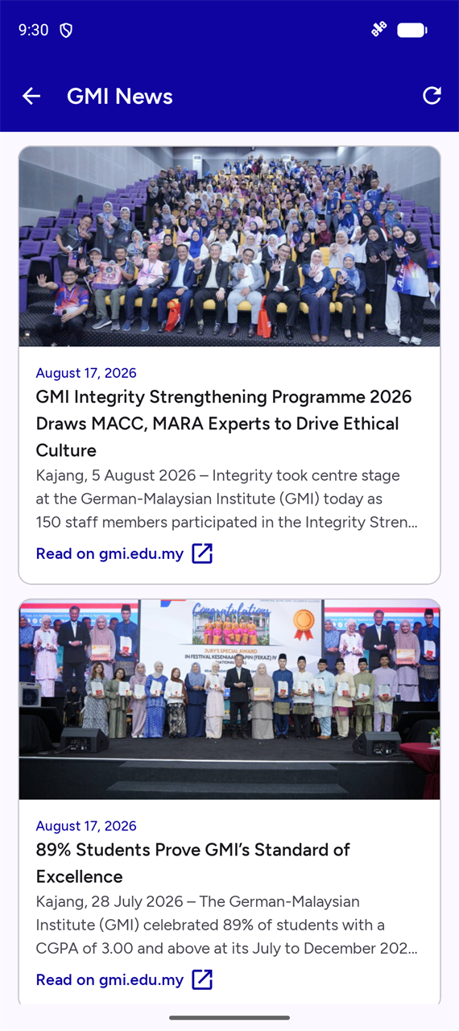  Figure 41: GMI News

3.12 UI/UX Design
The app follows one small design system, so every screen feels part of the same product.
- One font: Figtree, in three weights, on a 12-style type scale. Nothing is smaller than 12sp.
- Colours with one job each: blue navigates, red only ever means Apply, gold appears only on blue, and grey means Not eligible.
- One shape system: 8dp corners for buttons and fields, 12dp for cards, and one screen margin: 16dp on phones, 48dp on tablets and 96dp on tablets in landscape.
- Clear priorities: Home leads with the two main tasks, and every course page ends with the same two actions, Enquire and Apply.
- Readable over photos: text on a photo always sits on a dark fade, so it keeps its contrast whatever the picture.
- Calm motion: short screen transitions and a 200ms fade-up as lists appear, so nothing slows the student down.
- Accessibility: all text pairs pass WCAG AA contrast, tap targets are at least 48dp, icon-only buttons have screen reader labels, and the layouts grow to fit text at twice the normal size.
- Feedback: validation shows on the field, and every external action explains itself if it cannot run.

4. Source Code
This section lists the code that makes up the app. Package names are shortened: every Java path below starts at app/src/main/java/com/week14/gmipathway/, and every res/ path starts at app/src/main/. The Malay text in values-ms/ mirrors the English strings.xml shown here, and courses_ms.json mirrors courses.json, so they are not repeated.

4.1 Project Structure
GMIPathway/
app/src/main/
AndroidManifest.xml
assets/ courses.json, courses_ms.json, licences/
java/com/week14/gmipathway/
GmiPathwayApp.java
data/ CourseRepository, AppSettings, BookmarkStore, CampusCatalog,
NewsRepository, ImageLoader
logic/ EligibilityChecker, CourseSearch
model/ Course, EntryRule, Qualification and other data classes
ui/campus/ Campus, photo viewer, Technology Centres
ui/common/ BaseActivity, DetailViews, ExternalLinks, ZoomImageView
ui/courses/ course list, details, saved programmes
ui/eligibility/ checker form and results
ui/enquiry/ Contact Us, Enquiry Form, About Us, FAQ
ui/funding/ Financial Aid
ui/home/ MainActivity, HighlightAdapter
ui/news/ GMI News
ui/settings/ SettingsActivity
ui/splash/ SplashActivity
res/ layout, layout-land, values, values-ms, values-night, values-land,
values-sw600dp (tablets), drawable, drawable-nodpi (campus
photos), anim, font, menu, mipmap
app/src/test/ unit tests
docs/ demo script and UI revision notes
research/ GMI research, eligibility rules and campus sources
report/ this report and the presentation outline

4.2 Android Manifest

app/src/main/AndroidManifest.xml
<?xml version="1.0" encoding="utf-8"?>
<manifest xmlns:android="http://schemas.android.com/apk/res/android"
xmlns:tools="http://schemas.android.com/tools">

<uses-permission android:name="android.permission.ACCESS_NETWORK_STATE" />
<!-- Only the GMI News screen downloads anything. Everything else ships inside the app. -->
<uses-permission android:name="android.permission.INTERNET" />

<application
android:name=".GmiPathwayApp"
android:allowBackup="true"
android:dataExtractionRules="@xml/data_extraction_rules"
android:fullBackupContent="@xml/backup_rules"
android:icon="@mipmap/ic_launcher"
android:label="@string/app_name"
android:roundIcon="@mipmap/ic_launcher_round"
android:supportsRtl="true"
android:theme="@style/Theme.GMIPathway"
tools:targetApi="31">
<activity
android:name=".ui.splash.SplashActivity"
android:exported="true"
android:theme="@style/Theme.GMIPathway.Splash">
<intent-filter>
<action android:name="android.intent.action.MAIN" />

<category android:name="android.intent.category.LAUNCHER" />
</intent-filter>
</activity>
<activity
android:name=".ui.home.MainActivity"
android:exported="false" />
<activity
android:name=".ui.courses.CourseListActivity"
android:exported="false" />
<activity
android:name=".ui.courses.CourseDetailActivity"
android:exported="false" />
<activity
android:name=".ui.eligibility.EligibilityActivity"
android:exported="false"
android:windowSoftInputMode="adjustResize" />
<activity
android:name=".ui.eligibility.EligibilityResultActivity"
android:exported="false" />
<activity
android:name=".ui.enquiry.ContactUsActivity"
android:exported="false" />
<activity
android:name=".ui.enquiry.EnquiryFormActivity"
android:exported="false"
android:windowSoftInputMode="adjustResize" />
<activity
android:name=".ui.enquiry.AboutUsActivity"
android:exported="false" />
<activity
android:name=".ui.enquiry.FaqActivity"
android:exported="false" />
<activity
android:name=".ui.courses.SavedCoursesActivity"
android:exported="false" />
<activity
android:name=".ui.settings.SettingsActivity"
android:exported="false" />
<activity
android:name=".ui.campus.CampusActivity"
android:exported="false" />
<activity
android:name=".ui.campus.PhotoViewerActivity"
android:exported="false" />
<activity
android:name=".ui.campus.TechCentresActivity"
android:exported="false" />
<activity
android:name=".ui.funding.FinancialAidActivity"
android:exported="false" />
<activity
android:name=".ui.news.NewsActivity"
android:exported="false" />

<!-- Lets AppCompat remember the chosen language on Android 12 and older. -->
<service
android:name="androidx.appcompat.app.AppLocalesMetadataHolderService"
android:enabled="false"
android:exported="false">
<meta-data
android:name="autoStoreLocales"
android:value="true" />
</service>
</application>

</manifest>

4.3 Activities

ui/common/BaseActivity.java
package com.week14.gmipathway.ui.common;

import android.graphics.Color;
import android.os.Bundle;
import android.view.View;
import android.view.ViewGroup;

import androidx.activity.EdgeToEdge;
import androidx.activity.SystemBarStyle;
import androidx.annotation.Nullable;
import androidx.annotation.StringRes;
import androidx.appcompat.app.ActionBar;
import androidx.appcompat.app.AppCompatActivity;
import androidx.core.graphics.Insets;
import androidx.core.view.ViewCompat;
import androidx.core.view.WindowInsetsCompat;

import com.google.android.material.appbar.MaterialToolbar;
import com.week14.gmipathway.R;

/**
* Shared set-up for every screen: drawing behind the system bars and the toolbar with a back arrow.
*/
public abstract class BaseActivity extends AppCompatActivity {

@Override
protected void onCreate(@Nullable Bundle savedInstanceState) {
// The app bar is always blue, so the status bar icons always stay light.
EdgeToEdge.enable(this, SystemBarStyle.dark(Color.TRANSPARENT));
super.onCreate(savedInstanceState);
}

/** Shows the toolbar with a title and a back arrow. */
protected void setUpToolbar(@StringRes int titleRes) {
MaterialToolbar toolbar = findViewById(R.id.toolbar);
setSupportActionBar(toolbar);
ActionBar actionBar = getSupportActionBar();
if (actionBar != null) {
actionBar.setTitle(titleRes);
actionBar.setDisplayHomeAsUpEnabled(true);
}
}

/** Returning to the previous screen keeps its state, such as the selected tab. */
@Override
public boolean onSupportNavigateUp() {
getOnBackPressedDispatcher().onBackPressed();
return true;
}

/**
* Keeps content clear of the status bar, navigation bar and keyboard.
* The screen's root view must have the id "main".
*/
protected void applyWindowInsets() {
ViewGroup root = findViewById(R.id.main);
View[] topViews = getTopInsetViews();
// Top views stretch over the root's padding, so it must not clip them.
root.setClipToPadding(false);
ViewCompat.setOnApplyWindowInsetsListener(root, (view, insets) -> {
Insets bars = insets.getInsets(WindowInsetsCompat.Type.systemBars()
| WindowInsetsCompat.Type.displayCutout());
Insets keyboard = insets.getInsets(WindowInsetsCompat.Type.ime());
int bottom = Math.max(bars.bottom, keyboard.bottom);
view.setPadding(bars.left, 0, bars.right, bottom);
for (View topView : topViews) {
if (topView != null) {
topView.setPadding(bars.left, bars.top, bars.right, 0);
ViewGroup.MarginLayoutParams params =
(ViewGroup.MarginLayoutParams) topView.getLayoutParams();
params.leftMargin = -bars.left;
params.rightMargin = -bars.right;
topView.setLayoutParams(params);
}
}
onInsetsApplied(bars, bottom);
return WindowInsetsCompat.CONSUMED;
});
}

/** Lets a screen adjust views that need more than the standard insets. */
protected void onInsetsApplied(Insets bars, int bottomInset) {
}

/** Returns the views that extend behind the status bar. Missing views can be left null. */
protected View[] getTopInsetViews() {
return new View[]{findViewById(R.id.app_bar)};
}
}

ui/splash/SplashActivity.java
package com.week14.gmipathway.ui.splash;

import android.annotation.SuppressLint;
import android.content.Intent;
import android.os.Bundle;
import android.os.Handler;
import android.os.Looper;
import android.os.SystemClock;
import android.view.View;
import android.view.ViewGroup;

import androidx.annotation.Nullable;
import androidx.core.splashscreen.SplashScreen;
import androidx.core.view.ViewCompat;
import androidx.core.view.WindowInsetsCompat;

import com.week14.gmipathway.R;
import com.week14.gmipathway.data.CourseRepository;
import com.week14.gmipathway.ui.common.BaseActivity;
import com.week14.gmipathway.ui.home.MainActivity;

import java.util.concurrent.ExecutorService;
import java.util.concurrent.Executors;

/**
* Shows the branded splash screen while the course data loads, then opens the home screen.
* Lint prefers no splash Activity, but the project brief asks for a custom branded screen.
* It follows the system SplashScreen API, so the two splash stages match on every Android version.
*/
@SuppressLint("CustomSplashScreen")
public class SplashActivity extends BaseActivity {
/** Keeps the branding on screen long enough to read, even if the data loads instantly. */
private static final long MIN_DISPLAY_MS = 1500;

private final Handler handler = new Handler(Looper.getMainLooper());
private final ExecutorService loader = Executors.newSingleThreadExecutor();
private final Runnable openHome = () -> {
if (isFinishing() || isDestroyed()) {
return;
}
startActivity(new Intent(this, MainActivity.class));
finish();
};

@Override
protected void onCreate(@Nullable Bundle savedInstanceState) {
// Must run before super.onCreate so the system splash hands over to this screen.
SplashScreen.installSplashScreen(this);
super.onCreate(savedInstanceState);
setContentView(R.layout.activity_splash);
keepInstituteNameAboveNavigationBar();
animateText(findViewById(R.id.splash_title));
animateText(findViewById(R.id.splash_tagline));
loadDataThenOpenHome();
}

/** Only this text moves. The logo must stay centred so it lines up with the system splash. */
private void keepInstituteNameAboveNavigationBar() {
int baseMargin = getResources().getDimensionPixelSize(R.dimen.spacing_xlarge);
ViewCompat.setOnApplyWindowInsetsListener(findViewById(R.id.splash_institute),
(view, insets) -> {
ViewGroup.MarginLayoutParams params =
(ViewGroup.MarginLayoutParams) view.getLayoutParams();
params.bottomMargin = baseMargin
+ insets.getInsets(WindowInsetsCompat.Type.systemBars()).bottom;
view.setLayoutParams(params);
return insets;
});
}

/** Reads the course data away from the main thread, so the screen never freezes. */
private void loadDataThenOpenHome() {
long startedAt = SystemClock.uptimeMillis();
loader.execute(() -> {
CourseRepository.getInstance(this);
long elapsed = SystemClock.uptimeMillis() - startedAt;
handler.postDelayed(openHome, Math.max(0, MIN_DISPLAY_MS - elapsed));
});
}

private void animateText(View view) {
view.setAlpha(0f);
view.setTranslationY(getResources().getDimension(R.dimen.splash_text_shift));
view.animate()
.alpha(1f)
.translationY(0f)
.setDuration(getResources().getInteger(R.integer.splash_text_fade_ms))
.start();
}

@Override
protected void onDestroy() {
// Stops a leftover timer from opening the home screen after this screen has closed.
handler.removeCallbacks(openHome);
loader.shutdown();
super.onDestroy();
}
}

ui/home/MainActivity.java
package com.week14.gmipathway.ui.home;

import android.content.Intent;
import android.os.Bundle;
import android.view.View;
import android.view.ViewGroup;
import android.widget.ImageView;
import android.widget.TextView;

import androidx.annotation.DrawableRes;
import androidx.annotation.IdRes;
import androidx.annotation.Nullable;
import androidx.annotation.StringRes;
import androidx.core.graphics.Insets;
import androidx.recyclerview.widget.LinearLayoutManager;
import androidx.recyclerview.widget.LinearSnapHelper;
import androidx.recyclerview.widget.RecyclerView;

import com.week14.gmipathway.R;
import com.week14.gmipathway.data.CourseRepository;
import com.week14.gmipathway.ui.campus.CampusActivity;
import com.week14.gmipathway.ui.campus.TechCentresActivity;
import com.week14.gmipathway.ui.common.BaseActivity;
import com.week14.gmipathway.ui.common.ExternalLinks;
import com.week14.gmipathway.ui.courses.CourseDetailActivity;
import com.week14.gmipathway.ui.courses.CourseListActivity;
import com.week14.gmipathway.ui.courses.SavedCoursesActivity;
import com.week14.gmipathway.ui.eligibility.EligibilityActivity;
import com.week14.gmipathway.ui.enquiry.AboutUsActivity;
import com.week14.gmipathway.ui.enquiry.ContactUsActivity;
import com.week14.gmipathway.ui.enquiry.FaqActivity;
import com.week14.gmipathway.ui.funding.FinancialAidActivity;
import com.week14.gmipathway.ui.news.NewsActivity;
import com.week14.gmipathway.ui.settings.SettingsActivity;

import java.util.Arrays;
import java.util.List;

/**
* Home screen: a welcome header, key facts and shortcuts to every part of the app.
*/
public class MainActivity extends BaseActivity {

@Override
protected void onCreate(@Nullable Bundle savedInstanceState) {
super.onCreate(savedInstanceState);
setContentView(R.layout.activity_main);
applyWindowInsets();

int programmeCount = CourseRepository.getInstance(this).getCourses().size();
bindStat(R.id.stat_programmes, String.valueOf(programmeCount), R.string.home_stat_programmes);
bindStat(R.id.stat_centres, getString(R.string.home_stat_centres_value),
R.string.home_stat_centres);
bindStat(R.id.stat_practical, getString(R.string.home_stat_practical_value),
R.string.home_stat_practical);

bindCard(R.id.card_courses, R.drawable.ic_school, R.string.home_courses_title,
R.string.home_courses_subtitle, CourseListActivity.class);
bindCard(R.id.card_eligibility, R.drawable.ic_fact_check, R.string.home_eligibility_title,
R.string.home_eligibility_subtitle, EligibilityActivity.class);
bindCard(R.id.card_campus, R.drawable.ic_domain, R.string.home_campus_title,
R.string.home_campus_subtitle, CampusActivity.class);
bindCard(R.id.card_centres, R.drawable.ic_precision_manufacturing,
R.string.home_centres_title, R.string.home_centres_subtitle,
TechCentresActivity.class);
bindCard(R.id.card_aid, R.drawable.ic_payments, R.string.home_aid_title,
R.string.home_aid_subtitle, FinancialAidActivity.class);
bindCard(R.id.card_news, R.drawable.ic_article, R.string.home_news_title,
R.string.home_news_subtitle, NewsActivity.class);
bindCard(R.id.card_contact, R.drawable.ic_call, R.string.home_contact_title,
R.string.home_contact_subtitle, ContactUsActivity.class);
bindCard(R.id.card_about, R.drawable.ic_info, R.string.home_about_title,
R.string.home_about_subtitle, AboutUsActivity.class);
bindCard(R.id.card_saved, R.drawable.ic_bookmark_border, R.string.home_saved_title,
R.string.home_saved_subtitle, SavedCoursesActivity.class);
bindCard(R.id.card_faq, R.drawable.ic_help, R.string.home_faq_title,
R.string.home_faq_subtitle, FaqActivity.class);

bindHighlights();

findViewById(R.id.button_apply).setOnClickListener(view ->
ExternalLinks.openWebPage(this, getString(R.string.url_online_application)));
findViewById(R.id.button_settings).setOnClickListener(view ->
startActivity(new Intent(this, SettingsActivity.class)));
}

/** The home screen has no toolbar: the header fills this space, or a strip in landscape. */
@Override
protected View[] getTopInsetViews() {
return new View[]{findViewById(R.id.home_header), findViewById(R.id.home_status_strip)};
}

/** The landscape welcome panel runs behind the cutout and navigation bar. */
@Override
protected void onInsetsApplied(Insets bars, int bottomInset) {
View panel = findViewById(R.id.home_panel);
if (panel != null) {
// The photo fills the panel; only its content keeps clear of the bars.
findViewById(R.id.home_panel_content).setPadding(bars.left, 0, 0, bottomInset);
ViewGroup.MarginLayoutParams params =
(ViewGroup.MarginLayoutParams) panel.getLayoutParams();
params.leftMargin = -bars.left;
params.bottomMargin = -bottomInset;
panel.setLayoutParams(params);
}
}

/**
* Fills the Highlights row. Every highlight is a fact GMI has published;
* the sources are listed in research/campus_research.md, section 7.
*/
private void bindHighlights() {
List<HighlightAdapter.Highlight> highlights = Arrays.asList(
new HighlightAdapter.Highlight(R.drawable.fac_mech_dmg,
R.string.highlight_intake_label, R.string.highlight_intake_title,
R.string.highlight_intake_body,
() -> ExternalLinks.openWebPage(this,
getString(R.string.url_online_application))),
new HighlightAdapter.Highlight(R.drawable.fac_elec_dcs_siemens,
R.string.highlight_belt_label, R.string.highlight_belt_title,
R.string.highlight_belt_body,
() -> startActivity(CourseDetailActivity.createIntent(this, "belt"))),
new HighlightAdapter.Highlight(R.drawable.fac_preu_chemistry,
R.string.highlight_gapp_label, R.string.highlight_gapp_title,
R.string.highlight_gapp_body,
() -> startActivity(CourseDetailActivity.createIntent(this, "gapp"))));

RecyclerView row = findViewById(R.id.home_highlights);
row.setLayoutManager(new LinearLayoutManager(this, LinearLayoutManager.HORIZONTAL, false));
row.setAdapter(new HighlightAdapter(highlights));
// Each swipe settles with one card neatly at the start of the row.
new LinearSnapHelper().attachToRecyclerView(row);
}

private void bindStat(@IdRes int statId, String value, @StringRes int labelRes) {
View stat = findViewById(statId);
((TextView) stat.findViewById(R.id.stat_value)).setText(value);
((TextView) stat.findViewById(R.id.stat_label)).setText(labelRes);
}

private void bindCard(@IdRes int cardId, @DrawableRes int iconRes, @StringRes int titleRes,
@StringRes int subtitleRes, Class<?> destination) {
View card = findViewById(cardId);
((ImageView) card.findViewById(R.id.card_icon)).setImageResource(iconRes);
((TextView) card.findViewById(R.id.card_title)).setText(titleRes);
((TextView) card.findViewById(R.id.card_subtitle)).setText(subtitleRes);
card.setOnClickListener(view -> startActivity(new Intent(this, destination)));
}
}

ui/courses/CourseListActivity.java
package com.week14.gmipathway.ui.courses;

import android.annotation.SuppressLint;
import android.os.Bundle;
import android.view.Menu;
import android.view.MenuItem;
import android.view.View;
import android.widget.TextView;

import androidx.annotation.NonNull;
import androidx.annotation.Nullable;
import androidx.appcompat.widget.SearchView;
import androidx.core.content.ContextCompat;
import androidx.core.widget.TextViewCompat;
import androidx.recyclerview.widget.RecyclerView;
import androidx.viewpager2.widget.ViewPager2;

import com.google.android.material.tabs.TabLayout;
import com.google.android.material.tabs.TabLayoutMediator;
import com.week14.gmipathway.R;
import com.week14.gmipathway.data.BookmarkStore;
import com.week14.gmipathway.data.CourseRepository;
import com.week14.gmipathway.logic.CourseSearch;
import com.week14.gmipathway.model.Course;
import com.week14.gmipathway.ui.common.BaseActivity;

import java.util.List;

/**
* Course list with one swipeable tab each for Diploma, Pre-University and Degree.
* Searching replaces the tabs with one list of matches from every category.
*/
public class CourseListActivity extends BaseActivity {
private static final String STATE_QUERY = "query";

private TabLayout tabs;
private ViewPager2 pager;
private RecyclerView searchResults;
private TextView searchEmpty;
private String query = "";

@Override
protected void onCreate(@Nullable Bundle savedInstanceState) {
super.onCreate(savedInstanceState);
setContentView(R.layout.activity_course_list);
setUpToolbar(R.string.courses_title);
applyWindowInsets();

pager = findViewById(R.id.pager);
tabs = findViewById(R.id.tabs);
searchResults = findViewById(R.id.search_results);
searchEmpty = findViewById(R.id.search_empty);
pager.setAdapter(new CoursePagerAdapter(this));
new TabLayoutMediator(tabs, pager, (tab, position) ->
tab.setText(CoursePagerAdapter.getTitleRes(position))).attach();

if (savedInstanceState != null) {
query = savedInstanceState.getString(STATE_QUERY, "");
}
}

@Override
public boolean onCreateOptionsMenu(Menu menu) {
getMenuInflater().inflate(R.menu.menu_course_list, menu);
MenuItem searchItem = menu.findItem(R.id.action_search);
SearchView searchView = (SearchView) searchItem.getActionView();
searchView.setQueryHint(getString(R.string.courses_search_hint));
searchView.setMaxWidth(Integer.MAX_VALUE);
styleSearchText(searchView);

// Runs before the listener is added, so restoring a search does not clear it.
if (!query.isEmpty()) {
String restoredQuery = query;
searchItem.expandActionView();
searchView.setQuery(restoredQuery, false);
// Otherwise the keyboard reopens over the results after every rotation.
searchView.clearFocus();
showSearch(restoredQuery);
}
searchView.setOnQueryTextListener(new SearchView.OnQueryTextListener() {
@Override
public boolean onQueryTextSubmit(String text) {
searchView.clearFocus();
return true;
}

@Override
public boolean onQueryTextChange(String text) {
showSearch(text);
return true;
}
});
return true;
}

/** The search box is built by AppCompat, so it needs the app's text style applied here. */
private void styleSearchText(SearchView searchView) {
TextView text = searchView.findViewById(androidx.appcompat.R.id.search_src_text);
TextViewCompat.setTextAppearance(text, R.style.TextAppearance_GMIPathway_BodyLarge);
text.setTextColor(ContextCompat.getColor(this, R.color.on_app_bar));
}

private void showSearch(String text) {
query = text.trim();
boolean searching = !query.isEmpty();
tabs.setVisibility(searching ? View.GONE : View.VISIBLE);
pager.setVisibility(searching ? View.GONE : View.VISIBLE);
if (!searching) {
searchResults.setVisibility(View.GONE);
searchEmpty.setVisibility(View.GONE);
return;
}
List<Course> matches =
CourseSearch.search(CourseRepository.getInstance(this).getCourses(), query);
searchResults.setVisibility(matches.isEmpty() ? View.GONE : View.VISIBLE);
searchEmpty.setVisibility(matches.isEmpty() ? View.VISIBLE : View.GONE);
searchEmpty.setText(getString(R.string.courses_search_empty, query));
searchResults.setAdapter(new CourseAdapter(matches, new BookmarkStore(this),
course -> startActivity(CourseDetailActivity.createIntent(this, course.getId()))));
}

/** A course may have been saved or removed elsewhere, so every row is refreshed. */
@SuppressLint("NotifyDataSetChanged")
@Override
protected void onResume() {
super.onResume();
if (searchResults.getAdapter() != null) {
searchResults.getAdapter().notifyDataSetChanged();
}
}

@Override
protected void onSaveInstanceState(@NonNull Bundle outState) {
super.onSaveInstanceState(outState);
outState.putString(STATE_QUERY, query);
}
}

ui/courses/CourseDetailActivity.java
package com.week14.gmipathway.ui.courses;

import android.content.Context;
import android.content.Intent;
import android.os.Bundle;
import android.text.SpannableStringBuilder;
import android.view.Menu;
import android.view.MenuItem;
import android.view.ViewGroup;
import android.widget.ImageView;
import android.widget.TextView;

import androidx.annotation.DrawableRes;
import androidx.annotation.NonNull;
import androidx.annotation.Nullable;

import com.week14.gmipathway.R;
import com.week14.gmipathway.data.BookmarkStore;
import com.week14.gmipathway.data.CourseRepository;
import com.week14.gmipathway.model.Course;
import com.week14.gmipathway.model.EntryGroup;
import com.week14.gmipathway.model.EntryRoute;
import com.week14.gmipathway.model.ProgrammeCategory;
import com.week14.gmipathway.model.SubjectGroup;
import com.week14.gmipathway.ui.common.BaseActivity;
import com.week14.gmipathway.ui.common.DetailViews;
import com.week14.gmipathway.ui.common.ExternalLinks;
import com.week14.gmipathway.ui.enquiry.EnquiryFormActivity;

import java.util.Arrays;

/**
* Shows everything about one course, with a button to apply online.
*/
public class CourseDetailActivity extends BaseActivity {
private static final String EXTRA_COURSE_ID = "courseId";
private static final String STATE_SUBJECTS_EXPANDED = "subjectsExpanded";
private static final String STATE_ENTRY_EXPANDED = "entryExpanded";

private CourseRepository repository;
private BookmarkStore bookmarks;
private Course course;
private boolean subjectsExpanded;
private boolean entryExpanded;

public static Intent createIntent(Context context, String courseId) {
return new Intent(context, CourseDetailActivity.class)
.putExtra(EXTRA_COURSE_ID, courseId);
}

@Override
protected void onCreate(@Nullable Bundle savedInstanceState) {
super.onCreate(savedInstanceState);
setContentView(R.layout.activity_course_detail);
setUpToolbar(R.string.course_detail_title);
applyWindowInsets();

if (savedInstanceState != null) {
subjectsExpanded = savedInstanceState.getBoolean(STATE_SUBJECTS_EXPANDED);
entryExpanded = savedInstanceState.getBoolean(STATE_ENTRY_EXPANDED);
}

repository = CourseRepository.getInstance(this);
bookmarks = new BookmarkStore(this);
course = repository.findCourse(getIntent().getStringExtra(EXTRA_COURSE_ID));
if (course == null) {
finish();
return;
}

bindHeader(course);
bindInfoRows(course);
bindSections(course);
findViewById(R.id.button_apply).setOnClickListener(view ->
ExternalLinks.openWebPage(this, getString(R.string.url_online_application)));
findViewById(R.id.button_enquire).setOnClickListener(view ->
startActivity(EnquiryFormActivity.createIntent(this, course.getName())));
}

@Override
protected void onSaveInstanceState(@NonNull Bundle outState) {
super.onSaveInstanceState(outState);
outState.putBoolean(STATE_SUBJECTS_EXPANDED, subjectsExpanded);
outState.putBoolean(STATE_ENTRY_EXPANDED, entryExpanded);
}

@Override
public boolean onCreateOptionsMenu(Menu menu) {
getMenuInflater().inflate(R.menu.menu_course_detail, menu);
return true;
}

/** Shows whether this course is saved. Runs again after invalidateOptionsMenu. */
@Override
public boolean onPrepareOptionsMenu(Menu menu) {
boolean saved = bookmarks.isSaved(course.getId());
MenuItem bookmark = menu.findItem(R.id.action_bookmark);
bookmark.setIcon(saved ? R.drawable.ic_bookmark : R.drawable.ic_bookmark_border);
bookmark.setTitle(saved ? R.string.course_unsave : R.string.course_save);
return super.onPrepareOptionsMenu(menu);
}

@Override
public boolean onOptionsItemSelected(@NonNull MenuItem item) {
if (item.getItemId() == R.id.action_bookmark) {
bookmarks.toggle(course.getId());
invalidateOptionsMenu();
return true;
}
if (item.getItemId() == R.id.action_share) {
ExternalLinks.shareText(this, getString(R.string.course_share_chooser),
getString(R.string.course_share_text, course.getName(),
getString(R.string.institute_name), course.getDuration(),
course.getIntake(), getString(R.string.url_online_application)));
return true;
}
return super.onOptionsItemSelected(item);
}

private void bindHeader(Course course) {
((ImageView) findViewById(R.id.course_hero)).setImageResource(getHeroPhoto(course));
((TextView) findViewById(R.id.course_department)).setText(course.getDepartment());
((TextView) findViewById(R.id.course_name)).setText(course.getName());
((TextView) findViewById(R.id.course_summary)).setText(course.getSummary());
}

private void bindInfoRows(Course course) {
ViewGroup rows = findViewById(R.id.info_container);
DetailViews.addInfoRow(rows, R.drawable.ic_tag, R.string.course_info_code, course.getCode());
DetailViews.addInfoRow(rows, R.drawable.ic_schedule, R.string.course_info_duration,
course.getDuration());
DetailViews.addInfoRow(rows, R.drawable.ic_event, R.string.course_info_intake,
course.getIntake());
DetailViews.addInfoRow(rows, R.drawable.ic_work, R.string.course_info_mode,
course.getStudyMode());
DetailViews.addInfoRow(rows, R.drawable.ic_workspace_premium, R.string.course_info_credits,
String.valueOf(course.getCredits()));
DetailViews.addInfoRow(rows, R.drawable.ic_payments, R.string.course_info_fee,
course.getFee());
}

private void bindSections(Course course) {
ViewGroup sections = findViewById(R.id.section_container);
DetailViews.addSection(sections, R.string.course_section_about, course.getDescription());
DetailViews.addSection(sections, R.string.course_section_core,
DetailViews.bulletList(this, course.getCoreAreas()));
DetailViews.addSection(sections, R.string.course_section_certificates,
formatCertificates(course));
DetailViews.addExpandableSection(sections, R.string.course_section_subjects,
formatSubjects(course), subjectsExpanded,
expanded -> subjectsExpanded = expanded);
DetailViews.addSection(sections, R.string.course_section_careers,
DetailViews.bulletList(this, course.getCareers()));
DetailViews.addExpandableSection(sections, R.string.course_section_entry,
formatEntryRequirements(course), entryExpanded,
expanded -> entryExpanded = expanded);
addPathway(sections, course);
}

/** A photo of the labs in the programme's department, from the bundled campus photos. */
@DrawableRes
private static int getHeroPhoto(Course course) {
switch (course.getDepartmentId()) {
case Course.DEPARTMENT_ELECTRICAL:
return R.drawable.fac_elec_dcs_emerson;
case Course.DEPARTMENT_MECHANICAL:
return R.drawable.fac_mech_cnc;
case Course.DEPARTMENT_COMPUTER:
return R.drawable.fac_comp_computer_lab;
default:
return R.drawable.fac_preu_chemistry;
}
}

/**
* Shows the programme as three steps: what you need first, what you study at GMI,
* and where it leads. Without a progression list, step 3 points to Career prospects above.
*/
private void addPathway(ViewGroup sections, Course course) {
CharSequence entry;
if (course.getEntryGroupId() == null) {
entry = getString(R.string.pathway_entry_unpublished);
} else if (course.getCategory() == ProgrammeCategory.DEGREE) {
entry = getString(R.string.pathway_entry_degree);
} else {
entry = getString(R.string.pathway_entry_spm);
}
CharSequence after = course.getProgression().isEmpty()
? getString(R.string.pathway_after_careers)
: DetailViews.bulletList(this, course.getProgression());
DetailViews.addPathway(sections, R.string.pathway_title,
Arrays.asList(getString(R.string.pathway_step_before),
getString(R.string.pathway_step_during),
getString(R.string.pathway_step_after)),
Arrays.asList(entry,
getString(R.string.pathway_during_body, course.getDuration()),
after));
}

private CharSequence formatCertificates(Course course) {
if (course.getCertificates().isEmpty()) {
return "";
}
return new SpannableStringBuilder(DetailViews.bulletList(this, course.getCertificates()))
.append("\n\n")
.append(getString(R.string.course_certificates_note));
}

private CharSequence formatSubjects(Course course) {
if (course.getSubjectGroups().isEmpty()) {
return getString(R.string.course_subjects_unavailable);
}
SpannableStringBuilder text = new SpannableStringBuilder();
for (SubjectGroup group : course.getSubjectGroups()) {
DetailViews.appendHeading(text, group.getLabel());
text.append(DetailViews.bulletList(this, group.getSubjects()));
}
return text;
}

private CharSequence formatEntryRequirements(Course course) {
EntryGroup group = course.getEntryGroupId() == null
? null : repository.findEntryGroup(course.getEntryGroupId());
if (group == null) {
return getString(R.string.course_entry_unpublished);
}
SpannableStringBuilder text = new SpannableStringBuilder(
getString(R.string.course_entry_standard, group.getStandard()));
for (EntryRoute route : group.getRoutes()) {
DetailViews.appendHeading(text, route.getQualification());
text.append(route.getRequirement());
}
for (String note : group.getNotes()) {
text.append("\n\n").append(note);
}
return text;
}
}

ui/courses/SavedCoursesActivity.java
package com.week14.gmipathway.ui.courses;

import android.content.Intent;
import android.os.Bundle;
import android.view.View;

import androidx.annotation.Nullable;
import androidx.recyclerview.widget.RecyclerView;

import com.week14.gmipathway.R;
import com.week14.gmipathway.data.BookmarkStore;
import com.week14.gmipathway.data.CourseRepository;
import com.week14.gmipathway.model.Course;
import com.week14.gmipathway.ui.common.BaseActivity;

import java.util.ArrayList;
import java.util.List;

/**
* Lists the courses the prospect has bookmarked.
*/
public class SavedCoursesActivity extends BaseActivity
implements CourseAdapter.OnCourseClickListener {

private BookmarkStore bookmarks;
private RecyclerView savedList;
private View emptyState;

@Override
protected void onCreate(@Nullable Bundle savedInstanceState) {
super.onCreate(savedInstanceState);
setContentView(R.layout.activity_saved_courses);
setUpToolbar(R.string.saved_title);
applyWindowInsets();

bookmarks = new BookmarkStore(this);
savedList = findViewById(R.id.saved_list);
emptyState = findViewById(R.id.saved_empty);
findViewById(R.id.button_browse).setOnClickListener(view ->
startActivity(new Intent(this, CourseListActivity.class)));
}

/** Runs on every return to this screen, because a course may have been saved elsewhere. */
@Override
protected void onResume() {
super.onResume();
showSavedCourses();
}

private void showSavedCourses() {
List<Course> saved = new ArrayList<>();
for (Course course : CourseRepository.getInstance(this).getCourses()) {
if (bookmarks.isSaved(course.getId())) {
saved.add(course);
}
}
savedList.setVisibility(saved.isEmpty() ? View.GONE : View.VISIBLE);
emptyState.setVisibility(saved.isEmpty() ? View.VISIBLE : View.GONE);
savedList.setAdapter(new CourseAdapter(saved, bookmarks, this));
}

@Override
public void onCourseClick(Course course) {
startActivity(CourseDetailActivity.createIntent(this, course.getId()));
}

@Override
public void onBookmarkChanged() {
showSavedCourses();
}
}

ui/eligibility/EligibilityActivity.java
package com.week14.gmipathway.ui.eligibility;

import android.content.Intent;
import android.graphics.Rect;
import android.os.Bundle;
import android.view.Gravity;
import android.view.View;
import android.view.ViewGroup;
import android.widget.ArrayAdapter;
import android.widget.TextView;

import androidx.annotation.NonNull;
import androidx.annotation.Nullable;
import androidx.core.os.BundleCompat;
import androidx.core.widget.NestedScrollView;

import com.google.android.material.snackbar.Snackbar;
import com.google.android.material.textfield.MaterialAutoCompleteTextView;
import com.google.android.material.textfield.TextInputLayout;
import com.week14.gmipathway.R;
import com.week14.gmipathway.data.CourseRepository;
import com.week14.gmipathway.model.EligibilityInput;
import com.week14.gmipathway.model.Qualification;
import com.week14.gmipathway.model.SubjectGrade;
import com.week14.gmipathway.ui.common.BaseActivity;
import com.week14.gmipathway.ui.enquiry.ContactUsActivity;

import java.util.ArrayList;
import java.util.List;

/**
* Collects the prospect's qualification and grades.
* Subjects and grades come from dropdowns, so an invalid grade can never be entered.
*/
public class EligibilityActivity extends BaseActivity {
private static final String STATE_INPUT = "input";
private static final String STATE_OTHER_ROUTE = "otherRoute";

private CourseRepository repository;
private List<Qualification> qualifications;

/** What the prospect has entered so far, or null before a qualification is chosen. */
private EligibilityInput input;
private boolean otherRouteSelected;

private NestedScrollView scrollView;
private MaterialAutoCompleteTextView qualificationInput;
private View formGroup;
private View supportingGroup;
private View guidedCard;
private View checkButton;
private ViewGroup primaryRows;
private ViewGroup supportingRows;

@Override
protected void onCreate(@Nullable Bundle savedInstanceState) {
super.onCreate(savedInstanceState);
setContentView(R.layout.activity_eligibility);
setUpToolbar(R.string.eligibility_title);
applyWindowInsets();

repository = CourseRepository.getInstance(this);
qualifications = repository.getQualifications();
bindViews();

if (savedInstanceState != null) {
input = BundleCompat.getSerializable(
savedInstanceState, STATE_INPUT, EligibilityInput.class);
otherRouteSelected = savedInstanceState.getBoolean(STATE_OTHER_ROUTE);
}
setUpQualificationDropdown();
renderForm();
}

@Override
protected void onSaveInstanceState(@NonNull Bundle outState) {
super.onSaveInstanceState(outState);
outState.putSerializable(STATE_INPUT, input);
outState.putBoolean(STATE_OTHER_ROUTE, otherRouteSelected);
}

private void bindViews() {
scrollView = findViewById(R.id.eligibility_scroll);
qualificationInput = findViewById(R.id.qualification_input);
formGroup = findViewById(R.id.form_group);
supportingGroup = findViewById(R.id.supporting_group);
guidedCard = findViewById(R.id.guided_card);
checkButton = findViewById(R.id.button_check);
primaryRows = findViewById(R.id.primary_rows);
supportingRows = findViewById(R.id.supporting_rows);

findViewById(R.id.button_add_subject).setOnClickListener(view -> addEmptyRow());
findViewById(R.id.button_contact).setOnClickListener(view ->
startActivity(new Intent(this, ContactUsActivity.class)));
checkButton.setOnClickListener(view -> submit());
}

private void setUpQualificationDropdown() {
List<String> names = new ArrayList<>();
for (Qualification qualification : qualifications) {
names.add(qualification.getName());
}
names.add(getString(R.string.eligibility_other_option));
qualificationInput.setSimpleItems(names.toArray(new String[0]));
qualificationInput.setOnItemClickListener((parent, view, position, id) -> {
selectQualification(position);
renderForm();
});
}

/** Starts a fresh form. The position after the last qualification is "Other qualification". */
private void selectQualification(int position) {
otherRouteSelected = position == qualifications.size();
if (otherRouteSelected) {
input = null;
return;
}
Qualification qualification = qualifications.get(position);
input = new EligibilityInput(qualification.getId());
for (String subject : qualification.getRequiredSubjects()) {
input.getGrades().add(new SubjectGrade(subject, null));
}
for (String subject : qualification.getDefaultSubjects()) {
input.getGrades().add(new SubjectGrade(subject, null));
}
for (String subject : qualification.getSupportingSubjects()) {
input.getSupportingGrades().add(new SubjectGrade(subject, null));
}
for (String subject : qualification.getSupportingOptionalSubjects()) {
input.getSupportingGrades().add(new SubjectGrade(subject, null));
}
}

/** Rebuilds the form from {@link #input}, including after a screen rotation. */
private void renderForm() {
Qualification qualification = getSelectedQualification();
boolean showForm = qualification != null;
formGroup.setVisibility(showForm ? View.VISIBLE : View.GONE);
findViewById(R.id.check_bar).setVisibility(showForm ? View.VISIBLE : View.GONE);
guidedCard.setVisibility(otherRouteSelected ? View.VISIBLE : View.GONE);

if (otherRouteSelected) {
qualificationInput.setText(getString(R.string.eligibility_other_option), false);
} else if (showForm) {
qualificationInput.setText(qualification.getName(), false);
}

primaryRows.removeAllViews();
supportingRows.removeAllViews();
supportingGroup.setVisibility(View.GONE);
if (!showForm) {
return;
}
for (SubjectGrade entry : input.getGrades()) {
addPrimaryRow(entry, qualification);
}
renderSupportingRows(qualification);
refreshSubjectOptions();
}

/** Some routes also look at SPM results, so those are collected in a second section. */
private void renderSupportingRows(Qualification qualification) {
Qualification supporting = repository.findQualification(
qualification.getSupportingQualificationId() == null
? "" : qualification.getSupportingQualificationId());
if (supporting == null) {
return;
}
supportingGroup.setVisibility(View.VISIBLE);
((TextView) findViewById(R.id.supporting_heading)).setText(
getString(R.string.eligibility_supporting_heading, supporting.getName()));
for (SubjectGrade entry : input.getSupportingGrades()) {
boolean optional =
qualification.getSupportingOptionalSubjects().contains(entry.getSubject());
addRow(supportingRows, entry, true, optional, supporting.getGrades());
}
}

private void addPrimaryRow(SubjectGrade entry, Qualification qualification) {
boolean required = qualification.getRequiredSubjects().contains(entry.getSubject());
View row = addRow(primaryRows, entry, required, !required, qualification.getGrades());
if (qualification.getSubjectLabel() != null) {
((TextInputLayout) row.findViewById(R.id.subject_layout))
.setHint(qualification.getSubjectLabel());
}
if (qualification.getGradeLabel() != null) {
((TextInputLayout) row.findViewById(R.id.grade_layout))
.setHint(qualification.getGradeLabel());
}
}

/** Adds one row. A locked subject cannot be changed, and only a removable row has an X. */
private View addRow(ViewGroup container, SubjectGrade entry, boolean subjectLocked,
boolean removable, List<String> grades) {
// Fixed names fit beside the grade. Chosen subjects can be long, so they get their own line.
View row = getLayoutInflater().inflate(subjectLocked
? R.layout.item_subject_grade : R.layout.item_subject_grade_open, container, false);
row.setTag(entry);
TextInputLayout subjectLayout = row.findViewById(R.id.subject_layout);
TextInputLayout gradeLayout = row.findViewById(R.id.grade_layout);
MaterialAutoCompleteTextView subjectInput = row.findViewById(R.id.subject_input);
MaterialAutoCompleteTextView gradeInput = row.findViewById(R.id.grade_input);
View removeButton = row.findViewById(R.id.button_remove);

gradeInput.setSimpleItems(grades.toArray(new String[0]));
gradeInput.setText(entry.getGrade(), false);
gradeInput.setOnItemClickListener((parent, view, position, id) -> {
entry.setGrade(grades.get(position));
gradeLayout.setError(null);
});

subjectInput.setText(entry.getSubject(), false);
if (subjectLocked) {
showAsPlainText(subjectLayout, subjectInput);
} else {
subjectInput.setOnItemClickListener((parent, view, position, id) -> {
entry.setSubject(parent.getItemAtPosition(position).toString());
subjectLayout.setError(null);
refreshSubjectOptions();
});
}
removeButton.setVisibility(removable ? View.VISIBLE : View.GONE);
removeButton.setOnClickListener(view -> removeRow(container, row, entry));
container.addView(row);
return row;
}

/** A fixed subject reads as a label, so it does not look like a field that can be edited. */
private void showAsPlainText(TextInputLayout layout, MaterialAutoCompleteTextView input) {
layout.setEndIconMode(TextInputLayout.END_ICON_NONE);
layout.setBoxBackgroundMode(TextInputLayout.BOX_BACKGROUND_NONE);
layout.setHintEnabled(false);
input.setBackground(null);
input.setFocusable(false);
input.setClickable(false);
input.setPadding(0, 0, 0, 0);
input.setMinHeight(getResources().getDimensionPixelSize(R.dimen.field_height));
input.setGravity(Gravity.CENTER_VERTICAL);
}

private void addEmptyRow() {
Qualification qualification = getSelectedQualification();
if (qualification == null) {
return;
}
if (getAvailableSubjects(qualification, null).isEmpty()) {
showMessage(R.string.eligibility_error_no_more_subjects);
return;
}
SubjectGrade entry = new SubjectGrade(null, null);
input.getGrades().add(entry);
addPrimaryRow(entry, qualification);
refreshSubjectOptions();
}

private void removeRow(ViewGroup container, View row, SubjectGrade entry) {
input.getGrades().remove(entry);
input.getSupportingGrades().remove(entry);
container.removeView(row);
refreshSubjectOptions();
}

/** Offers each row only the subjects no other row is using, so none can be entered twice. */
private void refreshSubjectOptions() {
Qualification qualification = getSelectedQualification();
if (qualification == null) {
return;
}
for (int i = 0; i < primaryRows.getChildCount(); i++) {
View row = primaryRows.getChildAt(i);
SubjectGrade entry = (SubjectGrade) row.getTag();
if (qualification.getRequiredSubjects().contains(entry.getSubject())) {
continue;
}
MaterialAutoCompleteTextView subjectInput = row.findViewById(R.id.subject_input);
subjectInput.setAdapter(new ArrayAdapter<>(this, R.layout.item_dropdown_option,
R.id.option_text, getAvailableSubjects(qualification, entry)));
subjectInput.setText(entry.getSubject(), false);
}
}

/** Lists the subjects still free for a row. Pass null to ask about a new row. */
private List<String> getAvailableSubjects(Qualification qualification,
@Nullable SubjectGrade current) {
List<String> available = new ArrayList<>(qualification.getSubjects());
for (SubjectGrade entry : input.getGrades()) {
if (entry != current) {
available.remove(entry.getSubject());
}
}
return available;
}

private void submit() {
if (!validate()) {
return;
}
startActivity(EligibilityResultActivity.createIntent(this, input));
}

/** Marks every unfinished field, then scrolls to the first one. */
private boolean validate() {
if (input.getGrades().isEmpty()) {
showMessage(R.string.eligibility_error_no_subjects);
return false;
}
View firstError = markMissingFields(primaryRows, null);
firstError = markMissingFields(supportingRows, firstError);
if (firstError == null) {
return true;
}
Rect position = new Rect();
firstError.getDrawingRect(position);
scrollView.offsetDescendantRectToMyCoords(firstError, position);
scrollView.smoothScrollTo(0, position.top);
showMessage(R.string.eligibility_error_incomplete);
return false;
}

private View markMissingFields(ViewGroup rows, @Nullable View firstError) {
for (int i = 0; i < rows.getChildCount(); i++) {
View row = rows.getChildAt(i);
SubjectGrade entry = (SubjectGrade) row.getTag();
TextInputLayout subjectLayout = row.findViewById(R.id.subject_layout);
TextInputLayout gradeLayout = row.findViewById(R.id.grade_layout);
if (entry.getSubject() == null) {
subjectLayout.setError(getString(R.string.eligibility_error_required));
}
if (entry.getGrade() == null) {
gradeLayout.setError(getString(R.string.eligibility_error_required));
}
if (firstError == null && (entry.getSubject() == null || entry.getGrade() == null)) {
firstError = row;
}
}
return firstError;
}

@Nullable
private Qualification getSelectedQualification() {
return input == null ? null : repository.findQualification(input.getQualificationId());
}

private void showMessage(int messageRes) {
Snackbar.make(findViewById(R.id.main), messageRes, Snackbar.LENGTH_LONG)
.setAnchorView(checkButton)
.show();
}
}

ui/eligibility/EligibilityResultActivity.java
package com.week14.gmipathway.ui.eligibility;

import android.content.Context;
import android.content.Intent;
import android.os.Bundle;
import android.view.View;
import android.widget.TextView;

import androidx.annotation.NonNull;
import androidx.annotation.Nullable;
import androidx.core.content.IntentCompat;
import androidx.recyclerview.widget.RecyclerView;

import com.week14.gmipathway.R;
import com.week14.gmipathway.data.CourseRepository;
import com.week14.gmipathway.logic.EligibilityChecker;
import com.week14.gmipathway.model.Course;
import com.week14.gmipathway.model.EligibilityInput;
import com.week14.gmipathway.model.EligibilityOutcome;
import com.week14.gmipathway.model.EligibilityStatus;
import com.week14.gmipathway.model.Qualification;
import com.week14.gmipathway.ui.common.BaseActivity;
import com.week14.gmipathway.ui.common.ExternalLinks;
import com.week14.gmipathway.ui.courses.CourseDetailActivity;
import com.week14.gmipathway.ui.enquiry.ContactUsActivity;

import java.util.List;

/**
* Runs the Eligibility Checker and shows how the prospect's results match each programme.
*/
public class EligibilityResultActivity extends BaseActivity
implements OutcomeAdapter.Listener {
private static final String EXTRA_INPUT = "input";
private static final String STATE_EXPANDED = "expandedSections";

private OutcomeAdapter adapter;

public static Intent createIntent(Context context, EligibilityInput input) {
return new Intent(context, EligibilityResultActivity.class).putExtra(EXTRA_INPUT, input);
}

@Override
protected void onCreate(@Nullable Bundle savedInstanceState) {
super.onCreate(savedInstanceState);
setContentView(R.layout.activity_eligibility_result);
setUpToolbar(R.string.eligibility_result_title);
applyWindowInsets();

EligibilityInput input = IntentCompat.getSerializableExtra(
getIntent(), EXTRA_INPUT, EligibilityInput.class);
if (input == null) {
finish();
return;
}

CourseRepository repository = CourseRepository.getInstance(this);
List<EligibilityOutcome> outcomes =
new EligibilityChecker(repository.getCatalog()).check(input);

Qualification qualification = repository.findQualification(input.getQualificationId());
((TextView) findViewById(R.id.result_summary)).setText(
getString(R.string.eligibility_result_summary, qualification.getName()));
showHeadline(outcomes);
adapter = new OutcomeAdapter(outcomes, this);
if (savedInstanceState != null) {
adapter.setExpandedSections(savedInstanceState.getStringArrayList(STATE_EXPANDED));
}
((RecyclerView) findViewById(R.id.outcome_list)).setAdapter(adapter);
}

@Override
protected void onSaveInstanceState(@NonNull Bundle outState) {
super.onSaveInstanceState(outState);
if (adapter != null) {
outState.putStringArrayList(STATE_EXPANDED, adapter.getExpandedSections());
}
}

/** Answers the main question first, with a friendly next step if nothing matches. */
private void showHeadline(List<EligibilityOutcome> outcomes) {
int eligible = 0;
for (EligibilityOutcome outcome : outcomes) {
if (outcome.getStatus() == EligibilityStatus.ELIGIBLE) {
eligible++;
}
}
TextView headline = findViewById(R.id.result_headline);
if (eligible > 0) {
headline.setText(getResources().getQuantityString(
R.plurals.eligibility_result_headline, eligible, eligible));
return;
}
headline.setText(R.string.eligibility_no_match_title);
findViewById(R.id.no_match_card).setVisibility(View.VISIBLE);
findViewById(R.id.button_contact).setOnClickListener(view -> onContactClick());
}

@Override
public void onCourseClick(Course course) {
startActivity(CourseDetailActivity.createIntent(this, course.getId()));
}

@Override
public void onApplyClick() {
ExternalLinks.openWebPage(this, getString(R.string.url_online_application));
}

@Override
public void onContactClick() {
startActivity(new Intent(this, ContactUsActivity.class));
}
}

ui/enquiry/ContactUsActivity.java
package com.week14.gmipathway.ui.enquiry;

import android.content.Intent;
import android.os.Bundle;
import android.view.View;

import androidx.annotation.DrawableRes;
import androidx.annotation.IdRes;
import androidx.annotation.Nullable;
import androidx.annotation.StringRes;

import com.week14.gmipathway.R;
import com.week14.gmipathway.ui.common.BaseActivity;
import com.week14.gmipathway.ui.common.DetailViews;
import com.week14.gmipathway.ui.common.ExternalLinks;

/**
* Shows GMI's contact details. Each row opens the matching app, such as the phone or maps app.
*/
public class ContactUsActivity extends BaseActivity {

@Override
protected void onCreate(@Nullable Bundle savedInstanceState) {
super.onCreate(savedInstanceState);
setContentView(R.layout.activity_contact_us);
setUpToolbar(R.string.contact_title);
applyWindowInsets();

bindContactRows();
bindSocialLink(R.id.social_facebook, R.string.url_facebook);
bindSocialLink(R.id.social_instagram, R.string.url_instagram);
bindSocialLink(R.id.social_x, R.string.url_x);
bindSocialLink(R.id.social_youtube, R.string.url_youtube);
bindSocialLink(R.id.social_tiktok, R.string.url_tiktok);
bindSocialLink(R.id.social_linkedin, R.string.url_linkedin);

findViewById(R.id.button_map).setOnClickListener(view ->
ExternalLinks.openCampusMap(this));
findViewById(R.id.button_enquiry).setOnClickListener(view ->
startActivity(new Intent(this, EnquiryFormActivity.class)));
}

private void bindContactRows() {
bindRow(R.id.row_address, R.drawable.ic_location_on, R.string.contact_address_label,
getString(R.string.address_full), view -> ExternalLinks.openCampusMap(this));
bindRow(R.id.row_phone, R.drawable.ic_call, R.string.contact_phone_label,
getString(R.string.phone_main),
view -> ExternalLinks.dial(this, getString(R.string.phone_main)));
bindRow(R.id.row_admissions, R.drawable.ic_call, R.string.contact_admissions_label,
getString(R.string.phone_admissions_display),
view -> ExternalLinks.dial(this, getString(R.string.phone_admissions)));
bindRow(R.id.row_fax, R.drawable.ic_print, R.string.contact_fax_label,
getString(R.string.phone_fax), null);
bindRow(R.id.row_email, R.drawable.ic_mail, R.string.contact_email_label,
getString(R.string.email_enquiry),
view -> ExternalLinks.composeEmail(
this, getString(R.string.email_enquiry), "", ""));
bindRow(R.id.row_whatsapp, R.drawable.ic_chat, R.string.contact_whatsapp_label,
getString(R.string.phone_whatsapp),
view -> ExternalLinks.openWebPage(this, getString(R.string.url_whatsapp)));
bindRow(R.id.row_website, R.drawable.ic_language, R.string.contact_website_label,
getString(R.string.website_display),
view -> ExternalLinks.openWebPage(this, getString(R.string.url_website)));
}

/** Fills in a row. A null action leaves it as plain text, as for the fax number. */
private void bindRow(@IdRes int rowId, @DrawableRes int iconRes, @StringRes int labelRes,
String value, @Nullable View.OnClickListener action) {
View row = findViewById(rowId);
DetailViews.bindInfoRow(row, iconRes, labelRes, value);
if (action != null) {
row.setOnClickListener(action);
row.findViewById(R.id.row_chevron).setVisibility(View.VISIBLE);
}
}

private void bindSocialLink(@IdRes int buttonId, @StringRes int urlRes) {
findViewById(buttonId).setOnClickListener(view ->
ExternalLinks.openWebPage(this, getString(urlRes)));
}
}

ui/enquiry/EnquiryFormActivity.java
package com.week14.gmipathway.ui.enquiry;

import android.content.Context;
import android.content.Intent;
import android.os.Bundle;
import android.text.Editable;
import android.text.TextUtils;
import android.text.TextWatcher;
import android.util.Patterns;

import android.widget.ArrayAdapter;

import androidx.annotation.NonNull;
import androidx.annotation.Nullable;
import androidx.annotation.StringRes;

import com.google.android.material.dialog.MaterialAlertDialogBuilder;
import com.google.android.material.textfield.MaterialAutoCompleteTextView;
import com.google.android.material.textfield.TextInputEditText;
import com.google.android.material.textfield.TextInputLayout;
import com.week14.gmipathway.R;
import com.week14.gmipathway.data.CourseRepository;
import com.week14.gmipathway.model.Course;
import com.week14.gmipathway.ui.common.BaseActivity;
import com.week14.gmipathway.ui.common.ExternalLinks;

import java.util.ArrayList;
import java.util.List;
import java.util.regex.Pattern;

/**
* Checks the enquiry details, then opens the email app with the message ready to send to GMI.
*/
public class EnquiryFormActivity extends BaseActivity {
private static final String STATE_PROGRAMME = "programme";
private static final String STATE_HANDED_OFF = "handedOff";
private static final String EXTRA_PROGRAMME = "programmeName";

/** Opens the form with a programme already chosen, for example from its course page. */
public static Intent createIntent(Context context, String programmeName) {
return new Intent(context, EnquiryFormActivity.class)
.putExtra(EXTRA_PROGRAMME, programmeName);
}

/** Digits with an optional leading plus, spaces or hyphens; 9 to 15 digits in total. */
private static final Pattern PHONE_PATTERN = Pattern.compile("^\\+?[0-9][0-9 -]{7,17}[0-9]$");

private TextInputLayout nameLayout;
private TextInputLayout emailLayout;
private TextInputLayout phoneLayout;
private TextInputLayout programmeLayout;
private TextInputLayout messageLayout;
private TextInputEditText nameInput;
private TextInputEditText emailInput;
private TextInputEditText phoneInput;
private TextInputEditText messageInput;
private MaterialAutoCompleteTextView programmeInput;

/** The dropdown is rebuilt after rotation, so its value is kept here. */
private String selectedProgramme;

/** True while the email app is open with this enquiry, so we can confirm on return. */
private boolean handedOff;

@Override
protected void onCreate(@Nullable Bundle savedInstanceState) {
super.onCreate(savedInstanceState);
setContentView(R.layout.activity_enquiry_form);
setUpToolbar(R.string.enquiry_title);
applyWindowInsets();

bindViews();
if (savedInstanceState != null) {
selectedProgramme = savedInstanceState.getString(STATE_PROGRAMME);
handedOff = savedInstanceState.getBoolean(STATE_HANDED_OFF);
} else {
// Opened from a course page: that programme is already chosen.
selectedProgramme = getIntent().getStringExtra(EXTRA_PROGRAMME);
}
setUpProgrammeDropdown();
findViewById(R.id.button_submit).setOnClickListener(view -> submit());
}

@Override
protected void onSaveInstanceState(@NonNull Bundle outState) {
super.onSaveInstanceState(outState);
outState.putString(STATE_PROGRAMME, selectedProgramme);
outState.putBoolean(STATE_HANDED_OFF, handedOff);
}

/** Back from the email app: say what happens next. The form keeps what was typed. */
@Override
protected void onResume() {
super.onResume();
if (!handedOff) {
return;
}
handedOff = false;
new MaterialAlertDialogBuilder(this)
.setIcon(R.drawable.ic_mail)
.setTitle(R.string.enquiry_sent_title)
.setMessage(getString(R.string.enquiry_sent_body, textOf(emailInput)))
.setPositiveButton(R.string.enquiry_sent_done, (dialog, which) -> finish())
.setNegativeButton(R.string.enquiry_sent_edit, null)
.show();
}

private void bindViews() {
nameLayout = findViewById(R.id.name_layout);
emailLayout = findViewById(R.id.email_layout);
phoneLayout = findViewById(R.id.phone_layout);
programmeLayout = findViewById(R.id.programme_layout);
messageLayout = findViewById(R.id.message_layout);
nameInput = findViewById(R.id.name_input);
emailInput = findViewById(R.id.email_input);
phoneInput = findViewById(R.id.phone_input);
messageInput = findViewById(R.id.message_input);
programmeInput = findViewById(R.id.programme_input);

clearErrorOnEdit(nameInput, nameLayout);
clearErrorOnEdit(emailInput, emailLayout);
clearErrorOnEdit(phoneInput, phoneLayout);
clearErrorOnEdit(messageInput, messageLayout);
}

/** Removes a field's error as soon as the prospect starts correcting it. */
private void clearErrorOnEdit(TextInputEditText input, TextInputLayout layout) {
input.addTextChangedListener(new TextWatcher() {
@Override
public void beforeTextChanged(CharSequence text, int start, int count, int after) {
}

@Override
public void onTextChanged(CharSequence text, int start, int before, int count) {
}

@Override
public void afterTextChanged(Editable text) {
layout.setError(null);
}
});
}

private void setUpProgrammeDropdown() {
List<String> options = new ArrayList<>();
options.add(getString(R.string.enquiry_general_option));
for (Course course : CourseRepository.getInstance(this).getCourses()) {
options.add(course.getName());
}
programmeInput.setAdapter(new ArrayAdapter<>(this, R.layout.item_dropdown_option,
R.id.option_text, options));
programmeInput.setText(selectedProgramme, false);
programmeInput.setOnItemClickListener((parent, view, position, id) -> {
selectedProgramme = options.get(position);
programmeLayout.setError(null);
});
}

private void submit() {
String name = textOf(nameInput);
String email = textOf(emailInput);
String phone = textOf(phoneInput);
String message = textOf(messageInput);

boolean valid = check(nameLayout, !name.isEmpty(), R.string.enquiry_error_name);
valid &= check(emailLayout, Patterns.EMAIL_ADDRESS.matcher(email).matches(),
R.string.enquiry_error_email);
valid &= check(phoneLayout, PHONE_PATTERN.matcher(phone).matches(),
R.string.enquiry_error_phone);
valid &= check(programmeLayout, !TextUtils.isEmpty(selectedProgramme),
R.string.enquiry_error_programme);
valid &= check(messageLayout, !message.isEmpty(), R.string.enquiry_error_message);
if (!valid) {
return;
}

handedOff = ExternalLinks.composeEmail(
this,
getString(R.string.email_enquiry),
getString(R.string.enquiry_email_subject, selectedProgramme),
getString(R.string.enquiry_email_body, name, email, phone, selectedProgramme,
message));
}

/** Shows or clears a field's error message, and returns whether the field passed. */
private boolean check(TextInputLayout layout, boolean passed, @StringRes int errorRes) {
layout.setError(passed ? null : getString(errorRes));
return passed;
}

private static String textOf(TextInputEditText input) {
return input.getText() == null ? "" : input.getText().toString().trim();
}
}

ui/enquiry/AboutUsActivity.java
package com.week14.gmipathway.ui.enquiry;

import android.os.Bundle;
import android.view.ViewGroup;

import androidx.annotation.Nullable;

import com.week14.gmipathway.R;
import com.week14.gmipathway.ui.common.BaseActivity;
import com.week14.gmipathway.ui.common.DetailViews;

import java.util.Arrays;

/**
* Introduces GMI: its background, vision, mission, approach and accreditation.
*/
public class AboutUsActivity extends BaseActivity {

@Override
protected void onCreate(@Nullable Bundle savedInstanceState) {
super.onCreate(savedInstanceState);
setContentView(R.layout.activity_about_us);
setUpToolbar(R.string.about_title);
applyWindowInsets();

ViewGroup sections = findViewById(R.id.section_container);
DetailViews.addSection(sections, R.string.about_section_who,
getString(R.string.about_who_body));
DetailViews.addHighlightSection(sections, R.string.about_section_vision,
getString(R.string.about_vision_body));
DetailViews.addHighlightSection(sections, R.string.about_section_mission,
getString(R.string.about_mission_body));
DetailViews.addSection(sections, R.string.about_section_german,
DetailViews.bulletList(this, Arrays.asList(
getString(R.string.about_german_practical),
getString(R.string.about_german_centres),
getString(R.string.about_german_language),
getString(R.string.about_german_industry))));
DetailViews.addTimeline(sections, R.string.about_section_history, Arrays.asList(
getString(R.string.about_history_1991),
getString(R.string.about_history_1992),
getString(R.string.about_history_2001),
getString(R.string.about_history_2008),
getString(R.string.about_history_2024)));
DetailViews.addSection(sections, R.string.about_section_governance,
getString(R.string.about_governance_body));
DetailViews.addSection(sections, R.string.about_section_accreditation,
getString(R.string.about_accreditation_body));
}
}

ui/enquiry/FaqActivity.java
package com.week14.gmipathway.ui.enquiry;

import android.content.Intent;
import android.os.Bundle;
import android.view.ViewGroup;

import androidx.annotation.NonNull;
import androidx.annotation.Nullable;

import com.week14.gmipathway.R;
import com.week14.gmipathway.ui.common.BaseActivity;
import com.week14.gmipathway.ui.common.DetailViews;

/**
* Lists common questions. Tapping a question opens its answer.
* Every answer comes from the sources listed in research/faq_sources.md.
*/
public class FaqActivity extends BaseActivity {
private static final String STATE_EXPANDED = "expanded";

private boolean[] expanded;

@Override
protected void onCreate(@Nullable Bundle savedInstanceState) {
super.onCreate(savedInstanceState);
setContentView(R.layout.activity_faq);
setUpToolbar(R.string.faq_title);
applyWindowInsets();

String[] questions = getResources().getStringArray(R.array.faq_questions);
String[] answers = getResources().getStringArray(R.array.faq_answers);
expanded = savedInstanceState != null
? savedInstanceState.getBooleanArray(STATE_EXPANDED)
: new boolean[questions.length];

ViewGroup container = findViewById(R.id.faq_container);
for (int i = 0; i < questions.length; i++) {
int index = i;
DetailViews.addExpandableSection(container, questions[i], answers[i], expanded[i],
isExpanded -> expanded[index] = isExpanded);
}
findViewById(R.id.button_contact).setOnClickListener(view ->
startActivity(new Intent(this, ContactUsActivity.class)));
}

@Override
protected void onSaveInstanceState(@NonNull Bundle outState) {
super.onSaveInstanceState(outState);
outState.putBooleanArray(STATE_EXPANDED, expanded);
}
}

ui/settings/SettingsActivity.java
package com.week14.gmipathway.ui.settings;

import android.os.Bundle;

import androidx.annotation.IdRes;
import androidx.annotation.Nullable;
import androidx.appcompat.app.AppCompatDelegate;
import androidx.core.os.LocaleListCompat;

import com.google.android.material.button.MaterialButtonToggleGroup;
import com.week14.gmipathway.R;
import com.week14.gmipathway.data.AppSettings;
import com.week14.gmipathway.ui.common.BaseActivity;

/**
* Lets the prospect switch between English and Bahasa Melayu, and between light and dark.
* Android reopens every screen after either change, so the whole app updates at once.
*/
public class SettingsActivity extends BaseActivity {
private static final String LANGUAGE_ENGLISH = "en";
private static final String LANGUAGE_MALAY = "ms";

private AppSettings settings;

@Override
protected void onCreate(@Nullable Bundle savedInstanceState) {
super.onCreate(savedInstanceState);
setContentView(R.layout.activity_settings);
setUpToolbar(R.string.settings_title);
applyWindowInsets();

settings = new AppSettings(this);
setUpLanguage();
setUpAppearance();
}

private void setUpLanguage() {
MaterialButtonToggleGroup group = findViewById(R.id.language_group);
boolean malay = LANGUAGE_MALAY.equals(getString(R.string.language_tag));
group.check(malay ? R.id.language_malay : R.id.language_english);
group.addOnButtonCheckedListener((toggleGroup, buttonId, isChecked) -> {
if (isChecked) {
selectLanguage(buttonId == R.id.language_malay ? LANGUAGE_MALAY : LANGUAGE_ENGLISH);
}
});
}

private void selectLanguage(String language) {
if (!language.equals(getString(R.string.language_tag))) {
AppCompatDelegate.setApplicationLocales(LocaleListCompat.forLanguageTags(language));
}
}

private void setUpAppearance() {
MaterialButtonToggleGroup group = findViewById(R.id.appearance_group);
group.check(getAppearanceButton(settings.getNightMode()));
group.addOnButtonCheckedListener((toggleGroup, buttonId, isChecked) -> {
if (isChecked) {
selectNightMode(getNightMode(buttonId));
}
});
}

private void selectNightMode(@AppCompatDelegate.NightMode int mode) {
if (mode != settings.getNightMode()) {
settings.setNightMode(mode);
AppCompatDelegate.setDefaultNightMode(mode);
}
}

@IdRes
private static int getAppearanceButton(@AppCompatDelegate.NightMode int mode) {
switch (mode) {
case AppCompatDelegate.MODE_NIGHT_NO:
return R.id.appearance_light;
case AppCompatDelegate.MODE_NIGHT_YES:
return R.id.appearance_dark;
default:
return R.id.appearance_system;
}
}

@AppCompatDelegate.NightMode
private static int getNightMode(@IdRes int buttonId) {
if (buttonId == R.id.appearance_light) {
return AppCompatDelegate.MODE_NIGHT_NO;
}
if (buttonId == R.id.appearance_dark) {
return AppCompatDelegate.MODE_NIGHT_YES;
}
return AppCompatDelegate.MODE_NIGHT_FOLLOW_SYSTEM;
}
}

ui/campus/CampusActivity.java
package com.week14.gmipathway.ui.campus;

import android.content.Intent;
import android.os.Bundle;
import android.text.TextUtils;
import android.view.LayoutInflater;
import android.view.View;
import android.view.ViewGroup;
import android.widget.ImageView;
import android.widget.TextView;

import androidx.annotation.Nullable;
import androidx.recyclerview.widget.LinearLayoutManager;
import androidx.recyclerview.widget.RecyclerView;

import com.google.android.material.chip.Chip;
import com.google.android.material.chip.ChipGroup;
import com.week14.gmipathway.R;
import com.week14.gmipathway.data.CampusCatalog;
import com.week14.gmipathway.model.Facility;
import com.week14.gmipathway.ui.common.BaseActivity;
import com.week14.gmipathway.ui.common.ExternalLinks;

import java.util.List;

/**
* Shows GMI's campus: photo galleries of each facility, the virtual tour spots and a link to the
* technology centres. The photos ship inside the app, so this screen works offline.
*/
public class CampusActivity extends BaseActivity {

@Override
protected void onCreate(@Nullable Bundle savedInstanceState) {
super.onCreate(savedInstanceState);
setContentView(R.layout.activity_campus);
setUpToolbar(R.string.campus_title);
applyWindowInsets();

View centresCard = findViewById(R.id.card_tech_centres);
((ImageView) centresCard.findViewById(R.id.link_icon))
.setImageResource(R.drawable.ic_precision_manufacturing);
((TextView) centresCard.findViewById(R.id.link_title)).setText(R.string.centres_title);
((TextView) centresCard.findViewById(R.id.link_subtitle))
.setText(R.string.campus_centres_link_subtitle);
centresCard.setOnClickListener(view ->
startActivity(new Intent(this, TechCentresActivity.class)));

addFacilities(findViewById(R.id.facility_container));
addTourSpots(findViewById(R.id.tour_spots));
findViewById(R.id.button_virtual_tour).setOnClickListener(view ->
ExternalLinks.openWebPage(this, getString(R.string.url_virtual_tour)));
}

private void addFacilities(ViewGroup container) {
LayoutInflater inflater = LayoutInflater.from(this);
List<Facility> facilities = CampusCatalog.getFacilities();
for (int i = 0; i < facilities.size(); i++) {
Facility facility = facilities.get(i);
int facilityIndex = i;
View section = inflater.inflate(R.layout.view_facility_section, container, false);
((TextView) section.findViewById(R.id.facility_name)).setText(facility.getNameRes());
((TextView) section.findViewById(R.id.facility_summary))
.setText(facility.getSummaryRes());
int count = facility.getPhotos().size();
((TextView) section.findViewById(R.id.facility_count)).setText(
getResources().getQuantityString(R.plurals.campus_photo_count, count, count));

RecyclerView strip = section.findViewById(R.id.facility_photos);
strip.setLayoutManager(
new LinearLayoutManager(this, LinearLayoutManager.HORIZONTAL, false));
strip.setAdapter(new PhotoStripAdapter(facility.getPhotos(), position ->
startActivity(PhotoViewerActivity.newIntent(this, facilityIndex, position))));
container.addView(section);
}
}

/** The tour spots are labels only. The tour itself is on GMI's website. */
private void addTourSpots(ChipGroup group) {
for (String spot : getResources().getStringArray(R.array.campus_tour_spots)) {
Chip chip = new Chip(this);
chip.setText(spot);
chip.setClickable(false);
chip.setFocusable(false);
chip.setEnsureMinTouchTargetSize(false);
group.addView(chip);
}
// Screen readers hear one sentence instead of 15 separate chips.
group.setContentDescription(getString(R.string.campus_tour_spots_description,
TextUtils.join(", ", getResources().getStringArray(R.array.campus_tour_spots))));
group.setImportantForAccessibility(View.IMPORTANT_FOR_ACCESSIBILITY_YES);
for (int i = 0; i < group.getChildCount(); i++) {
group.getChildAt(i).setImportantForAccessibility(
View.IMPORTANT_FOR_ACCESSIBILITY_NO);
}
}
}

ui/campus/PhotoViewerActivity.java
package com.week14.gmipathway.ui.campus;

import android.content.Context;
import android.content.Intent;
import android.os.Bundle;
import android.view.LayoutInflater;
import android.view.View;
import android.view.ViewGroup;
import android.widget.ImageView;
import android.widget.TextView;

import androidx.annotation.NonNull;
import androidx.annotation.Nullable;
import androidx.recyclerview.widget.RecyclerView;
import androidx.viewpager2.widget.ViewPager2;

import com.week14.gmipathway.R;
import com.week14.gmipathway.data.CampusCatalog;
import com.week14.gmipathway.model.CampusPhoto;
import com.week14.gmipathway.model.Facility;
import com.week14.gmipathway.ui.common.BaseActivity;

import java.util.List;

/**
* Shows one facility's photos full screen. Swipe left or right to move between them.
*/
public class PhotoViewerActivity extends BaseActivity {

private static final String EXTRA_FACILITY = "facility";
private static final String EXTRA_POSITION = "position";

private List<CampusPhoto> photos;
private TextView caption;
private TextView counter;

public static Intent newIntent(Context context, int facilityIndex, int position) {
return new Intent(context, PhotoViewerActivity.class)
.putExtra(EXTRA_FACILITY, facilityIndex)
.putExtra(EXTRA_POSITION, position);
}

@Override
protected void onCreate(@Nullable Bundle savedInstanceState) {
super.onCreate(savedInstanceState);
setContentView(R.layout.activity_photo_viewer);

List<Facility> facilities = CampusCatalog.getFacilities();
int facilityIndex = getIntent().getIntExtra(EXTRA_FACILITY, 0);
if (facilityIndex < 0 || facilityIndex >= facilities.size()) {
finish();
return;
}
Facility facility = facilities.get(facilityIndex);
setUpToolbar(facility.getNameRes());
applyWindowInsets();

photos = facility.getPhotos();
caption = findViewById(R.id.photo_caption);
counter = findViewById(R.id.photo_counter);
ViewPager2 pager = findViewById(R.id.photo_pager);
pager.setAdapter(new PhotoPageAdapter(photos));
pager.registerOnPageChangeCallback(new ViewPager2.OnPageChangeCallback() {
@Override
public void onPageSelected(int position) {
showPage(position);
}
});
// ViewPager2 restores its own page after rotation, so only set it the first time.
if (savedInstanceState == null) {
int start = getIntent().getIntExtra(EXTRA_POSITION, 0);
pager.setCurrentItem(Math.max(0, Math.min(start, photos.size() - 1)), false);
}
// ViewPager2 reports the first page in the middle of laying out the screen, too late
// for the counter to be measured. Filling both in now means they show from the start.
showPage(pager.getCurrentItem());
}

private void showPage(int position) {
caption.setText(photos.get(position).getCaptionRes());
counter.setText(getString(R.string.photo_counter, position + 1, photos.size()));
}

private static class PhotoPageAdapter extends RecyclerView.Adapter<PhotoPageAdapter.PageHolder> {
private final List<CampusPhoto> photos;

PhotoPageAdapter(List<CampusPhoto> photos) {
this.photos = photos;
}

@NonNull
@Override
public PageHolder onCreateViewHolder(@NonNull ViewGroup parent, int viewType) {
View view = LayoutInflater.from(parent.getContext())
.inflate(R.layout.item_photo_page, parent, false);
return new PageHolder(view);
}

@Override
public void onBindViewHolder(@NonNull PageHolder holder, int position) {
CampusPhoto photo = photos.get(position);
holder.image.setImageResource(photo.getImageRes());
holder.image.setContentDescription(
holder.image.getContext().getString(photo.getCaptionRes()));
}

@Override
public int getItemCount() {
return photos.size();
}

static class PageHolder extends RecyclerView.ViewHolder {
final ImageView image;

PageHolder(@NonNull View itemView) {
super(itemView);
image = (ImageView) itemView;
}
}
}
}

ui/campus/TechCentresActivity.java
package com.week14.gmipathway.ui.campus;

import android.os.Bundle;
import android.text.TextUtils;
import android.view.LayoutInflater;
import android.view.View;
import android.view.ViewGroup;
import android.widget.ImageView;
import android.widget.TextView;

import androidx.annotation.Nullable;

import com.week14.gmipathway.R;
import com.week14.gmipathway.data.CampusCatalog;
import com.week14.gmipathway.model.TechCentre;
import com.week14.gmipathway.ui.common.BaseActivity;
import com.week14.gmipathway.ui.common.ExternalLinks;

import java.util.List;

/**
* Lists GMI's technology centres and examination centres, each linking to its page on GMI's site.
*/
public class TechCentresActivity extends BaseActivity {

@Override
protected void onCreate(@Nullable Bundle savedInstanceState) {
super.onCreate(savedInstanceState);
setContentView(R.layout.activity_tech_centres);
setUpToolbar(R.string.centres_title);
applyWindowInsets();

addCentres(findViewById(R.id.centre_container), CampusCatalog.getTechCentres());
addCentres(findViewById(R.id.exam_container), CampusCatalog.getExamCentres());
}

private void addCentres(ViewGroup container, List<TechCentre> centres) {
LayoutInflater inflater = LayoutInflater.from(this);
for (TechCentre centre : centres) {
View card = inflater.inflate(R.layout.item_tech_centre, container, false);
String name = getString(centre.getNameRes());

ImageView photo = card.findViewById(R.id.centre_photo);
if (centre.getPhotoRes() == TechCentre.NO_PHOTO) {
photo.setVisibility(View.GONE);
} else {
photo.setImageResource(centre.getPhotoRes());
}

TextView partner = card.findViewById(R.id.centre_partner);
if (TextUtils.isEmpty(centre.getPartner())) {
partner.setVisibility(View.GONE);
} else {
partner.setText(getString(R.string.centres_partner, centre.getPartner()));
}

((TextView) card.findViewById(R.id.centre_name)).setText(name);
((TextView) card.findViewById(R.id.centre_description))
.setText(centre.getDescriptionRes());

View link = card.findViewById(R.id.centre_link);
link.setContentDescription(getString(R.string.centres_visit_page_for, name));
link.setOnClickListener(view -> ExternalLinks.openWebPage(this, centre.getUrl()));
container.addView(card);
}
}
}

ui/funding/FinancialAidActivity.java
package com.week14.gmipathway.ui.funding;

import android.os.Bundle;
import android.view.ViewGroup;

import androidx.annotation.NonNull;
import androidx.annotation.Nullable;

import com.week14.gmipathway.R;
import com.week14.gmipathway.ui.common.BaseActivity;
import com.week14.gmipathway.ui.common.DetailViews;
import com.week14.gmipathway.ui.common.ExternalLinks;

import java.util.Arrays;

/**
* Loans, scholarships and aid that GMI lists for Malaysian students, and how to reach GMI's
* sponsorship unit. Source: research/campus_research.md, section 4.
*/
public class FinancialAidActivity extends BaseActivity {
private static final String STATE_EXPANDED = "expanded";

private boolean[] expanded;

@Override
protected void onCreate(@Nullable Bundle savedInstanceState) {
super.onCreate(savedInstanceState);
setContentView(R.layout.activity_financial_aid);
setUpToolbar(R.string.aid_title);
applyWindowInsets();

DetailViews.addHighlightSection(findViewById(R.id.aid_rules), R.string.aid_rules_title,
DetailViews.bulletList(this, Arrays.asList(
getString(R.string.aid_rule_malaysian),
getString(R.string.aid_rule_one_sponsor),
getString(R.string.aid_rule_approval))));

String[] titles = getResources().getStringArray(R.array.aid_scheme_titles);
String[] bodies = getResources().getStringArray(R.array.aid_scheme_bodies);
expanded = savedInstanceState != null
? savedInstanceState.getBooleanArray(STATE_EXPANDED)
: new boolean[titles.length];

ViewGroup schemes = findViewById(R.id.aid_schemes);
for (int i = 0; i < titles.length; i++) {
int index = i;
DetailViews.addExpandableSection(schemes, titles[i], formatBody(bodies[i]),
expanded[i], isExpanded -> expanded[index] = isExpanded);
}

findViewById(R.id.button_aid_call).setOnClickListener(view ->
ExternalLinks.dial(this, getString(R.string.phone_sponsorship)));
findViewById(R.id.button_aid_email).setOnClickListener(view ->
ExternalLinks.composeEmail(this, getString(R.string.email_sponsorship),
getString(R.string.aid_email_subject), ""));
findViewById(R.id.button_aid_website).setOnClickListener(view ->
ExternalLinks.openWebPage(this, getString(R.string.url_financial_aid)));
}

/** A body written as several lines becomes a bulleted list, one line per sponsor. */
private CharSequence formatBody(String body) {
if (body.indexOf('\n') < 0) {
return body;
}
return DetailViews.bulletList(this, Arrays.asList(body.split("\n")));
}

@Override
protected void onSaveInstanceState(@NonNull Bundle outState) {
super.onSaveInstanceState(outState);
outState.putBooleanArray(STATE_EXPANDED, expanded);
}
}

ui/news/NewsActivity.java
package com.week14.gmipathway.ui.news;

import android.os.Bundle;
import android.text.format.DateUtils;
import android.view.Menu;
import android.view.MenuItem;
import android.view.View;
import android.widget.TextView;

import androidx.annotation.NonNull;
import androidx.annotation.Nullable;
import androidx.lifecycle.ViewModelProvider;
import androidx.recyclerview.widget.LinearLayoutManager;
import androidx.recyclerview.widget.RecyclerView;

import com.week14.gmipathway.R;
import com.week14.gmipathway.data.ImageLoader;
import com.week14.gmipathway.data.NewsRepository;
import com.week14.gmipathway.ui.common.BaseActivity;
import com.week14.gmipathway.ui.common.ExternalLinks;

import java.util.Locale;

/**
* GMI's latest news, downloaded from gmi.edu.my. Unlike the rest of the app this needs the
* internet, so it shows the last download when offline, or a message if there is none.
*/
public class NewsActivity extends BaseActivity {

private NewsViewModel viewModel;
private NewsAdapter adapter;
private RecyclerView list;
private View progress;
private View error;
private TextView offlineBanner;

@Override
protected void onCreate(@Nullable Bundle savedInstanceState) {
super.onCreate(savedInstanceState);
setContentView(R.layout.activity_news);
setUpToolbar(R.string.news_title);
applyWindowInsets();

list = findViewById(R.id.news_list);
progress = findViewById(R.id.news_progress);
error = findViewById(R.id.news_error);
offlineBanner = findViewById(R.id.news_offline_banner);

Locale locale = Locale.forLanguageTag(getString(R.string.language_tag));
adapter = new NewsAdapter(ImageLoader.getInstance(this), locale,
item -> ExternalLinks.openWebPage(this, item.getLink()));
list.setLayoutManager(new LinearLayoutManager(this));
list.setAdapter(adapter);

viewModel = new ViewModelProvider(this).get(NewsViewModel.class);
viewModel.getState().observe(this, this::render);
findViewById(R.id.news_retry).setOnClickListener(view -> viewModel.refresh());
viewModel.loadIfNeeded();
}

private void render(NewsViewModel.State state) {
NewsRepository.Result result = state.result;
boolean hasNews = result != null && !result.items.isEmpty();
if (hasNews) {
adapter.submit(result.items);
}
list.setVisibility(hasNews ? View.VISIBLE : View.GONE);
progress.setVisibility(state.loading ? View.VISIBLE : View.GONE);
error.setVisibility(!state.loading && !hasNews ? View.VISIBLE : View.GONE);

boolean showBanner = hasNews && result.fromCache && !state.loading;
offlineBanner.setVisibility(showBanner ? View.VISIBLE : View.GONE);
if (showBanner) {
long now = System.currentTimeMillis();
// Under a minute, Android would say "0 minutes ago".
CharSequence when = now - result.savedAt < DateUtils.MINUTE_IN_MILLIS
? getString(R.string.news_saved_just_now)
: DateUtils.getRelativeTimeSpanString(result.savedAt, now,
DateUtils.MINUTE_IN_MILLIS);
offlineBanner.setText(getString(R.string.news_offline_banner, when));
}
}

@Override
public boolean onCreateOptionsMenu(Menu menu) {
getMenuInflater().inflate(R.menu.menu_news, menu);
return true;
}

@Override
public boolean onOptionsItemSelected(@NonNull MenuItem item) {
if (item.getItemId() == R.id.action_refresh) {
viewModel.refresh();
return true;
}
return super.onOptionsItemSelected(item);
}
}

4.4 Key Classes
These classes hold the checker logic, the data access, the news download, the list adapters and the shared helpers, including the zoomable photo view.

logic/EligibilityChecker.java
package com.week14.gmipathway.logic;

import com.week14.gmipathway.model.Course;
import com.week14.gmipathway.model.CourseCatalog;
import com.week14.gmipathway.model.EligibilityInput;
import com.week14.gmipathway.model.EligibilityOutcome;
import com.week14.gmipathway.model.EligibilityReason;
import com.week14.gmipathway.model.EligibilityStatus;
import com.week14.gmipathway.model.EntryGroup;
import com.week14.gmipathway.model.EntryRequirement;
import com.week14.gmipathway.model.EntryRule;
import com.week14.gmipathway.model.Qualification;
import com.week14.gmipathway.model.SubjectGrade;

import java.util.ArrayList;
import java.util.Collections;
import java.util.HashMap;
import java.util.List;
import java.util.Map;

/**
* Compares a prospect's results with each programme's entry rules.
* The rules come from courses.json, so changing a requirement never needs a code change.
* This class uses no Android code, which lets plain JUnit tests run it against the real data.
*/
public final class EligibilityChecker {
private final CourseCatalog catalog;

public EligibilityChecker(CourseCatalog catalog) {
this.catalog = catalog;
}

/** Returns one outcome for every programme, in catalogue order. */
public List<EligibilityOutcome> check(EligibilityInput input) {
List<EligibilityOutcome> outcomes = new ArrayList<>();
for (Course course : catalog.getCourses()) {
outcomes.add(checkCourse(course, input));
}
return outcomes;
}

private EligibilityOutcome checkCourse(Course course, EligibilityInput input) {
EntryGroup group = findEntryGroup(course.getEntryGroupId());
if (group == null) {
return singleReason(course, EligibilityStatus.CONTACT_GMI,
EligibilityReason.Type.UNPUBLISHED);
}

List<EntryRule> rules = findRules(group, input.getQualificationId(), false);
if (rules.isEmpty()) {
return singleReason(course, EligibilityStatus.NOT_ASSESSED,
EligibilityReason.Type.NO_RULE);
}

// Meeting any one rule is enough. If none is met, explain the closest one.
Attempt closest = null;
for (EntryRule rule : rules) {
Attempt attempt = evaluate(rule, input);
if (attempt.isMet()) {
return eligibleOutcome(course, group, rule, input);
}
if (closest == null || attempt.unmet.size() < closest.unmet.size()) {
closest = attempt;
}
}
return shortfallOutcome(course, closest);
}

private EligibilityOutcome eligibleOutcome(Course course, EntryGroup group, EntryRule rule,
EligibilityInput input) {
List<String> notes = new ArrayList<>();
if (rule.getNote() != null) {
notes.add(rule.getNote());
}
for (EntryRule extra : findRules(group, input.getQualificationId(), true)) {
if (extra.getNote() != null && evaluate(extra, input).isMet()) {
notes.add(extra.getNote());
}
}
return new EligibilityOutcome(
course, EligibilityStatus.ELIGIBLE, Collections.emptyList(), notes);
}

private EligibilityOutcome shortfallOutcome(Course course, Attempt attempt) {
if (!attempt.onlyContactRequirementsUnmet()) {
return new EligibilityOutcome(course, EligibilityStatus.NOT_ELIGIBLE,
attempt.unmet, Collections.emptyList());
}
String contactNote = attempt.rule.getContactNote();
return new EligibilityOutcome(course, EligibilityStatus.CONTACT_GMI, attempt.unmet,
contactNote == null ? Collections.emptyList()
: Collections.singletonList(contactNote));
}

private EligibilityOutcome singleReason(Course course, EligibilityStatus status,
EligibilityReason.Type type) {
return new EligibilityOutcome(course, status,
Collections.singletonList(EligibilityReason.of(type)), Collections.emptyList());
}

/** Checks every part of a rule and records whatever is not met. */
private Attempt evaluate(EntryRule rule, EligibilityInput input) {
Qualification qualification = findQualification(input.getQualificationId());
Map<String, String> grades = toGradeMap(input.getGrades());
Attempt attempt = new Attempt(rule);

if (rule.isCertificateRequired() && !holdsCertificate(qualification, grades)) {
attempt.add(EligibilityReason.certificate(qualification.getCertificateSubjects()), false);
}
if (countSubjectsAtGrade(qualification, grades, rule.getMinSubjectGrade())
< rule.getMinSubjects()) {
attempt.add(EligibilityReason.subjectCount(rule.getMinSubjects(),
qualification.resolveGrade(rule.getMinSubjectGrade())), false);
}
for (EntryRequirement requirement : rule.getRequirements()) {
checkRequirement(requirement, qualification, input, grades, attempt);
}
return attempt;
}

private void checkRequirement(EntryRequirement requirement, Qualification qualification,
EligibilityInput input, Map<String, String> grades,
Attempt attempt) {
// Supporting requirements use the other qualification's results and grade scale.
Qualification scale = requirement.isSupporting()
? findQualification(qualification.getSupportingQualificationId()) : qualification;
Map<String, String> source = requirement.isSupporting()
? toGradeMap(input.getSupportingGrades()) : grades;
boolean usesGroup = requirement.getSubjectGroup() != null;
List<String> allowed = usesGroup
? scale.getSubjectGroup(requirement.getSubjectGroup()) : requirement.getSubjects();

for (String subject : allowed) {
if (scale.meetsGrade(source.get(subject), requirement.getMinGrade())) {
return;
}
}

String grade = scale.resolveGrade(requirement.getMinGrade());
attempt.add(usesGroup
? EligibilityReason.subjectGroup(requirement.getSubjectGroup(), grade)
: EligibilityReason.subject(allowed, grade, requirement.isSupporting()),
requirement.isContactIfMissing());
}

private boolean holdsCertificate(Qualification qualification, Map<String, String> grades) {
for (String subject : qualification.getCertificateSubjects()) {
if (!qualification.meetsGrade(grades.get(subject), Qualification.LEVEL_PASS)) {
return false;
}
}
return true;
}

private int countSubjectsAtGrade(Qualification qualification, Map<String, String> grades,
String minimumLevel) {
int count = 0;
for (String grade : grades.values()) {
if (qualification.meetsGrade(grade, minimumLevel)) {
count++;
}
}
return count;
}

private static Map<String, String> toGradeMap(List<SubjectGrade> entries) {
Map<String, String> grades = new HashMap<>();
for (SubjectGrade entry : entries) {
grades.put(entry.getSubject(), entry.getGrade());
}
return grades;
}

private List<EntryRule> findRules(EntryGroup group, String qualificationId, boolean noteOnly) {
List<EntryRule> rules = new ArrayList<>();
for (EntryRule rule : group.getRules()) {
if (rule.getQualificationId().equals(qualificationId)
&& rule.isNoteOnly() == noteOnly) {
rules.add(rule);
}
}
return rules;
}

private EntryGroup findEntryGroup(String id) {
for (EntryGroup group : catalog.getEntryGroups()) {
if (group.getId().equals(id)) {
return group;
}
}
return null;
}

private Qualification findQualification(String id) {
for (Qualification qualification : catalog.getQualifications()) {
if (qualification.getId().equals(id)) {
return qualification;
}
}
throw new IllegalArgumentException("Unknown qualification: " + id);
}

/** The result of trying one rule. */
private static final class Attempt {
final EntryRule rule;
final List<EligibilityReason> unmet = new ArrayList<>();
private boolean hasFirmShortfall;

Attempt(EntryRule rule) {
this.rule = rule;
}

/** Records a shortfall. GMI may waive a contact-only one, such as reinforcement Mathematics. */
void add(EligibilityReason reason, boolean contactOnly) {
unmet.add(reason);
hasFirmShortfall |= !contactOnly;
}

boolean isMet() {
return unmet.isEmpty();
}

boolean onlyContactRequirementsUnmet() {
return !hasFirmShortfall;
}
}
}

logic/CourseSearch.java
package com.week14.gmipathway.logic;

import com.week14.gmipathway.model.Course;

import java.util.ArrayList;
import java.util.List;
import java.util.Locale;

/**
* Finds courses by the words a prospect types.
*/
public final class CourseSearch {

private CourseSearch() {
}

/** Returns the courses whose text contains every word of the query, in any order. */
public static List<Course> search(List<Course> courses, String query) {
String[] words = normalise(query).trim().split("\\s+");
List<Course> matches = new ArrayList<>();
for (Course course : courses) {
if (containsAll(searchableText(course), words)) {
matches.add(course);
}
}
return matches;
}

private static String searchableText(Course course) {
return normalise(course.getName() + " " + course.getDepartment() + " "
+ course.getSummary() + " " + course.getCode());
}

private static boolean containsAll(String text, String[] words) {
for (String word : words) {
if (!text.contains(word)) {
return false;
}
}
return true;
}

private static String normalise(String text) {
return text.toLowerCase(Locale.ROOT);
}
}

data/CourseRepository.java
package com.week14.gmipathway.data;

import android.content.Context;

import com.google.gson.Gson;
import com.week14.gmipathway.R;
import com.week14.gmipathway.model.Course;
import com.week14.gmipathway.model.CourseCatalog;
import com.week14.gmipathway.model.EntryGroup;
import com.week14.gmipathway.model.ProgrammeCategory;
import com.week14.gmipathway.model.Qualification;

import java.io.IOException;
import java.io.InputStreamReader;
import java.io.Reader;
import java.nio.charset.StandardCharsets;
import java.util.ArrayList;
import java.util.List;

/**
* Gives the app one shared copy of the course data, in the language the app is using.
* English is in assets/courses.json and Bahasa Melayu is in assets/courses_ms.json.
*/
public final class CourseRepository {
private static CourseRepository instance;

private final String catalogFile;
private final CourseCatalog catalog;

private CourseRepository(String catalogFile, CourseCatalog catalog) {
this.catalogFile = catalogFile;
this.catalog = catalog;
}

/**
* Returns the shared repository, loading the data the first time it is needed and again if
* the language changes. Pass an Activity, because only it knows the language chosen in the app.
*/
public static synchronized CourseRepository getInstance(Context context) {
String file = context.getString(R.string.catalog_file);
if (instance == null || !instance.catalogFile.equals(file)) {
instance = new CourseRepository(file, loadCatalog(context, file));
}
return instance;
}

private static CourseCatalog loadCatalog(Context context, String file) {
try (Reader reader = new InputStreamReader(
context.getAssets().open(file), StandardCharsets.UTF_8)) {
return parseCatalog(reader);
} catch (IOException e) {
// The file ships inside the app, so this only fails if the build itself is broken.
throw new IllegalStateException("Could not read " + file, e);
}
}

/** Parses catalog JSON. Kept separate from Android so unit tests can check the real data. */
public static CourseCatalog parseCatalog(Reader reader) {
return new Gson().fromJson(reader, CourseCatalog.class);
}

public CourseCatalog getCatalog() {
return catalog;
}

public List<Course> getCourses() {
return catalog.getCourses();
}

public List<Course> getCourses(ProgrammeCategory category) {
List<Course> matches = new ArrayList<>();
for (Course course : catalog.getCourses()) {
if (course.getCategory() == category) {
matches.add(course);
}
}
return matches;
}

/** Returns the course with this id, or null if there is none. */
public Course findCourse(String id) {
for (Course course : catalog.getCourses()) {
if (course.getId().equals(id)) {
return course;
}
}
return null;
}

/** Returns the entry group with this id, or null if there is none. */
public EntryGroup findEntryGroup(String id) {
for (EntryGroup group : catalog.getEntryGroups()) {
if (group.getId().equals(id)) {
return group;
}
}
return null;
}

public List<Qualification> getQualifications() {
return catalog.getQualifications();
}

/** Returns the qualification with this id, or null if there is none. */
public Qualification findQualification(String id) {
for (Qualification qualification : catalog.getQualifications()) {
if (qualification.getId().equals(id)) {
return qualification;
}
}
return null;
}
}

data/AppSettings.java
package com.week14.gmipathway.data;

import android.content.Context;
import android.content.SharedPreferences;

import androidx.appcompat.app.AppCompatDelegate;

/**
* Remembers the light or dark choice. AppCompat stores the language choice by itself.
*/
public final class AppSettings {
private static final String PREFS_NAME = "settings";
private static final String KEY_NIGHT_MODE = "nightMode";

private final SharedPreferences preferences;

public AppSettings(Context context) {
preferences = context.getApplicationContext()
.getSharedPreferences(PREFS_NAME, Context.MODE_PRIVATE);
}

/** Returns one of the AppCompatDelegate night modes. New installs follow the phone. */
@AppCompatDelegate.NightMode
public int getNightMode() {
return preferences.getInt(KEY_NIGHT_MODE, AppCompatDelegate.MODE_NIGHT_FOLLOW_SYSTEM);
}

public void setNightMode(@AppCompatDelegate.NightMode int mode) {
preferences.edit().putInt(KEY_NIGHT_MODE, mode).apply();
}
}

data/BookmarkStore.java
package com.week14.gmipathway.data;

import android.content.Context;
import android.content.SharedPreferences;

import java.util.Collections;
import java.util.HashSet;
import java.util.Set;

/**
* Remembers which courses the prospect has saved, using SharedPreferences.
*/
public final class BookmarkStore {
private static final String PREFS_NAME = "bookmarks";
private static final String KEY_COURSE_IDS = "courseIds";

private final SharedPreferences preferences;

public BookmarkStore(Context context) {
preferences = context.getApplicationContext()
.getSharedPreferences(PREFS_NAME, Context.MODE_PRIVATE);
}

public boolean isSaved(String courseId) {
return getIds().contains(courseId);
}

/** Saves the course, or removes it if it was already saved. */
public void toggle(String courseId) {
// Android does not allow changes to the set it returns, so this edits a copy.
Set<String> ids = new HashSet<>(getIds());
if (!ids.add(courseId)) {
ids.remove(courseId);
}
preferences.edit().putStringSet(KEY_COURSE_IDS, ids).apply();
}

private Set<String> getIds() {
return preferences.getStringSet(KEY_COURSE_IDS, Collections.emptySet());
}
}

GmiPathwayApp.java
package com.week14.gmipathway;

import android.app.Application;

import androidx.appcompat.app.AppCompatDelegate;

import com.week14.gmipathway.data.AppSettings;

/**
* Applies the saved light or dark choice before the first screen opens.
*/
public class GmiPathwayApp extends Application {

@Override
public void onCreate() {
super.onCreate();
AppCompatDelegate.setDefaultNightMode(new AppSettings(this).getNightMode());
}
}

ui/courses/CourseListFragment.java
package com.week14.gmipathway.ui.courses;

import android.annotation.SuppressLint;
import android.os.Bundle;
import android.view.View;

import androidx.annotation.NonNull;
import androidx.annotation.Nullable;
import androidx.fragment.app.Fragment;
import androidx.recyclerview.widget.RecyclerView;

import com.week14.gmipathway.R;
import com.week14.gmipathway.data.BookmarkStore;
import com.week14.gmipathway.data.CourseRepository;
import com.week14.gmipathway.model.ProgrammeCategory;

/**
* Lists the courses in one programme category.
*/
public class CourseListFragment extends Fragment {
private static final String ARG_CATEGORY = "category";
private static final String STATE_EXPANDED = "expandedDepartments";

private CourseAdapter adapter;

public CourseListFragment() {
super(R.layout.fragment_course_list);
}

static CourseListFragment newInstance(ProgrammeCategory category) {
Bundle arguments = new Bundle();
arguments.putString(ARG_CATEGORY, category.name());
CourseListFragment fragment = new CourseListFragment();
fragment.setArguments(arguments);
return fragment;
}

@Override
public void onViewCreated(@NonNull View view, @Nullable Bundle savedInstanceState) {
super.onViewCreated(view, savedInstanceState);
ProgrammeCategory category =
ProgrammeCategory.valueOf(requireArguments().getString(ARG_CATEGORY));
adapter = new CourseAdapter(
CourseRepository.getInstance(requireContext()).getCourses(category),
new BookmarkStore(requireContext()),
course -> startActivity(
CourseDetailActivity.createIntent(requireContext(), course.getId())),
true);
if (savedInstanceState != null) {
adapter.setExpandedDepartments(savedInstanceState.getStringArrayList(STATE_EXPANDED));
}
((RecyclerView) view.findViewById(R.id.course_list)).setAdapter(adapter);
}

@Override
public void onSaveInstanceState(@NonNull Bundle outState) {
super.onSaveInstanceState(outState);
if (adapter != null) {
outState.putStringArrayList(STATE_EXPANDED, adapter.getExpandedDepartments());
}
}

/** A course may have been saved or removed elsewhere, so every row is refreshed. */
@SuppressLint("NotifyDataSetChanged")
@Override
public void onResume() {
super.onResume();
adapter.notifyDataSetChanged();
}
}

ui/courses/CoursePagerAdapter.java
package com.week14.gmipathway.ui.courses;

import androidx.annotation.NonNull;
import androidx.annotation.StringRes;
import androidx.fragment.app.Fragment;
import androidx.fragment.app.FragmentActivity;
import androidx.viewpager2.adapter.FragmentStateAdapter;

import com.week14.gmipathway.R;
import com.week14.gmipathway.model.ProgrammeCategory;

/**
* Supplies one course list page per programme category.
*/
class CoursePagerAdapter extends FragmentStateAdapter {
private static final ProgrammeCategory[] CATEGORIES = ProgrammeCategory.values();

CoursePagerAdapter(@NonNull FragmentActivity activity) {
super(activity);
}

@NonNull
@Override
public Fragment createFragment(int position) {
return CourseListFragment.newInstance(CATEGORIES[position]);
}

@Override
public int getItemCount() {
return CATEGORIES.length;
}

@StringRes
static int getTitleRes(int position) {
switch (CATEGORIES[position]) {
case PRE_UNIVERSITY:
return R.string.tab_pre_university;
case DEGREE:
return R.string.tab_degree;
case DIPLOMA:
default:
return R.string.tab_diploma;
}
}
}

ui/courses/CourseAdapter.java
package com.week14.gmipathway.ui.courses;

import android.content.res.Resources;
import android.view.LayoutInflater;
import android.view.View;
import android.view.ViewGroup;
import android.widget.ImageButton;
import android.widget.ImageView;
import android.widget.TextView;

import androidx.annotation.DrawableRes;
import androidx.annotation.NonNull;
import androidx.recyclerview.widget.RecyclerView;

import com.week14.gmipathway.R;
import com.week14.gmipathway.data.BookmarkStore;
import com.week14.gmipathway.model.Course;
import com.week14.gmipathway.ui.common.DetailViews;

import java.util.ArrayList;
import java.util.LinkedHashMap;
import java.util.List;
import java.util.Map;

/**
* Shows courses as cards under a heading for each department.
* With more than one department, a collapsible list starts closed, as a short overview.
*/
class CourseAdapter extends RecyclerView.Adapter<RecyclerView.ViewHolder> {
private static final int TYPE_HEADER = 0;
private static final int TYPE_COURSE = 1;
private static final float CHEVRON_EXPANDED = 180f;
private static final float CHEVRON_COLLAPSED = 0f;

interface OnCourseClickListener {
void onCourseClick(Course course);

/** Only the saved list needs this, because it must drop a course that is removed. */
default void onBookmarkChanged() {
}
}

/** A department, its courses, and whether they are showing. */
private static final class Department {
final String id;
final String name;
final List<Course> courses;
boolean expanded;

Department(List<Course> courses, boolean expanded) {
this.id = courses.get(0).getDepartmentId();
this.name = courses.get(0).getDepartment();
this.courses = courses;
this.expanded = expanded;
}
}

private final List<Department> departmentList = new ArrayList<>();
/** Holds a Department or a Course, in display order. */
private final List<Object> rows = new ArrayList<>();
private final BookmarkStore bookmarks;
private final OnCourseClickListener listener;
private final boolean collapsible;

/** A list of everything, used for search results and saved courses. */
CourseAdapter(List<Course> courses, BookmarkStore bookmarks, OnCourseClickListener listener) {
this(courses, bookmarks, listener, false);
}

CourseAdapter(List<Course> courses, BookmarkStore bookmarks, OnCourseClickListener listener,
boolean allowCollapsing) {
this.bookmarks = bookmarks;
this.listener = listener;
Map<String, List<Course>> departments = new LinkedHashMap<>();
for (Course course : courses) {
if (!departments.containsKey(course.getDepartmentId())) {
departments.put(course.getDepartmentId(), new ArrayList<>());
}
departments.get(course.getDepartmentId()).add(course);
}
// One department is already short, so there is nothing to tidy away.
collapsible = allowCollapsing && departments.size() > 1;
for (List<Course> courseGroup : departments.values()) {
departmentList.add(new Department(courseGroup, !collapsible));
}
rebuildRows();
}

/** Returns the departments that are open, so the screen can keep them after rotation. */
ArrayList<String> getExpandedDepartments() {
ArrayList<String> expanded = new ArrayList<>();
for (Department department : departmentList) {
if (department.expanded) {
expanded.add(department.id);
}
}
return expanded;
}

/** Call this before the list shows the adapter. */
void setExpandedDepartments(List<String> expanded) {
for (Department department : departmentList) {
department.expanded = expanded.contains(department.id);
}
rebuildRows();
}

private void rebuildRows() {
rows.clear();
for (Department department : departmentList) {
rows.add(department);
if (department.expanded) {
rows.addAll(department.courses);
}
}
}

private void toggle(Department department) {
int headerPosition = rows.indexOf(department);
department.expanded = !department.expanded;
rebuildRows();
notifyItemChanged(headerPosition);
if (department.expanded) {
notifyItemRangeInserted(headerPosition + 1, department.courses.size());
} else {
notifyItemRangeRemoved(headerPosition + 1, department.courses.size());
}
}

@DrawableRes
private static int getDepartmentIcon(String departmentId) {
switch (departmentId) {
case Course.DEPARTMENT_ELECTRICAL:
return R.drawable.ic_bolt;
case Course.DEPARTMENT_MECHANICAL:
return R.drawable.ic_precision_manufacturing;
case Course.DEPARTMENT_COMPUTER:
return R.drawable.ic_computer;
default:
return R.drawable.ic_school;
}
}

@Override
public int getItemViewType(int position) {
return rows.get(position) instanceof Course ? TYPE_COURSE : TYPE_HEADER;
}

@NonNull
@Override
public RecyclerView.ViewHolder onCreateViewHolder(@NonNull ViewGroup parent, int viewType) {
LayoutInflater inflater = LayoutInflater.from(parent.getContext());
if (viewType == TYPE_HEADER) {
return new HeaderViewHolder(inflater.inflate(collapsible
? R.layout.item_department_header : R.layout.item_section_header,
parent, false));
}
View card = inflater.inflate(R.layout.item_course, parent, false);
if (collapsible) {
// Indented under its department header, so an open department reads as one group.
ViewGroup.MarginLayoutParams params =
(ViewGroup.MarginLayoutParams) card.getLayoutParams();
params.setMarginStart(parent.getResources()
.getDimensionPixelSize(R.dimen.course_nested_indent));
card.setLayoutParams(params);
}
return new CourseViewHolder(card);
}

@Override
public void onBindViewHolder(@NonNull RecyclerView.ViewHolder holder, int position) {
Object row = rows.get(position);
if (holder instanceof HeaderViewHolder) {
bindHeader((HeaderViewHolder) holder, (Department) row);
return;
}
Course course = (Course) row;
CourseViewHolder courseHolder = (CourseViewHolder) holder;
courseHolder.name.setText(course.getName());
courseHolder.summary.setText(course.getSummary());
courseHolder.duration.setText(course.getDuration());
courseHolder.intake.setText(course.getIntake());
courseHolder.itemView.setOnClickListener(view -> listener.onCourseClick(course));
courseHolder.showBookmark(course, bookmarks.isSaved(course.getId()));
courseHolder.bookmark.setOnClickListener(view -> {
bookmarks.toggle(course.getId());
courseHolder.showBookmark(course, bookmarks.isSaved(course.getId()));
listener.onBookmarkChanged();
});
}

private void bindHeader(HeaderViewHolder holder, Department department) {
holder.bind(department);
if (collapsible) {
holder.chevron.setRotation(
department.expanded ? CHEVRON_EXPANDED : CHEVRON_COLLAPSED);
DetailViews.updateExpandedState(holder.itemView, department.expanded);
holder.itemView.setOnClickListener(view -> toggle(department));
}
}

@Override
public int getItemCount() {
return rows.size();
}

static class HeaderViewHolder extends RecyclerView.ViewHolder {
final ImageView icon;
final TextView title;
final TextView count;
final ImageView chevron;

HeaderViewHolder(@NonNull View itemView) {
super(itemView);
icon = itemView.findViewById(R.id.header_icon);
title = itemView.findViewById(R.id.header_title);
count = itemView.findViewById(R.id.header_count);
chevron = itemView.findViewById(R.id.header_chevron);
}

void bind(Department department) {
Resources resources = itemView.getResources();
int courseCount = department.courses.size();
icon.setImageResource(getDepartmentIcon(department.id));
title.setText(department.name);
count.setText(resources.getQuantityString(
R.plurals.course_count, courseCount, courseCount));
}
}

static class CourseViewHolder extends RecyclerView.ViewHolder {
final TextView name;
final TextView summary;
final TextView duration;
final TextView intake;
final ImageButton bookmark;

CourseViewHolder(@NonNull View itemView) {
super(itemView);
name = itemView.findViewById(R.id.course_name);
summary = itemView.findViewById(R.id.course_summary);
duration = itemView.findViewById(R.id.course_duration);
intake = itemView.findViewById(R.id.course_intake);
bookmark = itemView.findViewById(R.id.course_bookmark);
}

void showBookmark(Course course, boolean saved) {
bookmark.setImageResource(saved ? R.drawable.ic_bookmark : R.drawable.ic_bookmark_border);
bookmark.setContentDescription(itemView.getContext().getString(
saved ? R.string.course_bookmark_remove : R.string.course_bookmark_add,
course.getName()));
}
}
}

ui/eligibility/OutcomeAdapter.java
package com.week14.gmipathway.ui.eligibility;

import android.content.Context;
import android.content.res.ColorStateList;
import android.view.LayoutInflater;
import android.view.View;
import android.view.ViewGroup;
import android.widget.Button;
import android.widget.ImageView;
import android.widget.TextView;

import androidx.annotation.AttrRes;
import androidx.annotation.DrawableRes;
import androidx.annotation.NonNull;
import androidx.annotation.StringRes;
import androidx.recyclerview.widget.RecyclerView;

import com.google.android.material.card.MaterialCardView;
import com.google.android.material.color.MaterialColors;
import com.week14.gmipathway.R;
import com.week14.gmipathway.model.Course;
import com.week14.gmipathway.model.EligibilityOutcome;
import com.week14.gmipathway.model.EligibilityReason;
import com.week14.gmipathway.model.EligibilityStatus;
import com.week14.gmipathway.ui.common.DetailViews;

import java.util.ArrayList;
import java.util.List;

/**
* Lists results in collapsible sections by status, with the action that suits each one.
*/
class OutcomeAdapter extends RecyclerView.Adapter<RecyclerView.ViewHolder> {
private static final int TYPE_HEADER = 0;
private static final int TYPE_OUTCOME = 1;
private static final float CHEVRON_EXPANDED = 180f;
private static final float CHEVRON_COLLAPSED = 0f;

private static final EligibilityStatus[] DISPLAY_ORDER = {
EligibilityStatus.ELIGIBLE,
EligibilityStatus.CONTACT_GMI,
EligibilityStatus.NOT_ELIGIBLE,
EligibilityStatus.NOT_ASSESSED
};

interface Listener {
void onCourseClick(Course course);

void onApplyClick();

void onContactClick();
}

/** One status group and whether its cards are showing. */
private static final class Section {
final EligibilityStatus status;
final List<EligibilityOutcome> outcomes;
boolean expanded;

Section(EligibilityStatus status, List<EligibilityOutcome> outcomes) {
this.status = status;
this.outcomes = outcomes;
// "Not assessed" says little, so it starts closed to keep the useful results in view.
this.expanded = status != EligibilityStatus.NOT_ASSESSED;
}
}

private final List<Section> sections = new ArrayList<>();
/** Holds a Section or an EligibilityOutcome, in display order. */
private final List<Object> rows = new ArrayList<>();
private final Listener listener;

OutcomeAdapter(List<EligibilityOutcome> outcomes, Listener listener) {
this.listener = listener;
for (EligibilityStatus status : DISPLAY_ORDER) {
List<EligibilityOutcome> matches = new ArrayList<>();
for (EligibilityOutcome outcome : outcomes) {
if (outcome.getStatus() == status) {
matches.add(outcome);
}
}
if (!matches.isEmpty()) {
sections.add(new Section(status, matches));
}
}
rebuildRows();
}

/** Returns the sections that are open, so the screen can keep them after rotation. */
ArrayList<String> getExpandedSections() {
ArrayList<String> expanded = new ArrayList<>();
for (Section section : sections) {
if (section.expanded) {
expanded.add(section.status.name());
}
}
return expanded;
}

/** Call this before the list shows the adapter. */
void setExpandedSections(List<String> expanded) {
for (Section section : sections) {
section.expanded = expanded.contains(section.status.name());
}
rebuildRows();
}

private void rebuildRows() {
rows.clear();
for (Section section : sections) {
rows.add(section);
if (section.expanded) {
rows.addAll(section.outcomes);
}
}
}

private void toggle(Section section) {
int headerPosition = rows.indexOf(section);
section.expanded = !section.expanded;
rebuildRows();
notifyItemChanged(headerPosition);
if (section.expanded) {
notifyItemRangeInserted(headerPosition + 1, section.outcomes.size());
} else {
notifyItemRangeRemoved(headerPosition + 1, section.outcomes.size());
}
}

@StringRes
private static int getSectionTitle(EligibilityStatus status) {
switch (status) {
case ELIGIBLE:
return R.string.eligibility_section_eligible;
case CONTACT_GMI:
return R.string.eligibility_section_contact;
case NOT_ELIGIBLE:
return R.string.eligibility_section_not_eligible;
case NOT_ASSESSED:
default:
return R.string.eligibility_section_not_assessed;
}
}

@Override
public int getItemViewType(int position) {
return rows.get(position) instanceof EligibilityOutcome ? TYPE_OUTCOME : TYPE_HEADER;
}

@NonNull
@Override
public RecyclerView.ViewHolder onCreateViewHolder(@NonNull ViewGroup parent, int viewType) {
LayoutInflater inflater = LayoutInflater.from(parent.getContext());
if (viewType == TYPE_HEADER) {
return new HeaderViewHolder(
inflater.inflate(R.layout.item_section_header, parent, false));
}
return new OutcomeViewHolder(
inflater.inflate(R.layout.item_eligibility_outcome, parent, false));
}

@Override
public void onBindViewHolder(@NonNull RecyclerView.ViewHolder holder, int position) {
Object row = rows.get(position);
if (holder instanceof HeaderViewHolder) {
bindSection((HeaderViewHolder) holder, (Section) row);
return;
}
bindOutcome((OutcomeViewHolder) holder, (EligibilityOutcome) row);
}

private void bindSection(HeaderViewHolder holder, Section section) {
Context context = holder.itemView.getContext();
holder.title.setText(context.getString(R.string.eligibility_section_title,
context.getString(getSectionTitle(section.status)), section.outcomes.size()));
holder.chevron.setRotation(section.expanded ? CHEVRON_EXPANDED : CHEVRON_COLLAPSED);
DetailViews.updateExpandedState(holder.itemView, section.expanded);
holder.itemView.setOnClickListener(view -> toggle(section));
}

private void bindOutcome(OutcomeViewHolder holder, EligibilityOutcome outcome) {
Context context = holder.itemView.getContext();
Course course = outcome.getCourse();
holder.department.setText(course.getDepartment());
holder.name.setText(course.getName());
holder.itemView.setOnClickListener(view -> listener.onCourseClick(course));
holder.applyButton.setVisibility(View.GONE);
holder.contactButton.setVisibility(View.GONE);

List<String> lines = new ArrayList<>();
for (EligibilityReason reason : outcome.getReasons()) {
lines.add(ReasonFormatter.format(context, reason));
}
lines.addAll(outcome.getNotes());
holder.details.setText(DetailViews.bulletList(context, lines));
holder.details.setVisibility(lines.isEmpty() ? View.GONE : View.VISIBLE);

switch (outcome.getStatus()) {
case ELIGIBLE:
holder.showEmphasis(true);
holder.hideStatus();
holder.applyButton.setVisibility(View.VISIBLE);
holder.applyButton.setOnClickListener(view -> listener.onApplyClick());
break;
case CONTACT_GMI:
holder.showEmphasis(true);
holder.showStatus(R.drawable.ic_help, R.string.eligibility_status_contact,
androidx.appcompat.R.attr.colorPrimary);
holder.contactButton.setVisibility(View.VISIBLE);
holder.contactButton.setOnClickListener(view -> listener.onContactClick());
break;
case NOT_ELIGIBLE:
holder.showEmphasis(false);
holder.showStatus(R.drawable.ic_cancel, R.string.eligibility_status_not_eligible,
com.google.android.material.R.attr.colorOnSurfaceVariant);
break;
case NOT_ASSESSED:
default:
holder.showEmphasis(false);
holder.showStatus(R.drawable.ic_help, R.string.eligibility_status_not_assessed,
com.google.android.material.R.attr.colorOnSurfaceVariant);
break;
}
}

@Override
public int getItemCount() {
return rows.size();
}

static class HeaderViewHolder extends RecyclerView.ViewHolder {
final TextView title;
final ImageView chevron;

HeaderViewHolder(@NonNull View itemView) {
super(itemView);
title = itemView.findViewById(R.id.header_title);
chevron = itemView.findViewById(R.id.header_chevron);
itemView.findViewById(R.id.header_icon).setVisibility(View.GONE);
itemView.findViewById(R.id.header_count).setVisibility(View.GONE);
chevron.setVisibility(View.VISIBLE);
itemView.setClickable(true);
itemView.setFocusable(true);
}
}

static class OutcomeViewHolder extends RecyclerView.ViewHolder {
final TextView department;
final TextView name;
final ImageView statusIcon;
final TextView status;
final TextView details;
final Button applyButton;
final Button contactButton;

OutcomeViewHolder(@NonNull View itemView) {
super(itemView);
department = itemView.findViewById(R.id.outcome_department);
name = itemView.findViewById(R.id.outcome_name);
statusIcon = itemView.findViewById(R.id.outcome_status_icon);
status = itemView.findViewById(R.id.outcome_status);
details = itemView.findViewById(R.id.outcome_reasons);
applyButton = itemView.findViewById(R.id.outcome_apply);
contactButton = itemView.findViewById(R.id.outcome_contact);
}

/** Programmes a prospect can act on stand out. The rest step back. */
void showEmphasis(boolean emphasised) {
int colorAttr = emphasised ? androidx.appcompat.R.attr.colorPrimary
: com.google.android.material.R.attr.colorOnSurfaceVariant;
department.setTextColor(MaterialColors.getColor(itemView, colorAttr));
name.setTextColor(MaterialColors.getColor(itemView, emphasised
? com.google.android.material.R.attr.colorOnSurface
: com.google.android.material.R.attr.colorOnSurfaceVariant));
((MaterialCardView) itemView).setStrokeColor(MaterialColors.getColor(itemView,
emphasised ? androidx.appcompat.R.attr.colorPrimary
: com.google.android.material.R.attr.colorOutlineVariant));
}

void hideStatus() {
statusIcon.setVisibility(View.GONE);
status.setVisibility(View.GONE);
}

void showStatus(@DrawableRes int iconRes, @StringRes int textRes, @AttrRes int colorAttr) {
int color = MaterialColors.getColor(itemView, colorAttr);
statusIcon.setVisibility(View.VISIBLE);
status.setVisibility(View.VISIBLE);
statusIcon.setImageResource(iconRes);
statusIcon.setImageTintList(ColorStateList.valueOf(color));
status.setText(textRes);
status.setTextColor(color);
}
}
}

ui/eligibility/ReasonFormatter.java
package com.week14.gmipathway.ui.eligibility;

import android.content.Context;
import android.text.TextUtils;

import com.week14.gmipathway.R;
import com.week14.gmipathway.model.EligibilityReason;
import com.week14.gmipathway.model.Qualification;

/**
* Turns a checker reason into a sentence from strings.xml, keeping the logic free of display text.
*/
final class ReasonFormatter {

private ReasonFormatter() {
}

static String format(Context context, EligibilityReason reason) {
switch (reason.getType()) {
case CERTIFICATE:
return context.getString(R.string.eligibility_reason_certificate,
join(context, reason, R.string.eligibility_list_and));
case SUBJECT_COUNT:
return context.getResources().getQuantityString(
R.plurals.eligibility_reason_count, reason.getCount(),
reason.getCount(), reason.getGrade());
case SUBJECT:
return context.getString(reason.isSupporting()
? R.string.eligibility_reason_supporting
: R.string.eligibility_reason_subject,
reason.getGrade(), join(context, reason, R.string.eligibility_list_or));
case SUBJECT_GROUP:
return context.getString(
Qualification.GROUP_SCIENCE_TECHNICAL.equals(reason.getSubjectGroup())
? R.string.eligibility_reason_science_technical
: R.string.eligibility_reason_science_technical_vocational,
reason.getGrade());
case UNPUBLISHED:
return context.getString(R.string.eligibility_reason_unpublished);
case NO_RULE:
default:
return context.getString(R.string.eligibility_reason_no_rule);
}
}

private static String join(Context context, EligibilityReason reason, int separatorRes) {
return TextUtils.join(context.getString(separatorRes), reason.getSubjects());
}
}

ui/common/DetailViews.java
package com.week14.gmipathway.ui.common;

import android.content.Context;
import android.text.Spannable;
import android.text.SpannableStringBuilder;
import android.text.TextUtils;
import android.util.TypedValue;
import android.text.style.BulletSpan;
import android.text.style.StyleSpan;
import android.graphics.Typeface;
import android.view.LayoutInflater;
import android.view.View;
import android.view.ViewGroup;
import android.transition.TransitionManager;
import android.widget.ImageView;
import android.widget.TextView;

import androidx.annotation.DrawableRes;
import androidx.annotation.StringRes;
import androidx.core.view.ViewCompat;

import com.week14.gmipathway.R;

import java.util.List;

/**
* Builds the reusable pieces of the detail screens: titled cards, info rows and formatted text.
*/
public final class DetailViews {
private static final float CHEVRON_EXPANDED = 180f;
private static final float CHEVRON_COLLAPSED = 0f;

/** Tells the screen when a section opens or closes, so it can keep that after rotation. */
public interface OnSectionToggleListener {
void onSectionToggle(boolean expanded);
}

private DetailViews() {
}

/** Adds a titled card to the container. Empty text adds nothing. */
public static void addSection(ViewGroup container, @StringRes int titleRes, CharSequence body) {
if (TextUtils.isEmpty(body)) {
return;
}
View section = inflateSection(container);
((TextView) section.findViewById(R.id.section_title)).setText(titleRes);
((TextView) section.findViewById(R.id.section_body)).setText(body);
container.addView(section);
}

/** Adds a tinted card for a key statement. */
public static void addHighlightSection(ViewGroup container, @StringRes int titleRes,
CharSequence body) {
View section = LayoutInflater.from(container.getContext())
.inflate(R.layout.view_highlight_section, container, false);
((TextView) section.findViewById(R.id.highlight_title)).setText(titleRes);
((TextView) section.findViewById(R.id.highlight_body)).setText(body);
container.addView(section);
}

/** Adds a timeline from entries written as "1991: What happened." */
public static void addTimeline(ViewGroup container, @StringRes int titleRes,
List<String> entries) {
ViewGroup section = (ViewGroup) inflateSection(container);
((TextView) section.findViewById(R.id.section_title)).setText(titleRes);
section.findViewById(R.id.section_body).setVisibility(View.GONE);
LayoutInflater inflater = LayoutInflater.from(container.getContext());
for (int i = 0; i < entries.size(); i++) {
String entry = entries.get(i);
int separator = entry.indexOf(": ");
View row = inflater.inflate(R.layout.item_timeline_row, section, false);
((TextView) row.findViewById(R.id.timeline_year))
.setText(entry.substring(0, separator));
((TextView) row.findViewById(R.id.timeline_event))
.setText(entry.substring(separator + 2));
boolean last = i == entries.size() - 1;
row.findViewById(R.id.timeline_line).setVisibility(last ? View.INVISIBLE : View.VISIBLE);
section.addView(row);
}
container.addView(section);
}

/**
* Adds a numbered study pathway, such as SPM, then a diploma at GMI, then a degree.
* Each step is a title and its text; the line joins each step to the next.
*/
public static void addPathway(ViewGroup container, @StringRes int titleRes,
List<String> stepTitles, List<CharSequence> stepBodies) {
ViewGroup section = (ViewGroup) inflateSection(container);
((TextView) section.findViewById(R.id.section_title)).setText(titleRes);
section.findViewById(R.id.section_body).setVisibility(View.GONE);
LayoutInflater inflater = LayoutInflater.from(container.getContext());
for (int i = 0; i < stepTitles.size(); i++) {
View row = inflater.inflate(R.layout.item_pathway_step, section, false);
((TextView) row.findViewById(R.id.step_number)).setText(String.valueOf(i + 1));
((TextView) row.findViewById(R.id.step_title)).setText(stepTitles.get(i));
((TextView) row.findViewById(R.id.step_body)).setText(stepBodies.get(i));
boolean last = i == stepTitles.size() - 1;
row.findViewById(R.id.step_line).setVisibility(last ? View.INVISIBLE : View.VISIBLE);
section.addView(row);
}
container.addView(section);
}

/** The first section on a page needs no line above it. */
private static View inflateSection(ViewGroup container) {
View section = LayoutInflater.from(container.getContext())
.inflate(R.layout.view_detail_section, container, false);
if (container.getChildCount() == 0) {
section.findViewById(R.id.section_divider).setVisibility(View.GONE);
}
return section;
}

/** Adds a titled card whose text opens and closes when the title is tapped. */
public static void addExpandableSection(ViewGroup container, @StringRes int titleRes,
CharSequence body, boolean expanded,
OnSectionToggleListener listener) {
addExpandableSection(container, container.getContext().getString(titleRes), body, expanded,
listener);
}

/** Adds a titled card whose text opens and closes when the title is tapped. */
public static void addExpandableSection(ViewGroup container, CharSequence title,
CharSequence body, boolean expanded,
OnSectionToggleListener listener) {
View section = inflateSection(container);
View header = section.findViewById(R.id.section_header);
View chevron = section.findViewById(R.id.section_chevron);
TextView text = section.findViewById(R.id.section_body);
((TextView) section.findViewById(R.id.section_title)).setText(title);
text.setText(body);
chevron.setVisibility(View.VISIBLE);
chevron.setRotation(expanded ? CHEVRON_EXPANDED : CHEVRON_COLLAPSED);
text.setVisibility(expanded ? View.VISIBLE : View.GONE);
header.setMinimumHeight(
container.getResources().getDimensionPixelSize(R.dimen.min_touch_target));
header.setBackgroundResource(getSelectableBackground(container.getContext()));
updateExpandedState(header, expanded);

header.setOnClickListener(view -> {
boolean nowExpanded = text.getVisibility() != View.VISIBLE;
TransitionManager.beginDelayedTransition((ViewGroup) section.getRootView());
text.setVisibility(nowExpanded ? View.VISIBLE : View.GONE);
chevron.animate()
.rotation(nowExpanded ? CHEVRON_EXPANDED : CHEVRON_COLLAPSED)
.start();
updateExpandedState(header, nowExpanded);
listener.onSectionToggle(nowExpanded);
});
container.addView(section);
}

/** Lets screen readers announce whether a section is open. */
public static void updateExpandedState(View header, boolean expanded) {
ViewCompat.setStateDescription(header, header.getContext().getString(
expanded ? R.string.section_expanded : R.string.section_collapsed));
}

/** Adds an icon, label and value row. An empty value adds nothing. */
public static void addInfoRow(ViewGroup container, @DrawableRes int iconRes,
@StringRes int labelRes, CharSequence value) {
if (TextUtils.isEmpty(value)) {
return;
}
View row = LayoutInflater.from(container.getContext())
.inflate(R.layout.view_info_row, container, false);
bindInfoRow(row, iconRes, labelRes, value);
container.addView(row);
}

/** Fills in an info row that already exists in a layout. */
public static void bindInfoRow(View row, @DrawableRes int iconRes,
@StringRes int labelRes, CharSequence value) {
((ImageView) row.findViewById(R.id.row_icon)).setImageResource(iconRes);
((TextView) row.findViewById(R.id.row_label)).setText(labelRes);
((TextView) row.findViewById(R.id.row_value)).setText(value);
}

/** Joins items into a bulleted list. Long items wrap in line with their own text. */
public static CharSequence bulletList(Context context, List<String> items) {
int gap = context.getResources().getDimensionPixelSize(R.dimen.spacing_small);
SpannableStringBuilder text = new SpannableStringBuilder();
for (String item : items) {
if (text.length() > 0) {
text.append('\n');
}
int start = text.length();
text.append(item);
text.setSpan(new BulletSpan(gap), start, text.length(),
Spannable.SPAN_EXCLUSIVE_EXCLUSIVE);
}
return text;
}

@DrawableRes
private static int getSelectableBackground(Context context) {
TypedValue value = new TypedValue();
context.getTheme().resolveAttribute(
android.R.attr.selectableItemBackground, value, true);
return value.resourceId;
}

/** Adds a bold heading to the text, after a blank line if there is already text. */
public static void appendHeading(SpannableStringBuilder text, String heading) {
if (text.length() > 0) {
text.append("\n\n");
}
int start = text.length();
text.append(heading);
text.setSpan(new StyleSpan(Typeface.BOLD), start, text.length(),
Spannable.SPAN_EXCLUSIVE_EXCLUSIVE);
text.append('\n');
}
}

ui/common/ExternalLinks.java
package com.week14.gmipathway.ui.common;

import android.content.ActivityNotFoundException;
import android.content.Context;
import android.content.Intent;
import android.net.ConnectivityManager;
import android.net.NetworkCapabilities;
import android.net.Uri;
import android.widget.Toast;

import androidx.annotation.StringRes;

import com.week14.gmipathway.R;

/**
* Opens other apps for links, calls, email and maps.
* If the device has no suitable app, a message is shown instead of the app crashing.
*/
public final class ExternalLinks {

private ExternalLinks() {
}

/** Web links need the internet, unlike the course data, which ships inside the app. */
public static void openWebPage(Context context, String url) {
if (!isOnline(context)) {
Toast.makeText(context, R.string.error_no_internet, Toast.LENGTH_LONG).show();
return;
}
start(context, new Intent(Intent.ACTION_VIEW, Uri.parse(url)), R.string.error_no_browser);
}

private static boolean isOnline(Context context) {
ConnectivityManager connectivity = context.getSystemService(ConnectivityManager.class);
NetworkCapabilities network =
connectivity.getNetworkCapabilities(connectivity.getActiveNetwork());
return network != null && network.hasCapability(NetworkCapabilities.NET_CAPABILITY_INTERNET);
}

/** Opens the phone app with the number filled in, without calling it. */
public static void dial(Context context, String phoneNumber) {
Uri number = Uri.parse("tel:" + phoneNumber.replace(" ", ""));
start(context, new Intent(Intent.ACTION_DIAL, number), R.string.error_no_dialer);
}

/** Opens the email app with the message filled in. Returns false if there is no email app. */
public static boolean composeEmail(Context context, String address, String subject,
String body) {
Intent intent = new Intent(Intent.ACTION_SENDTO, Uri.parse("mailto:" + address));
intent.putExtra(Intent.EXTRA_EMAIL, new String[]{address});
intent.putExtra(Intent.EXTRA_SUBJECT, subject);
intent.putExtra(Intent.EXTRA_TEXT, body);
return start(context, intent, R.string.error_no_email);
}

/** Lets the prospect choose an app to share the text with. */
public static void shareText(Context context, String chooserTitle, String text) {
Intent intent = new Intent(Intent.ACTION_SEND);
intent.setType("text/plain");
intent.putExtra(Intent.EXTRA_TEXT, text);
context.startActivity(Intent.createChooser(intent, chooserTitle));
}

/** Opens the campus in a maps app, or in the browser if there is no maps app. */
public static void openCampusMap(Context context) {
Uri location = Uri.parse(context.getString(R.string.map_geo_uri));
try {
context.startActivity(new Intent(Intent.ACTION_VIEW, location));
} catch (ActivityNotFoundException e) {
openWebPage(context, context.getString(R.string.map_web_url));
}
}

/** Starts the other app, or shows the error message if none can open it. */
private static boolean start(Context context, Intent intent, @StringRes int errorRes) {
try {
context.startActivity(intent);
return true;
} catch (ActivityNotFoundException e) {
Toast.makeText(context, errorRes, Toast.LENGTH_LONG).show();
return false;
}
}
}

ui/common/ZoomImageView.java
package com.week14.gmipathway.ui.common;

import android.annotation.SuppressLint;
import android.content.Context;
import android.graphics.Matrix;
import android.graphics.RectF;
import android.graphics.drawable.Drawable;
import android.util.AttributeSet;
import android.view.GestureDetector;
import android.view.MotionEvent;
import android.view.ScaleGestureDetector;

import androidx.annotation.NonNull;
import androidx.annotation.Nullable;
import androidx.appcompat.widget.AppCompatImageView;

/**
* An image that can be zoomed with a pinch or a double tap, and moved around while zoomed.
* At normal size it fits the screen, and swipes pass through to the photo pager.
* While zoomed, swipes move the photo instead, so zoom out to change photos.
*/
public class ZoomImageView extends AppCompatImageView {

private static final float MAX_ZOOM = 4f;
private static final float DOUBLE_TAP_ZOOM = 2.5f;
/** Treat anything this close to 1x as "not zoomed", to absorb rounding. */
private static final float ZOOM_EPSILON = 0.01f;

/** Fits the whole image on screen, centred. Zoom is measured from here. */
private final Matrix baseMatrix = new Matrix();
/** The zoom and movement added on top of the base. */
private final Matrix zoomMatrix = new Matrix();
private final Matrix drawMatrix = new Matrix();
private final RectF bounds = new RectF();
private final float[] values = new float[9];

private final ScaleGestureDetector scaleDetector;
private final GestureDetector gestureDetector;

public ZoomImageView(@NonNull Context context) {
this(context, null);
}

public ZoomImageView(@NonNull Context context, @Nullable AttributeSet attrs) {
super(context, attrs);
setScaleType(ScaleType.MATRIX);
scaleDetector = new ScaleGestureDetector(context, new ScaleListener());
gestureDetector = new GestureDetector(context, new GestureListener());
}

/** A new photo always starts at normal size. */
@Override
public void setImageDrawable(@Nullable Drawable drawable) {
super.setImageDrawable(drawable);
resetZoom();
}

@Override
protected void onSizeChanged(int width, int height, int oldWidth, int oldHeight) {
super.onSizeChanged(width, height, oldWidth, oldHeight);
resetZoom();
}

public void resetZoom() {
zoomMatrix.reset();
updateBaseMatrix();
applyMatrix();
}

private void updateBaseMatrix() {
Drawable drawable = getDrawable();
baseMatrix.reset();
if (drawable == null || getWidth() == 0 || getHeight() == 0) {
return;
}
RectF image = new RectF(0, 0, drawable.getIntrinsicWidth(), drawable.getIntrinsicHeight());
RectF view = new RectF(0, 0, getWidth(), getHeight());
baseMatrix.setRectToRect(image, view, Matrix.ScaleToFit.CENTER);
}

private float currentZoom() {
zoomMatrix.getValues(values);
return values[Matrix.MSCALE_X];
}

private boolean isZoomed() {
return currentZoom() > 1f + ZOOM_EPSILON;
}

@SuppressLint("ClickableViewAccessibility")
@Override
public boolean onTouchEvent(MotionEvent event) {
scaleDetector.onTouchEvent(event);
gestureDetector.onTouchEvent(event);
// While zoomed (or mid-pinch), keep the pager from turning the page.
boolean keepTouch = isZoomed() || scaleDetector.isInProgress();
if (getParent() != null) {
getParent().requestDisallowInterceptTouchEvent(keepTouch);
}
return true;
}

/** Zooms by a factor around a point, staying between 1x and the maximum. */
private void zoomBy(float factor, float focusX, float focusY) {
float target = Math.max(1f, Math.min(MAX_ZOOM, currentZoom() * factor));
float applied = target / currentZoom();
zoomMatrix.postScale(applied, applied, focusX, focusY);
keepInside();
applyMatrix();
}

/** Stops the photo being dragged away from the screen edges, and centres it when smaller. */
private void keepInside() {
Drawable drawable = getDrawable();
if (drawable == null) {
return;
}
drawMatrix.set(baseMatrix);
drawMatrix.postConcat(zoomMatrix);
bounds.set(0, 0, drawable.getIntrinsicWidth(), drawable.getIntrinsicHeight());
drawMatrix.mapRect(bounds);
zoomMatrix.postTranslate(correction(bounds.left, bounds.right, getWidth()),
correction(bounds.top, bounds.bottom, getHeight()));
}

private static float correction(float start, float end, float viewSize) {
float size = end - start;
if (size <= viewSize) {
return (viewSize - size) / 2f - start;
}
if (start > 0) {
return -start;
}
if (end < viewSize) {
return viewSize - end;
}
return 0;
}

private void applyMatrix() {
drawMatrix.set(baseMatrix);
drawMatrix.postConcat(zoomMatrix);
setImageMatrix(drawMatrix);
}

private class ScaleListener extends ScaleGestureDetector.SimpleOnScaleGestureListener {
@Override
public boolean onScale(@NonNull ScaleGestureDetector detector) {
zoomBy(detector.getScaleFactor(), detector.getFocusX(), detector.getFocusY());
return true;
}
}

private class GestureListener extends GestureDetector.SimpleOnGestureListener {
@Override
public boolean onDown(@NonNull MotionEvent event) {
return true;
}

/** Double tap zooms in on that spot, or back out if already zoomed. */
@Override
public boolean onDoubleTap(@NonNull MotionEvent event) {
if (isZoomed()) {
zoomMatrix.reset();
applyMatrix();
} else {
zoomBy(DOUBLE_TAP_ZOOM, event.getX(), event.getY());
}
return true;
}

@Override
public boolean onScroll(@Nullable MotionEvent first, @NonNull MotionEvent current,
float distanceX, float distanceY) {
if (!isZoomed()) {
return false;
}
zoomMatrix.postTranslate(-distanceX, -distanceY);
keepInside();
applyMatrix();
return true;
}
}
}

ui/home/HighlightAdapter.java
package com.week14.gmipathway.ui.home;

import android.view.LayoutInflater;
import android.view.View;
import android.view.ViewGroup;
import android.widget.ImageView;
import android.widget.TextView;

import androidx.annotation.DrawableRes;
import androidx.annotation.NonNull;
import androidx.annotation.StringRes;
import androidx.recyclerview.widget.RecyclerView;

import com.week14.gmipathway.R;

import java.util.List;

/**
* The sideways row of highlight cards on the home screen.
* Each highlight has a photo, a short label, a headline, a line of detail and an action.
*/
class HighlightAdapter extends RecyclerView.Adapter<HighlightAdapter.HighlightHolder> {

/** One highlight. The action runs when the card is tapped. */
static final class Highlight {
@DrawableRes
final int imageRes;
@StringRes
final int labelRes;
@StringRes
final int titleRes;
@StringRes
final int bodyRes;
final Runnable action;

Highlight(@DrawableRes int imageRes, @StringRes int labelRes, @StringRes int titleRes,
@StringRes int bodyRes, Runnable action) {
this.imageRes = imageRes;
this.labelRes = labelRes;
this.titleRes = titleRes;
this.bodyRes = bodyRes;
this.action = action;
}
}

private final List<Highlight> highlights;

HighlightAdapter(List<Highlight> highlights) {
this.highlights = highlights;
}

@NonNull
@Override
public HighlightHolder onCreateViewHolder(@NonNull ViewGroup parent, int viewType) {
View view = LayoutInflater.from(parent.getContext())
.inflate(R.layout.item_home_highlight, parent, false);
return new HighlightHolder(view);
}

@Override
public void onBindViewHolder(@NonNull HighlightHolder holder, int position) {
Highlight highlight = highlights.get(position);
holder.image.setImageResource(highlight.imageRes);
holder.label.setText(highlight.labelRes);
holder.title.setText(highlight.titleRes);
holder.body.setText(highlight.bodyRes);
holder.itemView.setOnClickListener(view -> highlight.action.run());
}

@Override
public int getItemCount() {
return highlights.size();
}

static class HighlightHolder extends RecyclerView.ViewHolder {
final ImageView image;
final TextView label;
final TextView title;
final TextView body;

HighlightHolder(@NonNull View itemView) {
super(itemView);
image = itemView.findViewById(R.id.highlight_image);
label = itemView.findViewById(R.id.highlight_label);
title = itemView.findViewById(R.id.highlight_title);
body = itemView.findViewById(R.id.highlight_body);
}
}
}

ui/campus/PhotoStripAdapter.java
package com.week14.gmipathway.ui.campus;

import android.view.LayoutInflater;
import android.view.View;
import android.view.ViewGroup;
import android.widget.ImageView;

import androidx.annotation.NonNull;
import androidx.recyclerview.widget.RecyclerView;

import com.week14.gmipathway.R;
import com.week14.gmipathway.model.CampusPhoto;

import java.util.List;

/**
* The sideways strip of photo thumbnails under each facility.
*/
class PhotoStripAdapter extends RecyclerView.Adapter<PhotoStripAdapter.PhotoHolder> {

interface OnPhotoClickListener {
void onPhotoClick(int position);
}

private final List<CampusPhoto> photos;
private final OnPhotoClickListener listener;

PhotoStripAdapter(List<CampusPhoto> photos, OnPhotoClickListener listener) {
this.photos = photos;
this.listener = listener;
}

@NonNull
@Override
public PhotoHolder onCreateViewHolder(@NonNull ViewGroup parent, int viewType) {
View view = LayoutInflater.from(parent.getContext())
.inflate(R.layout.item_campus_photo, parent, false);
return new PhotoHolder(view);
}

@Override
public void onBindViewHolder(@NonNull PhotoHolder holder, int position) {
CampusPhoto photo = photos.get(position);
holder.image.setImageResource(photo.getImageRes());
holder.itemView.setContentDescription(
holder.itemView.getContext().getString(photo.getCaptionRes()));
holder.itemView.setOnClickListener(view ->
listener.onPhotoClick(holder.getBindingAdapterPosition()));
}

@Override
public int getItemCount() {
return photos.size();
}

static class PhotoHolder extends RecyclerView.ViewHolder {
final ImageView image;

PhotoHolder(@NonNull View itemView) {
super(itemView);
image = itemView.findViewById(R.id.photo_image);
}
}
}

data/CampusCatalog.java
package com.week14.gmipathway.data;

import com.week14.gmipathway.R;
import com.week14.gmipathway.model.CampusPhoto;
import com.week14.gmipathway.model.Facility;
import com.week14.gmipathway.model.TechCentre;

import java.util.Arrays;
import java.util.Collections;
import java.util.List;

/**
* GMI's campus facilities and technology centres.
* Source: research/campus_research.md. Photos are GMI's own, from its Facilities Gallery
* and technology centre pages, and are credited on screen.
*/
public final class CampusCatalog {

private static final String CENTRE_URL = "https://www.gmi.edu.my/technology-center/";

private static final List<Facility> FACILITIES = Collections.unmodifiableList(Arrays.asList(
new Facility(R.string.facility_mechanical, R.string.facility_mechanical_summary,
new CampusPhoto(R.drawable.fac_mech_cnc, R.string.photo_cnc_workshop),
new CampusPhoto(R.drawable.fac_mech_dmg, R.string.photo_dmg_workshop),
new CampusPhoto(R.drawable.fac_mech_machine_shop, R.string.photo_machine_shop),
new CampusPhoto(R.drawable.fac_mech_stamping, R.string.photo_stamping),
new CampusPhoto(R.drawable.fac_mech_zeiss, R.string.photo_zeiss),
new CampusPhoto(R.drawable.fac_mech_3d_printing, R.string.photo_3d_printers)),
new Facility(R.string.facility_electrical, R.string.facility_electrical_summary,
new CampusPhoto(R.drawable.fac_elec_autotronics, R.string.photo_autotronics),
new CampusPhoto(R.drawable.fac_elec_dcs_emerson, R.string.photo_dcs_emerson),
new CampusPhoto(R.drawable.fac_elec_dcs_siemens, R.string.photo_dcs_siemens),
new CampusPhoto(R.drawable.fac_elec_digital, R.string.photo_digital_lab)),
new Facility(R.string.facility_computer, R.string.facility_computer_summary,
new CampusPhoto(R.drawable.fac_comp_computer_lab, R.string.photo_computer_lab),
new CampusPhoto(R.drawable.fac_comp_network, R.string.photo_network_lab),
new CampusPhoto(R.drawable.fac_comp_cyber, R.string.photo_cyber_lab),
new CampusPhoto(R.drawable.fac_comp_multimedia, R.string.photo_multimedia_lab),
new CampusPhoto(R.drawable.fac_comp_post_production,
R.string.photo_post_production),
new CampusPhoto(R.drawable.fac_comp_cinematic, R.string.photo_cinematic)),
new Facility(R.string.facility_pre_university, R.string.facility_pre_university_summary,
new CampusPhoto(R.drawable.fac_preu_chemistry, R.string.photo_chemistry_lab),
new CampusPhoto(R.drawable.fac_preu_lecture_hall, R.string.photo_lecture_hall),
new CampusPhoto(R.drawable.fac_preu_classroom, R.string.photo_classroom)),
new Facility(R.string.facility_library, R.string.facility_library_summary,
new CampusPhoto(R.drawable.fac_library_1, R.string.photo_library),
new CampusPhoto(R.drawable.fac_library_2, R.string.photo_library),
new CampusPhoto(R.drawable.fac_library_3, R.string.photo_library),
new CampusPhoto(R.drawable.fac_library_4, R.string.photo_library)),
new Facility(R.string.facility_sport, R.string.facility_sport_summary,
new CampusPhoto(R.drawable.fac_sport_gym, R.string.photo_gym),
new CampusPhoto(R.drawable.fac_sport_badminton, R.string.photo_badminton),
new CampusPhoto(R.drawable.fac_sport_futsal, R.string.photo_futsal),
new CampusPhoto(R.drawable.fac_sport_tennis, R.string.photo_tennis),
new CampusPhoto(R.drawable.fac_sport_field, R.string.photo_football_field),
new CampusPhoto(R.drawable.fac_sport_netball, R.string.photo_netball)),
new Facility(R.string.facility_hostel, R.string.facility_hostel_summary,
new CampusPhoto(R.drawable.fac_hostel_block, R.string.photo_hostel_block),
new CampusPhoto(R.drawable.fac_hostel_room_1, R.string.photo_hostel_room),
new CampusPhoto(R.drawable.fac_hostel_room_2, R.string.photo_hostel_room)),
new Facility(R.string.facility_surau, R.string.facility_surau_summary,
new CampusPhoto(R.drawable.fac_surau_outside, R.string.photo_surau_outside),
new CampusPhoto(R.drawable.fac_surau_hall, R.string.photo_surau_hall),
new CampusPhoto(R.drawable.fac_surau_inside, R.string.photo_surau_inside))));

private static final List<TechCentre> TECH_CENTRES = Collections.unmodifiableList(Arrays.asList(
new TechCentre(R.string.centre_precision_machining,
R.string.centre_precision_machining_body, R.drawable.tc_precision_machining,
null, CENTRE_URL + "precision-machiningtechnology-center/"),
new TechCentre(R.string.centre_metrology, R.string.centre_metrology_body,
R.drawable.tc_metrology, "ZEISS",
CENTRE_URL + "industrial-metrology-technologycentre/"),
new TechCentre(R.string.centre_robotics, R.string.centre_robotics_body,
R.drawable.tc_robotics, null,
CENTRE_URL + "industrial-robotics-technologycenter/"),
new TechCentre(R.string.centre_digital_manufacturing,
R.string.centre_digital_manufacturing_body, R.drawable.tc_digital_manufacturing,
null, CENTRE_URL + "digital-manufacturing-center/"),
new TechCentre(R.string.centre_sheet_metal, R.string.centre_sheet_metal_body,
R.drawable.tc_sheet_metal, "LVD",
CENTRE_URL + "sheet-metal-processing-technologycentre-lvd/"),
new TechCentre(R.string.centre_injection_moulding,
R.string.centre_injection_moulding_body, R.drawable.tc_injection_moulding,
null, CENTRE_URL + "injectionmoulding-technologycenter/"),
new TechCentre(R.string.centre_hydraulic, R.string.centre_hydraulic_body,
TechCentre.NO_PHOTO, null, CENTRE_URL + "hydraulic-technology-center/"),
new TechCentre(R.string.centre_dcs_siemens, R.string.centre_dcs_siemens_body,
R.drawable.fac_elec_dcs_siemens, "Siemens",
CENTRE_URL + "distribution-control-systemtechnology-centersiemens/"),
new TechCentre(R.string.centre_dcs_emerson, R.string.centre_dcs_emerson_body,
R.drawable.tc_dcs_emerson, "Emerson",
CENTRE_URL + "distribution-control-system-technology-center-emerson/"),
new TechCentre(R.string.centre_calibration, R.string.centre_calibration_body,
R.drawable.tc_calibration, null,
CENTRE_URL + "calibration-management-and-services-centre/"),
new TechCentre(R.string.centre_cisco, R.string.centre_cisco_body,
R.drawable.tc_cisco, "Cisco", CENTRE_URL + "networking-academycisco/"),
new TechCentre(R.string.centre_cyber_security, R.string.centre_cyber_security_body,
R.drawable.fac_comp_cyber, null,
CENTRE_URL + "cybersecurity-technology-center/")));

private static final List<TechCentre> EXAM_CENTRES = Collections.unmodifiableList(Arrays.asList(
new TechCentre(R.string.exam_cambridge, R.string.exam_cambridge_body,
TechCentre.NO_PHOTO, null, CENTRE_URL + "examcenter-cambridge-a-level/"),
new TechCentre(R.string.exam_telc, R.string.exam_telc_body,
TechCentre.NO_PHOTO, null, CENTRE_URL + "examcenter-telc/"),
new TechCentre(R.string.exam_ielts, R.string.exam_ielts_body,
TechCentre.NO_PHOTO, null, "https://www.gmi.edu.my/ielts-exam/")));

private CampusCatalog() {
}

public static List<Facility> getFacilities() {
return FACILITIES;
}

public static List<TechCentre> getTechCentres() {
return TECH_CENTRES;
}

public static List<TechCentre> getExamCentres() {
return EXAM_CENTRES;
}
}

data/NewsRepository.java
package com.week14.gmipathway.data;

import android.content.Context;

import androidx.annotation.Nullable;
import androidx.annotation.VisibleForTesting;

import com.google.gson.JsonArray;
import com.google.gson.JsonElement;
import com.google.gson.JsonObject;
import com.google.gson.JsonParseException;
import com.google.gson.JsonParser;
import com.week14.gmipathway.model.NewsItem;

import java.io.ByteArrayOutputStream;
import java.io.File;
import java.io.FileInputStream;
import java.io.FileOutputStream;
import java.io.IOException;
import java.io.InputStream;
import java.io.OutputStream;
import java.net.HttpURLConnection;
import java.net.URL;
import java.nio.charset.StandardCharsets;
import java.util.ArrayList;
import java.util.Collections;
import java.util.List;

/**
* Downloads GMI's latest news from the public WordPress feed on gmi.edu.my.
* The last download is kept on the phone, so the news still shows when it is offline.
* Call {@link #load()} on a background thread.
*/
public final class NewsRepository {

/** The 12 newest posts, with each post's photo, and only the fields the app shows. */
private static final String FEED_URL = "https://www.gmi.edu.my/wp-json/wp/v2/posts"
+ "?per_page=12&_embed=wp:featuredmedia"
+ "&_fields=date,link,title,excerpt,_links.wp:featuredmedia,_embedded";
private static final String CACHE_FILE = "news_cache.json";
private static final int TIMEOUT_MS = 15000;
/** Smallest first. All are wide enough for a phone-width card. */
private static final String[] IMAGE_SIZES = {"medium_large", "large", "full"};

/** The news and where it came from. */
public static final class Result {
public final List<NewsItem> items;
/** True when the download failed and these are the saved copy. */
public final boolean fromCache;
/** When the saved copy was downloaded, in milliseconds. */
public final long savedAt;

Result(List<NewsItem> items, boolean fromCache, long savedAt) {
this.items = items;
this.fromCache = fromCache;
this.savedAt = savedAt;
}
}

private final File cacheFile;

public NewsRepository(Context context) {
cacheFile = new File(context.getFilesDir(), CACHE_FILE);
}

/**
* Downloads the news, or falls back to the saved copy.
*
* @throws IOException if the download fails and there is no saved copy
*/
public Result load() throws IOException {
try {
String json = download(FEED_URL);
List<NewsItem> items = parse(json);
save(json);
return new Result(items, false, System.currentTimeMillis());
} catch (IOException | JsonParseException | IllegalStateException e) {
String saved = readSaved();
if (saved == null) {
throw e instanceof IOException ? (IOException) e : new IOException(e);
}
return new Result(parse(saved), true, cacheFile.lastModified());
}
}

/** Turns the feed into news items. Posts without a title or link are skipped. */
@VisibleForTesting
static List<NewsItem> parse(String json) {
JsonArray posts = JsonParser.parseString(json).getAsJsonArray();
List<NewsItem> items = new ArrayList<>();
for (JsonElement element : posts) {
JsonObject post = element.getAsJsonObject();
String title = rendered(post, "title");
String link = string(post, "link");
if (title.isEmpty() || link.isEmpty()) {
continue;
}
items.add(new NewsItem(title, rendered(post, "excerpt"), string(post, "date"), link,
imageUrl(post)));
}
return Collections.unmodifiableList(items);
}

/** Reads the post's photo URL from the embedded media, picking the first size that exists. */
@Nullable
private static String imageUrl(JsonObject post) {
try {
JsonObject media = post.getAsJsonObject("_embedded")
.getAsJsonArray("wp:featuredmedia").get(0).getAsJsonObject();
JsonObject sizes = media.getAsJsonObject("media_details").getAsJsonObject("sizes");
for (String size : IMAGE_SIZES) {
if (sizes.has(size)) {
return sizes.getAsJsonObject(size).get("source_url").getAsString();
}
}
return media.has("source_url") ? media.get("source_url").getAsString() : null;
} catch (RuntimeException e) {
// Posts without a photo have no embedded media, or GMI may change the format.
return null;
}
}

private static String rendered(JsonObject post, String field) {
JsonElement value = post.get(field);
if (value == null || !value.isJsonObject()) {
return "";
}
return string(value.getAsJsonObject(), "rendered");
}

private static String string(JsonObject object, String field) {
JsonElement value = object.get(field);
return value != null && value.isJsonPrimitive() ? value.getAsString().trim() : "";
}

private static String download(String address) throws IOException {
HttpURLConnection connection = (HttpURLConnection) new URL(address).openConnection();
try {
connection.setConnectTimeout(TIMEOUT_MS);
connection.setReadTimeout(TIMEOUT_MS);
connection.setRequestProperty("Accept", "application/json");
int status = connection.getResponseCode();
if (status != HttpURLConnection.HTTP_OK) {
throw new IOException("GMI's news feed returned HTTP " + status);
}
try (InputStream in = connection.getInputStream()) {
return new String(readAll(in), StandardCharsets.UTF_8);
}
} finally {
connection.disconnect();
}
}

static byte[] readAll(InputStream in) throws IOException {
ByteArrayOutputStream out = new ByteArrayOutputStream();
byte[] buffer = new byte[8192];
int read;
while ((read = in.read(buffer)) != -1) {
out.write(buffer, 0, read);
}
return out.toByteArray();
}

private void save(String json) {
try (OutputStream out = new FileOutputStream(cacheFile)) {
out.write(json.getBytes(StandardCharsets.UTF_8));
} catch (IOException e) {
// Saving is a bonus for offline use. The news on screen is unaffected.
}
}

@Nullable
private String readSaved() {
if (!cacheFile.exists()) {
return null;
}
try (InputStream in = new FileInputStream(cacheFile)) {
return new String(readAll(in), StandardCharsets.UTF_8);
} catch (IOException e) {
return null;
}
}
}

data/ImageLoader.java
package com.week14.gmipathway.data;

import android.content.Context;
import android.graphics.Bitmap;
import android.graphics.BitmapFactory;
import android.os.Handler;
import android.os.Looper;
import android.util.LruCache;
import android.widget.ImageView;

import androidx.annotation.Nullable;

import com.week14.gmipathway.R;

import java.io.File;
import java.io.FileInputStream;
import java.io.FileOutputStream;
import java.io.IOException;
import java.io.InputStream;
import java.io.OutputStream;
import java.net.HttpURLConnection;
import java.net.URL;
import java.util.concurrent.ExecutorService;
import java.util.concurrent.Executors;

/**
* Downloads news photos in the background and shows them in an ImageView.
* Photos are kept in memory while the app runs, and on the phone so they show offline.
* A recycled list row never shows an old photo, because each view remembers the URL it wants.
*/
public final class ImageLoader {

private static final int TIMEOUT_MS = 15000;
private static final int THREADS = 3;
private static final long FADE_MS = 150;
private static final String DISK_FOLDER = "news_images";

@Nullable
private static ImageLoader instance;

private final LruCache<String, Bitmap> memory;
private final File diskFolder;
private final ExecutorService executor = Executors.newFixedThreadPool(THREADS);
private final Handler mainThread = new Handler(Looper.getMainLooper());

private ImageLoader(Context context) {
// An eighth of the app's memory, counted in kilobytes.
int maxKb = (int) (Runtime.getRuntime().maxMemory() / 1024 / 8);
memory = new LruCache<String, Bitmap>(maxKb) {
@Override
protected int sizeOf(String key, Bitmap bitmap) {
return bitmap.getByteCount() / 1024;
}
};
diskFolder = new File(context.getCacheDir(), DISK_FOLDER);
}

public static synchronized ImageLoader getInstance(Context context) {
if (instance == null) {
instance = new ImageLoader(context.getApplicationContext());
}
return instance;
}

/** Shows the photo at the URL in the view. A null URL clears the view. */
public void load(ImageView view, @Nullable String url) {
view.setTag(R.id.image_loader_url, url);
// A recycled row may still be part-way through an earlier fade.
view.animate().cancel();
view.setAlpha(1f);
if (url == null) {
view.setImageDrawable(null);
return;
}
Bitmap cached = memory.get(url);
if (cached != null) {
view.setImageBitmap(cached);
return;
}
view.setImageDrawable(null);
int targetWidth = Math.max(view.getWidth(),
view.getResources().getDisplayMetrics().widthPixels);
executor.execute(() -> {
Bitmap bitmap = fetch(url, targetWidth);
if (bitmap == null) {
return;
}
memory.put(url, bitmap);
mainThread.post(() -> {
if (url.equals(view.getTag(R.id.image_loader_url))) {
view.setAlpha(0f);
view.setImageBitmap(bitmap);
view.animate().alpha(1f).setDuration(FADE_MS).start();
}
});
});
}

@Nullable
private Bitmap fetch(String url, int targetWidth) {
File file = new File(diskFolder, Integer.toHexString(url.hashCode()) + ".img");
try {
if (!file.exists()) {
download(url, file);
}
return decode(file, targetWidth);
} catch (IOException e) {
file.delete();
return null;
}
}

private static void download(String address, File file) throws IOException {
File folder = file.getParentFile();
if (folder != null && !folder.exists() && !folder.mkdirs()) {
throw new IOException("Could not create " + folder);
}
HttpURLConnection connection = (HttpURLConnection) new URL(address).openConnection();
// Writing to a temporary file first means a dropped connection never leaves half a photo.
File partial = new File(file.getPath() + ".part");
try {
connection.setConnectTimeout(TIMEOUT_MS);
connection.setReadTimeout(TIMEOUT_MS);
if (connection.getResponseCode() != HttpURLConnection.HTTP_OK) {
throw new IOException("HTTP " + connection.getResponseCode());
}
try (InputStream in = connection.getInputStream();
OutputStream out = new FileOutputStream(partial)) {
out.write(NewsRepository.readAll(in));
}
if (!partial.renameTo(file)) {
throw new IOException("Could not save " + file);
}
} finally {
partial.delete();
connection.disconnect();
}
}

/** Decodes at no more than twice the needed width, to save memory. */
@Nullable
private static Bitmap decode(File file, int targetWidth) throws IOException {
BitmapFactory.Options bounds = new BitmapFactory.Options();
bounds.inJustDecodeBounds = true;
try (InputStream in = new FileInputStream(file)) {
BitmapFactory.decodeStream(in, null, bounds);
}
if (bounds.outWidth <= 0) {
throw new IOException("Not an image: " + file);
}
BitmapFactory.Options options = new BitmapFactory.Options();
options.inSampleSize = 1;
while (bounds.outWidth / (options.inSampleSize * 2) >= targetWidth) {
options.inSampleSize *= 2;
}
try (InputStream in = new FileInputStream(file)) {
return BitmapFactory.decodeStream(in, null, options);
}
}
}

ui/news/NewsViewModel.java
package com.week14.gmipathway.ui.news;

import android.app.Application;

import androidx.annotation.NonNull;
import androidx.annotation.Nullable;
import androidx.lifecycle.AndroidViewModel;
import androidx.lifecycle.LiveData;
import androidx.lifecycle.MutableLiveData;

import com.week14.gmipathway.data.NewsRepository;

import java.util.concurrent.ExecutorService;
import java.util.concurrent.Executors;

/**
* Loads the news off the main thread and keeps it when the screen rotates,
* so turning the phone does not download it again.
*/
public class NewsViewModel extends AndroidViewModel {

/** What the news screen should show. */
static final class State {
final boolean loading;
@Nullable
final NewsRepository.Result result;
final boolean failed;

private State(boolean loading, @Nullable NewsRepository.Result result, boolean failed) {
this.loading = loading;
this.result = result;
this.failed = failed;
}
}

private final NewsRepository repository;
private final ExecutorService executor = Executors.newSingleThreadExecutor();
private final MutableLiveData<State> state = new MutableLiveData<>();

public NewsViewModel(@NonNull Application application) {
super(application);
repository = new NewsRepository(application);
}

LiveData<State> getState() {
return state;
}

/** Loads the news the first time only. */
void loadIfNeeded() {
if (state.getValue() == null) {
refresh();
}
}

void refresh() {
State current = state.getValue();
if (current != null && current.loading) {
return;
}
// Keep the old list on screen while the new one downloads.
state.setValue(new State(true, current != null ? current.result : null, false));
executor.execute(() -> {
try {
state.postValue(new State(false, repository.load(), false));
} catch (Exception e) {
state.postValue(new State(false, null, true));
}
});
}

@Override
protected void onCleared() {
executor.shutdownNow();
}
}

ui/news/NewsAdapter.java
package com.week14.gmipathway.ui.news;

import android.annotation.SuppressLint;
import android.view.LayoutInflater;
import android.view.View;
import android.view.ViewGroup;
import android.widget.ImageView;
import android.widget.TextView;

import androidx.annotation.NonNull;
import androidx.core.text.HtmlCompat;
import androidx.recyclerview.widget.RecyclerView;

import com.week14.gmipathway.R;
import com.week14.gmipathway.data.ImageLoader;
import com.week14.gmipathway.model.NewsItem;

import java.text.DateFormat;
import java.text.ParseException;
import java.text.SimpleDateFormat;
import java.util.ArrayList;
import java.util.Date;
import java.util.List;
import java.util.Locale;

/**
* News cards: photo, date, headline and the opening lines. Tapping a card opens the article.
*/
class NewsAdapter extends RecyclerView.Adapter<NewsAdapter.NewsHolder> {

interface OnNewsClickListener {
void onNewsClick(NewsItem item);
}

private final List<NewsItem> items = new ArrayList<>();
private final OnNewsClickListener listener;
private final ImageLoader imageLoader;
private final DateFormat displayDate;

NewsAdapter(ImageLoader imageLoader, Locale locale, OnNewsClickListener listener) {
this.imageLoader = imageLoader;
this.listener = listener;
displayDate = DateFormat.getDateInstance(DateFormat.LONG, locale);
}

/** Each download replaces the whole list, so there are no finer changes to report. */
@SuppressLint("NotifyDataSetChanged")
void submit(List<NewsItem> news) {
items.clear();
items.addAll(news);
notifyDataSetChanged();
}

@NonNull
@Override
public NewsHolder onCreateViewHolder(@NonNull ViewGroup parent, int viewType) {
View view = LayoutInflater.from(parent.getContext())
.inflate(R.layout.item_news, parent, false);
return new NewsHolder(view);
}

@Override
public void onBindViewHolder(@NonNull NewsHolder holder, int position) {
NewsItem item = items.get(position);
String title = toPlainText(item.getTitleHtml());
String excerpt = toPlainText(item.getExcerptHtml());
String date = formatDate(item.getDate());

holder.title.setText(title);
holder.date.setText(date);
holder.date.setVisibility(date.isEmpty() ? View.GONE : View.VISIBLE);
holder.excerpt.setText(excerpt);
holder.excerpt.setVisibility(excerpt.isEmpty() ? View.GONE : View.VISIBLE);
holder.image.setVisibility(item.getImageUrl() == null ? View.GONE : View.VISIBLE);
imageLoader.load(holder.image, item.getImageUrl());

holder.itemView.setContentDescription(holder.itemView.getContext()
.getString(R.string.news_item_description, title, date));
holder.itemView.setOnClickListener(view -> listener.onNewsClick(item));
}

@Override
public int getItemCount() {
return items.size();
}

/** GMI's text contains HTML tags and entities such as &#8217;. */
private static String toPlainText(String html) {
return HtmlCompat.fromHtml(html, HtmlCompat.FROM_HTML_MODE_LEGACY).toString()
.replace('\n', ' ').replaceAll("\\s+", " ").trim();
}

private String formatDate(String raw) {
if (raw.length() < 10) {
return "";
}
try {
SimpleDateFormat feedFormat = new SimpleDateFormat("yyyy-MM-dd", Locale.US);
Date parsed = feedFormat.parse(raw.substring(0, 10));
return parsed == null ? "" : displayDate.format(parsed);
} catch (ParseException e) {
return "";
}
}

static class NewsHolder extends RecyclerView.ViewHolder {
final ImageView image;
final TextView date;
final TextView title;
final TextView excerpt;

NewsHolder(@NonNull View itemView) {
super(itemView);
image = itemView.findViewById(R.id.news_image);
date = itemView.findViewById(R.id.news_date);
title = itemView.findViewById(R.id.news_title);
excerpt = itemView.findViewById(R.id.news_excerpt);
}
}
}

4.5 Model Classes
Gson fills these classes from the course data. EntryRule and Qualification matter most, because they hold the rules and the grade order the checker uses.

model/CampusPhoto.java
package com.week14.gmipathway.model;

import androidx.annotation.DrawableRes;
import androidx.annotation.StringRes;

/**
* One campus photo that ships inside the app, with a short caption.
*/
public final class CampusPhoto {
@DrawableRes
private final int imageRes;
@StringRes
private final int captionRes;

public CampusPhoto(@DrawableRes int imageRes, @StringRes int captionRes) {
this.imageRes = imageRes;
this.captionRes = captionRes;
}

@DrawableRes
public int getImageRes() {
return imageRes;
}

@StringRes
public int getCaptionRes() {
return captionRes;
}
}

model/Course.java
package com.week14.gmipathway.model;

import java.util.Collections;
import java.util.List;

/**
* One GMI programme, read from assets/courses.json.
* Optional text fields are null when GMI has not published them.
*/
public class Course {
public static final String DEPARTMENT_ELECTRICAL = "ELECTRICAL";
public static final String DEPARTMENT_MECHANICAL = "MECHANICAL";
public static final String DEPARTMENT_COMPUTER = "COMPUTER";

private String id;
private String name;
private ProgrammeCategory category;
private String department;
private String departmentId;
private String code;
private int credits;
private String summary;
private String description;
private String duration;
private String intake;
private String studyMode;
private String fee;
private List<String> coreAreas;
private List<String> certificates;
private List<String> careers;
private List<String> progression;
private List<SubjectGroup> subjectGroups;
private String entryGroupId;

public String getId() {
return id;
}

public String getName() {
return name;
}

public ProgrammeCategory getCategory() {
return category;
}

public String getDepartment() {
return department;
}

/** Stays the same in every language, unlike the department name. */
public String getDepartmentId() {
return departmentId;
}

public String getCode() {
return code;
}

public int getCredits() {
return credits;
}

public String getSummary() {
return summary;
}

public String getDescription() {
return description;
}

public String getDuration() {
return duration;
}

public String getIntake() {
return intake;
}

public String getStudyMode() {
return studyMode;
}

public String getFee() {
return fee;
}

public List<String> getCoreAreas() {
return orEmpty(coreAreas);
}

public List<String> getCertificates() {
return orEmpty(certificates);
}

public List<String> getCareers() {
return orEmpty(careers);
}

public List<String> getProgression() {
return orEmpty(progression);
}

public List<SubjectGroup> getSubjectGroups() {
return orEmpty(subjectGroups);
}

/** Returns the shared entry rule group, or null if GMI has not published one. */
public String getEntryGroupId() {
return entryGroupId;
}

private static <T> List<T> orEmpty(List<T> list) {
return list == null ? Collections.emptyList() : list;
}
}

model/CourseCatalog.java
package com.week14.gmipathway.model;

import java.util.Collections;
import java.util.List;

/**
* Everything stored in assets/courses.json.
*/
public class CourseCatalog {
private List<Course> courses;
private List<EntryGroup> entryGroups;
private List<Qualification> qualifications;

public List<Course> getCourses() {
return courses == null ? Collections.emptyList() : courses;
}

public List<EntryGroup> getEntryGroups() {
return entryGroups == null ? Collections.emptyList() : entryGroups;
}

public List<Qualification> getQualifications() {
return qualifications == null ? Collections.emptyList() : qualifications;
}
}

model/EligibilityInput.java
package com.week14.gmipathway.model;

import java.io.Serializable;
import java.util.ArrayList;
import java.util.List;

/**
* The results a prospect enters on the Eligibility Checker form.
* Supporting grades hold the SPM results that some STPM routes also need.
*/
public class EligibilityInput implements Serializable {
private static final long serialVersionUID = 1L;

private final String qualificationId;
private final ArrayList<SubjectGrade> grades = new ArrayList<>();
private final ArrayList<SubjectGrade> supportingGrades = new ArrayList<>();

public EligibilityInput(String qualificationId) {
this.qualificationId = qualificationId;
}

public String getQualificationId() {
return qualificationId;
}

public List<SubjectGrade> getGrades() {
return grades;
}

public List<SubjectGrade> getSupportingGrades() {
return supportingGrades;
}
}

model/EligibilityOutcome.java
package com.week14.gmipathway.model;

import java.util.Collections;
import java.util.List;

/**
* The result of checking one programme.
* Reasons explain a shortfall. Notes are extra guidance, such as a MUET requirement.
*/
public class EligibilityOutcome {
private final Course course;
private final EligibilityStatus status;
private final List<EligibilityReason> reasons;
private final List<String> notes;

public EligibilityOutcome(Course course, EligibilityStatus status,
List<EligibilityReason> reasons, List<String> notes) {
this.course = course;
this.status = status;
this.reasons = Collections.unmodifiableList(reasons);
this.notes = Collections.unmodifiableList(notes);
}

public Course getCourse() {
return course;
}

public EligibilityStatus getStatus() {
return status;
}

public List<EligibilityReason> getReasons() {
return reasons;
}

public List<String> getNotes() {
return notes;
}
}

model/EligibilityReason.java
package com.week14.gmipathway.model;

import java.util.Collections;
import java.util.List;

/**
* Why a rule was not met. It holds facts, not sentences, so the screen can word it from strings.xml.
*/
public final class EligibilityReason {

public enum Type {
/** The prospect does not hold the full certificate, such as a pass in SPM. */
CERTIFICATE,
/** Too few subjects reached the required grade. */
SUBJECT_COUNT,
/** A named subject did not reach the required grade. */
SUBJECT,
/** No subject in a group reached the required grade. */
SUBJECT_GROUP,
/** The checker has no rule for this qualification on this programme. */
NO_RULE,
/** GMI has not published entry requirements for this programme. */
UNPUBLISHED
}

private final Type type;
private final List<String> subjects;
private final String subjectGroup;
private final String grade;
private final int count;
private final boolean supporting;

private EligibilityReason(Type type, List<String> subjects, String subjectGroup, String grade,
int count, boolean supporting) {
this.type = type;
this.subjects = subjects;
this.subjectGroup = subjectGroup;
this.grade = grade;
this.count = count;
this.supporting = supporting;
}

public static EligibilityReason of(Type type) {
return new EligibilityReason(type, Collections.emptyList(), null, null, 0, false);
}

public static EligibilityReason certificate(List<String> subjects) {
return new EligibilityReason(Type.CERTIFICATE, subjects, null, null, 0, false);
}

public static EligibilityReason subjectCount(int count, String grade) {
return new EligibilityReason(
Type.SUBJECT_COUNT, Collections.emptyList(), null, grade, count, false);
}

public static EligibilityReason subject(List<String> subjects, String grade, boolean supporting) {
return new EligibilityReason(Type.SUBJECT, subjects, null, grade, 0, supporting);
}

public static EligibilityReason subjectGroup(String groupName, String grade) {
return new EligibilityReason(
Type.SUBJECT_GROUP, Collections.emptyList(), groupName, grade, 0, false);
}

public Type getType() {
return type;
}

public List<String> getSubjects() {
return subjects;
}

public String getSubjectGroup() {
return subjectGroup;
}

public String getGrade() {
return grade;
}

public int getCount() {
return count;
}

public boolean isSupporting() {
return supporting;
}
}

model/EligibilityStatus.java
package com.week14.gmipathway.model;

/**
* How a prospect's results compare with a programme's entry requirements.
*/
public enum EligibilityStatus {
ELIGIBLE,
/** The app cannot decide, so the prospect should ask GMI. */
CONTACT_GMI,
NOT_ELIGIBLE,
/** The checker has no rule for this qualification on this programme. */
NOT_ASSESSED
}

model/EntryGroup.java
package com.week14.gmipathway.model;

import java.util.Collections;
import java.util.List;

/**
* Entry requirements shared by every programme under the same accreditation standard.
* Routes and notes are shown on the course page. Rules are what the Eligibility Checker applies.
*/
public class EntryGroup {
private String id;
private String standard;
private List<EntryRoute> routes;
private List<String> notes;
private List<EntryRule> rules;

public String getId() {
return id;
}

public String getStandard() {
return standard;
}

public List<EntryRoute> getRoutes() {
return routes == null ? Collections.emptyList() : routes;
}

public List<String> getNotes() {
return notes == null ? Collections.emptyList() : notes;
}

public List<EntryRule> getRules() {
return rules == null ? Collections.emptyList() : rules;
}
}

model/EntryRequirement.java
package com.week14.gmipathway.model;

import java.util.Collections;
import java.util.List;

/**
* One condition inside an entry rule: a minimum grade in a named subject or a subject group.
*/
public class EntryRequirement {
private List<String> subjects;
private String subjectGroup;
private String minGrade;
private boolean supporting;
private boolean contactIfMissing;

/** Any one of these subjects meets the requirement. Empty when a subject group is used. */
public List<String> getSubjects() {
return subjects == null ? Collections.emptyList() : subjects;
}

/** Returns the name of a subject group, or null when named subjects are used. */
public String getSubjectGroup() {
return subjectGroup;
}

/** Returns CREDIT, PASS or an exact grade from the qualification's scale. */
public String getMinGrade() {
return minGrade;
}

/** True when this checks the supporting results, such as SPM results for an STPM holder. */
public boolean isSupporting() {
return supporting;
}

/** True when missing this sends the prospect to GMI instead of ruling them out. */
public boolean isContactIfMissing() {
return contactIfMissing;
}
}

model/EntryRoute.java
package com.week14.gmipathway.model;

/**
* One published way into a programme, such as the SPM route, as display text.
*/
public class EntryRoute {
private String qualification;
private String requirement;

public String getQualification() {
return qualification;
}

public String getRequirement() {
return requirement;
}
}

model/EntryRule.java
package com.week14.gmipathway.model;

import java.util.Collections;
import java.util.List;

/**
* One way to qualify for a programme with a given qualification, stored as data in courses.json.
* When a qualification has several rules, meeting any one of them is enough.
*/
public class EntryRule {
private String qualificationId;
private boolean certificateRequired;
private int minSubjects;
private String minSubjectGrade;
private List<EntryRequirement> requirements;
private String note;
private String contactNote;
private boolean noteOnly;

public String getQualificationId() {
return qualificationId;
}

/** True when the prospect must hold the full certificate, such as a pass in SPM. */
public boolean isCertificateRequired() {
return certificateRequired;
}

/** Returns how many different subjects must reach {@link #getMinSubjectGrade()}. */
public int getMinSubjects() {
return minSubjects;
}

public String getMinSubjectGrade() {
return minSubjectGrade;
}

public List<EntryRequirement> getRequirements() {
return requirements == null ? Collections.emptyList() : requirements;
}

/** Returns extra guidance shown when this rule is met, or null if there is none. */
public String getNote() {
return note;
}

/** Returns the guidance shown when only contact-GMI requirements are missing, or null. */
public String getContactNote() {
return contactNote;
}

/** True when this rule only adds its note, and does not decide eligibility. */
public boolean isNoteOnly() {
return noteOnly;
}
}

model/Facility.java
package com.week14.gmipathway.model;

import androidx.annotation.StringRes;

import java.util.Arrays;
import java.util.Collections;
import java.util.List;

/**
* A group of campus facilities, such as the library or the sports facilities, with its photos.
*/
public final class Facility {
@StringRes
private final int nameRes;
@StringRes
private final int summaryRes;
private final List<CampusPhoto> photos;

public Facility(@StringRes int nameRes, @StringRes int summaryRes, CampusPhoto... photos) {
this.nameRes = nameRes;
this.summaryRes = summaryRes;
this.photos = Collections.unmodifiableList(Arrays.asList(photos));
}

@StringRes
public int getNameRes() {
return nameRes;
}

@StringRes
public int getSummaryRes() {
return summaryRes;
}

public List<CampusPhoto> getPhotos() {
return photos;
}
}

model/NewsItem.java
package com.week14.gmipathway.model;

import androidx.annotation.Nullable;

/**
* One news post from GMI's website. The title and excerpt are HTML, as GMI publishes them.
*/
public final class NewsItem {
private final String titleHtml;
private final String excerptHtml;
private final String date;
private final String link;
@Nullable
private final String imageUrl;

public NewsItem(String titleHtml, String excerptHtml, String date, String link,
@Nullable String imageUrl) {
this.titleHtml = titleHtml;
this.excerptHtml = excerptHtml;
this.date = date;
this.link = link;
this.imageUrl = imageUrl;
}

public String getTitleHtml() {
return titleHtml;
}

public String getExcerptHtml() {
return excerptHtml;
}

/** The publish date in GMI's format, for example "2026-08-17T16:44:17". */
public String getDate() {
return date;
}

public String getLink() {
return link;
}

/** The post's photo, or null when the post has none. */
@Nullable
public String getImageUrl() {
return imageUrl;
}
}

model/ProgrammeCategory.java
package com.week14.gmipathway.model;

/**
* The programme groups shown as tabs on the course list.
*/
public enum ProgrammeCategory {
DIPLOMA,
PRE_UNIVERSITY,
DEGREE
}

model/Qualification.java
package com.week14.gmipathway.model;

import java.util.Collections;
import java.util.List;
import java.util.Map;

/**
* A qualification the Eligibility Checker accepts: its grade scale and the subjects its form offers.
*/
public class Qualification {
/** Subject group names used by the entry rules in courses.json. */
public static final String GROUP_SCIENCE_TECHNICAL = "SCIENCE_TECHNICAL";
public static final String GROUP_SCIENCE_TECHNICAL_VOCATIONAL = "SCIENCE_TECHNICAL_VOCATIONAL";

/** Rule levels that stand for this qualification's credit and pass grades. */
public static final String LEVEL_CREDIT = "CREDIT";
public static final String LEVEL_PASS = "PASS";

private String id;
private String name;
private String subjectLabel;
private String gradeLabel;
private List<String> grades;
private String creditGrade;
private String passGrade;
private List<String> certificateSubjects;
private List<String> requiredSubjects;
private List<String> defaultSubjects;
private List<String> subjects;
private Map<String, List<String>> subjectGroups;
private String supportingQualificationId;
private List<String> supportingSubjects;
private List<String> supportingOptionalSubjects;

public String getId() {
return id;
}

public String getName() {
return name;
}

/** Returns a label to replace "Subject" on the form, or null to keep it. */
public String getSubjectLabel() {
return subjectLabel;
}

/** Returns a label to replace "Grade" on the form, or null to keep it. */
public String getGradeLabel() {
return gradeLabel;
}

/** Grades from best to worst, so a lower index always means a better grade. */
public List<String> getGrades() {
return orEmpty(grades);
}

/** Subjects that must be passed to hold the certificate, such as Sejarah for SPM. */
public List<String> getCertificateSubjects() {
return orEmpty(certificateSubjects);
}

/** Subjects every candidate must enter. Their form rows cannot be removed. */
public List<String> getRequiredSubjects() {
return orEmpty(requiredSubjects);
}

/** Subjects suggested on the form, which the prospect may remove. */
public List<String> getDefaultSubjects() {
return orEmpty(defaultSubjects);
}

/** Subjects offered by the "Add subject" dropdown. */
public List<String> getSubjects() {
return orEmpty(subjects);
}

/** Returns the subjects in a named group, or an empty list if there is no such group. */
public List<String> getSubjectGroup(String groupName) {
if (subjectGroups == null || !subjectGroups.containsKey(groupName)) {
return Collections.emptyList();
}
return subjectGroups.get(groupName);
}

/** Returns the other qualification whose results are also needed, or null if there is none. */
public String getSupportingQualificationId() {
return supportingQualificationId;
}

/** Supporting subjects every candidate must enter. */
public List<String> getSupportingSubjects() {
return orEmpty(supportingSubjects);
}

/** Supporting subjects the prospect may remove. */
public List<String> getSupportingOptionalSubjects() {
return orEmpty(supportingOptionalSubjects);
}

/** Turns CREDIT or PASS into this qualification's grade. An exact grade is returned as it is. */
public String resolveGrade(String level) {
if (LEVEL_CREDIT.equals(level)) {
return creditGrade;
}
if (LEVEL_PASS.equals(level)) {
return passGrade;
}
return level;
}

/** Returns true if the grade is at least the minimum. A missing grade never meets it. */
public boolean meetsGrade(String grade, String minimumLevel) {
int rank = getGrades().indexOf(grade);
int minimumRank = getGrades().indexOf(resolveGrade(minimumLevel));
return rank >= 0 && minimumRank >= 0 && rank <= minimumRank;
}

private static List<String> orEmpty(List<String> list) {
return list == null ? Collections.emptyList() : list;
}
}

model/SubjectGrade.java
package com.week14.gmipathway.model;

import java.io.Serializable;

/**
* A subject and the grade the prospect entered for it.
* Either value is null until the prospect selects it on the form.
*/
public class SubjectGrade implements Serializable {
private static final long serialVersionUID = 1L;

private String subject;
private String grade;

public SubjectGrade(String subject, String grade) {
this.subject = subject;
this.grade = grade;
}

public String getSubject() {
return subject;
}

public void setSubject(String subject) {
this.subject = subject;
}

public String getGrade() {
return grade;
}

public void setGrade(String grade) {
this.grade = grade;
}
}

model/SubjectGroup.java
package com.week14.gmipathway.model;

import java.util.Collections;
import java.util.List;

/**
* A labelled set of subjects, such as "Semester 1" and its subjects.
*/
public class SubjectGroup {
private String label;
private List<String> subjects;

public String getLabel() {
return label;
}

public List<String> getSubjects() {
return subjects == null ? Collections.emptyList() : subjects;
}
}

model/TechCentre.java
package com.week14.gmipathway.model;

import androidx.annotation.DrawableRes;
import androidx.annotation.Nullable;
import androidx.annotation.StringRes;

/**
* A GMI technology centre or examination centre, with a link to its page on GMI's website.
*/
public final class TechCentre {
/** Used when GMI's page has no photo of the centre itself. */
public static final int NO_PHOTO = 0;

@StringRes
private final int nameRes;
@StringRes
private final int descriptionRes;
@DrawableRes
private final int photoRes;
@Nullable
private final String partner;
private final String url;

public TechCentre(@StringRes int nameRes, @StringRes int descriptionRes,
@DrawableRes int photoRes, @Nullable String partner, String url) {
this.nameRes = nameRes;
this.descriptionRes = descriptionRes;
this.photoRes = photoRes;
this.partner = partner;
this.url = url;
}

@StringRes
public int getNameRes() {
return nameRes;
}

@StringRes
public int getDescriptionRes() {
return descriptionRes;
}

@DrawableRes
public int getPhotoRes() {
return photoRes;
}

/** The industry partner named on GMI's page, or null when the page names none. */
@Nullable
public String getPartner() {
return partner;
}

public String getUrl() {
return url;
}
}

4.6 XML Layouts
Portrait layouts are in layout/. Three screens also have landscape versions in layout-land/, listed after them.

res/layout/activity_about_us.xml
<?xml version="1.0" encoding="utf-8"?>
<LinearLayout xmlns:android="http://schemas.android.com/apk/res/android"
xmlns:app="http://schemas.android.com/apk/res-auto"
xmlns:tools="http://schemas.android.com/tools"
android:id="@+id/main"
android:layout_width="match_parent"
android:layout_height="match_parent"
android:orientation="vertical"
tools:context=".ui.enquiry.AboutUsActivity">

<include layout="@layout/view_app_bar" />

<androidx.core.widget.NestedScrollView
android:id="@+id/about_scroll"
android:layout_width="match_parent"
android:layout_height="0dp"
android:layout_weight="1">

<LinearLayout
android:layout_width="match_parent"
android:layout_height="wrap_content"
android:orientation="vertical">

<androidx.constraintlayout.widget.ConstraintLayout
android:layout_width="match_parent"
android:layout_height="wrap_content"
android:background="@drawable/bg_home_header"
android:paddingHorizontal="@dimen/screen_padding"
android:paddingVertical="@dimen/spacing_medium">

<ImageView
android:id="@+id/about_logo"
android:layout_width="@dimen/about_banner_logo_size"
android:layout_height="@dimen/about_banner_logo_size"
android:importantForAccessibility="no"
android:src="@drawable/ic_app_emblem"
app:layout_constraintBottom_toBottomOf="parent"
app:layout_constraintStart_toStartOf="parent"
app:layout_constraintTop_toTopOf="parent" />

<TextView
android:id="@+id/about_name"
android:layout_width="0dp"
android:layout_height="wrap_content"
android:layout_marginStart="@dimen/spacing_small_plus"
android:text="@string/institute_name"
android:textAppearance="?attr/textAppearanceHeadlineSmall"
android:textColor="@color/on_app_bar"
app:layout_constraintBottom_toTopOf="@id/about_subtitle"
app:layout_constraintEnd_toEndOf="parent"
app:layout_constraintStart_toEndOf="@id/about_logo"
app:layout_constraintTop_toTopOf="parent"
app:layout_constraintVertical_chainStyle="packed" />

<TextView
android:id="@+id/about_subtitle"
android:layout_width="0dp"
android:layout_height="wrap_content"
android:layout_marginStart="@dimen/spacing_small_plus"
android:layout_marginTop="@dimen/spacing_xsmall"
android:text="@string/about_banner_subtitle"
android:textAppearance="?attr/textAppearanceBodyMedium"
android:textColor="@color/on_app_bar_muted"
app:layout_constraintBottom_toBottomOf="parent"
app:layout_constraintEnd_toEndOf="parent"
app:layout_constraintStart_toEndOf="@id/about_logo"
app:layout_constraintTop_toBottomOf="@id/about_name" />

</androidx.constraintlayout.widget.ConstraintLayout>

<LinearLayout
android:id="@+id/section_container"
android:layout_width="match_parent"
android:layout_height="wrap_content"
android:orientation="vertical"
android:padding="@dimen/screen_padding" />

</LinearLayout>

</androidx.core.widget.NestedScrollView>

</LinearLayout>

res/layout/activity_campus.xml
<?xml version="1.0" encoding="utf-8"?>
<LinearLayout xmlns:android="http://schemas.android.com/apk/res/android"
xmlns:app="http://schemas.android.com/apk/res-auto"
xmlns:tools="http://schemas.android.com/tools"
android:id="@+id/main"
android:layout_width="match_parent"
android:layout_height="match_parent"
android:orientation="vertical"
tools:context=".ui.campus.CampusActivity">

<include layout="@layout/view_app_bar" />

<androidx.core.widget.NestedScrollView
android:id="@+id/campus_scroll"
android:layout_width="match_parent"
android:layout_height="0dp"
android:layout_weight="1">

<LinearLayout
android:layout_width="match_parent"
android:layout_height="wrap_content"
android:orientation="vertical">

<FrameLayout
android:layout_width="match_parent"
android:layout_height="@dimen/campus_hero_height">

<ImageView
android:id="@+id/campus_hero"
android:layout_width="match_parent"
android:layout_height="match_parent"
android:contentDescription="@string/campus_hero_description"
android:scaleType="centerCrop"
android:src="@drawable/campus_hero" />

<View
android:layout_width="match_parent"
android:layout_height="match_parent"
android:background="@drawable/bg_photo_scrim" />

<TextView
android:layout_width="match_parent"
android:layout_height="wrap_content"
android:layout_gravity="bottom"
android:padding="@dimen/screen_padding"
android:text="@string/campus_hero_caption"
android:textAppearance="?attr/textAppearanceHeadlineSmall"
android:textColor="@color/on_app_bar" />

</FrameLayout>

<LinearLayout
android:layout_width="match_parent"
android:layout_height="wrap_content"
android:orientation="vertical"
android:padding="@dimen/screen_padding">

<TextView
android:layout_width="match_parent"
android:layout_height="wrap_content"
android:text="@string/campus_intro"
android:textAppearance="?attr/textAppearanceBodyLarge" />

<include
android:id="@+id/card_tech_centres"
layout="@layout/view_link_card"
android:layout_width="match_parent"
android:layout_height="wrap_content"
android:layout_marginTop="@dimen/spacing_medium" />

<LinearLayout
android:id="@+id/facility_container"
android:layout_width="match_parent"
android:layout_height="wrap_content"
android:layout_marginTop="@dimen/spacing_small"
android:orientation="vertical" />

<com.google.android.material.divider.MaterialDivider
android:layout_width="match_parent"
android:layout_height="wrap_content"
android:layout_marginTop="@dimen/spacing_small" />

<TextView
android:layout_width="match_parent"
android:layout_height="wrap_content"
android:paddingVertical="@dimen/spacing_small_plus"
android:text="@string/campus_tour_title"
android:textAppearance="?attr/textAppearanceTitleMedium"
android:textColor="?attr/colorPrimary" />

<TextView
android:layout_width="match_parent"
android:layout_height="wrap_content"
android:text="@string/campus_tour_body"
android:textAppearance="?attr/textAppearanceBodyLarge" />

<com.google.android.material.chip.ChipGroup
android:id="@+id/tour_spots"
android:layout_width="match_parent"
android:layout_height="wrap_content"
android:layout_marginTop="@dimen/spacing_small_plus"
android:importantForAccessibility="no"
app:chipSpacingVertical="@dimen/spacing_xsmall" />

<Button
android:id="@+id/button_virtual_tour"
style="@style/Widget.GMIPathway.Button.Primary"
android:layout_width="match_parent"
android:layout_height="wrap_content"
android:layout_marginTop="@dimen/spacing_medium"
android:text="@string/campus_tour_button"
app:icon="@drawable/ic_threesixty"
app:iconGravity="textStart" />

<TextView
android:layout_width="match_parent"
android:layout_height="wrap_content"
android:layout_marginTop="@dimen/spacing_large"
android:text="@string/campus_photo_credit"
android:textAppearance="?attr/textAppearanceBodySmall"
android:textColor="?attr/colorOnSurfaceVariant" />

</LinearLayout>

</LinearLayout>

</androidx.core.widget.NestedScrollView>

</LinearLayout>

res/layout/activity_contact_us.xml
<?xml version="1.0" encoding="utf-8"?>
<LinearLayout xmlns:android="http://schemas.android.com/apk/res/android"
xmlns:app="http://schemas.android.com/apk/res-auto"
xmlns:tools="http://schemas.android.com/tools"
android:id="@+id/main"
android:layout_width="match_parent"
android:layout_height="match_parent"
android:orientation="vertical"
tools:context=".ui.enquiry.ContactUsActivity">

<include layout="@layout/view_app_bar" />

<androidx.core.widget.NestedScrollView
android:id="@+id/contact_scroll"
android:layout_width="match_parent"
android:layout_height="0dp"
android:layout_weight="1">

<LinearLayout
android:layout_width="match_parent"
android:layout_height="wrap_content"
android:orientation="vertical"
android:padding="@dimen/screen_padding">

<!-- The location card stands in for an embedded map, which would need an API key. -->
<com.google.android.material.card.MaterialCardView
style="@style/Widget.GMIPathway.Card.Standard"
android:layout_width="match_parent"
android:layout_height="wrap_content">

<LinearLayout
android:layout_width="match_parent"
android:layout_height="wrap_content"
android:orientation="vertical"
android:paddingTop="@dimen/spacing_small">

<include
android:id="@+id/row_address"
layout="@layout/view_info_row" />

<Button
android:id="@+id/button_map"
android:layout_width="match_parent"
android:layout_height="wrap_content"
android:layout_margin="@dimen/spacing_small_plus"
android:text="@string/contact_map_button"
app:icon="@drawable/ic_map"
app:iconGravity="textStart" />

</LinearLayout>

</com.google.android.material.card.MaterialCardView>

<com.google.android.material.card.MaterialCardView
style="@style/Widget.GMIPathway.Card.Standard"
android:layout_width="match_parent"
android:layout_height="wrap_content"
android:layout_marginTop="@dimen/spacing_small_plus">

<LinearLayout
android:layout_width="match_parent"
android:layout_height="wrap_content"
android:orientation="vertical"
android:paddingVertical="@dimen/spacing_small">

<include
android:id="@+id/row_phone"
layout="@layout/view_info_row" />

<include
android:id="@+id/row_admissions"
layout="@layout/view_info_row" />

<include
android:id="@+id/row_fax"
layout="@layout/view_info_row" />

<include
android:id="@+id/row_email"
layout="@layout/view_info_row" />

<include
android:id="@+id/row_whatsapp"
layout="@layout/view_info_row" />

<include
android:id="@+id/row_website"
layout="@layout/view_info_row" />

</LinearLayout>

</com.google.android.material.card.MaterialCardView>

<Button
android:id="@+id/button_enquiry"
style="?attr/materialButtonOutlinedStyle"
android:layout_width="match_parent"
android:layout_height="wrap_content"
android:layout_marginTop="@dimen/spacing_small_plus"
android:text="@string/contact_enquiry_button"
app:icon="@drawable/ic_edit_note"
app:iconGravity="textStart" />

<TextView
android:layout_width="match_parent"
android:layout_height="wrap_content"
android:layout_marginTop="@dimen/spacing_large"
android:text="@string/contact_social_title"
android:textAppearance="?attr/textAppearanceTitleMedium" />

<LinearLayout
android:layout_width="match_parent"
android:layout_height="wrap_content"
android:layout_marginTop="@dimen/spacing_small"
android:orientation="horizontal">

<Button
android:id="@+id/social_facebook"
style="@style/Widget.GMIPathway.Button.Social"
android:layout_width="0dp"
android:layout_height="wrap_content"
android:layout_weight="1"
android:contentDescription="@string/social_facebook"
app:icon="@drawable/ic_social_facebook" />

<Button
android:id="@+id/social_instagram"
style="@style/Widget.GMIPathway.Button.Social"
android:layout_width="0dp"
android:layout_height="wrap_content"
android:layout_marginStart="@dimen/spacing_small"
android:layout_weight="1"
android:contentDescription="@string/social_instagram"
app:icon="@drawable/ic_social_instagram" />

<Button
android:id="@+id/social_x"
style="@style/Widget.GMIPathway.Button.Social"
android:layout_width="0dp"
android:layout_height="wrap_content"
android:layout_marginStart="@dimen/spacing_small"
android:layout_weight="1"
android:contentDescription="@string/social_x"
app:icon="@drawable/ic_social_x" />

<Button
android:id="@+id/social_youtube"
style="@style/Widget.GMIPathway.Button.Social"
android:layout_width="0dp"
android:layout_height="wrap_content"
android:layout_marginStart="@dimen/spacing_small"
android:layout_weight="1"
android:contentDescription="@string/social_youtube"
app:icon="@drawable/ic_social_youtube" />

<Button
android:id="@+id/social_tiktok"
style="@style/Widget.GMIPathway.Button.Social"
android:layout_width="0dp"
android:layout_height="wrap_content"
android:layout_marginStart="@dimen/spacing_small"
android:layout_weight="1"
android:contentDescription="@string/social_tiktok"
app:icon="@drawable/ic_social_tiktok" />

<Button
android:id="@+id/social_linkedin"
style="@style/Widget.GMIPathway.Button.Social"
android:layout_width="0dp"
android:layout_height="wrap_content"
android:layout_marginStart="@dimen/spacing_small"
android:layout_weight="1"
android:contentDescription="@string/social_linkedin"
app:icon="@drawable/ic_social_linkedin" />

</LinearLayout>

</LinearLayout>

</androidx.core.widget.NestedScrollView>

</LinearLayout>

res/layout/activity_course_detail.xml
<?xml version="1.0" encoding="utf-8"?>
<LinearLayout xmlns:android="http://schemas.android.com/apk/res/android"
xmlns:app="http://schemas.android.com/apk/res-auto"
xmlns:tools="http://schemas.android.com/tools"
android:id="@+id/main"
android:layout_width="match_parent"
android:layout_height="match_parent"
android:orientation="vertical"
tools:context=".ui.courses.CourseDetailActivity">

<include layout="@layout/view_app_bar" />

<androidx.core.widget.NestedScrollView
android:id="@+id/detail_scroll"
android:layout_width="match_parent"
android:layout_height="0dp"
android:layout_weight="1">

<LinearLayout
android:layout_width="match_parent"
android:layout_height="wrap_content"
android:orientation="vertical">

<!-- A photo of the department's labs. Decorative, so screen readers skip it. -->
<ImageView
android:id="@+id/course_hero"
android:layout_width="match_parent"
android:layout_height="@dimen/course_hero_height"
android:importantForAccessibility="no"
android:scaleType="centerCrop" />

<LinearLayout
android:layout_width="match_parent"
android:layout_height="wrap_content"
android:orientation="vertical"
android:padding="@dimen/screen_padding">

<TextView
android:id="@+id/course_department"
android:layout_width="match_parent"
android:layout_height="wrap_content"
android:textAppearance="?attr/textAppearanceLabelLarge"
android:textColor="?attr/colorPrimary" />

<TextView
android:id="@+id/course_name"
android:layout_width="match_parent"
android:layout_height="wrap_content"
android:layout_marginTop="@dimen/spacing_xsmall"
android:textAppearance="?attr/textAppearanceHeadlineMedium" />

<TextView
android:id="@+id/course_summary"
android:layout_width="match_parent"
android:layout_height="wrap_content"
android:layout_marginTop="@dimen/spacing_small"
android:textAppearance="?attr/textAppearanceBodyLarge"
android:textColor="?attr/colorOnSurfaceVariant" />

<com.google.android.material.card.MaterialCardView
style="@style/Widget.GMIPathway.Card.Standard"
android:layout_width="match_parent"
android:layout_height="wrap_content"
android:layout_marginTop="@dimen/spacing_medium">

<LinearLayout
android:id="@+id/info_container"
android:layout_width="match_parent"
android:layout_height="wrap_content"
android:orientation="vertical"
android:paddingVertical="@dimen/spacing_small" />

</com.google.android.material.card.MaterialCardView>

<LinearLayout
android:id="@+id/section_container"
android:layout_width="match_parent"
android:layout_height="wrap_content"
android:layout_marginTop="@dimen/spacing_small"
android:orientation="vertical" />

</LinearLayout>

</LinearLayout>

</androidx.core.widget.NestedScrollView>

<com.google.android.material.divider.MaterialDivider
android:layout_width="match_parent"
android:layout_height="wrap_content" />

<!-- Always on screen: ask GMI about this programme, or apply for it. -->
<LinearLayout
android:layout_width="match_parent"
android:layout_height="wrap_content"
android:baselineAligned="false"
android:orientation="horizontal"
android:paddingHorizontal="@dimen/screen_padding"
android:paddingVertical="@dimen/spacing_small_plus">

<Button
android:id="@+id/button_enquire"
style="@style/Widget.GMIPathway.Button.Secondary"
android:layout_width="0dp"
android:layout_height="wrap_content"
android:layout_marginEnd="@dimen/spacing_small"
android:layout_weight="1"
android:text="@string/course_enquire"
app:icon="@drawable/ic_mail"
app:iconGravity="textStart" />

<Button
android:id="@+id/button_apply"
style="@style/Widget.GMIPathway.Button.Action"
android:layout_width="0dp"
android:layout_height="wrap_content"
android:layout_weight="1"
android:text="@string/apply_online"
app:icon="@drawable/ic_open_in_new"
app:iconGravity="textStart" />

</LinearLayout>

</LinearLayout>

res/layout/activity_course_list.xml
<?xml version="1.0" encoding="utf-8"?>
<LinearLayout xmlns:android="http://schemas.android.com/apk/res/android"
xmlns:app="http://schemas.android.com/apk/res-auto"
xmlns:tools="http://schemas.android.com/tools"
android:id="@+id/main"
android:layout_width="match_parent"
android:layout_height="match_parent"
android:orientation="vertical"
tools:context=".ui.courses.CourseListActivity">

<com.google.android.material.appbar.AppBarLayout
android:id="@+id/app_bar"
android:layout_width="match_parent"
android:layout_height="wrap_content"
android:background="@color/app_bar_background">

<include layout="@layout/view_toolbar" />

<com.google.android.material.tabs.TabLayout
android:id="@+id/tabs"
style="@style/Widget.GMIPathway.Tabs"
android:layout_width="match_parent"
android:layout_height="wrap_content"
app:tabMode="fixed" />

</com.google.android.material.appbar.AppBarLayout>

<androidx.viewpager2.widget.ViewPager2
android:id="@+id/pager"
android:layout_width="match_parent"
android:layout_height="0dp"
android:layout_weight="1" />

<androidx.recyclerview.widget.RecyclerView
android:id="@+id/search_results"
android:layout_width="match_parent"
android:layout_height="0dp"
android:layout_weight="1"
android:clipToPadding="false"
android:paddingHorizontal="@dimen/screen_padding"
android:paddingTop="@dimen/spacing_medium"
android:visibility="gone"
app:layoutManager="androidx.recyclerview.widget.LinearLayoutManager"
tools:listitem="@layout/item_course" />

<TextView
android:id="@+id/search_empty"
android:layout_width="match_parent"
android:layout_height="0dp"
android:layout_weight="1"
android:gravity="center"
android:padding="@dimen/spacing_large"
android:textAppearance="?attr/textAppearanceBodyLarge"
android:textColor="?attr/colorOnSurfaceVariant"
android:visibility="gone" />

</LinearLayout>

res/layout/activity_eligibility.xml
<?xml version="1.0" encoding="utf-8"?>
<LinearLayout xmlns:android="http://schemas.android.com/apk/res/android"
xmlns:tools="http://schemas.android.com/tools"
android:id="@+id/main"
android:layout_width="match_parent"
android:layout_height="match_parent"
android:orientation="vertical"
tools:context=".ui.eligibility.EligibilityActivity">

<include layout="@layout/view_app_bar" />

<androidx.core.widget.NestedScrollView
android:id="@+id/eligibility_scroll"
android:layout_width="match_parent"
android:layout_height="0dp"
android:layout_weight="1">

<LinearLayout
android:layout_width="match_parent"
android:layout_height="wrap_content"
android:orientation="vertical"
android:padding="@dimen/screen_padding">

<include layout="@layout/view_eligibility_form" />

</LinearLayout>

</androidx.core.widget.NestedScrollView>

<LinearLayout
android:id="@+id/check_bar"
android:layout_width="match_parent"
android:layout_height="wrap_content"
android:orientation="vertical"
android:visibility="gone"
tools:visibility="visible">

<com.google.android.material.divider.MaterialDivider
android:layout_width="match_parent"
android:layout_height="wrap_content" />

<Button
android:id="@+id/button_check"
android:layout_width="match_parent"
android:layout_height="wrap_content"
android:layout_marginHorizontal="@dimen/screen_padding"
android:layout_marginVertical="@dimen/spacing_small_plus"
android:text="@string/eligibility_check_button" />

</LinearLayout>

</LinearLayout>

res/layout/activity_eligibility_result.xml
<?xml version="1.0" encoding="utf-8"?>
<LinearLayout xmlns:android="http://schemas.android.com/apk/res/android"
xmlns:app="http://schemas.android.com/apk/res-auto"
xmlns:tools="http://schemas.android.com/tools"
android:id="@+id/main"
android:layout_width="match_parent"
android:layout_height="match_parent"
android:orientation="vertical"
tools:context=".ui.eligibility.EligibilityResultActivity">

<include layout="@layout/view_app_bar" />

<!-- The summary scrolls with the results, otherwise it leaves no room for them in landscape.
The list is short, so showing every row inside the scroll view has no real cost.
The inner layout takes focus first, or older Android jumps down to the list and hides the
disclaimer. -->
<androidx.core.widget.NestedScrollView
android:id="@+id/result_scroll"
android:layout_width="match_parent"
android:layout_height="0dp"
android:layout_weight="1">

<LinearLayout
android:layout_width="match_parent"
android:layout_height="wrap_content"
android:descendantFocusability="beforeDescendants"
android:focusableInTouchMode="true"
android:orientation="vertical"
android:padding="@dimen/screen_padding">

<TextView
android:id="@+id/result_summary"
android:layout_width="match_parent"
android:layout_height="wrap_content"
android:textAppearance="?attr/textAppearanceLabelMedium"
android:textColor="?attr/colorPrimary" />

<TextView
android:id="@+id/result_headline"
android:layout_width="match_parent"
android:layout_height="wrap_content"
android:layout_marginTop="@dimen/spacing_xsmall"
android:textAppearance="?attr/textAppearanceHeadlineSmall" />

<TextView
android:layout_width="match_parent"
android:layout_height="wrap_content"
android:layout_marginTop="@dimen/spacing_small"
android:text="@string/eligibility_disclaimer"
android:textAppearance="?attr/textAppearanceBodySmall"
android:textColor="?attr/colorOnSurfaceVariant" />

<com.google.android.material.card.MaterialCardView
android:id="@+id/no_match_card"
style="@style/Widget.GMIPathway.Card.Emphasis"
android:layout_width="match_parent"
android:layout_height="wrap_content"
android:layout_marginTop="@dimen/spacing_medium"
android:visibility="gone"
tools:visibility="visible">

<LinearLayout
android:layout_width="match_parent"
android:layout_height="wrap_content"
android:orientation="vertical"
android:padding="@dimen/spacing_medium">

<TextView
android:layout_width="match_parent"
android:layout_height="wrap_content"
android:text="@string/eligibility_no_match_body"
android:textAppearance="?attr/textAppearanceBodyLarge"
android:textColor="?attr/colorOnPrimaryContainer" />

<Button
android:id="@+id/button_contact"
android:layout_width="match_parent"
android:layout_height="wrap_content"
android:layout_marginTop="@dimen/spacing_small_plus"
android:text="@string/eligibility_guided_button" />

</LinearLayout>

</com.google.android.material.card.MaterialCardView>

<androidx.recyclerview.widget.RecyclerView
android:id="@+id/outcome_list"
android:layout_width="match_parent"
android:layout_height="wrap_content"
android:layout_marginTop="@dimen/spacing_small"
android:nestedScrollingEnabled="false"
app:layoutManager="androidx.recyclerview.widget.LinearLayoutManager"
tools:listitem="@layout/item_eligibility_outcome" />

</LinearLayout>

</androidx.core.widget.NestedScrollView>

</LinearLayout>

res/layout/activity_enquiry_form.xml
<?xml version="1.0" encoding="utf-8"?>
<LinearLayout xmlns:android="http://schemas.android.com/apk/res/android"
xmlns:tools="http://schemas.android.com/tools"
android:id="@+id/main"
android:layout_width="match_parent"
android:layout_height="match_parent"
android:orientation="vertical"
tools:context=".ui.enquiry.EnquiryFormActivity">

<include layout="@layout/view_app_bar" />

<androidx.core.widget.NestedScrollView
android:id="@+id/form_scroll"
android:layout_width="match_parent"
android:layout_height="0dp"
android:layout_weight="1">

<LinearLayout
android:layout_width="match_parent"
android:layout_height="wrap_content"
android:orientation="vertical"
android:padding="@dimen/screen_padding">

<include layout="@layout/view_enquiry_form" />

</LinearLayout>

</androidx.core.widget.NestedScrollView>

<com.google.android.material.divider.MaterialDivider
android:layout_width="match_parent"
android:layout_height="wrap_content" />

<Button
android:id="@+id/button_submit"
android:layout_width="match_parent"
android:layout_height="wrap_content"
android:layout_marginHorizontal="@dimen/screen_padding"
android:layout_marginVertical="@dimen/spacing_small_plus"
android:text="@string/enquiry_submit" />

</LinearLayout>

res/layout/activity_faq.xml
<?xml version="1.0" encoding="utf-8"?>
<LinearLayout xmlns:android="http://schemas.android.com/apk/res/android"
xmlns:tools="http://schemas.android.com/tools"
android:id="@+id/main"
android:layout_width="match_parent"
android:layout_height="match_parent"
android:orientation="vertical"
tools:context=".ui.enquiry.FaqActivity">

<include layout="@layout/view_app_bar" />

<androidx.core.widget.NestedScrollView
android:id="@+id/faq_scroll"
android:layout_width="match_parent"
android:layout_height="0dp"
android:layout_weight="1">

<LinearLayout
android:layout_width="match_parent"
android:layout_height="wrap_content"
android:orientation="vertical"
android:paddingHorizontal="@dimen/screen_padding"
android:paddingVertical="@dimen/spacing_medium">

<TextView
android:layout_width="match_parent"
android:layout_height="wrap_content"
android:text="@string/faq_intro"
android:textAppearance="?attr/textAppearanceBodyMedium"
android:textColor="?attr/colorOnSurfaceVariant" />

<LinearLayout
android:id="@+id/faq_container"
android:layout_width="match_parent"
android:layout_height="wrap_content"
android:orientation="vertical" />

<Button
android:id="@+id/button_contact"
android:layout_width="match_parent"
android:layout_height="wrap_content"
android:layout_marginTop="@dimen/spacing_medium"
android:text="@string/eligibility_guided_button" />

</LinearLayout>

</androidx.core.widget.NestedScrollView>

</LinearLayout>

res/layout/activity_financial_aid.xml
<?xml version="1.0" encoding="utf-8"?>
<LinearLayout xmlns:android="http://schemas.android.com/apk/res/android"
xmlns:app="http://schemas.android.com/apk/res-auto"
xmlns:tools="http://schemas.android.com/tools"
android:id="@+id/main"
android:layout_width="match_parent"
android:layout_height="match_parent"
android:orientation="vertical"
tools:context=".ui.funding.FinancialAidActivity">

<include layout="@layout/view_app_bar" />

<androidx.core.widget.NestedScrollView
android:id="@+id/aid_scroll"
android:layout_width="match_parent"
android:layout_height="0dp"
android:layout_weight="1">

<LinearLayout
android:layout_width="match_parent"
android:layout_height="wrap_content"
android:orientation="vertical"
android:padding="@dimen/screen_padding">

<TextView
android:layout_width="match_parent"
android:layout_height="wrap_content"
android:text="@string/aid_intro"
android:textAppearance="?attr/textAppearanceBodyLarge" />

<LinearLayout
android:id="@+id/aid_rules"
android:layout_width="match_parent"
android:layout_height="wrap_content"
android:layout_marginTop="@dimen/spacing_medium"
android:orientation="vertical" />

<TextView
android:layout_width="match_parent"
android:layout_height="wrap_content"
android:layout_marginTop="@dimen/spacing_small"
android:text="@string/aid_schemes_title"
android:textAppearance="?attr/textAppearanceTitleMedium" />

<TextView
android:layout_width="match_parent"
android:layout_height="wrap_content"
android:layout_marginTop="@dimen/spacing_xsmall"
android:layout_marginBottom="@dimen/spacing_small"
android:text="@string/aid_schemes_hint"
android:textAppearance="?attr/textAppearanceBodyMedium"
android:textColor="?attr/colorOnSurfaceVariant" />

<LinearLayout
android:id="@+id/aid_schemes"
android:layout_width="match_parent"
android:layout_height="wrap_content"
android:orientation="vertical" />

<com.google.android.material.card.MaterialCardView
style="@style/Widget.GMIPathway.Card.Emphasis"
android:layout_width="match_parent"
android:layout_height="wrap_content"
android:layout_marginTop="@dimen/spacing_medium">

<LinearLayout
android:layout_width="match_parent"
android:layout_height="wrap_content"
android:orientation="vertical"
android:padding="@dimen/spacing_medium">

<TextView
android:layout_width="match_parent"
android:layout_height="wrap_content"
android:text="@string/aid_contact_title"
android:textAppearance="?attr/textAppearanceTitleMedium"
android:textColor="?attr/colorOnPrimaryContainer" />

<TextView
android:layout_width="match_parent"
android:layout_height="wrap_content"
android:layout_marginTop="@dimen/spacing_xsmall"
android:text="@string/aid_contact_body"
android:textAppearance="?attr/textAppearanceBodyMedium"
android:textColor="?attr/colorOnPrimaryContainer" />

<Button
android:id="@+id/button_aid_call"
style="@style/Widget.GMIPathway.Button.Primary"
android:layout_width="match_parent"
android:layout_height="wrap_content"
android:layout_marginTop="@dimen/spacing_small_plus"
android:text="@string/aid_call_button"
app:icon="@drawable/ic_call"
app:iconGravity="textStart" />

<Button
android:id="@+id/button_aid_email"
style="@style/Widget.GMIPathway.Button.Secondary"
android:layout_width="match_parent"
android:layout_height="wrap_content"
android:layout_marginTop="@dimen/spacing_small"
android:text="@string/aid_email_button"
app:icon="@drawable/ic_mail"
app:iconGravity="textStart" />

</LinearLayout>

</com.google.android.material.card.MaterialCardView>

<Button
android:id="@+id/button_aid_website"
style="@style/Widget.GMIPathway.Button.Text"
android:layout_width="match_parent"
android:layout_height="wrap_content"
android:layout_marginTop="@dimen/spacing_small"
android:text="@string/aid_website_button"
app:icon="@drawable/ic_open_in_new"
app:iconGravity="textEnd" />

<TextView
android:layout_width="match_parent"
android:layout_height="wrap_content"
android:layout_marginTop="@dimen/spacing_small"
android:text="@string/aid_source_note"
android:textAppearance="?attr/textAppearanceBodySmall"
android:textColor="?attr/colorOnSurfaceVariant" />

</LinearLayout>

</androidx.core.widget.NestedScrollView>

</LinearLayout>

res/layout/activity_main.xml
<?xml version="1.0" encoding="utf-8"?>
<androidx.core.widget.NestedScrollView xmlns:android="http://schemas.android.com/apk/res/android"
xmlns:app="http://schemas.android.com/apk/res-auto"
xmlns:tools="http://schemas.android.com/tools"
android:id="@+id/main"
android:layout_width="match_parent"
android:layout_height="match_parent"
android:fillViewport="true"
tools:context=".ui.home.MainActivity">

<LinearLayout
android:layout_width="match_parent"
android:layout_height="wrap_content"
android:orientation="vertical">

<!-- A campus photo sits under a blue tint, so the white text stays readable.
The photo and tint fill the outer frame, which also covers the status bar. -->
<androidx.constraintlayout.widget.ConstraintLayout
android:layout_width="match_parent"
android:layout_height="wrap_content"
android:background="@drawable/bg_home_header">

<!-- The header text sets the height; the photo and tint stretch to match it. -->
<com.google.android.material.imageview.ShapeableImageView
android:layout_width="0dp"
android:layout_height="0dp"
android:importantForAccessibility="no"
android:scaleType="centerCrop"
android:src="@drawable/campus_hero"
app:layout_constraintBottom_toBottomOf="@id/home_header"
app:layout_constraintEnd_toEndOf="parent"
app:layout_constraintStart_toStartOf="parent"
app:layout_constraintTop_toTopOf="@id/home_header"
app:shapeAppearanceOverlay="@style/ShapeAppearance.GMIPathway.HomeHeader" />

<View
android:layout_width="0dp"
android:layout_height="0dp"
android:background="@drawable/bg_home_header_tint"
app:layout_constraintBottom_toBottomOf="@id/home_header"
app:layout_constraintEnd_toEndOf="parent"
app:layout_constraintStart_toStartOf="parent"
app:layout_constraintTop_toTopOf="@id/home_header" />

<FrameLayout
android:id="@+id/home_header"
android:layout_width="0dp"
android:layout_height="wrap_content"
app:layout_constraintEnd_toEndOf="parent"
app:layout_constraintStart_toStartOf="parent"
app:layout_constraintTop_toTopOf="parent">

<include layout="@layout/view_home_header" />

</FrameLayout>

</androidx.constraintlayout.widget.ConstraintLayout>

<include
layout="@layout/view_home_menu"
android:layout_width="match_parent"
android:layout_height="wrap_content"
android:layout_marginTop="@dimen/home_menu_top_margin" />

</LinearLayout>

</androidx.core.widget.NestedScrollView>

res/layout/activity_news.xml
<?xml version="1.0" encoding="utf-8"?>
<LinearLayout xmlns:android="http://schemas.android.com/apk/res/android"
xmlns:app="http://schemas.android.com/apk/res-auto"
xmlns:tools="http://schemas.android.com/tools"
android:id="@+id/main"
android:layout_width="match_parent"
android:layout_height="match_parent"
android:orientation="vertical"
tools:context=".ui.news.NewsActivity">

<include layout="@layout/view_app_bar" />

<!-- Shown when the list comes from the last download because the phone is offline. -->
<TextView
android:id="@+id/news_offline_banner"
android:layout_width="match_parent"
android:layout_height="wrap_content"
android:background="?attr/colorSecondaryContainer"
android:drawablePadding="@dimen/spacing_small"
android:gravity="center_vertical"
android:paddingHorizontal="@dimen/screen_padding"
android:paddingVertical="@dimen/spacing_small"
android:textAppearance="?attr/textAppearanceBodySmall"
android:textColor="?attr/colorOnSecondaryContainer"
android:visibility="gone" />

<FrameLayout
android:layout_width="match_parent"
android:layout_height="0dp"
android:layout_weight="1">

<androidx.recyclerview.widget.RecyclerView
android:id="@+id/news_list"
android:layout_width="match_parent"
android:layout_height="match_parent"
android:clipToPadding="false"
android:paddingHorizontal="@dimen/screen_padding"
android:paddingBottom="@dimen/spacing_medium" />

<com.google.android.material.progressindicator.CircularProgressIndicator
android:id="@+id/news_progress"
android:layout_width="wrap_content"
android:layout_height="wrap_content"
android:layout_gravity="center"
android:contentDescription="@string/news_loading"
android:indeterminate="true"
android:visibility="gone" />

<LinearLayout
android:id="@+id/news_error"
android:layout_width="match_parent"
android:layout_height="wrap_content"
android:layout_gravity="center"
android:gravity="center_horizontal"
android:orientation="vertical"
android:padding="@dimen/spacing_large"
android:visibility="gone">

<ImageView
android:layout_width="@dimen/empty_state_icon"
android:layout_height="@dimen/empty_state_icon"
android:importantForAccessibility="no"
android:src="@drawable/ic_cloud_off"
app:tint="?attr/colorOnSurfaceVariant" />

<TextView
android:layout_width="wrap_content"
android:layout_height="wrap_content"
android:layout_marginTop="@dimen/spacing_medium"
android:text="@string/news_error_title"
android:textAppearance="?attr/textAppearanceTitleMedium" />

<TextView
android:layout_width="wrap_content"
android:layout_height="wrap_content"
android:layout_marginTop="@dimen/spacing_xsmall"
android:gravity="center"
android:text="@string/news_error_body"
android:textAppearance="?attr/textAppearanceBodyMedium"
android:textColor="?attr/colorOnSurfaceVariant" />

<Button
android:id="@+id/news_retry"
style="@style/Widget.GMIPathway.Button.Primary"
android:layout_width="wrap_content"
android:layout_height="wrap_content"
android:layout_marginTop="@dimen/spacing_medium"
android:text="@string/news_retry" />

</LinearLayout>

</FrameLayout>

</LinearLayout>

res/layout/activity_photo_viewer.xml
<?xml version="1.0" encoding="utf-8"?>
<!-- Photos sit on black, the usual backdrop for a gallery, so their colours read true. -->
<LinearLayout xmlns:android="http://schemas.android.com/apk/res/android"
xmlns:tools="http://schemas.android.com/tools"
android:id="@+id/main"
android:layout_width="match_parent"
android:layout_height="match_parent"
android:background="@color/photo_backdrop"
android:orientation="vertical"
tools:context=".ui.campus.PhotoViewerActivity">

<include layout="@layout/view_app_bar" />

<androidx.viewpager2.widget.ViewPager2
android:id="@+id/photo_pager"
android:layout_width="match_parent"
android:layout_height="0dp"
android:layout_weight="1" />

<LinearLayout
android:layout_width="match_parent"
android:layout_height="wrap_content"
android:gravity="center_vertical"
android:orientation="horizontal"
android:padding="@dimen/screen_padding">

<TextView
android:id="@+id/photo_caption"
android:layout_width="0dp"
android:layout_height="wrap_content"
android:layout_weight="1"
android:accessibilityLiveRegion="polite"
android:textAppearance="?attr/textAppearanceBodyLarge"
android:textColor="@color/on_app_bar" />

<TextView
android:id="@+id/photo_counter"
android:layout_width="wrap_content"
android:layout_height="wrap_content"
android:layout_marginStart="@dimen/spacing_small"
android:textAppearance="?attr/textAppearanceLabelLarge"
android:textColor="@color/on_app_bar_muted" />

</LinearLayout>

</LinearLayout>

res/layout/activity_saved_courses.xml
<?xml version="1.0" encoding="utf-8"?>
<LinearLayout xmlns:android="http://schemas.android.com/apk/res/android"
xmlns:app="http://schemas.android.com/apk/res-auto"
xmlns:tools="http://schemas.android.com/tools"
android:id="@+id/main"
android:layout_width="match_parent"
android:layout_height="match_parent"
android:orientation="vertical"
tools:context=".ui.courses.SavedCoursesActivity">

<include layout="@layout/view_app_bar" />

<androidx.recyclerview.widget.RecyclerView
android:id="@+id/saved_list"
android:layoutAnimation="@anim/layout_fade_up"
android:layout_width="match_parent"
android:layout_height="0dp"
android:layout_weight="1"
android:clipToPadding="false"
android:paddingHorizontal="@dimen/screen_padding"
android:paddingTop="@dimen/spacing_medium"
app:layoutManager="androidx.recyclerview.widget.LinearLayoutManager"
tools:listitem="@layout/item_course" />

<androidx.core.widget.NestedScrollView
android:id="@+id/saved_empty"
android:layout_width="match_parent"
android:layout_height="0dp"
android:layout_weight="1"
android:fillViewport="true"
android:visibility="gone">

<LinearLayout
android:layout_width="match_parent"
android:layout_height="wrap_content"
android:gravity="center"
android:orientation="vertical"
android:padding="@dimen/spacing_large">

<ImageView
android:layout_width="@dimen/empty_state_icon"
android:layout_height="@dimen/empty_state_icon"
android:importantForAccessibility="no"
android:src="@drawable/ic_bookmark_border"
app:tint="?attr/colorPrimary" />

<TextView
android:layout_width="wrap_content"
android:layout_height="wrap_content"
android:layout_marginTop="@dimen/spacing_medium"
android:text="@string/saved_empty_title"
android:textAlignment="center"
android:textAppearance="?attr/textAppearanceTitleMedium" />

<TextView
android:layout_width="wrap_content"
android:layout_height="wrap_content"
android:layout_marginTop="@dimen/spacing_small"
android:text="@string/saved_empty_body"
android:textAlignment="center"
android:textAppearance="?attr/textAppearanceBodyMedium"
android:textColor="?attr/colorOnSurfaceVariant" />

<Button
android:id="@+id/button_browse"
android:layout_width="wrap_content"
android:layout_height="wrap_content"
android:layout_marginTop="@dimen/spacing_medium"
android:text="@string/saved_browse" />

</LinearLayout>

</androidx.core.widget.NestedScrollView>

</LinearLayout>

res/layout/activity_settings.xml
<?xml version="1.0" encoding="utf-8"?>
<LinearLayout xmlns:android="http://schemas.android.com/apk/res/android"
xmlns:app="http://schemas.android.com/apk/res-auto"
xmlns:tools="http://schemas.android.com/tools"
android:id="@+id/main"
android:layout_width="match_parent"
android:layout_height="match_parent"
android:orientation="vertical"
tools:context=".ui.settings.SettingsActivity">

<include layout="@layout/view_app_bar" />

<androidx.core.widget.NestedScrollView
android:id="@+id/settings_scroll"
android:layout_width="match_parent"
android:layout_height="0dp"
android:layout_weight="1">

<LinearLayout
android:layout_width="match_parent"
android:layout_height="wrap_content"
android:orientation="vertical"
android:paddingHorizontal="@dimen/screen_padding"
android:paddingVertical="@dimen/spacing_medium">

<com.google.android.material.card.MaterialCardView
style="@style/Widget.GMIPathway.Card.Standard"
android:layout_width="match_parent"
android:layout_height="wrap_content">

<LinearLayout
android:layout_width="match_parent"
android:layout_height="wrap_content"
android:orientation="vertical"
android:padding="@dimen/spacing_medium">

<TextView
android:layout_width="match_parent"
android:layout_height="wrap_content"
android:text="@string/settings_language_title"
android:textAppearance="?attr/textAppearanceTitleMedium"
android:textColor="?attr/colorPrimary" />

<com.google.android.material.button.MaterialButtonToggleGroup
android:id="@+id/language_group"
android:layout_width="match_parent"
android:layout_height="wrap_content"
android:layout_marginTop="@dimen/spacing_small"
app:selectionRequired="true"
app:singleSelection="true">

<Button
android:id="@+id/language_english"
style="?attr/materialButtonOutlinedStyle"
android:layout_width="0dp"
android:layout_height="wrap_content"
android:layout_weight="1"
android:text="@string/settings_language_english" />

<Button
android:id="@+id/language_malay"
style="?attr/materialButtonOutlinedStyle"
android:layout_width="0dp"
android:layout_height="wrap_content"
android:layout_weight="1"
android:text="@string/settings_language_malay" />

</com.google.android.material.button.MaterialButtonToggleGroup>

<TextView
android:layout_width="match_parent"
android:layout_height="wrap_content"
android:layout_marginTop="@dimen/spacing_small"
android:text="@string/settings_language_note"
android:textAppearance="?attr/textAppearanceBodySmall"
android:textColor="?attr/colorOnSurfaceVariant" />

</LinearLayout>

</com.google.android.material.card.MaterialCardView>

<com.google.android.material.card.MaterialCardView
style="@style/Widget.GMIPathway.Card.Standard"
android:layout_width="match_parent"
android:layout_height="wrap_content"
android:layout_marginTop="@dimen/spacing_medium">

<LinearLayout
android:layout_width="match_parent"
android:layout_height="wrap_content"
android:orientation="vertical"
android:padding="@dimen/spacing_medium">

<TextView
android:layout_width="match_parent"
android:layout_height="wrap_content"
android:text="@string/settings_appearance_title"
android:textAppearance="?attr/textAppearanceTitleMedium"
android:textColor="?attr/colorPrimary" />

<com.google.android.material.button.MaterialButtonToggleGroup
android:id="@+id/appearance_group"
android:layout_width="match_parent"
android:layout_height="wrap_content"
android:layout_marginTop="@dimen/spacing_small"
app:selectionRequired="true"
app:singleSelection="true">

<Button
android:id="@+id/appearance_system"
style="?attr/materialButtonOutlinedStyle"
android:layout_width="0dp"
android:layout_height="wrap_content"
android:layout_weight="1"
android:text="@string/settings_appearance_system" />

<Button
android:id="@+id/appearance_light"
style="?attr/materialButtonOutlinedStyle"
android:layout_width="0dp"
android:layout_height="wrap_content"
android:layout_weight="1"
android:text="@string/settings_appearance_light" />

<Button
android:id="@+id/appearance_dark"
style="?attr/materialButtonOutlinedStyle"
android:layout_width="0dp"
android:layout_height="wrap_content"
android:layout_weight="1"
android:text="@string/settings_appearance_dark" />

</com.google.android.material.button.MaterialButtonToggleGroup>

</LinearLayout>

</com.google.android.material.card.MaterialCardView>

</LinearLayout>

</androidx.core.widget.NestedScrollView>

</LinearLayout>

res/layout/activity_splash.xml
<?xml version="1.0" encoding="utf-8"?>
<androidx.constraintlayout.widget.ConstraintLayout xmlns:android="http://schemas.android.com/apk/res/android"
xmlns:app="http://schemas.android.com/apk/res-auto"
xmlns:tools="http://schemas.android.com/tools"
android:id="@+id/main"
android:layout_width="match_parent"
android:layout_height="match_parent"
android:background="@color/app_bar_background"
tools:context=".ui.splash.SplashActivity">

<ImageView
android:id="@+id/splash_logo"
android:layout_width="@dimen/splash_logo_size"
android:layout_height="@dimen/splash_logo_size"
android:importantForAccessibility="no"
android:src="@drawable/ic_app_emblem"
app:layout_constraintBottom_toBottomOf="parent"
app:layout_constraintEnd_toEndOf="parent"
app:layout_constraintStart_toStartOf="parent"
app:layout_constraintTop_toTopOf="parent" />

<TextView
android:id="@+id/splash_title"
android:layout_width="wrap_content"
android:layout_height="wrap_content"
android:layout_marginTop="@dimen/splash_title_offset"
android:text="@string/app_name"
android:textAppearance="?attr/textAppearanceHeadlineLarge"
android:textColor="@color/on_app_bar"
app:layout_constraintEnd_toEndOf="parent"
app:layout_constraintStart_toStartOf="parent"
app:layout_constraintTop_toTopOf="@id/splash_logo" />

<TextView
android:id="@+id/splash_tagline"
android:layout_width="wrap_content"
android:layout_height="wrap_content"
android:layout_marginTop="@dimen/spacing_small"
android:text="@string/splash_tagline"
android:textAppearance="?attr/textAppearanceBodyLarge"
android:textColor="@color/on_app_bar_muted"
app:layout_constraintEnd_toEndOf="parent"
app:layout_constraintStart_toStartOf="parent"
app:layout_constraintTop_toBottomOf="@id/splash_title" />

<com.google.android.material.progressindicator.LinearProgressIndicator
android:id="@+id/splash_progress"
android:layout_width="@dimen/splash_progress_width"
android:layout_height="wrap_content"
android:layout_marginBottom="@dimen/spacing_medium"
android:contentDescription="@string/splash_loading"
android:indeterminate="true"
app:indicatorColor="@color/brand_gold"
app:layout_constraintBottom_toTopOf="@id/splash_institute"
app:layout_constraintEnd_toEndOf="parent"
app:layout_constraintStart_toStartOf="parent"
app:trackColor="@color/emblem_background" />

<TextView
android:id="@+id/splash_institute"
android:layout_width="wrap_content"
android:layout_height="wrap_content"
android:layout_marginBottom="@dimen/spacing_xlarge"
android:text="@string/institute_name"
android:textAppearance="?attr/textAppearanceLabelLarge"
android:textColor="@color/on_app_bar_muted"
app:layout_constraintBottom_toBottomOf="parent"
app:layout_constraintEnd_toEndOf="parent"
app:layout_constraintStart_toStartOf="parent" />

</androidx.constraintlayout.widget.ConstraintLayout>

res/layout/activity_tech_centres.xml
<?xml version="1.0" encoding="utf-8"?>
<LinearLayout xmlns:android="http://schemas.android.com/apk/res/android"
xmlns:tools="http://schemas.android.com/tools"
android:id="@+id/main"
android:layout_width="match_parent"
android:layout_height="match_parent"
android:orientation="vertical"
tools:context=".ui.campus.TechCentresActivity">

<include layout="@layout/view_app_bar" />

<androidx.core.widget.NestedScrollView
android:id="@+id/centres_scroll"
android:layout_width="match_parent"
android:layout_height="0dp"
android:layout_weight="1">

<LinearLayout
android:layout_width="match_parent"
android:layout_height="wrap_content"
android:orientation="vertical"
android:padding="@dimen/screen_padding">

<TextView
android:layout_width="match_parent"
android:layout_height="wrap_content"
android:text="@string/centres_intro"
android:textAppearance="?attr/textAppearanceBodyLarge" />

<LinearLayout
android:id="@+id/centre_container"
android:layout_width="match_parent"
android:layout_height="wrap_content"
android:orientation="vertical" />

<TextView
android:layout_width="match_parent"
android:layout_height="wrap_content"
android:layout_marginTop="@dimen/spacing_large"
android:text="@string/centres_exam_title"
android:textAppearance="?attr/textAppearanceTitleMedium"
android:textColor="?attr/colorPrimary" />

<TextView
android:layout_width="match_parent"
android:layout_height="wrap_content"
android:layout_marginTop="@dimen/spacing_xsmall"
android:text="@string/centres_exam_intro"
android:textAppearance="?attr/textAppearanceBodyMedium"
android:textColor="?attr/colorOnSurfaceVariant" />

<LinearLayout
android:id="@+id/exam_container"
android:layout_width="match_parent"
android:layout_height="wrap_content"
android:orientation="vertical" />

<TextView
android:layout_width="match_parent"
android:layout_height="wrap_content"
android:layout_marginTop="@dimen/spacing_large"
android:text="@string/campus_photo_credit"
android:textAppearance="?attr/textAppearanceBodySmall"
android:textColor="?attr/colorOnSurfaceVariant" />

</LinearLayout>

</androidx.core.widget.NestedScrollView>

</LinearLayout>

res/layout/fragment_course_list.xml
<?xml version="1.0" encoding="utf-8"?>
<androidx.recyclerview.widget.RecyclerView xmlns:android="http://schemas.android.com/apk/res/android"
xmlns:app="http://schemas.android.com/apk/res-auto"
xmlns:tools="http://schemas.android.com/tools"
android:id="@+id/course_list"
android:layoutAnimation="@anim/layout_fade_up"
android:layout_width="match_parent"
android:layout_height="match_parent"
android:clipToPadding="false"
android:paddingHorizontal="@dimen/screen_padding"
android:paddingTop="@dimen/spacing_medium"
app:layoutManager="androidx.recyclerview.widget.LinearLayoutManager"
tools:context=".ui.courses.CourseListFragment"
tools:listitem="@layout/item_course" />

res/layout/item_campus_photo.xml
<?xml version="1.0" encoding="utf-8"?>
<com.google.android.material.card.MaterialCardView xmlns:android="http://schemas.android.com/apk/res/android"
style="@style/Widget.GMIPathway.Card.Standard"
android:layout_width="@dimen/campus_thumb_width"
android:layout_height="@dimen/campus_thumb_height"
android:layout_marginEnd="@dimen/spacing_small"
android:clickable="true"
android:focusable="true">

<ImageView
android:id="@+id/photo_image"
android:layout_width="match_parent"
android:layout_height="match_parent"
android:importantForAccessibility="no"
android:scaleType="centerCrop" />

</com.google.android.material.card.MaterialCardView>

res/layout/item_course.xml
<?xml version="1.0" encoding="utf-8"?>
<!-- Every card has the same structure, so a long list is easy to scan.
The full description is on the details page, so the list shows two lines of it. -->
<com.google.android.material.card.MaterialCardView xmlns:android="http://schemas.android.com/apk/res/android"
xmlns:app="http://schemas.android.com/apk/res-auto"
style="@style/Widget.GMIPathway.Card.Standard"
android:layout_width="match_parent"
android:layout_height="wrap_content"
android:layout_marginBottom="@dimen/spacing_small_plus"
android:clickable="true"
android:focusable="true">

<androidx.constraintlayout.widget.ConstraintLayout
android:layout_width="match_parent"
android:layout_height="wrap_content"
android:padding="@dimen/spacing_medium">

<TextView
android:id="@+id/course_name"
android:layout_width="0dp"
android:layout_height="wrap_content"
android:textAppearance="?attr/textAppearanceTitleMedium"
app:layout_constraintEnd_toStartOf="@id/course_bookmark"
app:layout_constraintStart_toStartOf="parent"
app:layout_constraintTop_toTopOf="parent" />

<!-- The icon sits in a full touch target, shifted into the corner to line up with the title. -->
<ImageButton
android:id="@+id/course_bookmark"
android:layout_width="@dimen/min_touch_target"
android:layout_height="@dimen/min_touch_target"
android:background="?attr/selectableItemBackgroundBorderless"
android:contentDescription="@string/course_save"
android:src="@drawable/ic_bookmark_border"
android:translationX="@dimen/course_bookmark_shift_x"
android:translationY="@dimen/course_bookmark_shift_y"
app:layout_constraintEnd_toEndOf="parent"
app:layout_constraintTop_toTopOf="parent"
app:tint="?attr/colorPrimary" />

<TextView
android:id="@+id/course_summary"
android:layout_width="0dp"
android:layout_height="wrap_content"
android:layout_marginTop="@dimen/spacing_xsmall"
android:ellipsize="end"
android:maxLines="2"
android:minLines="2"
android:textAppearance="?attr/textAppearanceBodyMedium"
android:textColor="?attr/colorOnSurfaceVariant"
app:layout_constraintEnd_toEndOf="parent"
app:layout_constraintStart_toStartOf="parent"
app:layout_constraintTop_toBottomOf="@id/course_name" />

<com.google.android.material.divider.MaterialDivider
android:id="@+id/course_divider"
android:layout_width="0dp"
android:layout_height="wrap_content"
android:layout_marginTop="@dimen/spacing_small_plus"
app:layout_constraintEnd_toEndOf="parent"
app:layout_constraintStart_toStartOf="parent"
app:layout_constraintTop_toBottomOf="@id/course_summary" />

<androidx.constraintlayout.widget.Guideline
android:id="@+id/course_middle"
android:layout_width="wrap_content"
android:layout_height="wrap_content"
android:orientation="vertical"
app:layout_constraintGuide_percent="0.5" />

<TextView
android:id="@+id/course_duration_label"
android:layout_width="0dp"
android:layout_height="wrap_content"
android:layout_marginTop="@dimen/spacing_small_plus"
android:text="@string/course_info_duration"
android:textAppearance="?attr/textAppearanceLabelMedium"
android:textColor="?attr/colorOnSurfaceVariant"
app:layout_constraintEnd_toStartOf="@id/course_middle"
app:layout_constraintStart_toStartOf="parent"
app:layout_constraintTop_toBottomOf="@id/course_divider" />

<TextView
android:id="@+id/course_duration"
android:layout_width="0dp"
android:layout_height="wrap_content"
android:layout_marginEnd="@dimen/spacing_small"
android:textAppearance="?attr/textAppearanceBodyMedium"
app:layout_constraintEnd_toStartOf="@id/course_middle"
app:layout_constraintStart_toStartOf="parent"
app:layout_constraintTop_toBottomOf="@id/course_duration_label" />

<TextView
android:id="@+id/course_intake_label"
android:layout_width="0dp"
android:layout_height="wrap_content"
android:layout_marginTop="@dimen/spacing_small_plus"
android:text="@string/course_info_intake"
android:textAppearance="?attr/textAppearanceLabelMedium"
android:textColor="?attr/colorOnSurfaceVariant"
app:layout_constraintEnd_toEndOf="parent"
app:layout_constraintStart_toEndOf="@id/course_middle"
app:layout_constraintTop_toBottomOf="@id/course_divider" />

<TextView
android:id="@+id/course_intake"
android:layout_width="0dp"
android:layout_height="wrap_content"
android:textAppearance="?attr/textAppearanceBodyMedium"
app:layout_constraintEnd_toEndOf="parent"
app:layout_constraintStart_toEndOf="@id/course_middle"
app:layout_constraintTop_toBottomOf="@id/course_intake_label" />

</androidx.constraintlayout.widget.ConstraintLayout>

</com.google.android.material.card.MaterialCardView>

res/layout/item_department_header.xml
<?xml version="1.0" encoding="utf-8"?>
<!-- A department that opens and closes, so long lists start as a short overview. -->
<com.google.android.material.card.MaterialCardView xmlns:android="http://schemas.android.com/apk/res/android"
xmlns:app="http://schemas.android.com/apk/res-auto"
style="@style/Widget.GMIPathway.Card.Standard"
android:layout_width="match_parent"
android:layout_height="wrap_content"
android:layout_marginBottom="@dimen/spacing_small_plus"
android:clickable="true"
android:focusable="true">

<androidx.constraintlayout.widget.ConstraintLayout
android:layout_width="match_parent"
android:layout_height="wrap_content"
android:padding="@dimen/spacing_small_plus">

<ImageView
android:id="@+id/header_icon"
android:layout_width="@dimen/icon_tile"
android:layout_height="@dimen/icon_tile"
android:background="@drawable/bg_icon_tile"
android:importantForAccessibility="no"
android:padding="@dimen/spacing_small"
app:layout_constraintBottom_toBottomOf="parent"
app:layout_constraintStart_toStartOf="parent"
app:layout_constraintTop_toTopOf="parent"
app:tint="?attr/colorOnPrimaryContainer" />

<TextView
android:id="@+id/header_title"
android:layout_width="0dp"
android:layout_height="wrap_content"
android:layout_marginHorizontal="@dimen/spacing_small_plus"
android:textAppearance="?attr/textAppearanceTitleMedium"
app:layout_constraintBottom_toTopOf="@id/header_count"
app:layout_constraintEnd_toStartOf="@id/header_chevron"
app:layout_constraintStart_toEndOf="@id/header_icon"
app:layout_constraintTop_toTopOf="parent"
app:layout_constraintVertical_chainStyle="packed" />

<TextView
android:id="@+id/header_count"
android:layout_width="0dp"
android:layout_height="wrap_content"
android:layout_marginHorizontal="@dimen/spacing_small_plus"
android:textAppearance="?attr/textAppearanceLabelMedium"
android:textColor="?attr/colorOnSurfaceVariant"
app:layout_constraintBottom_toBottomOf="parent"
app:layout_constraintEnd_toStartOf="@id/header_chevron"
app:layout_constraintStart_toEndOf="@id/header_icon"
app:layout_constraintTop_toBottomOf="@id/header_title" />

<ImageView
android:id="@+id/header_chevron"
android:layout_width="@dimen/icon_medium"
android:layout_height="@dimen/icon_medium"
android:importantForAccessibility="no"
android:src="@drawable/ic_expand_more"
app:layout_constraintBottom_toBottomOf="parent"
app:layout_constraintEnd_toEndOf="parent"
app:layout_constraintTop_toTopOf="parent"
app:tint="?attr/colorPrimary" />

</androidx.constraintlayout.widget.ConstraintLayout>

</com.google.android.material.card.MaterialCardView>

res/layout/item_dropdown_option.xml
<?xml version="1.0" encoding="utf-8"?>
<!-- Android's dropdown list keeps a row on one line when the row itself is a TextView, so the text
sits inside a frame. Long subject and programme names can then wrap on narrow phones. -->
<FrameLayout xmlns:android="http://schemas.android.com/apk/res/android"
android:layout_width="match_parent"
android:layout_height="wrap_content">

<TextView
android:id="@+id/option_text"
android:layout_width="match_parent"
android:layout_height="wrap_content"
android:gravity="center_vertical"
android:minHeight="@dimen/min_touch_target"
android:paddingHorizontal="@dimen/spacing_medium"
android:paddingVertical="@dimen/spacing_small"
android:textAppearance="?attr/textAppearanceBodyMedium" />

</FrameLayout>

res/layout/item_dropdown_simple.xml
<?xml version="1.0" encoding="utf-8"?>
<!-- Short options, such as grades. Material's default row is under the 48dp touch target. -->
<TextView xmlns:android="http://schemas.android.com/apk/res/android"
android:layout_width="match_parent"
android:layout_height="wrap_content"
android:ellipsize="end"
android:gravity="center_vertical"
android:maxLines="1"
android:minHeight="@dimen/min_touch_target"
android:paddingHorizontal="@dimen/spacing_medium"
android:textAppearance="?attr/textAppearanceBodyLarge" />

res/layout/item_eligibility_outcome.xml
<?xml version="1.0" encoding="utf-8"?>
<com.google.android.material.card.MaterialCardView xmlns:android="http://schemas.android.com/apk/res/android"
xmlns:app="http://schemas.android.com/apk/res-auto"
style="@style/Widget.GMIPathway.Card.Standard"
android:layout_width="match_parent"
android:layout_height="wrap_content"
android:layout_marginBottom="@dimen/spacing_small_plus"
android:clickable="true"
android:focusable="true">

<androidx.constraintlayout.widget.ConstraintLayout
android:layout_width="match_parent"
android:layout_height="wrap_content"
android:padding="@dimen/spacing_medium">

<TextView
android:id="@+id/outcome_department"
android:layout_width="0dp"
android:layout_height="wrap_content"
android:textAppearance="?attr/textAppearanceLabelMedium"
app:layout_constraintEnd_toEndOf="parent"
app:layout_constraintStart_toStartOf="parent"
app:layout_constraintTop_toTopOf="parent" />

<TextView
android:id="@+id/outcome_name"
android:layout_width="0dp"
android:layout_height="wrap_content"
android:layout_marginTop="@dimen/spacing_xsmall"
android:textAppearance="?attr/textAppearanceTitleMedium"
app:layout_constraintEnd_toEndOf="parent"
app:layout_constraintStart_toStartOf="parent"
app:layout_constraintTop_toBottomOf="@id/outcome_department" />

<ImageView
android:id="@+id/outcome_status_icon"
android:layout_width="@dimen/icon_small"
android:layout_height="@dimen/icon_small"
android:layout_marginTop="@dimen/spacing_small"
android:importantForAccessibility="no"
app:layout_constraintStart_toStartOf="parent"
app:layout_constraintTop_toBottomOf="@id/outcome_name" />

<TextView
android:id="@+id/outcome_status"
android:layout_width="0dp"
android:layout_height="wrap_content"
android:layout_marginStart="@dimen/spacing_small"
android:textAppearance="?attr/textAppearanceLabelLarge"
app:layout_constraintBottom_toBottomOf="@id/outcome_status_icon"
app:layout_constraintEnd_toEndOf="parent"
app:layout_constraintStart_toEndOf="@id/outcome_status_icon"
app:layout_constraintTop_toTopOf="@id/outcome_status_icon" />

<TextView
android:id="@+id/outcome_reasons"
android:layout_width="0dp"
android:layout_height="wrap_content"
android:layout_marginTop="@dimen/spacing_small"
android:textAppearance="?attr/textAppearanceBodyMedium"
android:textColor="?attr/colorOnSurfaceVariant"
app:layout_constraintEnd_toEndOf="parent"
app:layout_constraintStart_toStartOf="parent"
app:layout_constraintTop_toBottomOf="@id/outcome_status_icon" />

<Button
android:id="@+id/outcome_apply"
style="@style/Widget.GMIPathway.Button.Action.Compact"
android:layout_width="wrap_content"
android:layout_height="wrap_content"
android:layout_marginTop="@dimen/spacing_small"
android:text="@string/apply_now"
android:visibility="gone"
app:icon="@drawable/ic_open_in_new"
app:iconGravity="textStart"
app:layout_constraintEnd_toEndOf="parent"
app:layout_constraintTop_toBottomOf="@id/outcome_reasons" />

<Button
android:id="@+id/outcome_contact"
style="@style/Widget.GMIPathway.Button.Secondary.Compact"
android:layout_width="wrap_content"
android:layout_height="wrap_content"
android:layout_marginTop="@dimen/spacing_small"
android:text="@string/eligibility_guided_button"
android:visibility="gone"
app:layout_constraintEnd_toEndOf="parent"
app:layout_constraintTop_toBottomOf="@id/outcome_apply" />

</androidx.constraintlayout.widget.ConstraintLayout>

</com.google.android.material.card.MaterialCardView>

res/layout/item_home_highlight.xml
<?xml version="1.0" encoding="utf-8"?>
<!-- One highlight: a campus photo with a dark fade, a label, a headline and a line of detail.
The text sets the card's height (at least highlight_height), so large font sizes never
cut it off. The photo and fade stretch to fill whatever height that gives. -->
<com.google.android.material.card.MaterialCardView xmlns:android="http://schemas.android.com/apk/res/android"
xmlns:app="http://schemas.android.com/apk/res-auto"
style="@style/Widget.GMIPathway.Card.Standard"
android:layout_width="@dimen/highlight_width"
android:layout_height="match_parent"
android:layout_marginEnd="@dimen/spacing_small_plus"
android:clickable="true"
android:focusable="true"
app:strokeWidth="0dp">

<androidx.constraintlayout.widget.ConstraintLayout
android:layout_width="match_parent"
android:layout_height="match_parent"
android:minHeight="@dimen/highlight_height">

<ImageView
android:id="@+id/highlight_image"
android:layout_width="0dp"
android:layout_height="0dp"
android:importantForAccessibility="no"
android:scaleType="centerCrop"
app:layout_constraintBottom_toBottomOf="parent"
app:layout_constraintEnd_toEndOf="parent"
app:layout_constraintStart_toStartOf="parent"
app:layout_constraintTop_toTopOf="parent" />

<View
android:layout_width="0dp"
android:layout_height="0dp"
android:background="@drawable/bg_highlight_scrim"
app:layout_constraintBottom_toBottomOf="parent"
app:layout_constraintEnd_toEndOf="parent"
app:layout_constraintStart_toStartOf="parent"
app:layout_constraintTop_toTopOf="parent" />

<LinearLayout
android:layout_width="0dp"
android:layout_height="wrap_content"
android:orientation="vertical"
android:padding="@dimen/spacing_medium"
app:layout_constraintBottom_toBottomOf="parent"
app:layout_constraintEnd_toEndOf="parent"
app:layout_constraintStart_toStartOf="parent"
app:layout_constraintTop_toTopOf="parent"
app:layout_constraintVertical_bias="1">

<TextView
android:id="@+id/highlight_label"
android:layout_width="wrap_content"
android:layout_height="wrap_content"
android:background="@drawable/bg_highlight_label"
android:paddingHorizontal="@dimen/spacing_small"
android:paddingVertical="@dimen/spacing_xxsmall"
android:textAppearance="?attr/textAppearanceLabelMedium"
android:textColor="@color/on_highlight_label" />

<TextView
android:id="@+id/highlight_title"
android:layout_width="match_parent"
android:layout_height="wrap_content"
android:layout_marginTop="@dimen/spacing_small"
android:textAppearance="?attr/textAppearanceTitleMedium"
android:textColor="@color/on_app_bar" />

<TextView
android:id="@+id/highlight_body"
android:layout_width="match_parent"
android:layout_height="wrap_content"
android:layout_marginTop="@dimen/spacing_xxsmall"
android:textAppearance="?attr/textAppearanceBodySmall"
android:textColor="@color/on_app_bar_muted" />

</LinearLayout>

</androidx.constraintlayout.widget.ConstraintLayout>

</com.google.android.material.card.MaterialCardView>

res/layout/item_news.xml
<?xml version="1.0" encoding="utf-8"?>
<com.google.android.material.card.MaterialCardView xmlns:android="http://schemas.android.com/apk/res/android"
xmlns:app="http://schemas.android.com/apk/res-auto"
style="@style/Widget.GMIPathway.Card.Standard"
android:layout_width="match_parent"
android:layout_height="wrap_content"
android:layout_marginTop="@dimen/spacing_small_plus"
android:clickable="true"
android:focusable="true">

<LinearLayout
android:layout_width="match_parent"
android:layout_height="wrap_content"
android:orientation="vertical">

<!-- A fixed height keeps the list steady while photos download. -->
<com.google.android.material.imageview.ShapeableImageView
android:id="@+id/news_image"
android:layout_width="match_parent"
android:layout_height="@dimen/news_image_height"
android:background="?attr/colorSurfaceContainer"
android:importantForAccessibility="no"
android:scaleType="centerCrop" />

<LinearLayout
android:layout_width="match_parent"
android:layout_height="wrap_content"
android:orientation="vertical"
android:padding="@dimen/spacing_medium">

<TextView
android:id="@+id/news_date"
android:layout_width="match_parent"
android:layout_height="wrap_content"
android:textAppearance="?attr/textAppearanceLabelMedium"
android:textColor="?attr/colorPrimary" />

<TextView
android:id="@+id/news_title"
android:layout_width="match_parent"
android:layout_height="wrap_content"
android:layout_marginTop="@dimen/spacing_xsmall"
android:textAppearance="?attr/textAppearanceTitleMedium" />

<TextView
android:id="@+id/news_excerpt"
android:layout_width="match_parent"
android:layout_height="wrap_content"
android:layout_marginTop="@dimen/spacing_xsmall"
android:ellipsize="end"
android:maxLines="3"
android:textAppearance="?attr/textAppearanceBodyMedium"
android:textColor="?attr/colorOnSurfaceVariant" />

<TextView
android:layout_width="wrap_content"
android:layout_height="wrap_content"
android:layout_marginTop="@dimen/spacing_small"
android:drawablePadding="@dimen/spacing_xsmall"
android:gravity="center_vertical"
android:importantForAccessibility="no"
android:text="@string/news_read_more"
android:textAppearance="?attr/textAppearanceLabelLarge"
android:textColor="?attr/colorPrimary"
app:drawableEndCompat="@drawable/ic_open_in_new"
app:drawableTint="?attr/colorPrimary" />

</LinearLayout>

</LinearLayout>

</com.google.android.material.card.MaterialCardView>

res/layout/item_pathway_step.xml
<?xml version="1.0" encoding="utf-8"?>
<!-- One step of a study pathway: a numbered circle joined to the next step by a line,
then the step's title and what it involves. -->
<androidx.constraintlayout.widget.ConstraintLayout xmlns:android="http://schemas.android.com/apk/res/android"
xmlns:app="http://schemas.android.com/apk/res-auto"
android:layout_width="match_parent"
android:layout_height="wrap_content">

<View
android:id="@+id/step_line"
android:layout_width="@dimen/pathway_line_width"
android:layout_height="0dp"
android:background="?attr/colorOutlineVariant"
app:layout_constraintBottom_toBottomOf="parent"
app:layout_constraintEnd_toEndOf="@id/step_number"
app:layout_constraintStart_toStartOf="@id/step_number"
app:layout_constraintTop_toBottomOf="@id/step_number" />

<TextView
android:id="@+id/step_number"
android:layout_width="@dimen/pathway_circle"
android:layout_height="@dimen/pathway_circle"
android:background="@drawable/bg_pathway_circle"
android:gravity="center"
android:importantForAccessibility="no"
android:textAppearance="?attr/textAppearanceLabelLarge"
android:textColor="?attr/colorOnPrimary"
app:layout_constraintStart_toStartOf="parent"
app:layout_constraintTop_toTopOf="parent" />

<TextView
android:id="@+id/step_title"
android:layout_width="0dp"
android:layout_height="wrap_content"
android:layout_marginStart="@dimen/spacing_small_plus"
android:minHeight="@dimen/pathway_circle"
android:gravity="center_vertical"
android:textAppearance="?attr/textAppearanceTitleSmall"
android:textColor="?attr/colorPrimary"
app:layout_constraintEnd_toEndOf="parent"
app:layout_constraintStart_toEndOf="@id/step_number"
app:layout_constraintTop_toTopOf="parent" />

<TextView
android:id="@+id/step_body"
android:layout_width="0dp"
android:layout_height="wrap_content"
android:layout_marginStart="@dimen/spacing_small_plus"
android:paddingBottom="@dimen/spacing_medium"
android:textAppearance="?attr/textAppearanceBodyLarge"
app:layout_constraintEnd_toEndOf="parent"
app:layout_constraintStart_toEndOf="@id/step_number"
app:layout_constraintTop_toBottomOf="@id/step_title" />

</androidx.constraintlayout.widget.ConstraintLayout>

res/layout/item_photo_page.xml
<?xml version="1.0" encoding="utf-8"?>
<!-- Pinch or double-tap to zoom. The caption becomes the content description when bound. -->
<com.week14.gmipathway.ui.common.ZoomImageView xmlns:android="http://schemas.android.com/apk/res/android"
xmlns:tools="http://schemas.android.com/tools"
android:id="@+id/photo_page_image"
android:layout_width="match_parent"
android:layout_height="match_parent"
tools:ignore="ContentDescription" />

res/layout/item_section_header.xml
<?xml version="1.0" encoding="utf-8"?>
<androidx.constraintlayout.widget.ConstraintLayout xmlns:android="http://schemas.android.com/apk/res/android"
xmlns:app="http://schemas.android.com/apk/res-auto"
android:layout_width="match_parent"
android:layout_height="wrap_content"
android:minHeight="@dimen/min_touch_target"
android:paddingBottom="@dimen/spacing_small">

<ImageView
android:id="@+id/header_icon"
android:layout_width="@dimen/icon_medium"
android:layout_height="@dimen/icon_medium"
android:layout_marginEnd="@dimen/spacing_small"
android:importantForAccessibility="no"
app:layout_constraintBottom_toBottomOf="parent"
app:layout_constraintEnd_toStartOf="@id/header_title"
app:layout_constraintHorizontal_chainStyle="packed"
app:layout_constraintStart_toStartOf="parent"
app:layout_constraintTop_toTopOf="parent"
app:tint="?attr/colorPrimary" />

<TextView
android:id="@+id/header_title"
android:layout_width="0dp"
android:layout_height="wrap_content"
android:textAppearance="?attr/textAppearanceTitleMedium"
android:textColor="?attr/colorPrimary"
app:layout_constraintBottom_toBottomOf="parent"
app:layout_constraintEnd_toStartOf="@id/header_count"
app:layout_constraintStart_toEndOf="@id/header_icon"
app:layout_constraintTop_toTopOf="parent" />

<TextView
android:id="@+id/header_count"
android:layout_width="wrap_content"
android:layout_height="wrap_content"
android:layout_marginStart="@dimen/spacing_small"
android:textAppearance="?attr/textAppearanceLabelMedium"
android:textColor="?attr/colorOnSurfaceVariant"
app:layout_constraintBottom_toBottomOf="parent"
app:layout_constraintEnd_toStartOf="@id/header_chevron"
app:layout_constraintStart_toEndOf="@id/header_title"
app:layout_constraintTop_toTopOf="parent" />

<ImageView
android:id="@+id/header_chevron"
android:layout_width="@dimen/icon_medium"
android:layout_height="@dimen/icon_medium"
android:importantForAccessibility="no"
android:src="@drawable/ic_expand_more"
android:visibility="gone"
app:layout_constraintBottom_toBottomOf="parent"
app:layout_constraintEnd_toEndOf="parent"
app:layout_constraintTop_toTopOf="parent"
app:tint="?attr/colorPrimary" />

</androidx.constraintlayout.widget.ConstraintLayout>

res/layout/item_subject_grade.xml
<?xml version="1.0" encoding="utf-8"?>
<!-- Rows share these ids and are rebuilt from saved data, so automatic state saving is off.
The compact padding and arrow leave room for subject names on 360dp phones. -->
<androidx.constraintlayout.widget.ConstraintLayout xmlns:android="http://schemas.android.com/apk/res/android"
xmlns:app="http://schemas.android.com/apk/res-auto"
android:layout_width="match_parent"
android:layout_height="wrap_content"
android:layout_marginTop="@dimen/spacing_small">

<com.google.android.material.textfield.TextInputLayout
android:id="@+id/subject_layout"
style="@style/Widget.GMIPathway.Select"
android:layout_width="0dp"
android:layout_height="wrap_content"
android:hint="@string/eligibility_subject_hint"
android:saveEnabled="false"
app:endIconMinSize="@dimen/dropdown_arrow_size"
app:layout_constraintEnd_toStartOf="@id/grade_layout"
app:layout_constraintStart_toStartOf="parent"
app:layout_constraintTop_toTopOf="parent">

<com.google.android.material.textfield.MaterialAutoCompleteTextView
android:id="@+id/subject_input"
android:layout_width="match_parent"
android:layout_height="wrap_content"
android:inputType="none"
android:paddingStart="@dimen/form_field_padding"
android:paddingEnd="@dimen/spacing_xsmall"
android:saveEnabled="false"
android:textAppearance="?attr/textAppearanceBodyMedium" />

</com.google.android.material.textfield.TextInputLayout>

<com.google.android.material.textfield.TextInputLayout
android:id="@+id/grade_layout"
style="@style/Widget.GMIPathway.Select"
android:layout_width="@dimen/grade_field_width"
android:layout_height="wrap_content"
android:layout_marginStart="@dimen/spacing_small"
android:hint="@string/eligibility_grade_hint"
android:saveEnabled="false"
app:endIconMinSize="@dimen/dropdown_arrow_size"
app:layout_constraintEnd_toStartOf="@id/button_remove"
app:layout_constraintStart_toEndOf="@id/subject_layout"
app:layout_constraintTop_toTopOf="parent">

<com.google.android.material.textfield.MaterialAutoCompleteTextView
android:id="@+id/grade_input"
android:layout_width="match_parent"
android:layout_height="wrap_content"
android:inputType="none"
android:paddingStart="@dimen/form_field_padding"
android:paddingEnd="@dimen/spacing_xsmall"
android:saveEnabled="false"
android:textAppearance="?attr/textAppearanceBodyMedium"
app:simpleItemLayout="@layout/item_dropdown_simple" />

</com.google.android.material.textfield.TextInputLayout>

<com.google.android.material.button.MaterialButton
android:id="@+id/button_remove"
style="@style/Widget.Material3.Button.IconButton"
android:layout_width="wrap_content"
android:layout_height="wrap_content"
android:contentDescription="@string/eligibility_remove_subject"
app:icon="@drawable/ic_close"
app:layout_constraintBottom_toBottomOf="@id/grade_layout"
app:layout_constraintEnd_toEndOf="parent"
app:layout_constraintStart_toEndOf="@id/grade_layout"
app:layout_constraintTop_toTopOf="@id/grade_layout" />

</androidx.constraintlayout.widget.ConstraintLayout>

res/layout/item_subject_grade_open.xml
<?xml version="1.0" encoding="utf-8"?>
<!-- For subjects the prospect chooses. Long names need the full width, so the grade sits below.
Rows share these ids and are rebuilt from saved data, so automatic state saving is off. -->
<androidx.constraintlayout.widget.ConstraintLayout xmlns:android="http://schemas.android.com/apk/res/android"
xmlns:app="http://schemas.android.com/apk/res-auto"
android:layout_width="match_parent"
android:layout_height="wrap_content"
android:layout_marginTop="@dimen/spacing_small_plus">

<com.google.android.material.textfield.TextInputLayout
android:id="@+id/subject_layout"
style="@style/Widget.GMIPathway.Select"
android:layout_width="0dp"
android:layout_height="wrap_content"
android:hint="@string/eligibility_subject_hint"
android:saveEnabled="false"
app:layout_constraintEnd_toEndOf="parent"
app:layout_constraintStart_toStartOf="parent"
app:layout_constraintTop_toTopOf="parent">

<com.google.android.material.textfield.MaterialAutoCompleteTextView
android:id="@+id/subject_input"
android:layout_width="match_parent"
android:layout_height="wrap_content"
android:inputType="none"
android:saveEnabled="false"
android:textAppearance="?attr/textAppearanceBodyMedium" />

</com.google.android.material.textfield.TextInputLayout>

<com.google.android.material.textfield.TextInputLayout
android:id="@+id/grade_layout"
style="@style/Widget.GMIPathway.Select"
android:layout_width="@dimen/grade_field_width"
android:layout_height="wrap_content"
android:layout_marginTop="@dimen/spacing_small"
android:hint="@string/eligibility_grade_hint"
android:saveEnabled="false"
app:endIconMinSize="@dimen/dropdown_arrow_size"
app:layout_constraintStart_toStartOf="parent"
app:layout_constraintTop_toBottomOf="@id/subject_layout">

<com.google.android.material.textfield.MaterialAutoCompleteTextView
android:id="@+id/grade_input"
android:layout_width="match_parent"
android:layout_height="wrap_content"
android:inputType="none"
android:paddingStart="@dimen/form_field_padding"
android:paddingEnd="@dimen/spacing_xsmall"
android:saveEnabled="false"
android:textAppearance="?attr/textAppearanceBodyMedium"
app:simpleItemLayout="@layout/item_dropdown_simple" />

</com.google.android.material.textfield.TextInputLayout>

<com.google.android.material.button.MaterialButton
android:id="@+id/button_remove"
style="@style/Widget.Material3.Button.IconButton"
android:layout_width="wrap_content"
android:layout_height="wrap_content"
android:contentDescription="@string/eligibility_remove_subject"
app:icon="@drawable/ic_close"
app:layout_constraintBottom_toBottomOf="@id/grade_layout"
app:layout_constraintEnd_toEndOf="parent"
app:layout_constraintTop_toTopOf="@id/grade_layout" />

</androidx.constraintlayout.widget.ConstraintLayout>

res/layout/item_tech_centre.xml
<?xml version="1.0" encoding="utf-8"?>
<com.google.android.material.card.MaterialCardView xmlns:android="http://schemas.android.com/apk/res/android"
xmlns:app="http://schemas.android.com/apk/res-auto"
style="@style/Widget.GMIPathway.Card.Standard"
android:layout_width="match_parent"
android:layout_height="wrap_content"
android:layout_marginTop="@dimen/spacing_small_plus">

<LinearLayout
android:layout_width="match_parent"
android:layout_height="wrap_content"
android:orientation="vertical">

<ImageView
android:id="@+id/centre_photo"
android:layout_width="match_parent"
android:layout_height="@dimen/centre_photo_height"
android:importantForAccessibility="no"
android:scaleType="centerCrop" />

<LinearLayout
android:layout_width="match_parent"
android:layout_height="wrap_content"
android:orientation="vertical"
android:paddingHorizontal="@dimen/spacing_medium"
android:paddingTop="@dimen/spacing_medium">

<TextView
android:id="@+id/centre_partner"
android:layout_width="wrap_content"
android:layout_height="wrap_content"
android:layout_marginBottom="@dimen/spacing_small"
android:background="@drawable/bg_label_pill"
android:paddingHorizontal="@dimen/spacing_small"
android:paddingVertical="@dimen/spacing_xxsmall"
android:textAppearance="?attr/textAppearanceLabelMedium"
android:textColor="?attr/colorOnSecondaryContainer" />

<TextView
android:id="@+id/centre_name"
android:layout_width="match_parent"
android:layout_height="wrap_content"
android:textAppearance="?attr/textAppearanceTitleMedium" />

<TextView
android:id="@+id/centre_description"
android:layout_width="match_parent"
android:layout_height="wrap_content"
android:layout_marginTop="@dimen/spacing_xsmall"
android:textAppearance="?attr/textAppearanceBodyMedium"
android:textColor="?attr/colorOnSurfaceVariant" />

</LinearLayout>

<Button
android:id="@+id/centre_link"
style="@style/Widget.GMIPathway.Button.Text"
android:layout_width="wrap_content"
android:layout_height="wrap_content"
android:layout_marginHorizontal="@dimen/spacing_small"
android:layout_marginBottom="@dimen/spacing_xsmall"
android:text="@string/centres_visit_page"
app:icon="@drawable/ic_open_in_new"
app:iconGravity="textEnd" />

</LinearLayout>

</com.google.android.material.card.MaterialCardView>

res/layout/item_timeline_row.xml
<?xml version="1.0" encoding="utf-8"?>
<androidx.constraintlayout.widget.ConstraintLayout xmlns:android="http://schemas.android.com/apk/res/android"
xmlns:app="http://schemas.android.com/apk/res-auto"
android:layout_width="match_parent"
android:layout_height="wrap_content">

<ImageView
android:id="@+id/timeline_dot"
android:layout_width="@dimen/timeline_dot"
android:layout_height="@dimen/timeline_dot"
android:layout_marginTop="@dimen/spacing_xsmall"
android:importantForAccessibility="no"
android:src="@drawable/bg_timeline_dot"
app:layout_constraintStart_toStartOf="parent"
app:layout_constraintTop_toTopOf="parent" />

<View
android:id="@+id/timeline_line"
android:layout_width="@dimen/stroke_hairline"
android:layout_height="0dp"
android:background="?attr/colorOutlineVariant"
app:layout_constraintBottom_toBottomOf="parent"
app:layout_constraintEnd_toEndOf="@id/timeline_dot"
app:layout_constraintStart_toStartOf="@id/timeline_dot"
app:layout_constraintTop_toBottomOf="@id/timeline_dot" />

<TextView
android:id="@+id/timeline_year"
android:layout_width="0dp"
android:layout_height="wrap_content"
android:layout_marginStart="@dimen/spacing_small_plus"
android:textAppearance="?attr/textAppearanceTitleSmall"
android:textColor="?attr/colorPrimary"
app:layout_constraintEnd_toEndOf="parent"
app:layout_constraintStart_toEndOf="@id/timeline_dot"
app:layout_constraintTop_toTopOf="parent" />

<TextView
android:id="@+id/timeline_event"
android:layout_width="0dp"
android:layout_height="wrap_content"
android:layout_marginStart="@dimen/spacing_small_plus"
android:paddingBottom="@dimen/spacing_small_plus"
android:textAppearance="?attr/textAppearanceBodyLarge"
app:layout_constraintEnd_toEndOf="parent"
app:layout_constraintStart_toEndOf="@id/timeline_dot"
app:layout_constraintTop_toBottomOf="@id/timeline_year" />

</androidx.constraintlayout.widget.ConstraintLayout>

res/layout/view_app_bar.xml
<?xml version="1.0" encoding="utf-8"?>
<com.google.android.material.appbar.AppBarLayout xmlns:android="http://schemas.android.com/apk/res/android"
android:id="@+id/app_bar"
android:layout_width="match_parent"
android:layout_height="wrap_content"
android:background="@color/app_bar_background">

<include layout="@layout/view_toolbar" />

</com.google.android.material.appbar.AppBarLayout>

res/layout/view_detail_section.xml
<?xml version="1.0" encoding="utf-8"?>
<!-- Sections are plain text separated by hairlines, so a long page reads like a prospectus. -->
<LinearLayout xmlns:android="http://schemas.android.com/apk/res/android"
xmlns:app="http://schemas.android.com/apk/res-auto"
android:layout_width="match_parent"
android:layout_height="wrap_content"
android:orientation="vertical">

<com.google.android.material.divider.MaterialDivider
android:id="@+id/section_divider"
android:layout_width="match_parent"
android:layout_height="wrap_content" />

<LinearLayout
android:id="@+id/section_header"
android:layout_width="match_parent"
android:layout_height="wrap_content"
android:gravity="center_vertical"
android:orientation="horizontal"
android:paddingVertical="@dimen/spacing_small_plus">

<TextView
android:id="@+id/section_title"
android:layout_width="0dp"
android:layout_height="wrap_content"
android:layout_weight="1"
android:textAppearance="?attr/textAppearanceTitleMedium"
android:textColor="?attr/colorPrimary" />

<ImageView
android:id="@+id/section_chevron"
android:layout_width="@dimen/icon_medium"
android:layout_height="@dimen/icon_medium"
android:layout_marginStart="@dimen/spacing_small"
android:importantForAccessibility="no"
android:src="@drawable/ic_expand_more"
android:visibility="gone"
app:tint="?attr/colorPrimary" />

</LinearLayout>

<TextView
android:id="@+id/section_body"
android:layout_width="match_parent"
android:layout_height="wrap_content"
android:paddingBottom="@dimen/spacing_medium"
android:textAppearance="?attr/textAppearanceBodyLarge" />

</LinearLayout>

res/layout/view_eligibility_form.xml
<?xml version="1.0" encoding="utf-8"?>
<!-- Shared by the portrait and landscape checker layouts. The two numbered steps show the task's shape. -->
<merge xmlns:android="http://schemas.android.com/apk/res/android"
xmlns:app="http://schemas.android.com/apk/res-auto"
xmlns:tools="http://schemas.android.com/tools"
tools:parentTag="android.widget.LinearLayout">

<TextView
android:layout_width="match_parent"
android:layout_height="wrap_content"
android:text="@string/eligibility_intro"
android:textAppearance="?attr/textAppearanceBodyMedium"
android:textColor="?attr/colorOnSurfaceVariant" />

<com.google.android.material.card.MaterialCardView
style="@style/Widget.GMIPathway.Card.Standard"
android:layout_width="match_parent"
android:layout_height="wrap_content"
android:layout_marginTop="@dimen/spacing_medium">

<LinearLayout
android:layout_width="match_parent"
android:layout_height="wrap_content"
android:orientation="vertical"
android:padding="@dimen/spacing_small_plus">

<TextView
android:layout_width="match_parent"
android:layout_height="wrap_content"
android:text="@string/eligibility_step_one"
android:textAppearance="?attr/textAppearanceLabelMedium"
android:textColor="?attr/colorPrimary" />

<com.google.android.material.textfield.TextInputLayout
android:id="@+id/qualification_layout"
style="@style/Widget.GMIPathway.Select"
android:layout_width="match_parent"
android:layout_height="wrap_content"
android:layout_marginTop="@dimen/spacing_small"
android:hint="@string/eligibility_qualification_hint">

<com.google.android.material.textfield.MaterialAutoCompleteTextView
android:id="@+id/qualification_input"
android:layout_width="match_parent"
android:layout_height="wrap_content"
android:inputType="none"
android:saveEnabled="false"
app:simpleItemLayout="@layout/item_dropdown_simple" />

</com.google.android.material.textfield.TextInputLayout>

</LinearLayout>

</com.google.android.material.card.MaterialCardView>

<com.google.android.material.card.MaterialCardView
android:id="@+id/form_group"
style="@style/Widget.GMIPathway.Card.Standard"
android:layout_width="match_parent"
android:layout_height="wrap_content"
android:layout_marginTop="@dimen/spacing_small_plus"
android:visibility="gone"
tools:visibility="visible">

<LinearLayout
android:layout_width="match_parent"
android:layout_height="wrap_content"
android:orientation="vertical"
android:padding="@dimen/spacing_small_plus">

<TextView
android:layout_width="match_parent"
android:layout_height="wrap_content"
android:text="@string/eligibility_step_two"
android:textAppearance="?attr/textAppearanceLabelMedium"
android:textColor="?attr/colorPrimary" />

<TextView
android:layout_width="match_parent"
android:layout_height="wrap_content"
android:layout_marginTop="@dimen/spacing_xsmall"
android:text="@string/eligibility_subjects_heading"
android:textAppearance="?attr/textAppearanceTitleMedium" />

<LinearLayout
android:id="@+id/primary_rows"
android:layout_width="match_parent"
android:layout_height="wrap_content"
android:orientation="vertical" />

<Button
android:id="@+id/button_add_subject"
style="@style/Widget.GMIPathway.Button.Text"
android:layout_width="wrap_content"
android:layout_height="wrap_content"
android:layout_marginTop="@dimen/spacing_xsmall"
android:text="@string/eligibility_add_subject"
app:icon="@drawable/ic_add" />

<LinearLayout
android:id="@+id/supporting_group"
android:layout_width="match_parent"
android:layout_height="wrap_content"
android:layout_marginTop="@dimen/spacing_small"
android:orientation="vertical"
android:visibility="gone"
tools:visibility="visible">

<TextView
android:id="@+id/supporting_heading"
android:layout_width="match_parent"
android:layout_height="wrap_content"
android:textAppearance="?attr/textAppearanceTitleMedium" />

<LinearLayout
android:id="@+id/supporting_rows"
android:layout_width="match_parent"
android:layout_height="wrap_content"
android:orientation="vertical" />

</LinearLayout>

</LinearLayout>

</com.google.android.material.card.MaterialCardView>

<com.google.android.material.card.MaterialCardView
android:id="@+id/guided_card"
style="@style/Widget.GMIPathway.Card.Standard"
android:layout_width="match_parent"
android:layout_height="wrap_content"
android:layout_marginTop="@dimen/spacing_small_plus"
android:visibility="gone"
tools:visibility="visible">

<LinearLayout
android:layout_width="match_parent"
android:layout_height="wrap_content"
android:orientation="vertical"
android:padding="@dimen/spacing_medium">

<TextView
android:layout_width="match_parent"
android:layout_height="wrap_content"
android:text="@string/eligibility_guided_title"
android:textAppearance="?attr/textAppearanceTitleMedium"
android:textColor="?attr/colorPrimary" />

<TextView
android:layout_width="match_parent"
android:layout_height="wrap_content"
android:layout_marginTop="@dimen/spacing_small"
android:text="@string/eligibility_guided_body"
android:textAppearance="?attr/textAppearanceBodyLarge" />

<Button
android:id="@+id/button_contact"
android:layout_width="match_parent"
android:layout_height="wrap_content"
android:layout_marginTop="@dimen/spacing_medium"
android:text="@string/eligibility_guided_button" />

</LinearLayout>

</com.google.android.material.card.MaterialCardView>

</merge>

res/layout/view_enquiry_form.xml
<?xml version="1.0" encoding="utf-8"?>
<!-- Shared by the portrait and landscape Enquiry Form layouts. -->
<merge xmlns:android="http://schemas.android.com/apk/res/android"
xmlns:app="http://schemas.android.com/apk/res-auto"
xmlns:tools="http://schemas.android.com/tools"
tools:parentTag="android.widget.LinearLayout">

<TextView
android:layout_width="match_parent"
android:layout_height="wrap_content"
android:text="@string/enquiry_intro"
android:textAppearance="?attr/textAppearanceBodyMedium"
android:textColor="?attr/colorOnSurfaceVariant" />

<com.google.android.material.textfield.TextInputLayout
android:id="@+id/name_layout"
android:layout_width="match_parent"
android:layout_height="wrap_content"
android:layout_marginTop="@dimen/spacing_medium"
android:hint="@string/enquiry_name_hint">

<com.google.android.material.textfield.TextInputEditText
android:id="@+id/name_input"
android:layout_width="match_parent"
android:layout_height="wrap_content"
android:autofillHints="name"
android:imeOptions="actionNext"
android:inputType="textPersonName|textCapWords" />

</com.google.android.material.textfield.TextInputLayout>

<com.google.android.material.textfield.TextInputLayout
android:id="@+id/email_layout"
android:layout_width="match_parent"
android:layout_height="wrap_content"
android:layout_marginTop="@dimen/spacing_small_plus"
android:hint="@string/enquiry_email_hint"
app:helperText="@string/enquiry_email_helper"
app:helperTextEnabled="true">

<com.google.android.material.textfield.TextInputEditText
android:id="@+id/email_input"
android:layout_width="match_parent"
android:layout_height="wrap_content"
android:autofillHints="emailAddress"
android:imeOptions="actionNext"
android:inputType="textEmailAddress" />

</com.google.android.material.textfield.TextInputLayout>

<com.google.android.material.textfield.TextInputLayout
android:id="@+id/phone_layout"
android:layout_width="match_parent"
android:layout_height="wrap_content"
android:layout_marginTop="@dimen/spacing_small_plus"
android:hint="@string/enquiry_phone_hint"
app:helperText="@string/enquiry_phone_helper"
app:helperTextEnabled="true">

<com.google.android.material.textfield.TextInputEditText
android:id="@+id/phone_input"
android:layout_width="match_parent"
android:layout_height="wrap_content"
android:autofillHints="phone"
android:imeOptions="actionNext"
android:inputType="phone" />

</com.google.android.material.textfield.TextInputLayout>

<com.google.android.material.textfield.TextInputLayout
android:id="@+id/programme_layout"
style="@style/Widget.GMIPathway.Select"
android:layout_width="match_parent"
android:layout_height="wrap_content"
android:layout_marginTop="@dimen/spacing_small_plus"
android:hint="@string/enquiry_programme_hint">

<com.google.android.material.textfield.MaterialAutoCompleteTextView
android:id="@+id/programme_input"
android:layout_width="match_parent"
android:layout_height="wrap_content"
android:inputType="none"
android:saveEnabled="false" />

</com.google.android.material.textfield.TextInputLayout>

<com.google.android.material.textfield.TextInputLayout
android:id="@+id/message_layout"
android:layout_width="match_parent"
android:layout_height="wrap_content"
android:layout_marginTop="@dimen/spacing_small_plus"
android:hint="@string/enquiry_message_hint"
app:counterEnabled="false">

<com.google.android.material.textfield.TextInputEditText
android:id="@+id/message_input"
android:layout_width="match_parent"
android:layout_height="wrap_content"
android:gravity="top"
android:inputType="textMultiLine|textCapSentences"
android:minLines="4" />

</com.google.android.material.textfield.TextInputLayout>

</merge>

res/layout/view_facility_section.xml
<?xml version="1.0" encoding="utf-8"?>
<!-- One facility: a heading, what it includes, and a strip of photos that scrolls sideways. -->
<LinearLayout xmlns:android="http://schemas.android.com/apk/res/android"
xmlns:tools="http://schemas.android.com/tools"
android:layout_width="match_parent"
android:layout_height="wrap_content"
android:orientation="vertical"
android:paddingBottom="@dimen/spacing_medium">

<com.google.android.material.divider.MaterialDivider
android:layout_width="match_parent"
android:layout_height="wrap_content" />

<LinearLayout
android:layout_width="match_parent"
android:layout_height="wrap_content"
android:gravity="center_vertical"
android:orientation="horizontal"
android:paddingVertical="@dimen/spacing_small_plus">

<TextView
android:id="@+id/facility_name"
android:layout_width="0dp"
android:layout_height="wrap_content"
android:layout_weight="1"
android:accessibilityHeading="true"
tools:targetApi="28"
android:textAppearance="?attr/textAppearanceTitleMedium"
android:textColor="?attr/colorPrimary" />

<TextView
android:id="@+id/facility_count"
android:layout_width="wrap_content"
android:layout_height="wrap_content"
android:layout_marginStart="@dimen/spacing_small"
android:drawablePadding="@dimen/spacing_xsmall"
android:gravity="center_vertical"
android:textAppearance="?attr/textAppearanceLabelMedium"
android:textColor="?attr/colorOnSurfaceVariant" />

</LinearLayout>

<TextView
android:id="@+id/facility_summary"
android:layout_width="match_parent"
android:layout_height="wrap_content"
android:textAppearance="?attr/textAppearanceBodyMedium"
android:textColor="?attr/colorOnSurfaceVariant" />

<!-- Thumbnails are sized so part of the next photo shows, which invites a swipe. -->
<androidx.recyclerview.widget.RecyclerView
android:id="@+id/facility_photos"
android:layout_width="match_parent"
android:layout_height="wrap_content"
android:layout_marginTop="@dimen/spacing_small_plus"
android:orientation="horizontal" />

</LinearLayout>

res/layout/view_highlight_section.xml
<?xml version="1.0" encoding="utf-8"?>
<!-- For the key statements on a page, such as GMI's vision and mission. -->
<com.google.android.material.card.MaterialCardView xmlns:android="http://schemas.android.com/apk/res/android"
style="@style/Widget.GMIPathway.Card.Emphasis"
android:layout_width="match_parent"
android:layout_height="wrap_content"
android:layout_marginBottom="@dimen/spacing_small_plus">

<LinearLayout
android:layout_width="match_parent"
android:layout_height="wrap_content"
android:orientation="vertical"
android:padding="@dimen/spacing_medium">

<TextView
android:id="@+id/highlight_title"
android:layout_width="match_parent"
android:layout_height="wrap_content"
android:textAppearance="?attr/textAppearanceTitleMedium"
android:textColor="?attr/colorOnPrimaryContainer" />

<TextView
android:id="@+id/highlight_body"
android:layout_width="match_parent"
android:layout_height="wrap_content"
android:layout_marginTop="@dimen/spacing_xsmall"
android:textAppearance="?attr/textAppearanceBodyLarge"
android:textColor="?attr/colorOnPrimaryContainer" />

</LinearLayout>

</com.google.android.material.card.MaterialCardView>

res/layout/view_home_card.xml
<?xml version="1.0" encoding="utf-8"?>
<com.google.android.material.card.MaterialCardView xmlns:android="http://schemas.android.com/apk/res/android"
xmlns:app="http://schemas.android.com/apk/res-auto"
style="@style/Widget.GMIPathway.Card.Standard"
android:layout_width="match_parent"
android:layout_height="wrap_content"
android:clickable="true"
android:focusable="true">

<LinearLayout
android:layout_width="match_parent"
android:layout_height="wrap_content"
android:orientation="vertical"
android:padding="@dimen/spacing_medium">

<ImageView
android:id="@+id/card_icon"
android:layout_width="@dimen/icon_tile"
android:layout_height="@dimen/icon_tile"
android:background="@drawable/bg_icon_tile"
android:importantForAccessibility="no"
android:padding="@dimen/spacing_small"
app:tint="?attr/colorOnPrimaryContainer" />

<TextView
android:id="@+id/card_title"
android:layout_width="match_parent"
android:layout_height="wrap_content"
android:layout_marginTop="@dimen/spacing_small_plus"
android:textAppearance="?attr/textAppearanceTitleMedium" />

<TextView
android:id="@+id/card_subtitle"
android:layout_width="match_parent"
android:layout_height="wrap_content"
android:layout_marginTop="@dimen/spacing_xsmall"
android:minLines="2"
android:textAppearance="?attr/textAppearanceBodySmall"
android:textColor="?attr/colorOnSurfaceVariant" />

</LinearLayout>

</com.google.android.material.card.MaterialCardView>

res/layout/view_home_card_primary.xml
<?xml version="1.0" encoding="utf-8"?>
<!-- The same card as view_home_card, tinted, for the two main tasks: Courses and the checker.
It keeps the same view ids, so MainActivity binds both kinds of card the same way. -->
<com.google.android.material.card.MaterialCardView xmlns:android="http://schemas.android.com/apk/res/android"
xmlns:app="http://schemas.android.com/apk/res-auto"
style="@style/Widget.GMIPathway.Card.Emphasis"
android:layout_width="match_parent"
android:layout_height="wrap_content"
android:clickable="true"
android:focusable="true">

<LinearLayout
android:layout_width="match_parent"
android:layout_height="wrap_content"
android:orientation="vertical"
android:padding="@dimen/spacing_medium">

<ImageView
android:id="@+id/card_icon"
android:layout_width="@dimen/icon_tile"
android:layout_height="@dimen/icon_tile"
android:background="@drawable/bg_icon_tile_strong"
android:importantForAccessibility="no"
android:padding="@dimen/spacing_small"
app:tint="?attr/colorOnPrimary" />

<TextView
android:id="@+id/card_title"
android:layout_width="match_parent"
android:layout_height="wrap_content"
android:layout_marginTop="@dimen/spacing_small_plus"
android:textAppearance="?attr/textAppearanceTitleMedium"
android:textColor="?attr/colorOnPrimaryContainer" />

<TextView
android:id="@+id/card_subtitle"
android:layout_width="match_parent"
android:layout_height="wrap_content"
android:layout_marginTop="@dimen/spacing_xsmall"
android:minLines="2"
android:textAppearance="?attr/textAppearanceBodySmall"
android:textColor="?attr/colorOnPrimaryContainer" />

</LinearLayout>

</com.google.android.material.card.MaterialCardView>

res/layout/view_home_header.xml
<?xml version="1.0" encoding="utf-8"?>
<androidx.constraintlayout.widget.ConstraintLayout xmlns:android="http://schemas.android.com/apk/res/android"
xmlns:app="http://schemas.android.com/apk/res-auto"
android:layout_width="match_parent"
android:layout_height="wrap_content"
android:paddingHorizontal="@dimen/home_header_padding"
android:paddingTop="@dimen/spacing_small"
android:paddingBottom="@dimen/home_header_bottom_padding">

<ImageView
android:id="@+id/home_logo"
android:layout_width="@dimen/home_header_logo_size"
android:layout_height="@dimen/home_header_logo_size"
android:importantForAccessibility="no"
android:src="@drawable/ic_app_emblem"
app:layout_constraintStart_toStartOf="parent"
app:layout_constraintTop_toTopOf="parent" />

<TextView
android:id="@+id/home_welcome"
android:layout_width="0dp"
android:layout_height="wrap_content"
android:text="@string/home_welcome"
android:textAppearance="?attr/textAppearanceBodyMedium"
android:textColor="@color/on_app_bar_muted"
app:layout_constraintBottom_toTopOf="@id/home_title"
app:layout_constraintEnd_toStartOf="@id/button_settings"
app:layout_constraintStart_toEndOf="@id/home_logo"
app:layout_constraintTop_toTopOf="@id/home_logo"
app:layout_constraintVertical_chainStyle="packed" />

<TextView
android:id="@+id/home_title"
android:layout_width="0dp"
android:layout_height="wrap_content"
android:text="@string/app_name"
android:textAppearance="?attr/textAppearanceHeadlineLarge"
android:textColor="@color/on_app_bar"
app:layout_constraintBottom_toBottomOf="@id/home_logo"
app:layout_constraintEnd_toEndOf="parent"
app:layout_constraintStart_toEndOf="@id/home_logo"
app:layout_constraintTop_toBottomOf="@id/home_welcome" />

<ImageButton
android:id="@+id/button_settings"
android:layout_width="@dimen/min_touch_target"
android:layout_height="@dimen/min_touch_target"
android:background="?attr/selectableItemBackgroundBorderless"
android:contentDescription="@string/settings_title"
android:src="@drawable/ic_settings"
app:layout_constraintEnd_toEndOf="parent"
app:layout_constraintTop_toTopOf="parent"
app:tint="@color/on_app_bar" />

<View
android:id="@+id/home_accent"
android:layout_width="@dimen/accent_rule_width"
android:layout_height="@dimen/accent_rule_height"
android:layout_marginStart="@dimen/spacing_small"
android:layout_marginTop="@dimen/spacing_small_plus"
android:background="@drawable/bg_accent_rule"
app:layout_constraintStart_toStartOf="parent"
app:layout_constraintTop_toBottomOf="@id/home_logo" />

<TextView
android:id="@+id/home_tagline"
android:layout_width="0dp"
android:layout_height="wrap_content"
android:layout_marginHorizontal="@dimen/spacing_small"
android:layout_marginTop="@dimen/spacing_small_plus"
android:text="@string/home_tagline"
android:textAppearance="?attr/textAppearanceBodyMedium"
android:textColor="@color/on_app_bar_muted"
app:layout_constraintEnd_toEndOf="parent"
app:layout_constraintStart_toStartOf="parent"
app:layout_constraintTop_toBottomOf="@id/home_accent" />

</androidx.constraintlayout.widget.ConstraintLayout>

res/layout/view_home_menu.xml
<?xml version="1.0" encoding="utf-8"?>
<!-- Shared by the portrait and landscape home layouts.
Apply Now sits above the cards, so it stays on screen on small phones.
The cards are grouped so the two main tasks come first, then GMI, then help.
Every card repeats the ids card_icon, card_title and card_subtitle. That is safe because
MainActivity always looks them up inside one card, never across the whole screen. -->
<LinearLayout xmlns:android="http://schemas.android.com/apk/res/android"
xmlns:app="http://schemas.android.com/apk/res-auto"
xmlns:tools="http://schemas.android.com/tools"
android:layout_width="match_parent"
android:layout_height="wrap_content"
android:orientation="vertical"
android:paddingBottom="@dimen/spacing_large"
tools:ignore="DuplicateIncludedIds">

<com.google.android.material.card.MaterialCardView
style="@style/Widget.GMIPathway.Card.Standard"
android:layout_width="match_parent"
android:layout_height="wrap_content"
android:layout_marginHorizontal="@dimen/screen_padding">

<LinearLayout
android:layout_width="match_parent"
android:layout_height="wrap_content"
android:baselineAligned="false"
android:orientation="horizontal"
android:padding="@dimen/spacing_xsmall">

<include
android:id="@+id/stat_programmes"
layout="@layout/view_home_stat"
android:layout_width="0dp"
android:layout_height="wrap_content"
android:layout_weight="1" />

<include
android:id="@+id/stat_centres"
layout="@layout/view_home_stat"
android:layout_width="0dp"
android:layout_height="wrap_content"
android:layout_weight="1" />

<include
android:id="@+id/stat_practical"
layout="@layout/view_home_stat"
android:layout_width="0dp"
android:layout_height="wrap_content"
android:layout_weight="1" />

</LinearLayout>

</com.google.android.material.card.MaterialCardView>

<Button
android:id="@+id/button_apply"
style="@style/Widget.GMIPathway.Button.Action"
android:layout_width="match_parent"
android:layout_height="wrap_content"
android:layout_marginHorizontal="@dimen/screen_padding"
android:layout_marginTop="@dimen/spacing_small_plus"
android:text="@string/apply_now"
app:icon="@drawable/ic_open_in_new"
app:iconGravity="textStart" />

<!-- 1. The two main tasks, in tinted cards so they stand out from the rest. -->
<TextView
style="@style/Widget.GMIPathway.HomeSectionTitle"
android:layout_width="match_parent"
android:layout_height="wrap_content"
android:text="@string/home_explore" />

<LinearLayout
android:layout_width="match_parent"
android:layout_height="wrap_content"
android:layout_marginHorizontal="@dimen/screen_padding"
android:baselineAligned="false"
android:orientation="horizontal">

<include
android:id="@+id/card_courses"
layout="@layout/view_home_card_primary"
android:layout_width="0dp"
android:layout_height="match_parent"
android:layout_marginEnd="@dimen/spacing_xsmall"
android:layout_weight="1" />

<include
android:id="@+id/card_eligibility"
layout="@layout/view_home_card_primary"
android:layout_width="0dp"
android:layout_height="match_parent"
android:layout_marginStart="@dimen/spacing_xsmall"
android:layout_weight="1" />

</LinearLayout>

<!-- 2. Highlights: verified GMI news, as photo cards that scroll sideways. -->
<TextView
style="@style/Widget.GMIPathway.HomeSectionTitle"
android:layout_width="match_parent"
android:layout_height="wrap_content"
android:text="@string/home_section_highlights" />

<androidx.recyclerview.widget.RecyclerView
android:id="@+id/home_highlights"
android:layout_width="match_parent"
android:layout_height="wrap_content"
android:clipToPadding="false"
android:orientation="horizontal"
android:paddingHorizontal="@dimen/screen_padding" />

<!-- 3. Getting to know GMI. -->
<TextView
style="@style/Widget.GMIPathway.HomeSectionTitle"
android:layout_width="match_parent"
android:layout_height="wrap_content"
android:text="@string/home_section_discover" />

<LinearLayout
style="@style/Widget.GMIPathway.HomeCardRow"
android:baselineAligned="false"
android:orientation="horizontal"
android:layout_width="match_parent"
android:layout_height="wrap_content">

<include
android:id="@+id/card_campus"
layout="@layout/view_home_card"
android:layout_width="0dp"
android:layout_height="match_parent"
android:layout_marginEnd="@dimen/spacing_xsmall"
android:layout_weight="1" />

<include
android:id="@+id/card_centres"
layout="@layout/view_home_card"
android:layout_width="0dp"
android:layout_height="match_parent"
android:layout_marginStart="@dimen/spacing_xsmall"
android:layout_weight="1" />

</LinearLayout>

<LinearLayout
style="@style/Widget.GMIPathway.HomeCardRow"
android:baselineAligned="false"
android:orientation="horizontal"
android:layout_width="match_parent"
android:layout_height="wrap_content">

<include
android:id="@+id/card_news"
layout="@layout/view_home_card"
android:layout_width="0dp"
android:layout_height="match_parent"
android:layout_marginEnd="@dimen/spacing_xsmall"
android:layout_weight="1" />

<include
android:id="@+id/card_about"
layout="@layout/view_home_card"
android:layout_width="0dp"
android:layout_height="match_parent"
android:layout_marginStart="@dimen/spacing_xsmall"
android:layout_weight="1" />

</LinearLayout>

<!-- 4. Help and support. -->
<TextView
style="@style/Widget.GMIPathway.HomeSectionTitle"
android:layout_width="match_parent"
android:layout_height="wrap_content"
android:text="@string/home_section_help" />

<LinearLayout
style="@style/Widget.GMIPathway.HomeCardRow"
android:baselineAligned="false"
android:orientation="horizontal"
android:layout_width="match_parent"
android:layout_height="wrap_content">

<include
android:id="@+id/card_aid"
layout="@layout/view_home_card"
android:layout_width="0dp"
android:layout_height="match_parent"
android:layout_marginEnd="@dimen/spacing_xsmall"
android:layout_weight="1" />

<include
android:id="@+id/card_contact"
layout="@layout/view_home_card"
android:layout_width="0dp"
android:layout_height="match_parent"
android:layout_marginStart="@dimen/spacing_xsmall"
android:layout_weight="1" />

</LinearLayout>

<LinearLayout
style="@style/Widget.GMIPathway.HomeCardRow"
android:baselineAligned="false"
android:orientation="horizontal"
android:layout_width="match_parent"
android:layout_height="wrap_content">

<include
android:id="@+id/card_faq"
layout="@layout/view_home_card"
android:layout_width="0dp"
android:layout_height="match_parent"
android:layout_marginEnd="@dimen/spacing_xsmall"
android:layout_weight="1" />

<include
android:id="@+id/card_saved"
layout="@layout/view_home_card"
android:layout_width="0dp"
android:layout_height="match_parent"
android:layout_marginStart="@dimen/spacing_xsmall"
android:layout_weight="1" />

</LinearLayout>

</LinearLayout>

res/layout/view_home_stat.xml
<?xml version="1.0" encoding="utf-8"?>
<LinearLayout xmlns:android="http://schemas.android.com/apk/res/android"
android:layout_width="wrap_content"
android:layout_height="wrap_content"
android:focusable="true"
android:gravity="center_horizontal"
android:orientation="vertical"
android:paddingHorizontal="@dimen/spacing_xsmall"
android:paddingVertical="@dimen/spacing_small">

<TextView
android:id="@+id/stat_value"
android:layout_width="wrap_content"
android:layout_height="wrap_content"
android:textAppearance="?attr/textAppearanceHeadlineSmall"
android:textColor="?attr/colorPrimary" />

<TextView
android:id="@+id/stat_label"
android:layout_width="wrap_content"
android:layout_height="wrap_content"
android:gravity="center_horizontal"
android:textAppearance="?attr/textAppearanceLabelSmall"
android:textColor="?attr/colorOnSurfaceVariant" />

</LinearLayout>

res/layout/view_info_row.xml
<?xml version="1.0" encoding="utf-8"?>
<androidx.constraintlayout.widget.ConstraintLayout xmlns:android="http://schemas.android.com/apk/res/android"
xmlns:app="http://schemas.android.com/apk/res-auto"
android:layout_width="match_parent"
android:layout_height="wrap_content"
android:background="?attr/selectableItemBackground"
android:minHeight="@dimen/min_touch_target"
android:paddingHorizontal="@dimen/spacing_medium"
android:paddingVertical="@dimen/spacing_small">

<ImageView
android:id="@+id/row_icon"
android:layout_width="@dimen/icon_medium"
android:layout_height="@dimen/icon_medium"
android:importantForAccessibility="no"
app:layout_constraintStart_toStartOf="parent"
app:layout_constraintTop_toTopOf="parent"
app:tint="?attr/colorPrimary" />

<TextView
android:id="@+id/row_label"
android:layout_width="0dp"
android:layout_height="wrap_content"
android:layout_marginStart="@dimen/spacing_medium"
android:textAppearance="?attr/textAppearanceLabelMedium"
android:textColor="?attr/colorOnSurfaceVariant"
app:layout_constraintEnd_toStartOf="@id/row_chevron"
app:layout_constraintStart_toEndOf="@id/row_icon"
app:layout_constraintTop_toTopOf="parent" />

<TextView
android:id="@+id/row_value"
android:layout_width="0dp"
android:layout_height="wrap_content"
android:layout_marginStart="@dimen/spacing_medium"
android:textAppearance="?attr/textAppearanceBodyLarge"
app:layout_constraintEnd_toStartOf="@id/row_chevron"
app:layout_constraintStart_toEndOf="@id/row_icon"
app:layout_constraintTop_toBottomOf="@id/row_label" />

<!-- Shows the row can be tapped. Rows with no action, such as fax, leave it hidden. -->
<ImageView
android:id="@+id/row_chevron"
android:layout_width="@dimen/icon_medium"
android:layout_height="@dimen/icon_medium"
android:layout_marginStart="@dimen/spacing_small"
android:importantForAccessibility="no"
android:src="@drawable/ic_chevron_right"
android:visibility="gone"
app:layout_constraintBottom_toBottomOf="parent"
app:layout_constraintEnd_toEndOf="parent"
app:layout_constraintStart_toEndOf="@id/row_value"
app:layout_constraintTop_toTopOf="parent"
app:tint="?attr/colorOnSurfaceVariant" />

</androidx.constraintlayout.widget.ConstraintLayout>

res/layout/view_link_card.xml
<?xml version="1.0" encoding="utf-8"?>
<!-- A full-width card that leads to another screen: icon tile, title, subtitle and a chevron. -->
<com.google.android.material.card.MaterialCardView xmlns:android="http://schemas.android.com/apk/res/android"
xmlns:app="http://schemas.android.com/apk/res-auto"
style="@style/Widget.GMIPathway.Card.Standard"
android:layout_width="match_parent"
android:layout_height="wrap_content"
android:clickable="true"
android:focusable="true">

<LinearLayout
android:layout_width="match_parent"
android:layout_height="wrap_content"
android:gravity="center_vertical"
android:orientation="horizontal"
android:padding="@dimen/spacing_medium">

<ImageView
android:id="@+id/link_icon"
android:layout_width="@dimen/icon_tile"
android:layout_height="@dimen/icon_tile"
android:background="@drawable/bg_icon_tile"
android:importantForAccessibility="no"
android:padding="@dimen/spacing_small"
app:tint="?attr/colorOnPrimaryContainer" />

<LinearLayout
android:layout_width="0dp"
android:layout_height="wrap_content"
android:layout_marginHorizontal="@dimen/spacing_small_plus"
android:layout_weight="1"
android:orientation="vertical">

<TextView
android:id="@+id/link_title"
android:layout_width="match_parent"
android:layout_height="wrap_content"
android:textAppearance="?attr/textAppearanceTitleMedium" />

<TextView
android:id="@+id/link_subtitle"
android:layout_width="match_parent"
android:layout_height="wrap_content"
android:layout_marginTop="@dimen/spacing_xsmall"
android:textAppearance="?attr/textAppearanceBodySmall"
android:textColor="?attr/colorOnSurfaceVariant" />

</LinearLayout>

<ImageView
android:layout_width="@dimen/icon_medium"
android:layout_height="@dimen/icon_medium"
android:importantForAccessibility="no"
android:src="@drawable/ic_chevron_right"
app:tint="?attr/colorOnSurfaceVariant" />

</LinearLayout>

</com.google.android.material.card.MaterialCardView>

res/layout/view_toolbar.xml
<?xml version="1.0" encoding="utf-8"?>
<com.google.android.material.appbar.MaterialToolbar xmlns:android="http://schemas.android.com/apk/res/android"
android:id="@+id/toolbar"
style="@style/Widget.GMIPathway.AppBar"
android:layout_width="match_parent"
android:layout_height="?attr/actionBarSize"
android:theme="@style/ThemeOverlay.GMIPathway.Toolbar" />

res/layout-land/activity_eligibility.xml
<?xml version="1.0" encoding="utf-8"?>
<!-- In landscape the button scrolls with the form, because a pinned bar would hide most of it. -->
<LinearLayout xmlns:android="http://schemas.android.com/apk/res/android"
xmlns:tools="http://schemas.android.com/tools"
android:id="@+id/main"
android:layout_width="match_parent"
android:layout_height="match_parent"
android:orientation="vertical"
tools:context=".ui.eligibility.EligibilityActivity">

<include layout="@layout/view_app_bar" />

<androidx.core.widget.NestedScrollView
android:id="@+id/eligibility_scroll"
android:layout_width="match_parent"
android:layout_height="0dp"
android:layout_weight="1">

<LinearLayout
android:layout_width="match_parent"
android:layout_height="wrap_content"
android:orientation="vertical"
android:padding="@dimen/screen_padding">

<include layout="@layout/view_eligibility_form" />

<LinearLayout
android:id="@+id/check_bar"
android:layout_width="match_parent"
android:layout_height="wrap_content"
android:orientation="vertical"
android:paddingTop="@dimen/spacing_small_plus"
android:visibility="gone"
tools:visibility="visible">

<Button
android:id="@+id/button_check"
android:layout_width="match_parent"
android:layout_height="wrap_content"
android:text="@string/eligibility_check_button" />

</LinearLayout>

</LinearLayout>

</androidx.core.widget.NestedScrollView>

</LinearLayout>

res/layout-land/activity_enquiry_form.xml
<?xml version="1.0" encoding="utf-8"?>
<!-- In landscape the button scrolls with the form, because a pinned bar would hide most of it. -->
<LinearLayout xmlns:android="http://schemas.android.com/apk/res/android"
xmlns:tools="http://schemas.android.com/tools"
android:id="@+id/main"
android:layout_width="match_parent"
android:layout_height="match_parent"
android:orientation="vertical"
tools:context=".ui.enquiry.EnquiryFormActivity">

<include layout="@layout/view_app_bar" />

<androidx.core.widget.NestedScrollView
android:id="@+id/form_scroll"
android:layout_width="match_parent"
android:layout_height="0dp"
android:layout_weight="1">

<LinearLayout
android:layout_width="match_parent"
android:layout_height="wrap_content"
android:orientation="vertical"
android:padding="@dimen/screen_padding">

<include layout="@layout/view_enquiry_form" />

<Button
android:id="@+id/button_submit"
android:layout_width="match_parent"
android:layout_height="wrap_content"
android:layout_marginTop="@dimen/spacing_medium"
android:text="@string/enquiry_submit" />

</LinearLayout>

</androidx.core.widget.NestedScrollView>

</LinearLayout>

res/layout-land/activity_main.xml
<?xml version="1.0" encoding="utf-8"?>
<!-- Landscape puts the welcome panel beside the menu, so the menu fits without much scrolling. -->
<RelativeLayout xmlns:android="http://schemas.android.com/apk/res/android"
xmlns:tools="http://schemas.android.com/tools"
android:id="@+id/main"
android:layout_width="match_parent"
android:layout_height="match_parent"
android:clipChildren="false"
tools:context=".ui.home.MainActivity">

<!-- The status bar icons are light, so this strip keeps them readable across the whole width. -->
<FrameLayout
android:id="@+id/home_status_strip"
android:layout_width="match_parent"
android:layout_height="wrap_content"
android:background="@color/app_bar_background" />

<LinearLayout
android:layout_width="match_parent"
android:layout_height="match_parent"
android:layout_below="@id/home_status_strip"
android:baselineAligned="false"
android:orientation="horizontal">

<FrameLayout
android:id="@+id/home_panel"
android:layout_width="0dp"
android:layout_height="match_parent"
android:layout_weight="2"
android:background="@drawable/bg_home_panel">

<!-- The photo and tint fill the whole panel, behind the cutout and navigation bar.
Only the content inside is padded clear of them. -->
<ImageView
android:layout_width="match_parent"
android:layout_height="match_parent"
android:importantForAccessibility="no"
android:scaleType="centerCrop"
android:src="@drawable/campus_hero" />

<View
android:layout_width="match_parent"
android:layout_height="match_parent"
android:background="@drawable/bg_home_panel_tint" />

<FrameLayout
android:id="@+id/home_panel_content"
android:layout_width="match_parent"
android:layout_height="match_parent">

<include layout="@layout/view_home_header" />

</FrameLayout>

</FrameLayout>

<androidx.core.widget.NestedScrollView
android:layout_width="0dp"
android:layout_height="match_parent"
android:layout_weight="3">

<FrameLayout
android:layout_width="match_parent"
android:layout_height="wrap_content"
android:paddingTop="@dimen/spacing_medium">

<include layout="@layout/view_home_menu" />

</FrameLayout>

</androidx.core.widget.NestedScrollView>

</LinearLayout>

</RelativeLayout>

4.7 strings.xml
All the text the app shows is kept in resources, apart from the course data. Fixed GMI data, such as phone numbers and links, is marked translatable="false", so it can never differ between languages.

res/values/strings.xml
<resources>
<string name="app_name" translatable="false">GMI Pathway</string>
<string name="institute_name" translatable="false">German-Malaysian Institute</string>

<!-- These two change with the language, so the app needs no language checks in its code. -->
<string name="language_tag">en</string>
<string name="catalog_file">courses.json</string>

<!-- Fixed GMI data. Source: research/gmi_research.md, section 8 -->
<string name="phone_main" translatable="false">+603-8921 9000</string>
<string name="phone_admissions" translatable="false">+603-8921 9191</string>
<string name="phone_admissions_display" translatable="false">+603-8921 9191 / 9450 / 9257</string>
<string name="phone_fax" translatable="false">+603-8921 9001</string>
<string name="phone_whatsapp" translatable="false">+60 11-5674 1706</string>
<string name="email_enquiry" translatable="false">marketing@gmi.edu.my</string>
<string name="address_full" translatable="false">Jalan Ilmiah, Taman Universiti, 43000 Kajang, Selangor, Malaysia</string>
<string name="website_display" translatable="false">www.gmi.edu.my</string>
<string name="url_online_application" translatable="false">https://gmi.vialing.com/oa/login</string>
<string name="url_website" translatable="false">https://www.gmi.edu.my</string>
<string name="url_whatsapp" translatable="false">https://wasap.my/+601156741706</string>
<string name="url_facebook" translatable="false">https://www.facebook.com/germanmalaysianinstitute</string>
<string name="url_instagram" translatable="false">https://instagram.com/germanmalaysianinstitute</string>
<string name="url_x" translatable="false">https://twitter.com/gmiofficial92</string>
<string name="url_youtube" translatable="false">https://youtube.com/channel/UCbMySMz4KlW8MSmGiW64bNw</string>
<string name="url_tiktok" translatable="false">https://www.tiktok.com/@germanmalaysianinstitute</string>
<string name="url_linkedin" translatable="false">https://www.linkedin.com/company/gmi_official/</string>
<string name="map_geo_uri" translatable="false">geo:2.9328487,101.7979726?q=2.9328487,101.7979726(German-Malaysian Institute)</string>
<string name="map_web_url" translatable="false">https://www.google.com/maps/search/?api=1&amp;query=2.9328487,101.7979726</string>

<!-- Shared -->
<string name="apply_now">Apply Now</string>
<string name="apply_online">Apply Online</string>
<string name="section_expanded">Expanded</string>
<string name="section_collapsed">Collapsed</string>
<string name="error_no_browser">No app found to open this link.</string>
<string name="error_no_internet">No internet connection. Please connect and try again.</string>
<string name="error_no_dialer">No phone app found on this device.</string>
<string name="error_no_email">No email app found on this device.</string>

<!-- Splash -->
<string name="splash_tagline">Your path to studying at GMI</string>
<string name="splash_loading">Loading</string>

<!-- Home -->
<string name="home_welcome">Welcome to</string>
<string name="home_tagline">Explore GMI\'s programmes, check your eligibility and apply online.</string>
<string name="home_stat_programmes">Programmes</string>
<string name="home_stat_centres_value" translatable="false">22</string>
<string name="home_stat_centres">Technology centres</string>
<string name="home_stat_practical_value" formatted="false" translatable="false">70%</string>
<string name="home_stat_practical">Practical learning</string>
<string name="home_explore">Get started</string>
<string name="home_courses_title">Courses</string>
<string name="home_courses_subtitle">Diploma, Pre-University and Degree</string>
<string name="home_eligibility_title">Eligibility Checker</string>
<string name="home_eligibility_subtitle">See what you qualify for</string>
<string name="home_contact_title">Contact Us</string>
<string name="home_contact_subtitle">Phone, email and map</string>
<string name="home_about_title">About Us</string>
<string name="home_about_subtitle">GMI\'s story and vision</string>
<string name="home_saved_title">Saved</string>
<string name="home_saved_subtitle">Your bookmarked programmes</string>
<string name="home_faq_title">FAQ</string>
<string name="home_faq_subtitle">Answers to common questions</string>

<!-- Courses -->
<string name="courses_title">Courses</string>
<string name="tab_diploma">Diploma</string>
<string name="tab_pre_university">Pre-University</string>
<string name="tab_degree">Degree</string>
<string name="courses_search">Search</string>
<string name="courses_search_hint">Search programmes</string>
<string name="courses_search_empty">No programmes match \"%1$s\".</string>
<plurals name="course_count">
<item quantity="one">%d programme</item>
<item quantity="other">%d programmes</item>
</plurals>
<string name="course_detail_title">Course Details</string>
<string name="course_info_code">Programme code</string>
<string name="course_info_duration">Duration</string>
<string name="course_info_intake">Intake</string>
<string name="course_info_mode">Mode of study</string>
<string name="course_info_credits">Credits</string>
<string name="course_info_fee">Fees</string>
<string name="course_section_about">About this programme</string>
<string name="course_section_core">Core study areas</string>
<string name="course_section_certificates">Professional certificates</string>
<string name="course_section_subjects">Subjects</string>
<string name="course_section_careers">Career prospects</string>
<string name="course_section_entry">Entry requirements</string>
<string name="course_enquire">Enquire</string>
<!-- The pathway on each course page. Entry details are under Entry requirements. -->
<string name="pathway_title">Your pathway</string>
<string name="pathway_step_before">Before GMI</string>
<string name="pathway_step_during">At GMI</string>
<string name="pathway_step_after">After GMI</string>
<string name="pathway_entry_spm">SPM or an equivalent qualification. Entry requirements lists the grades you need.</string>
<string name="pathway_entry_degree">A diploma, STPM, matriculation, foundation or an equivalent qualification. Entry requirements lists the details.</string>
<string name="pathway_entry_unpublished">GMI has not published the entry requirements yet. Please ask GMI.</string>
<string name="pathway_during_body">Study for %1$s.</string>
<string name="pathway_after_careers">Graduate and start one of the careers listed under Career prospects.</string>
<string name="course_certificates_note">Terms and conditions apply.</string>
<string name="course_subjects_unavailable">Please contact GMI for the current subject list.</string>
<string name="course_entry_unpublished">GMI has not published entry requirements for this programme. Please contact GMI to confirm them.</string>
<string name="course_entry_standard">Based on: %1$s</string>
<string name="course_save">Save programme</string>
<string name="course_unsave">Remove from saved</string>
<string name="course_bookmark_add">Save %1$s</string>
<string name="course_bookmark_remove">Remove %1$s from saved</string>
<string name="course_share">Share programme</string>
<string name="course_share_chooser">Share with</string>
<string name="course_share_text">%1$s\n%2$s\n\nDuration: %3$s\nIntake: %4$s\n\nApply online: %5$s</string>

<!-- Saved programmes -->
<string name="saved_title">Saved Programmes</string>
<string name="saved_empty_title">Nothing saved yet</string>
<string name="saved_empty_body">Tap the bookmark on a programme to keep it here for later.</string>
<string name="saved_browse">Browse Courses</string>

<!-- Eligibility Checker -->
<string name="eligibility_title">Eligibility Checker</string>
<string name="eligibility_intro">Choose your qualification and enter your results. The checker then shows which GMI programmes match.</string>
<string name="eligibility_step_one">Step 1 of 2</string>
<string name="eligibility_step_two">Step 2 of 2</string>
<string name="eligibility_qualification_hint">Your qualification</string>
<string name="eligibility_other_option">Other qualification</string>
<string name="eligibility_subjects_heading">Your subjects and grades</string>
<string name="eligibility_subject_hint">Subject</string>
<string name="eligibility_grade_hint">Grade</string>
<string name="eligibility_add_subject">Add subject</string>
<string name="eligibility_remove_subject">Remove subject</string>
<string name="eligibility_supporting_heading">Your %1$s results</string>
<string name="eligibility_check_button">Check Eligibility</string>
<string name="eligibility_error_required">Required</string>
<string name="eligibility_error_incomplete">Please complete the highlighted fields.</string>
<string name="eligibility_error_no_subjects">Please add at least one subject.</string>
<string name="eligibility_error_no_more_subjects">All listed subjects have been added.</string>
<string name="eligibility_guided_title">Other entry routes</string>
<string name="eligibility_guided_body">GMI also accepts STAM, SKM Level 3, MQF Level 3 Certificates, Pre-Diploma, SVM, DKM, DLKM, GCE A-Level, IB and APEL for some programmes. These depend on your documents and field of study, so GMI\'s admissions team needs to assess them. Each course page lists the routes it accepts.</string>
<string name="eligibility_guided_button">Contact GMI</string>
<string name="eligibility_result_title">Your Results</string>
<string name="eligibility_result_summary">Your results for %1$s</string>
<plurals name="eligibility_result_headline">
<item quantity="one">You qualify for %d programme</item>
<item quantity="other">You qualify for %d programmes</item>
</plurals>
<string name="eligibility_disclaimer">This is a guide based on GMI\'s published requirements. GMI makes the final admission decision, and diplomas also need a medical check.</string>
<string name="eligibility_status_not_eligible">Not eligible</string>
<string name="eligibility_status_contact">Ask GMI</string>
<string name="eligibility_status_not_assessed">Not assessed</string>
<string name="eligibility_section_title" translatable="false">%1$s (%2$d)</string>
<string name="eligibility_section_eligible">You qualify</string>
<string name="eligibility_section_contact">Ask GMI</string>
<string name="eligibility_section_not_eligible">Not eligible yet</string>
<string name="eligibility_section_not_assessed">Not assessed</string>
<string name="eligibility_no_match_title">No match yet</string>
<string name="eligibility_no_match_body">Your results do not meet the published requirements for a programme yet, but GMI\'s admissions team can advise you on other routes.</string>
<string name="eligibility_list_or">" or "</string>
<string name="eligibility_list_and">" and "</string>
<string name="eligibility_reason_certificate">SPM needs a pass in %1$s.</string>
<string name="eligibility_reason_subject">Needs at least %1$s in %2$s.</string>
<string name="eligibility_reason_supporting">Needs at least %1$s in SPM %2$s.</string>
<string name="eligibility_reason_science_technical">Needs at least %1$s in 1 Science or Technical subject.</string>
<string name="eligibility_reason_science_technical_vocational">Needs at least %1$s in 1 Science, Technical or Vocational subject.</string>
<plurals name="eligibility_reason_count">
<item quantity="one">Needs at least %1$d subject at %2$s or better.</item>
<item quantity="other">Needs at least %1$d subjects at %2$s or better.</item>
</plurals>
<string name="eligibility_reason_no_rule">This checker has no rule for your qualification on this programme. See its entry requirements or ask GMI.</string>
<string name="eligibility_reason_unpublished">GMI has not published entry requirements for this programme.</string>

<!-- Contact Us -->
<string name="contact_title">Contact Us</string>
<string name="contact_address_label">Address</string>
<string name="contact_phone_label">Main line</string>
<string name="contact_admissions_label">Admissions</string>
<string name="contact_fax_label">Fax</string>
<string name="contact_email_label">Email</string>
<string name="contact_whatsapp_label">WhatsApp</string>
<string name="contact_website_label">Website</string>
<string name="contact_map_button">Open in Maps</string>
<string name="contact_enquiry_button">Send an Enquiry</string>
<string name="contact_social_title">Follow GMI</string>
<string name="social_facebook" translatable="false">Facebook</string>
<string name="social_instagram" translatable="false">Instagram</string>
<string name="social_x" translatable="false">X</string>
<string name="social_youtube" translatable="false">YouTube</string>
<string name="social_tiktok" translatable="false">TikTok</string>
<string name="social_linkedin" translatable="false">LinkedIn</string>

<!-- Enquiry Form -->
<string name="enquiry_title">Enquiry Form</string>
<string name="enquiry_intro">Fill in your details. Your email app will open with the message ready to send to GMI.</string>
<string name="enquiry_name_hint">Full name</string>
<string name="enquiry_email_hint">Email address</string>
<string name="enquiry_email_helper">So GMI can reply to you.</string>
<string name="enquiry_phone_hint">Phone number</string>
<string name="enquiry_phone_helper">For example, 012 345 6789</string>
<string name="enquiry_programme_hint">Programme of interest</string>
<string name="enquiry_general_option">General enquiry</string>
<string name="enquiry_message_hint">Your message</string>
<string name="enquiry_submit">Send Enquiry</string>
<string name="enquiry_error_name">Please enter your name.</string>
<string name="enquiry_error_email">Please enter a valid email address.</string>
<string name="enquiry_error_phone">Please enter a valid phone number.</string>
<string name="enquiry_error_programme">Please choose a programme.</string>
<string name="enquiry_error_message">Please enter your message.</string>
<string name="enquiry_email_subject">GMI Pathway enquiry: %1$s</string>
<string name="enquiry_email_body">Name: %1$s\nEmail: %2$s\nPhone: %3$s\nProgramme: %4$s\n\n%5$s</string>
<!-- Shown on returning from the email app. The app cannot see whether Send was tapped. -->
<string name="enquiry_sent_title">Almost done</string>
<string name="enquiry_sent_body">Your enquiry is ready in your email app. If you have not sent it yet, tap Send there. GMI will reply to %1$s.</string>
<string name="enquiry_sent_done">Done</string>
<string name="enquiry_sent_edit">Edit enquiry</string>

<!-- Settings -->
<string name="settings_title">Settings</string>
<string name="settings_language_title">Language</string>
<string name="settings_language_english" translatable="false">English</string>
<string name="settings_language_malay" translatable="false">Bahasa Melayu</string>
<string name="settings_language_note">Official programme names and codes, curriculum subjects, core study areas, career titles, and GMI\'s vision and mission stay in English, as GMI publishes them.</string>
<string name="settings_appearance_title">Appearance</string>
<string name="settings_appearance_system">System</string>
<string name="settings_appearance_light">Light</string>
<string name="settings_appearance_dark">Dark</string>

<!-- About Us. Source: research/gmi_research.md, section 1 -->
<string name="about_title">About Us</string>
<string name="about_banner_subtitle">Kajang, Selangor. Established in 1991.</string>
<string name="about_section_who">Who we are</string>
<string name="about_who_body">The German-Malaysian Institute (GMI) is a technical education institute on a 75-acre campus in Kajang, Selangor. It began as a joint venture between the Governments of Malaysia and Germany, and describes itself as a pioneer of German-style technical and vocational education and training (TVET) in Malaysia.</string>
<string name="about_section_history">Our history</string>
<string name="about_history_1991">1991: GMI was established.</string>
<string name="about_history_1992">1992: The first students enrolled, and Tun Dr Mahathir Mohamad led the grand opening.</string>
<string name="about_history_2001">2001: The German University Preparatory Programme (GAPP) was launched.</string>
<string name="about_history_2008">2008: GMI moved to its campus in Kajang.</string>
<string name="about_history_2024">2024: GMI reported Ministry of Higher Education approval to upgrade to GMI University College of Applied Sciences.</string>
<string name="about_section_vision">Vision</string>
<string name="about_vision_body" translatable="false">To be an internationally competitive higher learning institution delivering advanced technical education, training and services; empowering a skilled workforce to reach its fullest potential.</string>
<string name="about_section_mission">Mission</string>
<string name="about_mission_body" translatable="false">To provide cutting-edge industrial solutions in advanced technical education and training through innovative blended methodologies, fostering lifelong learning and responsive to global industry demands.</string>
<string name="about_section_german">German-based education</string>
<string name="about_german_practical" formatted="false">A learning approach of 70% practical and 30% theory</string>
<string name="about_german_centres">22 Advanced Technology Centres, many linked to industry names</string>
<string name="about_german_language">German language in the diploma curriculum</string>
<string name="about_german_industry">An Industry Advisory Council of industry partners</string>
<string name="about_section_governance">Governance</string>
<string name="about_governance_body">GMI is a Company Limited by Guarantee founded by Majlis Amanah Rakyat (MARA) and the Malaysian-German Chamber of Commerce and Industry (MGCC). Its implementing agencies are MARA and GIZ GmbH, and a 10-member Board of Directors governs the institute.</string>
<string name="about_section_accreditation">Accreditation</string>
<string name="about_accreditation_body">GMI\'s programmes are listed on the Malaysian Qualifications Register. Most diplomas follow Board of Engineers Malaysia or Malaysia Board of Technologists standards. GMI is also a Cambridge examination centre and a TELC certified examination centre.</string>
</resources>
The text for the campus, technology centre, financial aid and news screens is kept in its own file, values/campus.xml, with its Malay version in values-ms/campus.xml.

res/values/campus.xml
<?xml version="1.0" encoding="utf-8"?>
<!-- Campus, technology centres, financial aid and news. Sources: research/campus_research.md -->
<resources xmlns:tools="http://schemas.android.com/tools">
<!-- Fixed links and contacts -->
<string name="url_virtual_tour" translatable="false">https://www.gmi.edu.my/gmi-virtual-tour/</string>
<string name="url_financial_aid" translatable="false">https://www.gmi.edu.my/external-sponsorships-financial-aids/</string>
<string name="phone_sponsorship" translatable="false">+603-8921 9008</string>
<string name="email_sponsorship" translatable="false">sponsorship@gmi.edu.my</string>

<!-- Home cards -->
<string name="home_campus_title">Campus</string>
<string name="home_campus_subtitle">Facilities and photos</string>
<string name="home_centres_title">Tech Centres</string>
<string name="home_centres_subtitle">Hands-on industry labs</string>
<string name="home_aid_title">Financial Aid</string>
<string name="home_aid_subtitle">Loans and scholarships</string>
<string name="home_news_title">GMI News</string>
<string name="home_news_subtitle">Latest from the campus</string>

<!-- Home sections and highlights. Sources: research/campus_research.md, section 7 -->
<string name="home_section_highlights">Highlights</string>
<string name="home_section_discover">Discover GMI</string>
<string name="home_section_help">Help &amp; support</string>
<string name="highlight_intake_label">Intake</string>
<string name="highlight_intake_title">January 2027 intake</string>
<string name="highlight_intake_body">GMI is taking applications for Diploma and GAPP. Tap to apply online.</string>
<string name="highlight_belt_label">Degree</string>
<string name="highlight_belt_title">A UTeM degree on GMI\'s campus</string>
<string name="highlight_belt_body">Bachelor of Electrical Engineering Technology with Honours, taught at GMI.</string>
<string name="highlight_gapp_label">Achievement</string>
<string name="highlight_gapp_title">Top in the world for A-Level Mathematics</string>
<string name="highlight_gapp_body">Cambridge Learner Awards in 2010, 2013, 2017 and 2019. See GAPP.</string>

<!-- Campus -->
<string name="campus_title">Campus &amp; Facilities</string>
<string name="campus_hero_description">A GMI campus building, seen from a courtyard</string>
<string name="campus_hero_caption">A 75-acre campus in Kajang</string>
<string name="campus_intro">Each department has its own workshops, labs and studios. The campus also has a library, sports facilities, hostels and a surau. Swipe a row of photos, or tap one to see it full screen.</string>
<string name="campus_centres_link_subtitle">Industry-standard labs, many set up with partners such as ZEISS, Emerson and Cisco</string>
<plurals name="campus_photo_count">
<item quantity="one">%d photo</item>
<item quantity="other">%d photos</item>
</plurals>
<string name="campus_tour_title">Virtual tour</string>
<string name="campus_tour_body">GMI\'s 360° tour lets you look around these places on campus:</string>
<string name="campus_tour_spots_description">Places in the tour: %1$s</string>
<string name="campus_tour_button">Open the 360° Virtual Tour</string>
<string name="campus_photo_credit">Photos © German-Malaysian Institute, from gmi.edu.my, used for this student project.</string>
<string name="photo_counter" translatable="false">%1$d / %2$d</string>
<!-- Names as GMI's virtual tour shows them, so they stay the same in both languages. -->
<string-array name="campus_tour_spots" translatable="false">
<item>Kompleks Teknologi 1</item>
<item>Kompleks Teknologi 2</item>
<item>Kompleks Teknologi 3</item>
<item>Kompleks Teknologi 4</item>
<item>Kompleks Teknologi 5</item>
<item>Technology Centres</item>
<item>Feisol Hassan Halle</item>
<item>Der Platz</item>
<item>Sport Complex</item>
<item>Pusat Pelita Ilmiah</item>
<item>Hostel Compound</item>
<item>Surau An-Najah</item>
<item>Student Cafe</item>
<item>GMI Guest House</item>
<item>Administration Building</item>
</string-array>

<!-- Facilities, as grouped in GMI's Facilities Gallery -->
<string name="facility_mechanical">Mechanical Engineering Labs</string>
<string name="facility_mechanical_summary">CNC workshops, a machine shop, metal stamping, ZEISS measuring equipment and 3D printers.</string>
<string name="facility_electrical">Electrical Engineering Labs</string>
<string name="facility_electrical_summary">Labs for autotronics, digital electronics and process control, with Emerson and Siemens control systems.</string>
<string name="facility_computer">Computer &amp; Information Labs</string>
<string name="facility_computer_summary">Computer, network and cyber security labs, plus multimedia, post-production and cinematic studios.</string>
<string name="facility_pre_university">Pre-University &amp; General Studies</string>
<string name="facility_pre_university_summary">Classrooms, a chemistry lab and a lecture hall.</string>
<string name="facility_library">Library</string>
<string name="facility_library_summary">Study spaces and books on campus. Students can also use GMI\'s e-book collection, the U-Pustaka digital library, GMI\'s institutional repository and online dictionaries.</string>
<string name="facility_sport">Sports</string>
<string name="facility_sport_summary">A gymnasium, a badminton hall, an indoor futsal court, tennis courts, a football field and a netball court.</string>
<string name="facility_hostel">Hostel</string>
<string name="facility_hostel_summary">On-campus rooms. For Malaysian diploma students the hostel is optional and costs RM900 a semester. Fees are subject to change.</string>
<string name="facility_surau">Surau</string>
<string name="facility_surau_summary">The campus prayer hall, named Surau An-Najah in GMI\'s virtual tour.</string>

<!-- Photo captions -->
<string name="photo_cnc_workshop">CNC workshop</string>
<string name="photo_dmg_workshop">DMG MORI CNC workshop</string>
<string name="photo_machine_shop">Machine shop</string>
<string name="photo_stamping">Metal stamping press</string>
<string name="photo_zeiss">ZEISS measuring station</string>
<string name="photo_3d_printers">3D printers</string>
<string name="photo_autotronics">Autotronics workshop</string>
<string name="photo_dcs_emerson">Emerson process control lab</string>
<string name="photo_dcs_siemens">Siemens process control lab</string>
<string name="photo_digital_lab">Digital electronics lab</string>
<string name="photo_computer_lab">Computer lab</string>
<string name="photo_network_lab">Network lab</string>
<string name="photo_cyber_lab">Cyber security lab</string>
<string name="photo_multimedia_lab">Multimedia lab</string>
<string name="photo_post_production">Post-production studio</string>
<string name="photo_cinematic">Cinematic studio</string>
<string name="photo_chemistry_lab">Chemistry lab</string>
<string name="photo_lecture_hall">Lecture hall</string>
<string name="photo_classroom">Classroom</string>
<string name="photo_library">Library</string>
<string name="photo_gym">Gymnasium</string>
<string name="photo_badminton">Badminton hall</string>
<string name="photo_futsal">Indoor futsal court</string>
<string name="photo_tennis">Tennis courts</string>
<string name="photo_football_field">Football field</string>
<string name="photo_netball">Netball court</string>
<string name="photo_hostel_block">Hostel block</string>
<string name="photo_hostel_room">Hostel room</string>
<string name="photo_surau_outside">The surau</string>
<string name="photo_surau_hall">Prayer hall</string>
<string name="photo_surau_inside">Inside the surau</string>

<!-- Technology centres. Descriptions summarise each centre's page on GMI's website. -->
<string name="centres_title">Technology Centres</string>
<string name="centres_intro">GMI says it has 22 Advanced Technology Centres. These are the ones with their own page on GMI\'s website.</string>
<string name="centres_partner">With %1$s</string>
<string name="centres_visit_page">Visit page</string>
<string name="centres_visit_page_for">Visit the page for %1$s</string>
<string name="centres_exam_title">Examination centres</string>
<string name="centres_exam_intro">GMI also runs international exams on campus.</string>
<string name="centre_precision_machining" translatable="false">Precision Machining Technology Centre</string>
<string name="centre_precision_machining_body">A series of high-end CNC machines for training in making complex parts, such as those used in aerospace, automotive, oil and gas, and medical industries.</string>
<string name="centre_metrology" translatable="false">Industrial Metrology Technology Centre</string>
<string name="centre_metrology_body">Set up with ZEISS for precise dimensional measurement and quality inspection using Coordinate Measuring Machines (CMMs).</string>
<string name="centre_robotics" translatable="false">Industrial Robotics Technology Centre</string>
<string name="centre_robotics_body">Robot programming with a teach pendant and in offline simulation, with real industrial applications in each robot workcell.</string>
<string name="centre_digital_manufacturing" translatable="false">Digital Manufacturing Centre</string>
<string name="centre_digital_manufacturing_body">Product Lifecycle Management software that combines CAD, CAM and CAE, so design, machining and simulation can each be done as a digital twin for Industry 4.0.</string>
<string name="centre_sheet_metal" translatable="false">Sheet Metal Processing Technology Centre</string>
<string name="centre_sheet_metal_body">Opened on 4 October 2018 with LVD equipment for sheet metal CAD/CAM, cutting and bending, including a CNC press brake.</string>
<string name="centre_injection_moulding" translatable="false">Injection Moulding Technology Centre</string>
<string name="centre_injection_moulding_body">Plastic injection moulding training, from the basics to advanced troubleshooting and maintenance. The trainers are certified by the German Training Centre (Asia).</string>
<string name="centre_hydraulic" translatable="false">Hydraulic Technology Centre</string>
<string name="centre_hydraulic_body">Courses in basic and proportional hydraulics, the technology behind much of the machinery in construction, production and packaging.</string>
<string name="centre_dcs_siemens" translatable="false">Distributed Control System Technology Centre (Siemens)</string>
<string name="centre_dcs_siemens_body">A process control setup with automation and operator stations, field instruments and a mini-scale plant, run on Siemens PCS 7.</string>
<string name="centre_dcs_emerson" translatable="false">Distributed Control System Technology Centre (Emerson)</string>
<string name="centre_dcs_emerson_body">The same kind of process control setup, run on Emerson DeltaV. Participants configure control strategies, create alarms and troubleshoot the system.</string>
<string name="centre_calibration" translatable="false">Calibration Management and Services Centre</string>
<string name="centre_calibration_body">Training in instrument specification, calibration and maintenance, with flow and level calibration rigs, ending in a valid calibration report.</string>
<string name="centre_cisco" translatable="false">Cisco Networking Academy</string>
<string name="centre_cisco_body">A Cisco Networking Academy since 2011, with switches, routers, ASA firewalls and VoIP phones for hands-on CCNA training.</string>
<string name="centre_cyber_security" translatable="false">Cyber Security Technology Centre</string>
<string name="centre_cyber_security_body">Hands-on learning about the most common cyber threats, attacks and vulnerabilities, and how businesses protect themselves.</string>
<string name="exam_cambridge" translatable="false">Cambridge A-Level</string>
<string name="exam_cambridge_body">GMI is a Cambridge examination centre for GCE A-Level, the qualification GAPP prepares for.</string>
<string name="exam_telc">TELC German</string>
<string name="exam_telc_body">A TELC certified centre for German language exams.</string>
<string name="exam_ielts" translatable="false">IELTS</string>
<string name="exam_ielts_body">GMI also hosts IELTS English exams and runs an IELTS preparatory course.</string>

<!-- Financial aid. Source: GMI's External Sponsorships & Financial Aids page. -->
<string name="aid_title">Financial Aid</string>
<string name="aid_intro">GMI lists these loans, scholarships and grants for its students. Each sponsor sets its own rules and makes its own decision.</string>
<string name="aid_rules_title">Before you apply</string>
<string name="aid_rule_malaysian">Financial aid is only for Malaysian students for now.</string>
<string name="aid_rule_one_sponsor">You can hold only one education loan or scholarship at a time.</string>
<string name="aid_rule_approval">Only the sponsor can approve a loan or scholarship. GMI cannot approve or guarantee one.</string>
<string name="aid_schemes_title">Sponsors and schemes</string>
<string name="aid_schemes_hint">Tap a sponsor to see the details.</string>
<string name="aid_contact_title">GMI Loan &amp; Sponsorship Unit</string>
<string name="aid_contact_body" tools:ignore="TypographyDashes">For help with applications: 03-8921 9008 / 9013 or sponsorship@gmi.edu.my</string>
<string name="aid_call_button">Call the Unit</string>
<string name="aid_email_button">Email the Unit</string>
<string name="aid_email_subject">Financial aid enquiry</string>
<string name="aid_website_button">Full details on GMI\'s website</string>
<string name="aid_source_note">Amounts are as GMI lists them. Some dates on GMI\'s page are from 2025, so check the current dates with each sponsor before you apply.</string>
<!-- Keep the two arrays in the same order. A body with several lines shows as a list. -->
<string-array name="aid_scheme_titles">
<item>MARA Tertiary Education Sponsorship (TESP)</item>
<item>MARA Young Talent Programme (YTP)</item>
<item>PTPTN education loan</item>
<item>Yayasan Bank Rakyat</item>
<item>Affin Education Financing-i</item>
<item>State religious councils and zakat</item>
<item>Sabah state aid</item>
<item>JAKOA aid for Orang Asli</item>
</string-array>
<string-array name="aid_scheme_bodies">
<item>For diploma and degree students. If your parents earn RM12,000 a month or less (or RM150,000 a year in taxable income), it covers your study fees plus RM730 a month for living costs. From RM12,001 to RM20,000 a month (RM150,001 to RM250,000 a year), it covers study fees only. Apply through GMI\'s TESP page and MARA\'s education loan portal.</item>
<item>For GAPP students. Covers study fees and a living allowance at GMI and in Germany, plus flights between Malaysia and Germany.</item>
<item>Diploma students apply from 2 January to 28 February, or 1 July to 31 August. GUFP students apply in September or October through GMI\'s Loan &amp; Sponsorship Unit, using their UTP offer letter. PTPTN sets the eligibility and amounts.</item>
<item>For Computer &amp; Information diploma students with at least 5 As in SPM. RM11,000 a year. It usually opens in August.</item>
<item>A bank education loan for Malaysians aged 18 to 45, with family members as co-applicants. It can pay for semesters or fees that PTPTN, MARA or similar aid do not cover.</item>
<item>MAIPk, Perak: RM1,000 one-off for diploma students\nMAINS, Negeri Sembilan: RM1,000 one-off for new diploma students\nMUIP, Pahang: RM700 or RM800 one-off for students born in Pahang\nMAIK, Kelantan: RM1,000 to RM2,000 one-off for eligible asnaf students\nMAIDAM, Terengganu: education aid for asnaf miskin and fisabilillah students\nMAIJ, Johor: RM1,000 one-off at registration for low-income families\nLembaga Zakat Selangor: help with fees and living costs for asnaf fakir and miskin\nEach council has its own rules on where you live and your family\'s income.</item>
<item>JPA Sabah and Yayasan Sabah: scholarships and loans for diploma and degree study\nMUIS Sabah: aid for asnaf, fakir, miskin and mualaf students\nSabah Deputy State Secretary\'s Office: RM1,500 one-off registration aid for diploma students from B40 families</item>
<item>For Malaysians recognised as Orang Asli, aged 35 or under, who do not already have another scholarship, bursary or loan.</item>
</string-array>

<!-- News -->
<string name="news_title">GMI News</string>
<string name="news_loading">Loading news</string>
<string name="news_refresh">Refresh</string>
<string name="news_retry">Try Again</string>
<string name="news_error_title">Could not load the news</string>
<string name="news_error_body">GMI\'s news comes from its website, so it needs the internet. Check your connection and try again.</string>
<string name="news_offline_banner">You\'re offline. Showing news saved %1$s.</string>
<string name="news_saved_just_now">just now</string>
<string name="news_read_more">Read on gmi.edu.my</string>
<string name="news_item_description">%1$s. %2$s. Opens in your browser.</string>
</resources>

4.8 App Icon
The icon is our own design: a road leading up to a graduation cap, on a blue gradient. It is an adaptive icon with a separate background, foreground and monochrome layer. GMI's official logo is not used, because we did not have permission to use it.
Figure 42: The GMI Pathway app icon

res/mipmap-anydpi-v26/ic_launcher.xml
<?xml version="1.0" encoding="utf-8"?>
<adaptive-icon xmlns:android="http://schemas.android.com/apk/res/android">
<background android:drawable="@drawable/ic_launcher_background" />
<foreground android:drawable="@drawable/ic_launcher_foreground" />
<monochrome android:drawable="@drawable/ic_launcher_monochrome" />
</adaptive-icon>

res/drawable/ic_launcher_background.xml
<?xml version="1.0" encoding="utf-8"?>
<!-- Background layer of the adaptive app icon. -->
<vector xmlns:android="http://schemas.android.com/apk/res/android"
xmlns:aapt="http://schemas.android.com/aapt"
android:width="108dp"
android:height="108dp"
android:viewportWidth="108"
android:viewportHeight="108">
<path android:pathData="M0,0h108v108h-108z">
<aapt:attr name="android:fillColor">
<gradient
android:endColor="@color/icon_background_end"
android:endX="108"
android:endY="108"
android:startColor="@color/app_bar_background"
android:startX="0"
android:startY="0"
android:type="linear" />
</aapt:attr>
</path>
</vector>

res/drawable/ic_launcher_foreground.xml
<?xml version="1.0" encoding="utf-8"?>
<!-- Foreground layer of the app icon: a road leading to a graduation cap. -->
<vector xmlns:android="http://schemas.android.com/apk/res/android"
android:width="108dp"
android:height="108dp"
android:viewportWidth="108"
android:viewportHeight="108">
<path
android:fillColor="@color/brand_gold"
android:pathData="M16,108 C38,97 63,90 61,76 C59,66 47,63 50.5,52 L57.5,52 C57,60 73,65 75,78 C77,92 66,100 62,108 Z" />
<path
android:fillColor="@color/app_bar_background"
android:pathData="M53.5,56.5 L55.5,56.5 L55.5,60 L54.2,60 Z" />
<path
android:fillColor="@color/app_bar_background"
android:pathData="M60.5,64.5 L63,63.2 L65.5,67 L63,68.5 Z" />
<path
android:fillColor="@color/app_bar_background"
android:pathData="M67,74.5 L70,74.5 L70,81 L67,81 Z" />
<path
android:fillColor="@color/app_bar_background"
android:pathData="M63,88 L66.5,89.5 L62,96 L57.5,93.5 Z" />
<path
android:fillColor="@color/on_app_bar"
android:pathData="M38.5,43 L38.5,47.5 C42,52 66,52 69.5,47.5 L69.5,43 L54,49.5 Z" />
<path
android:fillColor="@color/on_app_bar"
android:pathData="M54,22 L83,34.5 L54,47 L25,34.5 Z" />
<path
android:fillColor="@color/brand_gold"
android:pathData="M77.2,37 L79.6,36 L79.6,48 L77.2,48 Z" />
<path
android:fillColor="@color/brand_gold"
android:pathData="M75.4,48 L81.4,48 L82.4,57 L74.4,57 Z" />
</vector>

res/drawable/ic_launcher_monochrome.xml
<?xml version="1.0" encoding="utf-8"?>
<!-- One-colour icon used by themed launchers on Android 13 and later. -->
<vector xmlns:android="http://schemas.android.com/apk/res/android"
android:width="108dp"
android:height="108dp"
android:viewportWidth="108"
android:viewportHeight="108">
<path
android:fillColor="@color/on_app_bar"
android:fillType="evenOdd"
android:pathData="M16,108 C38,97 63,90 61,76 C59,66 47,63 50.5,52 L57.5,52 C57,60 73,65 75,78 C77,92 66,100 62,108 Z M53.5,56.5 L55.5,56.5 L55.5,60 L54.2,60 Z M60.5,64.5 L63,63.2 L65.5,67 L63,68.5 Z M67,74.5 L70,74.5 L70,81 L67,81 Z M63,88 L66.5,89.5 L62,96 L57.5,93.5 Z" />
<path
android:fillColor="@color/on_app_bar"
android:pathData="M38.5,43 L38.5,47.5 C42,52 66,52 69.5,47.5 L69.5,43 L54,49.5 Z" />
<path
android:fillColor="@color/on_app_bar"
android:pathData="M54,22 L83,34.5 L54,47 L25,34.5 Z" />
<path
android:fillColor="@color/on_app_bar"
android:pathData="M77.2,37 L79.6,36 L79.6,48 L77.2,48 Z" />
<path
android:fillColor="@color/on_app_bar"
android:pathData="M75.4,48 L81.4,48 L82.4,57 L74.4,57 Z" />
</vector>

4.9 Splash Screen
The splash uses the AndroidX SplashScreen API, so it looks the same on Android 7 and on current versions (Android Developers, n.d.-c). Theme.GMIPathway.Splash below sets the system stage. SplashActivity in Section 4.3 and activity_splash.xml in Section 4.6 then show the app name and tagline while the data loads.

res/values/themes.xml
<resources>
<!-- Base application theme. Light and dark mode share it; the colours change in values-night. -->
<style name="Base.Theme.GMIPathway" parent="Theme.Material3.DayNight.NoActionBar">
<item name="colorPrimary">@color/md_primary</item>
<item name="colorOnPrimary">@color/md_on_primary</item>
<item name="colorPrimaryContainer">@color/md_primary_container</item>
<item name="colorOnPrimaryContainer">@color/md_on_primary_container</item>
<item name="colorSecondary">@color/md_secondary</item>
<item name="colorOnSecondary">@color/md_on_secondary</item>
<item name="colorSecondaryContainer">@color/md_secondary_container</item>
<item name="colorOnSecondaryContainer">@color/md_on_secondary_container</item>
<item name="colorError">@color/md_error</item>
<item name="colorOnError">@color/md_on_error</item>
<item name="colorErrorContainer">@color/md_error_container</item>
<item name="colorOnErrorContainer">@color/md_on_error_container</item>
<item name="colorTertiary">@color/md_tertiary</item>
<item name="colorOnTertiary">@color/md_on_tertiary</item>
<item name="colorTertiaryContainer">@color/md_tertiary_container</item>
<item name="colorOnTertiaryContainer">@color/md_on_tertiary_container</item>
<item name="android:colorBackground">@color/md_surface</item>
<item name="colorOnBackground">@color/md_on_surface</item>
<item name="colorSurface">@color/md_surface</item>
<item name="colorOnSurface">@color/md_on_surface</item>
<item name="colorSurfaceVariant">@color/md_surface_variant</item>
<item name="colorOnSurfaceVariant">@color/md_on_surface_variant</item>
<item name="colorOutline">@color/md_outline</item>
<item name="colorOutlineVariant">@color/md_outline_variant</item>
<item name="colorSurfaceContainerLowest">@color/md_surface_container_lowest</item>
<item name="colorSurfaceContainerLow">@color/md_surface_container_low</item>
<item name="colorSurfaceContainer">@color/md_surface_container</item>
<item name="colorSurfaceContainerHigh">@color/md_surface_container_high</item>
<item name="colorSurfaceContainerHighest">@color/md_surface_container_highest</item>
<item name="colorSurfaceDim">@color/md_surface_dim</item>
<item name="colorSurfaceBright">@color/md_surface_bright</item>
<item name="android:windowAnimationStyle">@style/Animation.GMIPathway.Activity</item>
<!-- The font is set in each text style, because a theme-wide font overrides their weights. -->
<item name="textAppearanceHeadlineLarge">@style/TextAppearance.GMIPathway.HeadlineLarge</item>
<item name="textAppearanceHeadlineMedium">@style/TextAppearance.GMIPathway.HeadlineMedium</item>
<item name="textAppearanceHeadlineSmall">@style/TextAppearance.GMIPathway.HeadlineSmall</item>
<item name="textAppearanceTitleLarge">@style/TextAppearance.GMIPathway.TitleLarge</item>
<item name="textAppearanceTitleMedium">@style/TextAppearance.GMIPathway.TitleMedium</item>
<item name="textAppearanceTitleSmall">@style/TextAppearance.GMIPathway.TitleSmall</item>
<item name="textAppearanceBodyLarge">@style/TextAppearance.GMIPathway.BodyLarge</item>
<item name="textAppearanceBodyMedium">@style/TextAppearance.GMIPathway.BodyMedium</item>
<item name="textAppearanceBodySmall">@style/TextAppearance.GMIPathway.BodySmall</item>
<item name="textAppearanceLabelLarge">@style/TextAppearance.GMIPathway.LabelLarge</item>
<item name="textAppearanceLabelMedium">@style/TextAppearance.GMIPathway.LabelMedium</item>
<item name="textAppearanceLabelSmall">@style/TextAppearance.GMIPathway.LabelSmall</item>
<item name="materialButtonStyle">@style/Widget.GMIPathway.Button.Primary</item>
<item name="materialButtonOutlinedStyle">@style/Widget.GMIPathway.Button.Secondary</item>
<item name="borderlessButtonStyle">@style/Widget.GMIPathway.Button.Text</item>
<item name="materialCardViewStyle">@style/Widget.GMIPathway.Card.Standard</item>
<item name="textInputStyle">@style/Widget.GMIPathway.TextInput</item>
<item name="textInputOutlinedExposedDropdownMenuStyle">@style/Widget.GMIPathway.Select</item>
<item name="tabStyle">@style/Widget.GMIPathway.Tabs</item>
<item name="toolbarStyle">@style/Widget.GMIPathway.AppBar</item>
</style>

<style name="Theme.GMIPathway" parent="Base.Theme.GMIPathway" />

<!-- System splash shown first; Android 12 and later use it natively, older versions through the compat library. -->
<style name="Theme.GMIPathway.Splash" parent="Theme.SplashScreen">
<item name="windowSplashScreenBackground">@color/app_bar_background</item>
<item name="windowSplashScreenAnimatedIcon">@drawable/ic_app_emblem</item>
<item name="postSplashScreenTheme">@style/Theme.GMIPathway</item>
</style>

<!-- Every screen change uses the same short slide and fade. -->
<style name="Animation.GMIPathway.Activity" parent="@android:style/Animation.Activity">
<item name="android:activityOpenEnterAnimation">@anim/screen_open_enter</item>
<item name="android:activityOpenExitAnimation">@anim/screen_open_exit</item>
<item name="android:activityCloseEnterAnimation">@anim/screen_close_enter</item>
<item name="android:activityCloseExitAnimation">@anim/screen_close_exit</item>
</style>

<!-- Keeps the search box and its icons readable on the blue toolbar in light and dark mode. -->
<style name="ThemeOverlay.GMIPathway.Toolbar" parent="">
<item name="colorControlNormal">@color/on_app_bar</item>
<item name="colorControlActivated">@color/on_app_bar</item>
<item name="colorOnSurfaceVariant">@color/on_app_bar</item>
<item name="android:textColorPrimary">@color/on_app_bar</item>
<item name="android:textColorHint">@color/on_app_bar_muted</item>
</style>

</resources>

4.10 Course Data Sample
The entry rules are data, not Java code. This sample shows Entry Group D, used by the Diploma in Software Engineering, followed by the SPM grade settings. The full catalogue is assets/courses.json.
{
"id": "D",
"standard": "MQA Programme Standard: Computing",
"routes": [
{
"qualification": "SPM",
"requirement": "Pass SPM with at least 3 credits in any subjects, including Mathematics, or an equivalent qualification."
},
{
"qualification": "O-Level",
"requirement": "Pass O-Level with at least Grade C in 3 subjects, including Mathematics."
},
{
"qualification": "STPM",
"requirement": "Pass STPM with at least Grade C (2.00) in a subject, and a credit in Mathematics at SPM level or equivalent."
},
{
"qualification": "STAM",
"requirement": "Pass STAM with at least Maqbul, and a credit in Mathematics at SPM level or equivalent."
},
{
"qualification": "SKM Level 3",
"requirement": "Pass SKM Level 3 in a related field. Candidates without Mathematics can be admitted after a rigorous assessment of their Mathematics competency."
},
{
"qualification": "Certificate",
"requirement": "A Certificate (MQF Level 3) in a related field with at least a CGPA of 2.00."
},
{
"qualification": "APEL",
"requirement": "APEL.A T-4 and appropriate experience as determined by the institution."
},
{
"qualification": "Other",
"requirement": "Other qualifications recognised as equivalent by the Government of Malaysia."
}
],
"notes": [
"Candidates without a pass in Mathematics at SPM level or equivalent can be admitted but must take and pass a reinforcement Mathematics subject.",
"A credit in a Computing-related subject at SPM level or equivalent may earn preferential consideration.",
"SVM holders also need at least C in BM 1104, a pass in Sejarah 1251, at least 3 credits in vocational subjects equivalent to SPM electives, a minimum CGPA of 2.00 (Academic) and 2.67 (Vocational), and competency in all vocational modules.",
"International students need TOEFL 500, IELTS 5.0 or equivalent.",
"GMI's offer conditions require applicants to be confirmed healthy and pass a medical examination and drug test, with no serious physical disability and no colour blindness."
],
"rules": [
{
"qualificationId": "SPM",
"certificateRequired": true,
"minSubjects": 3,
"minSubjectGrade": "CREDIT",
"requirements": [
{
"minGrade": "CREDIT",
"subjects": [
"Mathematics"
],
"contactIfMissing": true
}
],
"contactNote": "GMI may admit candidates without this if they take and pass a reinforcement Mathematics subject."
},
{
"qualificationId": "OLEVEL",
"minSubjects": 3,
"minSubjectGrade": "CREDIT",
"requirements": [
{
"minGrade": "CREDIT",
"subjects": [
"Mathematics"
],
"contactIfMissing": true
}
],
"contactNote": "GMI may admit candidates without this if they take and pass a reinforcement Mathematics subject."
},
{
"qualificationId": "STPM",
"minSubjects": 1,
"minSubjectGrade": "CREDIT",
"requirements": [
{
"minGrade": "CREDIT",
"subjects": [
"Mathematics"
],
"supporting": true,
"contactIfMissing": true
}
],
"contactNote": "GMI may admit candidates without this if they take and pass a reinforcement Mathematics subject."
}
]
}

{
"id": "SPM",
"name": "SPM",
"grades": [
"A+",
"A",
"A-",
"B+",
"B",
"C+",
"C",
"D",
"E",
"G"
],
"creditGrade": "C",
"passGrade": "E",
"certificateSubjects": [
"Bahasa Melayu",
"Sejarah"
],
"requiredSubjects": [
"Bahasa Melayu",
"English",
"Mathematics",
"Sejarah"
]
}

5. Conclusion

5.1 Summary
GMI Pathway meets its objectives. It lists all 18 GMI programmes, checks results for six qualifications against GMI's published rules, explains every outcome, and gives a direct route to the online application and to every contact channel. It works in English and Bahasa Melayu, and offline for everything except GMI News and web links. It also shows GMI's campus, technology centres, financial aid and news, so a prospect can learn about life at GMI, not only the programmes.
The most important decision was to store the entry rules as data and keep the checker free of Android code. This let us run tests against the real rules, and it means a changed requirement needs no change to the logic. We also chose not to guess: where GMI has not published something, the app says so and points the student to GMI.

5.2 Testing
Table 8: Test results
Check | Device | Result
Unit tests | Computer | 68 of 68 passed
Android Lint | Computer | No issues found
All features, including dropdowns, dark mode and BM | Android 7 (API 24) emulator | 40 of 40 passed
All features, including dropdowns, dark mode and BM | Pixel 9a (API 37) emulator | 40 of 40 passed
Six social logos open the right link | API 24 and Pixel 9a emulators | 6 of 6 passed on each
Form, rotation, and phone, map and Apply hand-offs | Pixel 9a emulator | 16 of 16 passed
Course structure | Pixel 9a emulator | 14 of 14 passed
Real eligibility results | Pixel 9a emulator | 11 of 11 passed
Enquiry Form and email hand-off | Pixel 9a emulator | 6 of 6 passed
Edge cases: offline, no email app, no maps app, rotation | Pixel 9a emulator | 10 of 10 passed
BM at 360dp | Pixel 9a emulator | Passed, screens checked by eye
Results and long lists at 360dp, dark mode | Pixel 9a emulator | 6 of 6 passed
Screen sizes: 5" phone, 6.7" phone, landscape, Large text | Pixel 9a emulator | No overflow or clipping, no crashes
Campus, photo zoom, Technology Centres, Financial Aid, highlights, pathway and Enquire | Pixel 9a emulator | Passed, in English, Malay, light and dark
GMI News online, offline with a saved copy, and offline with none | Pixel 9a emulator | 3 of 3 passed
Enquiry confirmation after the email app | Pixel 9a emulator | Passed
Text at twice the normal size, and a 10-inch tablet | Pixel 9a emulator, tablet simulated | Passed after two fixes

Unit tests, Lint, the two full feature runs and the logo checks ran on the final build. The other device checks ran on earlier builds of the redesign, and only the course list, Contact Us and the subject list changed after them. The form, Enquiry and edge-case runs passed on API 24 before the redesign and were not repeated there afterwards, although the checker and Enquiry logic did not change. The feature runs used a lower display density, so every row fit on screen for the test scripts, and real sizes were checked separately. The campus, centres, aid and news screens and the later design changes were checked on the Pixel 9a only, not on API 24. The large-text check found highlight cards cutting off text, and the tablet check found the Home header out of line with the cards. Both were fixed and checked again.

5.3 Limitations
- The checker is a guide based on published rules. GMI makes the final decision.
- The data is a snapshot from 30 October 2026 and ships inside the app, so a change at GMI needs a new app version.
- The Enquiry Form sends through the student's email app, not to a GMI system, so a device needs an email app.
- Testing was on emulators. The hand-offs to the email and Maps apps were confirmed, but the emulators had no signed-in email account or set-up Maps app, so the filled-in email and the map pin itself were not seen.
- In landscape, the Course List app bar takes up more height than we would like.
- GMI News depends on GMI's public news feed. If GMI changes its website, the screen shows its error message until the app is updated.
- The campus photos are GMI's own, used with a credit for this student project. Formal permission would be needed before any public release.
- The January 2027 intake highlight is correct for now, but will need updating after that intake.
- Tablets were checked on a simulated 10-inch screen, not a real tablet.

5.4 Future Improvements
- Load the course data from a GMI-managed source, so updates need no new app version.
- Send enquiries directly to GMI's admissions team from inside the app.
- Add rules for more entry routes once GMI confirms them, including Cyber Security Technology.
- Load the home highlights from GMI's news, so they stay current.
- Test on more real phones and tablets, and with prospective students.

5.5 Personal Reflection
[Student 1: write your own reflection here. What did you work on, what did you learn, what was hardest, and what would you do differently?]

[Student 2: write your own reflection here. What did you work on, what did you learn, what was hardest, and what would you do differently?]

6. References
Android Developers. (n.d.-a). Create dynamic lists with RecyclerView. Retrieved October 31, 2026, from https://developer.android.com/develop/ui/views/layout/recyclerview
Android Developers. (n.d.-b). Per-app language preferences. Retrieved October 31, 2026, from https://developer.android.com/guide/topics/resources/app-languages
Android Developers. (n.d.-c). Splash screens. Retrieved October 31, 2026, from https://developer.android.com/develop/ui/views/launch/splash-screen
Cambridge International. (n.d.). What is the difference between Cambridge IGCSE and Cambridge O Levels? Retrieved October 30, 2026, from https://help.cambridgeinternational.org/hc/en-gb/articles/115004449425-What-is-the-difference-between-Cambridge-IGCSE-and-Cambridge-O-Levels
eCentral. (n.d.). STEM subject packages. Retrieved October 30, 2026, from https://ecentral.my/stem/
German-Malaysian Institute. (n.d.-a). Academic calendar. Retrieved October 30, 2026, from https://www.gmi.edu.my/academic-calendar/
German-Malaysian Institute. (n.d.-b). Bachelor of Electrical Engineering Technology with Honours (BELT). Retrieved October 30, 2026, from https://www.gmi.edu.my/bachelor-electrical-engineering-technology-belt/
German-Malaysian Institute. (n.d.-c). Computer and Information. Retrieved October 30, 2026, from https://www.gmi.edu.my/computer-and-information/
German-Malaysian Institute. (n.d.-d). Contact us. Retrieved October 30, 2026, from https://www.gmi.edu.my/contact-us/
German-Malaysian Institute. (n.d.-e). Diploma in Cyber Security Technology. Retrieved October 30, 2026, from https://www.gmi.edu.my/computer-and-information/cyber-security-technology/
German-Malaysian Institute. (n.d.-f). Diploma in Software Engineering. Retrieved October 30, 2026, from https://www.gmi.edu.my/computer-and-information/software-engineering/
German-Malaysian Institute. (n.d.-g). Diploma programme (admission). Retrieved October 30, 2026, from https://www.gmi.edu.my/diploma-programme-admission/
German-Malaysian Institute. (n.d.-h). Diploma programmes. Retrieved October 30, 2026, from https://www.gmi.edu.my/diploma-programmes/
German-Malaysian Institute. (n.d.-i). Electrical Engineering. Retrieved October 30, 2026, from https://www.gmi.edu.my/electrical-engineering/
German-Malaysian Institute. (n.d.-j). External sponsorships & financial aids. Retrieved October 30, 2026, from https://www.gmi.edu.my/external-sponsorships-financial-aids/
German-Malaysian Institute. (n.d.-k). Facilities. Retrieved November 5, 2026, from https://www.gmi.edu.my/facilities/
German-Malaysian Institute. (n.d.-l). German A-Level Preparatory Programme (GAPP). Retrieved October 30, 2026, from https://www.gmi.edu.my/pre-university-programme/german-a-level-preparatory-programme-gapp/
German-Malaysian Institute. (n.d.-m). German-Malaysian Institute official website. Retrieved October 30, 2026, from https://www.gmi.edu.my/
German-Malaysian Institute. (n.d.-n). GMI virtual tour. Retrieved November 5, 2026, from https://www.gmi.edu.my/gmi-virtual-tour/
German-Malaysian Institute. (n.d.-o). GMI-UTP Foundation Programme (GUFP). Retrieved October 30, 2026, from https://www.gmi.edu.my/gmi-utp-foundation-studies-programme/
German-Malaysian Institute. (n.d.-p). History. Retrieved October 30, 2026, from https://www.gmi.edu.my/about/
German-Malaysian Institute. (n.d.-q). Mechanical Engineering. Retrieved October 30, 2026, from https://www.gmi.edu.my/mechanical-engineering/
German-Malaysian Institute. (n.d.-r). News posts [WordPress REST API]. Retrieved November 5, 2026, from https://www.gmi.edu.my/wp-json/wp/v2/posts
German-Malaysian Institute. (n.d.-s). Online application. Retrieved October 30, 2026, from https://gmi.vialing.com/oa/login
German-Malaysian Institute. (n.d.-t). Technology centres. Retrieved November 5, 2026, from https://www.gmi.edu.my/technology-center/
German-Malaysian Institute. (n.d.-u). Vision & mission. Retrieved October 30, 2026, from https://www.gmi.edu.my/vision-mission/
German-Malaysian Institute. (2019, February). GMI pathway [Infographic]. Retrieved October 30, 2026, from https://www.gmi.edu.my/wp-content/uploads/2019/06/FA-PG-D1-2018_VERSION-FEBRUARY-2019_Outline-31EDIT.jpg
German-Malaysian Institute. (2024a, November 19). The 30th German-Malaysian Institute convocation ceremony. Retrieved October 30, 2026, from https://www.gmi.edu.my/news/the-30th-german-malaysian-institute-convocation-ceremony/
German-Malaysian Institute. (2024b, October 10). GMI University College of Applied Sciences (GMI-UcAS). Retrieved October 30, 2026, from https://www.gmi.edu.my/news/gmi-university-college-of-applied-sciences-gmi-ucas/
German-Malaysian Institute. (2025a). BELT curriculum structure [Handbook 2025/2026]. Retrieved October 30, 2026, from https://www.gmi.edu.my/wp-content/uploads/2025/10/BELT_Curiculum-Structure-2025_2026.pdf
German-Malaysian Institute. (2025b, September). BELT entry requirements for Malaysian students [Infographic]. Retrieved October 30, 2026, from https://www.gmi.edu.my/wp-content/uploads/2025/10/Degree-requirement-local-scaled.jpg
German-Malaysian Institute. (2025c, June). GMI-UTeM BELT fees [REV2025/1/FAD-JUNE2025]. Retrieved October 30, 2026, from https://www.gmi.edu.my/wp-content/uploads/2025/10/03072025-GMI-UTEM-BELT-FEES-v2.0.pdf
German-Malaysian Institute. (2025d, January 15). GMI's commitment to innovation and excellence in 2025. Retrieved October 30, 2026, from https://www.gmi.edu.my/news/gmis-commitment-to-innovation-and-excellence-in-2025/
German-Malaysian Institute. (2025e, April). Lampiran A: Syarat tawaran dan panduan pendaftaran Diploma [rev. 04]. Retrieved October 30, 2026, from https://www.gmi.edu.my/wp-content/uploads/2025/04/Lampiran-A-Syarat-Tawaran-Panduan-Pendaftaran-Diploma.rev04-Apr2025.pdf
German-Malaysian Institute. (2025f, October 9). Strategic collaboration: GMI to offer UTeM's Bachelor of Electrical Engineering Technology with Honours. Retrieved October 30, 2026, from https://www.gmi.edu.my/news/strategic-collaboration-gmi-to-offer-utems-bachelor-of-electrical-engineering-technology-with-honours/
German-Malaysian Institute. (2026a, May). Programme guide [Version May 2026, rev. 02]. Retrieved October 30, 2026, from https://www.gmi.edu.my/wp-content/uploads/2026/05/PROGRAMME-GUIDE-May-2026-rev-02.pdf
German-Malaysian Institute. (2026b, January 8). Welcome the first cohort of Bachelor of Electrical Engineering Technology with Honour (BELT) in GMI. Retrieved October 30, 2026, from https://www.gmi.edu.my/news/welcome-the-first-cohort-of-bachelor-of-electrical-engineering-technology-with-honour-belt-in-gmi/
Google. (n.d.-a). Gson [Version 2.13.1 used; Computer software]. GitHub. Retrieved October 31, 2026, from https://github.com/google/gson
Google. (n.d.-b). Material Components for Android [Version 1.14.0 used; Computer software]. GitHub. Retrieved October 31, 2026, from https://github.com/material-components/material-components-android
Google. (n.d.-c). Material Symbols [Icons]. GitHub. Retrieved October 31, 2026, from https://github.com/google/material-design-icons
Malaysian Qualifications Agency. (n.d.). Malaysian Qualifications Register. Retrieved October 30, 2026, from https://www2.mqa.gov.my/mqr/
OpenStreetMap contributors. (n.d.). Nominatim search result for German-Malaysian Institute. Retrieved October 30, 2026, from https://nominatim.openstreetmap.org/search?q=German-Malaysian+Institute&format=json
Simple Icons contributors. (n.d.). Simple Icons [Version 11.0.0 used; Icons]. GitHub. Retrieved October 31, 2026, from https://github.com/simple-icons/simple-icons
StudyMalaysia. (n.d.-a). SPM vs IGCSE grading system. Retrieved October 30, 2026, from https://www.studymalaysia.com/education/top-stories/spm-vs-igse-grading-system
StudyMalaysia. (n.d.-b). STPM vs A-Levels grading system. Retrieved October 30, 2026, from https://studymalaysia.com/education/top-stories/stpm-vs-a-levels-grading-system
StudyMalaysia. (n.d.-c). Studying for the UEC and your education pathway at tertiary level. Retrieved October 30, 2026, from https://studymalaysia.com/education/top-stories/studying-for-the-uec-and-your-education-pathway-at-tertiary-level
The Figtree Project Authors. (2022). Figtree [Font]. GitHub. Retrieved October 31, 2026, from https://github.com/erikdkennedy/figtree
Unit Pengambilan Universiti. (n.d.). Pekeliling kemasukan lepasan SPM ke UA, politeknik, KK dan MARA BPT sesi akademik 26/27. Retrieved October 30, 2026, from https://upu.mohe.gov.my/PEKELILING%20KEMASUKAN%20LEPASAN%20SPM%20KE%20UA,%20POLITEKNIK,%20KK%20DAN%20MARA%20BPT%20SESI%20AKADEMIK%202627.pdf
Universiti Teknikal Malaysia Melaka. (n.d.). UTeM ACCESS: Open route programme list. Retrieved October 30, 2026, from https://utemaccess.utem.edu.my/en/programmes/open-access.html

