“Web Design & Development”

Monthly Test # 01

Submitted by

Name: Danish Ul Hassan

Date: 21th March, 2022

Group: Web-I (Section A)

Course Instructor

Sir. Syed Atif Raza

**Question: 1**

**Output**

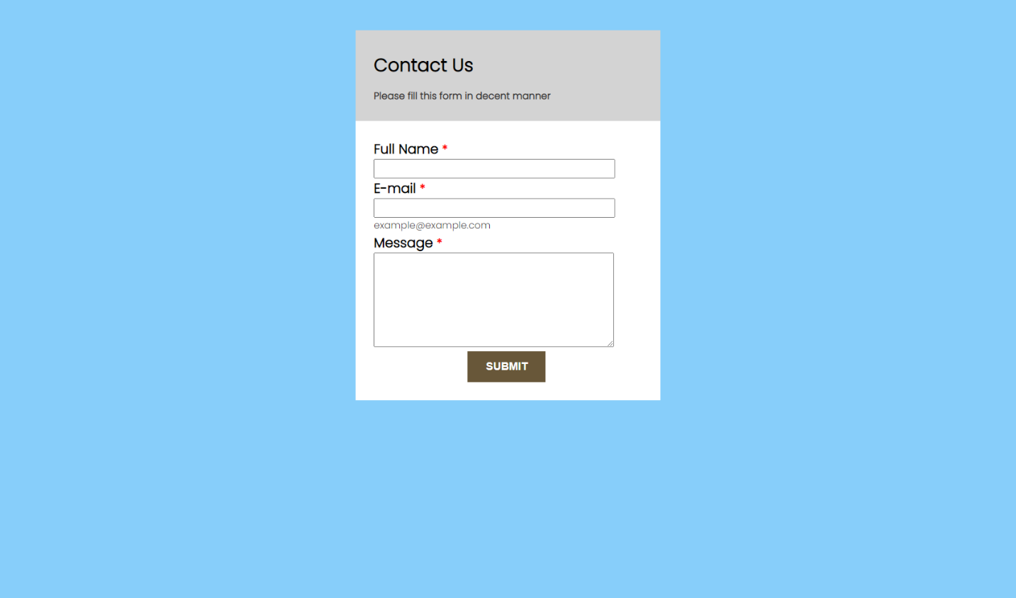

**Code**

<!DOCTYPE html>

<html lang="en">

<head>

    <link rel="preconnect" href="https://fonts.googleapis.com">

    <link rel="preconnect" href="https://fonts.gstatic.com" crossorigin>

    <link href="https://fonts.googleapis.com/css2?family=Poppins:wght@300&display=swap" rel="stylesheet">

    <title>Monthly Question Test : 1</title>

    <style>

        body {

            background-color: lightskyblue;

            padding: 0px;

            margin: 0px;

            font-family: 'Poppins', sans-serif;

        }

        section {

            width: 30%;

            margin: 0px auto;

            margin-top: 50px;

            background-color: white;

        }

        form {

            padding: 30px;

        }

        form label {

            display: inline-block;

            width: 100%;

            font-size: 22px;

            font-weight: bold;

        }

        .star {

            color: red;

            font-weight: bold;

            font-size: 20px;

        }

        .sm-txt {

            font-size: 16px;

            color: rgb(58, 56, 56);

        }

        .main-head {

            background-color: lightgray;

            padding: 10px 30px;

            height: 130px;

        }

        h1 {

            font-size: 30px;

        }

        form input[type='text'], form input[type='email'] {

            width: 391px;

            height: 26px;

        }

        .btn {

            width: 30%;

            margin: 0px auto;

        }

        .btn button {

            background-color: rgb(104, 87, 57);

            color: white;

            border: none;

            font-weight: bold;

            padding: 15px 30px;

            font-size: 18px;

        }

    </style>

</head>

<body>

    <section>

        <div class="main-head">

            <h1>Contact Us <br> <span class="sm-txt"> Please fill this form in decent manner</small></h1>

        </div>

        <form>

            <div>

                <label for="fname">Full Name <span class="star"> * </span></label>

                <input type="text" name="fname" id="fname" required>

            </div>

            <div>

                <label for="emailid">E-mail <span class="star"> * </span></label>

                <input type="email" name="emailid" id="emailid" required> <br>

                <small class="sm-txt">example@example.com</small>

            </div>

            <div>

                <label for="msg">Message <span class="star"> * </span></label>

                <textarea name="msg" id="msg" cols="51" rows="10"></textarea>

            </div>

            <div class="btn">

                <button type="button"> SUBMIT </button>

            </div>

        </form>

    </section>

</body>

</html>

**Question: 2**

**Output**



**Code**

<!DOCTYPE html>

<html lang="en">

<head>

    <link rel="preconnect" href="https://fonts.googleapis.com">

    <link rel="preconnect" href="https://fonts.gstatic.com" crossorigin>

    <link href="https://fonts.googleapis.com/css2?family=Poppins:wght@300&display=swap" rel="stylesheet">

    <title>Monthly Question Test : 2</title>

    <style>

        body {

            background-color: lightgray;

            padding: 0px;

            margin: 0px;

            font-family: 'Poppins', sans-serif;

        }

        section {

            width: 30%;

            margin: 0px auto;

            margin-top: 50px;

        }

        .top {

            background-color: teal;

            width: 390px;

            height: 95px;

            color: white;

            border-top-left-radius: 30px;

            border-top-right-radius: 30px;

            font-size: 400%;

            font-weight: bold;

            text-align: center;

            border-bottom: 4px dashed white;

            padding-top: 5px;

        }

        .mid {

            background-color: white;

            width: 390px;

            height: 125px;

            color: black;

            font-size: 600%;

            font-weight: bold;

            text-align: center;

        }

        .bot {

            background-color: teal;

            width: 390px;

            height: 95px;

            color: white;

            border-bottom-left-radius: 30px;

            border-bottom-right-radius: 30px;

            font-size: 400%;

            font-weight: bold;

            text-align: center;

        }

    </style>

</head>

<body>

    <section>

            <div class="main-flex">

                <div class="top">March</div>

                <div class="mid">21</div>

                <div class="bot">Monday</div>

            </div>

    </section>

</body>

</html>

**Question: 3**

**Output (a)**

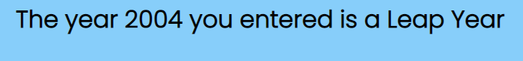**Output (b)**

**Code**

<!DOCTYPE html>

<html lang="en">

<head>

    <link rel="preconnect" href="https://fonts.googleapis.com">

    <link rel="preconnect" href="https://fonts.gstatic.com" crossorigin>

    <link href="https://fonts.googleapis.com/css2?family=Poppins:wght@300&display=swap" rel="stylesheet">

    <title>Monthly Question Test : 3</title>

    <style>

        body {

            background-color: lightskyblue;

            padding: 0px;

            margin: 0px;

            font-family: 'Poppins', sans-serif;

        }

        div {

            width: 60%;

            margin: 0px auto;

        }

    </style>

</head>

<body>

    <div>

        <h1 id="leapyear"></h1>

    </div>

    <script>

        var year = parseInt(prompt('Enter the year to check the leap year'));

        if((year) % 4 == 0) {

            document.getElementById('leapyear').innerHTML = 'The year ' + year + ' you entered is a Leap Year';

        } else if (year != 4) {

            document.getElementById('leapyear').innerHTML = 'The year ' + year + ' you entered is NOT a Leap Year';

        } else {

            document.getElementById('leapyear').innerHTML = 'Please enter a valid year';

        }

    </script>

</body>

</html>