Screenshots or program listings must be copied into appropriate cells in the following table.
Save this evidence document as evidence_ followed by your centre number_ candidate number, for example, evidence_ zz999_9999 and insert your name, centre number and candidate number into the header above.
Examiners must be able to read the contents including any screenshots without the use of a magnifying glass. Answers that are not readable or are missing will not be awarded any marks.
Save this evidence document at regular intervals, for example every 10 minutes.
Question 1
Part 1(a)
{Copy and paste program code listing for Question 1(a) here}

BeverageQueue = [None for i in range(10)]
DeverageFrontPointer = 0
BeverageRearPointer = 0

Part 1(b)(i)
{Copy and paste program code listing for Question 1(b)(i) here}

def DisplayMenu():
global menu
file = open('BeverageData.txt', 'r')
menu = file.readline().strip()
file.close()

Part 1(b)(ii)
{Copy and paste program code listing for Question 1(b)(ii) here}

def TakeOrder():
global file_order
order = input("Choose one or more beverages: ")
if order == menu:
file_order = open('Order.txt', 'w')
file_order.write()

Part 1(b)(iii)
{Copy and paste program code listing for Question 1(b)(iii) here}

def EnqueueBeverage(DataToEnqueue):
if BeverageRearPointer == 10:
return False
else:
BeverageQueue[BeverageRearPointer] = DataToEnqueue
BeverageRearPointer = BeverageRearPointer + 1
return True

Part 1(b)(iv)
{Copy and paste program code listing for Question 1(b)(iv) here}

def ReadOrderData():
data = open('Order.txt', 'r')
orderData = data.readline().strip()
EnqueueBeverage(orderData)

Part 1(c)(i)
{Copy and paste program code listing for Question 1(c)(i) here}

def DequeueBeverage():
if BeverageFrontPointer == BeverageRearPointer:
return ""
else:
ReturnData = BeverageQueue[BeverageFrontPointer]
BeverageFrontPointer = BeverageFrontPointer + 1
return ReturnData

Part 1(c)(ii)
{Copy and paste program code listing for Question 1(c)(ii) here}

def ServeItem():
if BeverageRearPointer != len(BeverageQueue) -1:
orderDequeue = DequeueBeverage()
print("You ordered ", orderDequeue)
else:
if BeverageRearPointer == BeverageFrontPointer:
print("No more orders to serve")

Part 1(d)(i)
{Copy and paste program code listing for Question 1(d)(ii) here}

DisplayMenu()
TakeOrder()
ReadOrderData()
ServeItem()

Part 1(d)(ii)
{Copy and paste the screenshot for Question 1(d)(ii) here}

Question 2
Part 2(a)
{Copy and paste program code listing for Question 2(a) here}

Data = [[[],[],[],[]],
[[],[],[],[]],
[[],[],[],[]],
[[],[],[],[]],
[[],[],[],[]]]

Rows = 5

Part 2(b)
{Copy and paste program code listing for Question 2(b) here}

def SetUp():
global rowVal
rowVal = int(input("Enter the quantity of rows you would like to enter: "))
if rowVal >= 1 and rowVal <= 5:
print("The quantity for row is valid")
else:
print("The quantity is not valid, please enter a number from 1 to 5")

for x in range(rowVal):
print("This is row", x+1)
for y in range(len(Data[x])):
data = int(input("Enter a number: "))
Data[x][y] = data

Part 2(c)(i)
{Copy and paste program code listing for Question 2(c)(i) here}

SetUp()
print(Data)

Part 2(c)(ii)
{Copy and paste the screenshot for Question 2(c)(ii) here}

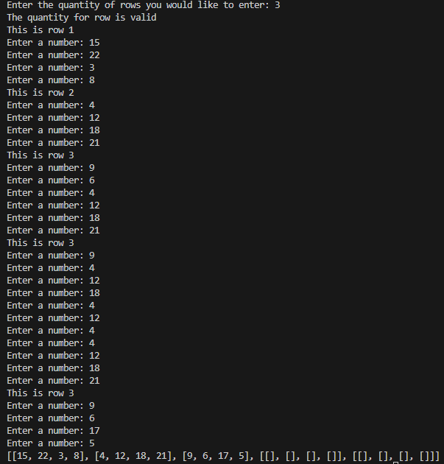

Part 2(d)(i)
{Copy and paste program code listing for Question 2(d)(i) here}

def BubbleSort():
for i in range(rowVal):
for j in range(len(Data[i]-1)):
while (Data[i][j] > Data[i][j+1]):
Data[i][j], Data[i][j+1] = Data[i][j+1], Data[i][j]
j += 1

Part 2(d)(ii)
{Copy and paste program code listing for Question 2(d)(ii) here}

Part 2(d)(iii)
{Copy and paste the screenshot for Question 2(d)(iii) here}

Part 2(e)(i)
{Copy and paste program code listing for Question 2(e)(i) here}

def RecursiveBinarySearch(rowSearch, DataToFind, low, high):
lenofarray = 0
for i in range(high - low):
if lenofarray == len(Data[rowSearch]):
print("Data is not found")
else:
if Data[i][low] != DataToFind:
lenofarray += 1
else:
print("Data is found in row ", rowSearch, " at column ", i)

Part 2(e)(ii)
{Copy and paste program code listing for Question 2(e)(ii) here}

Part 2(e)(iii)
{Copy and paste both the screenshots for Question 2(e)(iii) here}

Part 2(e)(iv)
{Copy and paste both the screenshots for Question 2(e)(iv) here}

Question 3
Part 3(a)(i)
{Copy and paste program code listing for Question 3(a)(i) here}

class Device:
def __init__(self, device_name, brand, battery_life, price):
self.__device_name = device_name
self.__brand = brand
self.__battery_life = battery_life
self.__price = price

def get_device_name(self):
return self.__device_name

def get_brand(self):
return self.__brand

def get_battery_life(self):
return self.__battery_life

def get_price(self):
return self.__price

def print_details():
print("The decive name is ", Device.get_device_name()," from", Device.get_brand()," and has a battery life of ", Device.get_battery_life(),
" with the price of ", Device.get_price())

Part 3(a)(ii)
{Copy and paste program code listing for Question 3(a)(ii) here}

class Phone():
def __init__(self, storage):
self.__storage = storage

def get_storage(self):
return self.__storage

def print_details():
print("The decive name is ",Device.get_device_name()," from ",Device.get_brand()," with a battery life of ",Device.get_battery_life(), " and a storage of ",Phone.get_storage(), " with the price of ",Device.get_price())

Part 3(a)(iii)
{Copy and paste program code listing for Question 3(a)(iii) here}

class Laptop:
def __init__(self, ram):
self.__ram = ram

def get_ram(self):
return self.__ram

def print_details():
print("The decive name is ",Device.get_device_name()," from ",Device.get_brand()," with a battery life of ",Device.get_battery_life(), " and a RAM of ",Laptop.get_ram(), " with the price of ",Device.get_price())

class Tablet:
def __init__(self, screen_size):
self.__screen_size = screen_size

def get_screen_size(self):
self.__screen_size

def print_details():
print("The decive name is ",Device.get_device_name()," from ",Device.get_brand()," with a battery life of ",Device.get_battery_life(), " and a screen size of ",Tablet.get_screen_size(), " with the price of ",Device.get_price())

Part 3(b)
{Copy and paste program code listing for Question 3(b) here}

Part 3(c)
{Copy and paste program code listing for Question 3(c) here}

Part 3(d)(i)
{Copy and paste program code listing for Question 3(d)(i) here}

Part 3(d)(ii)
{Copy and paste the screenshot for Question 3(d)(ii) here}

Part 3(e)(i)
{Copy and paste program code listing for Question 3(e)(i) here}

Part 3(e)(ii)
{Copy and paste program code listing for Question 3(e)(ii) here}

Part 3(e)(iii)
{Copy and paste the screenshot for Question 3(e)(iii) here}

