Validation Report
Name: Danial Iskandar Bin Zamry
Validated IP: FIR Filter

TC# | Name
1 | Global enable/disable
2 | POR register values
3 | Input buffer overflow and clearing
4 | Filter bypassing
5 | Signal processing

Instance 1 (impl0)

TC# | Description | Pass/Fail
1 | Global enable/disable | Fail
2 | POR register values | Fail
3 | Input buffer overflow and clearing | Pass
4 | Filter bypassing | Pass
5 | 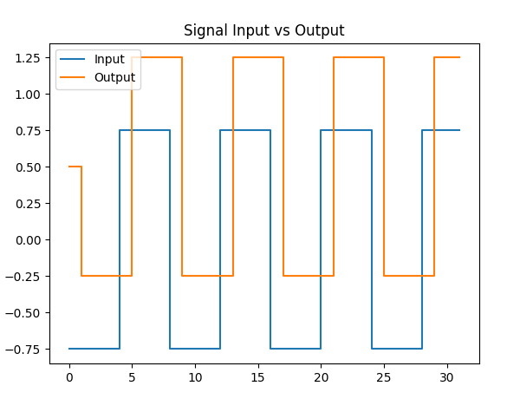

Instance 2 (impl1)

TC# | Description | Pass/Fail
1 | Global enable/disable | Fail
2 | POR register values | Pass
3 | Input buffer overflow and clearing | Pass
4 | Filter bypassing | Pass
5 | 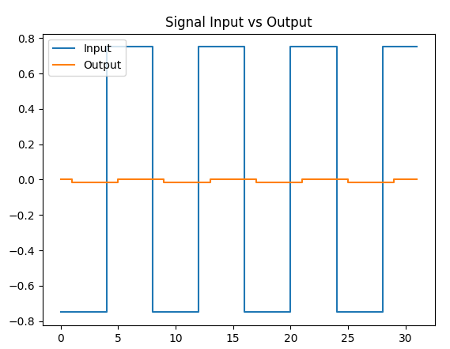

Instance 3 (impl2)

TC# | Description | Pass/Fail
1 | Global enable/disable | Fail
2 | POR register values | Fail
3 | Input buffer overflow and clearing | Pass
4 | Filter bypassing | Pass
5 | 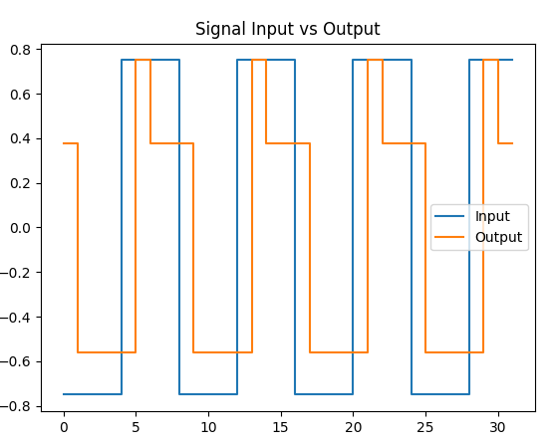

Instance 4 (impl3)

TC# | Description | Pass/Fail
1 | Global enable/disable | Fail
2 | POR register values | Fail
3 | Input buffer overflow and clearing | Pass
4 | Filter bypassing | Pass
5 | 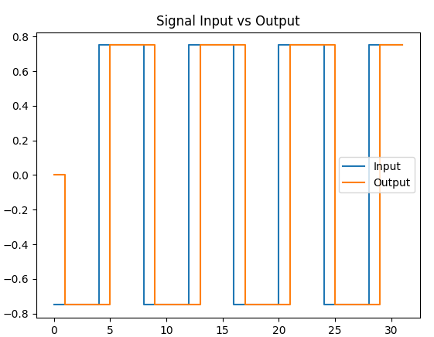

Instance 5 (impl4)

TC# | Description | Pass/Fail
1 | Global enable/disable | Fail
2 | POR register values | Fail
3 | Input buffer overflow and clearing | Pass
4 | Filter bypassing | Pass
5

Instance 6 (impl5)

TC# | Description | Pass/Fail
1 | Global enable/disable | Fail
2 | POR register values | Fail
3 | Input buffer overflow and clearing | Pass
4 | Filter bypassing | Pass
5 | 