TECHNICAL REPORT
PRAKTIKUM GRAFIKA KOMPUTER
MODUL 3
“INPUT”



Disusun Oleh :
TGL PRAKTIKUM : 14/3/2019
NAMA : ALFIN NIAM
NRP : 170411100091
KELAS : GRAFIKA KOMPUTER C
DOSEN PENGAMPU : Yonathan Ferry Hendrawan, S.T.,M.I.T.
ASISTEN :

Disetujui : ....../……./………../Bangkalan

PROGRAM STUDI TEKNIK INFORMATIKA
FAKULTAS TEKNIK
UNIVERSITAS TRUNOJOYO MADURA
2018/2019

Tugas
- Buatlah program untuk menampilkan gambar bintang segi 5 dengan warna yang dapat diubah dengan cara menggunakna tombol panah atas dan bawah.
- Modifikasi program dari percobaan.
  - Perpindahan kotak menjadi dua kali lebih besar/cepat daripada sebelumnya.
  - Perpindahan kotak menjadi dua kali lebih pendek/lambat daripada sebelumnya.
Jawaban
- Listing program :
#include <windows.h>
#include <iostream>
#include <stdio.h>
#ifdef __APPLE__
#include <GLUT/glut.h>
#else
#include <GL/glut.h>
#include <GL/glu.h>
#endif

#include <stdlib.h>
using namespace std;
float posY = 0.0, posX = 0.0,color = 0.0;

void display(){

glClear (GL_COLOR_BUFFER_BIT);
//glPointSize(1);
glColor3f(0.0+color, 1.0, 0.0+color);
glBegin(GL_POLYGON);
glVertex2f(0.0+posX,3.0+posY);
glVertex2f(-0.58+posX,2.07+posY);
glVertex2f(0.64+posX,2.07+posY);
glEnd();
glColor3f(0.0+color, 1.0, 0.0+color);
glBegin(GL_POLYGON);
glVertex2f(-1.52+posX,2.03+posY);
glVertex2f(-0.86+posX,1.25+posY);
glVertex2f(-0.58+posX,2.07+posY);
glEnd();
glColor3f(0.0+color, 1.0, 0.0+color);
glBegin(GL_POLYGON);
glVertex2f(-0.86+posX,1.25+posY);
glVertex2f(-1.48+posX,0.27+posY);
glVertex2f(0.0+posX,0.67+posY);
glEnd();
glColor3f(0.0+color, 1.0, 0.0+color);
glBegin(GL_POLYGON);
glVertex2f(0.0+posX,0.67+posY);
glVertex2f(1.44+posX,0.31+posY);
glVertex2f(0.92+posX,1.27+posY);
glEnd();
glColor3f(0.0+color, 1.0, 0.0+color);
glBegin(GL_POLYGON);
glVertex2f(0.92+posX,1.27+posY);
glVertex2f(1.54+posX,2.03+posY);
glVertex2f(0.64+posX,2.07+posY);
glEnd();
glColor3f(0.0+color, 1.0, 0.0+color);
glBegin(GL_POLYGON);
glVertex2f(-0.58+posX,2.07+posY);
glVertex2f(-0.86+posX,1.25+posY);
glVertex2f(0.0+posX,0.67+posY);
glVertex2f(0.92+posX,1.27+posY);
glVertex2f(0.64+posX,2.07+posY);
glEnd();
glFlush();
}

void react(unsigned char key, int x, int y){
if(key == 'w' || key == 'W'){
posY +=0.2;
display();
}
else if(key == 's' || key == 'S'){
posY -=0.2;
display();
}else if(key == 'd' || key == 'D'){
posX+=0.2;
display();
}else if(key == 'a' || key == 'A'){
posX -= 0.2;
display();
}else{
cout <<"salah pencet"<<endl;
}
}
void arah(int key, int x, int y){
if(key == GLUT_KEY_UP){
color +=0.1;
display();
}
else if(key == GLUT_KEY_DOWN){
color -=0.1;
display();
}else {
cout <<"salah pencet"<<endl;
}
}
void myinit(){
glMatrixMode(GL_PROJECTION);
glLoadIdentity();
gluOrtho2D(-10.0,10.0,-10.0,10.0);
glMatrixMode(GL_MODELVIEW);
glClearColor(1.0,1.0,1.0,1.0);
glColor3f (0.0, 1.0, 0.0);
}
int main(int argc, char* argv[]){
glutInit(&argc,argv);
glutInitDisplayMode(GLUT_SINGLE | GLUT_RGB);
glutInitWindowSize(700,700);
//glutInitWindowPosition(100,100);
glutCreateWindow("Modul3");
glutDisplayFunc(display);
glutKeyboardFunc(react);
glutSpecialFunc(arah);
myinit();
glutMainLoop();
return 0;
}
Hasil run program:
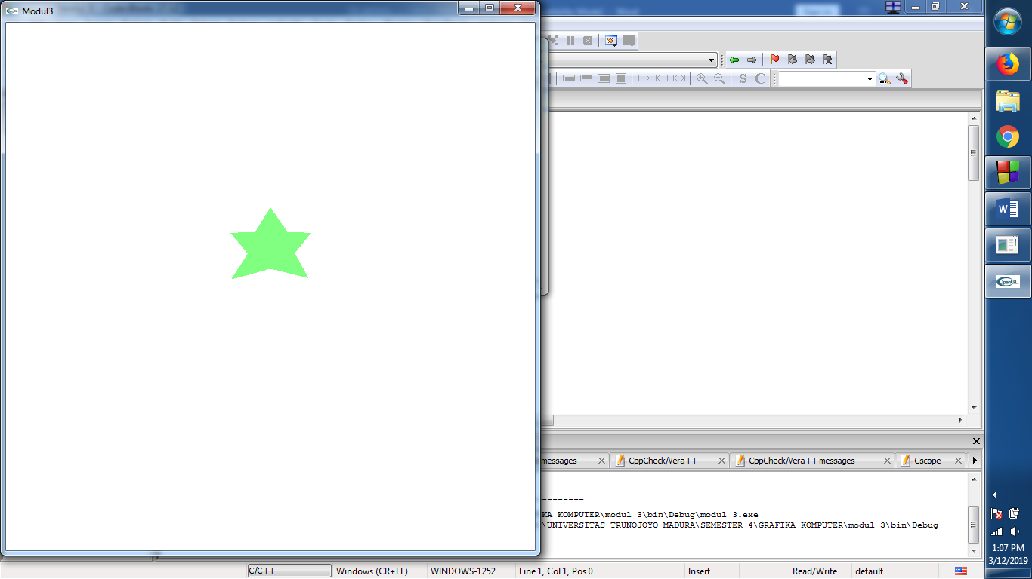
- Listing program:

#include <windows.h>
#include <iostream>
#ifdef __APPLE__
#include <GLUT/glut.h>
#else
#include <GL/glut.h>
#endif

#include <stdlib.h>
using namespace std;
float posY = 0.0, posX = 0.0;

void display(){

glClear (GL_COLOR_BUFFER_BIT);
//glPointSize(1);
glColor3f(0.0f, 1.0f, 1.0f);
glBegin(GL_POLYGON);
glVertex2f(-0.4+posX*2,-0.4+posY*2);
glVertex2f(0.4+posX*2,-0.4+posY*2);
glVertex2f(0.4+posX*2,0.4+posY*2);
glVertex2f(-0.4+posX*2,0.4+posY*2);
glEnd();
glFlush();
}

void kunci(unsigned char key, int x, int y)
{
switch (key)
{
/* aplikasi berhenti ketika tombol q ditekan */
case 27 :
case 'q':
exit(0);
break;
}
glutPostRedisplay();
}

void react(unsigned char key, int x, int y){
if(key == 'i' || key == 'I'){
posY +=0.2;
display();
}
else if(key == 'k' || key == 'K'){
posY -=0.2;
display();
}else if(key == 'l' || key == 'L'){
posX+=0.2;
display();
}else if(key == 'j' || key == 'J'){
posX -= 0.2;
display();
}else{
cout <<"salah pencet"<<endl;
}
}
void myinit(){
glMatrixMode(GL_PROJECTION);
glLoadIdentity();
gluOrtho2D(-2.0,2.0,-2.0,2.0);
glMatrixMode(GL_MODELVIEW);
glClearColor(1.0,1.0,1.0,1.0);
glColor3f (0.0, 1.0, 0.0);
}
int main(int argc, char* argv[]){
glutInit(&argc,argv);
glutInitDisplayMode(GLUT_SINGLE | GLUT_RGB);
glutInitWindowSize(700,700);
//glutInitWindowPosition(100,100);
glutCreateWindow("Modul3");
glutDisplayFunc(display);
glutKeyboardFunc(react);
myinit();
glutMainLoop();
return 0;
}
Hasil run program:
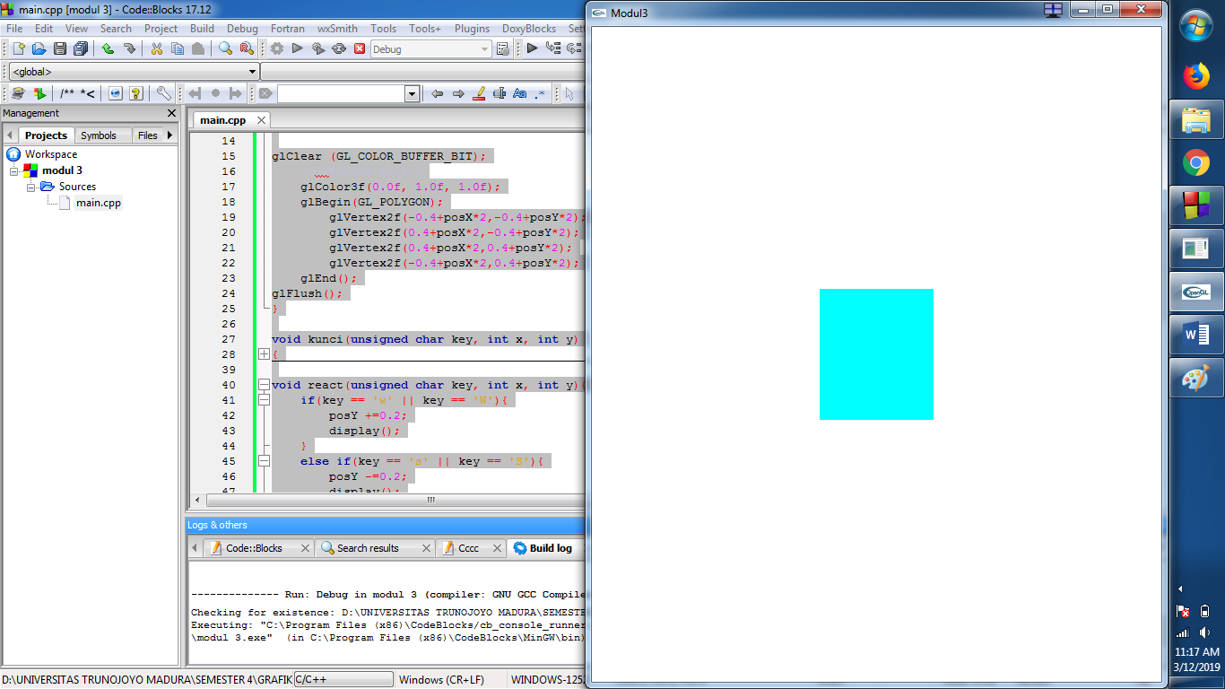
Setelah menerima inputan:
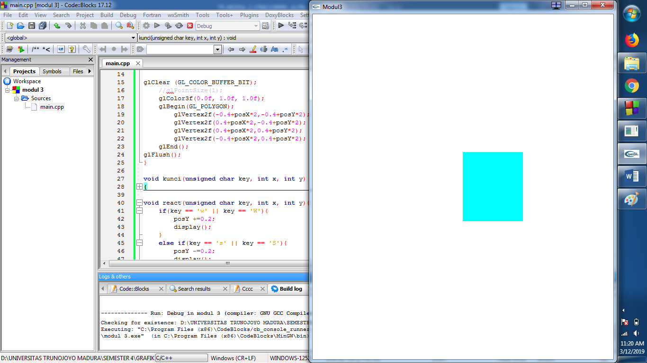

- Listing program:
#include <windows.h>
#include <iostream>
#ifdef __APPLE__
#include <GLUT/glut.h>
#else
#include <GL/glut.h>
#endif

#include <stdlib.h>
using namespace std;
float posY = 0.0, posX = 0.0;

void display(){

glClear (GL_COLOR_BUFFER_BIT);
//glPointSize(1);
glColor3f(0.0f, 1.0f, 1.0f);
glBegin(GL_POLYGON);
glVertex2f(-0.4+(posX/2),-0.4+(posY/2));
glVertex2f(0.4+(posX/2),-0.4+(posY/2));
glVertex2f(0.4+(posX/2),0.4+(posY/2));
glVertex2f(-0.4+(posX/2),0.4+(posY/2));
glEnd();
glFlush();
}

void kunci(unsigned char key, int x, int y)
{
switch (key)
{
/* aplikasi berhenti ketika tombol q ditekan */
case 27 :
case 'q':
exit(0);
break;
}
glutPostRedisplay();
}

void react(unsigned char key, int x, int y){
if(key == 'i' || key == 'I'){
posY +=0.2;
display();
}
else if(key == 'k' || key == 'K'){
posY -=0.2;
display();
}else if(key == 'l' || key == 'L'){
posX+=0.2;
display();
}else if(key == 'j' || key == 'J'){
posX -= 0.2;
display();
}else{
cout <<"salah pencet"<<endl;
}
}
void myinit(){
glMatrixMode(GL_PROJECTION);
glLoadIdentity();
gluOrtho2D(-2.0,2.0,-2.0,2.0);
glMatrixMode(GL_MODELVIEW);
glClearColor(1.0,1.0,1.0,1.0);
glColor3f (0.0, 1.0, 0.0);
}
int main(int argc, char* argv[]){
glutInit(&argc,argv);
glutInitDisplayMode(GLUT_SINGLE | GLUT_RGB);
glutInitWindowSize(700,700);
//glutInitWindowPosition(100,100);
glutCreateWindow("Modul3");
glutDisplayFunc(display);
glutKeyboardFunc(react);
myinit();
glutMainLoop();
return 0;
}
Hasil run program:

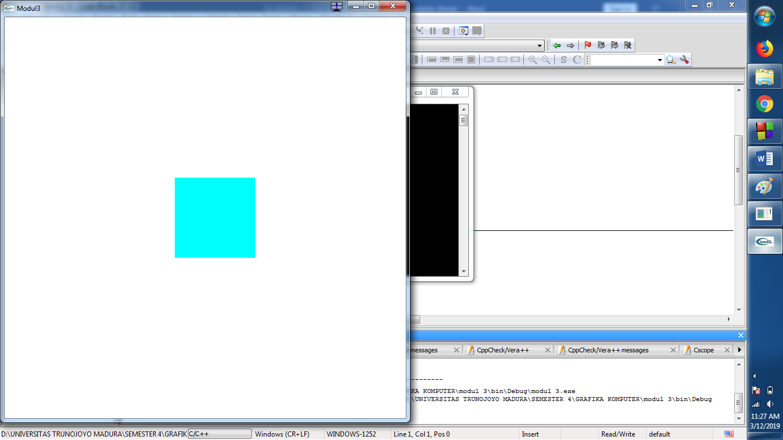

Setelah diberi input:
