TECHNICAL REPORT
PRAKTIKUM GRAFIKA KOMPUTER
MODUL 1
“PRIMITIF DRAWING : TITIK DAN GARIS”



Disusun Oleh :
TGL PRAKTIKUM : 14/3/2019
NAMA : MOH. ROMADHANI FIRDAUS
NRP : 170411100107
KELAS : GRAFIKA KOMPUTER B
DOSEN PENGAMPU : Ach Khozaimi, S.Kom., M.Kom.
ASISTEN : IQBAL OKTAPHIAN

Disetujui : ....../……./………../Bangkalan
(IQBAL OKTAPHIAN)
160411100108

PROGRAM STUDI TEKNIK INFORMATIKA
FAKULTAS TEKNIK
UNIVERSITAS TRUNOJOYO MADURA
2018/2019

Tugas
1. Lakukan percobaan sesuai dengan perintah diatas.
2. Buat Pelangi horisontal yang terdiri dari 7 warna berbeda menggunakan 7 line yang diatur ketebalannya (GL_LINES).
3. Buat Pelangi vertikal yang terdiri dari 7 warna berbeda menggunakan 7 line yang diatur ketebalannya (GL_LINES).
Jawaban
- Listing Program
#include <windows.h>
#ifdef __APPLE__
#include <GLUT/glut.h>
#else
#include <GL/glut.h>
#endif

/* GLUT callback Handlers */

void display(){
glClear(GL_COLOR_BUFFER_BIT);
glLineWidth(8);
glPointSize(8);
glBegin(GL_POINTS);
glVertex2f (0.0, 0.0);
glVertex2f (0.0, 0.8);
glVertex2f (0.8, 0.0);
glVertex2f (0.0, -0.8);
glVertex2f (-0.8, 0.0);
glEnd();

glBegin(GL_LINE_STRIP);
glVertex2f (2.0, 2.0);
glVertex2f (0.0, 2.0);
glVertex2f (2.0, 0.0);
glVertex2f (0.0, -2.0);
glVertex2f (-2.0, 0.0);
glEnd();

glBegin(GL_LINE_LOOP);
glVertex2f (3.0, 3.0);
glVertex2f (0.0, 3.0);
glVertex2f (3.0, 0.0);
glVertex2f (0.0, -3.0);
glVertex2f (-3.0, 0.0);
glEnd();

glBegin(GL_LINES);
glVertex2f (4.0, 4.0);
glVertex2f (0.0, 4.0);
glVertex2f (4.0, 0.0);
glVertex2f (0.0, -4.0);
glVertex2f (-4.0, 0.0);
glEnd();

glFlush();
}
void myinit(){
glMatrixMode(GL_PROJECTION);
glLoadIdentity();
gluOrtho2D(-10.0,10.0,-10.0,10.0);
glMatrixMode(GL_MODELVIEW);
glClearColor(1.0,1.0,1.0,1.0);
glColor3f (0.0, 1.0, 0.0);
}
int main(int argc, char* argv[]){
glutInit(&argc,argv);
glutInitDisplayMode(GLUT_SINGLE | GLUT_RGB);
glutInitWindowSize(500,500);
//glutInitWindowPosition(100,100);
glutCreateWindow("Obyek Primitif");
glutDisplayFunc(display);
myinit();
glutMainLoop();
return 0;
}

Hasil run progam:
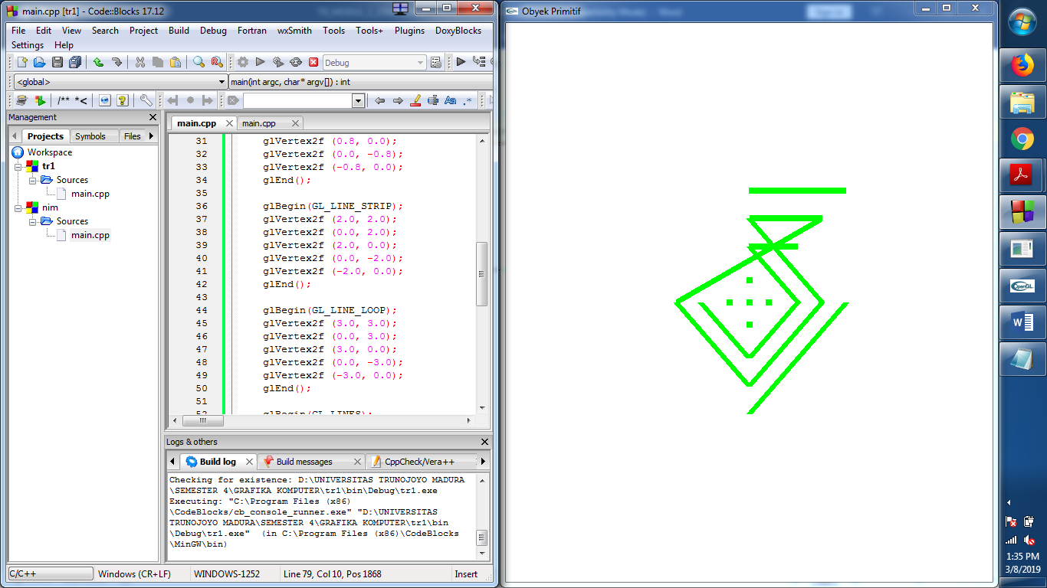

- pelangi horizontal dengan 7 warna yang berbeda:
Listing program:
/*
* GLUT Shapes Demo
*
* Written by Nigel Stewart November 2003
*
* This program is test harness for the sphere, cone
* and torus shapes in GLUT.
*
* Spinning wireframe and smooth shaded shapes are
* displayed until the ESC or q key is pressed. The
* number of geometry stacks and slices can be adjusted
* using the + and - keys.
*/

#include <windows.h>
#ifdef __APPLE__
#include <GLUT/glut.h>
#else
#include <GL/glut.h>
#endif

/* GLUT callback Handlers */

void display(){
glClear(GL_COLOR_BUFFER_BIT);
glLineWidth(8);
glPointSize(8);

glColor3f(0.0f, 1.0f, 0.0f);
glBegin(GL_LINES);
glVertex2f (-8.0, 0.0);
glVertex2f (8.0, 0.0);
glEnd();

glColor3f(1.0f, 0.0f, 0.0f);
glBegin(GL_LINES);
glVertex2f (-8.0, 0.33);
glVertex2f (8.0, 0.33);
glEnd();

glColor3f(0.0f, 0.0f, 1.0f);
glBegin(GL_LINES);
glVertex2f (-8.0, 0.63);
glVertex2f (8.0, 0.63);
glEnd();

glColor3f(0.0f, 1.0f, 1.0f);
glBegin(GL_LINES);
glVertex2f (-8.0, 0.93);
glVertex2f (8.0, 0.93);
glEnd();

glColor3f(1.0f, 1.0f, 0.0f);
glBegin(GL_LINES);
glVertex2f (-8.0, 1.2);
glVertex2f (8.0, 1.2);
glEnd();

glColor3f(0.0f, 0.0f, 0.0f);
glBegin(GL_LINES);
glVertex2f (-8.0, 1.53);
glVertex2f (8.0, 1.53);
glEnd();

glColor3f(0.0f, 0.5f, 0.5f);
glBegin(GL_LINES);
glVertex2f (-8.0, 1.83);
glVertex2f (8.0, 1.83);
glEnd();

glFlush();
}
void myinit(){
glMatrixMode(GL_PROJECTION);
glLoadIdentity();
gluOrtho2D(-10.0,10.0,-10.0,10.0);
glMatrixMode(GL_MODELVIEW);
glClearColor(1.0,1.0,1.0,1.0);
glColor3f (0.0, 1.0, 0.0);
}
int main(int argc, char* argv[]){
glutInit(&argc,argv);
glutInitDisplayMode(GLUT_SINGLE | GLUT_RGB);
glutInitWindowSize(500,500);
//glutInitWindowPosition(100,100);
glutCreateWindow("Obyek Primitif");
glutDisplayFunc(display);
myinit();
glutMainLoop();
return 0;
}

Hasil run program:
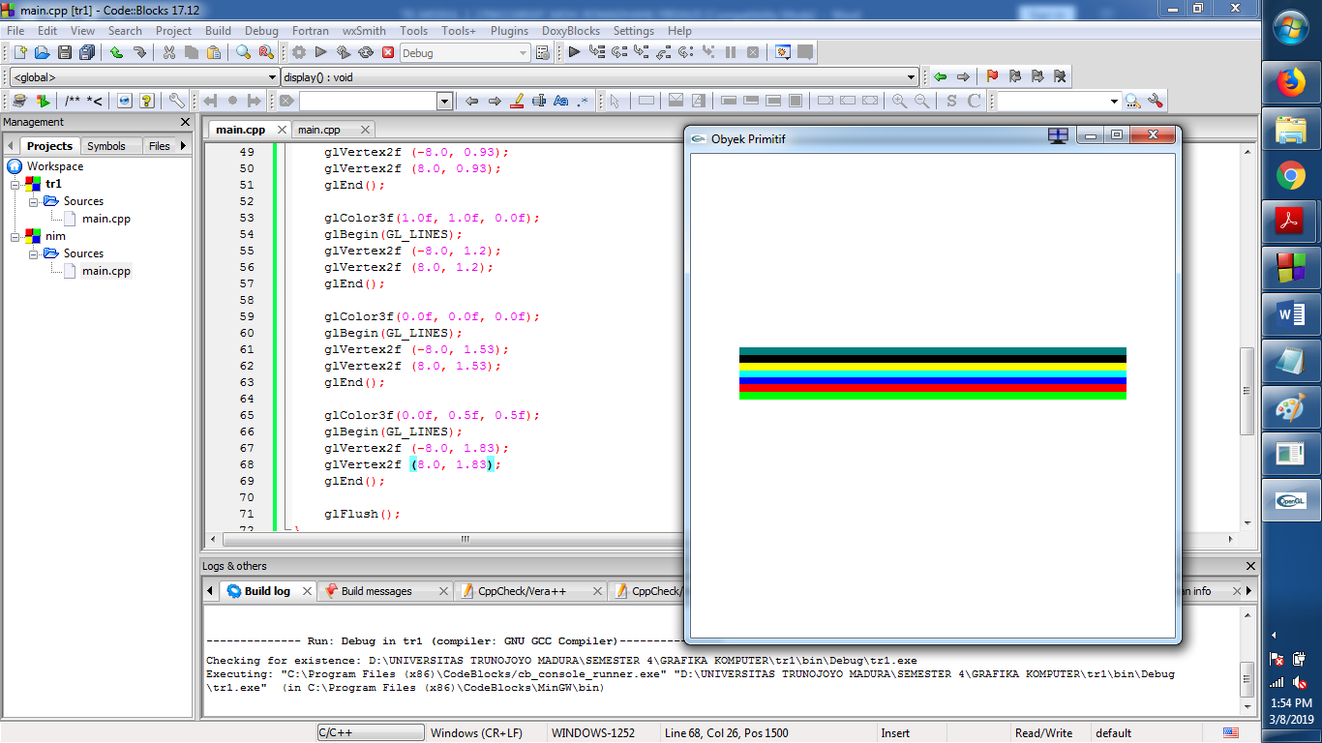

- Pelangi vertical dengan 7 warna yang berbeda
Listing program:
/*
* GLUT Shapes Demo
*
* Written by Nigel Stewart November 2003
*
* This program is test harness for the sphere, cone
* and torus shapes in GLUT.
*
* Spinning wireframe and smooth shaded shapes are
* displayed until the ESC or q key is pressed. The
* number of geometry stacks and slices can be adjusted
* using the + and - keys.
*/

#include <windows.h>
#ifdef __APPLE__
#include <GLUT/glut.h>
#else
#include <GL/glut.h>
#endif

/* GLUT callback Handlers */

void display(){
glClear(GL_COLOR_BUFFER_BIT);
glLineWidth(8);
glPointSize(8);

glColor3f(0.0f, 1.0f, 0.0f);
glBegin(GL_LINES);
glVertex2f (0.0, -8.0);
glVertex2f (0.0, 8.0);
glEnd();

glColor3f(1.0f, 0.0f, 0.0f);
glBegin(GL_LINES);
glVertex2f (0.33, -8.0);
glVertex2f (0.33, 8.0);
glEnd();

glColor3f(0.0f, 0.0f, 1.0f);
glBegin(GL_LINES);
glVertex2f (0.63, -8.0);
glVertex2f (0.63, 8.0);
glEnd();

glColor3f(0.0f, 1.0f, 1.0f);
glBegin(GL_LINES);
glVertex2f (0.93, -8.0);
glVertex2f (0.93, 8.0);
glEnd();

glColor3f(1.0f, 1.0f, 0.0f);
glBegin(GL_LINES);
glVertex2f (1.2, -8.0);
glVertex2f (1.2, 8.0);
glEnd();

glColor3f(0.0f, 0.0f, 0.0f);
glBegin(GL_LINES);
glVertex2f (1.53, -8.0);
glVertex2f (1.53, 8.0);
glEnd();

glColor3f(0.0f, 0.5f, 0.5f);
glBegin(GL_LINES);
glVertex2f (1.83, -8.0);
glVertex2f (1.83, 8.0);
glEnd();

glFlush();
}
void myinit(){
glMatrixMode(GL_PROJECTION);
glLoadIdentity();
gluOrtho2D(-10.0,10.0,-10.0,10.0);
glMatrixMode(GL_MODELVIEW);
glClearColor(1.0,1.0,1.0,1.0);
glColor3f (0.0, 1.0, 0.0);
}
int main(int argc, char* argv[]){
glutInit(&argc,argv);
glutInitDisplayMode(GLUT_SINGLE | GLUT_RGB);
glutInitWindowSize(500,500);
//glutInitWindowPosition(100,100);
glutCreateWindow("Obyek Primitif");
glutDisplayFunc(display);
myinit();
glutMainLoop();
return 0;
}

Hasil run program:
