TECHNICAL REPORT
PRAKTIKUM GRAFIKA KOMPUTER
MODUL 2
“PRIMITIF DRAWING : BIDANG DATAR”



Disusun Oleh :
TGL PRAKTIKUM : 14/3/2019
NAMA : MOH. ROMADHANI FIRDAUS
NRP : 170411100107
KELAS : GRAFIKA KOMPUTER B
DOSEN PENGAMPU : Ach Khozaimi, S.Kom., M.Kom.
ASISTEN : IQBAL OKTAPHIAN

Disetujui : ....../……./………../Bangkalan
(IQBAL OKTAPHIAN)
160411100108

PROGRAM STUDI TEKNIK INFORMATIKA
FAKULTAS TEKNIK
UNIVERSITAS TRUNOJOYO MADURA
2018/2019

Tugas
1. Lakukan percobaan sesuai dengan MODUL.
2. Buat Pelangi horisontal yang terdiri dari 7 warna berbeda menggunakan 7 rectangle (GL_POLYGON).
3. Buat Pelangi vertikal yang terdiri dari 7 warna berbeda menggunakan 7 rectangle (GL_POLYGON).
4. Ulang soal nomor 2 dan 3 menggunakan glRect().
Jawaban
- Listing program :
/*
* GLUT Shapes Demo
*
* Written by Nigel Stewart November 2003
*
* This program is test harness for the sphere, cone
* and torus shapes in GLUT.
*
* Spinning wireframe and smooth shaded shapes are
* displayed until the ESC or q key is pressed. The
* number of geometry stacks and slices can be adjusted
* using the + and - keys.
*/

#ifdef __APPLE__
#include <GLUT/glut.h>
#else
#include <GL/glut.h>
#endif

#include <stdlib.h>

/* GLUT callback Handlers */

void display(){
glClear(GL_COLOR_BUFFER_BIT);

glBegin(GL_POLYGON);
glVertex2f (-1.0, 0.0);
glVertex2f (0.0, -1.0);
glVertex2f (1.0, 0.0);
glVertex2f (0.0, 1.0);
glEnd();

glBegin(GL_TRIANGLES);
glVertex2f (-2.0, -2.0);
glVertex2f (-4.0, -2.0);
glVertex2f (-4.0, -4.0);
glEnd();

glBegin(GL_TRIANGLE_FAN);
glVertex2f (2.0, -2.0);
glVertex2f (4.0, -2.0);
glVertex2f (4.0, 4.0);
glEnd();

glBegin(GL_TRIANGLE_STRIP);
glVertex2f (3.0, -3.0);
glVertex2f (5.0, -3.0);
glVertex2f (5.0, 5.0);
glEnd();

glBegin(GL_QUADS);
glVertex2f (6.0, -2.0);
glVertex2f (6.0, -6.0);
glVertex2f (6.0, 0.0);
glVertex2f (6.0, 6.0);
glEnd();

glBegin(GL_QUAD_STRIP);
glVertex2f (-7.0, 0.0);
glVertex2f (-7.0, -7.0);
glVertex2f (-7.0, 7.0);
glVertex2f (-3.0, 7.0);
glEnd();

glFlush();
}
void myinit(){
glMatrixMode(GL_PROJECTION);
glLoadIdentity();
gluOrtho2D(-20.0,20.0,-20.0,20.0);
glMatrixMode(GL_MODELVIEW);
glClearColor(1.0,1.0,1.0,1.0);
glColor3f (0.0, 1.0, 0.0);
}

int main(int argc, char* argv[]){
glutInit(&argc,argv);
glutInitDisplayMode(GLUT_SINGLE | GLUT_RGB);
glutInitWindowSize(500,500);
//glutInitWindowPosition(100,100);
glutCreateWindow("Obyek Primitif");
glutDisplayFunc(display);
myinit();
glutMainLoop();
return 0;
}

Hasil run program:
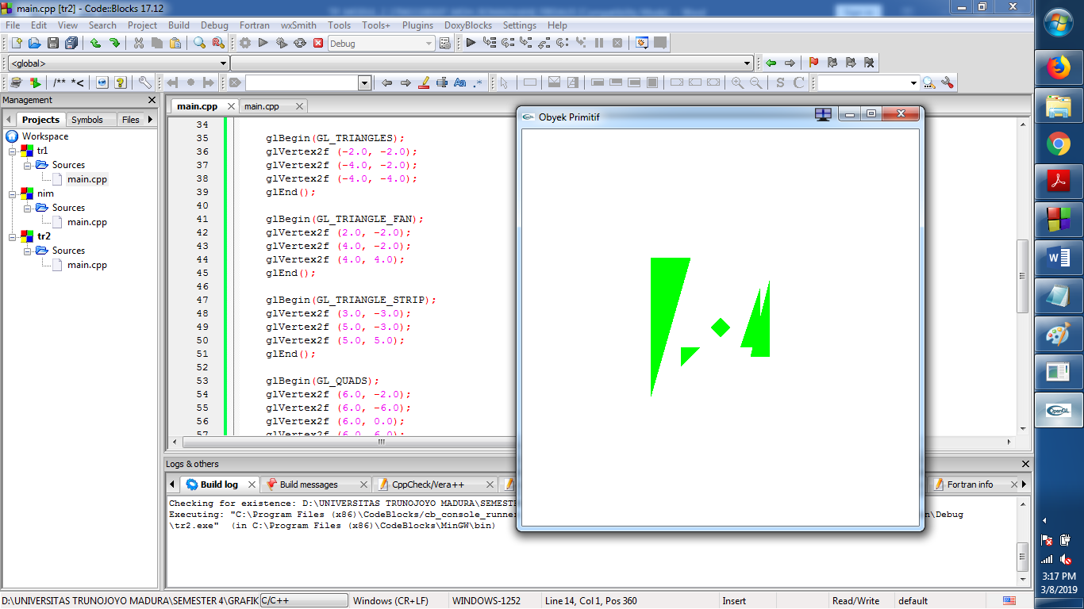

- Listing program:
/*
* GLUT Shapes Demo
*
* Written by Nigel Stewart November 2003
*
* This program is test harness for the sphere, cone
* and torus shapes in GLUT.
*
* Spinning wireframe and smooth shaded shapes are
* displayed until the ESC or q key is pressed. The
* number of geometry stacks and slices can be adjusted
* using the + and - keys.
*/

#ifdef __APPLE__
#include <GLUT/glut.h>
#else
#include <GL/glut.h>
#endif

#include <stdlib.h>

/* GLUT callback Handlers */

void display(){
glClear(GL_COLOR_BUFFER_BIT);

glColor3f(0.0f, 1.0f, 0.0f);
glBegin(GL_POLYGON);
glVertex2f (0.0, 1.0);
glVertex2f (0.0, 0.0);
glVertex2f (8.0, 0.0);
glVertex2f (8.0, 1.0);
glEnd();

glColor3f(1.0f, 0.0f, 0.0f);
glBegin(GL_POLYGON);
glVertex2f (0.0, 2.0);
glVertex2f (0.0, 1.0);
glVertex2f (8.0, 1.0);
glVertex2f (8.0, 2.0);
glEnd();

glColor3f(0.0f, 0.0f, 1.0f);
glBegin(GL_POLYGON);
glVertex2f (0.0, 3.0);
glVertex2f (0.0, 2.0);
glVertex2f (8.0, 2.0);
glVertex2f (8.0, 3.0);
glEnd();

glColor3f(0.0f, 1.0f, 1.0f);
glBegin(GL_POLYGON);
glVertex2f (0.0, 4.0);
glVertex2f (0.0, 3.0);
glVertex2f (8.0, 3.0);
glVertex2f (8.0, 4.0);
glEnd();

glColor3f(1.0f, 1.0f, 0.0f);
glBegin(GL_POLYGON);
glVertex2f (0.0, 5.0);
glVertex2f (0.0, 4.0);
glVertex2f (8.0, 4.0);
glVertex2f (8.0, 5.0);
glEnd();

glColor3f(0.0f, 0.0f, 0.0f);
glBegin(GL_POLYGON);
glVertex2f (0.0, 6.0);
glVertex2f (0.0, 5.0);
glVertex2f (8.0, 5.0);
glVertex2f (8.0, 6.0);
glEnd();

glColor3f(0.0f, 0.5f, 0.5f);
glBegin(GL_POLYGON);
glVertex2f (0.0, 7.0);
glVertex2f (0.0, 6.0);
glVertex2f (8.0, 6.0);
glVertex2f (8.0, 7.0);
glEnd();

glFlush();
}
void myinit(){
glMatrixMode(GL_PROJECTION);
glLoadIdentity();
gluOrtho2D(-20.0,20.0,-20.0,20.0);
glMatrixMode(GL_MODELVIEW);
glClearColor(1.0,1.0,1.0,1.0);
glColor3f (0.0, 1.0, 0.0);
}

int main(int argc, char* argv[]){
glutInit(&argc,argv);
glutInitDisplayMode(GLUT_SINGLE | GLUT_RGB);
glutInitWindowSize(500,500);
//glutInitWindowPosition(100,100);
glutCreateWindow("Obyek Primitif");
glutDisplayFunc(display);
myinit();
glutMainLoop();
return 0;
}

Hasil run program:
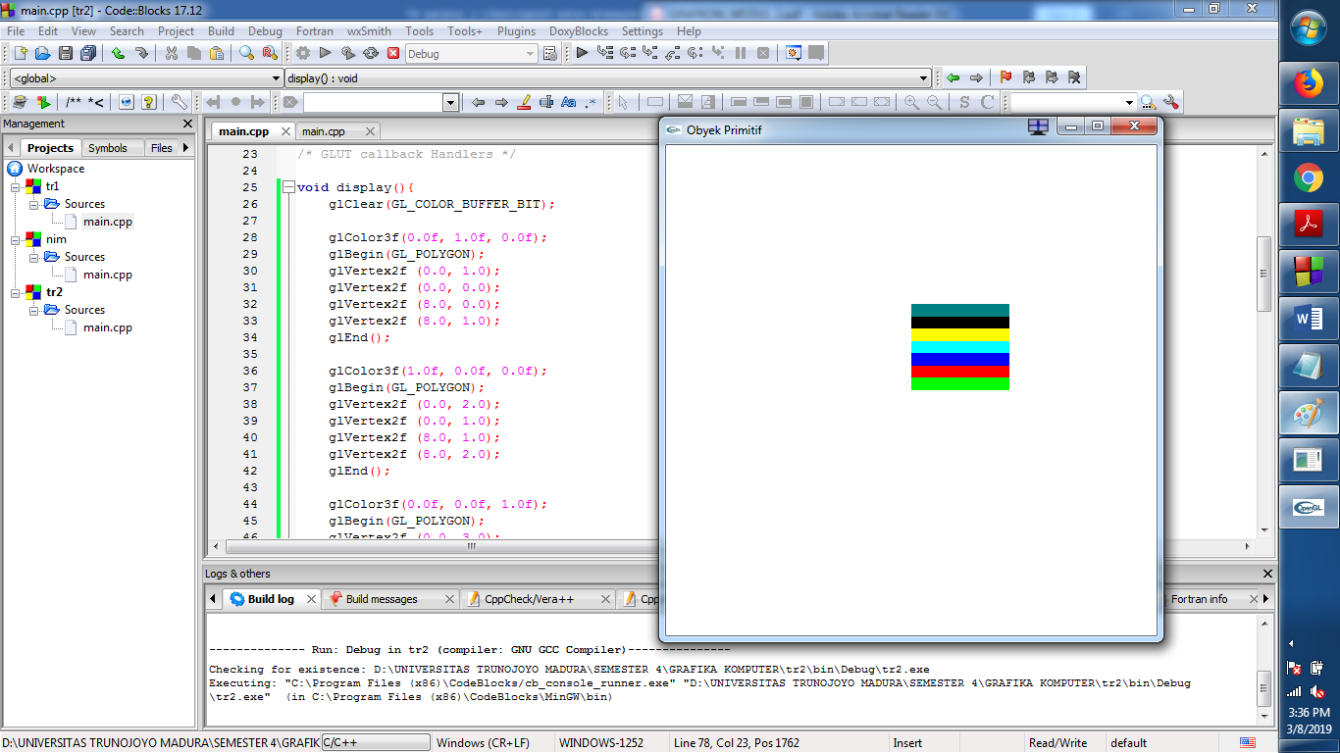

- Listing program:
/*
* GLUT Shapes Demo
*
* Written by Nigel Stewart November 2003
*
* This program is test harness for the sphere, cone
* and torus shapes in GLUT.
*
* Spinning wireframe and smooth shaded shapes are
* displayed until the ESC or q key is pressed. The
* number of geometry stacks and slices can be adjusted
* using the + and - keys.
*/

#ifdef __APPLE__
#include <GLUT/glut.h>
#else
#include <GL/glut.h>
#endif

#include <stdlib.h>

/* GLUT callback Handlers */

void display(){
glClear(GL_COLOR_BUFFER_BIT);

glColor3f(0.0f, 1.0f, 0.0f);
glBegin(GL_POLYGON);
glVertex2f (1.0, 0.0);
glVertex2f (0.0, 0.0);
glVertex2f (0.0, 8.0);
glVertex2f (1.0, 8.0);
glEnd();

glColor3f(1.0f, 0.0f, 0.0f);
glBegin(GL_POLYGON);
glVertex2f (2.0, 0.0);
glVertex2f (1.0, 0.0);
glVertex2f (1.0, 8.0);
glVertex2f (2.0, 8.0);
glEnd();

glColor3f(0.0f, 0.0f, 1.0f);
glBegin(GL_POLYGON);
glVertex2f (3.0, 0.0);
glVertex2f (2.0, 0.0);
glVertex2f (2.0, 8.0);
glVertex2f (3.0, 8.0);
glEnd();

glColor3f(0.0f, 1.0f, 1.0f);
glBegin(GL_POLYGON);
glVertex2f (4.0, 0.0);
glVertex2f (3.0, 0.0);
glVertex2f (3.0, 8.0);
glVertex2f (4.0, 8.0);
glEnd();

glColor3f(1.0f, 1.0f, 0.0f);
glBegin(GL_POLYGON);
glVertex2f (5.0, 0.0);
glVertex2f (4.0, 0.0);
glVertex2f (4.0, 8.0);
glVertex2f (5.0, 8.0);
glEnd();

glColor3f(0.0f, 0.0f, 0.0f);
glBegin(GL_POLYGON);
glVertex2f (6.0, 0.0);
glVertex2f (5.0, 0.0);
glVertex2f (5.0, 8.0);
glVertex2f (6.0, 8.0);
glEnd();

glColor3f(0.0f, 0.5f, 0.5f);
glBegin(GL_POLYGON);
glVertex2f (7.0, 0.0);
glVertex2f (6.0, 0.0);
glVertex2f (6.0, 8.0);
glVertex2f (7.0, 8.0);
glEnd();

glFlush();
}
void myinit(){
glMatrixMode(GL_PROJECTION);
glLoadIdentity();
gluOrtho2D(-20.0,20.0,-20.0,20.0);
glMatrixMode(GL_MODELVIEW);
glClearColor(1.0,1.0,1.0,1.0);
glColor3f (0.0, 1.0, 0.0);
}

int main(int argc, char* argv[]){
glutInit(&argc,argv);
glutInitDisplayMode(GLUT_SINGLE | GLUT_RGB);
glutInitWindowSize(500,500);
//glutInitWindowPosition(100,100);
glutCreateWindow("Obyek Primitif");
glutDisplayFunc(display);
myinit();
glutMainLoop();
return 0;
}
Hasil run program:
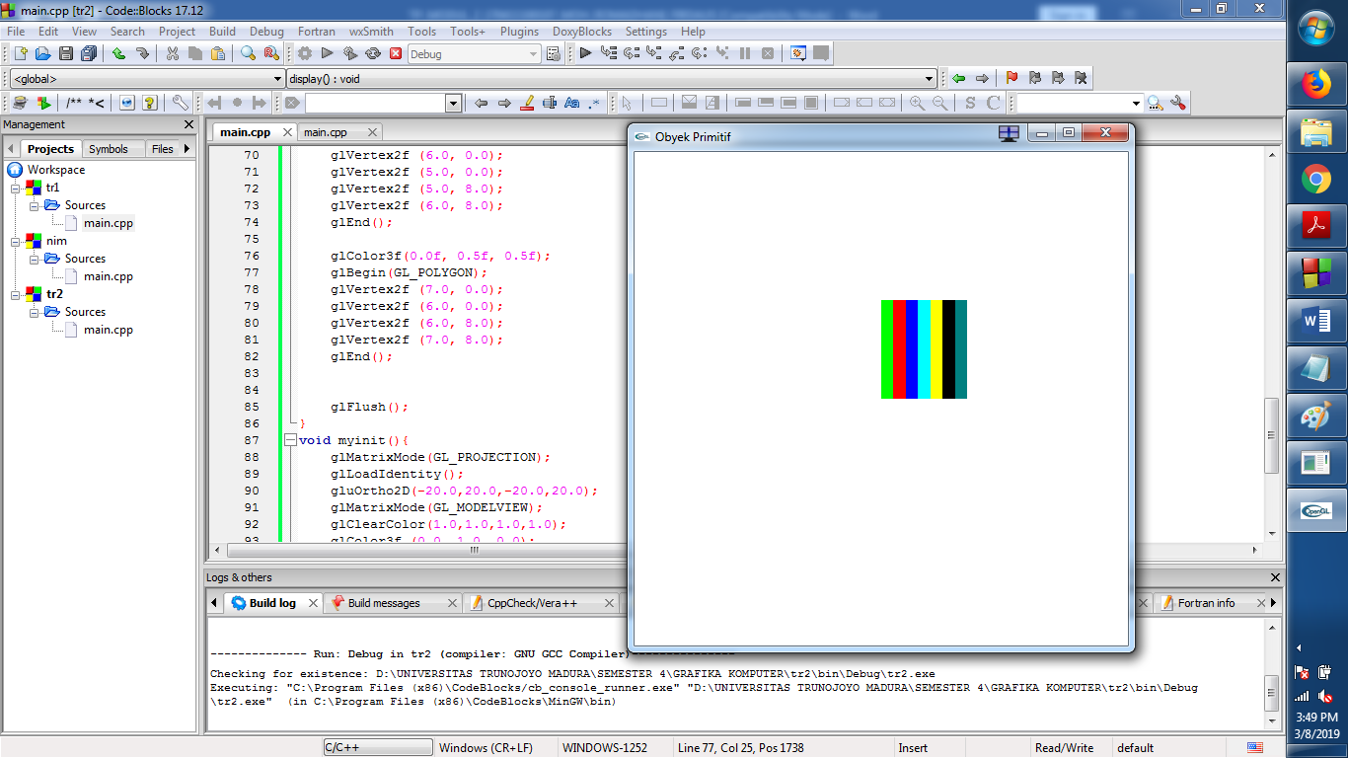
- Mengunakan glRect() horizontal
Listing program:
/*
* GLUT Shapes Demo
*
* Written by Nigel Stewart November 2003
*
* This program is test harness for the sphere, cone
* and torus shapes in GLUT.
*
* Spinning wireframe and smooth shaded shapes are
* displayed until the ESC or q key is pressed. The
* number of geometry stacks and slices can be adjusted
* using the + and - keys.
*/

#ifdef __APPLE__
#include <GLUT/glut.h>
#else
#include <GL/glut.h>
#endif

#include <stdlib.h>

/* GLUT callback Handlers */

void display(){
glClearColor(1.0f,1.0f,1.0f,1.0f);
glClear(GL_COLOR_BUFFER_BIT);

glMatrixMode( GL_PROJECTION );
glLoadIdentity();
glOrtho( -300, 300, -300, 300, -1, 1 );

glMatrixMode( GL_MODELVIEW );
glLoadIdentity();

glColor3f(0.0f,1.0f,0.0f);
glRectf(0.0f,100.0f,190.0f,90.0f);

glColor3f(1.0f,0.0f,0.0f);
glRectf(0.0f,100.0f,190.0f,110.0f);

glColor3f(0.0f,0.0f,1.0f);
glRectf(0.0f,110.0f,190.0f,120.0f);

glColor3f(0.0f,1.0f,1.0f);
glRectf(0.0f,120.0f,190.0f,130.0f);

glColor3f(1.0f,1.0f,0.0f);
glRectf(0.0f,130.0f,190.0f,140.0f);

glColor3f(0.0f,0.0f,0.0f);
glRectf(0.0f,140.0f,190.0f,150.0f);

glColor3f(0.5f,0.0f,0.5f);
glRectf(0.0f,150.0f,190.0f,160.0f);

glFlush();
}

int main(int argc, char* argv[]){
glutInit(&argc,argv);
glutInitDisplayMode(GLUT_SINGLE | GLUT_RGB);
glutInitWindowSize(500,500);
//glutInitWindowPosition(100,100);
glutCreateWindow("Obyek Primitif");
glutDisplayFunc(display);

glutMainLoop();
return 0;
}
Hasil run:
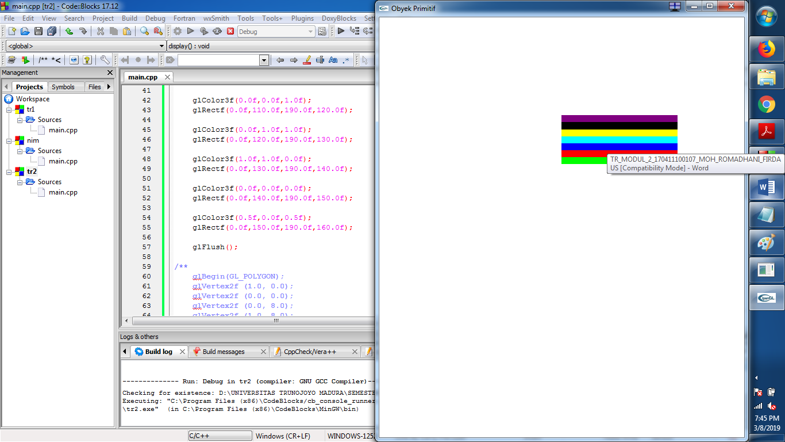
Listing program yang vertical:
/*
* GLUT Shapes Demo
*
* Written by Nigel Stewart November 2003
*
* This program is test harness for the sphere, cone
* and torus shapes in GLUT.
*
* Spinning wireframe and smooth shaded shapes are
* displayed until the ESC or q key is pressed. The
* number of geometry stacks and slices can be adjusted
* using the + and - keys.
*/

#ifdef __APPLE__
#include <GLUT/glut.h>
#else
#include <GL/glut.h>
#endif

#include <stdlib.h>

/* GLUT callback Handlers */

void display(){
glClearColor(1.0f,1.0f,1.0f,1.0f);
glClear(GL_COLOR_BUFFER_BIT);

glMatrixMode( GL_PROJECTION );
glLoadIdentity();
glOrtho( -300, 300, -300, 300, -1, 1 );

glMatrixMode( GL_MODELVIEW );
glLoadIdentity();

glColor3f(0.0f,1.0f,0.0f);
glRectf(100.0f,0.0f,90.0f,190.0f);

glColor3f(1.0f,0.0f,0.0f);
glRectf(100.0f,0.0f,110.0f,190.0f);

glColor3f(0.0f,0.0f,1.0f);
glRectf(110.0f,0.0f,120.0f,190.0f);

glColor3f(0.0f,1.0f,1.0f);
glRectf(120.0f,0.0f,130.0f,190.0f);

glColor3f(1.0f,1.0f,0.0f);
glRectf(130.0f,0.0f,140.0f,190.0f);

glColor3f(0.0f,0.0f,0.0f);
glRectf(140.0f,0.0f,150.0f,190.0f);

glColor3f(0.5f,0.0f,0.5f);
glRectf(150.0f,0.0f,160.0f,190.0f);

glFlush();
}

int main(int argc, char* argv[]){
glutInit(&argc,argv);
glutInitDisplayMode(GLUT_SINGLE | GLUT_RGB);
glutInitWindowSize(500,500);
//glutInitWindowPosition(100,100);
glutCreateWindow("Obyek Primitif");
glutDisplayFunc(display);

glutMainLoop();
return 0;
}
Hasil run program:
