Centos7+keepalived+mysql（双主+故障自动切换）操作说明

庞国明，2018-09-19

本操作说明包括以下内容：

目录

1.1 操作前的准备 2

1.2 Centos7 下安装keepalived 2

1.3 Keepalived配置 3

mysql1中keepalived的配置 3

第一步：编辑keepalived的配置文件 3

第二步：编写心跳检测脚本： 5

mysql2中keepalived的配置 5

第一步：编辑keepalived中的配置文件 5

第二步：编写检测脚本： 7

VIP漂移检测 8

* 1. 操作前的准备

1. 两台服务器，并同时按照Centos7 新装版本（必须装相同版本）；
2. 可用的外网连接（需要联网下载安装包）；
3. 已经配置好的 mysql （主主复制）

| 主机名 | ip地址 | 角色 |
| --- | --- | --- |
| mysql1 | RIP:172.20.201.25  VIP 172.20.201.16 | 主服务器1 |
| mysql2 | Rip:172.20.201.26  VIP 172.20.201.16 | 主服务器2 |

* 1. Centos7 下安装keepalived

注意：两台服务器上必须安装相同版本的Keepalived

**第一步：下载并安装keepalived**

下载并安装keepalived官方的源码

cd /usr/local/src

wget http://www.keepalived.org/software/keepalived-1.4.0.tar.gz

#解压文件

tar -zxvf keepalived-1.40.0.tar.gz

#编译

cd keepalived-1.40.0/

#--prefix 指定安装地址

#/usr/local/keepalived/ 安装的目录，不要和自己安装文件一个目录，不然报错

./configure --prefix=/usr/local/keepalived/

#编译并安装

make && make install

**第二步：复制**keepalived配置文件到指定目录

首先拷贝几个文件到CentOS7环境中：

[root@localhost ~]# cp keepalived-1.3.4/keepalived/etc/init.d/keepalived /etc/init.d/

[root@localhost ~]# mkdir /etc/keepalived

[root@localhost ~]# cp /usr/local/keepalived/etc/keepalived/keepalived.conf /etc/keepalived/

[root@localhost ~]# cp keepalived-1.3.4/keepalived/etc/sysconfig/keepalived /etc/sysconfig/

[root@localhost ~]# cp /usr/local/keepalived/sbin/keepalived /usr/sbin/

* 1. Keepalived配置

keepalived能够实现mysql1和mysql2共享一个虚拟ip，当前端访问数据库的时候，可以直接指向这个ip地址，若mysql1宕机了，VIP资源可以直接共享给mysql2.

**mysql1中keepalived的配置**

第一步：编辑keepalived的配置文件 （见附件s1/keepalived.cnf）

! Configuration File for keepalived

global_defs {

notification_email {

root@localhost

}

notification_email_from mysql@xiaomi.com

smtp_server 127.0.0.1

smtp_connect_timeout 30

router_id mysql_ha

}

vrrp_script chk_mysql {

script "/etc/keepalived/mysqlcheck/check_slave.sh"

interval 2

weight 2

}

vrrp_instance mysql-ha {

state BACKUP

interface eth0

virtual_router_id 68

priority 100

advert_int 1

nopreempt

authentication {

auth_type PASS

auth_pass centos

}

track_script {

chk_mysql

}

virtual_ipaddress {

172.20.201.100

}

}

第二步：编写心跳检测脚本：（见附件s1/mysqlcheck/check_slave.sh）

[root@mysql1 /etc/keepalived/mysqlcheck]# vim /etc/keepalived/mysqlcheck/check_slave.sh

#!/bin/bash

#This scripts is check for Mysql Slave status

counter=$(netstat -na|grep "LISTEN"|grep "3306"|wc -l)

if [ "${counter}" -eq 0 ]; then

systemctl stop keepalived.service

echo "keepalived stop"

fi

ping 172.20.201.23 -w1 -c1 &>/dev/null

if [ $? -ne 0 ]

then

systemctl stop keepalived.service

echo "keepalived stop"

fi

注意：回车符必须是Linux回车符

需要为此.sh文件添加可执行权限

chmod +x /etc/keepalived/mysqlcheck/check_slave.sh

基于网段是否可用以及mysql数据库是否工作来判断服务器的心跳

**mysql2中keepalived的配置**

第一步：编辑keepalived中的配置文件（见附件s1/keepalived.conf）

[root@mysql2 ~]# vim /etc/keepalived/keepalived.conf

! Configuration File for keepalived

global_defs {

notification_email {

root@localhost

}

notification_email_from mysql@xiaomi.com

smtp_server 127.0.0.1

smtp_connect_timeout 30

router_id mysql_ha

}

vrrp_script chk_mysql {

script "/etc/keepalived/mysqlcheck/check_slave.sh"

interval 2

weight 2

}

vrrp_instance mysql-ha {

state BACKUP

interface eth0

virtual_router_id 68

priority 90

advert_int 1

#nopreempt

authentication {

auth_type PASS

auth_pass centos

}

track_script {

chk_mysql

}

virtual_ipaddress {

172.20.201.100

}

}

第二步：编写检测脚本：（见附件s2/mysqlcheck/check_slave.sh）

[root@mysql2 ~]# vim /etc/keepalived/mysqlcheck/check_slave.sh

#!/bin/bash

#This scripts is check for Mysql Slave status

counter=$(netstat -na|grep "LISTEN"|grep "3306"|wc -l)

if [ "${counter}" -eq 0 ]; then

systemctl stop keepalived.service

echo "keepalived stop"

fi

ping 172.20.201.24 -w1 -c1 &>/dev/null

if [ $? -ne 0 ]

then

systemctl stop keepalived.service

echo "keepalived stop"

fi

需要为此.sh文件添加可执行权限

chmod +x /etc/keepalived/mysqlcheck/check_slave.sh

上述心跳检测脚本中，对于状态的检测写的很简单，其一是基于该服务器的mysql是否开启，其二是基于该网段是否可以ping通。可以根据自己的需求，将该脚本设计的更复杂一些。比如根据数据库的插入、删除等是否可用、主从线程是否开启等进行细分。提高检测的精准度。

**VIP漂移检测**

mysql1和mysql2中同时开启keepalived服务和msyql服务

查看mysql1中的ip地址：

[root@mysql1 ~]# ip a s

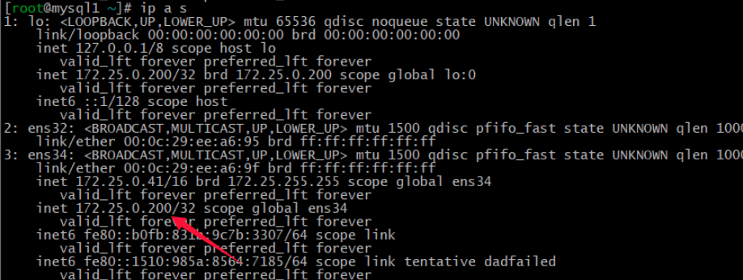

这里写图片描述

由上图可知，此时的VIP是在mysql1中的。

停止mysql1中的mysql服务（service msyqld stop），再观察mysql1和mysql2的ip状况。

mysql1：

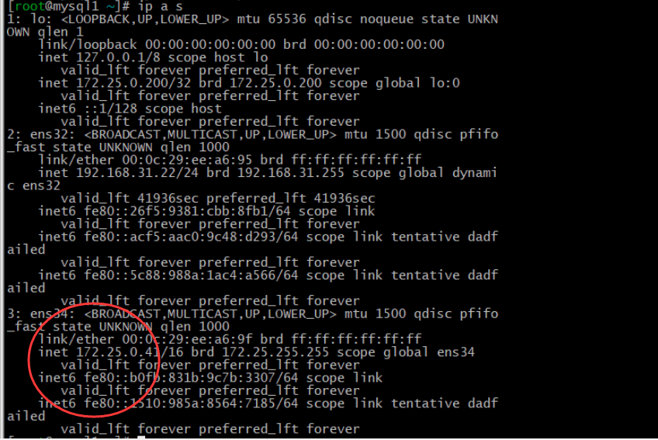MySQL2：

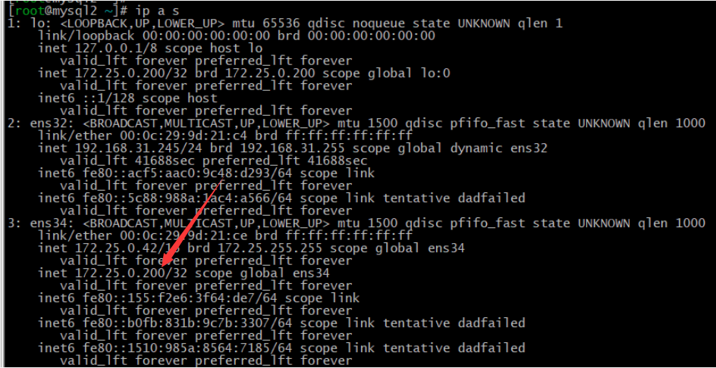可以看到VIP资源已经由mysql1转移到了mysql2当中。

在生产环境中，利用这种机制能够实现故障转移的功能。

注意：Keepalived添加到开机启动无效，如果重新启动服务器需要手动运行：service keepalived start ，来启动keepalived