- Rescan & Best Practices for Automation
In this exercise, you will apply best practices for automation using Tosca Cloud. You’ll learn how to enhance your automated test by introducing dynamic waits for improved stability and cardinality adjustments to optimize attribute reuse.

  - Rescan & Dynamic Waits
Dynamic waits are used to wait for the specific field to appear before doing any actions. It is recommended to use Dynamic wait (WaitOn) while moving from one page to next, dropdown to appear, search results to appear. In our case, a dynamic wait is required before clicking on the continue button in checkout page

    - Navigate to Build > Modules and select the module for shipping address
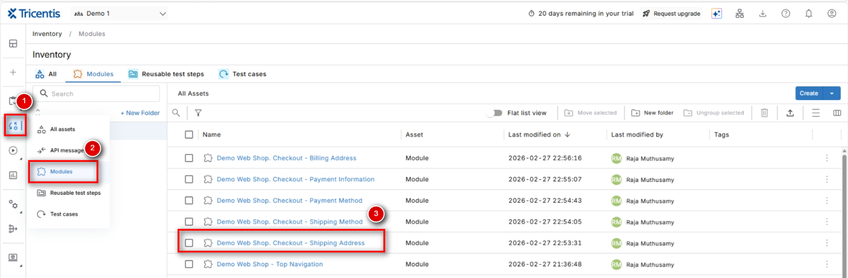
    - Click Rescan
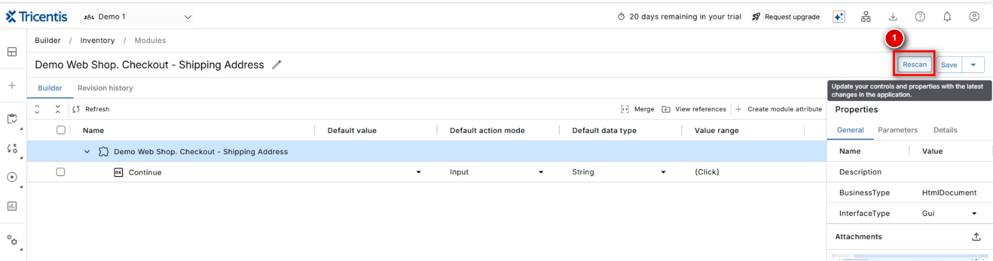
    - Select the application window (make sure that the application is open and in the right page for rescan) and click Scan
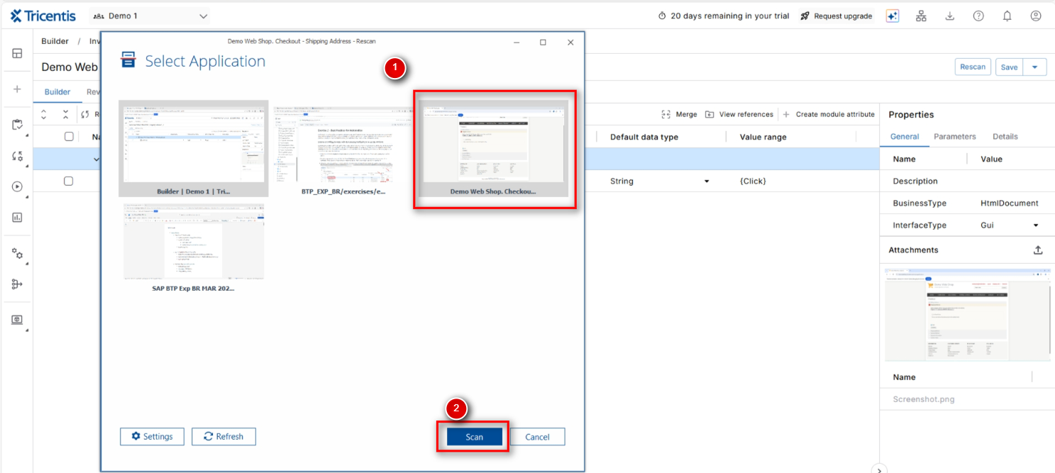
    - Select an additional field from Shipping Address section (for example – In-Store Pickup checkbox) and save the module
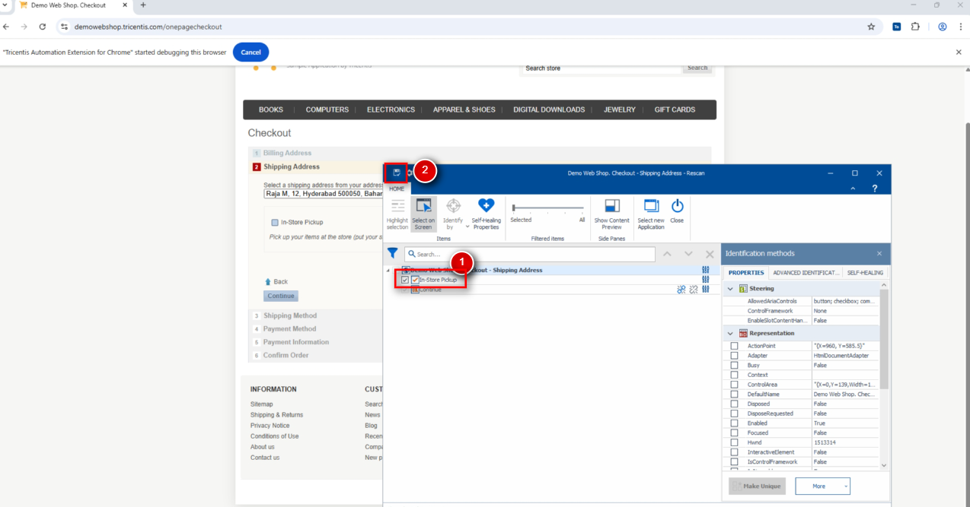
    - Go back to the modules page and refresh the screen – the newly added control should be displayed
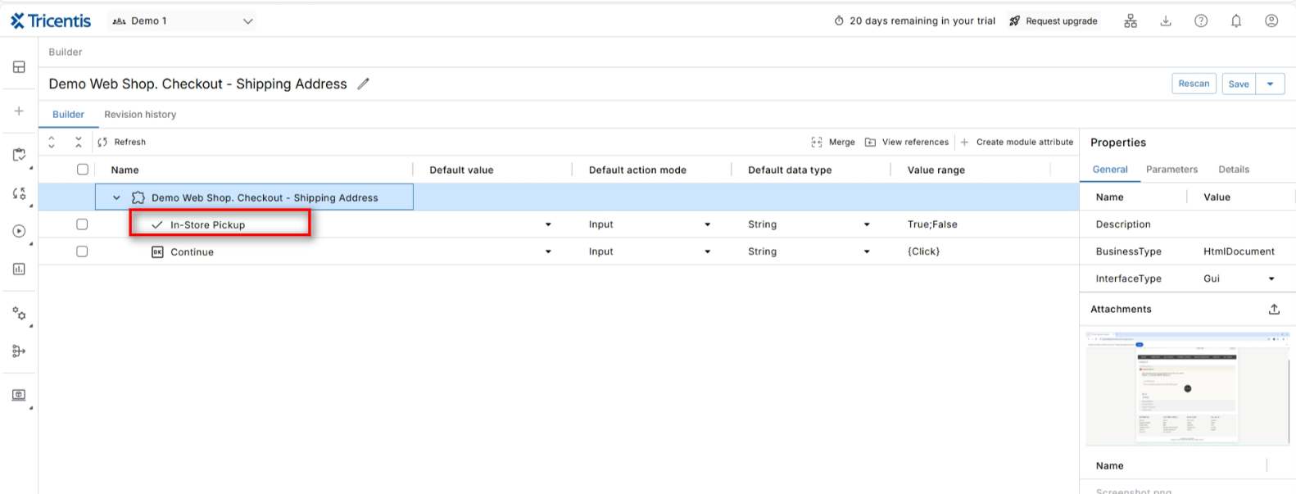
    - Navigate to Build > Test cases and click on the test case
    - Explan the test step – Enter Shipping Address and add WaitOn to ensure that the field is loaded before clicking on the Continue button
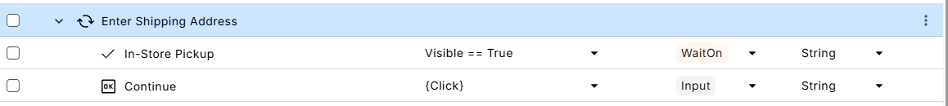
    - Repeat Steps 2.1.1 – 2.1.7 for 3 other modules as well (Shipping Method, Payment Method & Payment Information)
    - Once completed, the test case should look like below,
