**Assignment 2.3 – SQL**

**Question a**: Retrieve the names of passengers who survived the Titanic disaster?

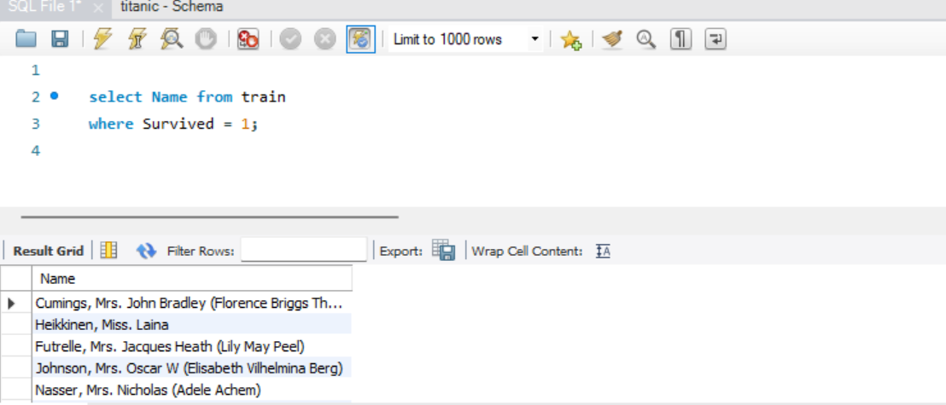

**Question b:** Find the names and ages of the five oldest survivors?

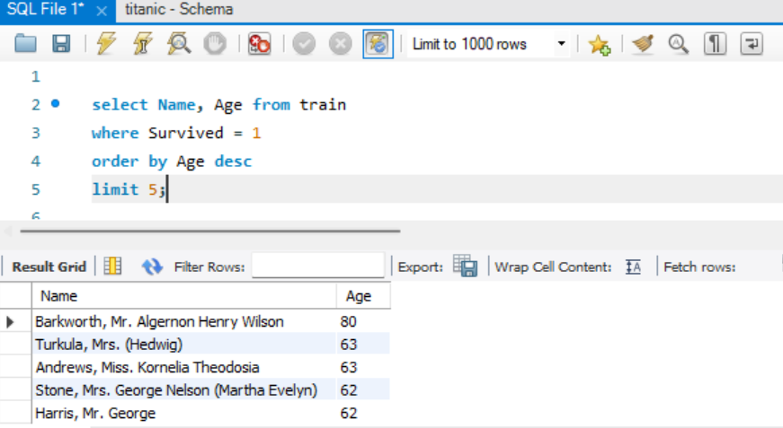

**Question c**: Calculate the average age of passengers who did not survive, and also the

average age of passengers who survived, grouped by sex?

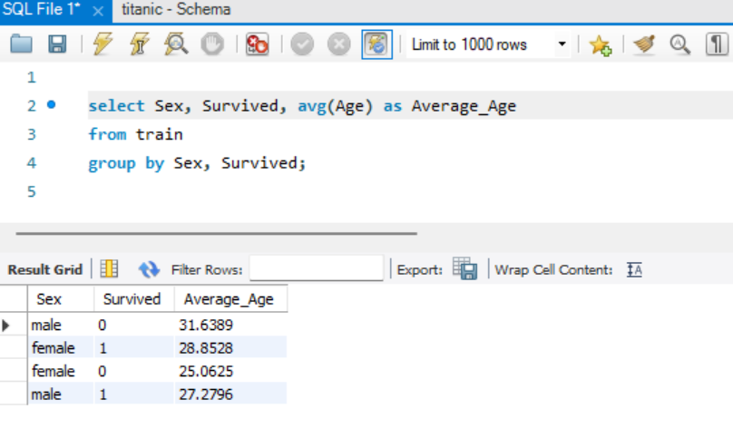

**Question d**: Count the number of males and females?

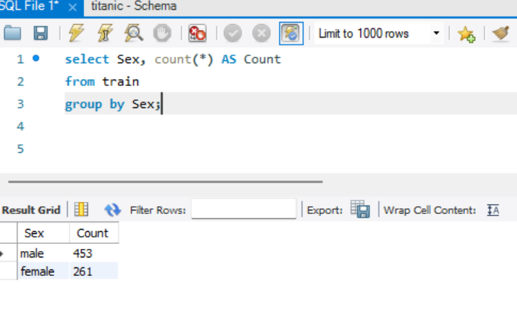

**Question e:** Update the cabin class of a Futrelle, Mrs. Jacques Heath (Lily May Peel) to

3rd class?

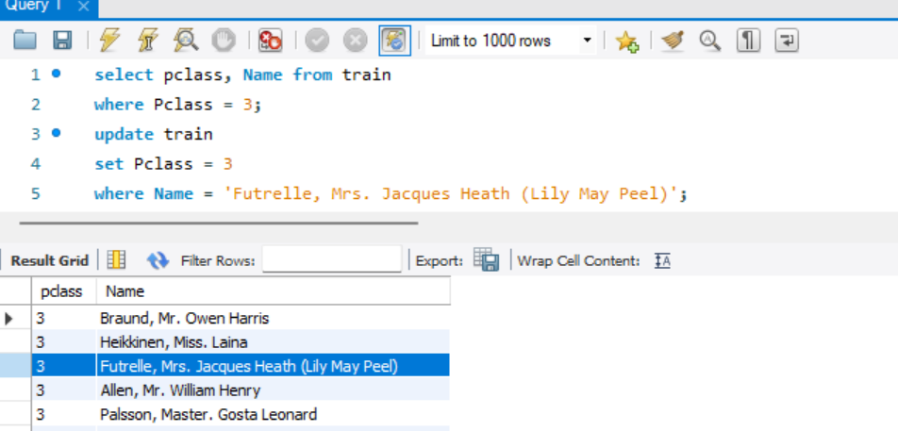

**Question f:** Delete all passengers who did not have a recorded age?

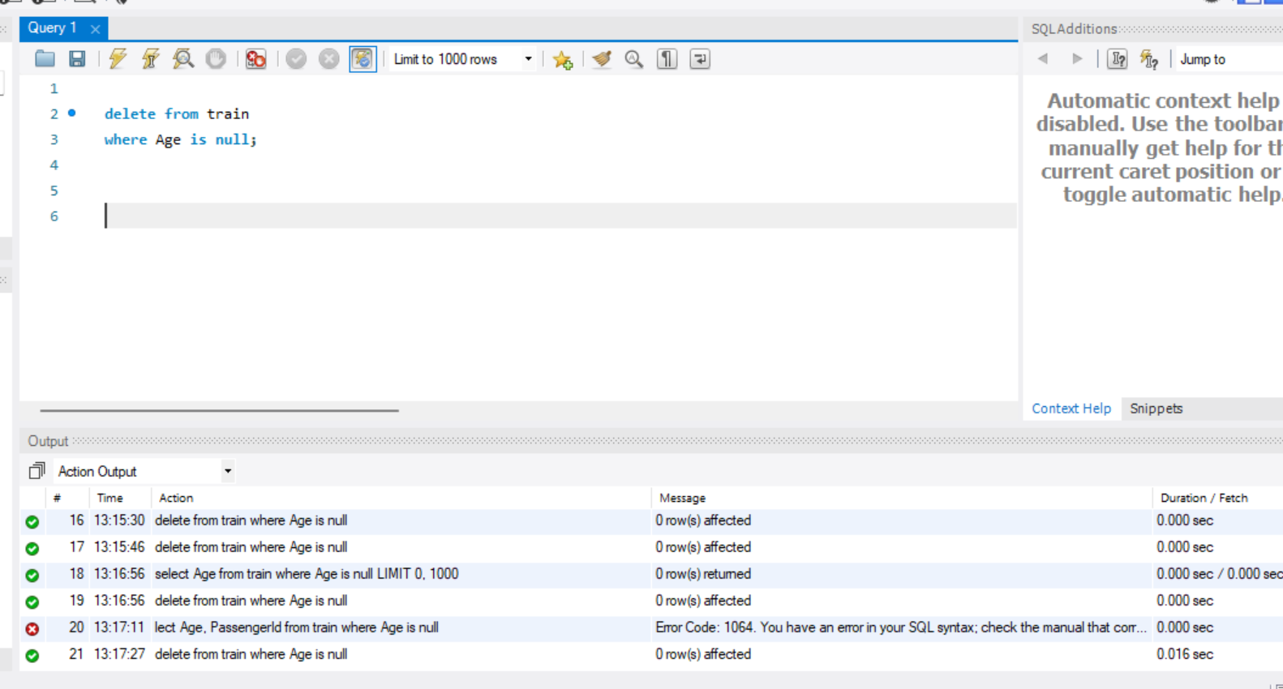

**Question g:** Retrieve the names of passengers who survived and have siblings or

spouses on board, along with the count of their siblings or spouses? 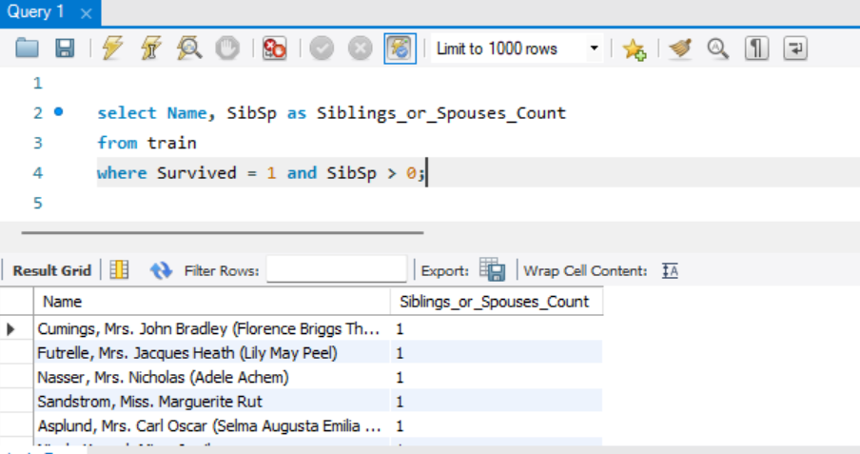

**Question h:** Find the top 10 oldest passengers who did not survive, along with their ages

and ticket numbers?

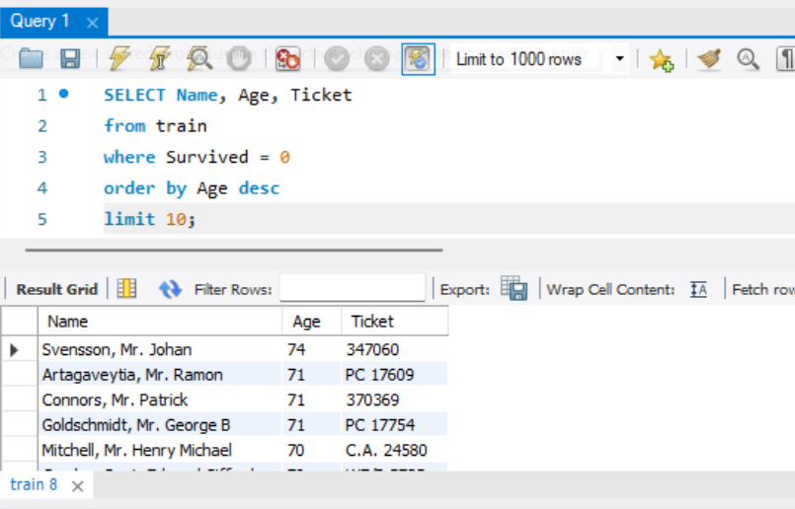

**Question i:** Calculate the survival counts for passengers in each cabin class (1st, 2nd,

3rd), and display the results in descending order?

