**Programming Fundamentals**

# **Lab # 3**

# **Problem # 4:**

# **Solution:**

1. Strat
2. Declare score, count =0 , avg =0 ,sum = 0
3. While ( count < 10 )
   1. Input score
   2. sum= score + sum
   3. count = Count + 1
4. End while
5. Avg = sum /10
6. Print avg
7. End

# **Flowchart:**

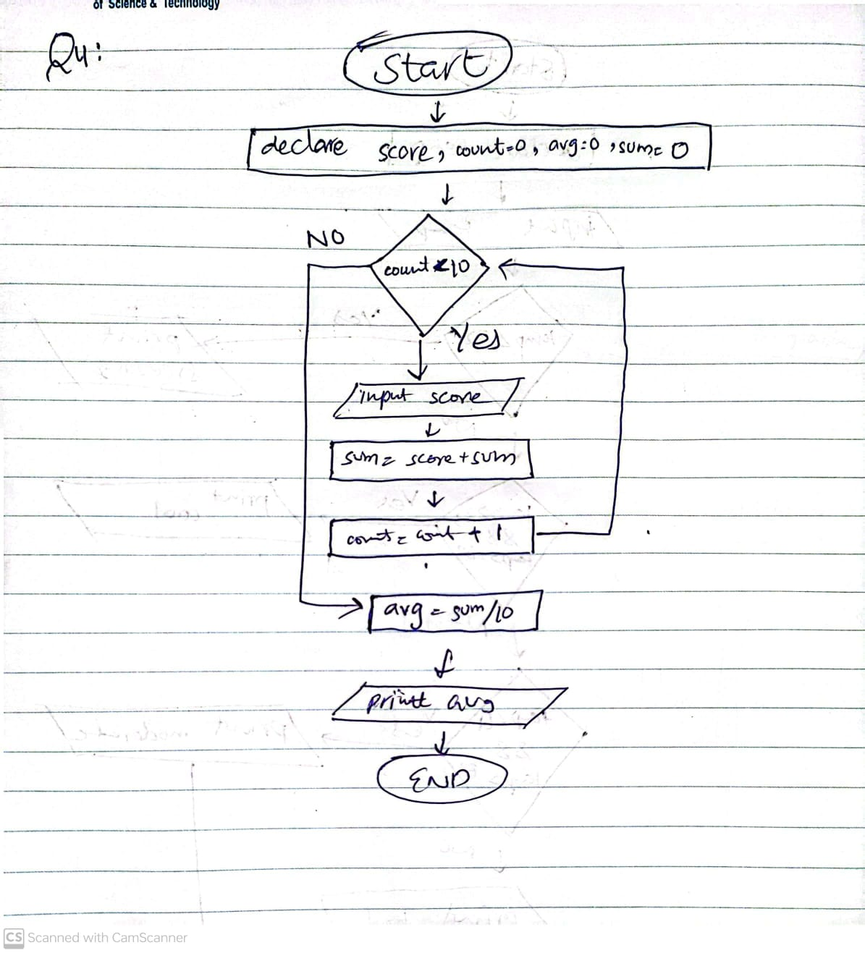

# **Problem # 5:**

# **Solution:**

1. Strat
2. Declare score, count =0 , avg =0 ,sum = 0
3. While ( count < 10 )
   1. Input score
   2. sum= score + sum
   3. count = Count + 1
4. End while
5. Avg = sum /10
6. Print avg
7. End

# **Flowchart:**

# **C:\Users\hp\AppData\Local\Packages\5319275A.WhatsAppDesktop_cv1g1gvanyjgm\TempState\83E8FE6279AD25F15B23C6298C6A3584\WhatsApp Image 2023-09-07 at 00.19.54.jpg**

# **Problem # 6:**

# **Solution:**

1. Strat
2. Declare score, count =0 , avg =0 ,sum = 0
3. While ( count < 10 )
   1. Input score
   2. If score > 100 && score < 0
      1. Print “wrong input. Please try again”.
      2. Else
      3. sum= score + sum
      4. count = Count + 1
      5. End if
4. End while
5. Avg = sum /10
6. Print avg
7. End

# **Flowchart:**

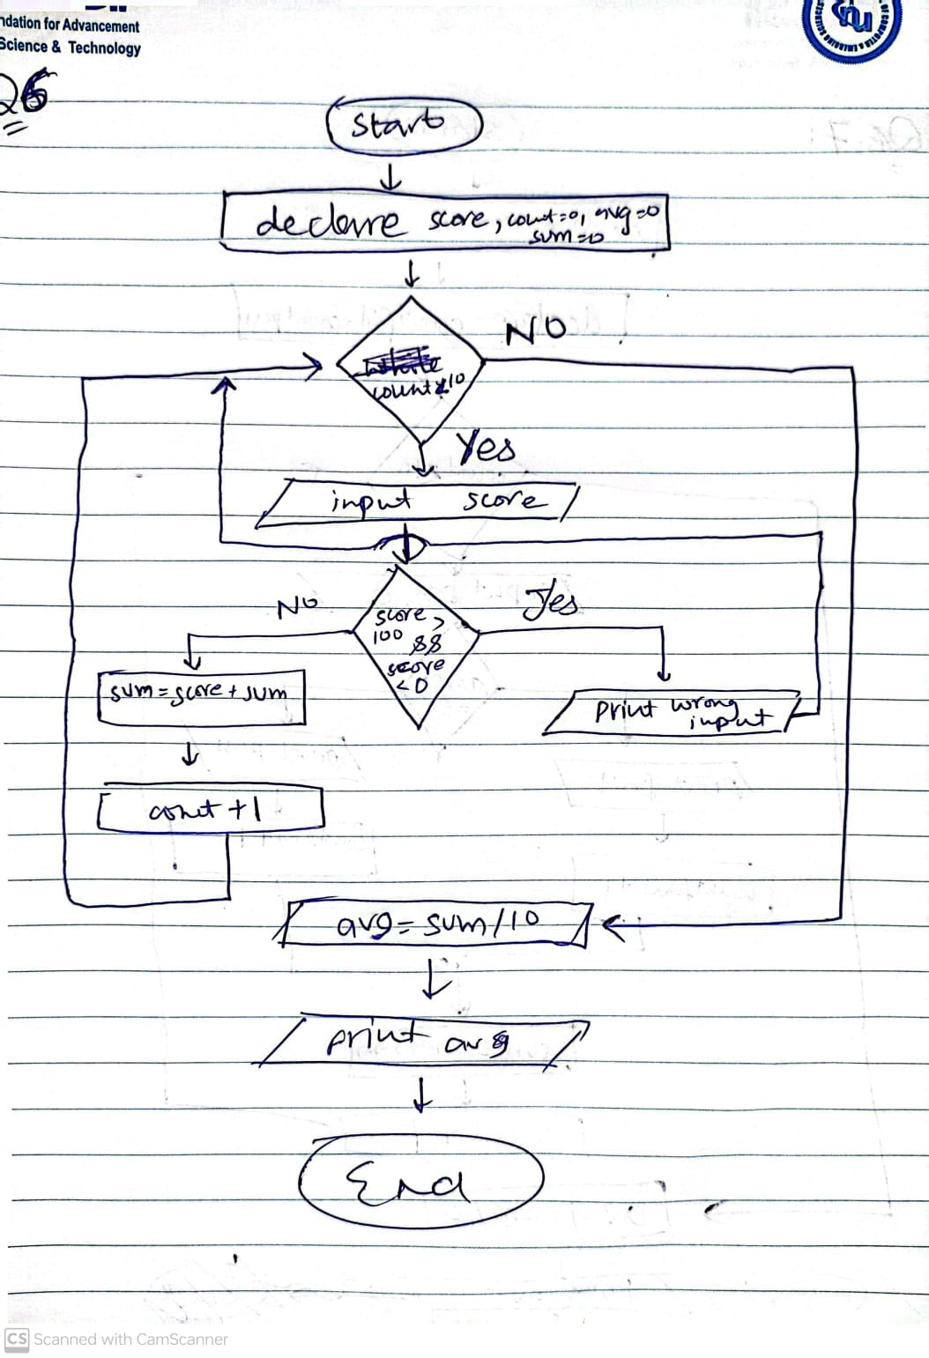

# **Problem # 7:**

# **Solution:**

1. Strat
2. Declare score, count =0 , avg =0 ,sum = 0 , countpass=0,countfail=0
3. While ( count < 10 )
   1. Input score
   2. If score >=60
      1. Print pass
      2. Countpass=countpasss+1
   3. Else
      1. Print fail
      2. Countfail=countfail+1
   4. End if
   5. sum= score + sum
   6. count = Count + 1
4. End while
5. Avg = sum /10
6. Print avg
7. Print countpass
8. Print countfail
9. End

# **Flowchart:**

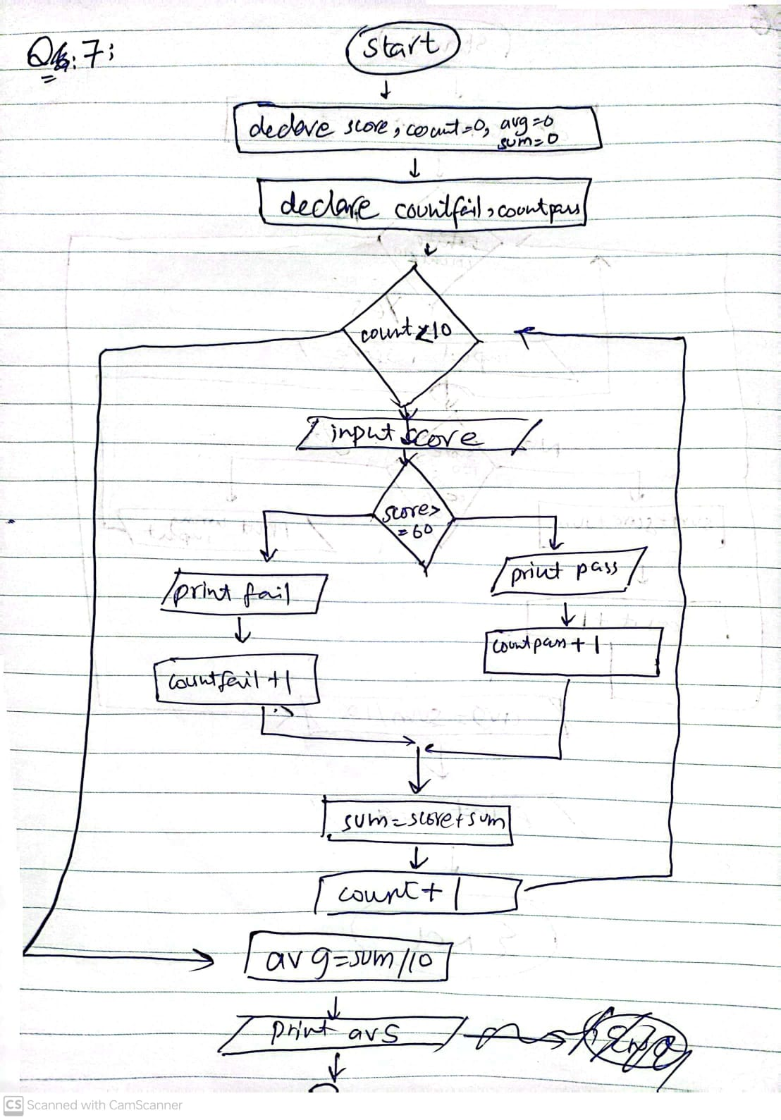

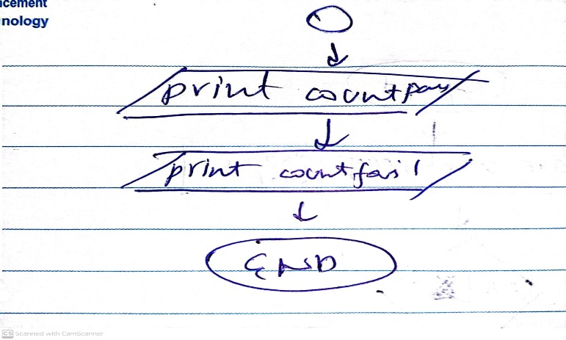

# **Problem # 8:**

# **Solution:**

1. Start
2. Declare item , count =0 , tax , total=0
3. While count < 4
   1. Input item
   2. Tax= item\*7/100
   3. Print tax
   4. Total = total + tax
4. End while
5. Print total
6. End

# **Flowchart:**

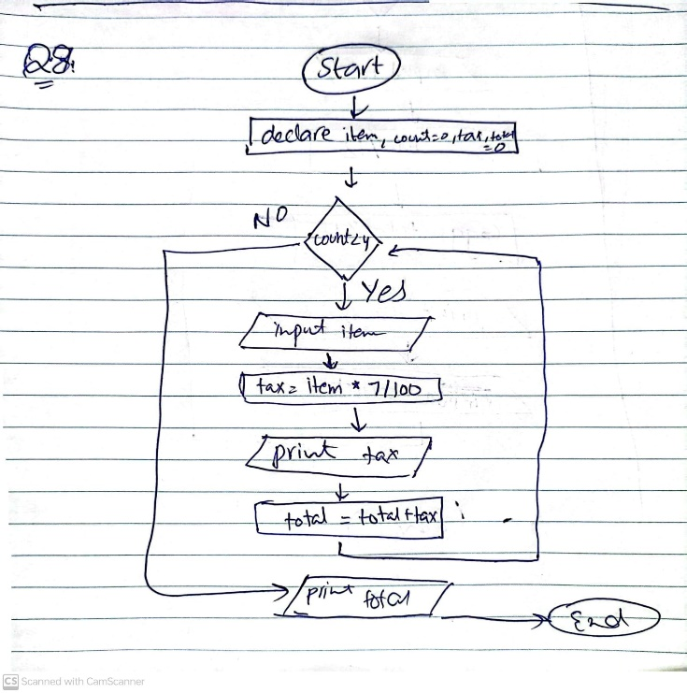

# **Problem # 9:**

# **Solution:**

1. Start
2. Declare count , eggs , dozens , total
3. While count > 0
   1. Input Total
   2. Dozens = total /12
   3. Eggs= total % 12
   4. Print dozens and eggs
   5. Input count
4. End while
5. End

# **Flowchart:**

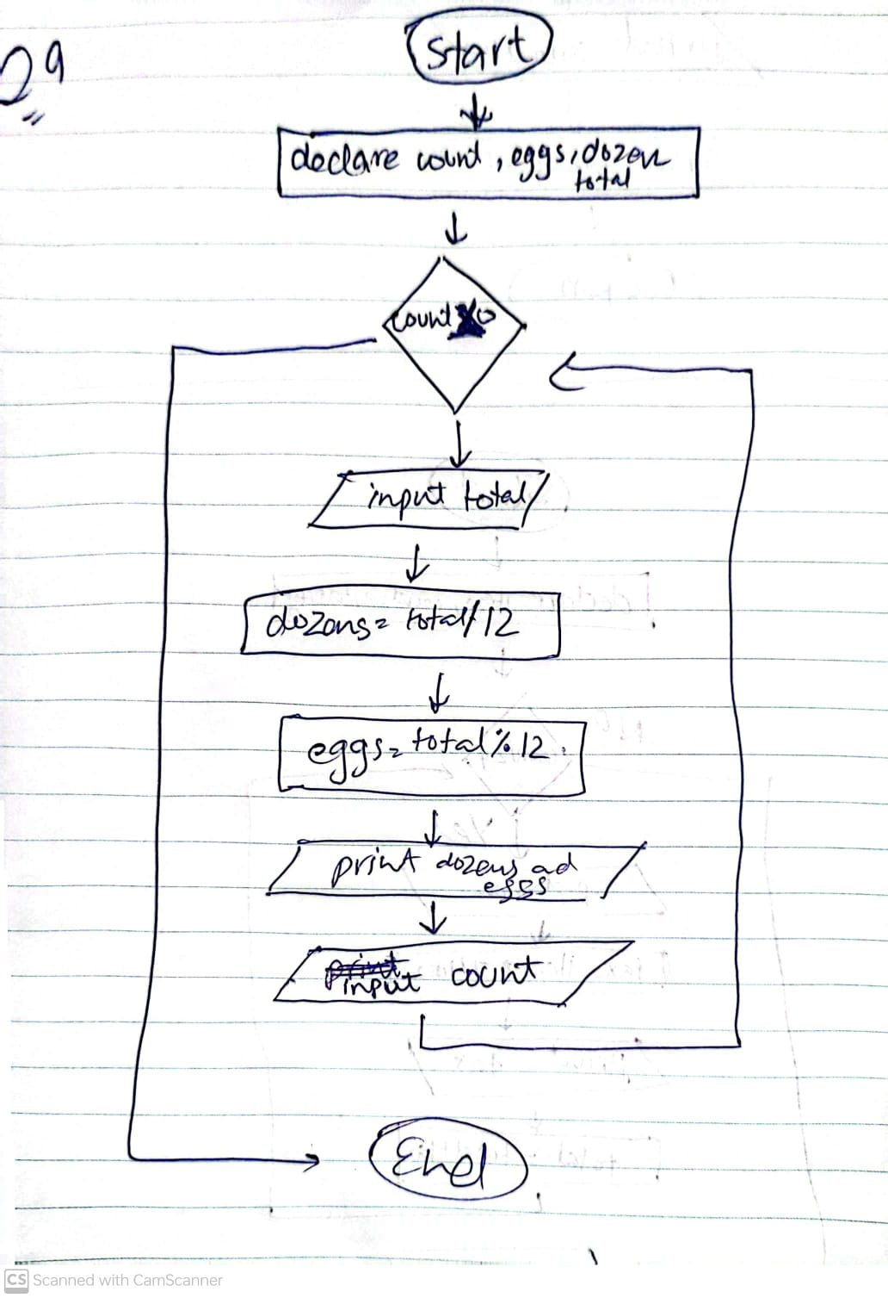

# **Problem # 10:**

# **Solution:**

1. Start
2. Declare count=1 , age ,x
3. Input age
4. While count != 0
5. If age >=100
   1. Print “ you have lived a century"
   2. Else if age >=50 && age < 100
   3. Print " You have lived a half century ‘’
   4. Else
   5. X=50-age
   6. Print “You have still “x” year left to live half century ”
6. End if
7. Input count
8. End while
9. End

# **Flowchart:**

