**Programming Fundamentals**

# **Lab # 3**

# **Problem # 1:**

# **Solution:**

1. Start
2. Declare total ,disc
3. Input total
4. If total <= 50
   1. Disc = 0
5. Else if total >50 && total <= 100
   1. disc = total*5/100
6. else if total >100 && total <= 200
   1. disc = total * 10/100
7. else if total >200
   1. disc=total*15/100
8. else
   1. print you entered wrong data
9. end if
10. total=total-disc
11. print total
12. end

# **Flowchart:**

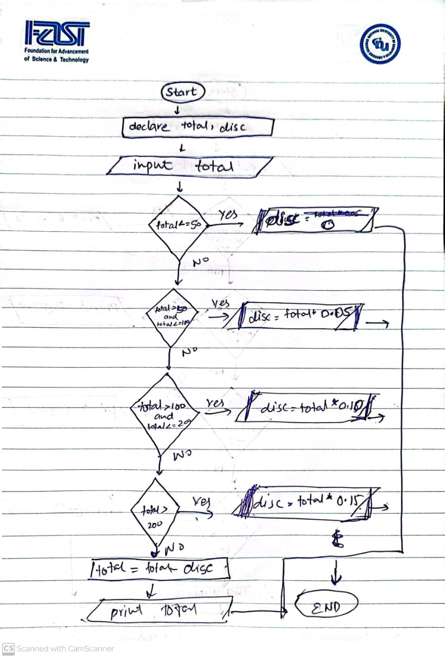

# **Problem # 2:**

# **Solution:**

1. Start
2. Declare marks
3. Input marks
4. If marks <=100 && marks >=90
   1. Print A grade
5. Else if marks < 90 && marks >=80
   1. Print B grade
6. Else if marks < 80 && marks >=70
   1. Print C grade
7. Else if marks < 70 && marks >=60
   1. Print D grade
8. Else
   1. Print F Grade
9. End if
10. End

# **Flowchart:**

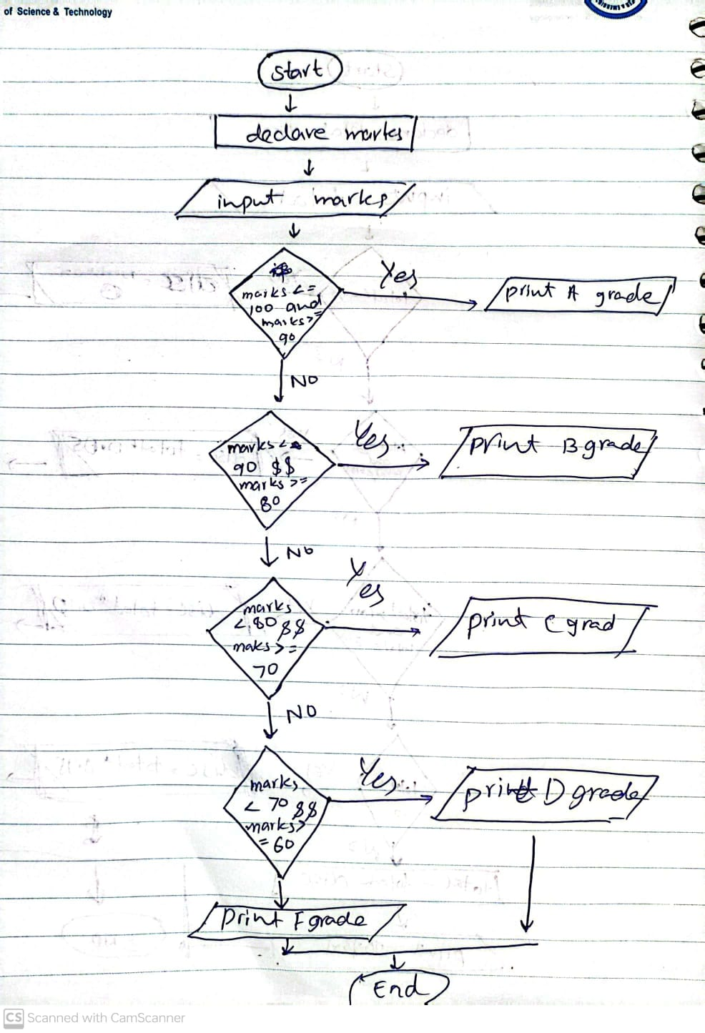

# **Problem # 3:**

# **Solution:**

1. Start
2. Declare temp
3. Input temp
4. If temp < 32
   1. Print freezing
5. Else if temp < 33 && temp >= 60
   1. Print cool
6. Else if temp < 61 && temp >= 80
   1. Print moderate
7. Else
   1. Print hot
8. End if
9. End

# Flowchart:

