**Programming Fundamentals**

**Lab 4**

# **Question no 1**

# **Solution**

1. Start
2. Declare count = 1 , miles , gallons , trips , total =0 , mileage
3. Input trips
4. While count <= trips
   1. Input miles , gallons
   2. mileage = miles / gallons
   3. print mileage
   4. total = total + mileage
   5. count = count + 1
5. End while
6. Print total
7. End

Flowchart

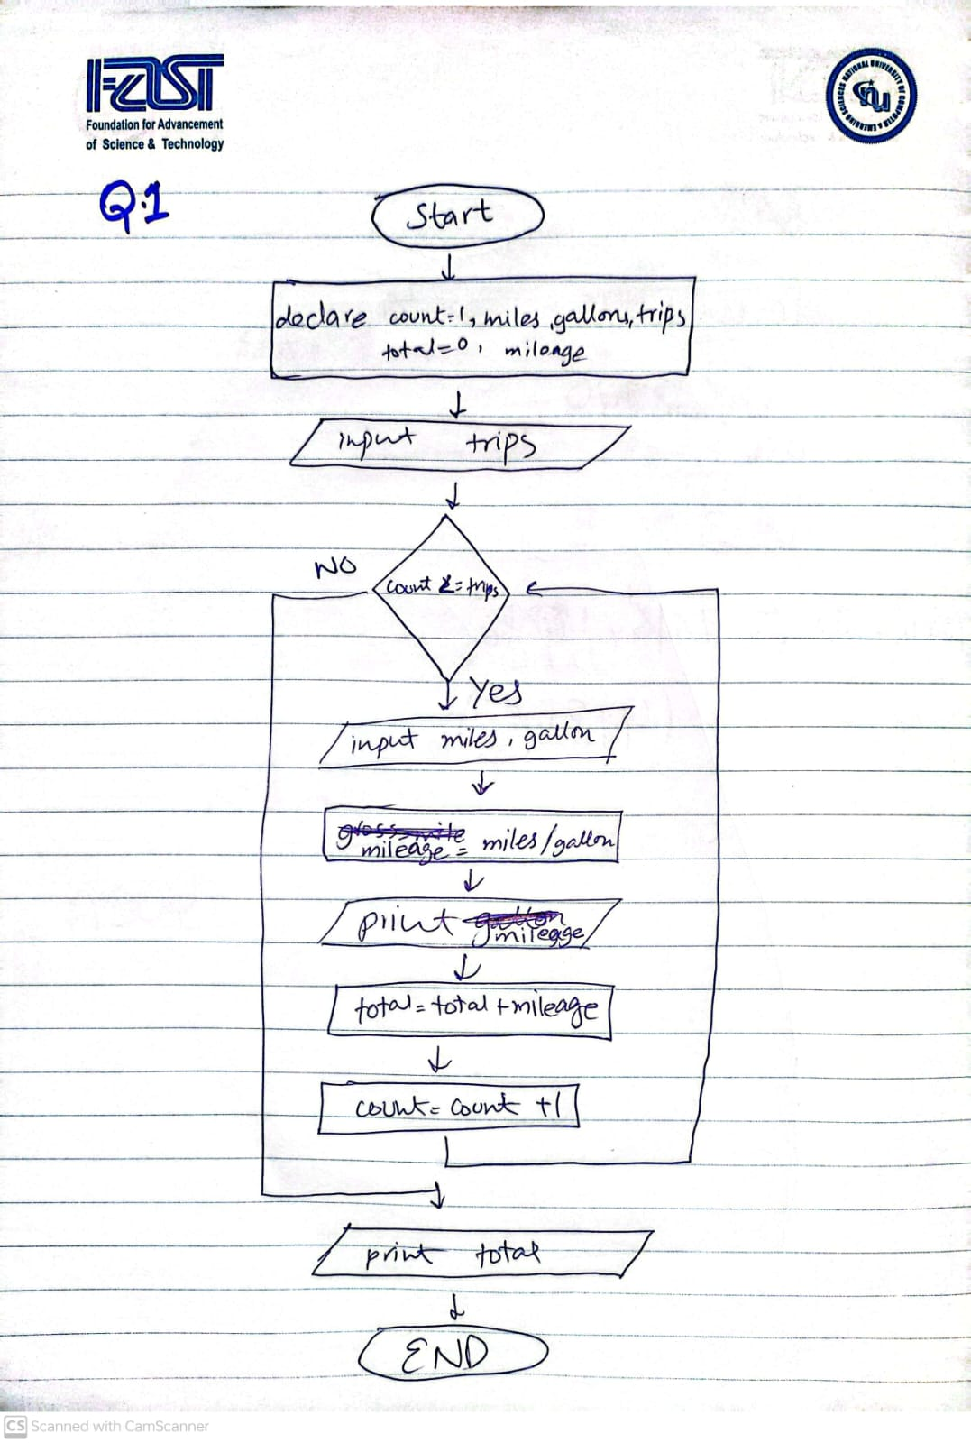

# **Problem 2: Salary Calculator**

# **Solution:**

1. Start
2. Declare hours , gross , count =1 , employees ,rate , name
3. Input employees
4. While count<=employees
   1. Input hours , rate , name
   2. Print name
   3. If hours <= 40
      1. gross = hours * rate
   4. Else
      1. gross = (40*rate)+((hours-40)*rate*1.5
   5. End if
   6. Print gross
   7. Count = count +1
5. End while
6. End

**FLOWCHART:**

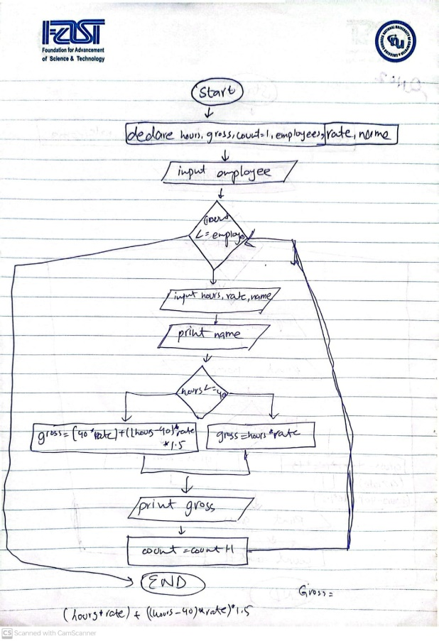

# **Problem # 3**

# **Solution:**

1. Start
2. Declare count =1 , number , largest=0
3. While count <= 10
   1. Input number
   2. If number > largest
      1. largest = number
   3. End if
   4. Count = count +1
4. End while
5. Print largest
6. End

# **Flowchart**

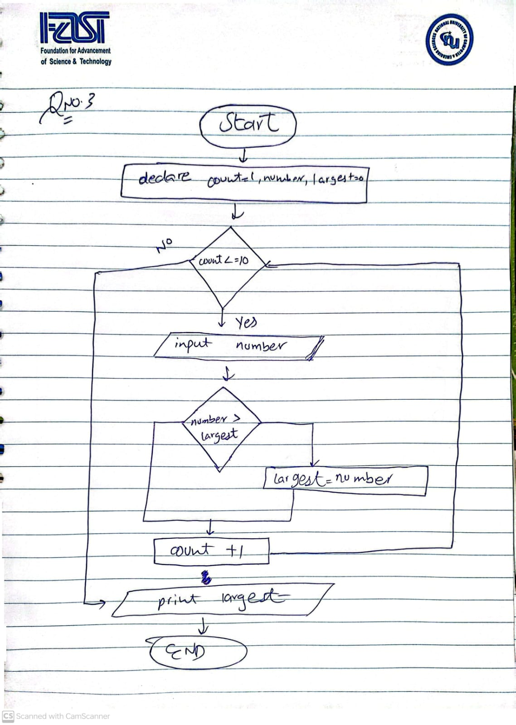

# **Question no 5**

# **Solution**

1. Start
2. Declare number , digit , remainder , count = 1, temp = 10000 , reverse=0 , num
3. Input number
4. num=number
5. While count <= 5
   1. digit = num %10
   2. remainder = num/10
   3. digit = digit * temp
   4. reverse=digit + reverse
   5. temp=temp/10
   6. count = count+1
   7. num=remainder
6. End while
7. Print reverse
8. If reverse == number
   1. Print it is a palindrome.
9. Else
   1. Print it is not a palindrome.
10. End if
11. End

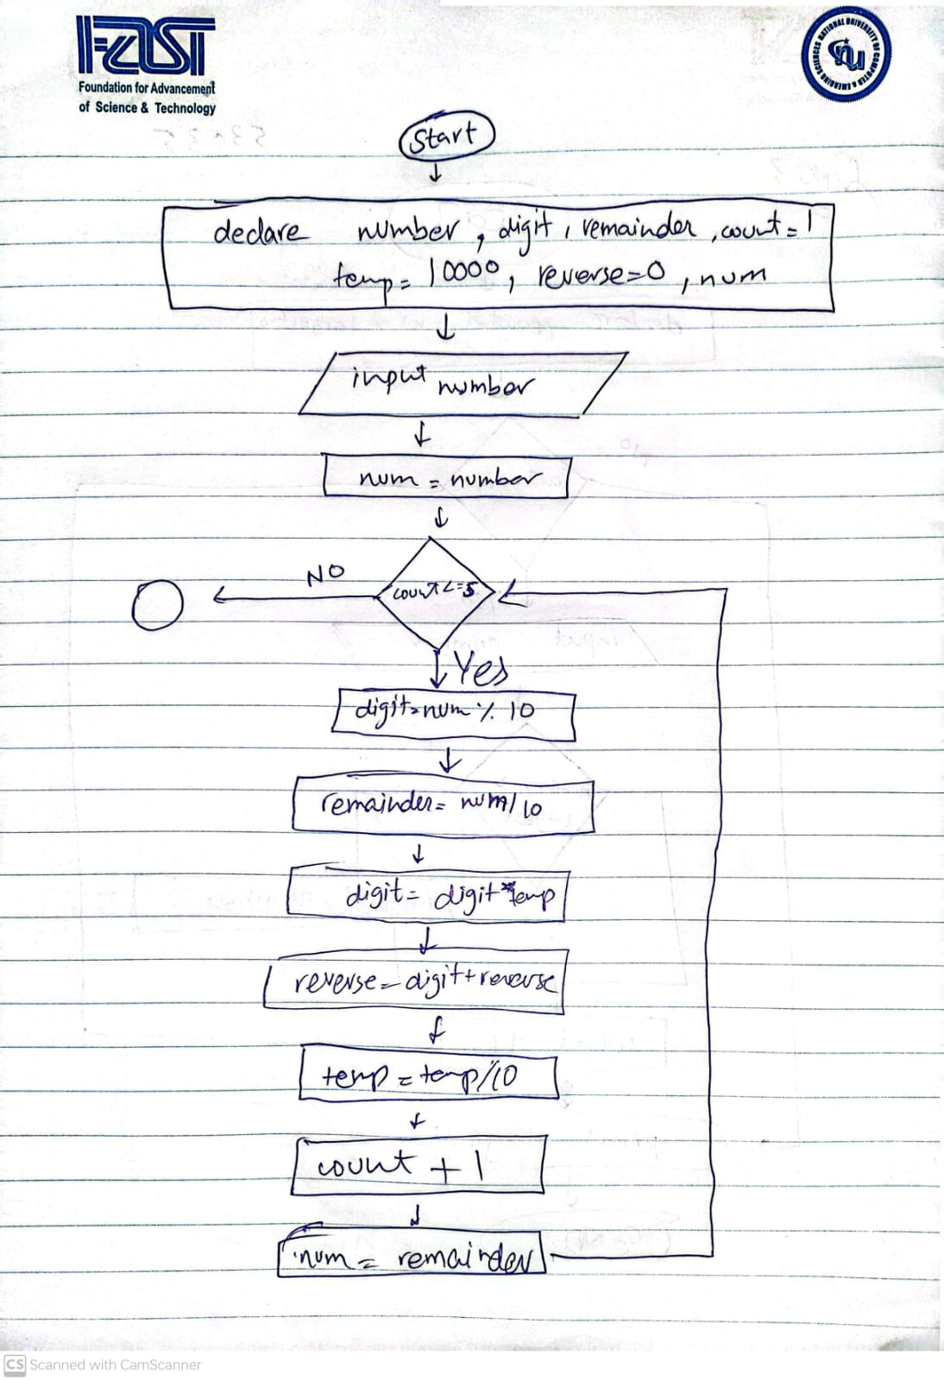

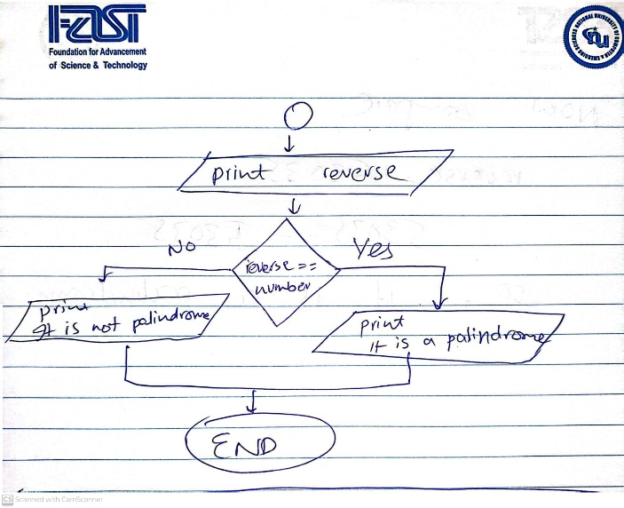

Dry run :

