LAB 12

# Task 1

#include <iostream>

int main()

{

int arr[15];

arr[0] = 1;

arr[1] = 2;

arr[2] = 10;

arr[3] = 123;

arr[4] = 176;

arr[5] = 451;

arr[6] = 871;

arr[7] = 112;

arr[8] = 41;

arr[9] = 551;

arr[10] = 132;

arr[11] = 451;

arr[12] = 561;

arr[13] = 871;

arr[14] = 143;

std::cout << "The value at Index 2 is " << arr[2]<<"\n";

system("pause");

}

# Output

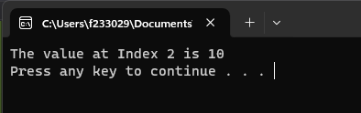

# Task 2

#include <iostream>

int main()

{

int sum=0;

int arr[10] = { 1,2,3,4,5,6,7,8,9,10 };

std::cout << "In reverse order = ";

for (int i = 9; i >= 0; i--)

{

sum = sum + arr[i];

std::cout << arr[i] << " ";

}

std::cout << "\nThe Sum is = " << sum<<"\n\n";

system("pause");

}

# Output

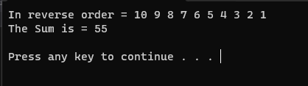

# Task 3

#include <iostream>

#include <ctime>

int main()

{

int i, r;

int arr[200];

srand(time(0));

for (int i = 0; i <= 199; i++)

{

r = (rand() % 9) + 1;

arr[i] = r;

std::cout << arr[i]<<" ";

if ((i+1) % 10 == 0 )

{

std::cout << "\n";

}

}

system("pause");

}

# Output

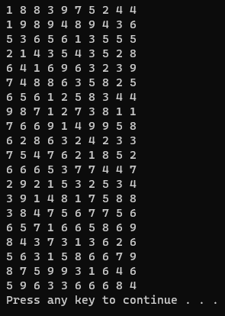

# Task 4

#include<iostream>

int main()

{

int list[6];

list[0] = 5;

for (int i = 1; i < 6; i++)

{

list[i] = i*i + 5;

if (i > 2)

{

list[i] = 2 * list[i] - list[i - 1];

}

}

for (int i = 0; i <= 5; i++)

{

std::cout << list[i]<<" ";

}

system("pause");

}

# Output

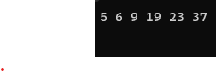

# Task 5

1. Correct
2. Correct
3. It is an Error because while initialization we can not left a space blank

int c[7] = { 12,13,14,16,,8 };

1. Correct
2. Correct.

# Output

1. 
2. 
3. ERROR
4. 
5. 

# task 6

#include <iostream>

int main()

{

double a[30];

for (int i = 0; i <= 9; i++)

{

a[i] = i*i;

}

for (int i = 0; i <= 9; i++)

{

std::cout << a[i] << " ";

}

std::cout << std::endl;

for (int i = 10; i <= 19; i++)

{

a[i] = i * 3;

}

for (int i = 10; i <= 19; i++)

{

std::cout << a[i] << " ";

}

std::cout << std::endl;

int j = 0;

for (int i = 20; i <= 29; i++)

{

a[i] = i + j;

j++;

}

for (int i = 20; i <= 29; i++)

{

std::cout << a[i] << " ";

}

std::cout << "\n\n";

system("pause");

}

# output

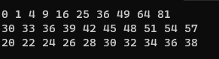

# Task 7

#include <iostream>

int main()

{

int a[5] = {1,5,3,5,5};

int element,count=0,j=0;

int n[10];

char y;

std::cin >> element;

for (int i = 0; i <= 4; i++)

{

if (element == a[i])

{

count++;

n[j] = i;

j++;

}

}

if (count > 0)

{

std::cout << "Match Found "<<count <<"Times\n\n";

if (count > 1)

{

std::cout << "At position ";

for (int i = 0; i < count; i++)

{

std::cout << n[i] << " ";

}

std::cout << "\nIf You want Replace number with any other Enter Y otherwise N";

std::cin >> y;

if (y == 'y' || y == 'Y')

{

for (int i = 0; i < count -1; i++)

{

std::cin >> a[n[i]];

}

}

}

}

else

{

std::cout << "No Repetetion Found\n\n";

}

system("pause");

}

# Output

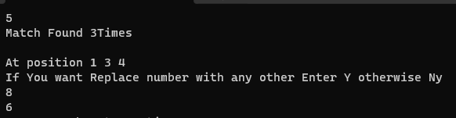

# Task 9

#include<iostream>

int main()

{

int j = 6, position;

int arr[6], a[6];

std::cout << "Enter values in array \n";

for (int i = 0; i < 6; i++) //getting an array

{

std::cin >> arr[i];

}

do

{

std::cout << "Enter value of p";

std::cin >> position;

if (position > 6 || position < 0)

{

std::cout << "Invalid value of p\n";

}

} while (position > 6 || position < 0);

j = j - position;

for (int i = 0; j < 6; j++)

{

a[i] = arr[j];

i++;

}

j = 0;

for (int i = position; i < 6; i++)

{

a[i] = arr[j];

j++;

}

for (int i = 0; i < 6; i++)

{

std::cout << a[i] << " ";

}

system("pause");

}

# Output

# 

# Task 9

#include<iostream>

int main()

{

int number, count = 0, n;

bool flag;

int arr[25];

std::cout << "Enter 25 numbers between 10 and 100 \n";

for (int i = 0; i < 25;)

{

flag = true;

n = i + 1;

std::cout << "Value Number "<<n<<" : ";

std::cin >> number;

if (number >= 10 && number <= 100)

{

for (int j = 0; j < i; j++)

{

if (arr[j] == number)

{

flag = false;

}

}

if (flag == false)

{

std::cout << "Invalid input.please try again \n";

count++;

}

else

{

arr[i] = number;

i++;

}

}

else

{

std::cout << "Invalid input.please try again \n";

count++;

}

}

std::cout << "Unique values are : ";

for (int i = 0; i < 25; i++)

{

std::cout << arr[i] << " ";

}

if (count == 0)

{

std::cout << " \nWorst Case \n";

}

system("pause");

}

# Output

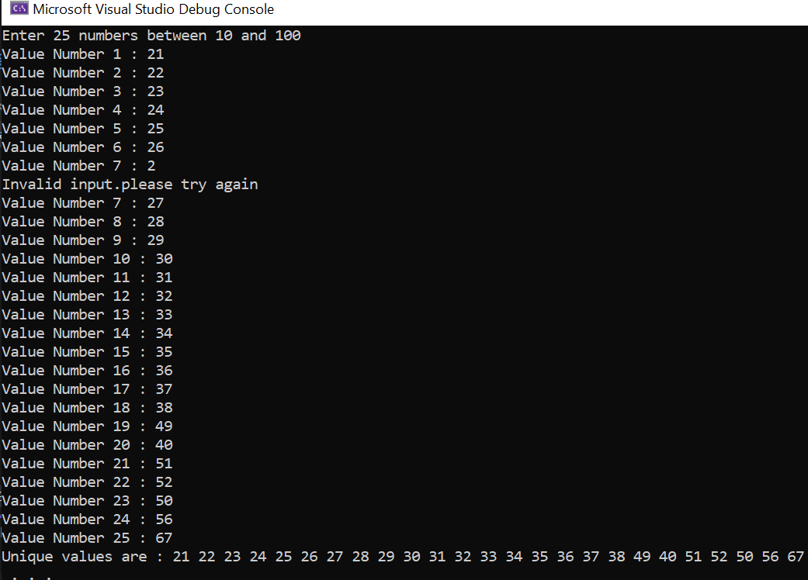

# Lab 10

#include<iostream>

int main()

{

int temp;

int arr[10] = { 10, 23, 44,89,76,64,45,11,40,33};

for (int i = 0; i < 10; i++)

{

temp = arr[i];

for (int j = i; j < 10; j++)

{

if (arr[j] < temp)

{

int k = temp;

temp = arr[j];

arr[j] = k;

}

}

arr[i] = temp;

}

for (int i = 0; i < 10; i++)

{

std::cout << arr[i] << " ";

}

std::cout << "\n";

system("pause");

}

# Output

