Lab 13

# Task 1

#include<iostream>

int main()

{

int i, j, sum;

char name[5][15];

double mile[5][7];

std::cout << "Enter the names of runners \n";

for (i = 0; i < 5; i++)

{

std::cin >> name[i];

}

for (i = 0; i < 5; i++)

{

std::cout << "Enter Number of Miles of " << name[i] << "\n";

for (j = 0; j < 7; j++)

{

std::cout << "Miles day " << j + 1 << ":";

std::cin >> mile[i][j];

}

}

for (i = 0; i < 5; i++)

{

sum = 0;

std::cout << name[i] << "=";

for (j = 0; j < 7; j++)

{

sum += mile[i][j];

std::cout << " miles travel at Day : " << j + 1 << mile[i][j];

}

std::cout << std::endl << "Total miles = " << sum;

std::cout << std::endl << "Average miles = " << sum / 7 << std::endl;

}

system("pause");

}

# Output

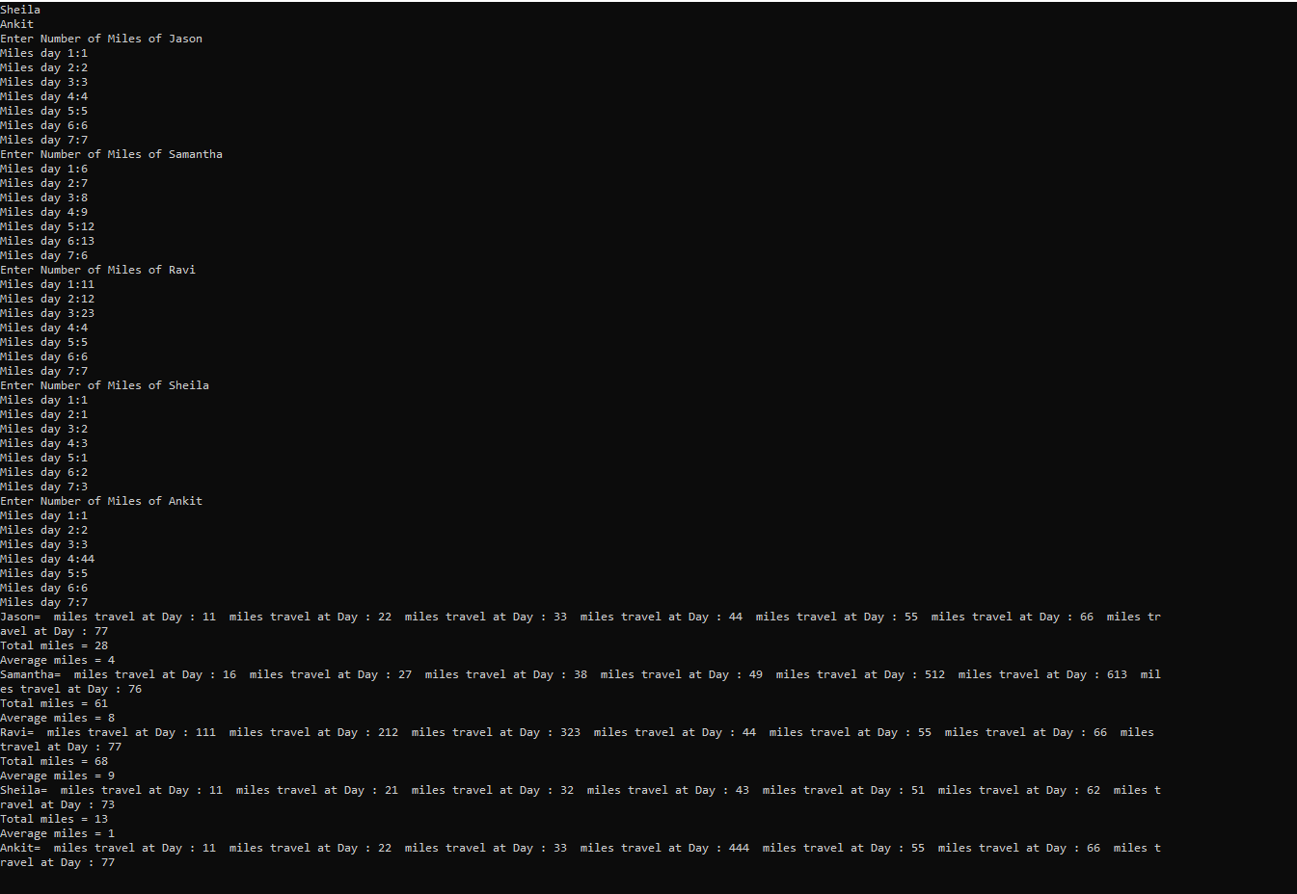

# Task 2

#include<iostream>

int main()

{

int d;

char a[13][6];

int choice;

int row, seat;

for (int i = 0; i <= 12; i++)

{

for (int j = 0; j <= 5; j++)

{

a[i][j] = '*';

}

}

std::cout << " A B C D E F " << std::endl;

for (int i = 0; i <= 12; i++)

{

d = i+1;

std::cout << "Row " << d<< " ";

if (i < 9)

{

std::cout << " ";

}

for (int j = 0; j <= 5; j++)

{

std::cout << a[i][j] << " ";

}

std::cout << std::endl;

}

bool flag = true;

while (flag)

{

std::cout << "\n\nEnter 1 for First Class\nEnter 2 for Business Class\nEnter 3 for Economy Class";

std::cin >> choice;

switch (choice)

{

case 1:

std::cout << "Congragulations!!You choosed First Class\n";

std::cout << "Enter The seat you want to have( from R1 or R2 ) \n";

std::cout << "Enter Row Number: ";

std::cin >> row;

std::cout << "Enter Seat Number: ";

std::cin >> seat;

if (!(row <=2 && seat <= 6))

{

std::cout << "Wrong Input ";

continue;

}

else

{

if (a[row-1][seat-1] != 'X')

{

a[row-1][seat-1] = 'X';

}

else

{

std::cout << "Seat is Reserved!! Kindly Enter again ";

continue;

}

}

break;

case 2:

std::cout << "Congragulations!!You choosed Business Class\n";

std::cout << "Enter The seat you want to have( from R3 to R7 ) \n";

std::cout << "Enter Row Number: ";

std::cin >> row;

std::cout << "Enter Seat Number: ";

std::cin >> seat;

if (!((row <= 7 && row >= 3 )&& seat <= 6))

{

std::cout << "Wrong Input ";

continue;

}

else

{

if (a[row-1][seat-1] != 'X')

{

a[row-1][seat-1] = 'X';

}

else

{

std::cout << "Seat is Reserved!! Kindly Enter again ";

continue;

}

}

break;

case 3:

std::cout << "Congragulations!!You choosed Economy Class\n";

std::cout << "Enter The seat you want to have( from R8 or R13 ) \n";

std::cout << "Enter Row Number: ";

std::cin >> row;

std::cout << "Enter Seat Number: ";

std::cin >> seat;

if (!(row <= 13 && row >= 7 && seat <= 6))

{

std::cout << "Wrong Input ";

continue;

}

else

{

if (a[row-1][seat-1] != 'X')

{

a[row-1][seat-1] = 'X';

}

else

{

std::cout << "Seat is Reserved!! Kindly Enter again ";

continue;

}

}

break;

default:

std::cout << "Wrong input ";

continue;

}

std::cout << std::endl;

std::cout << " A B C D E F " << std::endl;

for (int i = 0; i <= 12; i++)

{

d = 1 + i;

std::cout << "Row " << d<< " ";

if (i < 9)

{

std::cout << " ";

}

for (int j = 0; j <= 5; j++)

{

std::cout << a[i][j] << " ";

}

std::cout << std::endl;

}

std::cout << "If You want to continue booking Press 1 else press any other key ";

std::cin >> choice;

if (choice == 1)

{

continue;

}

else {

break;

}

}

std::cout << "Thanks for Using our Airline !! Have a Safe Journey !!";

}

# Output

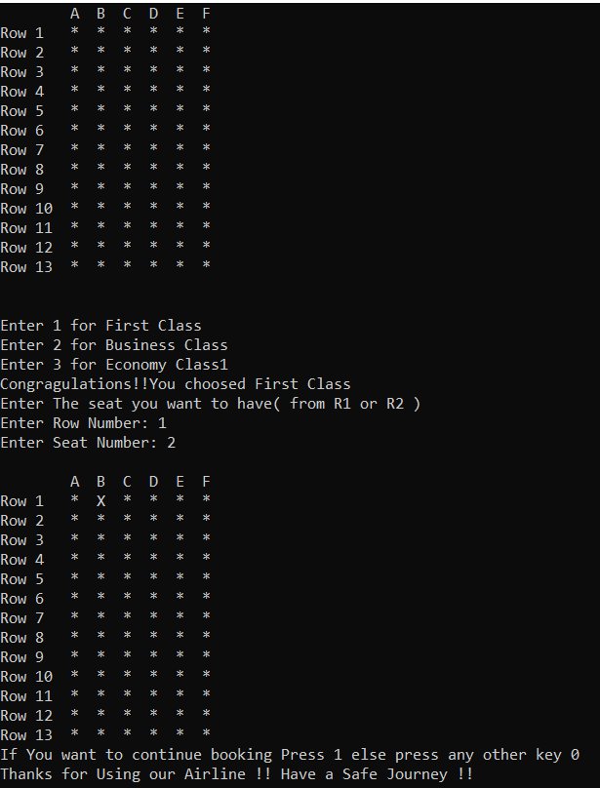

# Task 3

#include<iostream>

#include <string>

int main()

{

char str1[15];

char str2[15] = "Good Day";

//str1 = str2; // This Can not be run because we cannot initialize an array to any other other array

if (str1 == str2)

{

std::cout << "Both string are of same length\n";

}

if (strlen(str1) >= strlen(str2))//condition is fakse beacuse str1 has initialized nothing

{

//str1 = str2; //cant be run

std::cout << "yes\n";

}

if (strcmp(str1, str2) < 0)//condition is false

{

std::cout << "Str1 is less than str2 \n";

}

}

# Output



# Task 4

#include<iostream>

int main()

{

char str1[21] = {"Sunny Day"};

char str2[21];

int length=0;

for (int i = 0; str1[i] != '\0'; i++)

{

length++;

}

std::cout << "The Length of Str1 is " << length<<"\n";

for (int i = 0; str1[i] != '\0'; i++)

{

str2[i]=str1[i];

}

if (str1 <= str2)

{

std::cout << str1;

}

else

std::cout << str2;

}

# Output



# Task 5

#include<iostream>

int main()

{

char name[21];

char yourName[21];

char studentName[31];

std::cout << "Enter Name ";

std::cin >> name;

std::cout << studentName; //it will output nothing because array is uninitialized

yourName[0] = '\0';

//yourName = studentName; // this is a syntax error because we can,t initialize array like that

if (yourName == name)

//studentName = name; // It is same error of initializing characte array without loop

}

# Task 6

#include<iostream>

int main()

{

int temp = 0;

char uppercase;

char a[100];

std::cout << "Enter a string : ";

std::cin.getline(a, 100);

std::cout << "\nIn upper case it will be : ";

for (int i = 0; a[i] != '\0'; i++)

{

if (a[i] >= 97)

{

temp = a[i] - 32;

uppercase = temp;

}

else

{

uppercase = a[i];

}

std::cout << uppercase;

}

return 0;

}

# Output

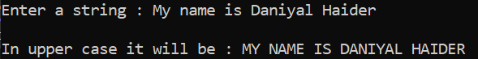

# Task 7

#include <iostream>

int main()

{

int i;

char temp[100];

char str1[100] = { "I Love Pakistan" };

char str2[100] = { "I Hate India" };

std::cout << "Before swaping: \n";

std::cout << str1 << std::endl;

std::cout << str2 << std::endl;

for (i = 0; i < 99; i++)

{

temp[i] = str1[i];

str1[i] = str2[i];

str2[i] = temp[i];

}

std::cout << "\n\nAfter swaping: \n";

std::cout << str1 << std::endl;

std::cout << str2 << std::endl;

}

# Output

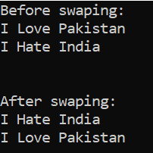

# Task 8

#include <iostream>

int main()

{

int i, j;

char a[100] = { "Pakistan!!" };

char reverse[100];

std::cout << "Before Reversing: \n" << a << std::endl;

for (j = 0; a[j] != '\0'; j++);//reversing the array

int k = j / 2;

for (i = 0; i < k; i++)

{

j = j - 1;

reverse[i] = a[j];

a[j] = a[i];

a[i] = reverse[i];

}

std::cout << "After Reversing: \n" << a << std::endl;

}

# Output

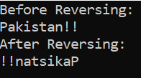

# Task 9

#include <iostream>

int main()

{

char input[50], reverse[50];

int count = 0;

bool temp = false;

std::cout << "Enter string \n";

gets_s(input);

int i, k = 0;

for (i = 0; input[i] != '\0'; i++)//counting number of chracter in string

{

count++;

}

for (i = count - 1; i >= 0; i--)// finding reverse

{

reverse[k] = input[i];

k = k + 1;

}

for (int j = 0; j < count; j++)//checking palindrome

{

if (reverse[j] == input[j])

{

temp = true;

}

else

{

temp = false;

}

}

if (temp == true)

{

std::cout << "Entered string is a palindrome.\n";

}

else

{

std::cout << "entered string is not a palindrome. \n";

}

system("pause");

}

# Output

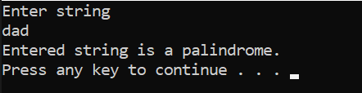

# Task 10

#include <iostream>

#include <cstdlib>

int main()

{

int vowelcount = 0;

char str[100];

std::cout << "Enter a string: ";

std::cin.get(str, 100);

for (int i = 0; str[i] != '\0'; i++)

{

if (str[i] == 'a' || str[i] == 'u' || str[i] == 'o' || str[i] == 'i' || str[i] == 'e')

vowelcount++;

if (str[i] == 'A' || str[i] == 'E' || str[i] == 'I' || str[i] == 'O' || str[i] == 'U')

vowelcount++;

}

std::cout << "The number of vowels in the given string are: " << vowelcount;

}

# Output

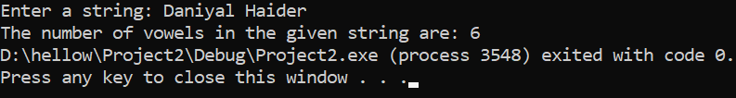

# Task 11

#include <iostream>

int main()

{

int max = 0;

int str1[5][5];

std::cout << "Enter Values: ";

for (int i = 0; i < 5; i++)//taking input in 2d array

{

for (int j = 0; j < 5; j++)

{

std::cin >> str1[i][j];

}

}

for (int i = 0; i < 5; i++)//finding maximum value

{

for (int j = 0; j < 5; j++)

{

if (max < str1[i][j])

max = str1[i][j];

}

}

std::cout << "The largest number is: " << max;

}

# Output

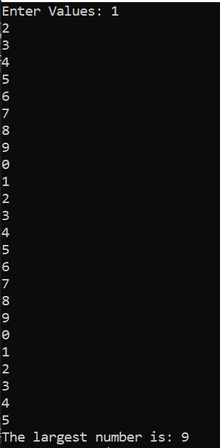

# Task 12

#include <iostream>

int main()

{

int matrix[3][3];

int i, j, k;

std::cout << "Enter Values of Matrix: \n";

for (i = 0; i < 3; i++)

{

for (j = 0; j < 3; j++)

{

std::cin >> matrix[i][j];

}

}

std::cout << "\nThe matrix is: \n";

std::cout << "The matrix is: \n";

for (i = 0; i < 3; i++)

{

for (j = 0; j < 3; j++)

{

std::cout << matrix[i][j] << "\t";

}

std::cout << std::endl;

}

std::cout << "\n\nThe left diagnoal is: \n";

for (i = 0; i < 3; i++)

{

for (j = 0; j < 3; j++)

{

if (i == j)

std::cout << matrix[i][j] << "\t";

}

}

std::cout << "\n\nThe right diagnoal is: \n";

for (i = 0; i < 3; i++)

{

for (j = 0; j < 3; j++)

{

if (i + j == 2)

std::cout << matrix[i][j] << "\t";

}

}

}

# Output

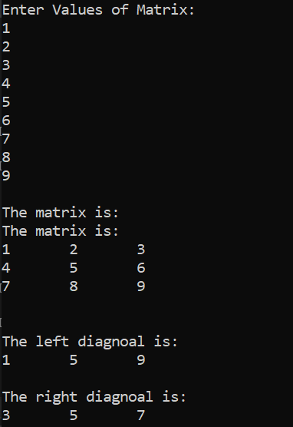

# Task 13

#include<iostream>

using namespace std;

int main()

{

int a[3][3];

cout << "Enter Valuse of matrix "<<endl;

for (int i = 0; i < 3; i++)

{

for (int j = 0; j < 3; j++)

{

cin >> a[i][j];

}

}

cout << endl << endl;

for (int i = 0; i < 3; i++)

{

for (int j = 0; j < 3; j++)

{

cout << a[i][j] <<" ";

}

cout << endl;

}

cout << "\n\nThe Transpose of the given Matrix is \n\n";

for (int i = 0; i < 3; i++)

{

for (int j = 0; j < 3; j++)

{

cout << a[j][i] << " ";

}

cout << endl;

}

}

# Output

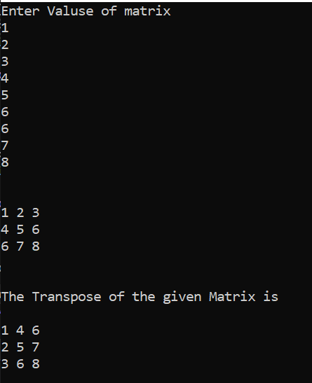

# Task 14

#include <iostream>

int main()

{

int matrix1[3][3], matrix2[3][3];

int answer[3][3] = { {0} };

int i, j, k, sum;

std::cout << "Enter elements for First matrix: \n"; //taking matrix 1

for (i = 0; i < 3; i++)

{

for (j = 0; j < 3; j++)

{

std::cin >> matrix1[i][j];

}

}

std::cout << "Enter elements for Second matrix: \n";//taking matrix 2

for (i = 0; i < 3; i++)

{

for (j = 0; j < 3; j++)

{

std::cin >> matrix2[i][j];

}

}

for (i = 0; i < 3; i++)//multiplying

{

for (j = 0; j < 3; j++)

{

sum = 0;

for (k = 0; k < 3; k++)

sum = sum + matrix1[i][k] * matrix2[j][k];

answer[i][j] = sum;

}

}

std::cout << "The answer is: \n";//saving answer

for (j = 0; j < 3; j++)//giving output

{

for (i = 0; i < 3; i++)

{

std::cout << answer[i][j] << "\t";

}

std::cout << std::endl;

}

}

# Output

