**Lab 15**

# Task 1

#include<iostream>

bool isnumpalandrome(int num);

int main()

{

int num;

std::cout << "Enter a number : ";

std::cin >> num;

if (isnumpalandrome(num) == true)

{

std::cout << "Number is Palandrome ";

}

else

{

std::cout << "Number is not Palandrome ";

}

std::cout << "\n\n";

system("pause");

}

bool isnumpalandrome(int num)

{

int sum = 0, orignalnum=num, count =0,temp=1, i=0, digit;

while (num != 0)

{

num = num / 10;

count++;

i++;

}

for (; i > 1;i--)

{

temp *= 10;

}

num = orignalnum;

while (num != 0)

{

digit = num % 10;

sum = sum + digit*temp;

num = num /10;

temp /= 10;

}

if (orignalnum == sum)

{

return true;

}

else

return false;

}

# Output

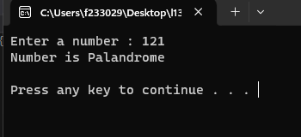

# Task 2

#include<iostream>

int nthterm(int num);

int main()

{

int num;

std::cout << "Enter a number : ";

std::cin >> num;

int nthvalueis = nthterm(num);

std::cout << "The nth Term of the series is : " << nthvalueis << "\n\n";

system("pause");

}

int nthterm(int num)

{

int N = num;

int nthvalue;

nthvalue = (N * ((N / 2) + ((N % 2) * 2) + N));

return nthvalue;

}

# Output

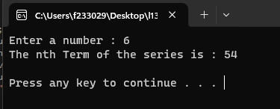

# Task 3

#include<iostream>

int fact(int num);

int main()

{

int num1;

while(1)

{

std::cout << "Enter Num 1 : ";

std::cin >> num1;

if (num1 < 0)

{

std::cout << "Enter Non-Negetive Number ";

continue;

}

else

break;

}

int factorial = fact(num1);

std::cout << "The Factorial of given Number is "<< factorial<<"\n\n";

system("pause");

}

int fact(int num)

{

int factorial = 1;

for (int i = num; i > 1; i--)

{

factorial *= i;

}

return factorial;

}

# Output

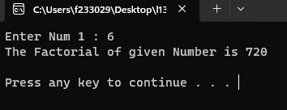

# Task 4

#include<iostream>

int large(int max,int num);

int main()

{

int num1, num2,i=1;

std::cout << "Enter Number ";

std::cin>>num1;

int maximum = num1;

while (i <= 9)

{

std::cout << "Enter Number ";

std::cin >> num2;

maximum = large(maximum, num2);

i++;

}

std::cout << "Maximum value Among these is " << maximum << "\n\n";

system("pause");

}

int large(int max, int num)

{

int maximum;

if (num == max)

{

return num;

}

maximum = (max > num) ? max : num;

return maximum;

}

# Output

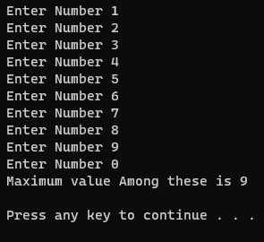

# Task 5

#include<iostream>

void swap(int num1, int num2);

int main()

{

int num1, num2;

std::cout << "Enter Num 1 : ";

std::cin >> num1;

std::cout << "Enter Num 2 : ";

std::cin >> num2;

std::cout << "Before Swaping " << "\nNum 1 = " << num1 << "\tNum 2 = " << num2<<"\n";

swap(num1, num2);

system("pause");

}

void swap (int num1 , int num2)

{

int temp;

temp = num1;

num1 = num2;

num2 = temp;

std::cout << "After Swaping " << "\nNum 1 = " << num1 << "\tNum 2 = " << num2<<"\n";

}

# Output

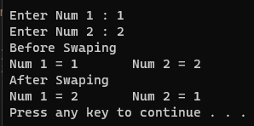

# Task 6

#include<iostream>

bool isperfect(int num);

void multiples(int num);

int main()

{

int i = 1;

for (; i <= 1000; i++)

{

if (isperfect(i))

{

std::cout << i << " is Perfect ";

std::cout << "with multiples = ";

multiples(i);

std::cout << "\n";

}

else

{

continue;

}

}

system("pause");

}

bool isperfect(int num)

{

int sum = 0;

for(int i = 1 ; i <num ; i++)

{

if (num%i == 0)

{

sum += i;

}

}

if (num == sum)

{

return true;

}

else

return false;

}

void multiples(int num)

{

for (int i = 1; i < num; i++)

{

if (num%i == 0)

{

std::cout << i << " ";

}

}

}

# Output

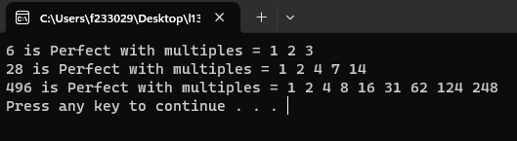

# Task 7

#include<iostream>

bool isvowel(char a);

int main()

{

char a;

std::cout << "Enter a Character ";

std::cin >> a;

if (isvowel(a) == true)

{

std::cout << "Your Entered Character is Vowel "<<"\n";

}

else

std::cout << "Your Entered Character is not Vowel " << "\n";

system("pause");

}

bool isvowel(char a)

{

if (a == 'a' || a == 'e' || a == 'i' || a == 'o' || a == 'u'||a == 'A' || a == 'E' || a == 'I' || a == 'O' || a == 'U')

{

return true;

}

else

{

return false;

}

}

# Output

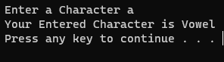

# Task 8

#include<iostream>

#include<ctime>

void guess(int num, int guessnum);//defining function

int main()

{

int guessnum ,attempts=0;

srand(time(0));//taking random numbers

int num = (rand() % 1000) + 1;

std::cout << "I have a number between 1 and 1000. \nCan you guess my number ?\n";

while (1)

{

do {

std::cout << "Guess the Number ";//guessing the numbers

std::cin >> guessnum;

guess(num, guessnum);

attempts++;

} while (num != guessnum);

std::cout << "You won Game in " << attempts << " Attempts\n";

std::cout << " Would you like to play again (y or n)?";//asking for replay or not

char choice;

std::cin >> choice;

if (choice == 'y' || choice == 'Y')

{

continue;

}

else

break;

}

system("pause");

}

//function for checking status

void guess(int num, int guessnum)

{

if (num == guessnum)

{

std::cout << "Excellent! You guessed the number!" << "\n";

}

else if (num > guessnum)

{

std::cout << "Too low. Try again." << "\n";

}

else

std::cout << "Too high. Try again." << "\n";

}

# Output

