**Lab No 7**

# Task 1

**Solution**

#include <iostream>

int main()

{

std::cout << "12" << "\t" << "30" << "\t" << "49\n";

system("pause ");

}

**Output**

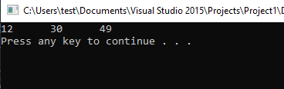

# Task 2

**Solution**

#include < iostream >

int main()

{

int number1;

std::cout << "Enter a number = ";

std::cin >> number1;

std::cout << " You entered = " << number1 << "\n";

system("pause");

}

**Output**

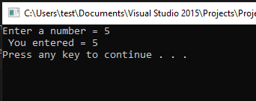

# Task 3

#include <iostream>

int main()

{

int num1, num2, num3 , avg;

std::cout << "Enter first number = ";

std::cin >> num1;

std::cout << "Enter second number = ";

std::cin >> num2;

std::cout << "Enter third number = ";

std::cin >> num3;

avg = (num1 + num2 + num3) / 3;

std::cout << "The average is = " << avg << "\n";

system("pause");

return 0;

}

**Output**

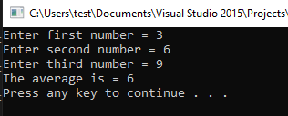

# Task 4

**Solution**

#include <iostream>

int main()

{

std::cout << "Subject\tMarks\n" << "Mathematics\t80\n" << "Computer\t77\n" << "Physics \t70\n";

system("pause");

}

**Output**

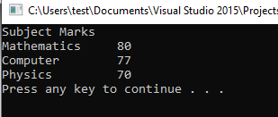

# Task 5

**Solution**

#include <iostream>

int main()

{

const int pi = 3.14;

int radius, area, circum;

std::cout << "Value of Pi is= " << pi << "\n";

std::cout << "enter radius of circle ";

std::cin >> radius ;

area = pi * radius *radius;

circum = 2 * pi * radius;

std::cout << " area of circle is = " << area << "\n";

std::cout << "circumfrance of circle = " << circum << "\n";

system("pause");

return 0;

}

**Output**

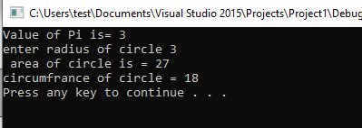

# Task 6

**Solution**

#include <iostream>

int main()

{

int len, wid, area, perimeter;

std::cout << "Enter length = ";

std::cin >> len;

std::cout << "Enter width = ";

std::cin >> wid;

area = wid * len;

perimeter = 2*(len + wid);

std::cout << "Area is = " << area << std::endl;

std::cout << "Perimeter is = " << perimeter << std::endl;

system("pause");

}

**Output**

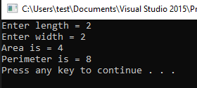

# Task 7

**Solution**

//(formula interest = amount*years*rate / 100).

#include <iostream>

int main()

{

int amount, year, rate;

float interest;

std::cout << "enter amount = ";

std::cin >> amount;

std::cout << "enter year = ";

std::cin >> year;

std::cout << "enter Rate = ";

std::cin >> rate;

interest = (amount*year*rate) / 100.0;

std::cout << "Intrest is = " << interest << std::endl;

system("pause");

}

**Output**

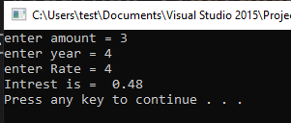

# Task 8

**Solution**

///Write a program to input/get a number of float type from the user and then show this number as

//both float with decimal points and integer without decimal points.

#include <iostream>

int main()

{

float num1;

std::cout << "Enter number in float = ";

std::cin >> num1;

std::cout << " Number in float is = " << num1 << std::endl;

int num2 = num1;

std::cout << "number without decimal is =" << num2 << std::endl;

system("pause");

}

**Output**

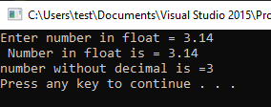

# Task 9

**Solution**

#include <iostream>

int main()

{

char character;

std::cout << "Enter Character = ";

std::cin >> character;

std::cout << " Character Entered = " << character << std::endl;

int num1 = character;

std::cout << "Its value =" << num1 << std::endl;

system("pause");

}

**Output**

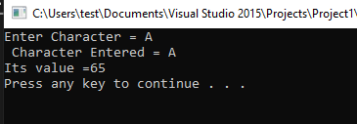

# Task 11

**Solution**

#include <iostream>

int main()

{

int a, b, temp;

std::cout << "Enter variable a : ";

std::cin >> a;

std::cout << "Enter variable b : ";

std::cin >> b;

std::cout << "Before swaping \n";

std::cout << "Value of variable a : "<< a <<std::endl;

std::cout << "value variable b : "<< b <<std::endl;

temp = a;

a = b;

b = temp;

std::cout << "After swaping \n";

std::cout << "Value of variable a : " << a << std::endl;

std::cout << "value variable b : " << b << std::endl;

system("pause");

return 0;

}

**Output**

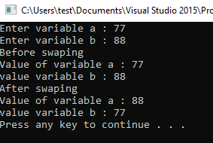

# Task 12

**Solution**

#include <iostream>

int main()

{

int a, b ;

std::cout << "enter variable a : ";

std::cin >> a;

std::cout << "enter variable b : ";

std::cin >> b;

std::cout << "before swaping \n";

std::cout << "value of variable a : "<< a <<std::endl;

std::cout << "value variable b : "<< b <<std::endl;

a = a + b;

b = a - b;

a = a - b;

std::cout << "after swaping \n";

std::cout << "value of variable a : " << a << std::endl;

std::cout << "value variable b : " << b << std::endl;

system("pause");

return 0;

}

**Output**

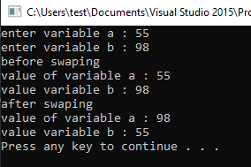

# Task 13

**Solution**

// this program calculates the product of three numbers

#include <iostream> //including Input/Ouput library

int main() //Main function

{

int x, y, z; // delcaring the variables

int result; // declaring the variable

std::cout << "Enter three integers: "; //Asking the user for input

std::cin >> x >> y >> z; //Taking the input from user and storing in variables

result = x * y * z; //Calculating the result of the products

std::cout << "The product is " << result << std::endl; //Printing the result on the screen.

system("pause"); //Pausing the screen to show the output clearly

}

**Output**

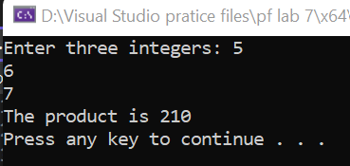

# Task 14

**Solution**

#include<iostream>;

int main()

{

int cel, far;

std::cout << " Enter temprature in Celsius = ";

std::cin >> far;

cel = 5.0/9.0*(far-32);

std::cout << "Temprature in Celsius is = " << cel << std::endl;

system("pause");

}

**Output**

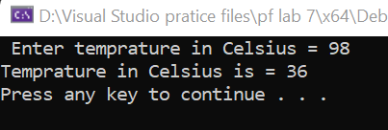

# Task 15

**Solution**

#include<iostream>

int main()

{

int divisor, dividend, quotient, remainder;

std:: cout << " Enter Divisor :";

std::cin >> divisor;

std::cout << " Enter Dividend:";

std::cin >> dividend;

quotient = dividend / divisor; //calculating quotient

remainder = dividend % divisor; // calculating remainder

std::cout << "Remainder is " << remainder<< std::endl;

std::cout << " Quotient is " << quotient << std::endl;

system("pause");

}

**Output**

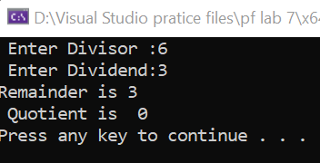

# Task 16

**Solution**

#include <iostream>

int main()

{

int num, digit1, digit2, digit3, digit4, digit5;;

std::cout << "Enter a five-digit integer: ";

std::cin >> num;

digit1 = num / 10000; //getting first digit

digit2 = (num / 1000) % 10;//getting second digit

digit3 = (num / 100) % 10;//getting third digit

digit4 = (num / 10) % 10;//getting forth digit

digit5 = num % 10;// getting fifth digit

std::cout << digit1 << "\t" << digit2 << "\t" << digit3 << "\t" << digit4 << "\t" << digit5 << std::endl;

system("pause");

return 0;

}

**Output**

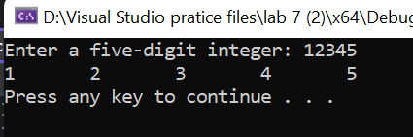

# Task 17

**Solution**

#include <iostream>

int main()

{

int x, y = 0, z = 0;

x = 7 + 3 * 6 / 2 - 1;

/* The following steps will be done by the compiler

7+3*6/2-1

7+18/2-1

7+9-1

16-1

x = 15 */

std::cout << "7 + 3 * 6 / 2 - 1 = " << x << std::endl;

x = 2 % 2 + 2 * 2 - 2 / 2;

/* The following steps will be done by the compiler

2%2+2*2-2/2

0+2*2-2/2

4-2/2

4-1

3 */

std::cout << "2 % 2 + 2 * 2 - 2 / 2 = " << x << std::endl;

std::cout << "(3 * 9 * ( 3 + ( 9 * 3 / ( 3 ) ) ) ) = " << (3 * 9 * (3 + (9 * 3 / (3)))) << std::endl;

/* The following steps will be done by the compiler

(3*9*(3+(9*3/(3))))

(3*9*(3+(9*3/3)))

(3*9*(3+(27/3)))

(3*9*(3+9))

(3*9*12)

27*12

324

1) y = a * x * x + b * x + c

The following steps will be done by the compiler

y = a * x * x + b * x + c

first of all the first muliplication operation will be done i.e a*x (lets say a*x = d)

then the 2nd multiplication operation will be done i.e d*x (lets say this results in z)

then the muliplication of b*x will be done (lets say it is equal to p)

so expression becomes : z + p + c

then z + p will be added first and then the answer of this will be added to c

and then it will be stored in the variable y

2) z = p * r % q + w / x - y

The following steps will be done by the compiler

first of all the first muliplication operation will be done i.e p * r (lets say this equals to d)

then d will be divided by q and the remainder will be the answer lets say it will be n

then w/x will be done lets say this equals to m

so equation becomes : n + m - y

after this, n will be added to m and then the answer will be subtracted from y

then this will be stored in variable z

3) z = pr % q + w/x � y

The following steps will be done by the compiler

first of all the first remainder operation will be done i.e pr % q (lets say this equals to d)

then w / x will be done which will lets say equal to k

so equation becomes : d + k - y

then d will be added to k and then the asnwer will be subtracted from y

after this the value of the expression will be stored in the variable z

*/

system("pause");

}

**Output**

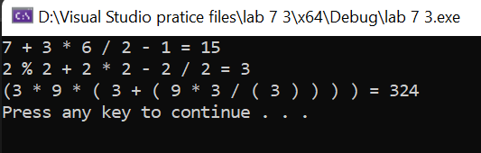

# Task 18

**Solution**

Output#include <iostream>

int main()

{

int c;

std::cout << "Enter the value of C: ";

std::cin >> c;

if (c < 7) // checking the condition

{

std::cout << "C is less than 7 " << std::endl; //Printing output

}

//the mark of greater than or equal to was misplaced, it also had std:: missing

if (c >= 7) //Checking the condition

{

std::cout << "C is greater than or equal to 7" << std::endl;

}

system("pause");

return 0;

}

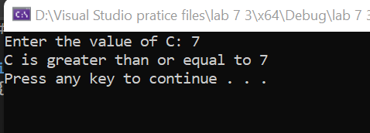

# Task 19

**Solution**

#include <iostream>

int main()

{

int marks;

std::cout << "Enter your marks: ";

std::cin >> marks;

if (marks < 80)//Applying condition

std::cout << "Sorry, you did not get admission in FAST. Please try again!" << std::endl;//Printing output if condition is true

else

std::cout << "You can get admission in FAST." << std::endl;//printing output if condition is false

system("pause"); //pausing the system

return 0;

}

**Output**

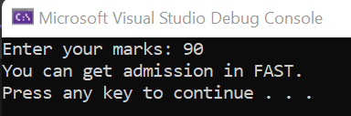

# Task 20

**Solution**

#include <iostream> //including Input/Ouput function

int main() // main function

{

int rem_wickets, score, target = 300, remain;

std::cout << "Enter your score: ";

std::cin >> score;

std::cout << "Enter wickets in hands: ";

std::cin >> rem_wickets;

remain = target - score;

if (score >= target)

{

if (score == target)

{

std::cout << "The match is draw" << std::endl;

}

else

{

std::cout << "Pakistan won by " << rem_wickets << " wickets" << std::endl;

}

}

else

std::cout << "Pakistan need " << remain << " runs to win while having " << rem_wickets << " wickets in hand" << std::endl;

system("pause"); //pausing the system

}

**Output**

