**Lab 8**

# Task 1

# Solution

#include <iostream>

int main()

{

int marks;

std::cout << "Enter Marks = ";

std::cin>>marks;

if (marks > 100 || marks < 0) // if greater than 100 and less than 0 so invalid

{

std::cout << "Invalid input \n ";

}

else if (marks > 80 && marks > 100)// for a grade

{

std::cout << " A Grade \n";

}

else if (marks > 50 && marks > 80)

{

std::cout << " A Grade \n";

}

else if (marks > 40 && marks > 50)

{

std::cout << “A Grade \n";

}

else

{

std::cout << "F Grade \n";// if less than 40 so fail

}

system("pause");

}

# Output

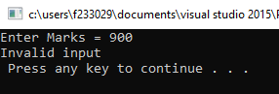

# Task 2

# Solution

#include <iostream>

int main() // int main should be written

{

const int SECRET = 5; // it should be initialized after main function

int x, y, w, z;

z = 9;

if (z > 10) //round bracket should be used for condition of if

{

x = 12; // should be written in delimeters

y = 5; // semi colon should be used here to end the line

w = x + y + SECRET;

}

else

{

x = 12; // statments of else should be in brackets

y = 4; // semi colon should be used

w = x + y + SECRET;

}

std::cout << " w = " << w << std::endl;

system("pause");

}

# Output

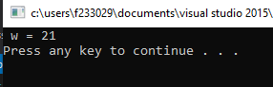

# Task 3

# Solution

#include <iostream>

using namespace std;

int main()

{

int myNum = 10;

int yourNum = 30;

if (yourNum % myNum == 3)

{

yourNum = 3;

myNum = 1;

}

else if (yourNum % myNum == 2)

{

yourNum = 2;

myNum = 2;

}

else

{

yourNum = 1;

myNum = 3;

}

std::cout << myNum << " " << yourNum << std::endl;

system("pause");

return 0;

}

# Output

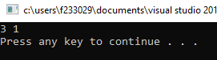

# Task 4

# Solution

//Suppose that x, y, and z are int variables, and x = 6, y = 25, and z = 100. Write a single C++ code to

//determine whether the following expressions evaluate to true or false.

//a) !(x > 10)

//b) x <= 5 || y < 15

// c) (x != 5) && (y != z)

// d) x >= z || (x + y >= z)

// e) (x <= y - 2) && (y >= z) || (z - 2 != 20)

#include<iostream>

int main()

{

int x = 6, y = 25, z = 100;

if (!(x > 10)) //according to values it will be true

{

std::cout << "(a) condition is True" << std::endl;

}

else

{

std::cout << "(a) condition is False"<<std::endl;

}

if (x <= 5 || y < 15)//according to values it will be false

{

std::cout << "(b) condition is True"<<std::endl;

}

else

{

std::cout << "(b) condition is False"<<std::endl;

}

if ((x != 5) && (y != z))//according to values it will be true

{

std::cout << "(c) condition is True"<<std::endl;

}

else

{

std::cout << "(c) condition is False"<<std::endl;

}

if (x >= z || (x + y >= z))//according to values it will be false

{

std::cout << "(d) condition is True"<<std::endl;

}

else

{

std::cout << "(d) condition is False"<<std::endl;

}

if ((x <= y - 2) && (y >= z) || (z - 2 != 20))//according to values it will be true

{

std::cout << "(e) condition is True"<<std::endl;

}

else

{

std::cout << "(e) condition is False"<<std::endl;

}

system("pause");

}

# Output

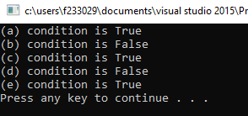

# Task 5

# Solution

#include <iostream>

int main()

{

int n1, n2, n3;

std::cout << "Enter first number ";

std::cin >> n1;

std::cout << "Enter second number ";

std::cin >> n2;

std::cout << "Enter third number ";

std::cin >> n3;

if (n1 == n2)

{

if (n2 == n3)

std::cout << "All are Equal" << std::endl;

else

std::cout << "These values are diffrent" << std::endl;

}

else

{

std::cout << "These values are diffrent" << std::endl;

}

std::cout << "Now finding Greates among 3 " << std::endl;

int max;

max = n1;

if (n2 > max )

{

max = n2;

}

if (n3 > max)

{

max = n3;

}

std::cout << "Highest number among these is = " << max << std::endl;

system("pause");

}

# Output

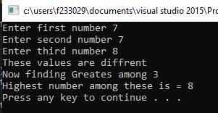

# Task 6

# Solution

#include <iostream>

int main()

{

int age, fee;

char membership;

std::cout << "Enter Your age = "; // input age

std::cin >> age;

std::cout << " Enter your membership status , Enter M or N "; // input membership sttsus from the user

std::cin >> membership;

if (membership == 'M'|| membership == 'm'&& age < 65)

fee = 10000;

else if (membership == 'M'|| membership == 'm'&& age >= 65)

fee = 5000;

else if (membership == 'N'||membership == 'n')

fee = 15000;

else

std::cout << " invalid input "; // invalid if gany condition not match

std::cout << "Seminar Fee is = "<<fee <<std::endl; // giving the fee

system("pause");

}

# Output

