**LAB 8 (TASK 7 – 10 )**

# Task 7

# Solution

#include <iostream>

#include <math.h>

int main()

{

const int i = -1;

int a, b, c, dics;

double root1, root2;

std::cout << "Enter value of a =";

std::cin >> a;

std::cout << "Enter value of b = ";

std::cin >> b;

std::cout << "Enter value of c = ";

std::cin >> c;

dics = b*b - sqrtf( 4 * a*c ); // finding discriminent

if (a == 0 || b == 0 || c == 0) // if zero so all are zero

std::cout << "The value can’t be zero\n";

else if (a < 0 || b < 0 || c < 0) // if less then zero

std::cout << "Values must be greater than Zero\n";

else

{

if (dics > 0) // for unequal roots condiotion

{

std::cout << "roots are real and unequal.\n";

root1 = (-b + ((dics)*1.0 / 2.0) / 2.0 * a);

root2 = (-b - ((dics)*1.0 / 2.0) / 2.0 * a);

}

else if (dics < 0) // for imaginary roots equation

{

std::cout << "roots are imaginary.\n";

root1 = (-b + (i*(dics) * 1.0 / 2.0) / 2.0 * a);

root2 = (-b - (i*(dics) * 1.0 / 2.0) / 2.0 * a);

}

else // for disc = o

{

std::cout << "Roots are Equal\n";

root1 = root2 = -b / (2.0 * a);

}

std::cout << "First Root of the equation is = " << root1 << "\tSecond Root ofthe equation is = " << root2 << std::endl; // printing the finded roots

}

system("pause");

}

# Output

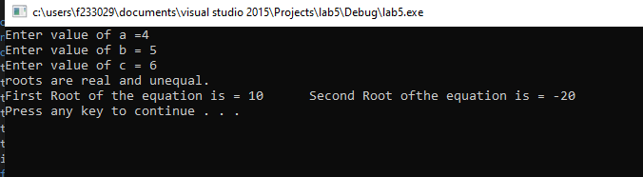

# Task 8

# Solution

#include <iostream>

#include<ctime>

int main()

{

srand((int)time(0));

int num = (rand() % 100) + 1; // taking random no. with help of clock so that it can not exceede from 100

std::cout << "Random number is = " << num << std::endl;

if (num > 50)

{

std::cout << "Input number is large" << std::endl;

}

else if (num < 50)

{

std::cout << "Input number is small" << std::endl;

}

else // in case of equal

std::cout << "Input number is average" << std::endl;

system("pause");

}

# Output

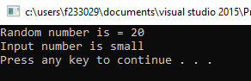

# Task 9

# Solution

#include <iostream>

int main()

{

float units, previous, current;

std::cout << "Enter previous units \n";

std::cin >> previous;

std::cout << "Enter current units \n";

std::cin >> current;

units = current - previous;

if (units <= 100 && units > 0)

{

std::cout << "Bill = " << units * 10 << "\n";

}

else if (units >= 101 && units <= 300)

{

units = units * 12.5;

std::cout << "Bill = " << units + 10 / 100 << "\n";

}

else if (units > 300)

{

units = units * 15;

std::cout << "Bill = " << units * 15 * 20 / 100 << "\n";

}

system("pause");

}

# Output

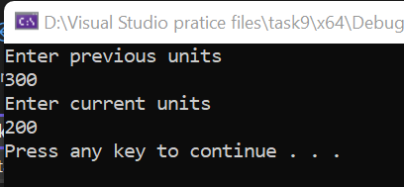

# Task 10

# Solution

#include <iostream>

int main()

{

int num1, num2;

char op;

std::cout << " Number 1 = ";

std::cin >> num1;

std::cout << " Number 2 = ";

std::cin >> num2;

std::cout << " Operation to be performed is (+,-,*,/) = ";

std::cin >> op;

if (op == '+')

std::cout << "Solution of num1 and num2 is = " << num1 + num2<<std::endl;

if (op == '*')

std::cout << "Solution of num1 and num2 is = " << num1 * num2 << std::endl;

if (op == '/')

std::cout << "Solution of num1 and num2 is = " << num1 / num2 << std::endl;

if (op == '-')

std::cout << "Solution of num1 and num2 is = " << num1 - num2 << std::endl;

if (op == '%')

std::cout << "Solution of num1 and num2 is = " << num1 % num2 << std::endl;

system("pause");

}

# Output

