**Lab 9**

# Task 1

#include<iostream>

int main()

{

int n;

std::cout << " Enter Day Name you want :";

std::cin >> n;

switch (n)

{

case 1 :

{

std::cout << "Monday";

break;

}

case 2:

{

std::cout << "Tuesday";

break;

}

case 3:

{

std::cout << "Wednesday";

break;

}

case 4:

{

std::cout << "Thursday";

break;

}

case 5:

{

std::cout << "Friday";

break;

}

case 6:

{

std::cout << "Saturday";

break;

}

case 7:

{

std::cout << "Sunday";

break;

}

default:

{

std::cout << "Invalid Input ";

}

system("pause");

}

}

# Output

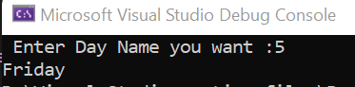

# Task 2

#include <iostream>

int main()

{

int age, choice;

std::cout << " Enter 1 for children \n Enter 2 for Teenagers \n Enter 3 for Adults \n Enter 4 for Seniors \n";

std::cin >> choice;

std::cout << "Enter Age \n";

std::cin >> age;

switch (choice)

{

case 1:

if (age > 0 && age <= 12)

{

std::cout << "Ticket price = $5 \n";

}

else

{

std::cout << "INvalid Age \n";

}

break;

case 2:

if (age > 12 && age <= 17)

{

std::cout << "Ticket price = $8 \n";

}

else

{

std::cout << "INvalid Age \n";

}

break;

case 3:

if (age > 17 && age <= 59)

{

std::cout << "Ticket price = $12 \n";

}

else

{

std::cout << "INvalid Age \n";

}

break;

case 4:

if (age > 60)

{

std::cout << "Ticket price = $6 \n";

}

else

{

std::cout << "INvalid Age \n";

}

break;

default:

std::cout << "Invaled choice \n";

}

system("pause");

}

# Output

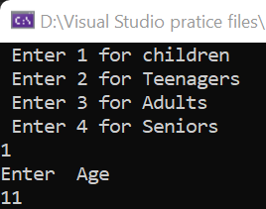

# Task 3

#include <iostream>

int main()

{

int price , size ,flav;

std::cout << "1 for Small, 2 for Medium, 3 for Large ";

std::cin >> size;

std::cout << "1 for Margherita, 2 for Pepperoni,3 for Veggie ";

std::cin >> flav;

switch (size)

{

case 1:

std::cout << "Price is 8$"<<std::endl;

price = 8;

switch (flav)

{

case 1:

std::cout << "No additional charge"<<std::endl;

price = price;

break;

case 2:

std::cout << "Pepproni charges 2 $" << std::endl;

price = price + 2;

break;

case 3:

std::cout << "Veggi charges 3 $ " << std::endl;

price = price + 3;

break;

default:

std::cout << "invalid input" << std::endl;

}

break;

case 2:

std::cout << "Price is 12$" << std::endl;

price = 12;

switch (flav)

{

case 1:

std::cout << "No additional charge" << std::endl;

price = price;

break;

case 2:

std::cout << "Pepproni charges 2 $" << std::endl;

price = price + 2;

break;

case 3:

std::cout << "Veggi charges 3 $ " << std::endl;

price = price + 3;

break;

default:

std::cout << "invalid input" << std::endl;

}

break;

case 3:

std::cout << "Price is 15$" << std::endl;

price = 15;

switch (flav)

{

case 1:

std::cout << "No additional charge" << std::endl;

price = price;

break;

case 2:

std::cout << "Pepproni charges 2 $" << std::endl;

price = price + 2;

break;

case 3:

std::cout << "Veggi charges 3 $ " << std::endl;

price = price + 3;

break;

default:

std::cout << "invalid input" << std::endl;

}

break;

default:

std::cout << "invalid input" << std::endl;

}

std::cout << "Total Bill is = " <<price;

}

# Output

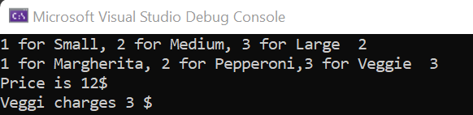

# Task 4

#include <iostream>

int main()

{

int temp ;

std:: cout << "Enter Temprature in Celcius ";

std::cin >> temp;

(temp < 0) ? std::cout << "Freezing" :

(temp >= 0 && temp <= 10) ? std::cout << "cold" :

(temp >= 11 && temp <= 20) ? std::cout << "Modereate" :

(temp >= 21 && temp <= 30) ? std::cout << "Warm" :

(temp > 30) ? std::cout << "Hot" : std::cout << "wrong input";

}

# Output

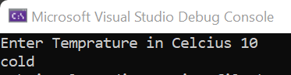

# Task 5

#include <iostream>

int main()

{

int marks, choice, cs, me, ee, comp;

std::cout << "Input Your agreegate ";

std::cin >> marks;

std::cout << "Enter 1 for Computer Engeeiring \n 2 For Mechanical Engeeniering \n 3 for Electrical Engeeniering ";

std::cin >> choice;

std::cout << "If You have taken All compulsory Subjects (Math , Physics , chemistry) press 1 otherwise 0";

std::cin >> comp;

if (comp == 1)

{

if (marks > 60)

{

if (choice == 1)

{

std::cout << "If You have taken Computer Science Then Enter 1 else 0";

std::cin >> cs;

if (cs == 1)

{

if (marks > 70)

std::cout << "You got Admission ";

else

std::cout << "Not Elligible ";

}

else

std::cout << "Not Elligible";

}

else if (choice == 2)

{

std::cout << "If You have taken Mechanical Engineering Then Enter 1 else 0";

std::cin >> me;

if (me == 1)

{

if (marks > 65)

std::cout << "You got Admission";

else

std::cout << "not Eligible";

}

else

std::cout << "Not Eligible";

}

else if (choice == 3)

{

std::cout << "If You have taken Electrical Engineering Then Enter 1 else 0";

std::cin >> ee;

if (ee == 1)

{

if (marks > 68)

std::cout << "You got Admission";

else

std::cout << "not Eligible";

}

else

std::cout << "Not Eligible";

}

else

std::cout << "Not elligible";

}

system("pause");

}

}

# Output

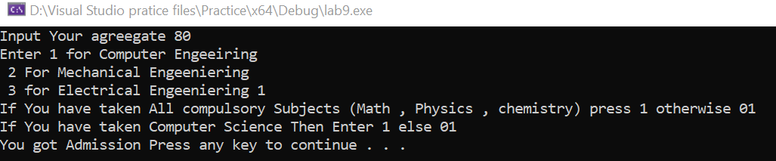

# Task 6

#include <iostream>

int main()

{

int n1 = 0, n2 = 1, sum , terms;//terms for program counter

std::cout << "Enter the Number of Terms you Want ";

std::cin >> terms;

std::cout << n1 << " " << n2;

terms = terms - 2;//first two numbers are already printed

for (int i = 1; i <= terms; i++)

{

sum = n1 + n2;

std::cout << " " << sum;

n1 = n2;

n2 = sum;

}

std::cout << "\n";

system("pause");

}

# Output

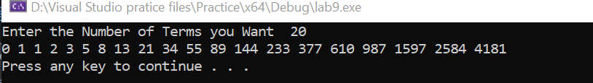

# Task 7

#include <iostream>

int main()

{

int n, a;

std::cout << "Enter both number";

std::cin >> n >> a;

for (int i = 1; i < n; i++)

{

std::cout << n * (a + i) << std::endl;

}

system("pause");

}

# Output

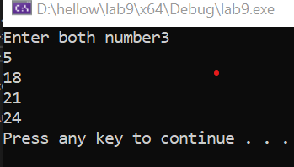

# Task 8

#include<iostream>

int main()

{

int limit, num , sum =0;

std::cout << "Enter the limit of Numbers";

std::cin >> limit;

for (int i = 1; i <= limit; i++)

{

std::cout << "Enter number " << i;

std::cin >> num;

sum = num + sum;

}

std::cout << "The average is = " << sum/ limit;

}

# Output

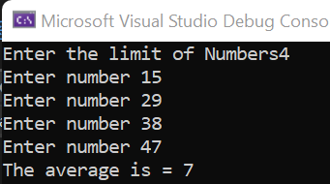

# Task 9

#include <iostream>

int main()

{

int num;

bool prime = true;

std::cout << "enter a number ";

std::cin >> num;

for (int i = 1; i<=(num-1)/2; i++) //it will not be divisble after half past of them so we can say we will check only the half

{

if (num % i== 0)//will check the number

prime = false;

}

if (prime == true)//now will check it is true or not

std::cout << "number is prime ";

else

std::cout << "number is not prime";

}

# Output

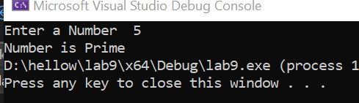

# Task 10

#include <iostream>

int main() {

int a, b;

std::cout << "Enter two numbers: ";

std::cin >> a >> b;

int max = (a > b) ? a : b;

for (; ;max++) {

if (max % a == 0 && max % b == 0) {

std::cout << "The Least Common Multiple is: " << max << std::endl;

break;

}

}

return 0;

}

# Output

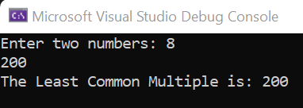

# Task 11

#include <iostream>

int main() {

double populationA, growthRateA, populationB, growthRateB;

std::cout << "Enter the population of town A : ";

std::cin >> populationA; // Inputs fo town A

std::cout << "Enter the growth rate of town A : ";

std::cin >> growthRateA;

std::cout << "Enter the population of town B : ";

std::cin >> populationB; // Inputs for town B

std::cout << "Enter the growth rate of town B : ";

std::cin >> growthRateB;

int years = 0;

while (populationA < populationB) //Checking the population increase when both become equal

{

populationA += (populationA * (growthRateA / 100));

populationB += (populationB * (growthRateB / 100));

years++;

}

std::cout << "The population of town A will be greater than or equal to the population of town B in Years = " << years << std::endl;

std::cout << "Population of town A: " << populationA << std::endl;

std::cout << "Population of town B: " << populationB << std::endl;//giving info about output

return 0;

}

# Output

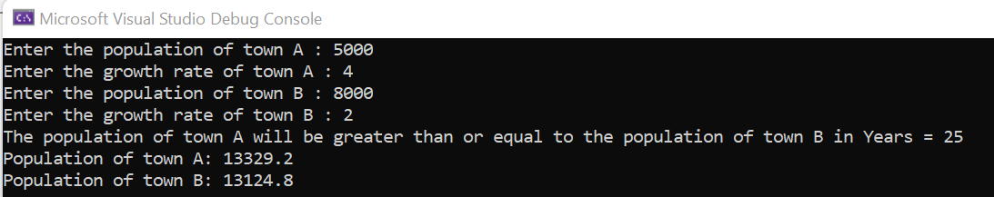

# Task 12

#include <iostream>

int main()

{

int num , sum=0 , digit ,orignalNum;

std::cout << "Enter a number = ";

std::cin >> num; //Entering number to check wether it is armstrong or not

orignalNum = num;

for (;num>0;) //giving condition

{

digit = num % 10; // taking single digit

sum = sum + (digit * digit * digit);

num =num / 10;

}

if (orignalNum == sum) //checking wether the number is armstrong or not

std::cout << "Number is Armstrong \n";

else

std::cout << "Number is not Armstrong \n";

system("pause");

}

# Output

# 